Electrochemical Kinetic Energy Harvesting Mediated by Ion Solvation Switching in Two-Immiscible Liquid Electrolyte

Donghoon Lee^{1,a},You-Yeob Song^{2,a}, Angyin Wu¹, Jia Li³, Jeonghun Yun¹, Dong-Hwa Seo², Seok Woo Lee*^{,1,3}

¹School of Electronic and Electrical Engineering, Nanyang Technological University (NTU), 50 Nanyang Avenue, 639798, Singapore
²Department of Materials Science and Engineering, Korea Advanced Institute of Science and Technology (KAIST), Daejeon 34141, Republic of Korea
³Rolls-Royce@NTU Corporate Lab Nanyang Technological University Singapore 639798, Singapore

Table of contents
Supplementary Figure 1 | CuHCFe electrodes are fabricated in both nanoparticles and thin-film.
Supplementary Figure 2 | Electrochemical characterizations of CuHCFe electrodes in aqueous and ionic liquid electrolytes.
Supplementary Figure 3 | Continuous observations on the height of interface level of IL/Aq.
Supplementary Figure 4 | The TGA measurement for the ionic liquid and the IL phase.
Supplementary Figure 5 | Galvanostatic Intermittent Titration Technique (GITT) of CuHCFe slurry electrodes in the Aq phase and the IL phase.
Supplementary Figure 6 | Changes in potential of LiMn₂O₄ (LMO) and LiCoO₂ (LCO) electrodes with switching the electrolyte phase.
Supplementary Figure 7 | Changes in potential of CuHCFe electrodes with switching the
electrolyte phase.
Supplementary Figure 8 | Open-circuit voltage increase between the Aq phase and the IL phase varying salt concentrations in each phase.
Supplementary Figure 9 | Raman analysis on various liquid samples.
Supplementary Figure 10 | Additional overall structures and solvation structures for Aq phase.
Supplementary Figure 11 | Additional overall structures and solvation structures for IL phase.
Table S1 | Solvation energies of Na⁺ ions in Aq and IL phase.
Supplementary Figure 12 | Electrochemical Impedance Spectroscopy (EIS) results with Nyquist plots.
Supplementary Figure 13 | Long-term test with various frequency.
Supplementary Figure 14 | The single-pair microfluidic harvester.
Supplementary Figure 15 | The Reynold number of water and EmimTFSI.
Table S2. | Absolute viscosity, density, and kinematic viscosity of water and EmimTFSI.
Supplementary Figure 16 | The three-cell experiment results for the single-pair microfluidic harvester.
Supplementary Figure 17 | The 8-pair microfluidic energy harvester.
Supplementary Figure 18 | Short-circuit current of the 8-pair microfluidic energy harvester.
Supplementary Figure 19 | Voltage profile between the two-phase electrolyte.
Supplementary Note 1. Deriving cell voltage equation in the two-phase electrolyte
Table S3 | The comparisons of the maximum power and load resistors of several main KEH methods
Supplementary References.

Supplementary Figures

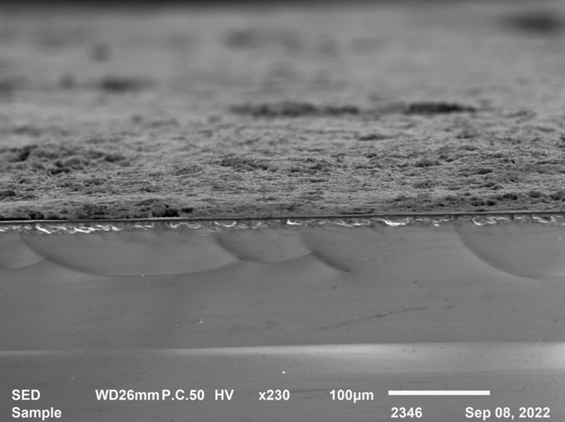
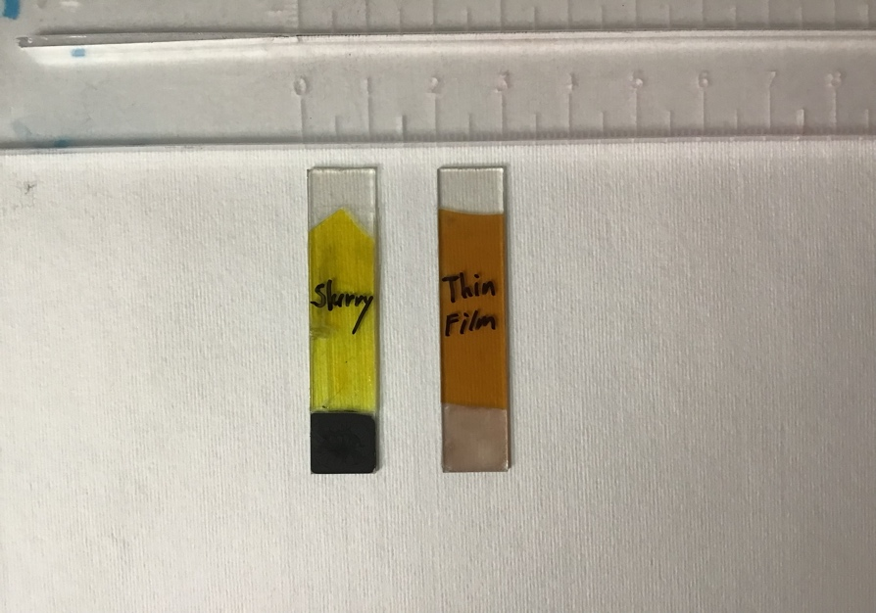
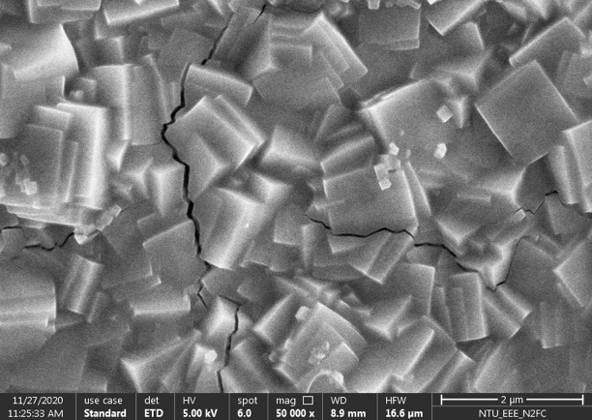
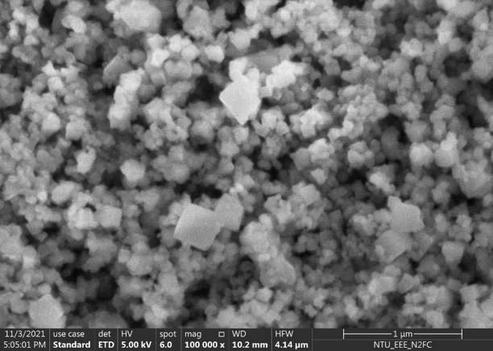
(d)
(c)
(b)
(a)
Glass
CuHCFe slurry
ITO
100 um
CuHCFe slurry
Insulating tape
ITO-coated glass
CuHCFe
thin-film
Insulating tape
ITO-coated glass
1 cm
2 um
1 um
Supplementary Figure 1 | CuHCFe electrodes are fabricated in both nanoparticles and thin-film. (a) Scanning electron microscopy (SEM) image of CuHCFe nanoparticles. The nanoparticle was prepared through the co-precipitation method. (b) The photos of CuHCFe electrodes. (left) Slurry deposition of CuHCFe nanoparticle and (right) Electrodeposited CuHCFe thin-film. Both electrodes are fabricated on the surface of conductive glass (ITO-coated). All area, except for the desired area of 1 cm x 1 cm, are protected by an insulating tape (Kapton) to inhibit electric shorting. (c) SEM image of CuHCFe thin-film. The film was fabricated by electrodeposition method. (d) cross-sectional SEM image of CuHCFe slurry electrode. On the glass substrate, a thin layer of ITO are deposited for electric conductivity and slurry of CuHCFe is deposited in sequence.

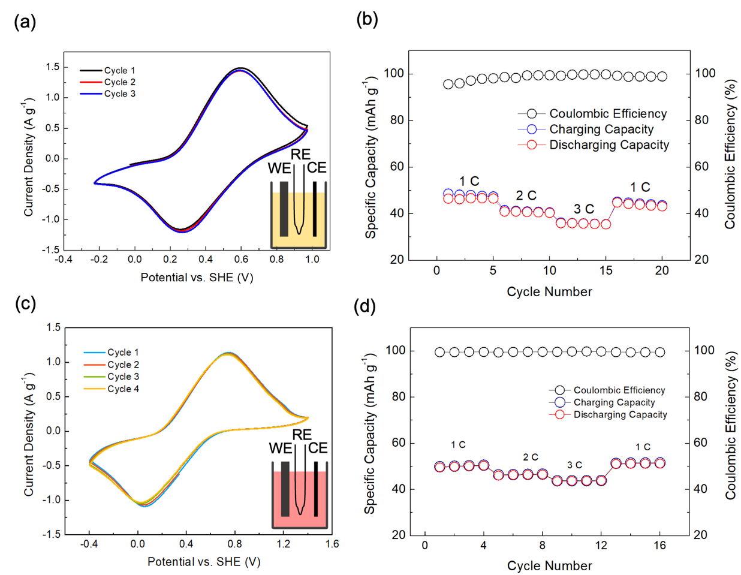

Supplementary Figure 2 | Electrochemical characterizations of CuHCFe electrodes in aqueous and ionic liquid electrolytes. CuHCFe slurries were deposited on carbon cloth. Separate electrolyte DI water with 0.2 M NaTFSI ((a) and (b)). The scan rate is 5 mV s⁻¹. EmimTFSI with 0.2 M NaTFSI ((c) and (d)). The c-rates were calculated based on the previous literatures. (a) CV in DI water with 0.2 M NaTFSI electrolyte. (b) cyclic performance in DI water with 0.2 M NaTFSI electrolyte. (c) CV in ionic liquid of EMI TFSI with 0.2 M NaTFSI. (d) cyclic performance in ionic liquid of EMI TFSI with 0.2 M NaTFSI.

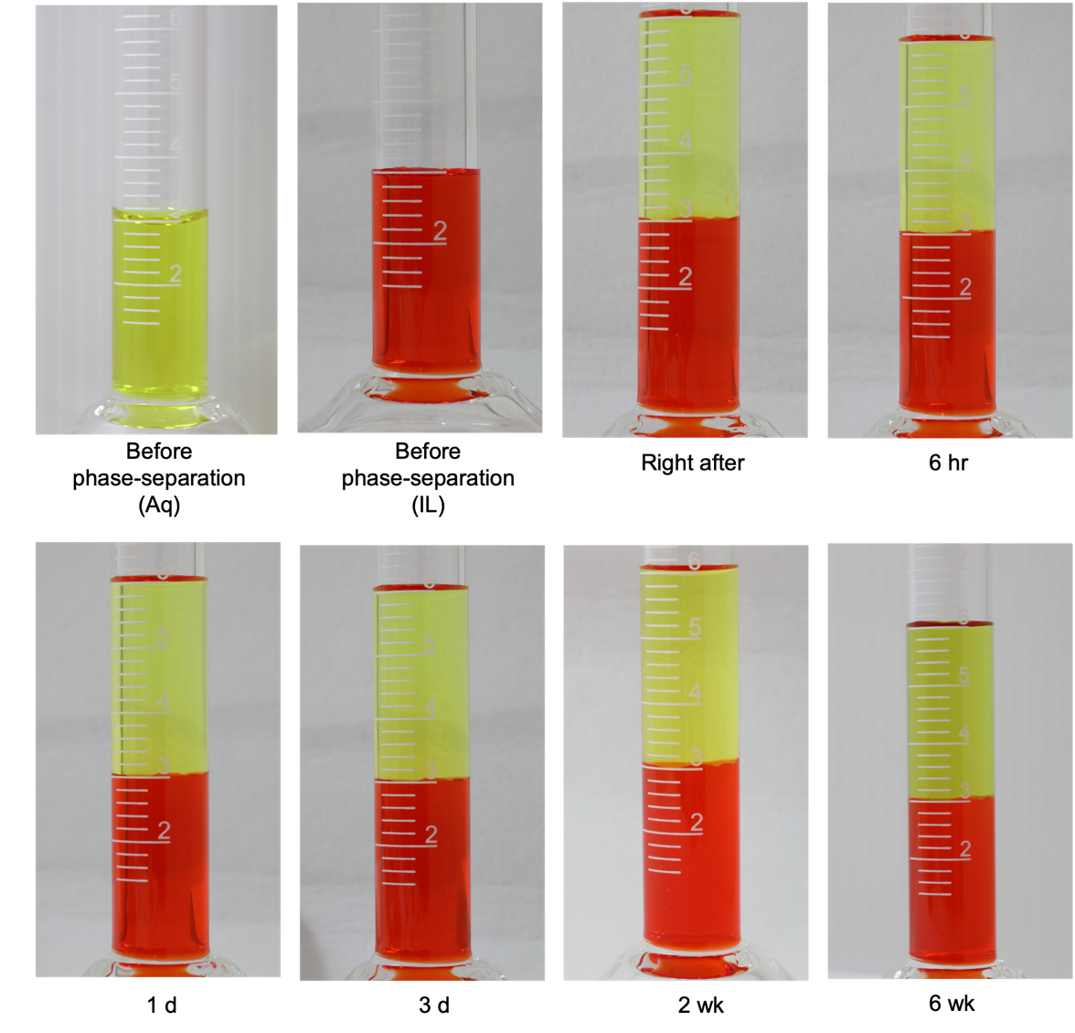

Supplementary Figure 3 | Continuous observations on the height of interface level of IL/Aq. The same electrolytes of the main experiments were prepared to examine there is no macro change volume of each phase. 0.2 M of NaTFSI was added in DI water and EmimTFSI. Then 3 ml of each electrolyte were made into a two-phase electrolyte. Even after more than 6 weeks, there was no noticeable mixing or volume change at the very first water level.

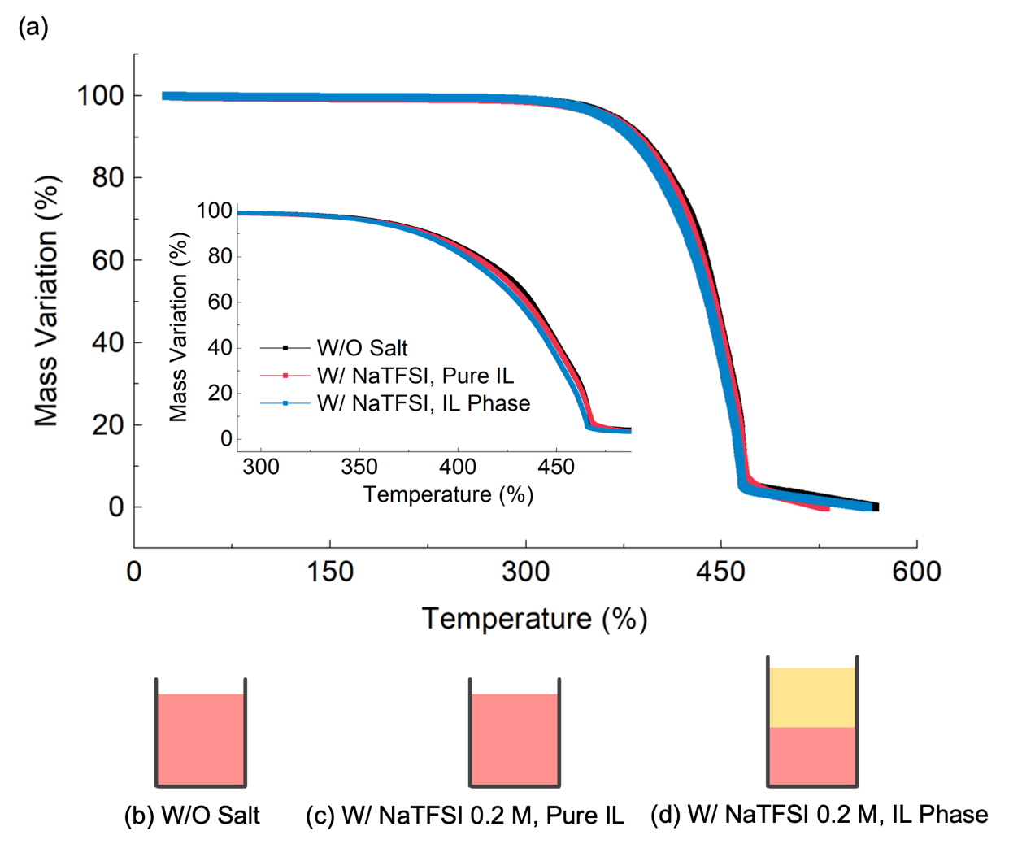

Supplementary Figure 4 | The TGA measurement for the ionic liquid and the IL phase. The TGA measurement for (b) and (c) was conducted within 30 min after it was taken from an Ar-filled glove box. The two-liquid in (d) was shaken robustly and remained 24 hrs. To take the TGA sample for (d), the upper Aq layer was taken away gently, and the lower IL layer was taken. From 25ºC to 350ºC, the three samples do not show sharp decrease in their mass, but after 350ºC, the mass of three samples drop to 0 when the temperature reaches 450ºC. The dramatic mass losses during 350ºC – 450ºC are well matched with the decomposition temperature of EmimTFSI and NaTFSI.

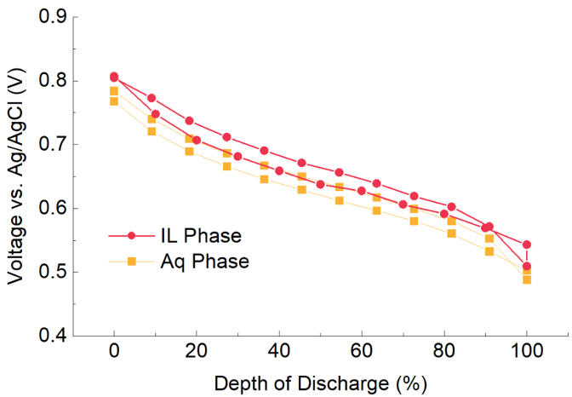

Supplementary Figure 5 | Galvanostatic Intermittent Titration Technique (GITT) of CuHCFe slurry electrodes in the Aq phase and the IL phase. With 1 C current, current flows for 5 min, and rest for 15 min to reach its saturation. Each points are the last moments after the rest. Both in charging and discharging states, the IL phase has always higher voltage than the Aq phase. It shows that the potential difference between the two phase does not come from the thermodynamic fluctuation.

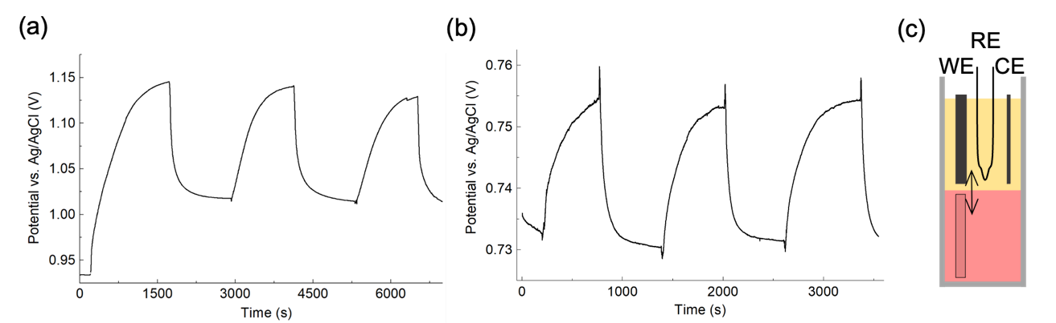

Supplementary Figure 6 | Changes in potential of LiMn₂O₄ (LMO) and LiCoO₂ (LCO) electrodes with switching the electrolyte phase. LMO and LCO powder are dissolved in NMP with Carbon black and PVdF and the slurry were deposited on ITO-coated glass. Potential change with time of (a) LMO and (b) LCO. (c) experimental details. A standard three-cell electrode set-up is used. For counter electrode, activated carbon is used. 0.2 M of LiTFSI was added in DI water and EmimTFSI and then the two liquid were made the two-phase electrolyte.

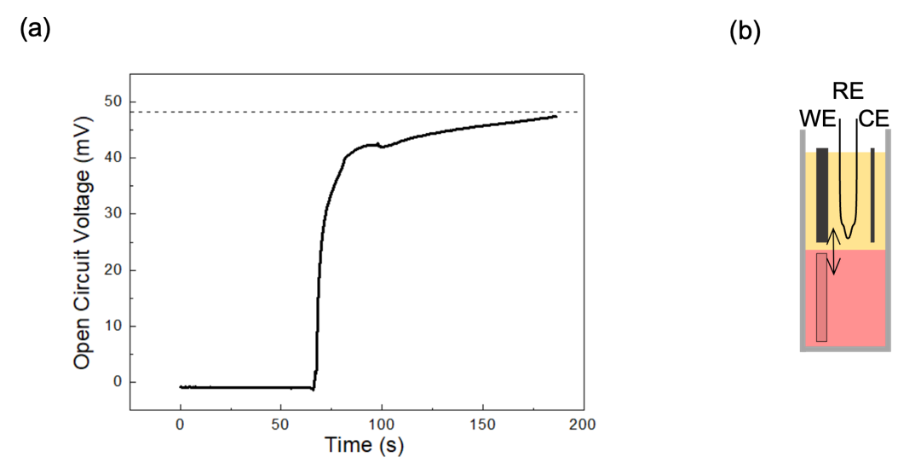

Supplementary Figure 7 | Changes in potential of CuHCFe electrodes with switching the
electrolyte phase. Potential change with time of (a) CuHCFe and (b) experimental details. A standard three-cell electrode set-up is used. For counter electrode, activated carbon is used. 0.2 M of LiTFSI was added in DI water and EmimTFSI and then the two liquid were made the two-phase electrolyte.

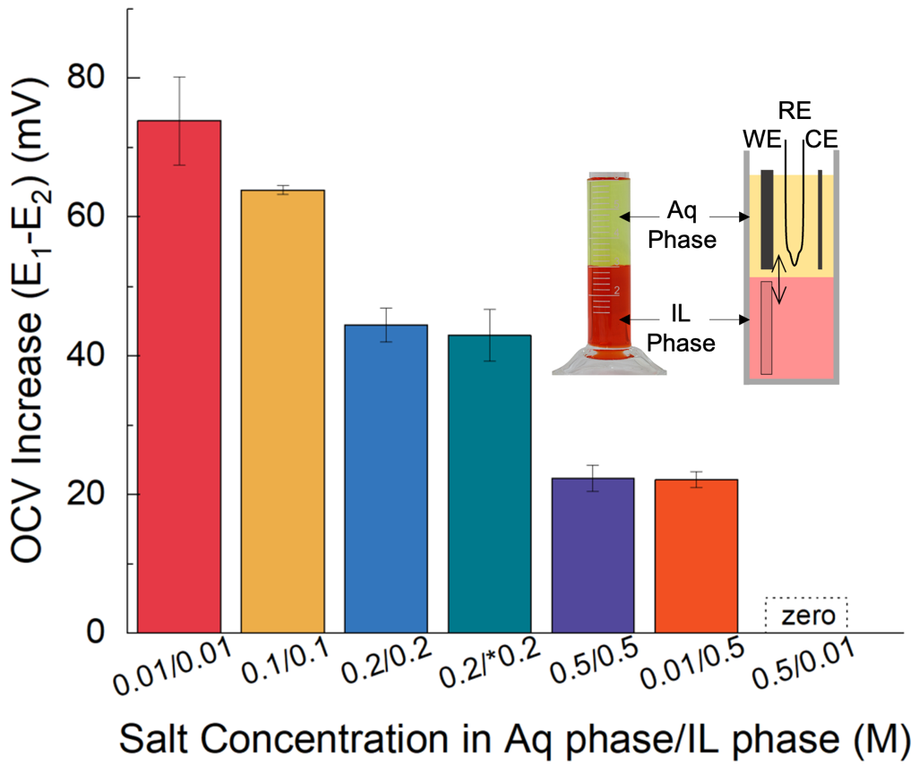

Supplementary Figure 8 | Open-circuit voltage increase between the Aq phase and the IL phase varying salt concentrations in each phase. In the Aq phase, two CuHCFe electrodes of E₁ and E₂ had been shorted to confirm there is no voltage difference. Then, E₁ was switched to the IL phase. The OCV increase (E₁-E₂) was measured. The saturated OCV increasements were recorded. The Aq phase is DI water with the desired salt concentration. The IL phase is EmimTFSI with the desired salt concentration. For * (dark-green bar), another ionic liquid of betainium bis(trifluoromethylsulfonyl)imide (Hbet TFSI) was used.

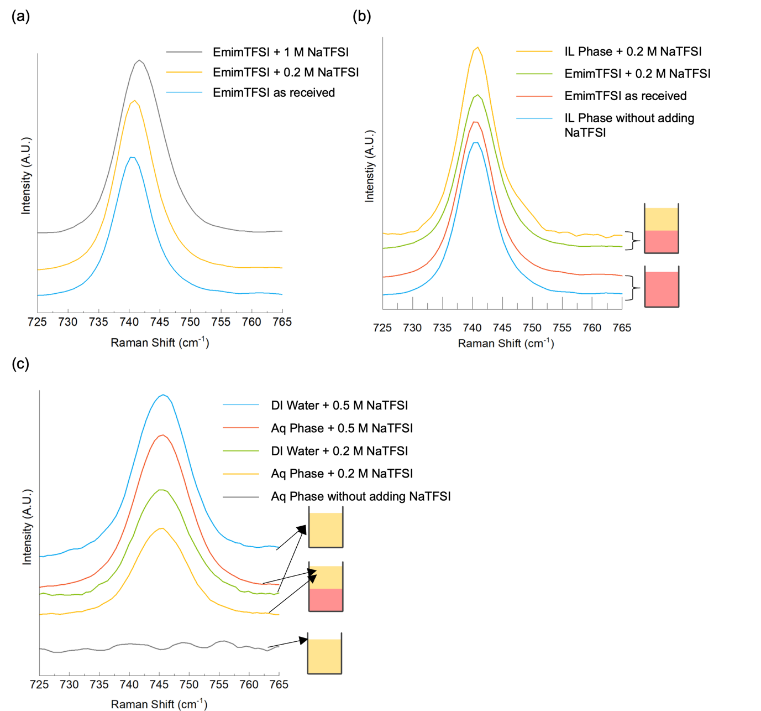

Supplementary Figure 9 | Raman analysis on various liquid samples. (a) In the pure EmimTFSI (blue), NaTFSI is added with 0.2 M (yellow) and 1 M (grey) concentration. (b) two control groups of IL phase and the ionic liquid with and without adding salt were compared. Among the four comparing sets, their peak shifts are at 742 cm⁻¹ within error of 1 cm⁻¹. (c) two control group of Aq phase and the DI water with and without adding salt were compared. Pure DI water (grey) does not show any peaks, indicating there is no TFSI⁻ molecules. Once the salt is added, all of them exhibit the TFSI⁻ peak at 745 cm⁻¹. The Raman results are corresponding with previous works. P. Johansson. et al.,⁵ dissolved NaTFSI salts into an EmimTFSI, thus resulting Na_{x}Emim_{(1-x)}TFSI with the molar fraction 0<x<0.3. The free TFSI peak, without adding the salt, while increasing the NaTFSI concentration, TFSI peak is shifted up to 744 cm⁻¹ at the saturation point.

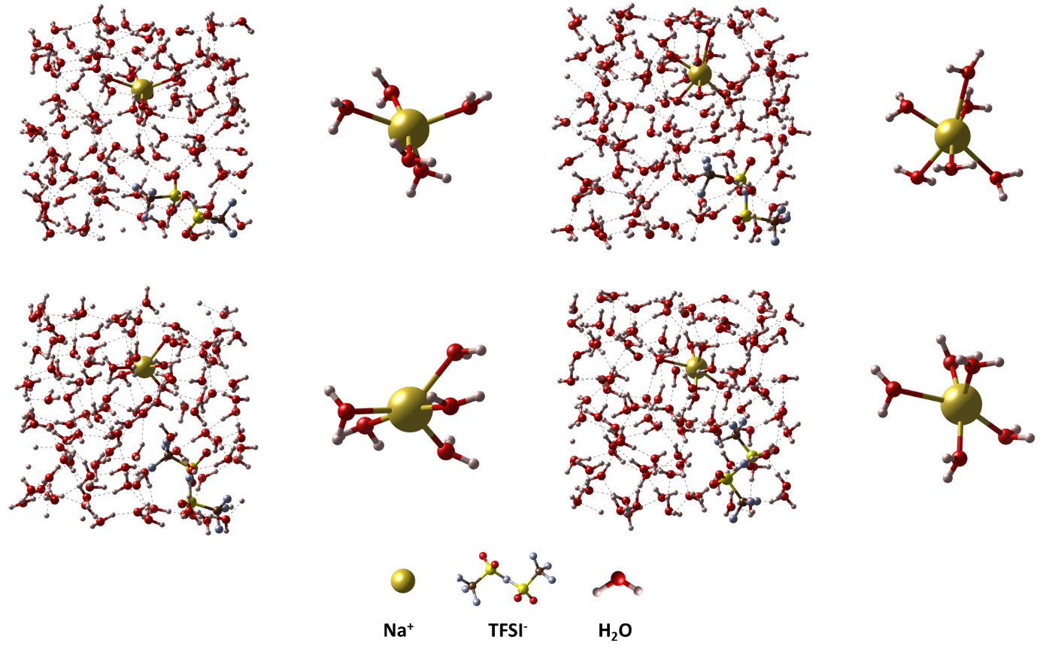
Supplementary Figure 10 | Additional overall structures and solvation structures for Aq phase. Among the structures used for calculation, some are represented at 10 ps intervals: 10 ps (top left), 20 ps (top right), 30 ps (bottom left), and 40 ps (bottom right).

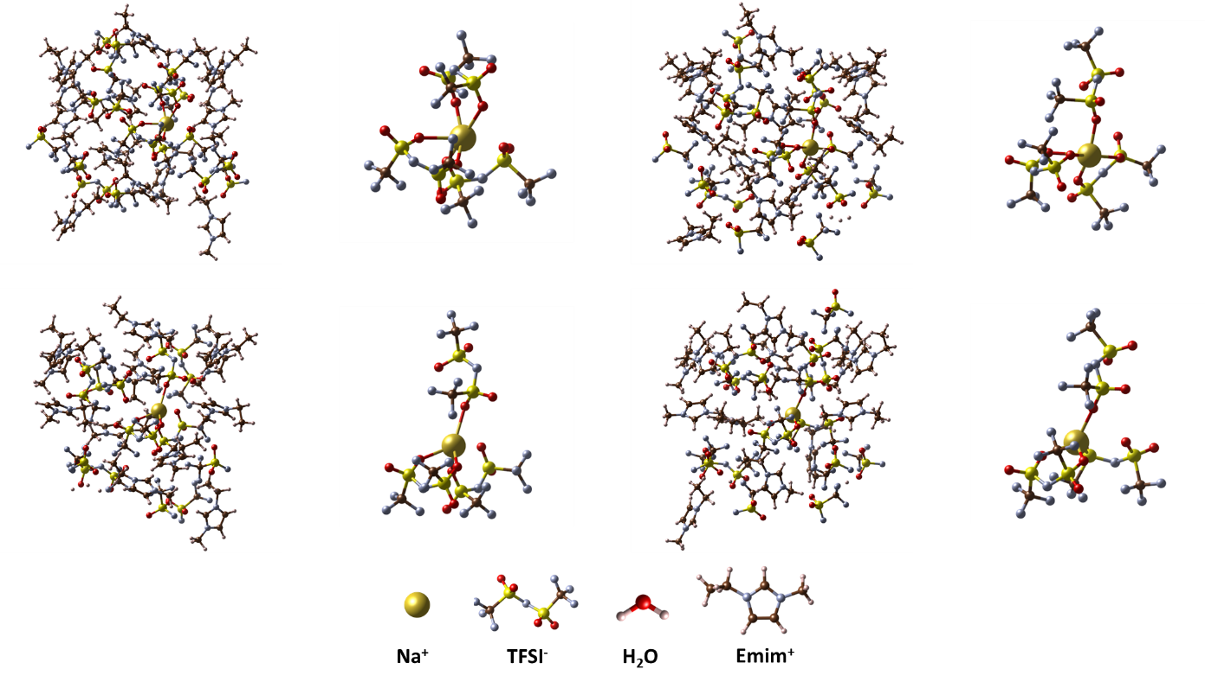
Supplementary Figure 11 | Additional overall structures and solvation structures for IL phase. Among the structures used for calculation, some are represented at 10 ps intervals: 10 ps (top left), 20 ps (top right), 30 ps (bottom left), and 40 ps (bottom right).

Aq phase | $E_{{Na}^{+}}$(eV) | $E_{{(H_{2}O )}_{n}}$(eV) | $E_{{{Na}^{+}(H_{2}O )}_{n}}$(eV) | Solvation energy (eV)
5ps | -0.229 | -70.488 | -72.732 | -2.016
10ps | -0.229 | -70.579 | -72.768 | -1.961
15ps | -0.229 | -56.515 | -58.283 | -1.539
20ps | -0.229 | -84.834 | -87.075 | -2.013
25ps | -0.229 | -70.104 | -72.279 | -1.946
30ps | -0.229 | -70.283 | -72.587 | -2.076
35ps | -0.229 | -70.416 | -72.607 | -1.962
40ps | -0.229 | -70.463 | -72.580 | -1.888
45ps | -0.229 | -70.526 | -72.579 | -1.824
50ps | -0.229 | -84.408 | -86.897 | -2.260

IL phase | $E_{{Na}^{+}}$(eV) | $E_{{( {TFSI}^{-})}_{n}}$(eV) | $E_{{{Na}^{+}({TFSI}^{-})}_{n}}$(eV) | Solvation energy (eV)
5ps | -0.229 | -241.513 | -248.201 | -6.459
10ps | -0.229 | -240.829 | -247.683 | -6.626
15ps | -0.229 | -241.116 | -247.571 | -6.227
20ps | -0.229 | -240.238 | -246.886 | -6.419
25ps | -0.229 | -240.784 | -247.355 | -6.342
30ps | -0.229 | -240.890 | -247.295 | -6.176
35ps | -0.229 | -241.623 | -248.081 | -6.229
40ps | -0.229 | -241.460 | -247.703 | -6.014
45ps | -0.229 | -241.529 | -248.169 | -6.411
50ps | -0.229 | -240.960 | -247.626 | -6.437

Table S1 | Solvation energies of Na⁺ ions in Aq and IL phase. The Solvation energies of Na⁺ ions, utilizing necessary variables obtained from DFT, were calculated at every 5 ps time interval.

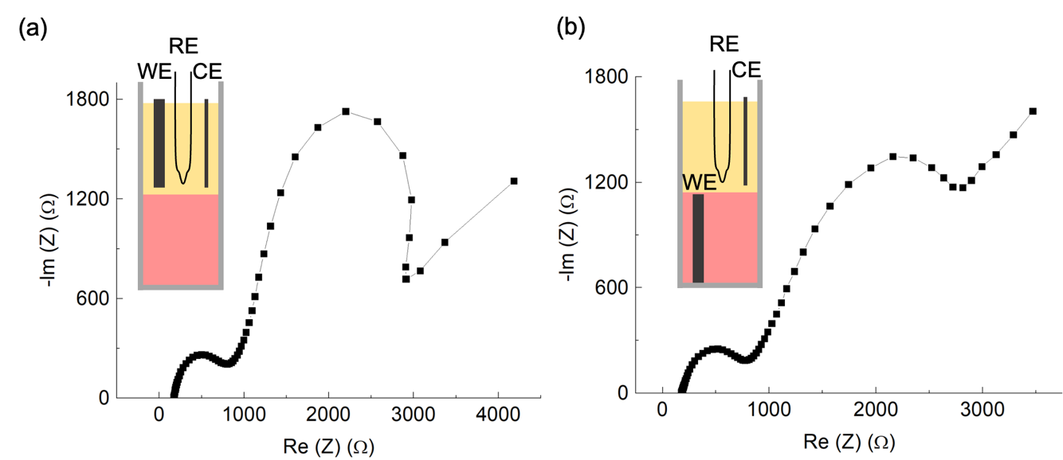

Supplementary Figure 12 | Electrochemical Impedance Spectroscopy (EIS) results with Nyquist plots. (a) When CuHCFe nanoparticle electrode is in the Aq phase. (b) When CuHCFe nanoparticle electrode is in the IL phase. The EIS experiments were conducted at the OCV with the frequency ranging from 3 MHz to 10 mHz. Slurry electrodes are prepared on a glass for the working electrodes. The concentration of salt (NaTFSI) in each phase is 0.2 M.

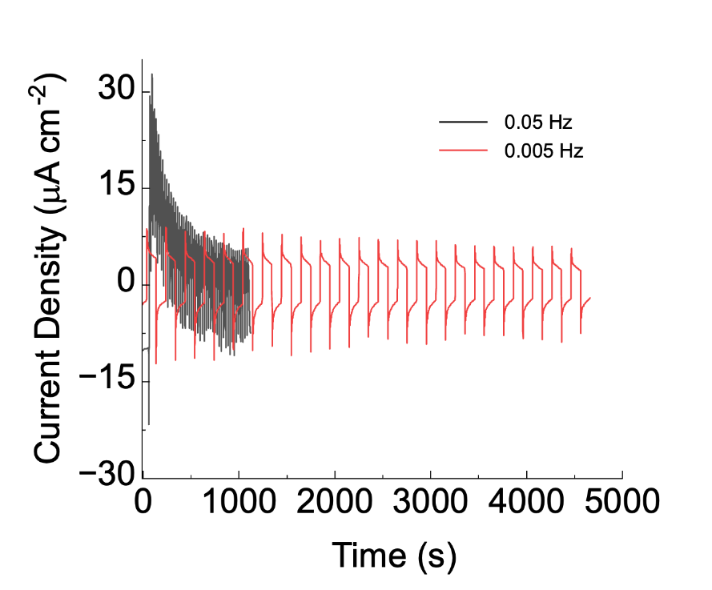

Supplementary Figure 13 | Long-term test with various frequency. (black) the positions of CuHCFe electrodes were switched every 10 seconds. (red) the positions of CuHCFe electrodes were switched every 100 seconds
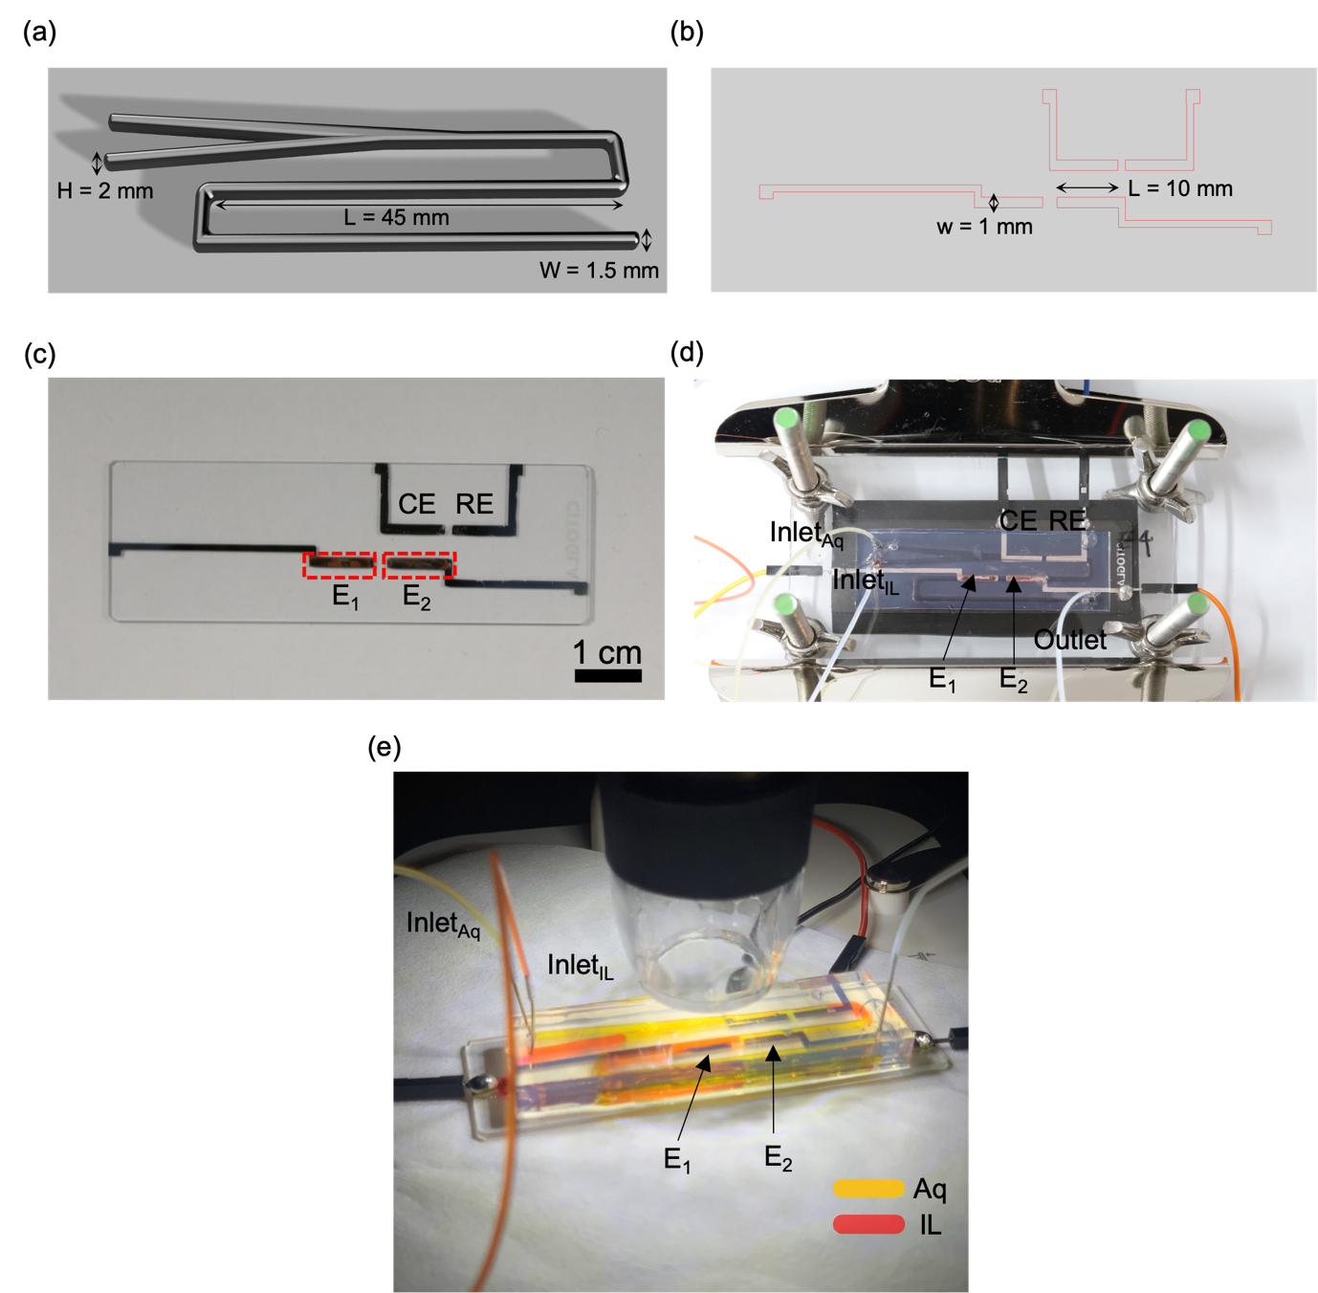

Supplementary Figure 14 | The single-pair microfluidic harvester. (a) the mold design of microfluidic channel. After preparation the mold, PDMS was poured on it and cured. (b) the design of mask for CuHCFe deposition. The area for active material is 10 mm x 1 mm. (c) a photograph of CuHCFe thin-film electrodes (E₁ and E₂, highlighted by red dots) on a glass substrate. Additional two Pt electrodes were inserted to act at a counter electrode and a reference electrode. (d) a photograph of the final product of the single-pair microfluidic harvester. (e) a photograph of the device during experiments. The IL phase is running on E₁, while the Aq phase is on E₂.

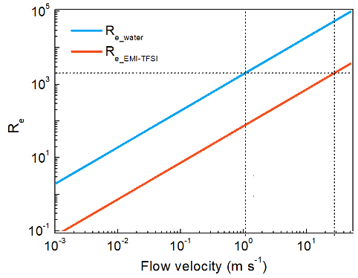

Supplementary Figure 15 | The Reynold number of water and EmimTFSI. The calculations of the Reynolds number (Re) for water and the ionic liquid were conducted. The values of μ and ρ for EmimTFSI come from the company’s data sheet. To make a laminar flow, the Reynold number should less than 2000. Based on the size of our channel, R_{e}>2000 occurs when the flow velocity is larger than 1 m s⁻¹ for water and 20 m s⁻¹ for EmimTFSI. Considering that the flow rate in this paper was in mm s⁻¹ scale, the two liquids flowed in a laminar flow.

 | Absolute viscosity (at 25ºC), μ (cP) | Density, ρ (g ml⁻¹) | Kinematic viscosity, ν (mm² s⁻¹)
Water | 0.890 | 0.9970 | 0.8927
EmimTFSI | 35.55 | 1.52 | 23.459

Table S2. | Absolute viscosity, density, and kinematic viscosity of water and EmimTFSI.

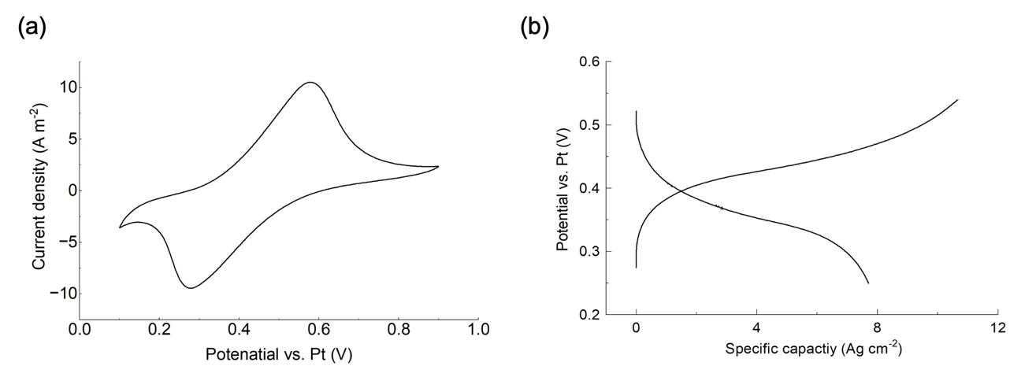

Supplementary Figure 16 | The three-cell experiment results for the single-pair microfluidic harvester. (a) CV. (b) GCPL. For the electrolyte, 0.2 M of NaTFSI added DI water was used.

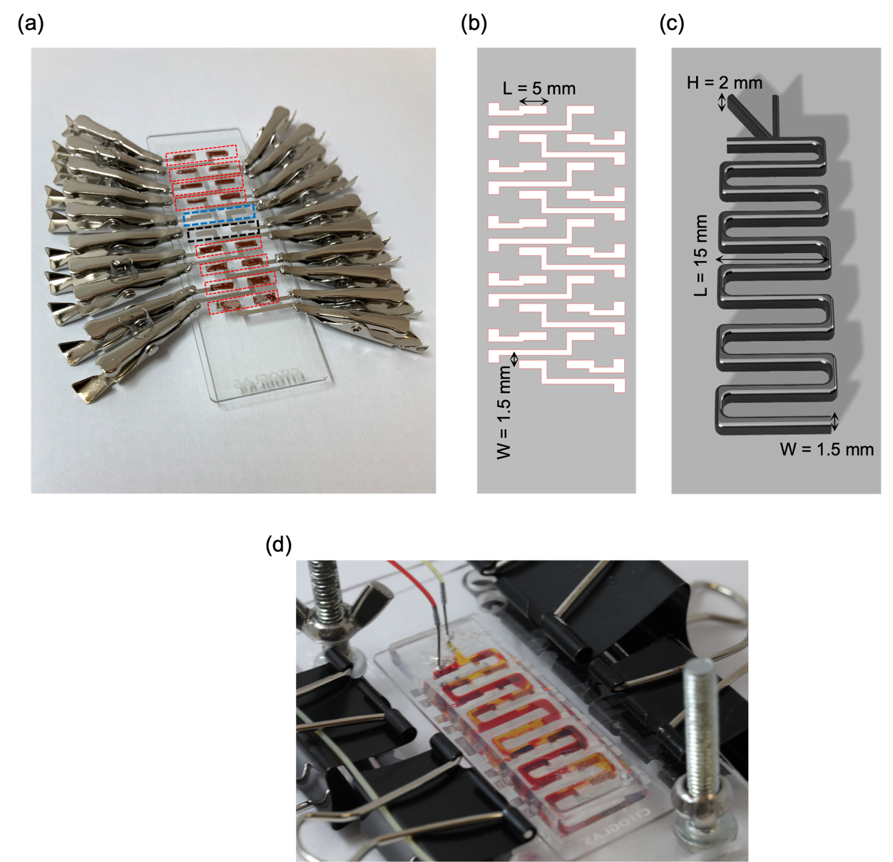

Supplementary Figure 17 | The 8-pair microfluidic energy harvester. (a) The CuHCFe thin-film electrodes on a glass substrate. Each pair of CuHCFe electrodes is highlighted by red dots. In the blue dots and black dots, Pt electrodes for a counter electrode and reference electrode are presented, respectively. (b) the design of mask for CuHCFe deposition. The area for active material is 5 mm x 1.5 mm. (c) the mold design of microfluidic channel. After preparation the mold, PDMS was poured on it and cured. (d) a photograph of the final product of multi-pair microfluidic harvester.

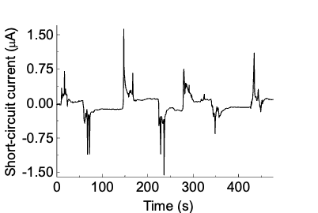

Supplementary Figure 18 | Short-circuit current of the 8-pair microfluidic energy harvester. The 8-pair (16 pieces) of electrodes are shorted and the short-circuit current was measured.

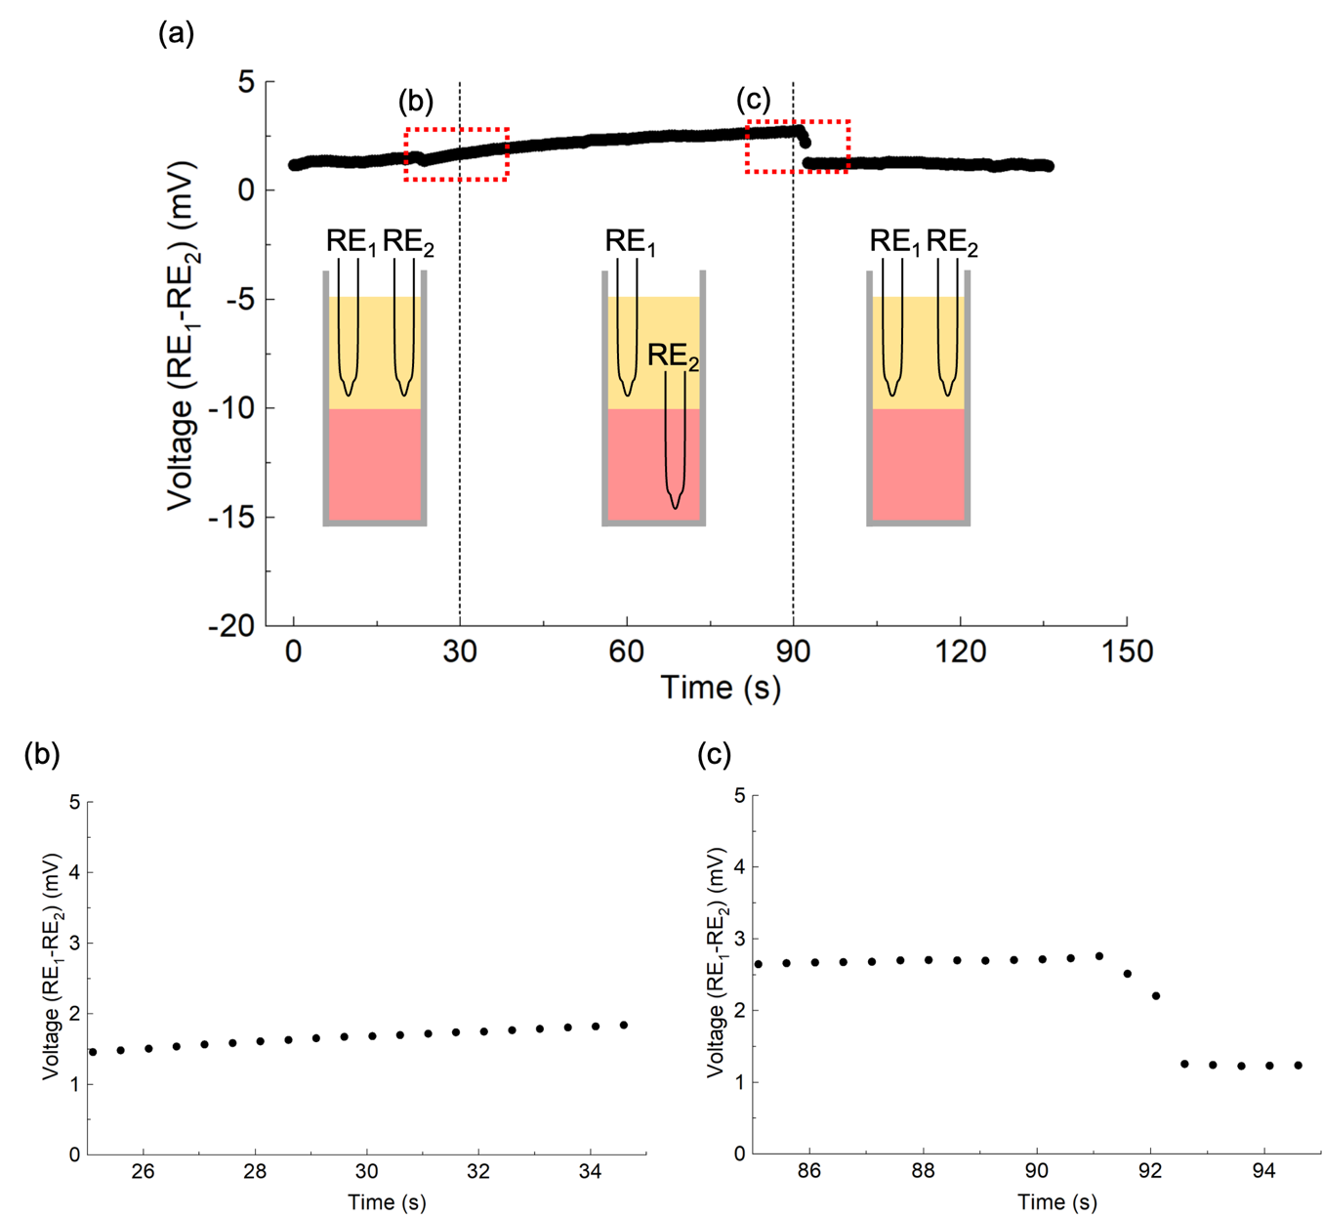

Supplementary Figure 19 | Voltage profile between the two-phase electrolyte. (a) Two Ag/AgCl reference electrodes (RE₁ and RE₂) are immersed in the Aq phase at the beginning. The voltage difference between RE₁ and RE₂ was measured. At 20s, RE₂ is switched to the IL phase and backed to the Aq phase at 90s. There is a negligible voltage drift. (b) and (c) red rectangle areas in (a).

Supplementary Notes

Note 1. Deriving cell voltage equation in the two-phase electrolyte

Here, we drive the cell potential from chemical potentials of the two-electrolyte system. The two half-cell reactions are written as below:
$$Na@CuHCFe_{Aq}→Na_{Aq}^{+}+e^{-} (1)$$
$$Na_{IL}^{+}+e^{-}→Na@CuHCFe_{IL} (2)$$
The solid-state sodium means the intercalated state of sodium in the CuHCFe structure. When we measure the open-circuit voltage of the two electrodes, they are at equilibrium. Equilibrium of electrochemical potentials are as below:
$${\overline{μ} }_{Na^{+}}^{Aq}+{\overline{μ} }_{e^{-}}^{Aq}-{\overline{μ} }_{Na@CuHCFe}^{Aq}= {\overline{μ} }_{Na^{+}}^{IL}+{\overline{μ} }_{e^{-}}^{IL}-{\overline{μ} }_{Na@CuHCFe}^{ IL} (3)$$
We can deduce ${\overline{μ} }_{e^{-}}^{Aq}$ and ${\overline{μ} }_{e^{-}}^{IL}$ as ${\overline{μ} }_{e^{-}}^{Aq}= {\overline{μ} }_{e^{-}}^{IL}$. Also, as electrochemical potential ($\overline{μ}$) is the sum of chemical potential component ($μ$) and electrostatic component ($φ$), now, the equation 3 can be written as,
$${(μ}_{Na^{+}}^{Aq}+Fφ_{Na^{+}}^{Aq})-{(μ}_{Na@CuHCFe}^{Aq}+Fφ_{Na@CuHCFe}^{Aq})= {(μ}_{Na^{+}}^{IL}+Fφ_{Na^{+}}^{IL})-{(μ}_{Na@CuHCFe}^{IL}+Fφ_{Na@CuHCFe}^{IL})$$
or
$$\left(Fφ_{Na@CuHCFe}^{IL}-Fφ_{Na@CuHCFe}^{Aq}\right)= {(μ}_{Na^{+}}^{IL}-μ_{Na^{+}}^{Aq})-{(μ}_{Na@CuHCFe}^{IL}-μ_{Na@CuHCFe}^{Aq})+(Fφ_{Na^{+}}^{IL}-Fφ_{Na^{+}}^{Aq}) (4)$$
The last term is the liquid-junction potential between the interface of the electrolytes, (${E_{LJ}= φ}_{Na^{+}}^{Aq}-φ_{Na^{+}}^{IL}$). Thus, the cell potential between the two CuHCFe electrodes is follow:
$$E_{cell}=φ_{Na@CuHCFe}^{IL}-φ_{Na@CuHCFe}^{Aq}= \frac{μ_{Na^{+}}^{IL}-μ_{Na^{+}}^{Aq}}{ F} - \frac{μ_{Na@CuHCFe}^{IL}-μ_{Na@CuHCFe}^{Aq}}{ F}-E_{LJ}$$
or
$E_{cell}=φ_{Na@CuHCFe}^{IL}-φ_{Na@CuHCFe}^{Aq}=\frac{ΔG_{sol}}{F} - \frac{ΔG_{Int}}{F} - E_{LJ}$(5)

The first term ($ΔG_{sol}$) is the solvation energy difference of sodium ions in the ionic liquid and aqueous phases. The second term ($ΔG_{Int})$is result from the difference in intercalation states of sodium when they enter into CuHCFe. Since the inserted ions all same in the Aq and the IL phase, $ΔG_{Int}$ can be reduced to 0. Also, we measured $E_{LJ}$ in Fig. S19, and the value is negligible (few mV). Then Eq. (5) is deduced to,
$E_{cell}=\frac{ΔG_{sol}}{F}$ (6)
The cell voltage between two CuHCFe electrodes in two different electrolytes only are affected by the solvation energy difference.

Load (Ω) | Power density (μW cm⁻²) | Ref. | Type
1E7 | 0.84 | ¹ | TENG
4000000 | 35 | ² | TENG
100 | 14.5 | ³ | TENG
3.055E8 | 722 | ³ | TENG
4E8 | 0.0065 | ⁴ | TENG
6000000 | 6.2 | ⁵ | TENG
1000000 | 236 | ⁶ | TENG
5E8 | 0.12 | ⁷ | TENG
300 | 6.4 |  | In this work
34 | 1 | ⁸ | Electrochemical
300 | 0.53 | ⁹ | Electrochemical
7E7 | 8.75 | ¹⁰ | PENG
5000000 | 1.14 | ¹¹ | PENG
1E8 | 0.85 | ¹² | PENG
2.5E11 | 39 | ¹³ | PENG
1000000 | 4 | ¹³ | PENG
10000 | 0.6 | ¹⁴ | PENG
1E7 | 80 | ¹⁵ | PENG
3E8 | 38.46 | ¹⁶ | Electret
2.1E7 | 5.01 | ¹⁷ | Electret
1E8 | 14 | ¹⁸ | TENG
8.8E7 | 5 | ¹⁹ | TENG
2E8 | 300 | ²⁰ | TENG
8.8E7 | 3 | ²¹ | TENG
100000 | 1.266 | ²² | TENG
332000 | 50100 | ²³ | TENG
1E7 | 1.18 | ²⁴ | TENG
1E7 | 2.653 | ²⁵ | TENG
80000 | 50 | ²⁶ | TENG
4.4E7 | 131 | ²⁷ | TENG
999 | 23.09 | ²⁸ | Osmotic energy harvesting
13000 | 766 | ²⁹ | Osmotic energy harvesting
23000 | 520 | ³⁰ | Osmotic energy harvesting
20000 | 250 | ³⁰ | Osmotic energy harvesting
10000 | 590 | ³¹ | Osmotic energy harvesting
27000 | 370 | ³² | Osmotic energy harvesting
27000 | 419 | ³³ | Osmotic energy harvesting
36000 | 195 | ³³ | Osmotic energy harvesting
17000 | 507 | ³⁴ | Osmotic energy harvesting
60000 | 230 | ³⁵ | Osmotic energy harvesting
13000 | 587 | ³⁶ | Osmotic energy harvesting
18000 | 506 | ³⁷ | Osmotic energy harvesting
14000 | 410 | ³⁸ | Osmotic energy harvesting

Table S3 | The comparisons of the maximum power and load resistors of several main KEH methods

Supplementary References

1. Zheng, Q. et al. In vivo powering of pacemaker by breathing-driven implanted triboelectric nanogenerator. Advanced Materials 26, 5851–5856 (2014).
2. Liu, W. et al. Integrated charge excitation triboelectric nanogenerator. Nat Commun 10, 1–9 (2019).
3. Yang, X., Chan, S., Wang, L. & Daoud, W. A. Water tank triboelectric nanogenerator for efficient harvesting of water wave energy over a broad frequency range. Nano Energy 44, 388–398 (2018).
4. Shaikh, M. O., Huang, Y. Bin, Wang, C. C. & Chuang, C. H. Wearable woven triboelectric nanogenerator utilizing electrospun PVDF nanofibers for mechanical energy harvesting. Micromachines (Basel) 10, (2019).
5. Yang, J. et al. Triboelectrification-based organic film nanogenerator for acoustic energy harvesting and self-powered active acoustic sensing. ACS Nano 8, 2649–2657 (2014).
6. Shin, Y., Cho, S., Han, S. & Jung, G. Y. Omni-directional wind-driven triboelectric nanogenerator with cross-shaped dielectric film. Nano Converg 8, 0–9 (2021).
7. Vivekananthan, V. et al. A sliding mode contact electrification based triboelectric-electromagnetic hybrid generator for small-scale biomechanical energy harvesting. Micro and Nano Systems Letters 7, 0–7 (2019).
8. Jung, I. D. et al. Selective Ion Sweeping on Prussian Blue Analogue Nanoparticles and Activated Carbon for Electrochemical Kinetic Energy Harvesting. Nano Lett 20, 1800–1807 (2020).
9. Kim, S. et al. Electrochemically driven mechanical energy harvesting. Nat Commun 7, (2016).
10. Zhang, L. et al. Enhanced performance of piezoelectric nanogenerator based on aligned nanofibers and three-dimensional interdigital electrodes. Nano Energy 65, 103924 (2019).
11. Ghosh, S. K. & Mandal, D. High-performance bio-piezoelectric nanogenerator made with fish scale. Appl Phys Lett 109, (2016).
12. Sahu, M. et al. Piezoelectric nanogenerator based on lead‐free flexible pvdf‐barium titanate composite films for driving low power electronics. Crystals (Basel) 11, 1–10 (2021).
13. Johar, M. A. et al. Highly Durable Piezoelectric Nanogenerator by Heteroepitaxy of GaN Nanowires on Cu Foil for Enhanced Output Using Ambient Actuation Sources. Adv Energy Mater 10, 1–10 (2020).
14. Lee, Y. et al. Direct-current flexible piezoelectric nanogenerators based on two-dimensional ZnO nanosheet. Appl Surf Sci 509, 145328 (2020).
15. Qin, S. et al. Hybrid Piezo/Triboelectric-Driven Self-Charging Electrochromic Supercapacitor Power Package. Adv Energy Mater 8, 1–9 (2018).
16. Boisseau, S., Despesse, G., Ricart, T., Defay, E. & Sylvestre, A. Cantilever-based electret energy harvesters. Smart Mater Struct 20, (2011).
17. Luo, A. et al. Spray-coated electret materials with enhanced stability in a harsh environment for an MEMS energy harvesting device. Microsyst Nanoeng 7, (2021).
18. Xiong, J. et al. Wearable All-Fabric-Based Triboelectric Generator for Water Energy Harvesting. Adv Energy Mater 7, (2017).
19. Lin, Z. H., Cheng, G., Lin, L., Lee, S. & Wang, Z. L. Water-solid surface contact electrification and its use for harvesting liquid-wave energy. Angewandte Chemie - International Edition 52, 12545–12549 (2013).
20. Li, G. Z. et al. High-Performance Transparent and Flexible Triboelectric Nanogenerators Based on PDMS-PTFE Composite Films. Adv Electron Mater 5, (2019).
21. Cheng, G., Lin, Z. H., Du, Z. L. & Wang, Z. L. Simultaneously harvesting electrostatic and mechanical energies from flowing water by a hybridized triboelectric nanogenerator. ACS Nano 8, 1932–1939 (2014).
22. Liang, Q., Yan, X., Liao, X. & Zhang, Y. Integrated multi-unit transparent triboelectric nanogenerator harvesting rain power for driving electronics. Nano Energy 25, 18–25 (2016).
23. Xu, W. et al. A droplet-based electricity generator with high instantaneous power density. Nature 578, 392–396 (2020).
24. Zhao, L. et al. Cumulative charging behavior of water droplet driven freestanding triboelectric nanogenerators toward hydrodynamic energy harvesting. J Mater Chem A Mater 8, 7880–7888 (2020).
25. Cheedarala, R. K., Shahriar, M., Ahn, J. H., Hwang, J. Y. & Ahn, K. K. Harvesting liquid stream energy from unsteady peristaltic flow induced pulsatile Flow-TENG (PF-TENG) using slipping polymeric surface inside elastomeric tubing. Nano Energy 65, (2019).
26. Kwon, S. H. et al. An effective energy harvesting method from a natural water motion active transducer. Energy Environ Sci 7, 3279–3283 (2014).
27. Lin, Z. H., Cheng, G., Wu, W., Pradel, K. C. & Wang, Z. L. Dual-mode triboelectric nanogenerator for harvesting water energy and as a self-powered ethanol nanosensor. ACS Nano 8, 6440–6448 (2014).
28. Yao, B., Hussain, S., Ye, Z. & Peng, X. Electrodeposited MOFs Membrane with In Situ Incorporation of Charged Molecules for Osmotic Energy Harvesting. Small (2023) doi:10.1002/smll.202207559.
29. Liu, S. H. et al. Topologically Programmed Graphene Oxide Membranes with Bioinspired Superstructures toward Boosting Osmotic Energy Harvesting. Adv Funct Mater 33, (2023).
30. Zhu, C. et al. Metallic Two-Dimensional MoS2Composites as High-Performance Osmotic Energy Conversion Membranes. J Am Chem Soc 143, 1932–1940 (2021).
31. Chen, C. et al. Bio-inspired Nanocomposite Membranes for Osmotic Energy Harvesting. Joule 4, 247–261 (2020).
32. Zhang, Z. et al. Mechanically strong MXene/Kevlar nanofiber composite membranes as high-performance nanofluidic osmotic power generators. Nat Commun 10, 1–9 (2019).
33. Wu, Y. et al. Enhanced ion transport by graphene oxide/cellulose nanofibers assembled membranes for high-performance osmotic energy harvesting. Mater Horiz 7, 2702–2709 (2020).
34. Xin, W. et al. Biomimetic Nacre-Like Silk-Crosslinked Membranes for Osmotic Energy Harvesting. ACS Nano 14, 9701–9710 (2020).
35. Yang, G. et al. Stable Ti3C2TxMXene-Boron Nitride Membranes with Low Internal Resistance for Enhanced Salinity Gradient Energy Harvesting. ACS Nano 15, 6594–6603 (2021).
36. Sun, T. et al. Flocculating-filtration-processed mesoporous structure in laminar ion-selective membrane for osmosis energy conversion and desalination. Chemical Engineering Journal 437, (2022).
37. Chen, J. et al. Biomimetic Nanocomposite Membranes with Ultrahigh Ion Selectivity for Osmotic Power Conversion. ACS Cent Sci 7, 1486–1492 (2021).
38. Cao, L. et al. Lamellar porous vermiculite membranes for boosting nanofluidic osmotic energy conversion. J Mater Chem A Mater 9, 14576–14581 (2021).

