Table S1. The sequences of siRNA
siRNA |  | sequence
siZNF251#1 | Forward strand | 5'-GCCUUUACUCACAGCUCAATT-3'
siZNF251#1 | Reverse strand | 5'-UUGAGCUGUGAGUAAAGGCTT-3'
siZNF251#2 | Forward strand | 5'-GAGCUGAGGAACCAGAUAUTT-3'
siZNF251#2 | Reverse strand | 5'-AUAUCUGGUUCCUCAGCUCTT-3'
siCtrl | Forward strand | 5'-UUCUCCGAACGUGUCACGUTT-3'
siCtrl | Reverse strand | 5'-ACGUGACACGUUCGGAGAATT-3'

Table S2. The primers of shRNA
Matching areas |  | sequence
CDS | Forward primer | 5'-CCGGATAGTTCAGATGACTACTAAACTC  GAGTTTAGTAGTCATCTGAACTATTTTTTG-3'
CDS | Reverse primer | 5'-AATTCAAAAAATAGTTCAGATGACTACT  AAACTCGAGTTTAGTAGTCATCTGAACTAT-3'
3UTR | Forward primer | 5'-CCGGATAGTTCAGATGACTACTAAACTC  GAGTTTAGTAGTCATCTGAACTATTTTTTG-3'
3UTR | Reverse primer | 5'-CCGGATAGTTCAGATGACTACTAAACTC  GAGTTTAGTAGTCATCTGAACTATTTTTTG-3'

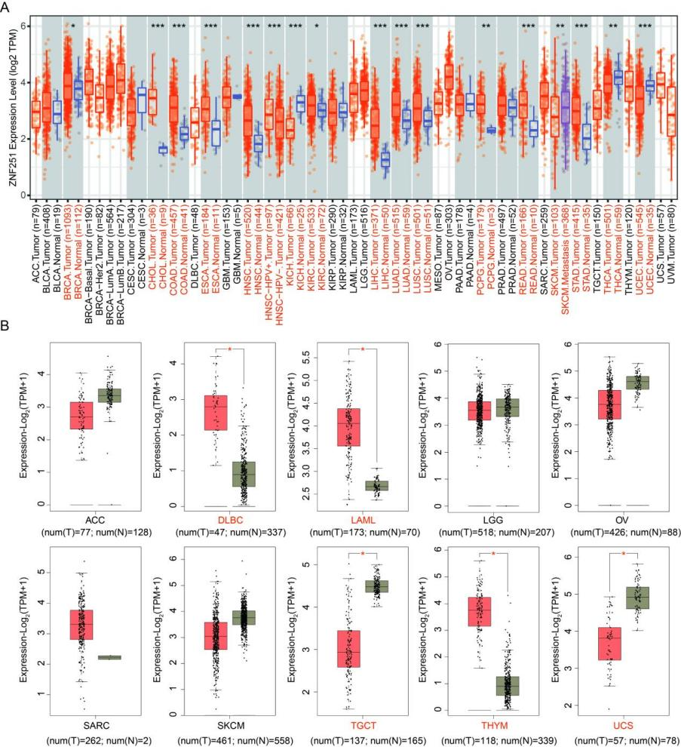
Figure S1. ZNF251 expression levels in different types of human cancers in TIMER2 (A) and GEPIA2 (B). *p < 0.05, **p < 0.01, ***p < 0.001. p < 0.05 was considered statistically significant.

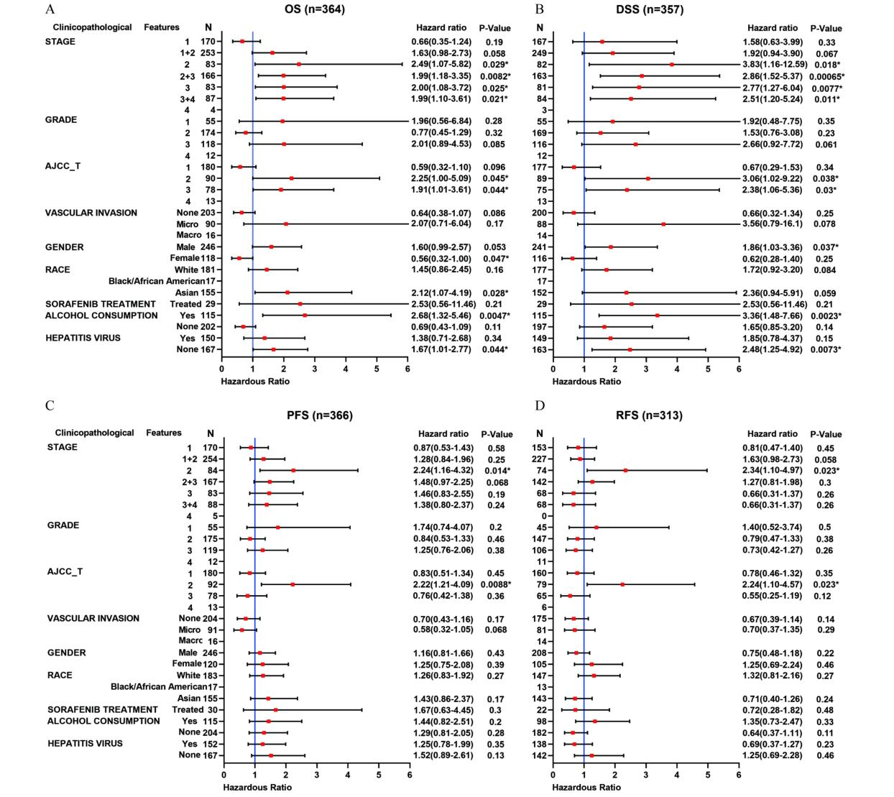
Figure S2. Correlation of ZNF251 expression with its OS (A), DSS (B), PFS (C) and RFS (D) in HCC patients with different clinicopathological features. Red squares represent risk ratios, *p < 0.05 was considered statistically significant.
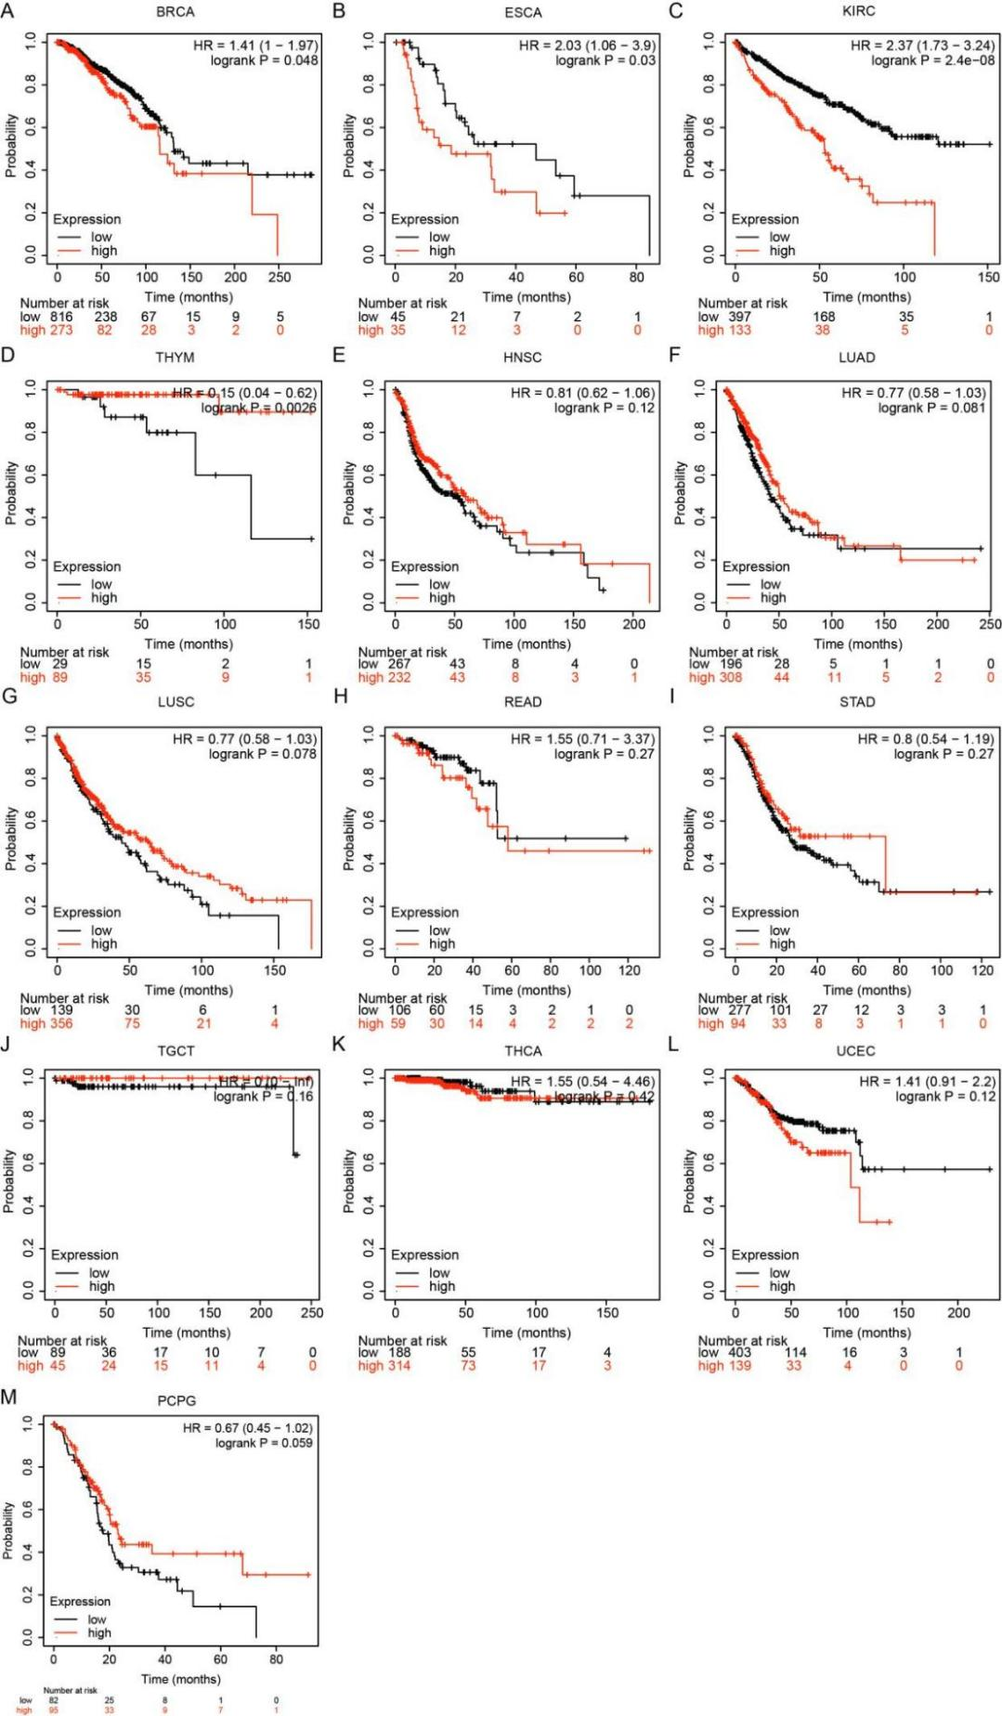
Figure S3. Kaplan-Meier survival curves comparing the high and low expression of ZNF251 in different types of cancer in Kaplan-Meier Plotter. (A) OS of BRCA. (B) OS of ESCA. (C) OS of KIRC. (D) OS of THYM. (E) OS of HNSC. (F) OS of LUAD. (G) OS of LUSC. (H) OS of READ. (I) OS of STAD. (J) OS of TGCT. (K) OS of THCA. (L) OS of UCEC. (M) OS of PCPG.
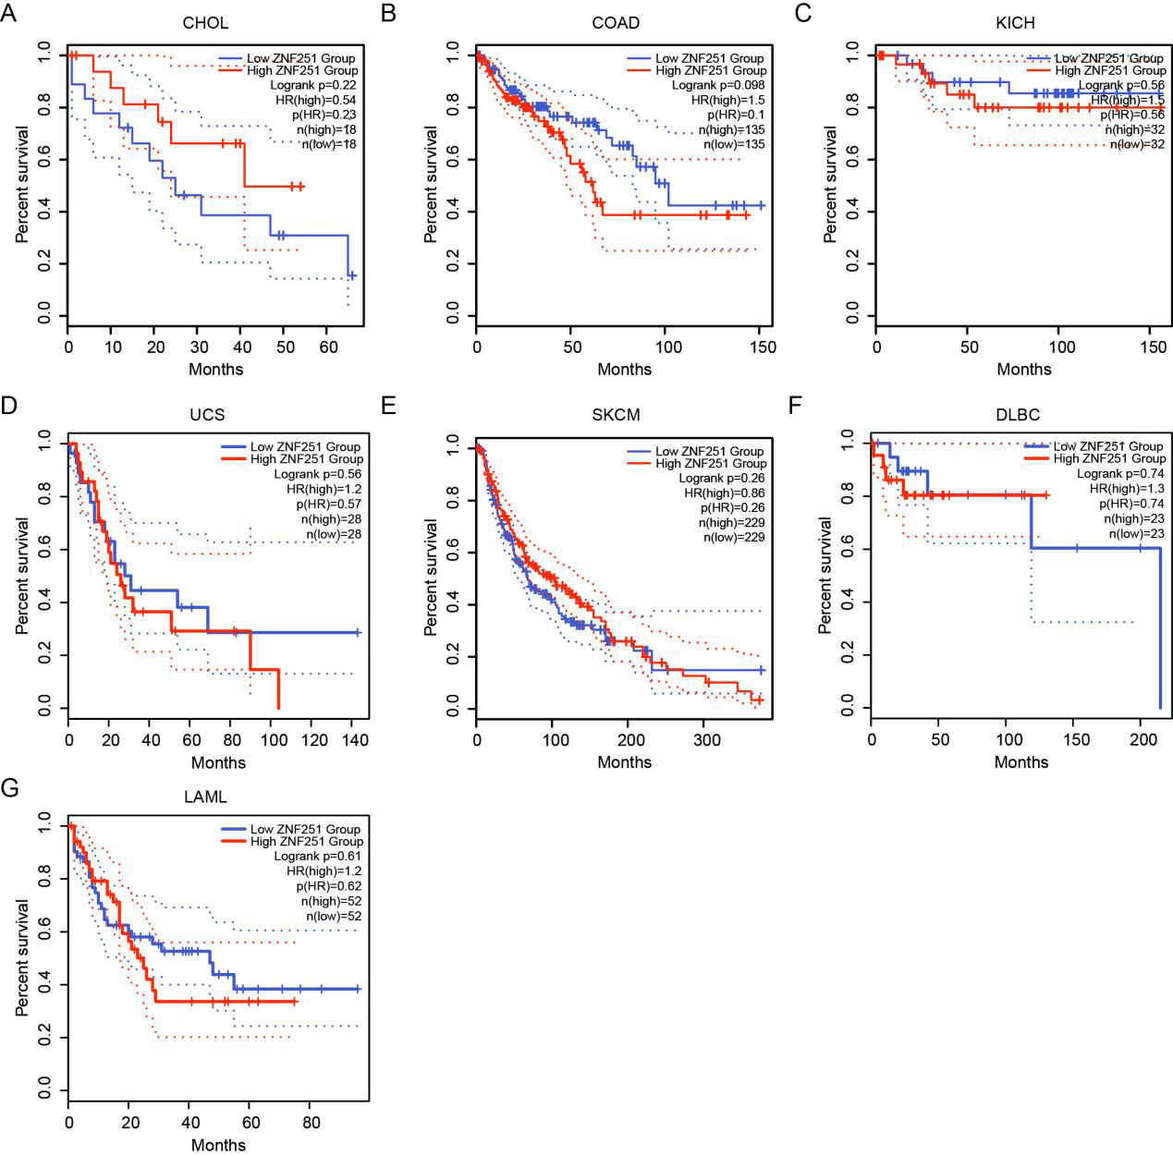
Figure S4. Kaplan-Meier survival curves comparing the high and low expression of ZNF251 in 7 types of cancer in GEPIA. (A) OS of CHOL. (B) OS of COAD. (C) OS of KICH. (D) OS of UCS. (E) OS of SKCM. (F) OS of DLBCL. (G) OS of LAML.

