The Efficacy and Safety of Perioperative Therapy for Resectable Locally Gastric Cancer: A Network Meta-Analysis of Randomized Clinical Trials

Ziyu Kuang, Qianhui Sun, Luchang Cao, Xinyi Ma, Jiaxi Wang, Kexin Liu, Jie Li

Supplementary Appendix

Appendix File 1. Detailed search strategy and the list of included studies (Page 3-4)
Appendix Table S1. Reasons for studies’ exclusions based on full text(Page 5-33)
Appendix Table S2. PRISMA statements (Page 34-38)
Appendix Table S3. Characteristics of included studies (Page 39-45)
Appendix Table S4. GRADE assessment of quality of evidence (Page 46)
Appendix Fig S1. Risk of bias summary(Page 47)
Appendix Fig S2. Risk of bias graph(Page 48)
Appendix Fig S3. The trace plot and density plot of R0 resection rate(Page 49)
Appendix Fig S4. The Brooks-Gelman-Rubin diagnosis plot of R0 resection rate(Page 50)
Appendix Fig S5. Local inconsistency detection of R0 resection rate(Page 51)
Appendix Fig S6. The trace plot and density plot of OS(Page 52)
Appendix Fig S7. The Brooks-Gelman-Rubin diagnosis plot of OS(Page 53)
Appendix Fig S8. Local inconsistency detection of OS(Page 54)
Appendix Fig S9. The trace plot and density plot of non-surgical SAEs (Page 55)
Appendix Fig S10. The Brooks-Gelman-Rubin diagnosis plot of non-surgical SAEs (Page 56)
Appendix Fig S11. Local inconsistency detection of non-surgical SAEs (Page 57)

Appendix File 1. Detailed search strategy
The following online electronic databases were searched:
• PubMed ( https://pubmed.ncbi.nlm.nih.gov/ );
• Embase ( https://www.embase.com/#search ) ;
• The Cochrane Library ( https://www.cochranelibrary.com/ ).
Search terms used are listed below, search time range: Establish the database until 2023.4.21

PubMed
#1 (Stomach[Title/Abstract]) OR (Gastric[Title/Abstract])
#2 (((Cancer[Title/Abstract]) OR (tumor[Title/Abstract])) OR (neoplasm[Title/Abstract])) OR (carcinoma[Title/Abstract])
#3 #1 AND 2#
((Stomach[Title/Abstract]) OR (Gastric[Title/Abstract])) AND ((((Cancer[Title/Abstract]) OR (tumor[Title/Abstract])) OR (neoplasm[Title/Abstract])) OR (carcinoma[Title/Abstract]))
#4 (((neoadjuvant[Title/Abstract]) OR (preoperative[Title/Abstract])) OR (Perioperative[Title/Abstract])) OR (Adjuvant[Title/Abstract])
#5 ((chemoradiotherapy[Title/Abstract]) OR (radiotherapy[Title/Abstract])) OR (chemotherapy[Title/Abstract])
#6 #4 AND #5
((((neoadjuvant[Title/Abstract]) OR (preoperative[Title/Abstract])) OR (Perioperative[Title/Abstract])) OR (Adjuvant[Title/Abstract])) AND (((chemoradiotherapy[Title/Abstract]) OR (radiotherapy[Title/Abstract])) OR (chemotherapy[Title/Abstract]))
#7 #3 AND #6
(((Stomach[Title/Abstract]) OR (Gastric[Title/Abstract])) AND ((((Cancer[Title/Abstract]) OR (tumor[Title/Abstract])) OR (neoplasm[Title/Abstract])) OR (carcinoma[Title/Abstract]))) AND (((((neoadjuvant[Title/Abstract]) OR (preoperative[Title/Abstract])) OR (Perioperative[Title/Abstract])) OR (Adjuvant[Title/Abstract])) AND (((chemoradiotherapy[Title/Abstract]) OR (radiotherapy[Title/Abstract])) OR (chemotherapy[Title/Abstract])))
8# #7 AND Random
((((Stomach[Title/Abstract]) OR (Gastric[Title/Abstract])) AND ((((Cancer[Title/Abstract]) OR (tumor[Title/Abstract])) OR (neoplasm[Title/Abstract])) OR (carcinoma[Title/Abstract]))) AND (((((neoadjuvant[Title/Abstract]) OR (preoperative[Title/Abstract])) OR (Perioperative[Title/Abstract])) OR (Adjuvant[Title/Abstract])) AND (((chemoradiotherapy[Title/Abstract]) OR (radiotherapy[Title/Abstract])) OR (chemotherapy[Title/Abstract])))) AND (random)

EMBASE
#1 (Stomach:ab,ti OR Gastric:ab,ti)
#2 (Cancer:ab,ti OR Tumor:ab,ti OR Neoplasm:ab,ti OR Carcinoma:ab,ti)
#3 (Neoadjuvant:ab,ti OR Preoperative:ab,ti OR Perioperative:ab,ti OR Adjuvant:ab,ti)
#4 (Chemoradiotherapy:ab,ti OR Radiotherapy:ab,ti OR Chemotherapy:ab,ti)
#5 Random
#6 #1 AND #2 AND #3 AND #4 AND #5

The Cochrane Library
#1 Stomach or Gastric:ti,ab,kw
#2 Cancer or Tumor or Neoplasm or Carcinoma:ti,ab,kw
#3 Neoadjuvant or Preoperative or Perioperative or Adjuvant:ti,ab,kw
#4 Chemoradiotherapy or Radiotherapy or Chemotherapy:ti,ab,kw
#5 Random (Word variations have been searched)
#6 #1 AND #2 AND #3 AND #4 AND #5

Appendix Table S1. Reasons for studies’ exclusions based on full text
(Participant/interventions/outcomes didn't meet the inclusion or exclusion criteria and unable to got full-text)
Reference | Reason for exclusion
[1] | The patient had undergone surgery before entering the clinical trial.
[2] | The patient had undergone surgery before entering the clinical trial.
[3] | The patient had undergone surgery before entering the clinical trial.
[4] | Outcome indicators did not meet the inclusion criteria.
[5] | The intervention measures are nutritional support.
[6] | The patient had undergone surgery before entering the clinical trial.
[7] | The patient had undergone surgery before entering the clinical trial.
[8] | The type of patient is oesophageal or Siewert I/II GOJ adenocarcinomas
[9] | The patient had undergone surgery before entering the clinical trial.
[10] | This clinical trial is still in progress.
[11] | The patient had undergone surgery before entering the clinical trial.
[12] | Targeted therapy/immunotherapy was combined in the intervention measures.
[13] | The patient had undergone surgery before entering the clinical trial.
[14] | The type of patient is unresectable gastric cancer.
[15] | The patient had undergone surgery before entering the clinical trial
[16] | The type of patient is oesophageal
[17] | The patient had undergone surgery before entering the clinical trial
[18] | The patient had undergone surgery before entering the clinical trial
[19] | Include patients with unresectable gastric cancer
[20] | Unable to obtain accurate data.
[21] | Include patients with unresectable gastric cancer
[22] | Unable to obtain accurate data.
[23] | Unable to obtain accurate data.
[24] | The patient had undergone surgery before entering the clinical trial.
[25] | The patient had undergone surgery before entering the clinical trial.
[26] | Include patients with unresectable gastric cancer
[27] | The patient had undergone surgery before entering the clinical trial.
[28] | The patient had undergone surgery before entering the clinical trial.
[29] | Include patients with unresectable gastric cancer
[30] | The patient had undergone surgery before entering the clinical trial.
[31] | The patient had undergone surgery before entering the clinical trial.
[32] | The treatment regimen was the same as that of the control group, only the treatment cycle was different.
[33] | The patient had undergone surgery before entering the clinical trial.
[34] | The patient had undergone surgery before entering the clinical trial.
[35] | The patient had undergone surgery before entering the clinical trial.
[36] | The patient had undergone surgery before entering the clinical trial.
[37] | The patient had undergone surgery before entering the clinical trial.
[38] | The patient had undergone surgery before entering the clinical trial.
[39] | Targeted therapy/immunotherapy was combined in the intervention measures.
[40] | The patient had undergone surgery before entering the clinical trial.
[41] | Targeted therapy/immunotherapy was combined in the intervention measures.
[42] | The trial arm involved the intervention combined with acupuncture.
[43] | The chemotherapy regimen was the same as that of the control group, and only lafutidine was added to the experimental group
[44] | Targeted therapy/immunotherapy was combined in the intervention measures.
[45] | Targeted therapy/immunotherapy was combined in the intervention measures.
[46] | The patient had undergone surgery before entering the clinical trial.
[47] | Targeted therapy/immunotherapy was combined in the intervention measures.
[48] | Targeted therapy/immunotherapy was combined in the intervention measures.
[49] | Participants had gastric or colorectal cancer
[50] | The patient had undergone surgery before entering the clinical trial.
[51] | Targeted therapy/immunotherapy was combined in the intervention measures.
[52] | The patient had undergone surgery before entering the clinical trial.
[53] | Targeted therapy/immunotherapy was combined in the intervention measures.
[54] | Targeted therapy/immunotherapy was combined in the intervention measures.
[55] | The patient had undergone surgery before entering the clinical trial.
[56] | The patient had undergone surgery before entering the clinical trial.
[57] | The patient had undergone surgery before entering the clinical trial.
[58] | The patient had undergone surgery before entering the clinical trial.
[59] | Targeted therapy/immunotherapy was combined in the intervention measures.
[60] | Include patients with unresectable gastric cancer
[61] | The patient had undergone surgery before entering the clinical trial.
[62] | The patient had undergone surgery before entering the clinical trial, combined with intraperitoneal hyperthermic chemotherapy
[63] | The patient had undergone surgery before entering the clinical trial.
[64] | The patient had undergone surgery before entering the clinical trial.
[65] | The patient had undergone surgery before entering the clinical trial.
[66] | Targeted therapy/immunotherapy was combined in the intervention measures.
[67] | Targeted therapy/immunotherapy was combined in the intervention measures.
[68] | Targeted therapy/immunotherapy was combined in the intervention measures.
[69] | Targeted therapy/immunotherapy was combined in the intervention measures.
[70] | Include patients with unresectable gastric cancer.
[71] | Targeted therapy/immunotherapy was combined in the intervention measures.
[72] | The patient had undergone surgery before entering the clinical trial.
[73] | The patient had undergone surgery before entering the clinical trial.
[74] | Targeted therapy/immunotherapy was combined in the intervention measures.
[75] | Combined with intraperitoneal hyperthermic chemotherapy.
[76] | The intervention measures are nutritional support.
[77] | The patient had undergone surgery before entering the clinical trial.
[78] | The patient had undergone surgery before entering the clinical trial.
[79] | The patient had undergone surgery before entering the clinical trial.
[80] | Targeted therapy/immunotherapy was combined in the intervention measures.
[81] | Targeted therapy/immunotherapy was combined in the intervention measures.
[82] | Targeted therapy/immunotherapy was combined in the intervention measures.
[83] | Targeted therapy/immunotherapy was combined in the intervention measures.
[84] | The patient had undergone surgery before entering the clinical trial.
[85] | The patient had undergone surgery before entering the clinical trial.
[86] | Targeted therapy/immunotherapy was combined in the intervention measures.
[87] | The patient had undergone surgery before entering the clinical trial.
[88] | The patient had undergone surgery before entering the clinical trial.
[89] | Targeted therapy/immunotherapy was combined in the intervention measures.
[90] | Targeted therapy/immunotherapy was combined in the intervention measures.
[91] | Targeted therapy/immunotherapy was combined in the intervention measures.
[92] | Targeted therapy/immunotherapy was combined in the intervention measures.
[93] | Targeted therapy/immunotherapy was combined in the intervention measures.
[94] | Include patients with unresectable gastric cancer
[95] | Targeted therapy/immunotherapy was combined in the intervention measures.
[96] | Tumour staging did not meet the inclusion criteria.
[97] | The chemotherapy regimen was the same as that of the control group, except that the mode of administration was different.
[98] | Targeted therapy/immunotherapy was combined in the intervention measures.
[99] | The full text cannot be obtained
[100] | The full text cannot be obtained
[101] | The full text cannot be obtained
[102] | The full text cannot be obtained
[103] | The full text cannot be obtained
[104] | The full text cannot be obtained
[105] | The full text cannot be obtained
[106] | The full text cannot be obtained
[107] | The full text cannot be obtained
[108] | The full text cannot be obtained
[109] | The full text cannot be obtained
[110] | The full text cannot be obtained
[111] | The full text cannot be obtained
[112] | The full text cannot be obtained
[113] | The full text cannot be obtained
[114] | The full text cannot be obtained
[115] | The full text cannot be obtained
[116] | The full text cannot be obtained
[117] | The full text cannot be obtained
[118] | The full text cannot be obtained
[119] | The full text cannot be obtained
[120] | The full text cannot be obtained
[121] | The full text cannot be obtained
[122] | The full text cannot be obtained
[123] | The full text cannot be obtained
[124] | The full text cannot be obtained
[125] | The full text cannot be obtained
[126] | The full text cannot be obtained
[127] | The full text cannot be obtained
[128] | The full text cannot be obtained
[129] | The full text cannot be obtained
[130] | The full text cannot be obtained
[131] | The full text cannot be obtained
[132] | The full text cannot be obtained
[133] | The full text cannot be obtained
[134] | The full text cannot be obtained
[135] | The full text cannot be obtained
[136] | The full text cannot be obtained
[137] | The full text cannot be obtained
[138] | The full text cannot be obtained
[139] | The full text cannot be obtained
[140] | The full text cannot be obtained
[141] | The full text cannot be obtained
[142] | The full text cannot be obtained
[143] | The full text cannot be obtained
[144] | The full text cannot be obtained
[145] | The full text cannot be obtained
[146] | The full text cannot be obtained
[147] | The full text cannot be obtained
[148] | The full text cannot be obtained
[149] | The full text cannot be obtained
[150] | The full text cannot be obtained
[151] | The full text cannot be obtained
[152] | The full text cannot be obtained
[153] | The full text cannot be obtained
[154] | The full text cannot be obtained
[155] | The full text cannot be obtained
[156] | The full text cannot be obtained
[157] | The full text cannot be obtained
[158] | The full text cannot be obtained
[159] | The full text cannot be obtained
[160] | The full text cannot be obtained
[161] | The full text cannot be obtained
[162] | The full text cannot be obtained
[163] | The full text cannot be obtained
[164] | The full text cannot be obtained
[165] | The full text cannot be obtained
[166] | The full text cannot be obtained
[167] | The full text cannot be obtained
[168] | The full text cannot be obtained
[169] | The full text cannot be obtained
[170] | The full text cannot be obtained
[171] | The full text cannot be obtained
[172] | The full text cannot be obtained
[173] | The full text cannot be obtained
[174] | The full text cannot be obtained
[175] | The full text cannot be obtained
[176] | The full text cannot be obtained
[177] | The full text cannot be obtained
[178] | The full text cannot be obtained
[179] | The full text cannot be obtained
[180] | The full text cannot be obtained
[181] | The full text cannot be obtained
[182] | The full text cannot be obtained
[183] | The full text cannot be obtained
[184] | The full text cannot be obtained
[185] | The full text cannot be obtained
[186] | The full text cannot be obtained
[187] | The full text cannot be obtained
[188] | The full text cannot be obtained
[189] | The full text cannot be obtained
References
1. Zhu Y, Zhang Z, Zou X. Comparative study of tegafur gimeracil and oteracil potassium (TS-1) plus docetaxel and oxaliplatin versus TS-1 plus oxaliplatin in postoperative adjuvant chemotherapy for gastric cancer. International journal of clinical and experimental medicine. 2020;13(4):2527‐33. PubMed PMID: CN-02163972.
2. Zhu WG, Xua DF, Pu J, Zong CD, Li T, Tao GZ, et al. A randomized, controlled, multicenter study comparing intensity-modulated radiotherapy plus concurrent chemotherapy with chemotherapy alone in gastric cancer patients with D2 resection. Radiother Oncol. 2012;104(3):361-6. Epub 20120914. doi: 10.1016/j.radonc.2012.08.024. PubMed PMID: 22985776.
3. Zhang XL, Shi HJ, Cui SZ, Tang YQ, Ba MC. Prospective, randomized trial comparing 5-FU/LV with or without oxaliplatin as adjuvant treatment following curative resection of gastric adenocarcinoma. European journal of surgical oncology. 2011;37(6):466‐72. doi: 10.1016/j.ejso.2011.01.027. PubMed PMID: CN-00786481.
4. Zhang Q, Tey J, Peng L, Yang Z, Xiong F, Jiang R, et al. Adjuvant chemoradiotherapy with or without intraoperative radiotherapy for the treatment of resectable locally advanced gastric adenocarcinoma. Radiother Oncol. 2012;102(1):51-5. Epub 20111216. doi: 10.1016/j.radonc.2011.10.008. PubMed PMID: 22178689.
5. Zhang L, Qi X, Zhao H. Roles of clinical pharmacists in nutritional therapy for gastric cancer patients treated with neoadjuvant chemotherapy. Journal of practical oncology. 2016;31(6):537‐40. PubMed PMID: CN-01327861.
6. Yu JI, Lim DH, Ahn YC, Lee J, Kang WK, Park SH, et al. Effects of adjuvant radiotherapy on completely resected gastric cancer: A radiation oncologist's view of the ARTIST randomized phase III trial. Radiother Oncol. 2015;117(1):171-7. Epub 20150820. doi: 10.1016/j.radonc.2015.08.009. PubMed PMID: 26299196.
7. Yu C, Yu R, Zhu W, Song Y, Li T. Intensity-modulated radiotherapy combined with chemotherapy for the treatment of gastric cancer patients after standard D1/D2 surgery. Journal of cancer research and clinical oncology. 2012;138(2):255‐9. doi: 10.1007/s00432-011-1085-y. PubMed PMID: CN-00881963.
8. Young R, Williams P, Lo T, Athanasiou A, Mehta S, Dexter S, et al. Pathological and early surgical outcomes of oesophagectomy after neoadjuvant FLOT chemotherapy in a single centre UK tertiary referral centre. British journal of surgery. 2019;106:68. PubMed PMID: CN-02120264.
9. Yoshikawa T, Terashima M, Mizusawa J, Nunobe S, Nishida Y, Yamada T, et al. Four courses versus eight courses of adjuvant S-1 for patients with stage II gastric cancer (JCOG1104 [OPAS-1]): an open-label, phase 3, non-inferiority, randomised trial. Lancet Gastroenterol Hepatol. 2019;4(3):208-16. Epub 20190122. doi: 10.1016/s2468-1253(18)30383-2. PubMed PMID: 30679107.
10. Yoshikawa T, Fujitani K, Nishikawa K, Tanabe K, Ito S, Matsui T, et al. Comparison of chemotherapy-related toxicities in a randomized 2X2 phase II trial comparing two and four courses of cisplatin/S-1 (CS) and docetaxel/cisplatin/S-1 (DCS) as neoadjuvant chemotherapy for locally advanced gastric cancer. European journal of cancer. 2015;51:S407. PubMed PMID: CN-01136309.
11. Yoshida K, Kodera Y, Kochi M, Ichikawa W, Kakeji Y, Sano T, et al. Addition of Docetaxel to Oral Fluoropyrimidine Improves Efficacy in Patients With Stage III Gastric Cancer: Interim Analysis of JACCRO GC-07, a Randomized Controlled Trial. J Clin Oncol. 2019;37(15):1296-304. Epub 20190329. doi: 10.1200/jco.18.01138. PubMed PMID: 30925125; PubMed Central PMCID: PMCPMC6524985.
12. Yin W, Chen Y, Wang M. Efficacy and Safety of Apatinib Combined with SOX in Neoadjuvant Chemotherapy for Locally Advanced Gastric Cancer. Anti-tumor pharmacy. 2020;10(3):349‐54 and 63. doi: 10.3969/j.issn.2095-1264.2020.03.16. PubMed PMID: CN-02199353.
13. Yang Y, Du J, Wei J, Guan W, Chen G, Wang M, et al. Phase III study of intraperitoneal/intravenous adjuvant chemotherapy compared intravenous adjuvant chemotherapy in patients with stage III gastric cancer. Journal of clinical oncology. 2018;36(15). doi: 10.1200/JCO.2018.36.15-suppl.4067. PubMed PMID: CN-01793701.
14. Yang XJ, Huang CQ, Suo T, Mei LJ, Yang GL, Cheng FL, et al. Cytoreductive surgery and hyperthermic intraperitoneal chemotherapy improves survival of patients with peritoneal carcinomatosis from gastric cancer: final results of a phase III randomized clinical trial. Annals of surgical oncology. 2011;18(6):1575‐81. doi: 10.1245/s10434-011-1631-5. PubMed PMID: CN-00801094.
15. Yang L, Yang Y, Qin Q, Zhou A, Zhao J, Wang J, et al. Evaluation of the optimal dosage of S-1 in adjuvant SOX chemotherapy for gastric cancer. Oncology letters. 2015;9(3):1451‐7. doi: 10.3892/ol.2014.2821. PubMed PMID: CN-01048785.
16. Yang H, Liu H, Chen Y, Zhu C, Fang W, Yu Z, et al. Neoadjuvant chemoradiotherapy followed by surgery versus surgery alone for locally advanced squamous cell carcinoma of the esophagus (NEOCRTEC5010): a phase III multicenter, randomized, open-label clinical trial. Journal of clinical oncology. 2018;36(27):2796‐803. doi: 10.1200/JCO.2018.79.1483. PubMed PMID: CN-01642366.
17. Yamatsuji T, Fujiwara Y, Matsumoto H, Hato S, Namikawa T, Hanazaki K, et al. Feasibility of oral administration of S-1 as adjuvant chemotherapy in gastric cancer: 4-week S-1 administration followed by 2-week rest vs. 2-week administration followed by 1-week rest. Mol Clin Oncol. 2015;3(3):527-32. Epub 20150202. doi: 10.3892/mco.2015.500. PubMed PMID: 26137261; PubMed Central PMCID: PMCPMC4471633.
18. Yamada Y, Higuchi K, Nishikawa K, Gotoh M, Fuse N, Sugimoto N, et al. Phase III study comparing oxaliplatin plus S-1 with cisplatin plus S-1 in chemotherapy-naïve patients with advanced gastric cancer. Ann Oncol. 2015;26(1):141-8. Epub 20141014. doi: 10.1093/annonc/mdu472. PubMed PMID: 25316259.
19. Yamada Y, Boku N, Mizusawa J, Iwasa S, Kadowaki S, Nakayama N, et al. Docetaxel plus cisplatin and S-1 versus cisplatin and S-1 in patients with advanced gastric cancer (JCOG1013): an open-label, phase 3, randomised controlled trial. The lancet Gastroenterology & hepatology. 2019;4(7):501‐10. doi: 10.1016/S2468-1253(19)30083-4. PubMed PMID: CN-01963330.
20. Waters JS, Norman A, Cunningham D, Scarffe JH, Webb A, Harper P, et al. Long-term survival after epirubicin, cisplatin and fluorouracil for gastric cancer: results of a randomized trial. Br J Cancer. 1999;80(1-2):269-72. doi: 10.1038/sj.bjc.6690350. PubMed PMID: 10390007; PubMed Central PMCID: PMCPMC2363002.
21. Wang X, Zhao DB, Jin J, Chi Y, Yang L, Tang Y, et al. A randomized phase II trial of neoadjuvant chemotherapy compared with chemoradiation therapy in locally advanced gastroesophageal and gastric adenocarcinoma: preliminary results. International journal of radiation oncology. 2016;96(2):S32. doi: 10.1016/j.ijrobp.2016.06.089. PubMed PMID: CN-01420464.
22. Wang X, Xie T, Guo X, Li S, Lu Y, Qiu Z, et al. Effects of preoperative preparation time on efficacy of neoadjuvant chemotherapy (SOX) in patients with advanced gastric cancer. Annals of oncology. 2019;30:v298. doi: 10.1093/annonc/mdz247.099. PubMed PMID: CN-02073578.
23. Verheij M, Jansen EPM, Cats A, NCT VaG, Aaronson NK, Boot H, et al. A multicenter randomized phase III trial of neo-adjuvant chemotherapy followed by surgery and chemotherapy or by surgery and chemoradiotherapy in resectable gastric cancer: first results from the CRITICS study. Journal of clinical oncology. 2016;34. PubMed PMID: CN-01781070.
24. Toge T, Fujita M, Hirata K, Kunii Y, Kitamura M, Nagawa H, et al. Interim report of JFMTC study no. 20 on the effectiveness of high dose CDDP plus 5-FU regimen as an adjuvant therapy for far-advanced cancer of the stomach. Gan to kagaku ryoho Cancer & chemotherapy. 2000;27(3):395‐403. PubMed PMID: CN-00276750.
25. Tatebe S, Tsujitani S, Nakamura S, Shimizu T, Yamane N, Nishidoi H, et al. Feasibility study of alternate-day S-1 as adjuvant chemotherapy for gastric cancer: a randomized controlled trial. Gastric Cancer. 2014;17(3):508-13. Epub 20130815. doi: 10.1007/s10120-013-0289-z. PubMed PMID: 23948997.
26. Shu Z, Ding D, Li Y. Adjuvant chemotherapy for chemotherapy-naive advanced gastric cancer patients with oxaliplatin plus tegafur versus oxaliplatin plus S-1. International journal of clinical and experimental medicine. 2017;10(6):9322‐9. PubMed PMID: CN-01396493.
27. Sasako M, Sakuramoto S, Katai H, Kinoshita T, Furukawa H, Yamaguchi T, et al. Five-year outcomes of a randomized phase III trial comparing adjuvant chemotherapy with S-1 versus surgery alone in stage II or III gastric cancer. J Clin Oncol. 2011;29(33):4387-93. Epub 20111017. doi: 10.1200/jco.2011.36.5908. PubMed PMID: 22010012.
28. Sakuramoto S, Sasako M, Yamaguchi T, Kinoshita T, Fujii M, Nashimoto A, et al. Adjuvant chemotherapy for gastric cancer with S-1, an oral fluoropyrimidine. N Engl J Med. 2007;357(18):1810-20. doi: 10.1056/NEJMoa072252. PubMed PMID: 17978289.
29. Roth AD, Fazio N, Stupp R, Falk S, Bernhard J, Saletti P, et al. Docetaxel, cisplatin, and fluorouracil; docetaxel and cisplatin; and epirubicin, cisplatin, and fluorouracil as systemic treatment for advanced gastric carcinoma: a randomized phase II trial of the Swiss Group for Clinical Cancer Research. J Clin Oncol. 2007;25(22):3217-23. doi: 10.1200/jco.2006.08.0135. PubMed PMID: 17664469.
30. Park SH, Lim DH, Sohn TS, Lee J, Zang DY, Kim ST, et al. A randomized phase III trial comparing adjuvant single-agent S1, S-1 with oxaliplatin, and postoperative chemoradiation with S-1 and oxaliplatin in patients with node-positive gastric cancer after D2 resection: the ARTIST 2 trial(☆). Ann Oncol. 2021;32(3):368-74. Epub 20201203. doi: 10.1016/j.annonc.2020.11.017. PubMed PMID: 33278599.
31. Noh SH, Park SR, Yang HK, Chung HC, Chung IJ, Kim SW, et al. Adjuvant capecitabine plus oxaliplatin for gastric cancer after D2 gastrectomy (CLASSIC): 5-year follow-up of an open-label, randomised phase 3 trial. Lancet Oncol. 2014;15(12):1389-96. Epub 20141015. doi: 10.1016/s1470-2045(14)70473-5. PubMed PMID: 25439693.
32. Nishikawa K, Yoshikawa T, Fujitani K, Tanabe K, Ito S, Matsui T, et al. Early results of a randomized two-by-two factorial phase II trial comparing neoadjuvant chemotherapy with 2 and 4 courses of cisplatin/S-1 (CS) and docetaxel/cisplatin/S-1 (DCS) as neoadjuvant chemotherapy for locally advanced gastric cancer. Annals of oncology. 2016;27. doi: 10.1093/annonc/mdw371.32. PubMed PMID: CN-01296018.
33. Nashimoto A, Nakajima T, Furukawa H, Kitamura M, Kinoshita T, Yamamura Y, et al. Randomized trial of adjuvant chemotherapy with mitomycin, Fluorouracil, and Cytosine arabinoside followed by oral Fluorouracil in serosa-negative gastric cancer: Japan Clinical Oncology Group 9206-1. J Clin Oncol. 2003;21(12):2282-7. doi: 10.1200/jco.2003.06.103. PubMed PMID: 12805327.
34. Nakanishi K, Kobayashi D, Mochizuki Y, Ishigure K, Ito S, Kojima H, et al. Phase II multi-institutional prospective randomized trial comparing S-1 plus paclitaxel with paclitaxel alone as second-line chemotherapy in S-1 pretreated gastric cancer (CCOG0701). Int J Clin Oncol. 2016;21(3):557-65. Epub 20151107. doi: 10.1007/s10147-015-0919-z. PubMed PMID: 26547424.
35. Nakamura S, Tatebe S, Shimizu T, Yamane N, Nishidoi H, Kurisu Y, et al. Randomized controlled phase II study of alternate-day S-1 as adjuvant chemotherapy for gastric cancer. Journal of clinical oncology. 2012;30(4). PubMed PMID: CN-01028085.
36. Nakajima T, Nashimoto A, Kitamura M, Kito T, Iwanaga T, Okabayashi K, et al. Adjuvant mitomycin and fluorouracil followed by oral uracil plus tegafur in serosa-negative gastric cancer: a randomised trial. Gastric Cancer Surgical Study Group. Lancet. 1999;354(9175):273-7. doi: 10.1016/s0140-6736(99)01048-x. PubMed PMID: 10440302.
37. Moon JH, Fujiwara Y, Hirao M, Imamura H, Kimura Y, Fujitani K, et al. Randomized Controlled Trial of Adjuvant Chemotherapy with Fluoropyrimidines Versus Surgery-alone for Gastric Cancer. Anticancer Res. 2017;37(6):3061-7. doi: 10.21873/anticanres.11661. PubMed PMID: 28551645.
38. Moertel CG, Childs DS, O'Fallon JR, Holbrook MA, Schutt AJ, Reitemeier RJ. Combined 5-fluorouracil and radiation therapy as a surgical adjuvant for poor prognosis gastric carcinoma. Journal of clinical oncology. 1984;2(11):1249‐54. doi: 10.1200/JCO.1984.2.11.1249. PubMed PMID: CN-00035851.
39. Moenig S, Plum P, Mihaljevic AL, Moehler M, Kanzler S, Hoehler T, et al. Importance of perioperative chemotherapy with ECX 1/-panitumumab in patients with locally advanced esophagogastric adenocarcinomas. Diseases of the esophagus. 2016;29:131A. doi: 10.1111/dote.12528. PubMed PMID: CN-01781770.
40. Miyashiro I, Furukawa H, Sasako M, Yamamoto S, Nashimoto A, Nakajima T, et al. Randomized clinical trial of adjuvant chemotherapy with intraperitoneal and intravenous cisplatin followed by oral fluorouracil (UFT) in serosa-positive gastric cancer versus curative resection alone: final results of the Japan Clinical Oncology Group trial JCOG9206-2. Gastric Cancer. 2011;14(3):212-8. Epub 20110219. doi: 10.1007/s10120-011-0027-3. PubMed PMID: 21336855.
41. Min LZ, Liu N, Zhou Y, Niu Z. 1220P Efficacy and safety of camrelizumab combined with FLOT versus FLOT alone as neoadjuvant therapy in patients with resectable locally advanced gastric and gastroesophageal junction adenocarcinoma who received D2 radical gastrectomy. Annals of oncology. 2022;33:S1106. doi: 10.1016/j.annonc.2022.07.1338. PubMed PMID: CN-02463839.
42. Miao X, Wu H, Liu Y, Zhang S, Li C, Hao J. Clinical Efficacy of Acupuncture on Neoadjuvant Chemotherapy with Capecitabine plus Paclitaxel and Radiotherapy in Progressive Gastric Cancer. J Oncol. 2022;2022:6156585. Epub 20220712. doi: 10.1155/2022/6156585. PubMed PMID: 35865087; PubMed Central PMCID: PMCPMC9296292.
43. Machida N, Terashima M, Taku K, Daimon T, Kimura M, Sugimoto A, et al. A prospective multicenter trial of S-1 with lafutidine vs S-1 as adjuvant chemotherapy for gastric cancer in Japan: AEOLUS. Journal of clinical oncology. 2018;36(4). doi: 10.1200/JCO.2018.36.4-suppl.91. PubMed PMID: CN-01762453.
44. Ma J, Yao S, Li XS, Kang HR, Yao FF, Du N. Neoadjuvant Therapy of DOF Regimen Plus Bevacizumab Can Increase Surgical Resection Ratein Locally Advanced Gastric Cancer: A Randomized, Controlled Study. Medicine (Baltimore). 2015;94(42):e1489. doi: 10.1097/md.0000000000001489. PubMed PMID: 26496252; PubMed Central PMCID: PMCPMC4620807.
45. Lordick F, Kang YK, Chung HC, Salman P, Oh SC, Bodoky G, et al. Capecitabine and cisplatin with or without cetuximab for patients with previously untreated advanced gastric cancer (EXPAND): a randomised, open-label phase 3 trial. Lancet Oncol. 2013;14(6):490-9. Epub 20130415. doi: 10.1016/s1470-2045(13)70102-5. PubMed PMID: 23594786.
46. Liu Y, Zhao G, Xu Y, Zhang T, Chen Z, Yan G, et al. Phase II Study of Adjuvant Chemoradiotherapy Using Docetaxel/Cisplatin/5-Fluorouracil Before and After Intensity-modulated Radiotherapy With Concurrent Docetaxel in Patients With Completely (R0) Resected Gastric Carcinoma. Am J Clin Oncol. 2018;41(7):619-25. doi: 10.1097/coc.0000000000000373. PubMed PMID: 28263232; PubMed Central PMCID: PMCPMC6023597.
47. Liu N, Liu Z, Zhou Y, Niu Z, Jiang H, Zhu Y, et al. Efficacy and safety of camrelizumab combined with FLOT versus FLOT alone as neoadjuvant therapy in patients with resectable locally advanced gastric and gastroesophageal junction adenocarcinoma who received D2 radical gastrectomy. Journal of clinical oncology. 2021;39(15 SUPPL). doi: 10.1200/JCO.2021.39.15_suppl.e16020. PubMed PMID: CN-02305387.
48. Lin JX, Xu YC, Lin W, Xue FQ, Ye JX, Zang WD, et al. Effectiveness and Safety of Apatinib Plus Chemotherapy as Neoadjuvant Treatment for Locally Advanced Gastric Cancer: A Nonrandomized Controlled Trial. JAMA Netw Open. 2021;4(7):e2116240. Epub 20210701. doi: 10.1001/jamanetworkopen.2021.16240. PubMed PMID: 34241629; PubMed Central PMCID: PMCPMC8271357.
49. Kiladze IZ, Sharikadze N, Esakia T. Calcium gluconate and magnesium sulfate in preventing neurotoxicity in patients receiving oxaliplatin-based combination chemotherapy-capeOX. Annals of oncology. 2016;27. doi: 10.1093/annonc/mdw370.52. PubMed PMID: CN-01296200.
50. Kang YK, Yook JH, Chang HM, Ryu MH, Yoo C, Zang DY, et al. Enhanced efficacy of postoperative adjuvant chemotherapy in advanced gastric cancer: results from a phase 3 randomized trial (AMC0101). Cancer Chemother Pharmacol. 2014;73(1):139-49. Epub 20131027. doi: 10.1007/s00280-013-2332-5. PubMed PMID: 24162381.
51. Kang YK, Chen LT, Ryu MH, Oh DY, Oh SC, Chung HC, et al. Nivolumab plus chemotherapy versus placebo plus chemotherapy in patients with HER2-negative, untreated, unresectable advanced or recurrent gastric or gastro-oesophageal junction cancer (ATTRACTION-4): a randomised, multicentre, double-blind, placebo-controlled, phase 3 trial. The lancet Oncology. 2022;23(2):234‐47. doi: 10.1016/S1470-2045(21)00692-6. PubMed PMID: CN-02363939.
52. Kakeji Y, Yoshida K, Kodera Y, Kochi M, Sano T, Ichikawa W, et al. Three-year outcomes of a randomized phase III trial comparing adjuvant chemotherapy with S-1 plus docetaxel versus S-1 alone in stage III gastric cancer: JACCRO GC-07. Gastric Cancer. 2022;25(1):188-96. Epub 20210805. doi: 10.1007/s10120-021-01224-2. PubMed PMID: 34351555.
53. Janjigian YY, Van Cutsem E, Muro K, Wainberg ZA, Al-Batran SE, Hyung WJ, et al. MATTERHORN: efficacy and safety of neoadjuvant-adjuvant durvalumab and FLOT chemotherapy in resectable gastric and gastroesophageal junction cancer' A randomized, double-blind, placebo-controlled, phase 3 study. Journal of clinical oncology. 2021;39(15 SUPPL). doi: 10.1200/JCO.2021.39.15_suppl.TPS4151. PubMed PMID: CN-02305473.
54. Janjigian YY, Van Cutsem E, Muro K, Wainberg Z, Al-Batran SE, Hyung WJ, et al. MATTERHORN: phase III study of durvalumab plus FLOT chemotherapy in resectable gastric/gastroesophageal junction cancer. Future Oncol. 2022;18(20):2465-73. Epub 20220510. doi: 10.2217/fon-2022-0093. PubMed PMID: 35535555.
55. Han X, Li H, Su L, Zhu W, Xu W, Li K, et al. Effect of celecoxib plus standard chemotherapy on serum levels of vascular endothelial growth factor and cyclooxygenase-2 in patients with gastric cancer. Biomed Rep. 2014;2(2):183-7. Epub 20131206. doi: 10.3892/br.2013.209. PubMed PMID: 24649093; PubMed Central PMCID: PMCPMC3917754.
56. Guo Q, Liu X, Lu L, Yuan H, Wang Y, Chen Z, et al. Comprehensive evaluation of clinical efficacy and safety of celecoxib combined with chemotherapy in management of gastric cancer. Medicine (Baltimore). 2017;96(51):e8857. doi: 10.1097/md.0000000000008857. PubMed PMID: 29390421; PubMed Central PMCID: PMCPMC5758123.
57. Grau JJ, Estapé J, Alcobendas F, Pera C, Daniels M, Terés J. Positive results of adjuvant mitomycin-C in resected gastric cancer: a randomised trial on 134 patients. Eur J Cancer. 1993;29a(3):340-2. doi: 10.1016/0959-8049(93)90381-o. PubMed PMID: 8398330.
58. Gong Y, Shen S, Yin X, Liu C, Liu C, Zhang T. Efficacy of adjuvant intravenous chemotherapy combined with intraperitoneal hyperthermic chemotherapy in treatment of gastric cancer after radical gastrectomy. Journal of practical oncology. 2019;34(2):140‐5. doi: 10.13267/j.cnki.syzlzz.2019.02.009. PubMed PMID: CN-01959287.
59. Goetze TO, Hofheinz RD, Schmalenberg H, Strumberg D, Goekkurt E, Angermeier S, et al. Perioperative ramucirumab in combination with FLOT versus FLOT alone for resectable esophagogastric adenocarcinoma (RAMSES/FLOT7) with high rate of signet cell component: final results of the multicenter, randomized phase II/III trial of the German AIO and Italian GOIM. Journal of clinical oncology. 2022;40(16). doi: 10.1200/JCO.2022.40.16_suppl.4042. PubMed PMID: CN-02454741.
60. Fujitani K, Yang HK, Mizusawa J, Kim YW, Terashima M, Han SU, et al. Gastrectomy plus chemotherapy versus chemotherapy alone for advanced gastric cancer with a single non-curable factor (REGATTA): a phase 3, randomised controlled trial. The lancet Oncology. 2016;17(3):309‐18. doi: 10.1016/S1470-2045(15)00553-7. PubMed PMID: CN-01142398.
61. Fujisawa K, Namikawa T, Munekage E, Munekage M, Maeda H, Kitagawa H, et al. Lafutidine prevents gastrointestinal toxicities during adjuvant chemotherapy for gastric cancer. Journal of gastroenterology and hepatology (australia). 2016;31:99. doi: 10.1111/jgh.13540. PubMed PMID: CN-01252910.
62. Fujimoto S, Takahashi M, Mutou T, Kobayashi K, Toyosawa T. Successful intraperitoneal hyperthermic chemoperfusion for the prevention of postoperative peritoneal recurrence in patients with advanced gastric carcinoma. Cancer. 1999;85(3):529‐34. PubMed PMID: CN-00161060.
63. Fuchs CS, Niedzwiecki D, Mamon HJ, Tepper JE, Ye X, Swanson RS, et al. Adjuvant Chemoradiotherapy With Epirubicin, Cisplatin, and Fluorouracil Compared With Adjuvant Chemoradiotherapy With Fluorouracil and Leucovorin After Curative Resection of Gastric Cancer: results From CALGB 80101 (Alliance). Journal of clinical oncology. 2017;35(32):3671‐7. doi: 10.1200/JCO.2017.74.2130. PubMed PMID: CN-01424207.
64. Feng WM, Tang CW, Guo HH, Bao Y, Fei MY. Prolonged adjuvant capecitabine chemotherapy improved survival of stage IIIA gastric cancer after D2 gastrectomy. Biomed Pharmacother. 2015;72:140-3. Epub 20150402. doi: 10.1016/j.biopha.2015.03.003. PubMed PMID: 26054688.
65. Fan B, Bu Z, Zhang J, Zong X, Ji X, Fu T, et al. Phase II trial of prophylactic hyperthermic intraperitoneal chemotherapy in patients with locally advanced gastric cancer after curative surgery. BMC Cancer. 2021;21(1):216. Epub 20210302. doi: 10.1186/s12885-021-07925-2. PubMed PMID: 33653317; PubMed Central PMCID: PMCPMC7923597.
66. Euctr DE. Ipilimumab or FOLFOX in combination with Nivolumab and Trastuzumab in previously untreated HER2 positive locally advanced or metastastic EsophagoGastric Adenocarcinoma - The randomized phase 2 INTEGA trial. http://trialsearchwhoint/Trial2aspx?TrialID=EUCTR2017-000624-10-DE. 2017. PubMed PMID: CN-01902361.
67. Euctr DE. ECX + Panitumumab vs. ECX alone in subjects with locally advanced gastric cancer or cancer of the gastroesophageal junction. http://trialsearchwhoint/Trial2aspx?TrialID=EUCTR2008-007798-18-DE. 2010. PubMed PMID: CN-01879192.
68. Euctr BE. Pembrolizumab plus Chemotherapy versus Placebo plus Chemotherapy as Neoadjuvant/Adjuvant Treatment for Gastric or Gastroesophageal Junction Adenocarcinoma. http://trialsearchwhoint/Trial2aspx?TrialID=EUCTR2016-004408-76-BE. 2017. PubMed PMID: CN-01906940.
69. Du N, Ma J, Wang S, Li X, Sun J, Kang H, et al. The R0 resection rate after neoadjuvant bevacizumab (Bev) plus DOF versus DOF in local advanced gastric carcinoma (LAGC) and its association with circulating tumor cell (CTC). Journal of clinical oncology. 2014;32(15). PubMed PMID: CN-01055936.
70. Douglass HO, Lavin PT, Goudsmit A, Klaassen DJ, Paul AR. An Eastern Cooperative Oncology Group evaluation of combinations of methyl-CCNU, mitomycin C, Adriamycin, and 5-fluorouracil in advanced measurable gastric cancer (EST 2277). Journal of clinical oncology. 1984;2(12):1372‐81. doi: 10.1200/JCO.1984.2.12.1372. PubMed PMID: CN-00036470.
71. Ding X, Wang X, Li B, Wang L, Guo H, Shang L, et al. PERSIST: a multicenter, randomized phase II trial of perioperative oxaliplatin and S-1 (SOX) with or without sintilimab in resectable locally advanced gastric/gastroesophageal junction cancer (GC/GEJC). Journal of clinical oncology. 2023;41(4):364. doi: 10.1200/jco.2023.41.4_suppl.364. PubMed PMID: CN-02528322.
72. Di Costanzo F, Gasperoni S, Manzione L, Bisagni G, Labianca R, Bravi S, et al. Adjuvant chemotherapy in completely resected gastric cancer: a randomized phase III trial conducted by GOIRC. J Natl Cancer Inst. 2008;100(6):388-98. Epub 20080311. doi: 10.1093/jnci/djn054. PubMed PMID: 18334706.
73. De Vita F, Giuliani F, Orditura M, Maiello E, Galizia G, Di Martino N, et al. Adjuvant chemotherapy with epirubicin, leucovorin, 5-fluorouracil and etoposide regimen in resected gastric cancer patients: a randomized phase III trial by the Gruppo Oncologico Italia Meridionale (GOIM 9602 Study). Ann Oncol. 2007;18(8):1354-8. Epub 20070524. doi: 10.1093/annonc/mdm128. PubMed PMID: 17525087.
74. Cunningham D, Stenning SP, Smyth EC, Okines AF, Allum WH, Rowley S, et al. Peri-operative chemotherapy with or without bevacizumab in operable oesophagogastric adenocarcinoma (UK Medical Research Council ST03): primary analysis results of a multicentre, open-label, randomised phase 2–3 trial. The Lancet Oncology. 2017;18(3):357-70. doi: 10.1016/S1470-2045(17)30043-8.
75. Cui HB, Ge HE, Bai XY, Zhang W, Zhang YY, Wang J, et al. Effect of neoadjuvant chemotherapy combined with hyperthermic intraperitoneal perfusion chemotherapy on advanced gastric cancer. Experimental and therapeutic medicine. 2014;7(5):1083‐8. doi: 10.3892/etm.2014.1599. PubMed PMID: CN-00981189.
76. Cong M, Song C, Zou B, Deng Y, Li S, Liu X, et al. Impact of glutamine, eicosapntemacnioc acid, branched-chain amino acid supplements on nutritional status and treatment compliance of esophageal cancer patients on concurrent chemoradiotherapy and gastric cancer patients on chemotherapy. National medical journal of china. 2015;95(10):766‐9. doi: 10.3760/cma.j.issn.0376-2491.2015.10.011. PubMed PMID: CN-01098135.
77. Cirera L, Balil A, Batiste-Alentorn E, Tusquets I, Cardona T, Arcusa A, et al. Randomized clinical trial of adjuvant mitomycin plus tegafur in patients with resected stage III gastric cancer. Journal of clinical oncology. 1999;17(12):3810‐5. doi: 10.1200/JCO.1999.17.12.3810. PubMed PMID: CN-00264525.
78. Choi JS, Lee KH, Ahn MJ, Lee JS, Lee JH, Zang DY, et al. A randomized trial comparing cisplatin plus 5-fluorouracil with or without levamisole in operable gastric cancer. Korean J Intern Med. 1997;12(2):155-62. doi: 10.3904/kjim.1997.12.2.155. PubMed PMID: 9439150; PubMed Central PMCID: PMCPMC4531987.
79. Chipponi J, Huguier M, Pezet D, Basso N, Hay JM, Quandalle P, et al. Randomized trial of adjuvant chemotherapy after curative resection for gastric cancer. Am J Surg. 2004;187(3):440-5. doi: 10.1016/j.amjsurg.2003.12.014. PubMed PMID: 15006580.
80. Cheng R, Yong H, Xia Y, Xie Q, Gao G, Zhou X. Chemotherapy regimen based on sorafenib combined with 5-FU on HIF-1α and VEGF expression and survival in advanced gastric cancer patients. Oncology letters. 2017;13(4):2703‐7. doi: 10.3892/ol.2017.5769. PubMed PMID: CN-01336583.
81. Chen Y, Tang J, Guo F, Li W, Zhang J, Zhang X, et al. Efficacy and safety of XELOX combined with anlotinib and penpulimab vs XELOX as adjuvant therapy in ctDNA-positive gastric and esophagogastric junction adenocarcinoma: a protocol for a randomized, controlled, multicenter phase II clinical trial-EXPLORING study. Journal of clinical oncology. 2023;41(4):TPS486. doi: 10.1200/jco.2023.41.4_suppl.tps486. PubMed PMID: CN-02528313.
82. Chan A, Delaloge S, Holmes FA, Moy B, Iwata H, Harvey VJ, et al. Neratinib after trastuzumab-based adjuvant therapy in patients with HER2-positive breast cancer (ExteNET): a multicentre, randomised, double-blind, placebo-controlled, phase 3 trial. The lancet Oncology. 2016;17(3):367‐77. doi: 10.1016/S1470-2045(15)00551-3. PubMed PMID: CN-01142166.
83. Chalabi M, Verschoor YL, Van De Haar J, van den Berg J, Kodach L, van Sandick J, et al. 1219P Neoadjuvant atezolizumab plus chemotherapy in gastric and gastroesophageal junction (G/GEJ) adenocarcinoma: the PANDA study. Annals of oncology. 2022;33:S1106. doi: 10.1016/j.annonc.2022.07.1337. PubMed PMID: CN-02463820.
84. Bresciani C, Gama-Rodrigues J, Strassmann V, Waitzberg DL, Matsuda M, Pinotti HW. Long term (five-year) survival following radical surgical treatment plus adjuvant chemotherapy (FAM) in advanced gastric cancer: a controlled study. Rev Hosp Clin Fac Med Sao Paulo. 2000;55(4):129-36. doi: 10.1590/s0041-87812000000400004. PubMed PMID: 11082221.
85. Bouché O, Ychou M, Burtin P, Bedenne L, Ducreux M, Lebreton G, et al. Adjuvant chemotherapy with 5-fluorouracil and cisplatin compared with surgery alone for gastric cancer: 7-year results of the FFCD randomized phase III trial (8801). Ann Oncol. 2005;16(9):1488-97. Epub 20050606. doi: 10.1093/annonc/mdi270. PubMed PMID: 15939717.
86. Bokemeyer C, Stein A, Ridwelski K, Atanackovic D, Arnold D, Wöll E, et al. A phase II study of catumaxomab administered intra- and postoperatively as part of a multimodal approach in primarily resectable gastric cancer. Gastric Cancer. 2015;18(4):833-42. Epub 20140912. doi: 10.1007/s10120-014-0423-6. PubMed PMID: 25214034.
87. Bajetta E, Floriani I, Di Bartolomeo M, Labianca R, Falcone A, Di Costanzo F, et al. Randomized trial on adjuvant treatment with FOLFIRI followed by docetaxel and cisplatin versus 5-fluorouracil and folinic acid for radically resected gastric cancer. Ann Oncol. 2014;25(7):1373-8. Epub 20140412. doi: 10.1093/annonc/mdu146. PubMed PMID: 24728035.
88. Bajetta E, Buzzoni R, Mariani L, Beretta E, Bozzetti F, Bordogna G, et al. Adjuvant chemotherapy in gastric cancer: 5-year results of a randomised study by the Italian Trials in Medical Oncology (ITMO) Group. Ann Oncol. 2002;13(2):299-307. doi: 10.1093/annonc/mdf040. PubMed PMID: 11886009.
89. Anonymous. Integration of trastuzumab, with or without pertuzumab, into perioperative chemotherapy of HER2-positive stomach cancer: the INNOVATION Trial (EORTC-1203-GITCG). Oncology research and treatment. 2016;39(3):153‐5. doi: 10.1159/000444702. PubMed PMID: CN-01154538.
90. Al-Batran SE, Pauligk C, Hofheinz RD, Lorenzen S, Wicki A, Siebenhuener AR, et al. Perioperative atezolizumab in combination with FLOT versus FLOT alone in patients with resectable esophagogastric adenocarcinoma: DANTE, a randomized, open-label phase II trial of the German Gastric Group of the AIO and the SAKK. Annals of oncology. 2019;30:v324. doi: 10.1093/annonc/mdz247.167. PubMed PMID: CN-02075603.
91. Al-Batran SE, Lorenzen S, Thuss-Patience PC, Homann N, Schenk M, Lindig U, et al. Surgical and pathological outcome, and pathological regression, in patients receiving perioperative atezolizumab in combination with FLOT chemotherapy versus FLOT alone for resectable esophagogastric adenocarcinoma: interim results from DANTE, a randomized, multicenter, phase IIb trial of the FLOT-AIO German Gastric Cancer Group and Swiss SAKK. Journal of clinical oncology. 2022;40(16). doi: 10.1200/JCO.2022.40.16_suppl.4003. PubMed PMID: CN-02454684.
92. Al-Batran SE, Lorenzen S, Homann N, Thuss-Patience PC, Schenk M, Lindig U, et al. 1429P Pathological regression in patients with microsatellite instability (MSI) receiving perioperative atezolizumab in combination with FLOT vs. FLOT alone for resectable esophagogastric adenocarcinoma: results from the DANTE trial of the German Gastric Group at the AIO and SAKK. Annals of oncology. 2021;32:S1069. doi: 10.1016/j.annonc.2021.08.1538. PubMed PMID: CN-02322670.
93. Al-Batran SE, Janjigian Y, Van Cutsem E, Muro K, Wainberg Z, Hyung WJ, et al. MATTERHORN: efficacy and safety of neoadjuvant-adjuvant durvalumab and FLOT chemotherapy in resectable gastric and gastroesophageal junction cancer-a randomized, doubleblind, placebo-controlled, phase 3 study. Oncology research and treatment. 2021;44(SUPPL 2):218. doi: 10.1159/000518417. PubMed PMID: CN-02358814.
94. Al-Batran SE, Homann N, Pauligk C, Illerhaus G, Martens UM, Stoehlmacher J, et al. Effect of Neoadjuvant Chemotherapy Followed by Surgical Resection on Survival in Patients With Limited Metastatic Gastric or Gastroesophageal Junction Cancer: The AIO-FLOT3 Trial. JAMA Oncol. 2017;3(9):1237-44. doi: 10.1001/jamaoncol.2017.0515. PubMed PMID: 28448662; PubMed Central PMCID: PMCPMC5824287.
95. Al-Batran SE, Gotze TO, Dechow T, Goekkurt E, Algul H, Decker T, et al. FOLFIRI plus ramucirumab versus paclitaxel plus ramucirumab for taxane-pretreated patients with advanced or metastatic adenocarcinoma of the stomach or gastroesophageal junction as second-line therapy – The phase II/III RAMIRIS study. Annals of oncology. 2020;31:S930. doi: 10.1016/j.annonc.2020.08.2005. PubMed PMID: CN-02176923.
96. Ajani JA, Rodriguez W, Bodoky G, Moiseyenko V, Lichinitser M, Gorbunova V, et al. Multicenter phase III comparison of cisplatin/S-1 with cisplatin/infusional fluorouracil in advanced gastric or gastroesophageal adenocarcinoma study: the FLAGS trial. Journal of clinical oncology. 2010;28(9):1547‐53. doi: 10.1200/JCO.2009.25.4706. PubMed PMID: CN-00743472.
97. Ahn MS, Kang SY, Lee HW, Jeong SH, Park JS, Lee KJ, et al. 5-Fluorouracil, mitomycin-c, and polysaccharide-k versus uracil-ftorafur and polysaccharide-K as adjuvant chemoimmunotherapy for patients with locally advanced gastric cancer with curative resection. Onkologie. 2013;36(7‐8):421‐6. doi: 10.1159/000349957. PubMed PMID: CN-00918646.
98. Integration of Trastuzumab, with or without Pertuzumab, into Perioperative Chemotherapy of HER2- Positive Stomach Cancer: The INNOVATION Trial (EORTC-1203-GITCG). Oncol Res Treat. 2016;39(3):153-4; discussion 5. doi: 10.1159/000444702. PubMed PMID: 27486629.
99. Zhou WH, Huang H, Tan JM, Li MY. Clinical report of neoadjuvant chemotherapy of capecitabine plus taxol for the preoperative patients with advanced gastric cancer. Chinese journal of cancer prevention and treatment. 2009;16(7):535‐7. PubMed PMID: CN-00754804.
100. Zheng X, Sun H. Preoperative neoadjuvant chemotherapy favors advanced gastric cancer treated with laparoscopic radical surgery. International journal of clinical and experimental medicine. 2020;13(2):1307‐15. PubMed PMID: CN-02147358.
101. Zhang XT, Zhang Z, Liu L, Xin YN, Xuan SY. Comparative study of different neoadjuvant therapy regimen in locally advanced gastric cancer. Chinese journal of cancer prevention and treatment. 2016;23(11):739‐43. PubMed PMID: CN-01366908.
102. Zhang W, Du CX, Jiang Z, Sun Y, Xie Y, Zhong Y, et al. Perioperative chemotherapy with docetaxel plus oxaliplatin and S-1 (DOS) versus oxaliplatin plus S-1 (SOX) for locally advanced gastric or gastro-esophageal junction adenocarcinoma (MATCH): an open-label, randomized, phase 2 study. Journal of clinical oncology. 2022;40(16). doi: 10.1200/JCO.2022.40.16_suppl.4031. PubMed PMID: CN-02454728.
103. Yoshikawa T, Tanabe K, Nishikawa K, Fujitani K, Ito Y, Matsui T, et al. A randomized 2X2 phase II trial comparing two and four courses of S-1/cisplatin (SC) and paclitaxel/cisplatin (PC) as neoadjuvant chemotherapy for locally resectable advanced gastric cancer: survival results of COMPASS. Journal of clinical oncology. 2015;33(3). PubMed PMID: CN-01077889.
104. Yoshikawa T, Tanabe K, Ito Y, Nishikawa K, Fujitani K, Matsui T, et al. Subset analysis of COMPASS: a randomized 2X2 phase II trial comparing two and four courses of S-1/ cisplatin (SC) and paclitaxel/cisplatin (PC) as neoadjuvant chemotherapy for locally advanced gastric cancer. Journal of clinical oncology. 2015;33(15). PubMed PMID: CN-01130166.
105. Yoshida K, Kodera Y, Kochi M, Sano T, Kakeji Y, Ichikawa W, et al. Confirmed three-year RFS and OS of the randomized trial of adjuvantS-1 versus S-1 plus docetaxel aftercurative resection of pStage IIIgastric cancer (JACCRO GC-07). Journal of clinical oncology. 2021;39(3 SUPPL). doi: 10.1200/JCO.2021.39.3_suppl.159. PubMed PMID: CN-02260763.
106. Yan Y, Lu L, Wang X, Wang D, Huang Q, Zhao Q, et al. P-67 Short-term outcomes of capecitabine plus oxaliplatin versus S-1 plus oxaliplatin as adjuvant chemotherapies for advanced gastric cancer after laparoscopic gastrectomy and D2 resection: a prospective, multicenter randomized, controlled clinical trial. Annals of oncology. 2020;31:S111. doi: 10.1016/j.annonc.2020.04.149. PubMed PMID: CN-02144454.
107. Yamamura Y, Nishimura M, Sakamoto J. A randomized controlled trial of surgical adjuvant therapy with mitomycin C, 5-fluorouracil and OK-432 for patients suffering from gastric cancer. JPN-J-CANCER-CHEMOTHER. 1986;13(6):2134‐40. PubMed PMID: CN-00178700.
108. Yamada Y, Kumai K, Kubota T, Ushijima Y, Fujisaki M, Yamafuji K, et al. Postoperative chemotherapy using mitomycin C plus UFT or mitomycin C plus tegafur for gastric cancer patients undergoing non-curative resection - A multi-institutional study. Journal of japan society for cancer therapy. 1994;29(11):1793‐9. PubMed PMID: CN-00174294.
109. Xie C, Jin X, Chen D. Capecitabine plus oxaliplatin versus capecitabine plus oxaliplatin with concurrent radiotherapy in the treatment of gastric cancer after D2 gastrectomy. Journal of clinical oncology. 2018;36(15). doi: 10.1200/JCO.2018.36.15-suppl.4059. PubMed PMID: CN-01793629.
110. Wils J, Nitti D, Guimaraes Dos Santos J, Fountzilas G, Conte F, Sava C, et al. Randomized phase III studies of adjuvant chemotherapy with FAMTX or FEMTX in resected gastric cancer. Pooled results of studies from the EORTC GI group and the ICCG. Proceedings of the american society of clinical oncology. 2002;21 (Pt 1):131a, Abstract 521. PubMed PMID: CN-00695562.
111. Wils J, Coombes RC, Chilvers C, Palmer A, Bliss J, Amadori D, et al. Randomized trial of FAM (5-Fluorouracil, Adriamycin, Mitomycin-C) chemotherapy versus control as adjuvant treatment for resected gastric cancer. Proc-annu-meet-am-soc-clin-oncol. 1988. PubMed PMID: CN-00246406.
112. Wang X, Li S, Xie T, Lu Y, Guo X, Lin C. Early results of the randomized, multicenter, controlled evaluation of S-1 and oxaliplatin as neoadjuvant chemotherapy for Chinese advanced gastric cancer patients (RESONANCE Trial). Journal of clinical oncology. 2020;38(4). doi: 10.1200/JCO.2020.38.4_suppl.280. PubMed PMID: CN-02086094.
113. Wang X, Chen L. The research progress in randomized, multicenter, controlled evaluation of S-1 and oxaliplatin as neoadjuvant chemotherapy for advanced gastric cancer patients. Annals of oncology. 2017;28:v219‐v20. doi: 10.1093/annonc/mdx369.027. PubMed PMID: CN-01438410.
114. Wang X. Comparison of preoperative neoadjuvant chemotherapy (SOX) with different courses of treatment on the patients with advanced gastric cancer. Annals of oncology. 2018;29:viii226. doi: 10.1093/annonc/mdy282.056. PubMed PMID: CN-01961538.
115. Umin. Comparison of multimodality treatment; 2 or 4 courses of Paclitaxel/CDDP or S1/CDDP followed by surgery for locally advanced gastric cancer, a randomized phase II trial (COMPASS). http://trialsearchwhoint/Trial2aspx?TrialID=JPRN-UMIN000002595. 2009. PubMed PMID: CN-01808824.
116. Tsujinaka T, Shiozaki H, Inoue M, Furukawa H, Hiratsuka M, Kikkawa N, et al. Evaluation of effectiveness of chemotherapy in patients with gastric cancer after curative resection. International journal of clinical oncology. 2000;5(6):372‐9. doi: 10.1007/PL00012066. PubMed PMID: CN-01785915.
117. Tsuburaya A, Yoshida K, Kobayashi M, Yoshino S, Takahashi M, Takiguchi N, et al. Sequential paclitaxel followed by tegafur and uracil (UFT) or S-1 versus UFT or S-1 monotherapy as adjuvant chemotherapy for T4a/b gastric cancer (SAMIT): a phase 3 factorial randomised controlled trial. Lancet Oncol. 2014;15(8):886-93. Epub 20140618. doi: 10.1016/s1470-2045(14)70025-7. PubMed PMID: 24954805.
118. Tsavaris N, Tentas K, Kosmidis P, Mylonakis N, Sakelaropoulos N, Kosmas C, et al. A randomized trial comparing adjuvant fluorouracil, epirubicin, and mitomycin with no treatment in operable gastric cancer. Chemotherapy. 1996;42(3):220-6. doi: 10.1159/000239446. PubMed PMID: 8983891.
119. Skoropad V, Berdov B. Randomized trial of preoperative (PRT) and intraoperative (IORT) radiotherapy versus surgery alone in resectable gastric cancer. European journal of cancer. 1999;35(Suppl 4):S139. PubMed PMID: CN-00205460.
120. Shchepotin I, Kolesnik O, Lukashenko A, Burlaka A, Gukov Y, Prymak V, et al. Neoadjuvant chemotherapy within combined treatment gastric cancer patients, evaluation of effectiveness. European journal of surgical oncology. 2014;40(11):S157. doi: 10.1016/j.ejso.2014.08.398. PubMed PMID: CN-01088037.
121. Shao ZY, Zhang JD. [Efficacy of oxaliplatin plus 5-fluorouracil/leucovorin calcium combined with concurrent radiotherapy for local advanced gastric cancer]. Zhonghua Yi Xue Za Zhi. 2008;88(36):2547-9. PubMed PMID: 19080647.
122. Qu JJ, Shi YR, Liu FR, Ma SQ, Ma FY. [A clinical study of paclitaxel combined with FOLFOX4 regimen as neoadjuvant chemotherapy for advanced gastric cancer]. Zhonghua Wei Chang Wai Ke Za Zhi. 2010;13(9):664-7. PubMed PMID: 20878572.
123. Pengfei Y, Du Y, Xu Z, Yang L, Ying J, Wang Y, et al. A randomized, controlled, multi-center, open-label study of adjuvant nab-paclitaxel plus S-1 (AS) versus capecitabine plus oxaliplatin (CapeOX) for stage III gastric cancer after D2 resection. Journal of clinical oncology. 2022;40(16). doi: 10.1200/JCO.2022.40.16_suppl.4052. PubMed PMID: CN-02454754.
124. Pengfei Y, Du Y, Xu Z, Yang L, Ying J, Chen P, et al. Adjuvant nab-paclitaxel plus S-1 versus oxaliplatin plus capecitabine after curative D2 gastrectomy in patients with stage III gastric adenocarcinoma: a phase 3 open-label, randomized controlled trial. Journal of clinical oncology. 2023;41(4):386. doi: 10.1200/jco.2023.41.4_suppl.386. PubMed PMID: CN-02528340.
125. Peng J, Zhang J, Ye J, Zhang X, Wu H, Xu J, et al. S-1 combined with oxaliplatin or cisplatin in neoadjuvant chemotherapy for stage IIb/III gastric adenocarcinoma-efficacy and safety results of a randomized clinical trial. Annals of oncology. 2017;28:x59. doi: 10.1093/annonc/mdx660.007. PubMed PMID: CN-01452597.
126. Pauligk C, Tannapfel A, Meiler J, Luley KB, Kopp HG, Homann N, et al. Pathological response to neoadjuvant 5-FU, oxaliplatin, and docetaxel (FLOT) versus epirubicin, cisplatin, and 5-FU (ECF) in patients with locally advanced, resectable gastric/esophagogastric junction (EGJ) cancer: data from the phase II part of the FLOT4 phase III study of the AIO. Journal of clinical oncology. 2015;33(15). PubMed PMID: CN-01130177.
127. Patsko V, Lukashenko A, Ostapenko Y. Assessment of effectiveness of neoadjuvant chemotherapy in patients with resectable gastric cancer. Journal of clinical oncology. 2022;40(16). doi: 10.1200/JCO.2022.40.16_suppl.e16006. PubMed PMID: CN-02454729.
128. Park SH, Zang DY, Han B, Ji JH, Kim TG, Oh SY, et al. ARTIST 2: interim results of a phase III trial involving adjuvant chemotherapy and/or chemoradiotherapy after D2-gastrectomy in stage II/III gastric cancer (GC). Journal of clinical oncology. 2019;37. doi: 10.1200/JCO.2019.37.15-suppl.4001. PubMed PMID: CN-01985985.
129. Park SH, Lee J, Lim DH, Kim KM, An JY, Choi MG, et al. Results from the safety interim analysis of the Adjuvant chemoRadioTherapy In Stomach Tumors 2 (ARTIST 2) randomized, multicenter clinical trial. Journal of clinical oncology. 2018;36(15). doi: 10.1200/JCO.2018.36.15-suppl.e16029. PubMed PMID: CN-01789213.
130. Oshima T, Tsuburaya A, Yoshida K, Yoshikawa T, Miyagi Y, Guan J, et al. An ancillary biomarker study in the SAMIT randomized trial: sequential paclitaxel followed by UFT or S-1 versus UFT or S-1 alone as adjuvant chemotherapy for T4a/b gastric cancer. Annals of cancer research and therapy. 2018;26(1):39‐42. doi: 10.4993/acrt.26.39. PubMed PMID: CN-01568676.
131. Nunobe S, Yoshikawa T, Nishida Y, Yamada T, Kaji M, Takagane A, et al. Five-year follow-up results of a randomized phase III trial comparing 4 and 8 courses of S- 1 adjuvant chemotherapy for pathological stage II gastric cancer: JCOG1104 (OPAS-1). Journal of clinical oncology. 2023;41(4):381. doi: 10.1200/jco.2023.41.4_suppl.381. PubMed PMID: CN-02528333.
132. Noh SH, Park SR, Yang HK, Chung HC, Chung IJ, Lee KH, et al. Adjuvant capecitabine and oxaliplatin (XELOX) for gastric cancer after d2 gastrectomy: final results from the classic trial. Annals of oncology. 2013;24:iv14. doi: 10.1093/annonc/mdt201.7. PubMed PMID: CN-01074217.
133. Noël G, Jauffret E, Mazeron JJ. Randomized clinical trial on the combination of preoperative irradiation and surgery in the treatment of adenocarcinoma of gastric cardia (AGC)--report on 370 patients. Cancer radiotherapie. 1999;3(4):344. PubMed PMID: CN-00167519.
134. Neri B, Cini G, Andreoli F, Boffi B, Francesconi D, Mazzanti R, et al. Randomized trial of adjuvant chemotherapy versus control after curative resection for gastric cancer: 5-year follow-up. Br J Cancer. 2001;84(7):878-80. doi: 10.1054/bjoc.2000.1472. PubMed PMID: 11286464; PubMed Central PMCID: PMCPMC2363834.
135. Nct. Comparison Between Pylorus-resecting and Preserving Pancreaticoduodenectomy on Delayed Gastric Emptying and Nutrition. http://clinicaltrialsgov/show/NCT05314244. 2022. PubMed PMID: CN-02392178.
136. Nakajima T, Takahashi T, Takagi K, Kuno K, Kajitani T. Comparison of 5-fluorouracil with ftorafur in adjuvant chemotherapies with combined inductive and maintenance therapies for gastric cancer. J Clin Oncol. 1984;2(12):1366-71. doi: 10.1200/jco.1984.2.12.1366. PubMed PMID: 6439835.
137. Nakajima T, Okabayashi K, Nakazato H, Iwanaga T, Ota K, Kinoshita T, et al. Adjuvant chemotherapy with MFC-related regimens for patients with gastric cancer after curative gastrectomy. Journal of japan society for cancer therapy. 1994;29(4):654‐62. PubMed PMID: CN-00172276.
138. Nakajima T, Kinoshita T, Nashimoto A, Sairenji M, Yamaguchi T, Sakamoto J, et al. Randomized controlled trial of adjuvant uracil-tegafur versus surgery alone for serosa-negative, locally advanced gastric cancer. Br J Surg. 2007;94(12):1468-76. doi: 10.1002/bjs.5996. PubMed PMID: 17948223.
139. Nakajima T, Kajitani T. Adjuvant chemotherapy with inductive multi-drug combination and long-term oral maintenance therapies for gastric cancer. Journal of japan society for cancer therapy. 1980;15(6):980‐8. PubMed PMID: CN-00177156.
140. Mimori K, Iwatsuki M, Yokobori T, Mori M. Important matters to identify robust markers for metastasis and recurrence in solid cancer. Annals of surgical oncology. 2009;16(4):1070‐1. doi: 10.1245/s10434-008-0306-3. PubMed PMID: CN-01784560.
141. Marcelo G, Maria S, Paula F, Gonzalez-Rey C, Alberto C, Maria S, et al. Evaluation of docetaxel, cisplatin and capecitabine (DCX) as perioperative chemotherapy for resectable gastric and esophago-gastric cancer. Annals of oncology. 2014;25:ii26‐ii7. doi: 10.1093/annonc/mdu165.40. PubMed PMID: CN-01214022.
142. Makuuchi R, Terada M, Mizusawa J, Tokunaga M, Hosoda K, Ojima T, et al. Randomized controlled phase IIItrial to investigate superiority ofrobot-assisted gastrectomy overlaparoscopic gastrectomy forclinical stage T1-2N0-2 gastriccancer patients: japan ClinicalOncology Group study JCOG1907(MONA LISA study). Journal of clinical oncology. 2021;39(3 SUPPL). doi: 10.1200/JCO.2021.39.3-suppl.TPS254. PubMed PMID: CN-02260753.
143. Liu L, Yang X, Wang H, Yin D, Wang Q, Lei C, et al. Efficacy and perioperative effect of docetaxel plus oxaliplatin and S-1 in treating advanced gastric cancer. Chinese journal of clinical oncology. 2013;40(13):788‐91. doi: 10.3969/j.issn.1000-8179.2013.13.010. PubMed PMID: CN-00914031.
144. Lise M, Nitti D, Marchet A, Sahmoud T, Buyse M, Duez N, et al. Final results of a phase III clinical trial of adjuvant chemotherapy with the modified fluorouracil, doxorubicin, and mitomycin regimen in resectable gastric cancer. J Clin Oncol. 1995;13(11):2757-63. doi: 10.1200/jco.1995.13.11.2757. PubMed PMID: 7595735.
145. Lise M, Nitti D, Buyse M, Cartei G, Fornasiero A, Guimaraes dos Santos J, et al. Phase-III clinical trial of adjuvant FAM2 (5-FU, adriamycin and mitomycin C) vs control in resectable gastric cancer: a study of the EORTC Gastrointestinal Tract Cancer Cooperative Group. Recent results in cancer research. 1988;110:36‐43. doi: 10.1007/978-3-642-83293-2_5. PubMed PMID: CN-00055197.
146. Li T, Chen L. S-1 combined with oxaliplatin as preoperative chemotherapy followed by surgery shows better surgical outcomes compared with surgery alone for advanced gastric cancer patients. Annals of surgical oncology. 2012;19:S150. doi: 10.1245/s10434-012-2244-3. PubMed PMID: CN-01033744.
147. Li CL, Wu ZY, Yang WJ, Chen G. Conformal radiation therapy combined with XELOX chemotherapy for management of abdominal lymph node metastasis in patients with gastric cancer after surgery. World chinese journal of digestology. 2013;21(31):3413‐7. doi: 10.11569/wcjd.v21.i31.3413. PubMed PMID: CN-01043916.
148. Lee KH, Hyun MS, Kim HK, Jin HM, Yang J, Song HS, et al. Randomized, multicenter, phase III trial of heptaplatin 1-hour infusion and 5-fluorouracil combination chemotherapy comparing with cisplatin and 5-fluorouracil combination chemotherapy in patients with advanced gastric cancer. Cancer Res Treat. 2009;41(1):12-8. Epub 20090331. doi: 10.4143/crt.2009.41.1.12. PubMed PMID: 19688066; PubMed Central PMCID: PMCPMC2699097.
149. Lee J, Lim DH, Kim S, Park SH, Park JO, Lim HY, et al. Phase III trial to compare capecitabine/cisplatin (XP) versus XP plus concurrent capecitabine-radiotherapy in gastric cancer (GC): the final report on the ARTIST trial. Journal of clinical oncology. 2014;32(15). PubMed PMID: CN-01055908.
150. Lee CK, Jung M, Kang SY, Kim BS, Kim KH, Lee KH, et al. Randomized, multicenter, phase III trial to compare S-1 plus docetaxel (DS) with S-1 plus cisplatin (SP) in gastric cancer patients with stage III (POST trial). Journal of clinical oncology. 2014;32(15). PubMed PMID: CN-01055933.
151. Lee C, Jung M, Kim HS, Jung I, Shin DB, Kang SY, et al. An update on the randomized phase III POST trial: S-1 based doublet as an adjuvant chemotherapy for curatively resected stage III gastric cancer. Journal of clinical oncology. 2016;34. PubMed PMID: CN-01749301.
152. Kodera Y, Yoshida K, Kochi M, Ichikawa W, Kakeji Y, Sano T, et al. A randomized phase III study comparing S-1 plus docetaxel with S-1 alone as a postoperative adjuvant chemotherapy for curatively resected stage III gastric cancer (JACCRO GC-07 trial). Journal of clinical oncology. 2018;36(15). doi: 10.1200/JCO.2018.36.15_suppl.4007. PubMed PMID: CN-01790706.
153. Kodera E, Fujiwara M, Ito Y, Ohashi N, Nakayama G, Koike M, et al. Radical surgery for gastric carcinoma: it is not an issue of whether to perform D1 or D2. Dissect as many lymph nodes as possible and you will be rewarded. Acta chirurgica Belgica. 2009;109(1):27‐35. doi: 10.1080/00015458.2009.11680367. PubMed PMID: CN-01755951.
154. Kobayashi T, Kimura T. [Long-term outcome of preoperative chemotherapy with 5'-deoxy-5-fluorouridine (5'-DFUR) for gastric cancer]. Gan To Kagaku Ryoho. 2000;27(10):1521-6. PubMed PMID: 11015996.
155. Kinoshita T, Nakajima T, Ohashi Y. Adjuvant chemotherapy with uracil-tegafur (UFT) for serosa negative advanced gastric cancer : results of a randomized trial by national surgical adjuvant study of gastric cancer. Annual meeting proceedings of the american society of clinical oncology. 2005;23:313. PubMed PMID: CN-00646510.
156. Kim YW, Ryu KW, Choi IJ, Kook MC, Park YI, Kim HK. Updated results of a randomized phase II trial for neoadjuvant versus adjuvant docetaxel/cisplatin chemotherapy in patients with locally advanced gastric cancer. Journal of clinical oncology. 2014;32(3). PubMed PMID: CN-01063237.
157. Kim JY, Ryoo HM, Bae SH, Kang BW, Chae YS, Yoon S, et al. Multi-center Randomized Phase II Study of Weekly Docetaxel Versus Weekly Docetaxel-plus-Oxaliplatin as a Second-line Chemotherapy for Patients with Advanced Gastric Cancer. Anticancer research. 2015;35(6):3531‐6. PubMed PMID: CN-01083225.
158. Kikuchi K, Inokuchi K, Hattori T. Multihospital randomized study on adjuvant chemotherapy with futraful and mitomycin-C for gastric cancer. III. Estimation of three-year survival rate. Japanese journal of cancer and chemotherapy. 1980;7(6):1040‐8. PubMed PMID: CN-00176400.
159. Kawase T, Imamura H, Gotoh M, Kimura Y, Ueda S, Matsuyama J, et al. Randomized phase II study of CPT-11 versus PTX versus each combination chemotherapy with S-1 in patients with advanced gastric cancer refractory to S-1 or S-1 plus CDDP. Journal of clinical oncology. 2014;32(15). PubMed PMID: CN-01055906.
160. Karacetin D, Incekara O. A randomized trial of 5-fluorouracil, leucovorin, cisplatin and epirubicin (PELF) versus 5-fluorouracil, leucovorin and etoposide (ELF) given as adjuvant chemotherapy to patients with resected advanced gastric adenocarcinomas. J buon. 2004;9(3):263-7. PubMed PMID: 17415824.
161. Kakeji Y, Kodera Y, Yoshida K, Kochi M, Takahashi M, Kii T, et al. Pre-planned feasibility and safety analyses of docetaxel/S-1 combination in a phase III study comparing docetaxel/S-1with S-1 alone as postoperative adjuvant chemotherapy for stage III gastric cancer (JACCRO GC-07). Journal of clinical oncology. 2015;33(15). PubMed PMID: CN-01130204.
162. Ji Y, Peng T, Wang G, Zhang Y, Cao M, Gao Q, et al. Short-term efficacy and safety of the synchronous neoadjuvant chemoradiotherapy with paclitaxel plus carboplatin in stage III adenocarcinoma of esophagogastric junction. Zhonghua wei chang wai ke za zhi [Chinese journal of gastrointestinal surgery]. 2018;21(9):1019‐24. PubMed PMID: CN-01649252.
163. Ji J, Shen L, Li Z, Zhang X, Liang H, Xue Y, et al. Perioperative chemotherapy of oxaliplatin combined with S-1 (SOX) versus postoperative chemotherapy of SOX or oxaliplatin with capecitabine (XELOX) in locally advanced gastric adenocarcinoma with D2 gastrectomy: a randomized phase III trial (RESOLVE trial). Annals of oncology. 2019;30:v877. doi: 10.1093/annonc/mdz394.033. PubMed PMID: CN-02095338.
164. Ji J, Liang H, Zhan Y, Liu Y, He Y, Ye Y, et al. [Adjuvant capecitabine and oxaliplatin for gastric cancer after D2 gastrectomy (CLASSIC): Chinese subgroup analysis]. Zhonghua Wei Chang Wai Ke Za Zhi. 2014;17(2):133-8. PubMed PMID: 24577767.
165. Jakesz R, Dittrich C, Funovics J, Hofbauer F, Rainer H, Reiner G, et al. The effect of adjuvant chemotherapy in gastric carcinoma is dependent on tumor histology: 5-year results of a prospective randomized trial. Recent Results Cancer Res. 1988;110:44-51. doi: 10.1007/978-3-642-83293-2_6. PubMed PMID: 3043596.
166. Iwasaki Y, Terashima M, Mizusawa J, Katayama H, Nakamura K, Katai H, et al. Randomized phase III trial of gastrectomy with or without neoadjuvant S-1 plus cisplatin for type 4 or large type 3 gastric cancer: japan Clinical Oncology Group study (JCOG0501). Journal of clinical oncology. 2018;36(15). doi: 10.1200/JCO.2018.36.15-suppl.4046. PubMed PMID: CN-01794279.
167. Guo X, Bian SB, Peng Z, Wang N, Wei B, Cui JX, et al. [Surgical selection and metastatic warning of splenic lymph node dissection in advanced gastric cancer radical surgery: a prospective, single-center, randomized controlled trial]. Zhonghua Wei Chang Wai Ke Za Zhi. 2020;23(2):144-51. doi: 10.3760/cma.j.issn.1671-0274.2020.02.009. PubMed PMID: 32074794.
168. Grau JJ, Estapé J, Fuster J, Filella X, Visa J, Terés J, et al. Randomized trial of adjuvant chemotherapy with mitomycin plus ftorafur versus mitomycin alone in resected locally advanced gastric cancer. Journal of clinical oncology. 1998;16(3):1036‐9. doi: 10.1200/JCO.1998.16.3.1036. PubMed PMID: CN-00148610.
169. Grau JJ, Estapé J, Albiol S. Randomized adjuvant mitomycin versus abstention in resected gastric cancer: results after 17-year follow-up. Annals of oncology. 1998;9(4):46. PubMed PMID: CN-00288606.
170. Fujitani K, Kobayashi K, Tamaki Y, Tsujinaka T, Hirao M. [Adjuvant chemotherapy after curative resection for gastric cancer-5'-DFUR + cisplatin vs 5'-DFUR]. Gan To Kagaku Ryoho. 2002;29(1):61-5. PubMed PMID: 11816479.
171. Fujii M, Sakabe T, Wakabayashi K, Kochi M, Mochizuki F, Kasakura Y, et al. [The optimal period for orally administered fluoropyrimidines as an adjuvant chemotherapy for gastric cancer--a pilot study using 5-FU tablets compared with surgical operation alone]. Gan To Kagaku Ryoho. 1994;21(8):1199-208. PubMed PMID: 8031162.
172. Fujii M, Kosaki G, Tsuchiya S, Kimura K, Suzuki H, Nakajima T, et al. Randomized trial of preoperative adjuvant chemotherapy using oral 5-FU in operable gastric cancer. Proceedings of the american society of clinical oncology. 1999;18:272a, Abstract 1045. PubMed PMID: CN-00694135.
173. Estape J, Grau JJ, Lcobendas F, Curto J, Daniels M, Viñolas N, et al. Mitomycin C as an adjuvant treatment to resected gastric cancer. A 10-year follow-up. Ann Surg. 1991;213(3):219-21. doi: 10.1097/00000658-199103000-00006. PubMed PMID: 1900148; PubMed Central PMCID: PMCPMC1358330.
174. Esakia T, Metonidze B, Turkiashvili L, Dgebuadze E, Katselashvili L, Melkadze T, et al. Perioperative chemotherapy with FLOT vs other regimens for resectable gastric cancer. Annals of oncology. 2019;30:AA60. doi: 10.1093/annonc/mdz183. PubMed PMID: CN-01989230.
175. Douglass Jr HO, Stablein DM, Bruckner H, Moertl CG, Livstone E, Lokich J, et al. Randomized controlled trial by the gastrointestinal tumor study group of adjuvant chemotherapy of 5-fluorouracil plus Methyl-CCNU following curative resection for gastric adenocarcinoma. Proc-annu-meet-am-soc-clin-oncol. 1981:Abs. 381. PubMed PMID: CN-00355521.
176. Djuraev F, Abdujapparov A, Atakhanova N. Perioperative treatment of gastric cancer: FLOT or not. Annals of oncology. 2018;29:v91. doi: 10.1093/annonc/mdy151. PubMed PMID: CN-01620249.
177. Cui Y, Zhang R, Wang F, Wei B, Zhang J. Efficacy of neoadjuvant chemotherapy combined with postoperative adjuvant concurrent radiotherapy and chemotherapy for stage III advanced gastric cancer. Chinese journal of clinical oncology. 2016;43(17):747‐52. doi: 10.3969/j.issn.1000-8179.2016.17.389. PubMed PMID: CN-01373337.
178. Costa F, Schwartz G, Kelsen D. Adjuvant chemotherapy in gastric adenocarcinomas. Cancer treatment and research. 1998;98:41‐63. doi: 10.1007/978-1-4615-4977-2_2. PubMed PMID: CN-01745795.
179. Cirera L, Cardona T, Batiste E, Arcusa A, Tusquets I, Saigi E, et al. Randomized trial of adjuvant chemotherapy vs. control in stage III gastric cancer. Proc-annu-meet-am-soc-clin-oncol. 1992. PubMed PMID: CN-00244882.
180. Cascinu S, Labianca R, Barone C, Santoro A, Carnaghi C, Cassano A, et al. Adjuvant treatment of high-risk, radically resected gastric cancer patients with 5-fluorouracil, leucovorin, cisplatin, and epidoxorubicin in a randomized controlled trial. J Natl Cancer Inst. 2007;99(8):601-7. doi: 10.1093/jnci/djk131. PubMed PMID: 17440161.
181. Cao XF. Clinical study on intraperitoneal hyperthermic perfusion chemotherapy for patients with gastric cancer. European journal of cancer. 1999;35(Suppl 4):S140. PubMed PMID: CN-00205457.
182. Bleiberg H, Goffin JC, Dalesio O, Buyse M, Pector JC, Gignoux M, et al. Adjuvant radiotherapy and chemotherapy in resectable gastric cancer. A randomized trial of the gastro-intestinal tract cancer cooperative group of the EORTC. Eur J Surg Oncol. 1989;15(6):535-43. PubMed PMID: 2689236.
183. Blake JR, Hardcastle JD, Wilson RG. Gastric cancer: a controlled trial of adjuvant chemotherapy following gastrectomy. Clin Oncol. 1981;7(1):13-21. PubMed PMID: 7011643.
184. Allum WH, Hallissey MT, Kelly KA. Adjuvant chemotherapy in operable gastric cancer. 5 year follow-up of first British Stomach Cancer Group trial. Lancet. 1989;1(8638):571-4. doi: 10.1016/s0140-6736(89)91607-3. PubMed PMID: 2564109.
185. Al-Batran SE, Pauligk C, Homann N, Schmalenberg H, Kopp HG, Haag GM, et al. Perioperative chemotherapy with docetaxel, oxaliplatin and fluorouracil/leucovorin (FLOT) versus epirubicin, cisplatin and fluorouracil or capecitabine (ECF/ECX) for resectable gastric or gastroesophageal junction (GEJ) adenocarcinoma (FLOT4-AIO): a randomized, multicenter phase 3 trial. Oncology research and treatment. 2017;40:200‐1. doi: 10.1159/000479566. PubMed PMID: CN-01422754.
186. Ahmed BM, Wani KA, Wani M. Feasibility and efficacy of neoadjuvant chemotherapy in locally advanced gastric cancer: a randomised trial. European journal of cancer. 2015;51:e1‐e2. doi: 10.1016/j.ejca.2015.06.008. PubMed PMID: CN-01759665.
187. Adenis A, Sourd SL, Mirabel X, Paumier A, Bogart E, Vendrely V, et al. Preoperative chemoradiation (CRT) with carboplatin (CBP)/paclitaxel (PCL) (CP) or with 5-fluorouracil (FU)/oxaliplatin (OX) (Fx) for esophageal or junctional cancer: a randomized phase 2 trial. Journal of clinical oncology. 2022;40(16). doi: 10.1200/JCO.2022.40.16_suppl.4015. PubMed PMID: CN-02454705.
188. Abe O, Inokuchi K, Hattori T, Inoue K, Taguchi T, Kondo T, et al. Randomized study on the long-term adjuvant chemotherapy with ftorafur and mitomycin C for stomach cancer: second report. Gan to kagaku ryoho Cancer & chemotherapy. 1983;10(11):2408‐17. PubMed PMID: CN-00032798.
189. Docetaxel: new indication. Metastatic gastric cancer: keep using fluorouracil-based chemotherapy. No tangible progress. Prescrire international. 2008;17(95):107. PubMed PMID: CN-01710225.
190. Zhao Q, Lian C, Huo Z, Li M, Liu Y, Fan L, et al. The efficacy and safety of neoadjuvant chemotherapy on patients with advanced gastric cancer: A multicenter randomized clinical trial. Cancer Med. 2020;9(16):5731-45. Epub 20200624. doi: 10.1002/cam4.3224. PubMed PMID: 32583567; PubMed Central PMCID: PMCPMC7433829.
191. Zhao Q, Li Y, Huang J, Fan L, Tan B, Tian Y, et al. Short-term curative effect of S-1 plus oxaliplatin as perioperative chemotherapy for locally advanced gastric cancer: a prospective comparison study. Die Pharmazie. 2017;72(4):236‐40. doi: 10.1691/ph.2017.6865. PubMed PMID: CN-01374763.
192. Zhao Q, Li Y, Tan BB, Tian Y, Jiao ZK, Zhao XF, et al. [Effects of XELOX regimen as neoadjuvant chemotherapy on radical resection rate and prognosis in patients with advanced gastric cancer]. Zhonghua Zhong Liu Za Zhi. 2013;35(10):773-7. PubMed PMID: 24378101.
193. Zhang X, Liang H, Li Z, Xue Y, Wang Y, Zhou Z, et al. Perioperative or postoperative adjuvant oxaliplatin with S-1 versus adjuvant oxaliplatin with capecitabine in patients with locally advanced gastric or gastro-oesophageal junction adenocarcinoma undergoing D2 gastrectomy (RESOLVE): an open-label, superiority and non-inferiority, phase 3 randomised controlled trial. The lancet Oncology. 2021;22(8):1081‐92. doi: 10.1016/S1470-2045(21)00297-7. PubMed PMID: CN-02296193.
194. Yu J, Gao Y, Chen L, Wu D, Shen Q, Zhao Z, et al. Effect of S-1 Plus Oxaliplatin Compared With Fluorouracil, Leucovorin Plus Oxaliplatin as Perioperative Chemotherapy for Locally Advanced, Resectable Gastric Cancer: A Randomized Clinical Trial. JAMA Netw Open. 2022;5(2):e220426. Epub 20220201. doi: 10.1001/jamanetworkopen.2022.0426. PubMed PMID: 35226081; PubMed Central PMCID: PMCPMC8886520.
195. Yoshikawa T, Tanabe K, Nishikawa K, Ito Y, Matsui T, Kimura Y, et al. Induction of a pathological complete response by four courses of neoadjuvant chemotherapy for gastric cancer: early results of the randomized phase II COMPASS trial. Ann Surg Oncol. 2014;21(1):213-9. Epub 20130710. doi: 10.1245/s10434-013-3055-x. PubMed PMID: 23838904.
196. Ychou M, Boige V, Pignon JP, Conroy T, Bouché O, Lebreton G, et al. Perioperative chemotherapy compared with surgery alone for resectable gastroesophageal adenocarcinoma: an FNCLCC and FFCD multicenter phase III trial. J Clin Oncol. 2011;29(13):1715-21. Epub 20110328. doi: 10.1200/jco.2010.33.0597. PubMed PMID: 21444866.
197. Xue K, Ying X, Bu Z, Wu A, Li Z, Tang L, et al. Oxaliplatin plus S-1 or capecitabine as neoadjuvant or adjuvant chemotherapy for locally advanced gastric cancer with D2 lymphadenectomy: 5-year follow-up results of a phase II−III randomized trial. Chinese journal of cancer research. 2018;30(5):516‐25. doi: 10.21147/J.ISSN.1000-9604.2018.05.05. PubMed PMID: CN-01936239.
198. Wang X, Zhao DB, Yang L, Chi Y, Zhao H, Jiang LM, et al. Preoperative Concurrent Chemoradiotherapy Versus Neoadjuvant Chemotherapy for Locally Advanced Gastric Cancer: phase II Randomized Study. Frontiers in oncology. 2022;12. doi: 10.3389/fonc.2022.870741. PubMed PMID: CN-02424402.
199. Wang F, Qu A, Sun Y, Zhang J, Wei B, Cui Y, et al. Neoadjuvant chemoradiotherapy plus postoperative adjuvant XELOX chemotherapy versus postoperative adjuvant chemotherapy with XELOX regimen for local advanced gastric cancer-A randomized, controlled study. Br J Radiol. 2021;94(1124):20201088. Epub 20210714. doi: 10.1259/bjr.20201088. PubMed PMID: 34260297; PubMed Central PMCID: PMCPMC8764914.
200. Tian Y, Zhao Q, Li Y, Fan L, Zhang Z, Zhao X, et al. Efficacy of Neoadjuvant Chemotherapy DOX and XELOX Regimens for Patients with Resectable Gastric or Gastroesophageal Junction Adenocarcinoma. Gastroenterology research and practice. 2021;2021. doi: 10.1155/2021/5590626. PubMed PMID: CN-02305124.
201. Terashima M, Iwasaki Y, Mizusawa J, Katayama H, Nakamura K, Katai H, et al. Randomized phase III trial of gastrectomy with or without neoadjuvant S-1 plus cisplatin for type 4 or large type 3 gastric cancer, the short-term safety and surgical results: Japan Clinical Oncology Group Study (JCOG0501). Gastric Cancer. 2019;22(5):1044-52. Epub 20190302. doi: 10.1007/s10120-019-00941-z. PubMed PMID: 30827001.
202. Sun G, Wang S, Liu G. Preoperative neoadjuvant chemotherapy on surgical condition and oncogene expression in advanced gastric cancer. Pak J Med Sci. 2020;36(3):485-9. doi: 10.12669/pjms.36.3.1608. PubMed PMID: 32292457; PubMed Central PMCID: PMCPMC7150411.
203. Sun XC, Lin J, Ju AH. Treatment of Borrmann type IV gastric cancer with a neoadjuvant chemotherapy combination of docetaxel, cisplatin and 5-fluorouracil/leucovorin. J Int Med Res. 2011;39(6):2096-102. doi: 10.1177/147323001103900605. PubMed PMID: 22289524.
204. Sah BK, Zhang B, Zhang H, Li J, Yuan F, Ma T, et al. Neoadjuvant FLOT versus SOX phase II randomized clinical trial for patients with locally advanced gastric cancer. Nat Commun. 2020;11(1):6093. Epub 20201130. doi: 10.1038/s41467-020-19965-6. PubMed PMID: 33257672; PubMed Central PMCID: PMCPMC7705676.
205. Lorenzen S, Pauligk C, Homann N, Schmalenberg H, Jäger E, Al-Batran SE. Feasibility of perioperative chemotherapy with infusional 5-FU, leucovorin, and oxaliplatin with (FLOT) or without (FLO) docetaxel in elderly patients with locally advanced esophagogastric cancer. British journal of cancer. 2013;108(3):519‐26. doi: 10.1038/bjc.2012.588. PubMed PMID: CN-00859379.
206. Leong T, Smithers BM, Haustermans K, Michael M, Gebski V, Miller D, et al. TOPGEAR: A Randomized, Phase III Trial of Perioperative ECF Chemotherapy with or Without Preoperative Chemoradiation for Resectable Gastric Cancer: Interim Results from an International, Intergroup Trial of the AGITG, TROG, EORTC and CCTG. Ann Surg Oncol. 2017;24(8):2252-8. Epub 20170323. doi: 10.1245/s10434-017-5830-6. PubMed PMID: 28337660.
207. Kang YK, Yook JH, Park YK, Lee JS, Kim YW, Kim JY, et al. PRODIGY: A Phase III Study of Neoadjuvant Docetaxel, Oxaliplatin, and S-1 Plus Surgery and Adjuvant S-1 Versus Surgery and Adjuvant S-1 for Resectable Advanced Gastric Cancer. J Clin Oncol. 2021;39(26):2903-13. Epub 20210616. doi: 10.1200/jco.20.02914. PubMed PMID: 34133211; PubMed Central PMCID: PMCPMC8425847.
208. Iwasaki Y, Terashima M, Mizusawa J, Katayama H, Nakamura K, Katai H, et al. Gastrectomy with or without neoadjuvant S-1 plus cisplatin for type 4 or large type 3 gastric cancer (JCOG0501): an open-label, phase 3, randomized controlled trial. Gastric Cancer. 2021;24(2):492-502. Epub 20201116. doi: 10.1007/s10120-020-01136-7. PubMed PMID: 33200303.
209. Hayashi T, Yoshikawa T, Sakamaki K, Nishikawa K, Fujitani K, Tanabe K, et al. Primary results of a randomized two-by-two factorial phase II trial comparing neoadjuvant chemotherapy with two and four courses of cisplatin/S-1 and docetaxel/cisplatin/S-1 as neoadjuvant chemotherapy for advanced gastric cancer. Ann Gastroenterol Surg. 2020;4(5):540-8. Epub 20200716. doi: 10.1002/ags3.12352. PubMed PMID: 33005849; PubMed Central PMCID: PMCPMC7511564.
210. Hashemzadeh S, Pourzand A, Somi MH, Zarrintan S, Javad-Rashid R, Esfahani A. The effects of neoadjuvant chemotherapy on resectability of locally-advanced gastric adenocarcinoma: a clinical trial. Int J Surg. 2014;12(10):1061-9. Epub 20140823. doi: 10.1016/j.ijsu.2014.08.349. PubMed PMID: 25157992.
211. Fazio N, Biffi R, Maibach R, Hayoz S, Thierstein S, Brauchli P, et al. Preoperative versus postoperative docetaxel-cisplatin-fluorouracil (TCF) chemotherapy in locally advanced resectable gastric carcinoma: 10-year follow-up of the SAKK 43/99 phase III trial. Ann Oncol. 2016;27(4):668-73. Epub 20151227. doi: 10.1093/annonc/mdv620. PubMed PMID: 26712905.
212. Cunningham D, Allum WH, Stenning SP, Thompson JN, Van de Velde CJ, Nicolson M, et al. Perioperative chemotherapy versus surgery alone for resectable gastroesophageal cancer. N Engl J Med. 2006;355(1):11-20. doi: 10.1056/NEJMoa055531. PubMed PMID: 16822992.
213. Cats A, Jansen EPM, van Grieken NCT, Sikorska K, Lind P, Nordsmark M, et al. Chemotherapy versus chemoradiotherapy after surgery and preoperative chemotherapy for resectable gastric cancer (CRITICS): an international, open-label, randomised phase 3 trial. Lancet Oncol. 2018;19(5):616-28. Epub 20180409. doi: 10.1016/s1470-2045(18)30132-3. PubMed PMID: 29650363.
214. Biffi R, Fazio N, Luca F, Chiappa A, Andreoni B, Zampino MG, et al. Surgical outcome after docetaxel-based neoadjuvant chemotherapy in locally-advanced gastric cancer. World journal of gastroenterology. 2010;16(7):868‐74. doi: 10.3748/wjg.v16.i7.868. PubMed PMID: CN-00741911.
215. Basi A, Sohrabkhani S, Zamani F, Baghai-Wadji M, Razavi SM, Ajdarkosh H. Comparing efficacy of preoperative neo-adjuvant chemotherapy and surgery versus surgery alone in patients with resectable gastroesophageal cancer. International journal of hematology-oncology and stem cell research. 2013;7(4):24‐8. PubMed PMID: CN-00913897.
216. Aoyama T, Nishikawa K, Fujitani K, Tanabe K, Ito S, Matsui T, et al. Early results of a randomized two-by-two factorial phase II trial comparing neoadjuvant chemotherapy with two and four courses of cisplatin/S-1 and docetaxel/cisplatin/S-1 as neoadjuvant chemotherapy for locally advanced gastric cancer. Ann Oncol. 2017;28(8):1876-81. doi: 10.1093/annonc/mdx236. PubMed PMID: 28486692.
217. Al-Batran SE, Homann N, Pauligk C, Goetze TO, Meiler J, Kasper S, et al. Perioperative chemotherapy with fluorouracil plus leucovorin, oxaliplatin, and docetaxel versus fluorouracil or capecitabine plus cisplatin and epirubicin for locally advanced, resectable gastric or gastro-oesophageal junction adenocarcinoma (FLOT4): a randomised, phase 2/3 trial. Lancet. 2019;393(10184):1948-57. Epub 20190411. doi: 10.1016/s0140-6736(18)32557-1. PubMed PMID: 30982686.
218. Al-Batran SE, Hofheinz RD, Pauligk C, Kopp HG, Haag GM, Luley KB, et al. Histopathological regression after neoadjuvant docetaxel, oxaliplatin, fluorouracil, and leucovorin versus epirubicin, cisplatin, and fluorouracil or capecitabine in patients with resectable gastric or gastro-oesophageal junction adenocarcinoma (FLOT4-AIO): results from the phase 2 part of a multicentre, open-label, randomised phase 2/3 trial. Lancet Oncol. 2016;17(12):1697-708. Epub 20161022. doi: 10.1016/s1470-2045(16)30531-9. PubMed PMID: 27776843.
219. Adenis A, Samalin E, Mazard T, Portales F, Mourregot A, Ychou M. [Does the FLOT regimen a new standard of perioperative chemotherapy for localized gastric cancer?]. Bull Cancer. 2020;107(1):54-60. Epub 20200121. doi: 10.1016/j.bulcan.2019.12.005. PubMed PMID: 31980145.

Appendix Table S2. Checklist of the PRISMA extension for network meta-analysis.

Section/Topic | Item # | Checklist Item | Reported on Page #
TITLE
Title | 1 | Identify the report as a systematic review incorporating a network meta-analysis (or related form of meta-analysis). | 1
ABSTRACT
Structured summary | 2 | Provide a structured summary including, as applicable:  Background: main objectives  Methods: data sources; study eligibility criteria, participants, and interventions; study appraisal; and synthesis methods, such as network meta-analysis.  Results: number of studies and participants identified; summary estimates with corresponding confidence/credible intervals; treatment rankings may also be discussed. Authors may choose to summarize pairwise comparisons against a chosen treatment included in their analyses for brevity.  Discussion/Conclusions: limitations; conclusions and implications of findings.  Other: primary source of funding; systematic review registration number with registry name. | 2-3
INTRODUCTION
Rationale | 3 | Describe the rationale for the review in the context of what is already known, including mention of why a network meta-analysis has been conducted. | 3-5
Objectives | 4 | Provide an explicit statement of questions being addressed, with reference to participants, interventions, comparisons, outcomes, and study design (PICOS). | 3-5
METHODS
Protocol and registration | 5 | Indicate whether a review protocol exists and if and where it can be accessed (e.g., Web address); and, if available, provide registration information, including registration number. | 5
Eligibility criteria | 6 | Specify study characteristics (e.g., PICOS, length of follow-up) and report characteristics (e.g., years considered, language, publication status) used as criteria for eligibility, giving rationale. Clearly describe eligible treatments included in the treatment network, and note whether any have been clustered or merged into the same node (with justification). | 5-6
Information sources | 7 | Describe all information sources (e.g., databases with dates of coverage, contact with study authors to identify additional studies) in the search and date last searched. | 5-6
Search | 8 | Present full electronic search strategy for at least one database, including any limits used, such that it could be repeated. | 5
Study selection | 9 | State the process for selecting studies (i.e., screening, eligibility, included in systematic review, and, if applicable, included in the meta-analysis). | 7
Data collection process | 10 | Describe method of data extraction from reports (e.g., piloted forms, independently, in duplicate) and any processes for obtaining and confirming data from investigators. | 7
Data items | 11 | List and define all variables for which data were sought (e.g., PICOS, funding sources) and any assumptions and simplifications made. | 7-8
Geometry of the network | Fig.3a-5a | Describe methods used to explore the geometry of the treatment network under study and potential biases related to it. This should include how the evidence base has been graphically summarized for presentation, and what characteristics were compiled and used to describe the evidence base to readers. | 8
Risk of bias within individual studies | 12 | Describe methods used for assessing risk of bias of individual studies (including specification of whether this was done at the study or outcome level), and how this information is to be used in any data synthesis. | 7-8
Summary measures | 13 | State the principal summary measures (e.g., risk ratio, difference in means). Also describe the use of additional summary measures assessed, such as treatment rankings and surface under the cumulative ranking curve (SUCRA) values, as well as modified approaches used to present summary findings from meta-analyses. | 7-8
Planned methods of analysis | 14 | Describe the methods of handling data and combining results of studies for each network meta-analysis. This should include, but not be limited to:  - Handling of multi-arm trials;  - Selection of variance structure;  - Selection of prior distributions in Bayesian analyses; and  - Assessment of model fit. | 7-9
Assessment of Inconsistency | Fig.S5,S8,S11 | Describe the statistical methods used to evaluate the agreement of direct and indirect evidence in the treatment network(s) studied. Describe efforts taken to address its presence when found. | 7-9
Risk of bias across studies | 15 | Specify any assessment of risk of bias that may affect the cumulative evidence (e.g., publication bias, selective reporting within studies). | 7
Additional analyses | 16 | Describe methods of additional analyses if done, indicating which were pre-specified. This may include, but not be limited to, the following:  - Sensitivity or subgroup analyses;  - Meta-regression analyses;  - Alternative formulations of the treatment network; and  - Use of alternative prior distributions for Bayesian analyses (if applicable). | NA
RESULTS†
Study selection | 17 | Give numbers of studies screened, assessed for eligibility, and included in the review, with reasons for exclusions at each stage, ideally with a flow diagram. | 9-10
Presentation of network structure | Fig.3a-5a | Provide a network graph of the included studies to enable visualization of the geometry of the treatment network. | 11-20
Summary of network geometry | Fig.3a-5a | Provide a brief overview of characteristics of the treatment network. This may include commentary on the abundance of trials and randomized patients for the different interventions and pairwise comparisons in the network, gaps of evidence in the treatment network, and potential biases reflected by the network structure. | 11-20
Study characteristics | Table S3 | For each study, present characteristics for which data were extracted (e.g., study size, PICOS, follow-up period) and provide the citations. | 10-11
Risk of bias within studies | Fig. S1-2 | Present data on risk of bias of each study and, if available, any outcome level assessment. | 10-11
Results of individual studies | 18 | For all outcomes considered (benefits or harms), present, for each study: 1) simple summary data for each intervention group, and 2) effect estimates and confidence intervals. Modified approaches may be needed to deal with information from larger networks. | 11-20
Synthesis of results | 19 | Present results of each meta-analysis done, including confidence/credible intervals. In larger networks, authors may focus on comparisons versus a particular comparator (e.g. placebo or standard care), with full findings presented in an appendix. League tables and forest plots may be considered to summarize pairwise comparisons. If additional summary measures were explored (such as treatment rankings), these should also be presented. | 11-20
Exploration for inconsistency | Fig.S5,S8,S11 | Describe results from investigations of inconsistency. This may include such information as measures of model fit to compare consistency and inconsistency models, P values from statistical tests, or summary of inconsistency estimates from different parts of the treatment network. | 11-20
Risk of bias across studies | 22 | Present results of any assessment of risk of bias across studies for the evidence base being studied. | 11-20
Results of additional analyses | 23 | Give results of additional analyses, if done (e.g., sensitivity or subgroup analyses, meta-regression analyses, alternative network geometries studied, alternative choice of prior distributions for Bayesian analyses, and so forth). | NA
DISCUSSION
Summary of evidence | 24 | Summarize the main findings, including the strength of evidence for each main outcome; consider their relevance to key groups (e.g., healthcare providers, users, and policy-makers). | 21-24
Limitations | 25 | Discuss limitations at study and outcome level (e.g., risk of bias), and at review level (e.g., incomplete retrieval of identified research, reporting bias). Comment on the validity of the assumptions, such as transitivity and consistency. Comment on any concerns regarding network geometry (e.g., avoidance of certain comparisons). | 21-24
Conclusions | 26 | Provide a general interpretation of the results in the context of other evidence, and implications for future research. | 24
FUNDING
Funding | 27 | Describe sources of funding for the systematic review and other support (e.g., supply of data); role of funders for the systematic review. This should also include information regarding whether funding has been received from manufacturers of treatments in the network and/or whether some of the authors are content experts with professional conflicts of interest that could affect use of treatments in the network. | 36
PRISMA = Preferred Reporting Items for Systematic Reviews and Meta-Analysis; PICOS = population, intervention, comparators, outcomes, study design. *Text in italics indicates wording specific to reporting of network meta-analyses that has been added to guidance from the PRISMA statement

Appendix Table S3. Characteristics of included studies
Study | Registration | Country | Start-stop time | Sample size | Median age | Male/Female | Neoadjuvant therapy | Adjuvant therapy | Outcome | Ref.
Zhao 2020 | NCT01516944 | China | 2011.1-2016.5 | 749(290/223/236) | NA | 570/179 | NA | SOX | ①②④ | [190]
 |  |  |  |  |  |  | SOX | SOX | ①②④ | [190]
 |  |  |  |  |  |  | XELOX | XELOX | ①②④ | [190]
Zhao 2017 | 20111214029 | China | 2011.11-2013.5 | 102(50/52) | 59/58.5 | 88/20 | NA | SOX | ①②③ | [191]
 |  |  |  |  |  |  | SOX | SOX | ①②③ | [191]
Zhao 2013 | NA | China | 2010.9-2011.9 | 95(40/45) | 59/57 | 65/20 | XELOX | XELOX | ①②③ | [192]
 |  |  |  |  |  |  | NA | NA | ①②③ | [192]
Zhang 2021 | NCT01534546 | China | 2012.8-2017.2 | 1022(345/340/337) | 59/59/60 | 768/254 | NA | SOX | ①②③④ | [193]
 |  |  |  |  |  |  | NA | XELOX | ①②③④ | [193]
 |  |  |  |  |  |  | SOX | SOX | ①②③④ | [193]
Yu 2022 | NCT01364376 | China | 2011.6-2016.8 | 571(288/283) | 61/62 | 406/165 | SOX | SOX | ①②④ | [194]
 |  |  |  |  |  |  | FOLFOX | FOLFOX | ①②④ | [194]
Yoshikawa 2014 | UMIN000002595 | Japan | 2009.10-2011.7 | 83(41/42) | 64.5/66.5 | 58/25 | CS | S-1 | ① | [195]
 |  |  |  |  |  |  | PC | S-1 | ① | [195]
Ychou 2011 | NA | France | 1995.11-2003.12 | 224(113/111) | 63/63 | 187/37 | CF | CF | ①②③ | [196]
 |  |  |  |  |  |  | NA | NA | ①②③ | [196]
Xue 2018 | ISRCTN12206108 | China | 2011.9-2012.12 | 100(25/25/25/25) | NA | 76/24 | NA | SOX | ④ | [197]
 |  |  |  |  |  |  | NA | XELOX | ④ | [197]
 |  |  |  |  |  |  | SOX | SOX | ④ | [197]
 |  |  |  |  |  |  | XELOX | XELOX | ④ | [197]
Wang 2022 | NCT02301481 | China | 2014.1-2017.10 | 75(37/38) | 58/57 | 61/14 | SOX plus Radiotherapy | SOX | ①②④ | [198]
 |  |  |  |  |  |  | SOX | SOX | ①②④ | [198]
Wang 2021 | NA | China | 2014.1-2016.12 | 60(30/30) | NA | 32/28 | XELOX plus Radiotherapy | XELOX | ①④ | [199]
 |  |  |  |  |  |  | NA | XELOX | ①④ | [199]
Tian 2021 | NCT02555358 | China | 2014.9-2018.6 | 280(93/92/95) | NA | 216/84 | DOX | XELOX | ①④ | [200]
 |  |  |  |  |  |  | XELOX | XELOX | ①④ | [200]
 |  |  |  |  |  |  | NA | XELOX | ①④ | [200]
Terashima 2019 | C000000279 | Japan | 2007.2-2013.7 | 300(149/151) | 62/64 | 176/124 | CS | S-1 | ① | [201]
 |  |  |  |  |  |  | NA | NA | ① | [201]
Sun 2020 | NA | China | 2015.1-2016.7 | 124(62/62) | 58.41/57.31 | 63/61 | XELOX | XELOX | ① | [202]
 |  |  |  |  |  |  | NA | XELOX | ① | [202]
Sun 2011 | NA | China | 2008.7-2010.7 | 55(29/26) | 52.6 | 37/18 | FLOT | FLOT | ① | [203]
 |  |  |  |  |  |  | NA | FLOT | ① | [203]
Sah 2020 | NCT03636893 | China | 2018.8-2019.11 | 74(40/34) | 67/61 | 50/24 | SOX | SOX | ①④ | [204]
 |  |  |  |  |  |  | FLOT | FLOT | ①④ | [204]
Lorenzen 2013 | NCT 00737373 | Germany | 2007.2-2008.10 | 43(22/21) | 71.5/69 | 29/14 | FLO | FLO | ①④ | [205]
 |  |  |  |  |  |  | FLOT | FLOT | ①④ | [205]
Leong 2017 | NA | Australia | 2009.9-2014.6 | 120(60/60) | NA | 91/29 | ECF plus Radiotherapy | ECF | ① | [206]
 |  |  |  |  |  |  | ECF | ECF | ① | [206]
Kang 2021 | NCT01515748 | South Korea | 2012.1-2017.1 | 484(246/238) | 58/58 | 384/100 | DOS | S-1 | ① | [207]
 |  |  |  |  |  |  | NA | S-1 | ① | [207]
Iwasaki 2020 | No. C000000279 | Japan | 2005.10-2013.7 | 300(149/151) | 62/64 | 176/124 | CS | S-1 | ①② | [208]
 |  |  |  |  |  |  | NA | S-1 | ①② | [208]
Hayashi 2021 | UMIN000006387 | Japan | 2011.10-2014.9 | 127(62/65) | 63/65.25 | 76/51 | DCS | S-1 | ①② | [209]
 |  |  |  |  |  |  | CS | S-1 | ①② | [209]
Hashemzadeh 2014 | IRCT2014053113736N1 | Iran | 2011.3-2014.3 | 51(22/29) | 58.3/59.7 | 56/18 | DCF | NA | ① | [210]
 |  |  |  |  |  |  | NA | NA | ① | [210]
Fazio 2015 | NA | Italy | 1999.11-2005.11 | 69(34/35) | 57/59 | 22/47 | DCF | NA | ① | [211]
 |  |  |  |  |  |  | NA | DCF | ① | [211]
Cunningham 2006 | NA | UK | 1994.7-2002.4 | 503(250/253) | 62/62 | 396/107 | ECF | ECF | ①② | [212]
 |  |  |  |  |  |  | NA | NA | ①② | [212]
Cats 2018 | NCT00407186 | Netherland | 2007.1-2015.4 | 788(393/395) | 62/63 | 529/259 | ECF | ECF plus Radiotherapy | ②④ | [213]
 |  |  |  |  |  |  | ECF | ECF | ②④ | [213]
Biffi 2010 | NA | Italy | 1999.11-2005.11 | 69(34/35) | 57/59 | 48/21 | DCF | NA | ① | [214]
 |  |  |  |  |  |  | NA | DCF | ① | [214]
Basi 2013 | NA | Iran | 2011-2012 | 54(28/26) | 62.63/61.22 | 45/9 | DCF | NA | ①② | [215]
 |  |  |  |  |  |  | NA | NA | ①② | [215]
Aoyama 2017 | NA | Japan | 2011.10-2014.9 | 127(62/65) | NA | 76/51 | DCS | S-1 | ① | [216]
 |  |  |  |  |  |  | CS | S-1 | ① | [216]
Al-Batran 2019 | NCT01216644 | Germany | 2010.8-2012.8 | 716(360/356) | 62/62 | 533/183 | ECF | ECF | ①②③④ | [217]
 |  |  |  |  |  |  | FLOT | FLOT | ①②③④ | [217]
Al-Batran 2016 | NCT01216644 | Germany | 2010.8-2012.8 | 265(137/128) | 62/62 | 202/63 | ECF | ECF | ①④ | [218]
 |  |  |  |  |  |  | FLOT | FLOT | ①④ | [218]
Adenis 2020 | NA | France | NA | 716(356/360) | NA | NA | ECF | ECF | ①②③ | [219]
 |  |  |  |  |  |  | FLOT | FLOT | ①②③ | [219]
Outcomes: ① R0 resection rate; ② OS; ③ DFS; ④ Non-surgical SAEs.
Abbreviations:
SOX: Oxaliplatin,Tegafur
XELOX: Oxaliplatin, Capecitabine
FOLFOX: Oxaliplatin, Fluorouracil
CS: Cisplatin, Tegafur
PC: Paclitaxel, Cisplatin
CF: Cisplatin, Fluorouracil
DOX: Docetaxel, Oxaliplatin, Capecitabine
FLOT: Docetaxel, Oxaliplatin, Leucovorin, Fluorouracil
FLO: Oxaliplatin, Leucovorin, Fluorouracil
ECF(Including ECF and its derivatives, ECX/EOX): Epirubicin, Cisplatin , Fluorouracil, Capecitabine
DOS: Docetaxel, Oxaliplatin, Tegafur
DCS: Docetaxel, Cisplatin, Tegafur
DCF: Docetaxel, Cisplatin, Fluorouracil
S-1: Tegafu
Reference list of included studies
190. Zhao Q, Lian C, Huo Z, Li M, Liu Y, Fan L, et al. The efficacy and safety of neoadjuvant chemotherapy on patients with advanced gastric cancer: A multicenter randomized clinical trial. Cancer Med. 2020;9(16):5731-45. Epub 20200624. doi: 10.1002/cam4.3224. PubMed PMID: 32583567; PubMed Central PMCID: PMCPMC7433829.
191. Zhao Q, Li Y, Huang J, Fan L, Tan B, Tian Y, et al. Short-term curative effect of S-1 plus oxaliplatin as perioperative chemotherapy for locally advanced gastric cancer: a prospective comparison study. Die Pharmazie. 2017;72(4):236‐40. doi: 10.1691/ph.2017.6865. PubMed PMID: CN-01374763.
192. Zhao Q, Li Y, Tan BB, Tian Y, Jiao ZK, Zhao XF, et al. [Effects of XELOX regimen as neoadjuvant chemotherapy on radical resection rate and prognosis in patients with advanced gastric cancer]. Zhonghua Zhong Liu Za Zhi. 2013;35(10):773-7. PubMed PMID: 24378101.
193. Zhang X, Liang H, Li Z, Xue Y, Wang Y, Zhou Z, et al. Perioperative or postoperative adjuvant oxaliplatin with S-1 versus adjuvant oxaliplatin with capecitabine in patients with locally advanced gastric or gastro-oesophageal junction adenocarcinoma undergoing D2 gastrectomy (RESOLVE): an open-label, superiority and non-inferiority, phase 3 randomised controlled trial. The lancet Oncology. 2021;22(8):1081‐92. doi: 10.1016/S1470-2045(21)00297-7. PubMed PMID: CN-02296193.
194. Yu J, Gao Y, Chen L, Wu D, Shen Q, Zhao Z, et al. Effect of S-1 Plus Oxaliplatin Compared With Fluorouracil, Leucovorin Plus Oxaliplatin as Perioperative Chemotherapy for Locally Advanced, Resectable Gastric Cancer: A Randomized Clinical Trial. JAMA Netw Open. 2022;5(2):e220426. Epub 20220201. doi: 10.1001/jamanetworkopen.2022.0426. PubMed PMID: 35226081; PubMed Central PMCID: PMCPMC8886520.
195. Yoshikawa T, Tanabe K, Nishikawa K, Ito Y, Matsui T, Kimura Y, et al. Induction of a pathological complete response by four courses of neoadjuvant chemotherapy for gastric cancer: early results of the randomized phase II COMPASS trial. Ann Surg Oncol. 2014;21(1):213-9. Epub 20130710. doi: 10.1245/s10434-013-3055-x. PubMed PMID: 23838904.
196. Ychou M, Boige V, Pignon JP, Conroy T, Bouché O, Lebreton G, et al. Perioperative chemotherapy compared with surgery alone for resectable gastroesophageal adenocarcinoma: an FNCLCC and FFCD multicenter phase III trial. J Clin Oncol. 2011;29(13):1715-21. Epub 20110328. doi: 10.1200/jco.2010.33.0597. PubMed PMID: 21444866.
197. Xue K, Ying X, Bu Z, Wu A, Li Z, Tang L, et al. Oxaliplatin plus S-1 or capecitabine as neoadjuvant or adjuvant chemotherapy for locally advanced gastric cancer with D2 lymphadenectomy: 5-year follow-up results of a phase II−III randomized trial. Chinese journal of cancer research. 2018;30(5):516‐25. doi: 10.21147/J.ISSN.1000-9604.2018.05.05. PubMed PMID: CN-01936239.
198. Wang X, Zhao DB, Yang L, Chi Y, Zhao H, Jiang LM, et al. Preoperative Concurrent Chemoradiotherapy Versus Neoadjuvant Chemotherapy for Locally Advanced Gastric Cancer: phase II Randomized Study. Frontiers in oncology. 2022;12. doi: 10.3389/fonc.2022.870741. PubMed PMID: CN-02424402.
199. Wang F, Qu A, Sun Y, Zhang J, Wei B, Cui Y, et al. Neoadjuvant chemoradiotherapy plus postoperative adjuvant XELOX chemotherapy versus postoperative adjuvant chemotherapy with XELOX regimen for local advanced gastric cancer-A randomized, controlled study. Br J Radiol. 2021;94(1124):20201088. Epub 20210714. doi: 10.1259/bjr.20201088. PubMed PMID: 34260297; PubMed Central PMCID: PMCPMC8764914.
200. Tian Y, Zhao Q, Li Y, Fan L, Zhang Z, Zhao X, et al. Efficacy of Neoadjuvant Chemotherapy DOX and XELOX Regimens for Patients with Resectable Gastric or Gastroesophageal Junction Adenocarcinoma. Gastroenterology research and practice. 2021;2021. doi: 10.1155/2021/5590626. PubMed PMID: CN-02305124.
201. Terashima M, Iwasaki Y, Mizusawa J, Katayama H, Nakamura K, Katai H, et al. Randomized phase III trial of gastrectomy with or without neoadjuvant S-1 plus cisplatin for type 4 or large type 3 gastric cancer, the short-term safety and surgical results: Japan Clinical Oncology Group Study (JCOG0501). Gastric Cancer. 2019;22(5):1044-52. Epub 20190302. doi: 10.1007/s10120-019-00941-z. PubMed PMID: 30827001.
202. Sun G, Wang S, Liu G. Preoperative neoadjuvant chemotherapy on surgical condition and oncogene expression in advanced gastric cancer. Pak J Med Sci. 2020;36(3):485-9. doi: 10.12669/pjms.36.3.1608. PubMed PMID: 32292457; PubMed Central PMCID: PMCPMC7150411.
203. Sun XC, Lin J, Ju AH. Treatment of Borrmann type IV gastric cancer with a neoadjuvant chemotherapy combination of docetaxel, cisplatin and 5-fluorouracil/leucovorin. J Int Med Res. 2011;39(6):2096-102. doi: 10.1177/147323001103900605. PubMed PMID: 22289524.
204. Sah BK, Zhang B, Zhang H, Li J, Yuan F, Ma T, et al. Neoadjuvant FLOT versus SOX phase II randomized clinical trial for patients with locally advanced gastric cancer. Nat Commun. 2020;11(1):6093. Epub 20201130. doi: 10.1038/s41467-020-19965-6. PubMed PMID: 33257672; PubMed Central PMCID: PMCPMC7705676.
205. Lorenzen S, Pauligk C, Homann N, Schmalenberg H, Jäger E, Al-Batran SE. Feasibility of perioperative chemotherapy with infusional 5-FU, leucovorin, and oxaliplatin with (FLOT) or without (FLO) docetaxel in elderly patients with locally advanced esophagogastric cancer. British journal of cancer. 2013;108(3):519‐26. doi: 10.1038/bjc.2012.588. PubMed PMID: CN-00859379.
206. Leong T, Smithers BM, Haustermans K, Michael M, Gebski V, Miller D, et al. TOPGEAR: A Randomized, Phase III Trial of Perioperative ECF Chemotherapy with or Without Preoperative Chemoradiation for Resectable Gastric Cancer: Interim Results from an International, Intergroup Trial of the AGITG, TROG, EORTC and CCTG. Ann Surg Oncol. 2017;24(8):2252-8. Epub 20170323. doi: 10.1245/s10434-017-5830-6. PubMed PMID: 28337660.
207. Kang YK, Yook JH, Park YK, Lee JS, Kim YW, Kim JY, et al. PRODIGY: A Phase III Study of Neoadjuvant Docetaxel, Oxaliplatin, and S-1 Plus Surgery and Adjuvant S-1 Versus Surgery and Adjuvant S-1 for Resectable Advanced Gastric Cancer. J Clin Oncol. 2021;39(26):2903-13. Epub 20210616. doi: 10.1200/jco.20.02914. PubMed PMID: 34133211; PubMed Central PMCID: PMCPMC8425847.
208. Iwasaki Y, Terashima M, Mizusawa J, Katayama H, Nakamura K, Katai H, et al. Gastrectomy with or without neoadjuvant S-1 plus cisplatin for type 4 or large type 3 gastric cancer (JCOG0501): an open-label, phase 3, randomized controlled trial. Gastric Cancer. 2021;24(2):492-502. Epub 20201116. doi: 10.1007/s10120-020-01136-7. PubMed PMID: 33200303.
209. Hayashi T, Yoshikawa T, Sakamaki K, Nishikawa K, Fujitani K, Tanabe K, et al. Primary results of a randomized two-by-two factorial phase II trial comparing neoadjuvant chemotherapy with two and four courses of cisplatin/S-1 and docetaxel/cisplatin/S-1 as neoadjuvant chemotherapy for advanced gastric cancer. Ann Gastroenterol Surg. 2020;4(5):540-8. Epub 20200716. doi: 10.1002/ags3.12352. PubMed PMID: 33005849; PubMed Central PMCID: PMCPMC7511564.
210. Hashemzadeh S, Pourzand A, Somi MH, Zarrintan S, Javad-Rashid R, Esfahani A. The effects of neoadjuvant chemotherapy on resectability of locally-advanced gastric adenocarcinoma: a clinical trial. Int J Surg. 2014;12(10):1061-9. Epub 20140823. doi: 10.1016/j.ijsu.2014.08.349. PubMed PMID: 25157992.
211. Fazio N, Biffi R, Maibach R, Hayoz S, Thierstein S, Brauchli P, et al. Preoperative versus postoperative docetaxel-cisplatin-fluorouracil (TCF) chemotherapy in locally advanced resectable gastric carcinoma: 10-year follow-up of the SAKK 43/99 phase III trial. Ann Oncol. 2016;27(4):668-73. Epub 20151227. doi: 10.1093/annonc/mdv620. PubMed PMID: 26712905.
212. Cunningham D, Allum WH, Stenning SP, Thompson JN, Van de Velde CJ, Nicolson M, et al. Perioperative chemotherapy versus surgery alone for resectable gastroesophageal cancer. N Engl J Med. 2006;355(1):11-20. doi: 10.1056/NEJMoa055531. PubMed PMID: 16822992.
213. Cats A, Jansen EPM, van Grieken NCT, Sikorska K, Lind P, Nordsmark M, et al. Chemotherapy versus chemoradiotherapy after surgery and preoperative chemotherapy for resectable gastric cancer (CRITICS): an international, open-label, randomised phase 3 trial. Lancet Oncol. 2018;19(5):616-28. Epub 20180409. doi: 10.1016/s1470-2045(18)30132-3. PubMed PMID: 29650363.
214. Biffi R, Fazio N, Luca F, Chiappa A, Andreoni B, Zampino MG, et al. Surgical outcome after docetaxel-based neoadjuvant chemotherapy in locally-advanced gastric cancer. World journal of gastroenterology. 2010;16(7):868‐74. doi: 10.3748/wjg.v16.i7.868. PubMed PMID: CN-00741911.
215. Basi A, Sohrabkhani S, Zamani F, Baghai-Wadji M, Razavi SM, Ajdarkosh H. Comparing efficacy of preoperative neo-adjuvant chemotherapy and surgery versus surgery alone in patients with resectable gastroesophageal cancer. International journal of hematology-oncology and stem cell research. 2013;7(4):24‐8. PubMed PMID: CN-00913897.
216. Aoyama T, Nishikawa K, Fujitani K, Tanabe K, Ito S, Matsui T, et al. Early results of a randomized two-by-two factorial phase II trial comparing neoadjuvant chemotherapy with two and four courses of cisplatin/S-1 and docetaxel/cisplatin/S-1 as neoadjuvant chemotherapy for locally advanced gastric cancer. Ann Oncol. 2017;28(8):1876-81. doi: 10.1093/annonc/mdx236. PubMed PMID: 28486692.
217. Al-Batran SE, Homann N, Pauligk C, Goetze TO, Meiler J, Kasper S, et al. Perioperative chemotherapy with fluorouracil plus leucovorin, oxaliplatin, and docetaxel versus fluorouracil or capecitabine plus cisplatin and epirubicin for locally advanced, resectable gastric or gastro-oesophageal junction adenocarcinoma (FLOT4): a randomised, phase 2/3 trial. Lancet. 2019;393(10184):1948-57. Epub 20190411. doi: 10.1016/s0140-6736(18)32557-1. PubMed PMID: 30982686.
218. Al-Batran SE, Hofheinz RD, Pauligk C, Kopp HG, Haag GM, Luley KB, et al. Histopathological regression after neoadjuvant docetaxel, oxaliplatin, fluorouracil, and leucovorin versus epirubicin, cisplatin, and fluorouracil or capecitabine in patients with resectable gastric or gastro-oesophageal junction adenocarcinoma (FLOT4-AIO): results from the phase 2 part of a multicentre, open-label, randomised phase 2/3 trial. Lancet Oncol. 2016;17(12):1697-708. Epub 20161022. doi: 10.1016/s1470-2045(16)30531-9. PubMed PMID: 27776843.
219. Adenis A, Samalin E, Mazard T, Portales F, Mourregot A, Ychou M. [Does the FLOT regimen a new standard of perioperative chemotherapy for localized gastric cancer?]. Bull Cancer. 2020;107(1):54-60. Epub 20200121. doi: 10.1016/j.bulcan.2019.12.005. PubMed PMID: 31980145.

Appendix Table S4. GRADE assessment of quality of evidence

Outcomes | Risk of bias* | Inconsistency** | Indirectness | Imprecision† | Publication bias†† | Large effect | Dose response | Residual bias | Quality of evidence‡
R0 | Serious | Not serious | Not serious | Not serious | Undetected | Undetected | Undetected | Undetected | ⊕⊕⊕⭕  Low
OS | Serious | Not serious | Not serious | Not serious | Undetected | Undetected | Undetected | Undetected | ⊕⊕⊕⭕
 |  |  |  |  |  |  |  |  | Low
PFS | Serious | Not serious | Not serious | Not serious | Undetected | Undetected | Undetected | Undetected | ⊕⊕⊕⭕
 |  |  |  |  |  |  |  |  | Low
Non-surgical SAEs | Serious | Not serious | Not serious | Not serious | Undetected | Undetected | Undetected | Undetected | ⊕⊕⊕⭕  Low
*Risk of bias of included studies were assessed by study number and Cochrane Risk and Bias tool;
**Serious inconsistency indicated significant heterogeneity of 80% > I² > 50%, P < 0.05; very serious inconsistency indicated significant heterogeneity of I² > 80%, P value < 0.05;
†Serious imprecision indicated the confidence intervals for pooled results were board (larger than 0.3);
††Publication bias were evaluated by Egger's test, a P < 0.05 indicated significant publication bias (Detected bias);
‡If there were one or more "serious", the evidence was "low", if there were one or more "Very serious", the evidence was "Very low" and if there was no "serious", the evidence was "High".

Appendix Fig S1. Risk of bias summary
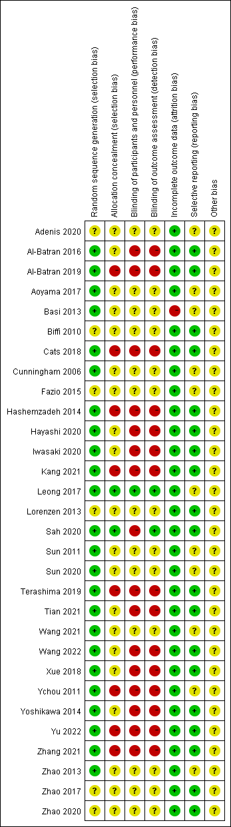
Appendix Fig S2. Risk of bias graph
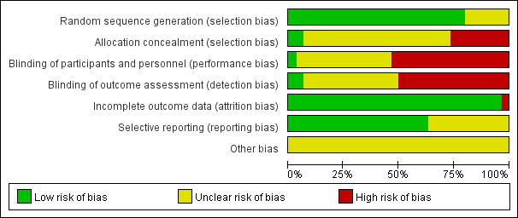

Appendix Fig S3. The trace plot and density plot of R0 resection rate
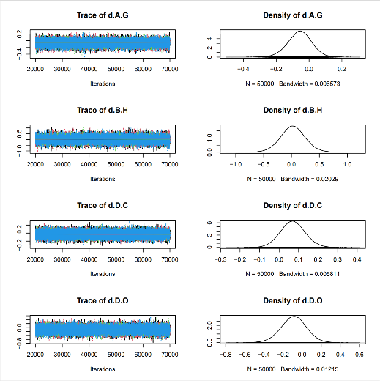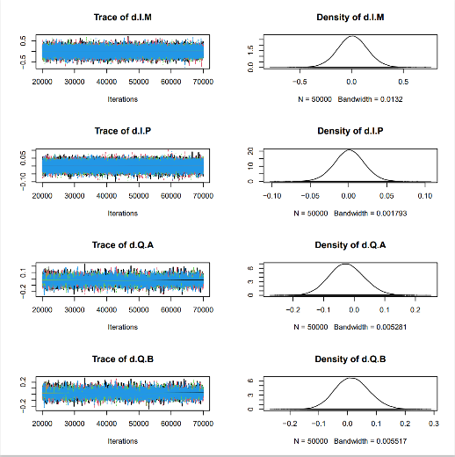
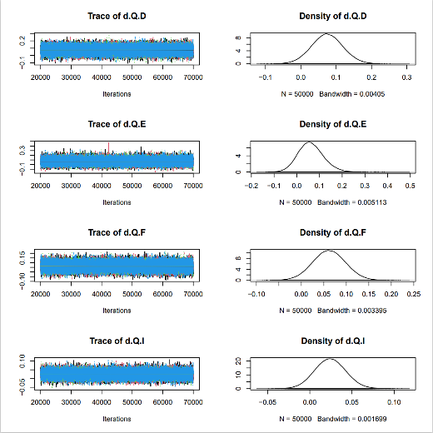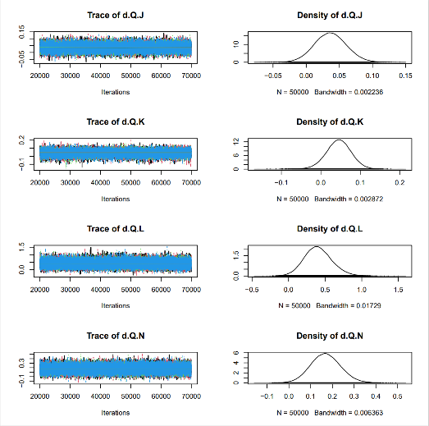
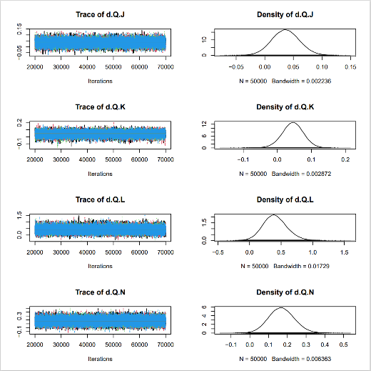

Appendix Fig S4. The Brooks-Gelman-Rubin diagnosis plot of R0 resection rate
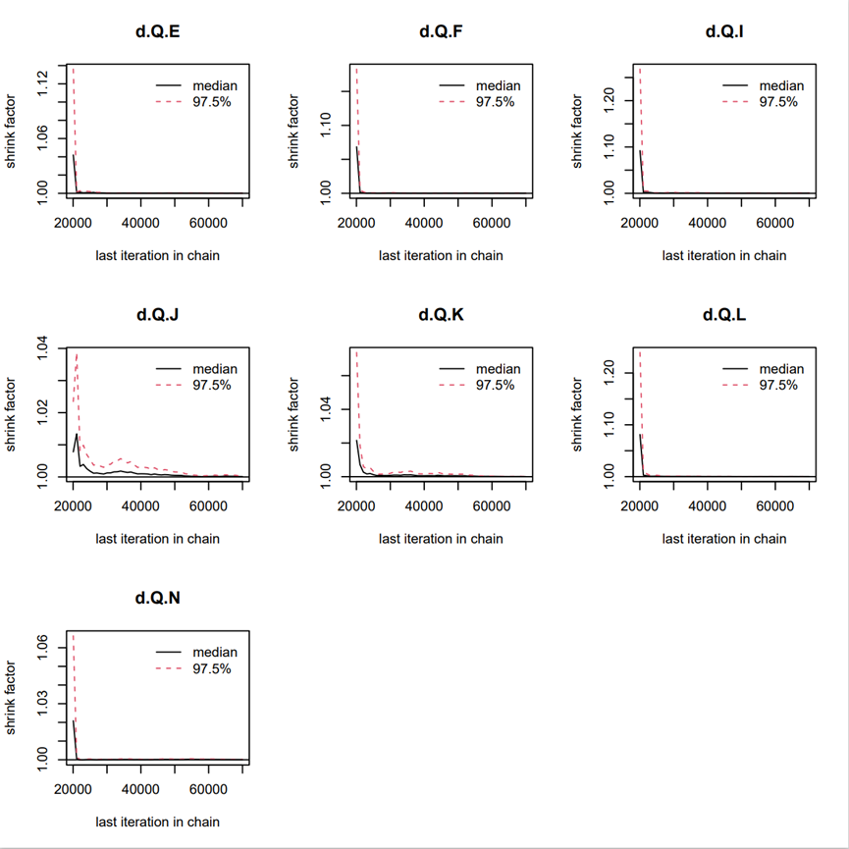

Appendix Fig S5. Local inconsistency detection of R0 resection rate
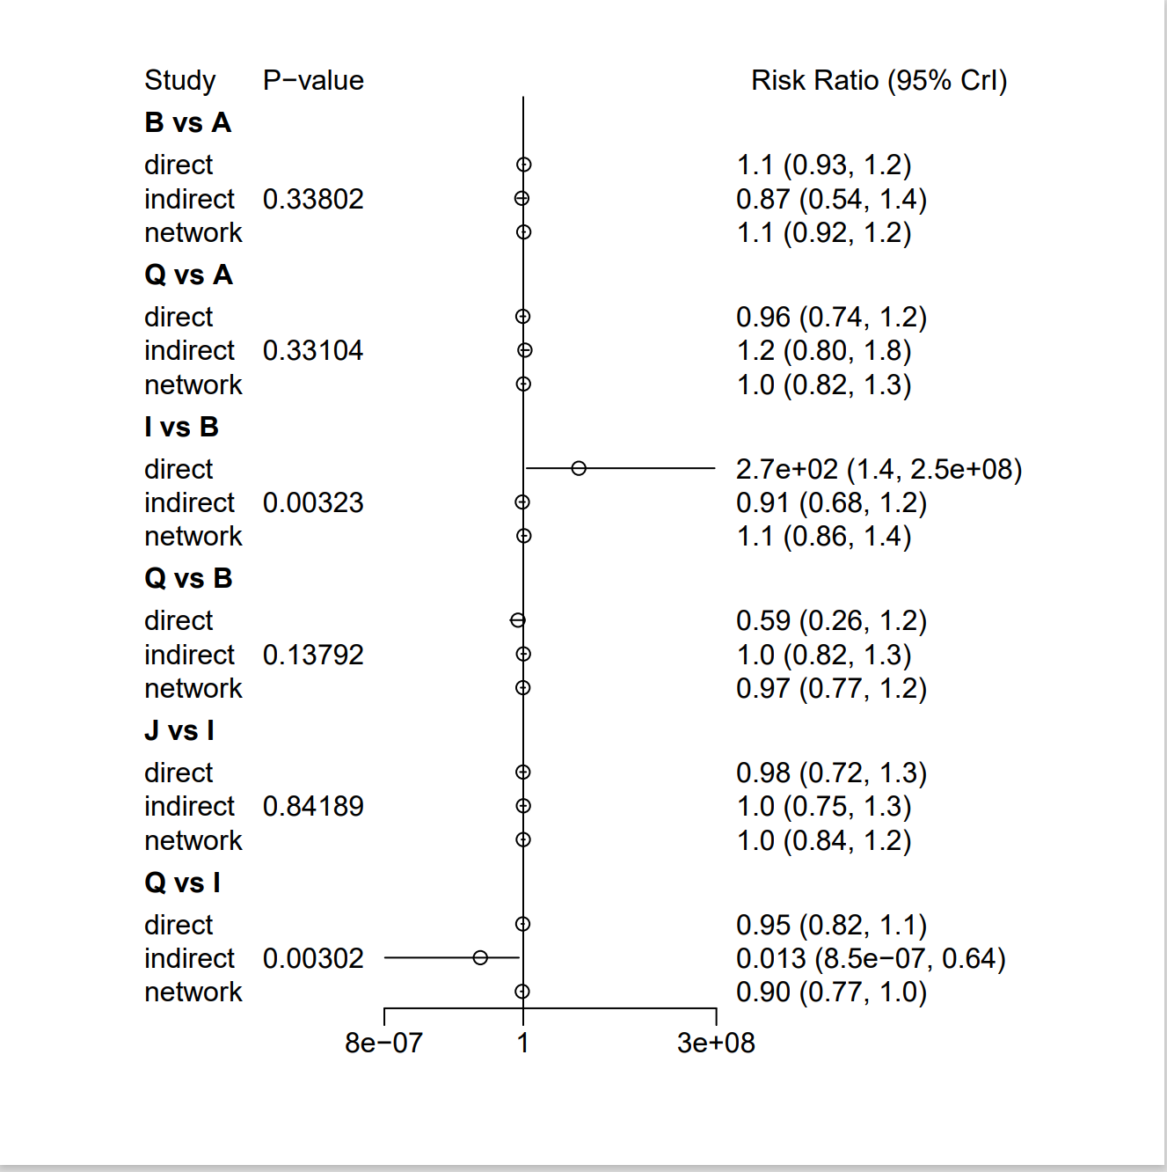

Appendix Fig S6. The trace plot and density plot of of OS
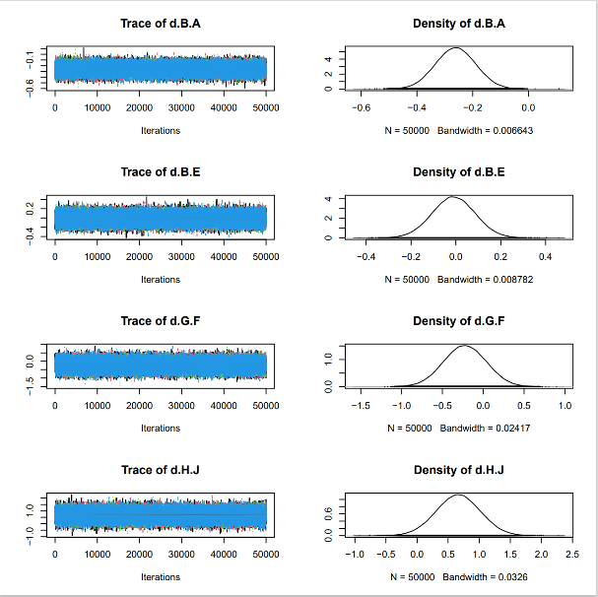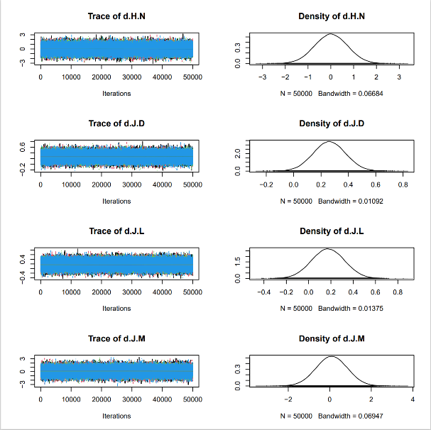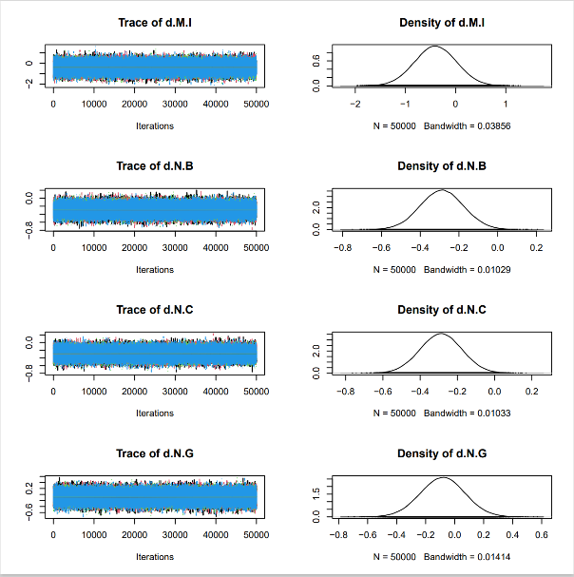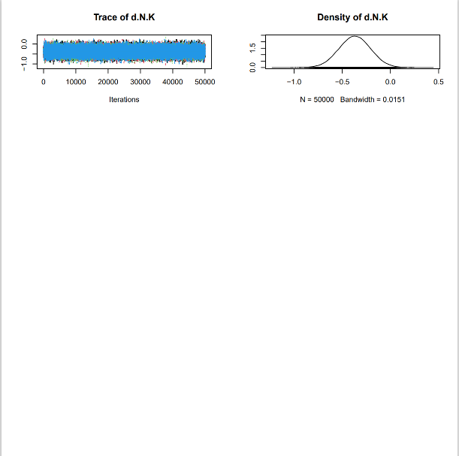

Appendix Fig S7. The Brooks-Gelman-Rubin diagnosis plot of OS
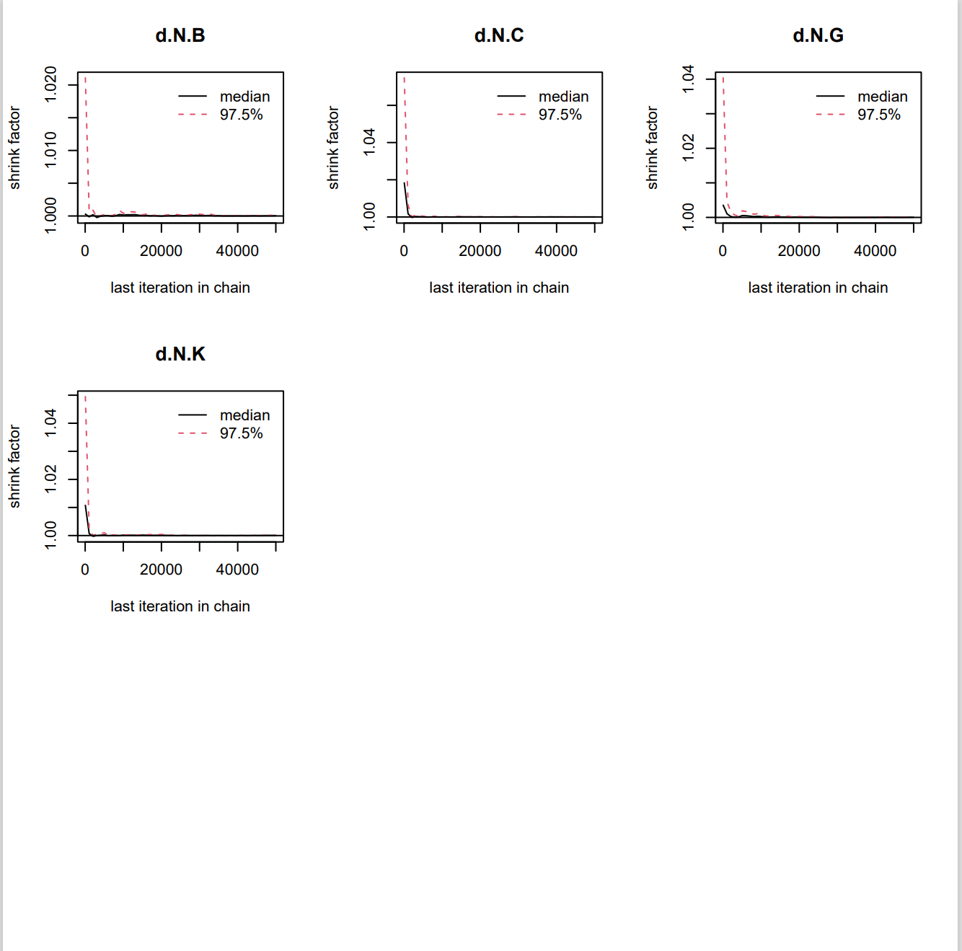

Appendix Fig S8. Local inconsistency detection of OS
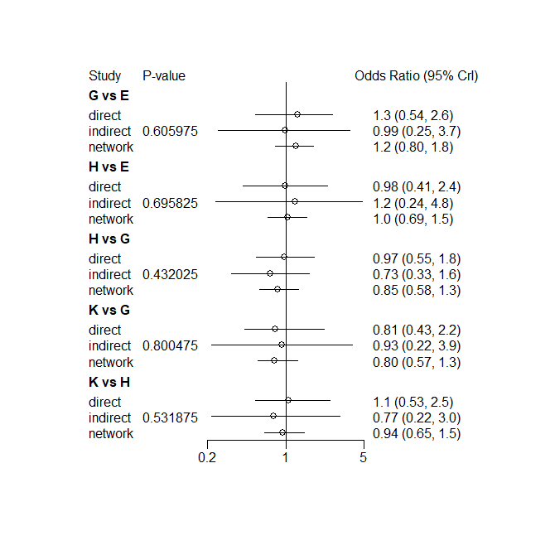

Appendix Fig S9. The trace plot and density plot of of non-surgical SAEs
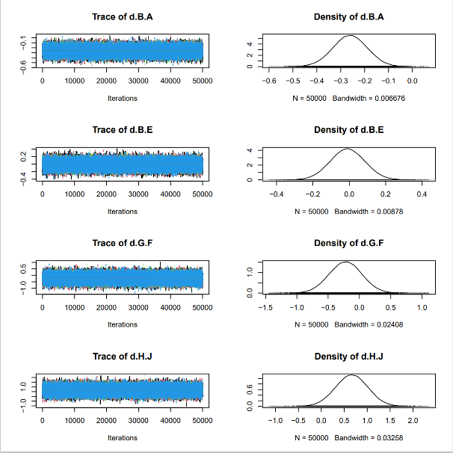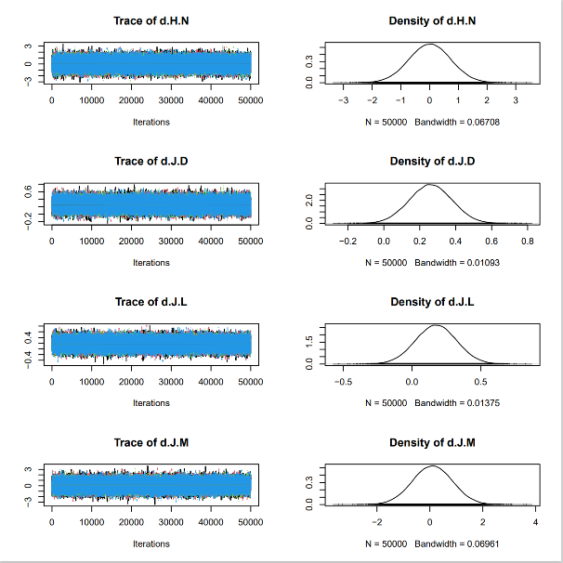
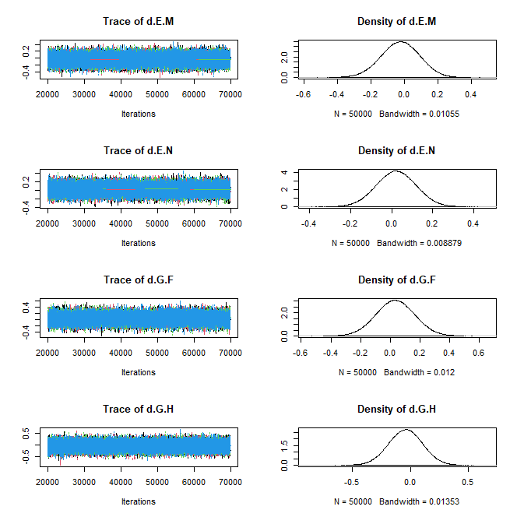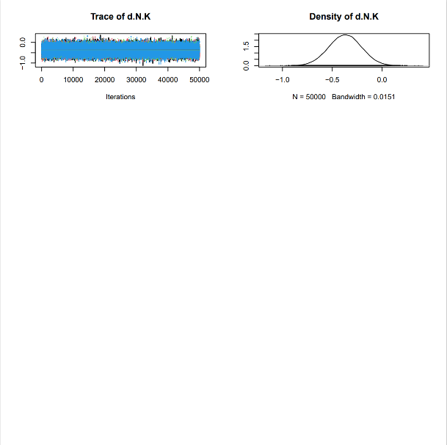

Appendix Fig S10. The Brooks-Gelman-Rubin diagnosis plot of non-surgical SAEs
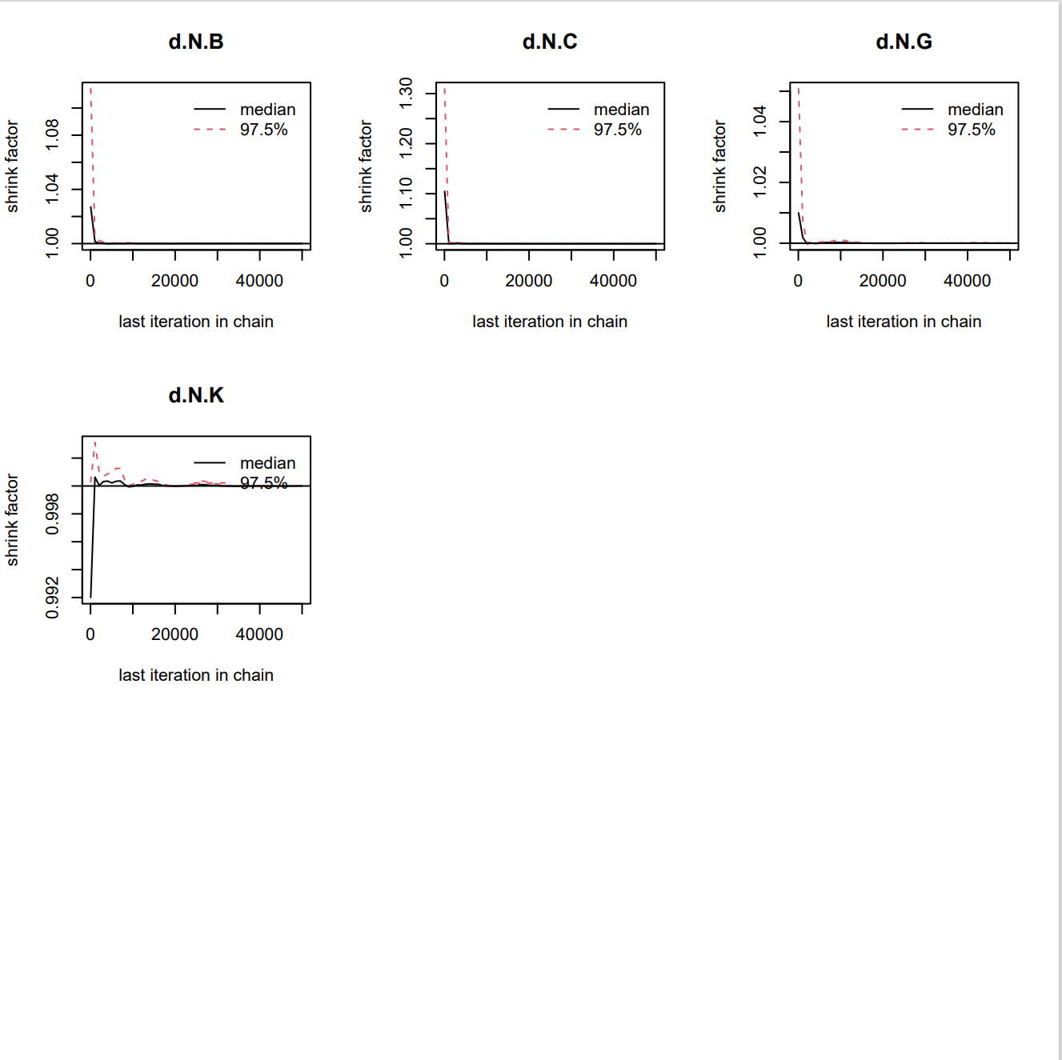

Appendix Fig S11. Local inconsistency detection of non-surgical SAEs
