Exploring the Anticorrosive Capabilities of TGEDADPTBBA on E24 Carbon Steel in Acidic Environments: A Comprehensive Study

Naoual El-Aouni¹, Omar Dagdag²*, Abed slam Amri³, Hansang Kim²*, Nadia Dkhireche³, Abderrahim Elbachiri⁴, Elyor Berdimurodov^{5,6}*, Avni Berisha⁷, Mohamed Rafik¹.

¹Laboratory of Organic Chemistry, Catalysis and Environment, Department of Chemistry, Faculty of Sciences, University Ibn Tofail, BP 242, 14000 Kenitra, Morocco
²Department of Mechanical Engineering, Gachon University, Seongnam 13120, Republic of Korea
³Laboratory of Advanced Materials and Process Engineering, Faculty of Sciences, Ibn Tofail University, BP 242, Kenitra, 14000, Morocco
⁴Royal Naval School, University Department –Boulevard Sour-Jdid, Casablanca, Morocco
⁵Faculty of Chemistry, National University of Uzbekistan, Tashkent, 100034, Uzbekistan;
⁶Medical School, Central Asian University, Tashkent 111221, Uzbekistan
⁷Department of Chemistry, Faculty of Natural and Mathematics Science, University of Prishtina, 10000 Prishtina, Kosovo.

Corresponding authors E-mail: omar.dagdag@uit.ac.ma, hskim70@gachon.ac.kr, elyor170690@gmail.com

Supplementary information
Figures
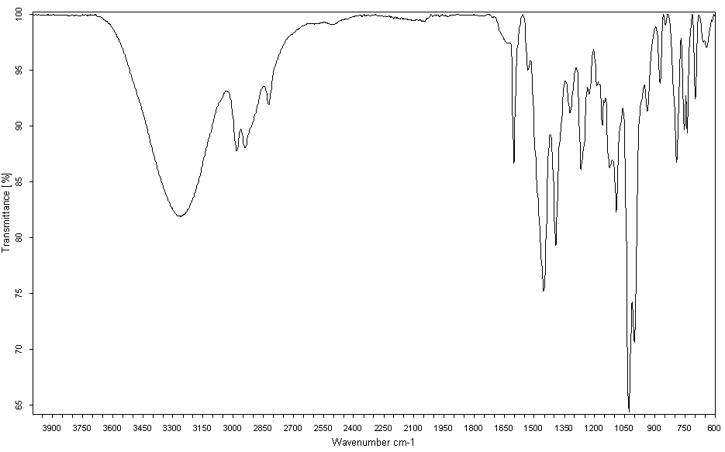
Figure SI1 : IR spectrum of TGEDADPTBBA.

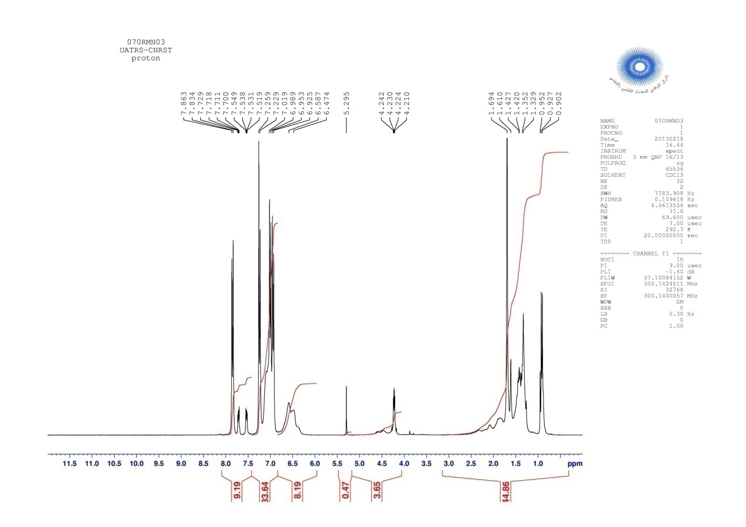
Figure SI2 : ¹H NMR spectrum of TGEDADPTBBA
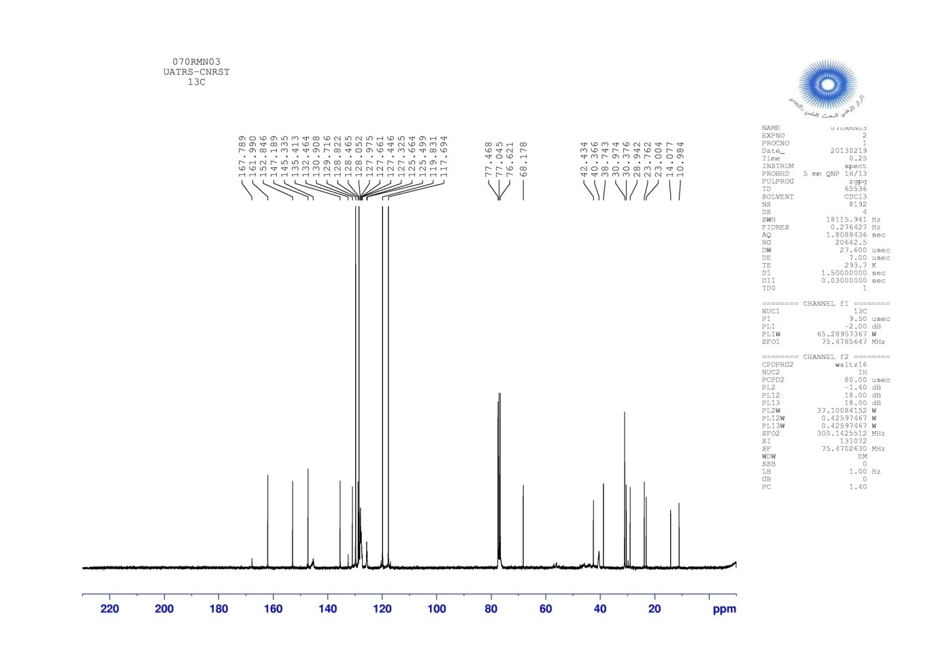
Figure SI3 : ¹³C NMR spectrum of TGEDADPTBBA

Tables
Table SI1 : IR spectrum bands of the tetrafunctional resin TGEDADPTBBA
Band ν (cm⁻¹) | Assignments
3263 | νO-H residual
2981 | νs CH₂ epoxy
2940,2 | νas CH₂ methylene ether
1532-1620 | ν Car=Car aromatic benzene ring of the para-substituted
1453 | δ C-H epoxy ou δCH₂ methylene bound to the oxirane ring
1393,7 | δC-Car tertiary carbon
1226,6-1267,4 | ν Car-O–Alkyl : aromatic ether, ν Car-N- et ν C-O-C epoxy
1161,9 | δ C-Har deformation in the aromatic plane
1001,3-1091,5 | ν C-N-Ar, et δ C-H aromatic
937 | Asymmetric deformation of the epoxy cycle
846,5-873,2 | Epoxy cycle sym deformation
791,3 | δ C-H out-of-plane deformation of the para-substituted aromatic ring
752,8 | δ C-H out-of-plane deformation of the ortho-substituted aromatic ring

Table SI2: Chemical shifts in the ¹H NMR spectrum of TGEDADPTBBA.
δ ppm | Protons and interpretations
0,90-0.95 | s, 6H, CH₃
1,42-1,69 | d, 2H, CH₂ oxirane
4,21-4,24 | d, 8H, CH₂ bound to oxirane
5,29 | d, 2H, CH₂ bonded with oxygen
6,47-7,86 | m, 14, CH aromatic

Table SI3 : Chemical shifts in the ¹³C NMR spectrum of TGEDADPTBBA.

δ ppm | Carbons and interpretations
23-23,76 | C-CH₃
30,97 | CH₃-C
40,36 | CH₂ oxirane
42,43 | CH-CH₂-O
68,17 | CH oxirane
76,62 | N-CH₂-CH
77,04-77,46 | CH₂-CH-CH₂
117,69-135,41 | CH aromatic
145,33-167,78 | C aromatic tertiary

