SUPPORTING INFORMATION

Design，Synthesis and Evaluation of Aurone and Indanone Derivatives as Novel Antibacterial Agents
Baoxing Xie ^{a,b}, Haiqing Zhaoª, Ailin Hu^{a,b}, Chao Niu*^{a,b}, Haji Akber Aisa*^{a,b,}

1.State Key Laboratory Basis of Xinjiang Indigenous Medicinal Plants Resource Utilization, CAS Key Laboratory of Chemistry of Plant Resources in Arid Regions, Xinjiang Technical Institute of Physics and Chemistry, Chinese Academy of Sciences, Urumqi, 830011 China
2.University of Chinese Academy of Sciences, Beijing, 100049 China

¹H, and ¹³C NMR spectrums of compounds M1-M2, A1-A10, B1-B7, C1-C6, D1-D4, E1-E3.

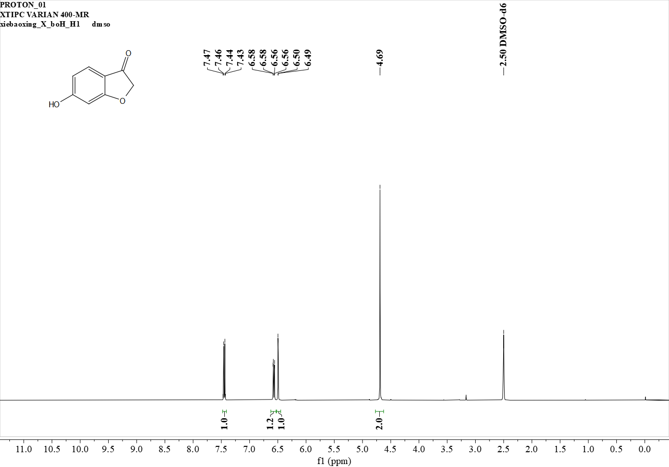
¹H NMR (400 MHz, dmso) δ 7.45 (d, J = 8.5 Hz, 1H), 6.57 (d, J = 8.5 Hz, 1H), 6.49 (s, 1H), 4.69 (s, 2H).

Figure S1. ¹H NMR spectrum of M1

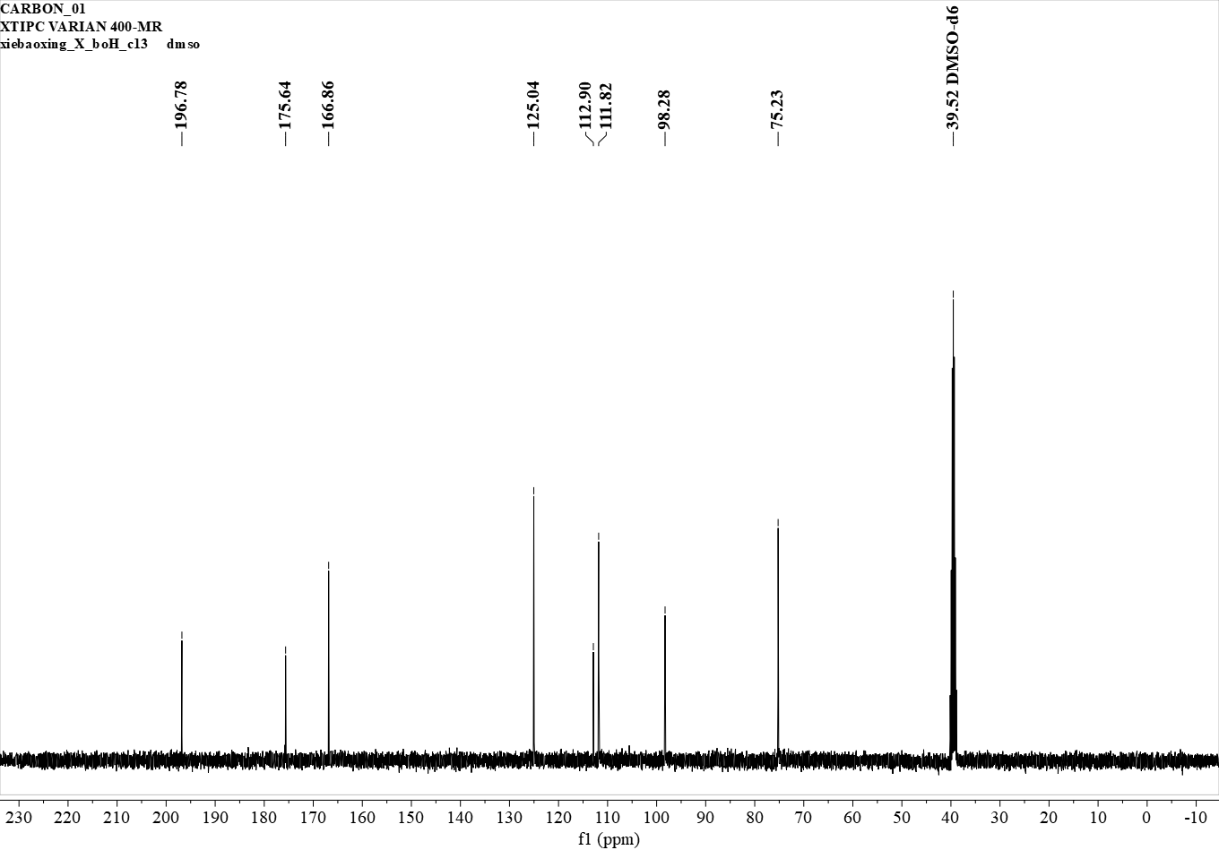
¹³C NMR (101 MHz, dmso) δ 196.78, 175.64, 166.86, 125.04, 112.90, 111.82, 98.28, 75.23.

Figure S2. ¹³C NMR spectrum of M1

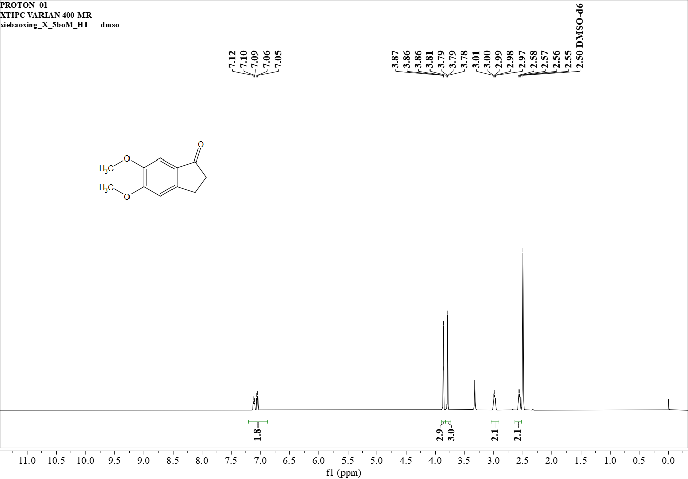
¹H NMR (400 MHz, dmso) δ 7.14 – 7.02 (m, 2H), 3.86 (s, 3H), 3.79 (s, 3H), 3.03 – 2.94 (m, 2H), 2.61 – 2.52 (m, 2H).

Figure S3. ¹H NMR spectrum of M2
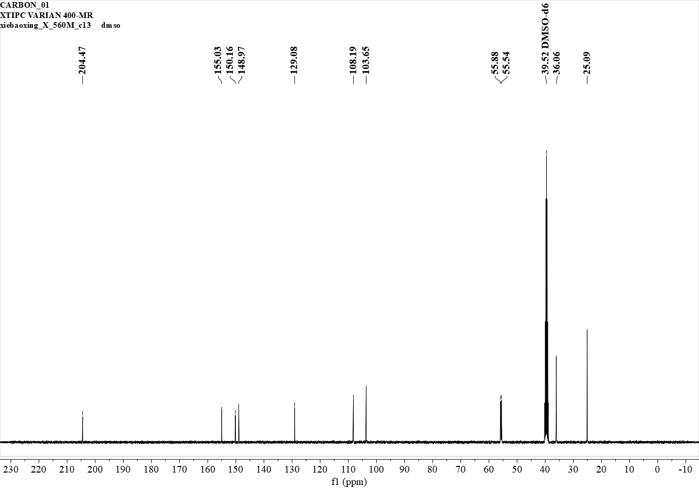
¹³C NMR (101 MHz, dmso) δ 204.47, 155.03, 150.16, 148.97, 129.08, 108.19, 103.65, 55.88, 55.54, 36.06, 25.09.

Figure S4. ¹³C NMR spectrum of M2

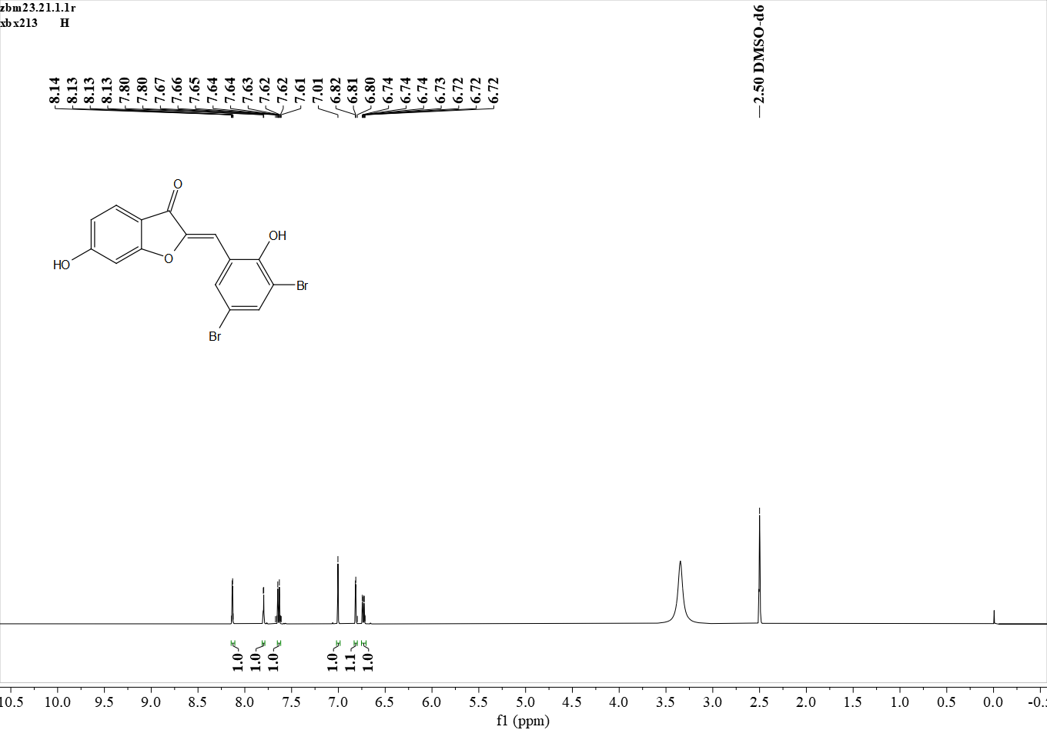
¹H NMR (500 MHz, DMSO) δ 8.13 (s, 1H), 7.80 (s, 1H), 7.64 (d, J = 8.4 Hz, 1H), 7.01 (s, 1H), 6.82 (s, 1H), 6.73 (d, J = 8.6 Hz, 1H).

Figure S5. ¹H NMR spectrum of A1

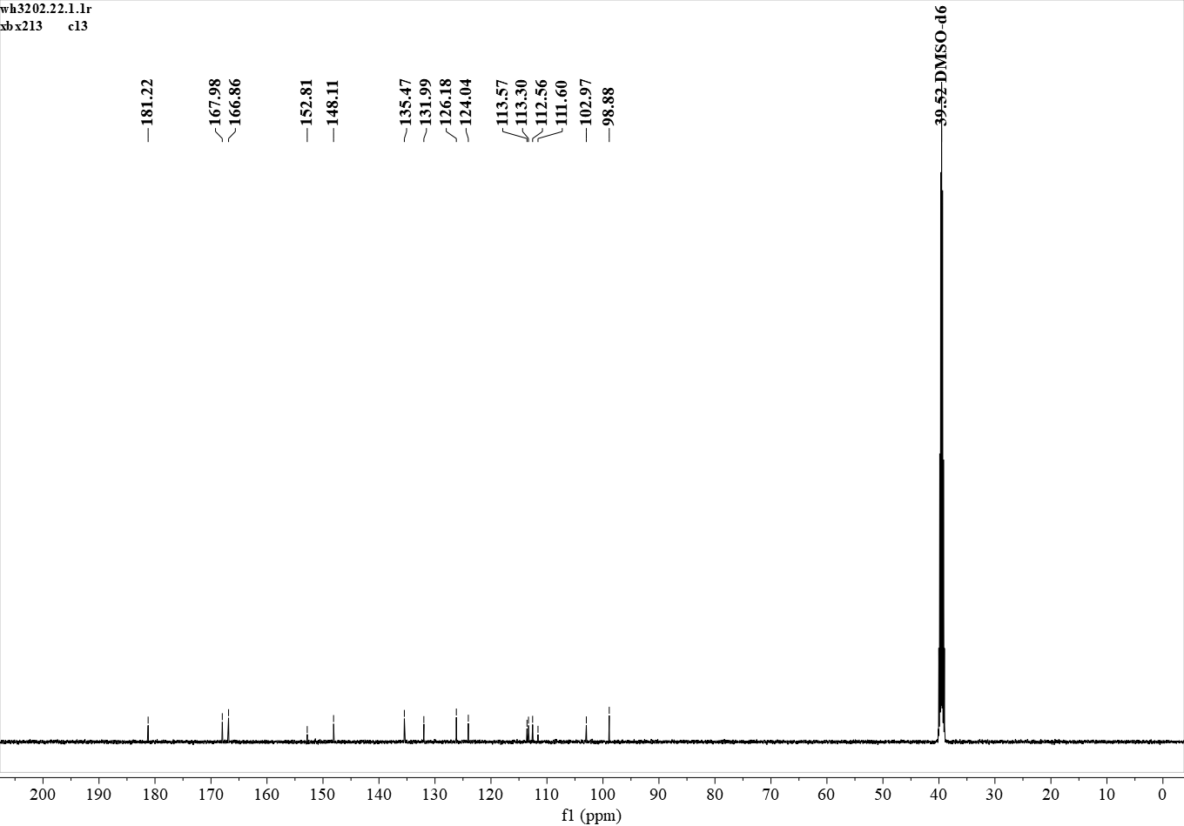
¹³C NMR (126 MHz, DMSO) δ 181.22, 167.98, 166.86, 152.81, 148.11, 135.47, 131.99, 126.18, 124.04, 113.57, 113.30, 112.56, 111.60, 102.97, 98.88.

Figure S6. ¹³C NMR spectrum of A1

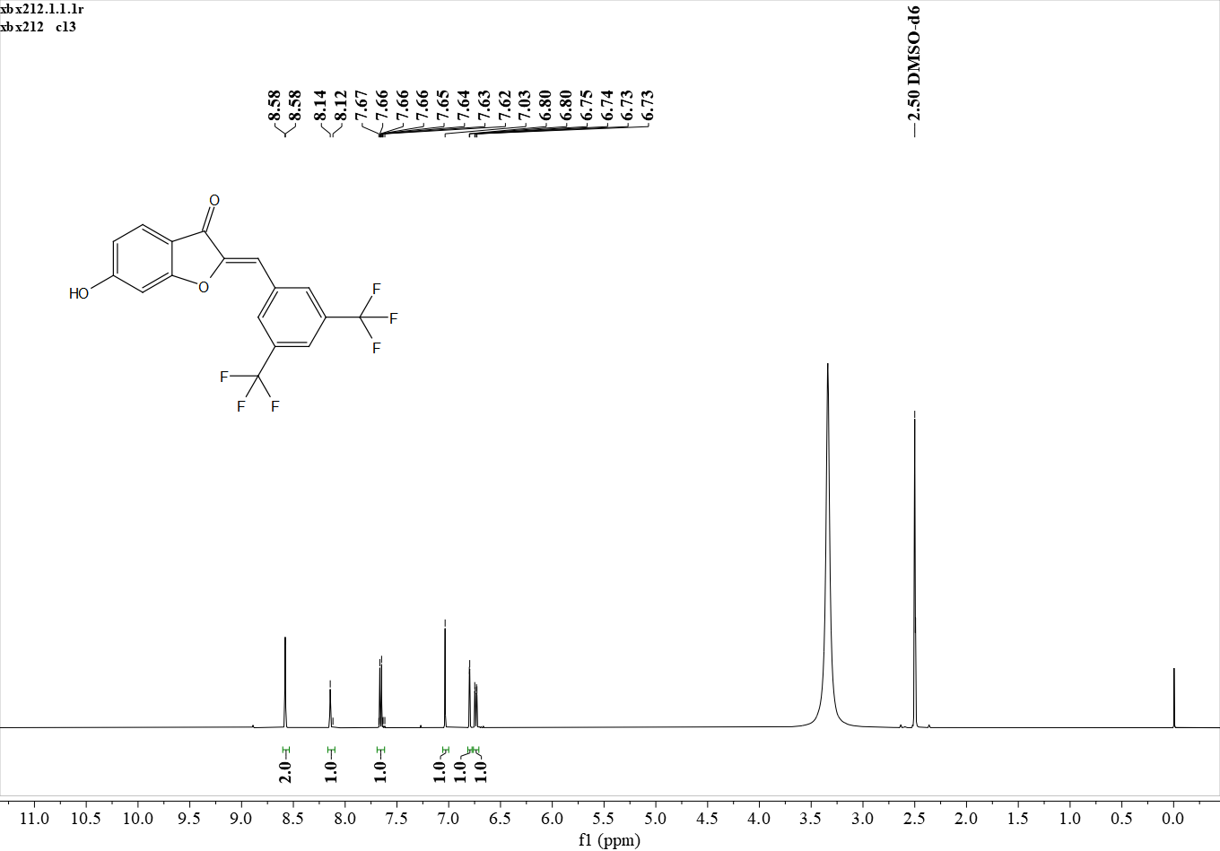
¹H NMR (500 MHz, DMSO) δ 8.58 (s, 2H), 8.14 (s, 1H), 7.66 (d, J = 8.5 Hz, 1H), 7.03 (s, 1H), 6.80 (s, 1H), 6.74 (d, J = 8.6 Hz, 1H).

Figure S7. ¹H NMR spectrum of A2

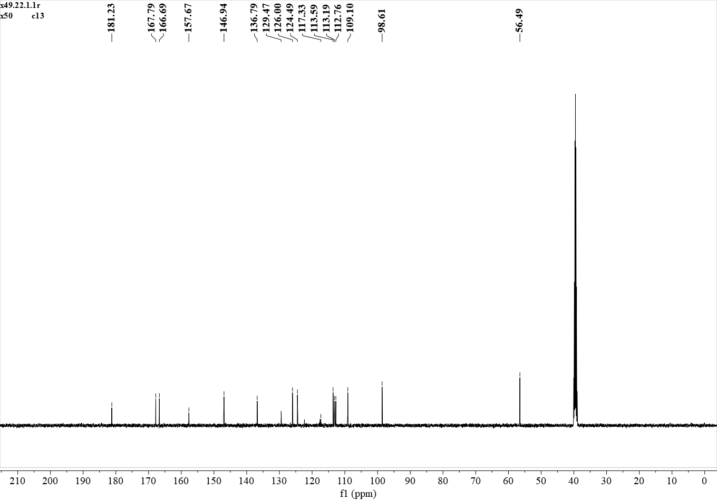
¹³C NMR (126 MHz, DMSO) δ 181.23, 167.79, 166.69, 157.67, 146.94, 136.79, 129.47, 126.00, 124.49, 117.33, 113.59, 113.19, 112.76, 109.10, 98.61, 56.49.

Figure S8. ¹³C NMR spectrum of A2
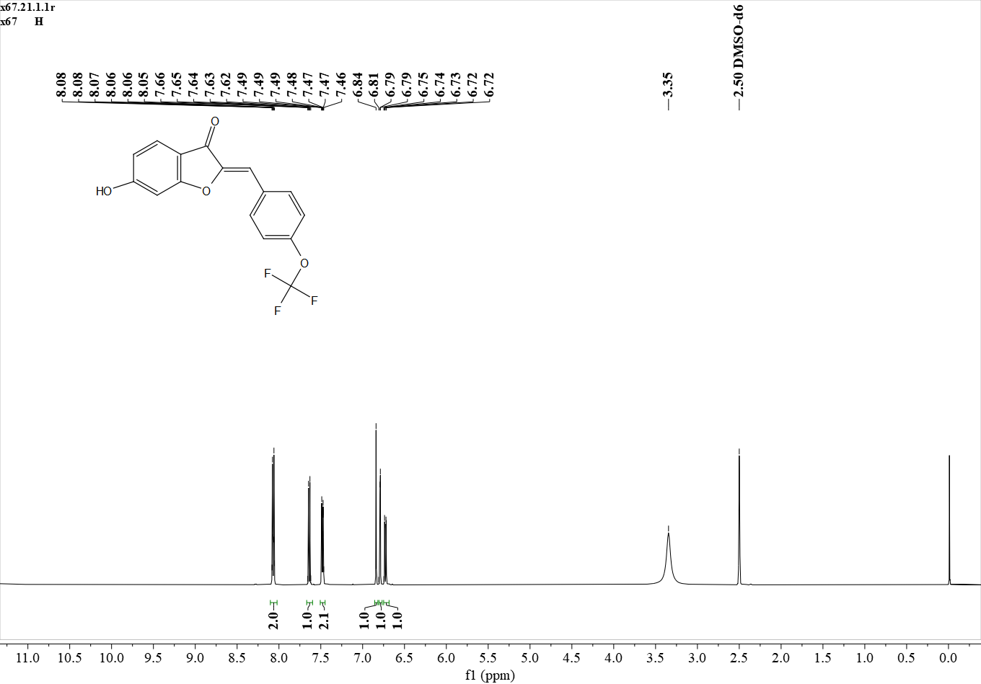
¹H NMR (500 MHz, DMSO) δ 8.10 – 8.02 (m, 2H), 7.64 (d, J = 8.4 Hz, 1H), 7.48 (d, J = 7.6 Hz, 2H), 6.84 (s, 1H), 6.79 (s, 1H), 6.73 (d, J = 8.4 Hz, 1H).

Figure S9. ¹H NMR spectrum of A3
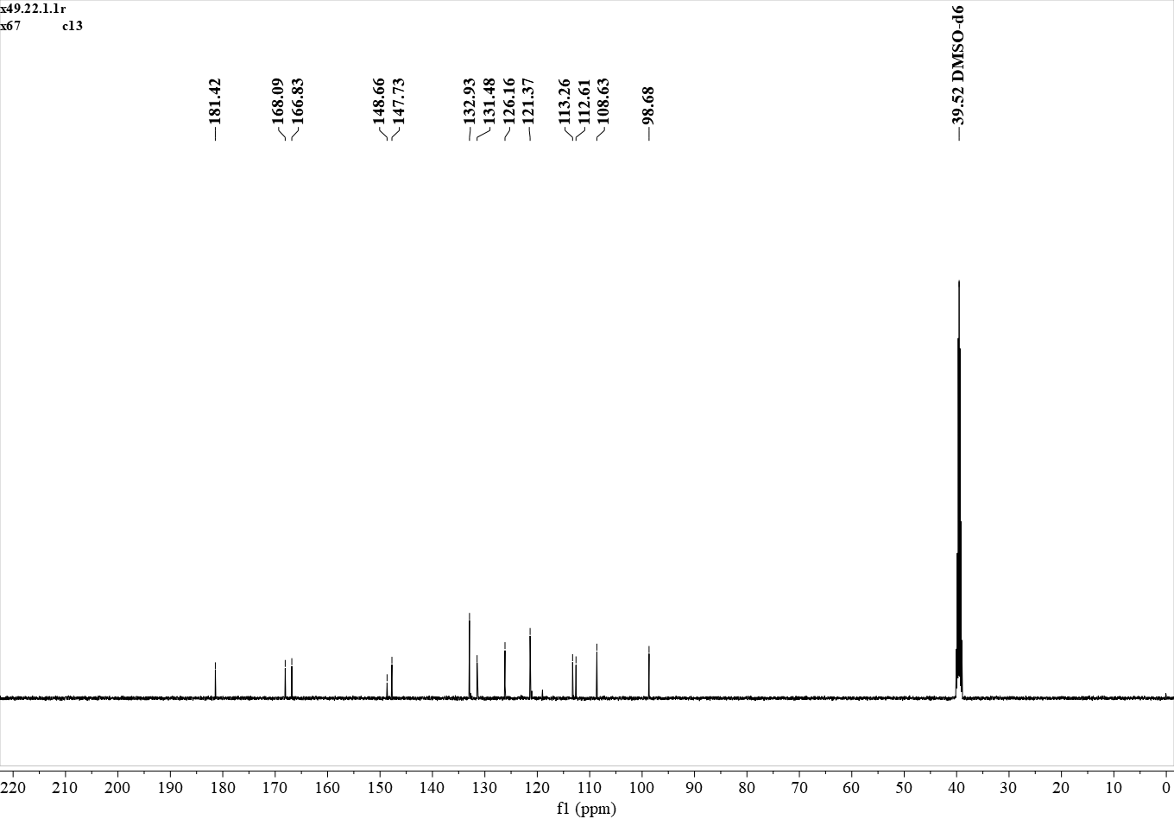
¹³C NMR (126 MHz, DMSO) δ 181.42, 168.09, 166.83, 148.66, 147.73, 132.93, 131.48, 126.16, 121.37, 113.26, 112.61, 108.63, 98.68.

Figure S10. ¹³C NMR spectrum of A3

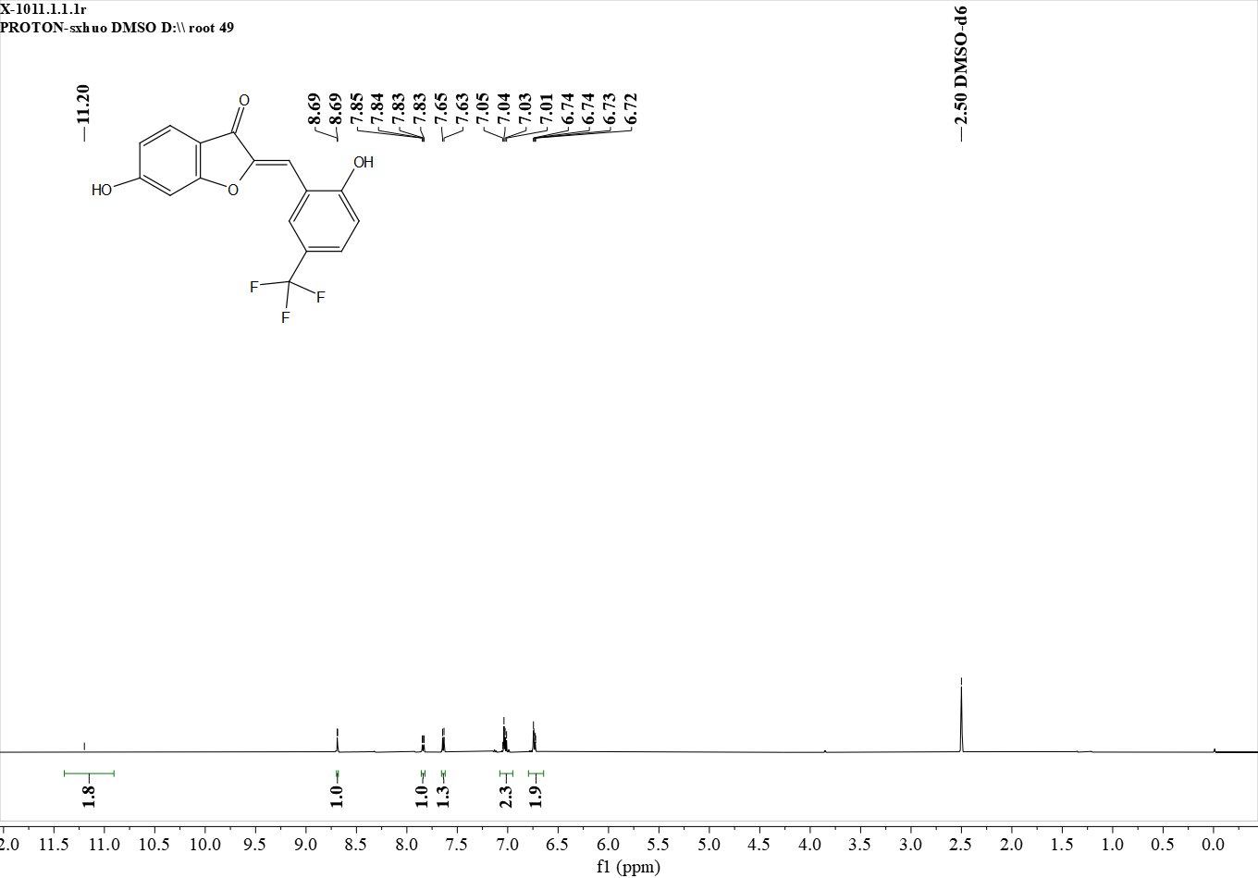
¹H NMR (600 MHz, DMSO) δ 11.20 (s, 2H), 8.69 (s, 1H), 7.84 (d, J = 2.2 Hz, 1H), 7.64 (d, J = 8.3 Hz, 1H), 7.09 – 6.97 (m, 2H), 6.80 – 6.67 (m, 2H).

Figure S11. ¹H NMR spectrum of A4
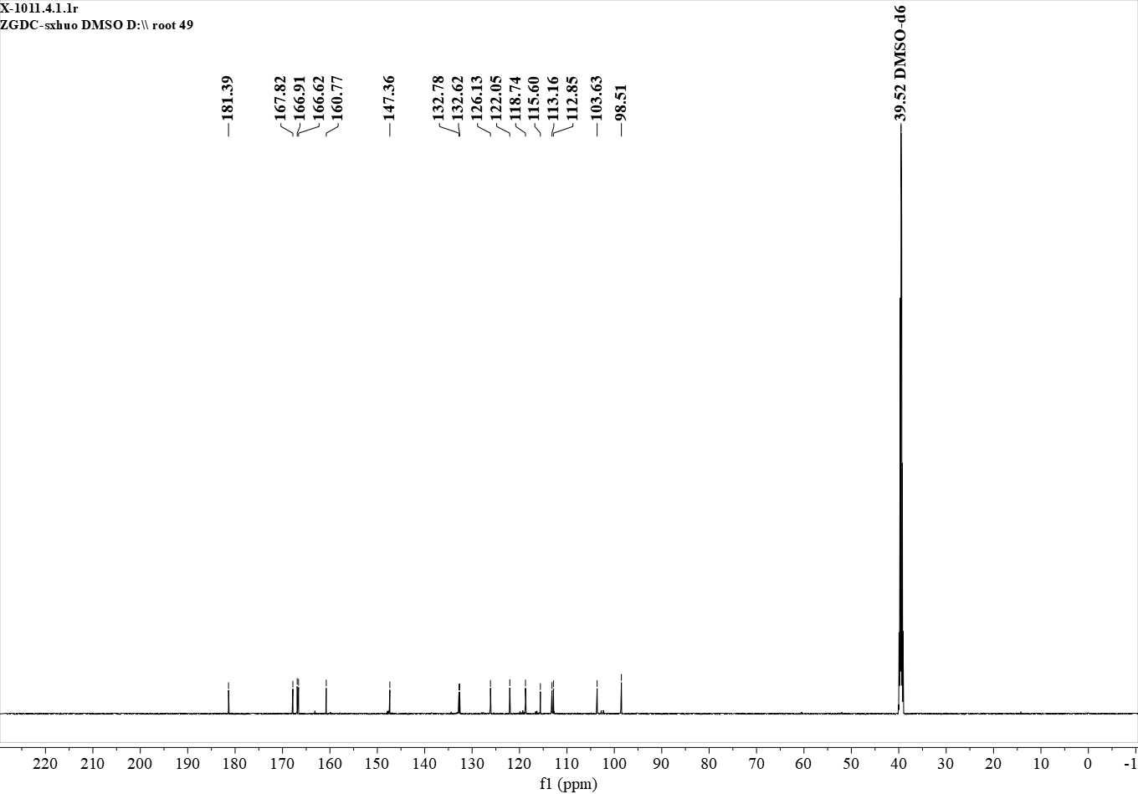
¹³C NMR (151 MHz, DMSO) δ 181.39, 167.82, 166.91, 166.62, 160.77, 147.36, 132.78, 132.62, 126.13, 122.05, 118.74, 115.60, 113.16, 112.85, 103.63, 98.51.
Figure S12. ¹³C NMR spectrum of A4

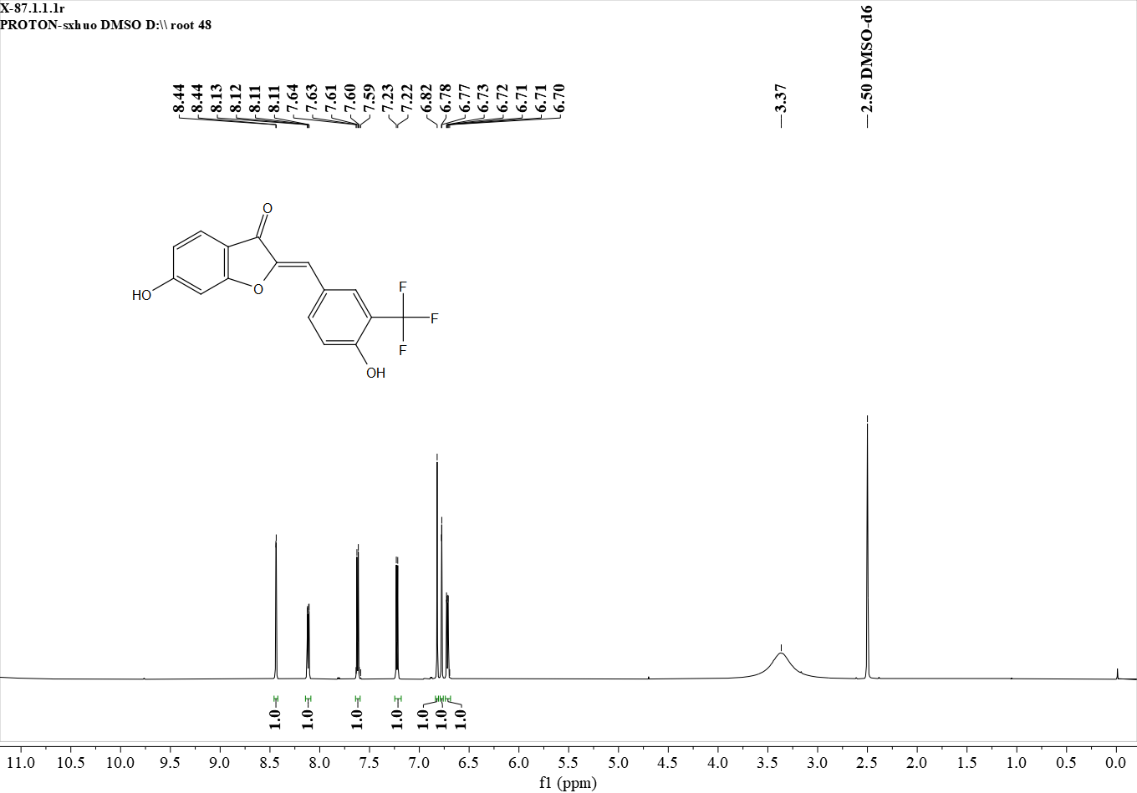
¹H NMR (600 MHz, DMSO) δ 8.44 (s, 1H), 8.12 (d, J = 8.8 Hz, 1H), 7.62 (d, J = 8.4 Hz, 1H), 7.22 (d, J = 8.6 Hz, 1H), 6.82 (s, 1H), 6.78 (s, 1H), 6.72 (d, J = 8.6 Hz, 1H).

Figure S13. ¹H NMR spectrum of A5

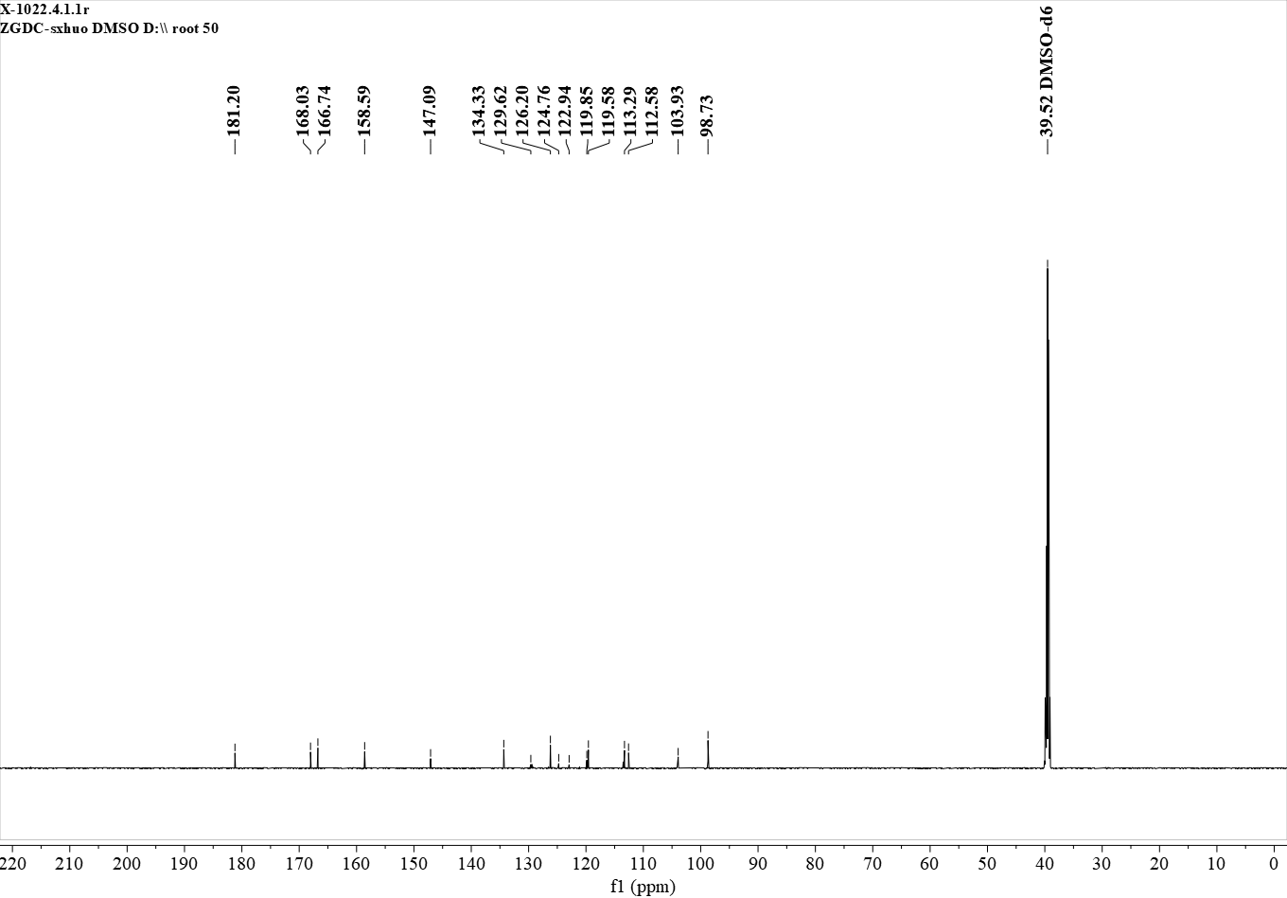
¹³C NMR (151 MHz, DMSO) δ 181.20, 168.02, 166.76, 158.59, 147.09, 134.33, 129.50, 126.20, 124.76, 122.95, 119.85, 119.57, 113.29, 112.57, 103.93, 98.74.

Figure S14. ¹³C NMR spectrum of A5

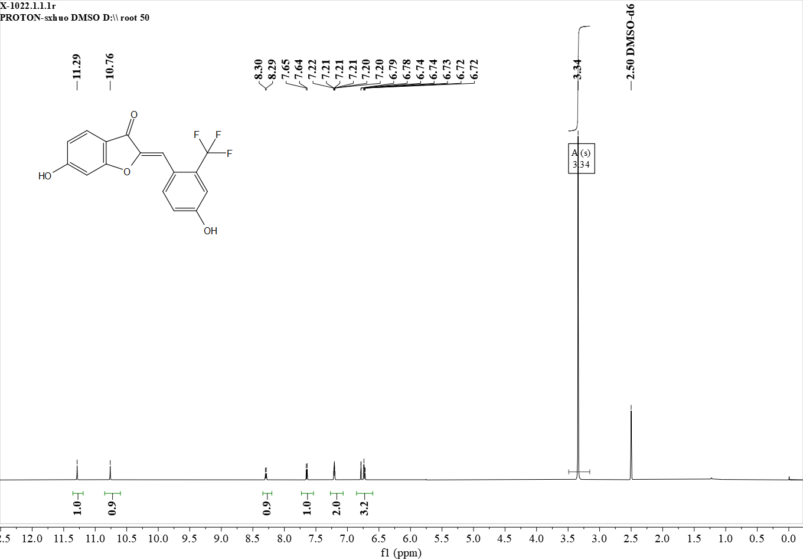
¹H NMR (600 MHz, DMSO) δ 11.29 (s, 1H), 10.76 (s, 1H), 8.29 (d, J = 9.3 Hz, 1H), 7.65 (d, J = 8.5 Hz, 1H), 7.23 – 7.18 (m, 2H), 6.78 (s, 1H), 6.76 – 6.71 (m, 2H).

Figure S15. ¹H NMR spectrum of A6
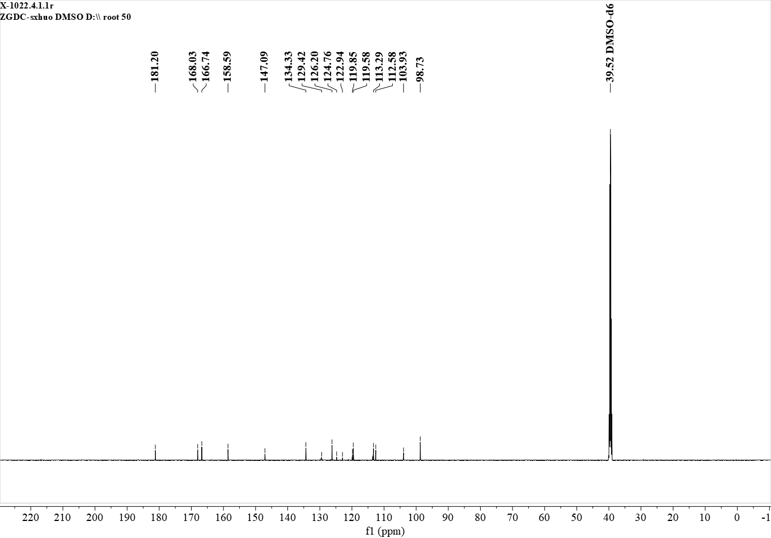
¹³C NMR (151 MHz, DMSO) δ 181.20, 168.03, 166.74, 158.59, 147.09, 134.33, 129.42, 126.20, 124.76, 122.94, 119.85, 119.58, 113.29, 112.58, 103.93, 98.73..

Figure S16. ¹³C NMR spectrum of A6
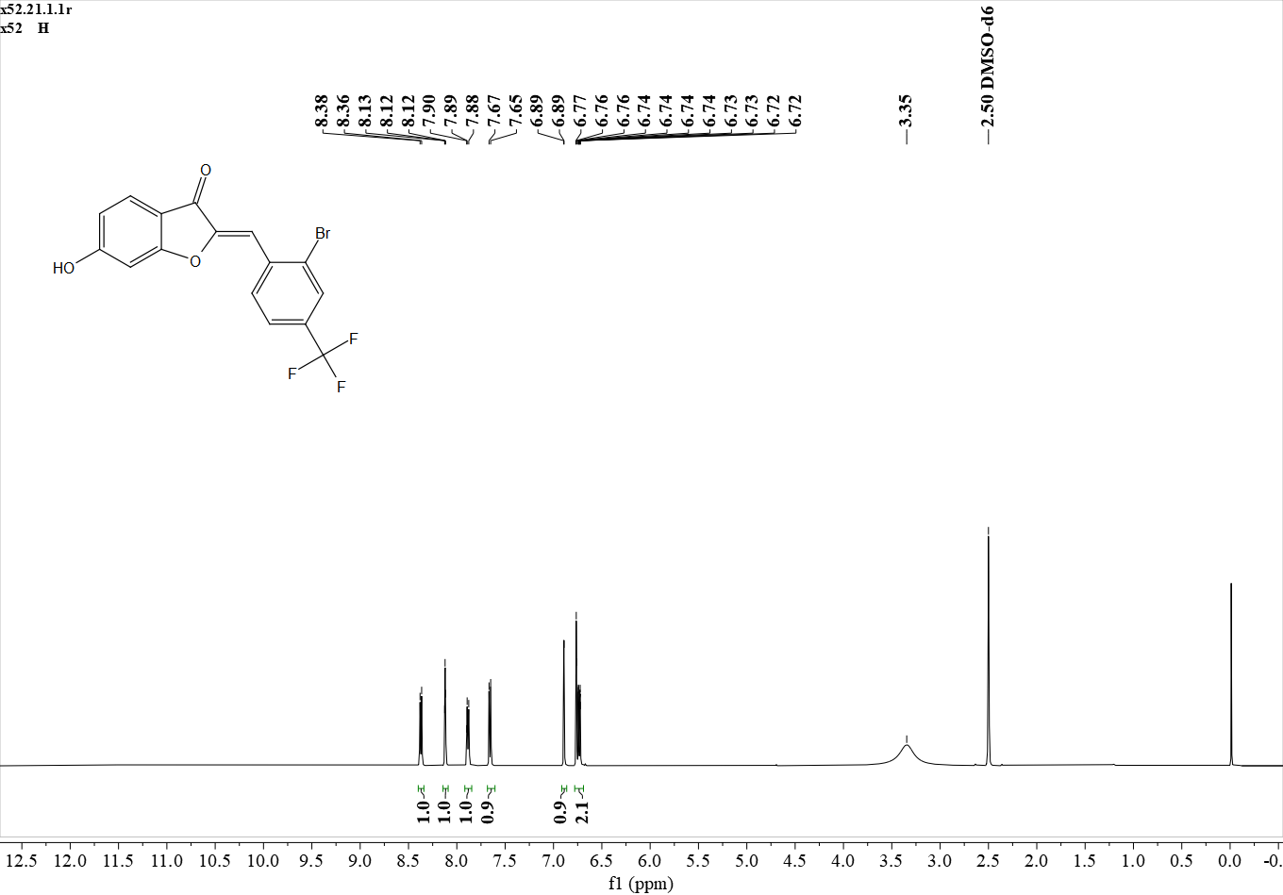
¹H NMR (500 MHz, DMSO) δ 8.37 (d, J = 8.2 Hz, 1H), 8.12 (s, 1H), 7.89 (d, J = 8.2 Hz, 1H), 7.66 (d, J = 8.5 Hz, 1H), 6.89 (s, 1H), 6.79 – 6.70 (m, 2H).

Figure S17. ¹H NMR spectrum of A7
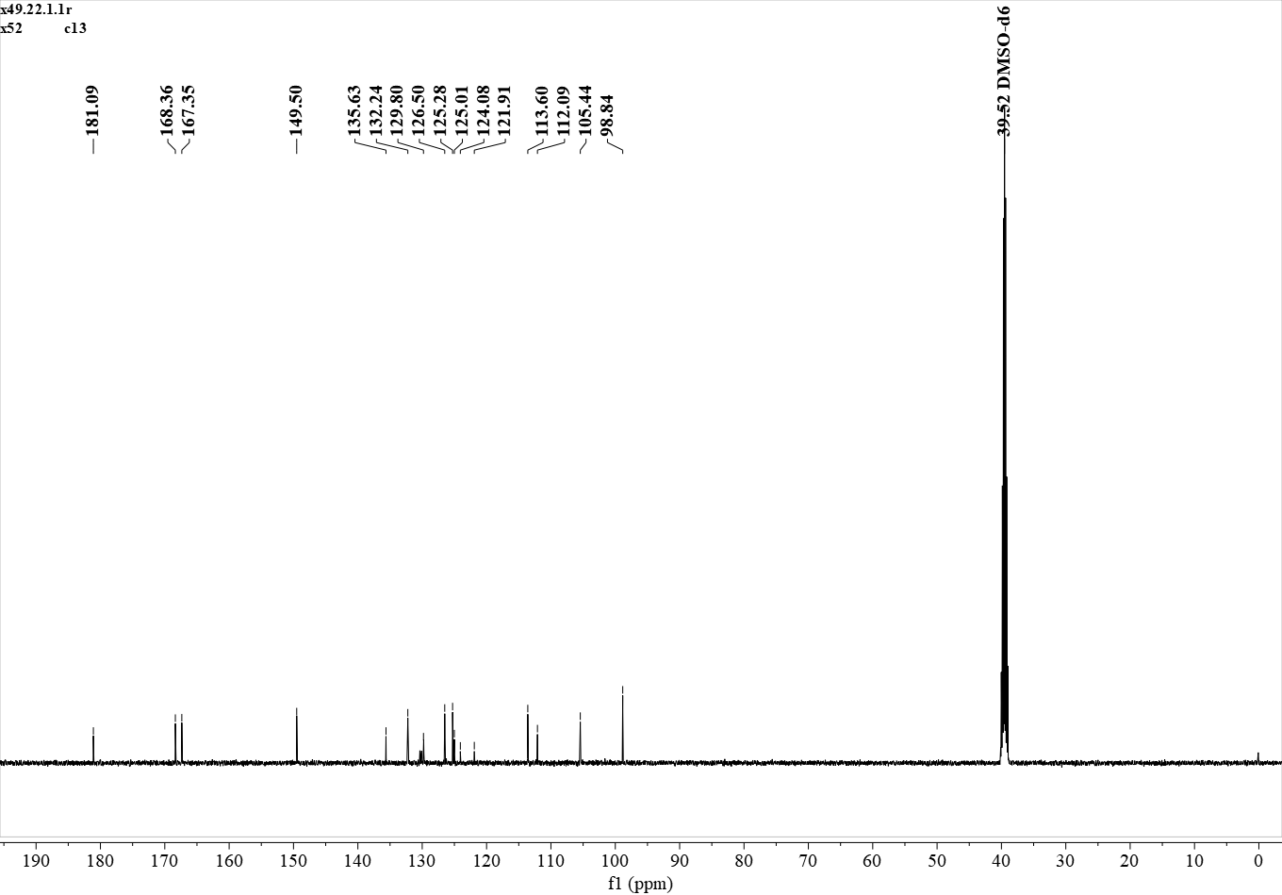
¹³C NMR (126 MHz, DMSO) δ 181.09, 168.36, 167.35, 149.50, 135.63, 132.24, 129.80, 126.50, 125.28, 125.01, 124.08, 121.91, 113.60, 112.09, 105.44, 98.84.

Figure S18. ¹³C NMR spectrum of A7
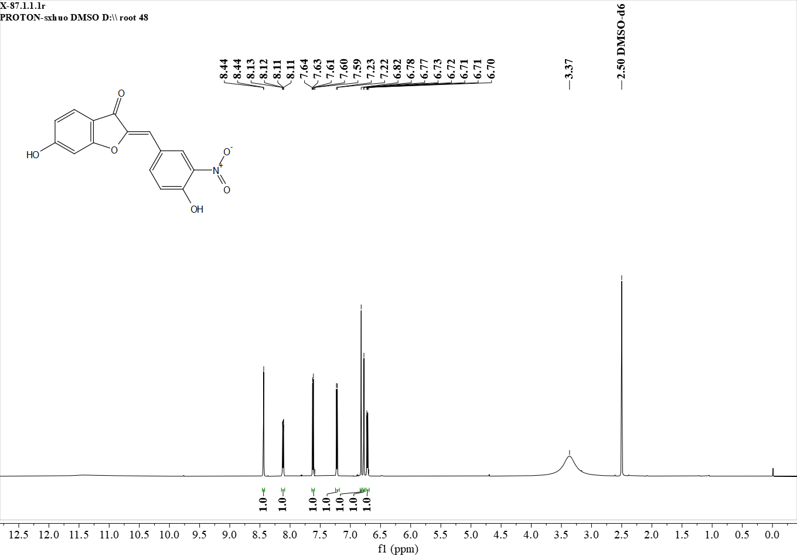
¹H NMR (600 MHz, DMSO) δ 8.44 (s, 1H), 8.12 (d, J = 8.8 Hz, 1H), 7.62 (d, J = 8.4 Hz, 1H), 7.22 (d, J = 8.6 Hz, 1H), 6.82 (s, 1H), 6.78 (s, 1H), 6.72 (d, J = 8.6 Hz, 1H).

Figure S19. ¹H NMR spectrum of A8

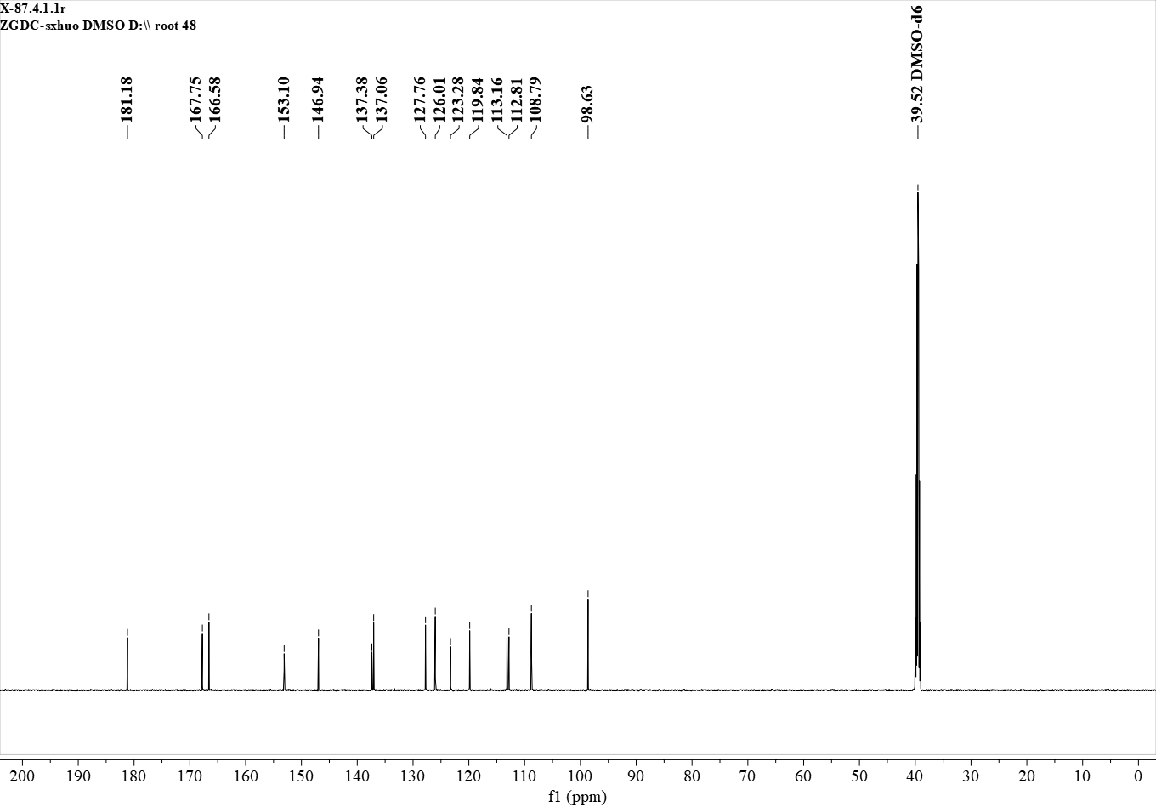
¹³C NMR (151 MHz, DMSO) δ 181.18, 167.75, 166.58, 153.10, 146.94, 137.38, 137.06, 127.76, 126.01, 123.28, 119.84, 113.16, 112.81, 108.79, 98.63.

Figure S20. ¹³C NMR spectrum of A8
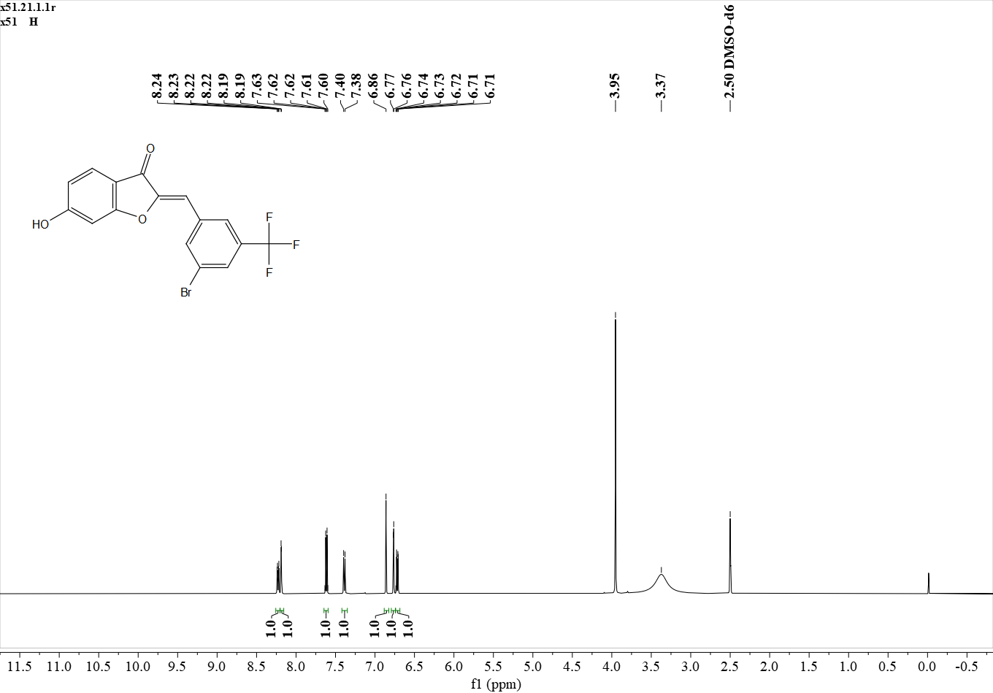
¹H NMR (500 MHz, DMSO) δ 8.23 (d, J = 8.6 Hz, 1H), 8.19 (s, 1H), 7.62 (d, J = 8.4 Hz, 1H), 7.39 (d, J = 8.8 Hz, 1H), 6.86 (s, 1H), 6.76 (s, 1H), 6.72 (d, J = 8.7 Hz, 1H).

Figure S21 ¹H NMR spectrum of A9
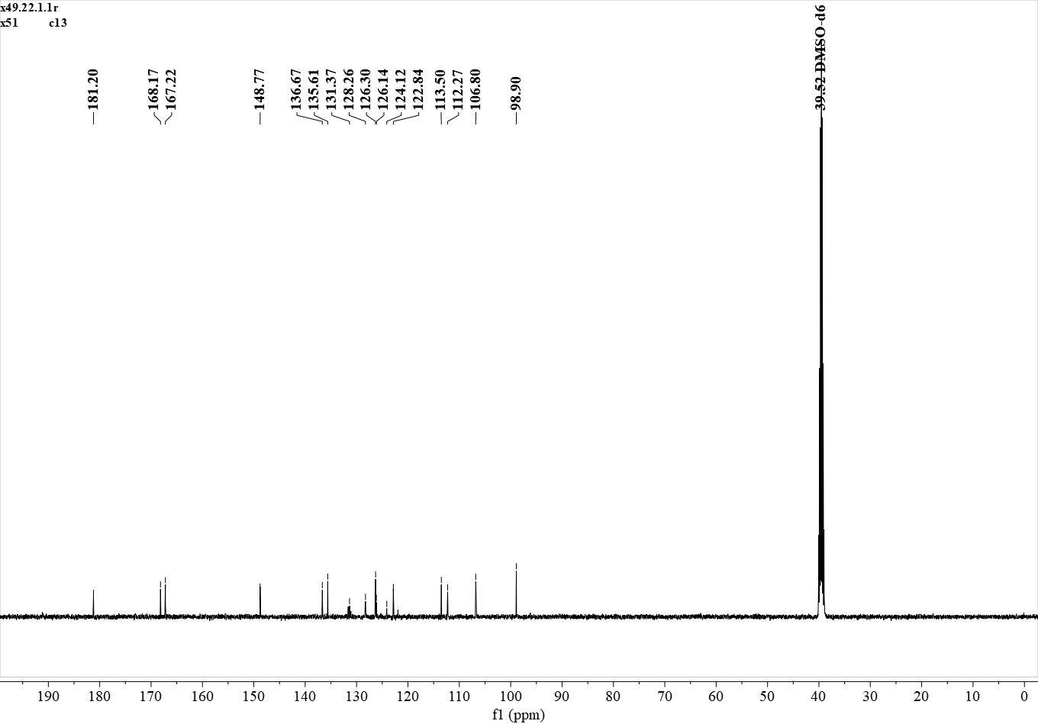
¹³C NMR (126 MHz, DMSO) δ 181.20, 168.17, 167.22, 148.77, 136.67, 135.61, 131.37, 128.26, 126.30, 126.14, 124.12, 122.84, 113.50, 112.27, 106.80, 98.90.

Figure S22. ¹³C NMR spectrum of A9

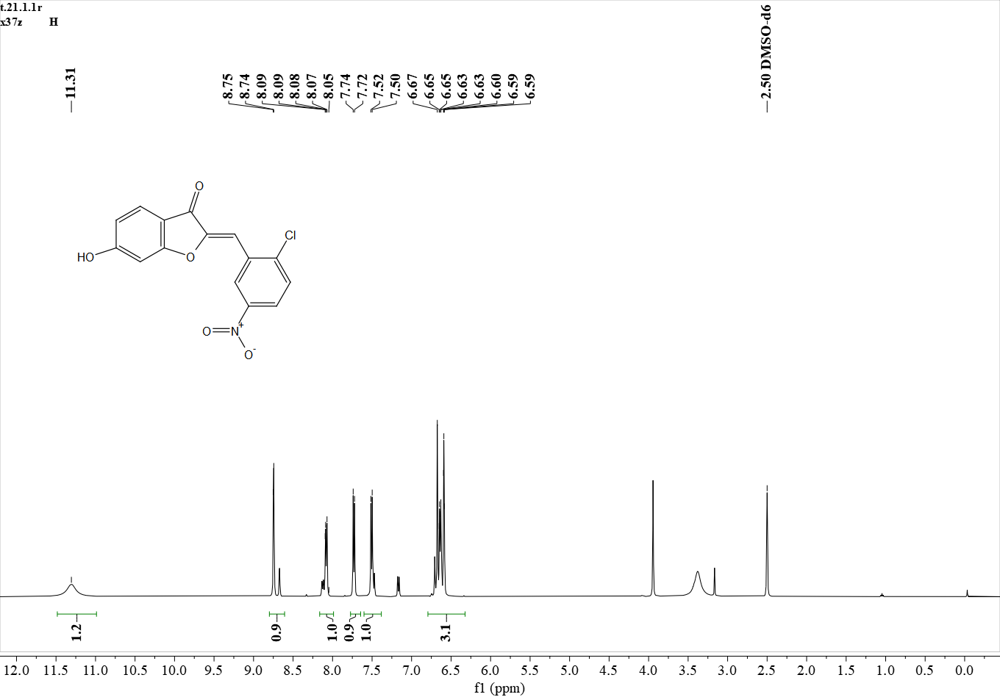
¹H NMR (500 MHz, DMSO) δ 11.31 (s, 1H), 8.75 (s, 1H), 8.08 (d, J = 8.9 Hz, 1H), 7.73 (d, J = 8.8 Hz, 1H), 7.51 (d, J = 8.3 Hz, 1H), 6.75 – 6.47 (m, 2H).

Figure S23. ¹H NMR spectrum of A10
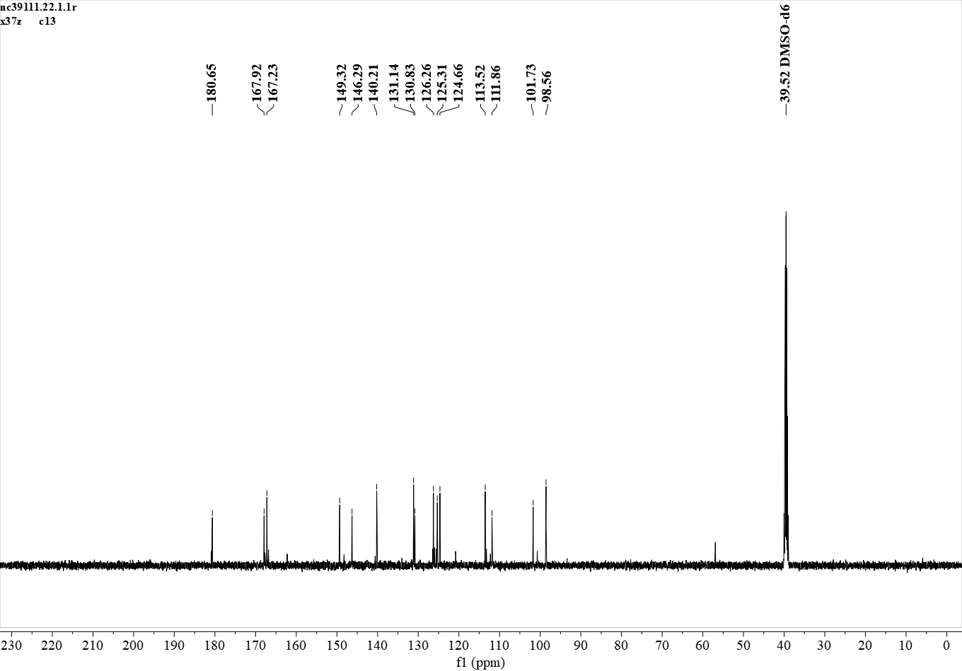
¹³C NMR (126 MHz, DMSO) δ 180.65, 167.92, 167.23, 149.32, 146.29, 140.21, 131.14, 130.83, 126.26, 125.31, 124.66, 113.52, 111.86, 101.73, 98.56.

Figure S24. ¹³C NMR spectrum of A10

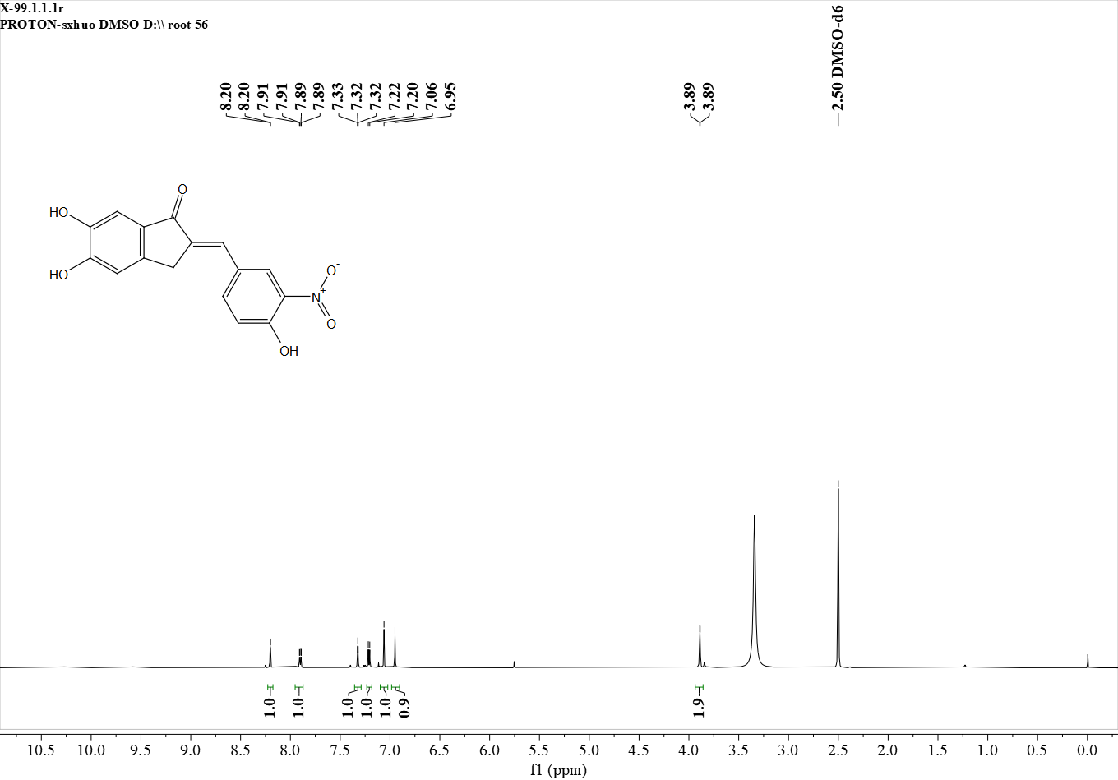
¹H NMR (600 MHz, DMSO) δ 8.20 (s, 1H), 7.90 (d, J = 8.8 Hz, 1H), 7.32 (s, 1H), 7.21 (d, J = 8.7 Hz, 1H), 7.06 (s, 1H), 6.95 (s, 1H), 3.89 (s, 2H).

Figure S25. ¹H NMR spectrum of B1
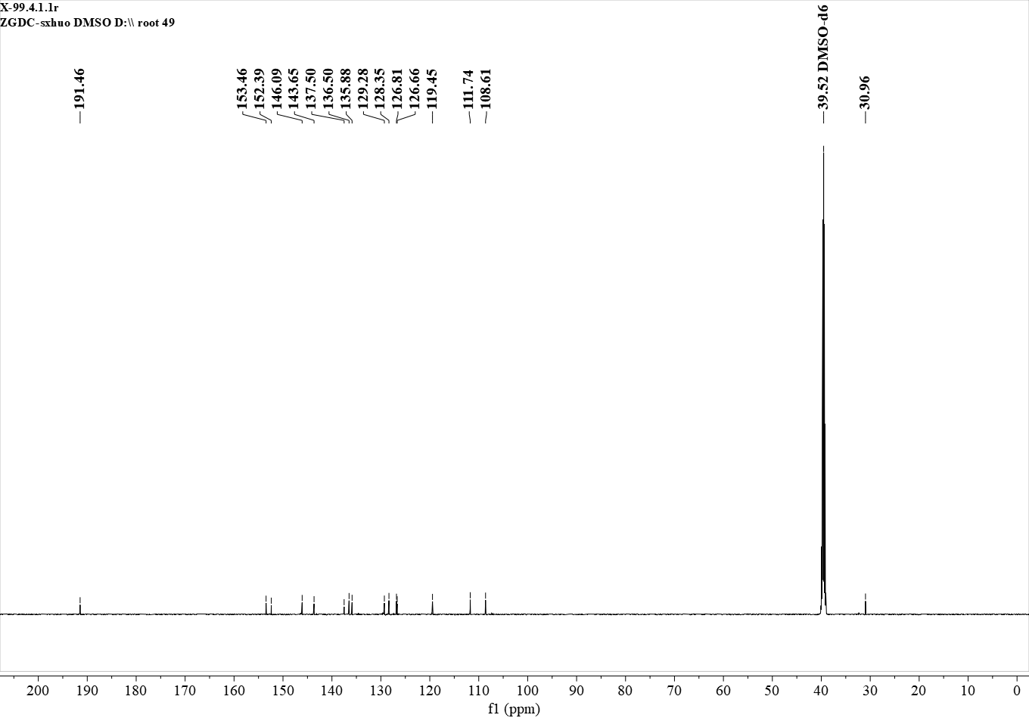
¹³C NMR (151 MHz, DMSO) δ 191.46, 153.46, 152.39, 146.09, 143.65, 137.50, 136.50, 135.88, 129.28, 128.35, 126.81, 126.66, 119.45, 111.74, 108.61, 30.96.

Figure S26. ¹³C NMR spectrum of B1

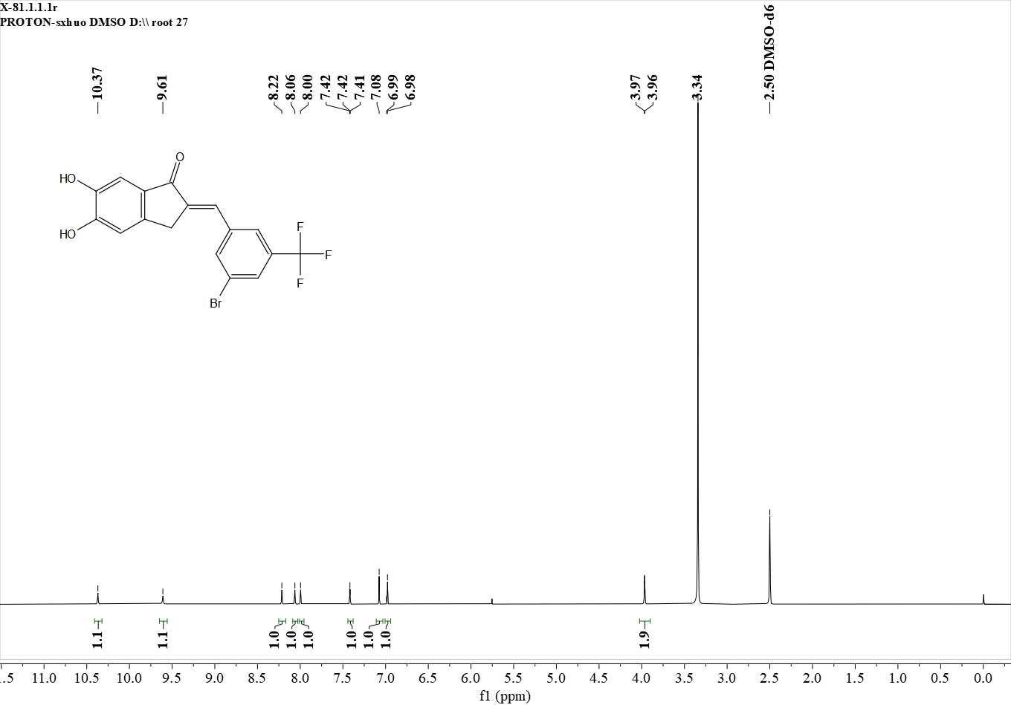
¹H NMR (600 MHz, DMSO) δ 10.37 (s, 1H), 9.61 (s, 1H), 8.22 (s, 1H), 8.06 (s, 1H), 8.00 (s, 1H), 7.42 (s, 1H), 7.08 (s, 1H), 6.98 (s, 1H), 3.97 (s, 2H).

Figure S27. ¹H NMR spectrum of B2
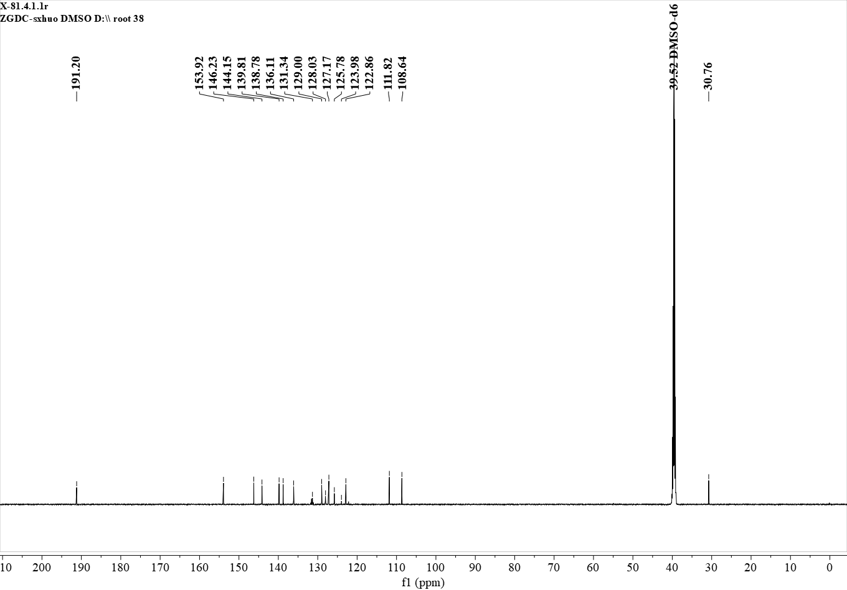
¹³C NMR (151 MHz, DMSO) δ 191.20, 153.92, 146.23, 144.15, 139.81, 138.78, 136.11, 131.34, 129.00, 128.03, 127.17, 125.78, 123.98, 122.86, 111.82, 108.64, 30.76.

Figure S28. ¹³C NMR spectrum of B2

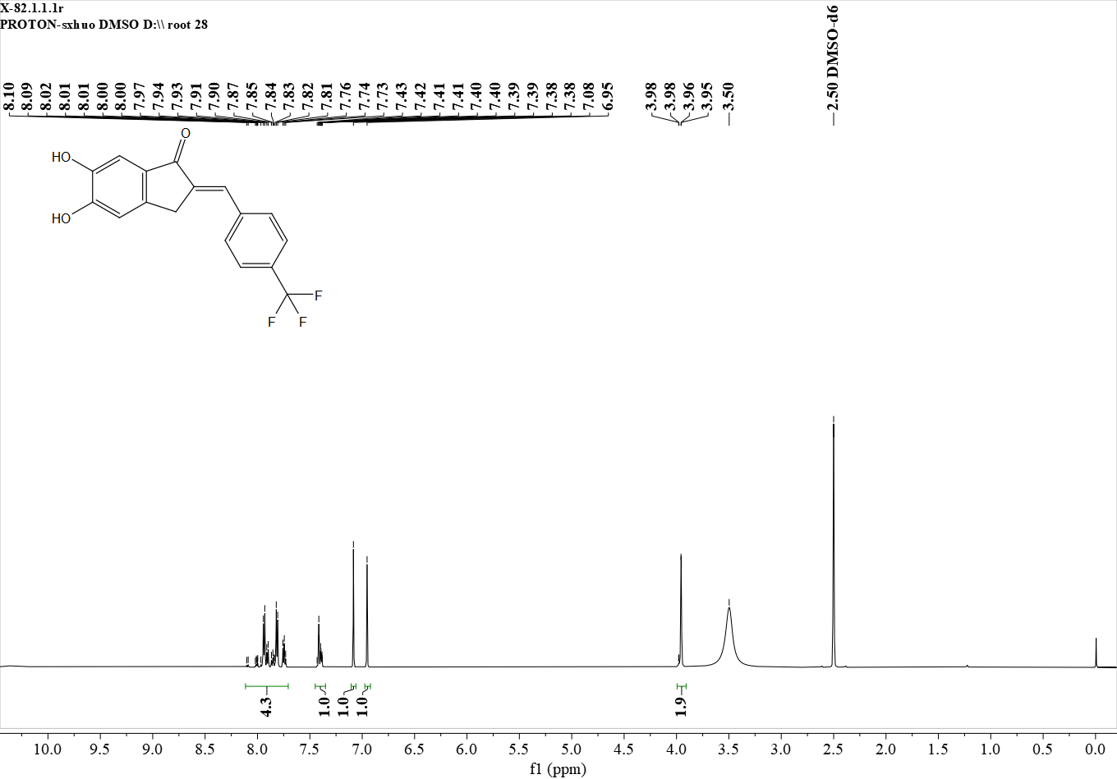
¹H NMR (600 MHz, DMSO) δ 8.11 – 7.70 (m, 4H), 7.41 (s, 1H), 7.08 (s, 1H), 6.95 (s, 1H), 3.96 (s, 2H).

Figure S29. ¹H NMR spectrum of B3

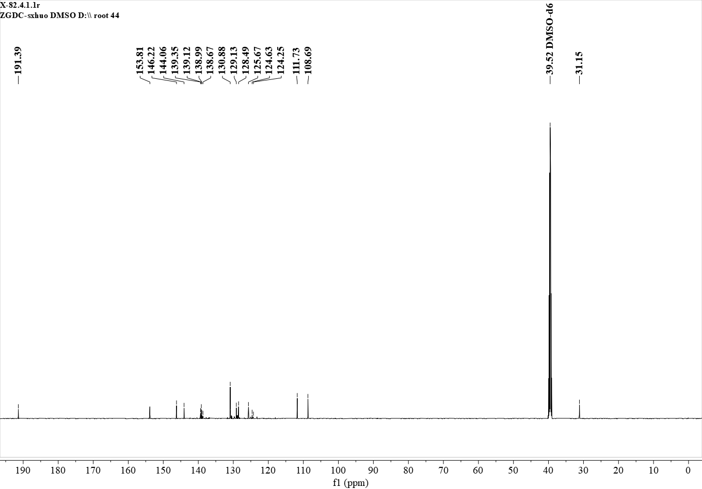
¹³C NMR (151 MHz, DMSO) δ 191.39, 153.81, 146.22, 144.06, 139.35, 139.12, 138.99, 138.67, 130.88, 129.13, 128.49, 125.67, 124.63, 124.25, 111.73, 108.69, 31.15.

Figure S30. ¹³C NMR spectrum of B3

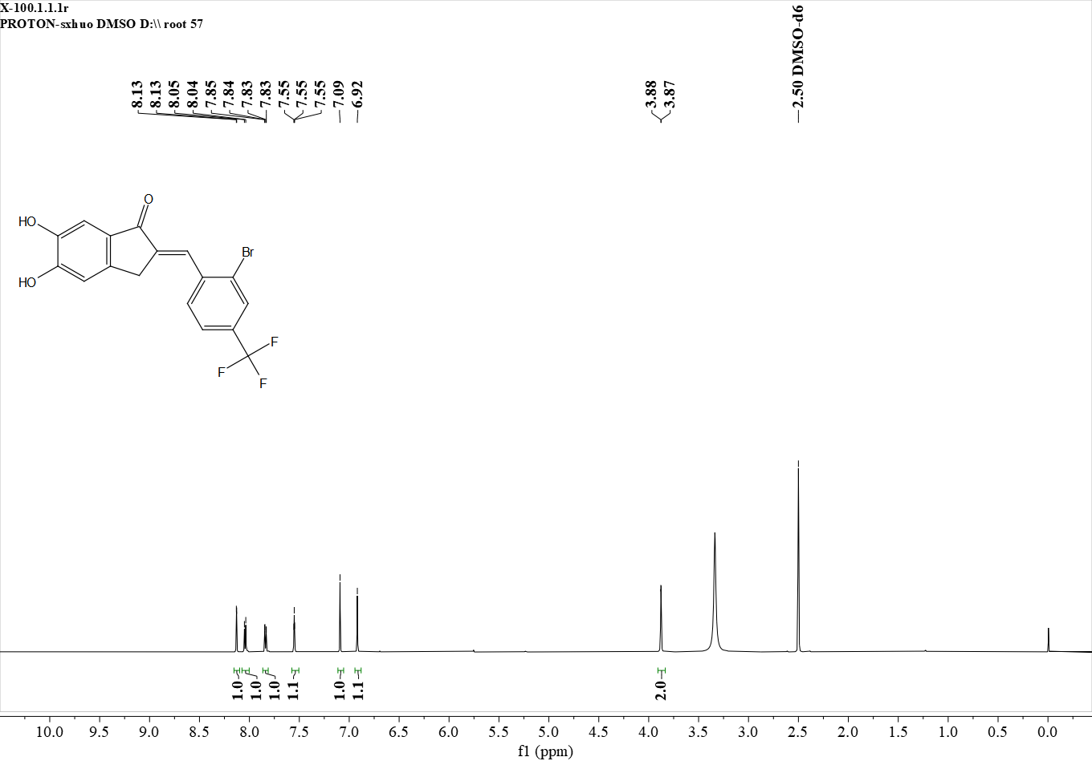
¹H NMR (600 MHz, DMSO) δ 8.13 (s, 1H), 8.04 (d, J = 8.2 Hz, 1H), 7.84 (d, J = 8.6 Hz, 1H), 7.55 (s, 1H), 7.09 (s, 1H), 6.92 (s, 1H), 3.88 (s, 2H).

Figure S31. ¹H NMR spectrum of B4
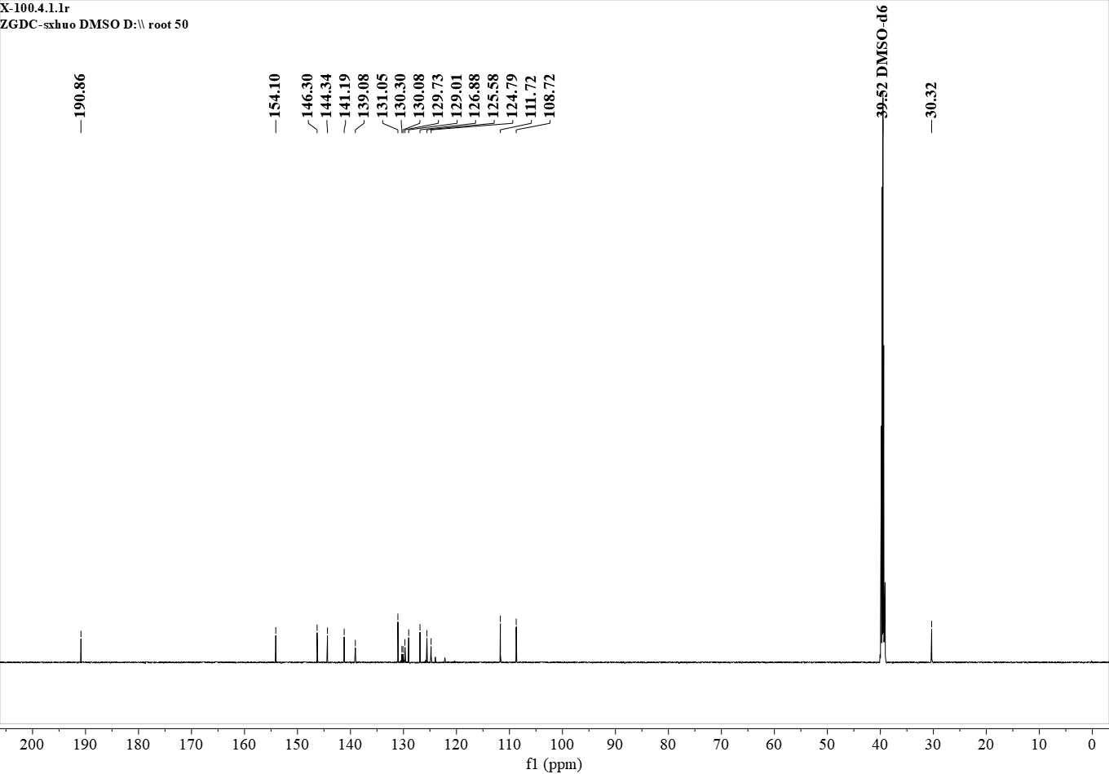
¹³C NMR (151 MHz, DMSO) δ 190.86, 154.10, 146.30, 144.34, 141.19, 139.08, 131.05, 130.30, 130.08, 129.73, 129.01, 126.88, 125.58, 124.79, 111.72, 108.72, 30.32.

Figure S32. ¹³C NMR spectrum of B4

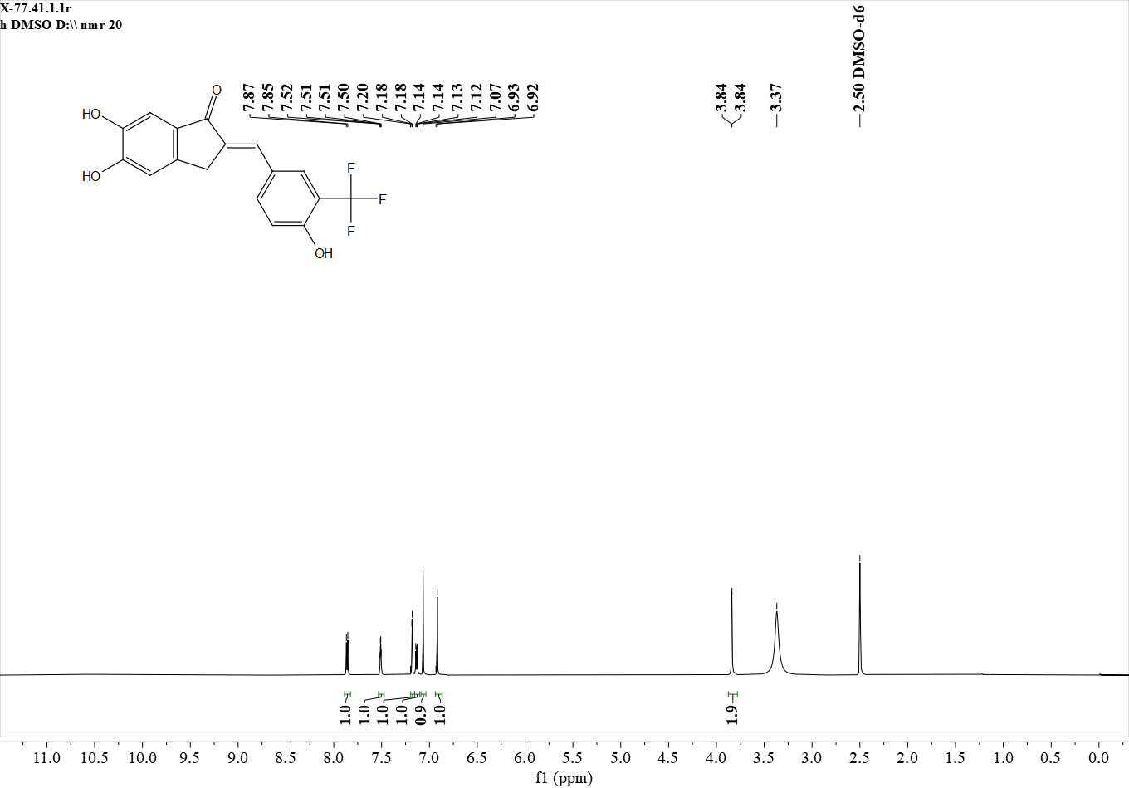
¹H NMR (600 MHz, DMSO) δ 7.86 (d, J = 8.6 Hz, 1H), 7.51 (s, 1H), 7.18 (s, 1H), 7.13 (d, J = 8.6 Hz, 1H), 7.07 (s, 1H), 6.92 (s, 1H), 3.84 (s, 2H).

Figure S33. ¹H NMR spectrum of B5

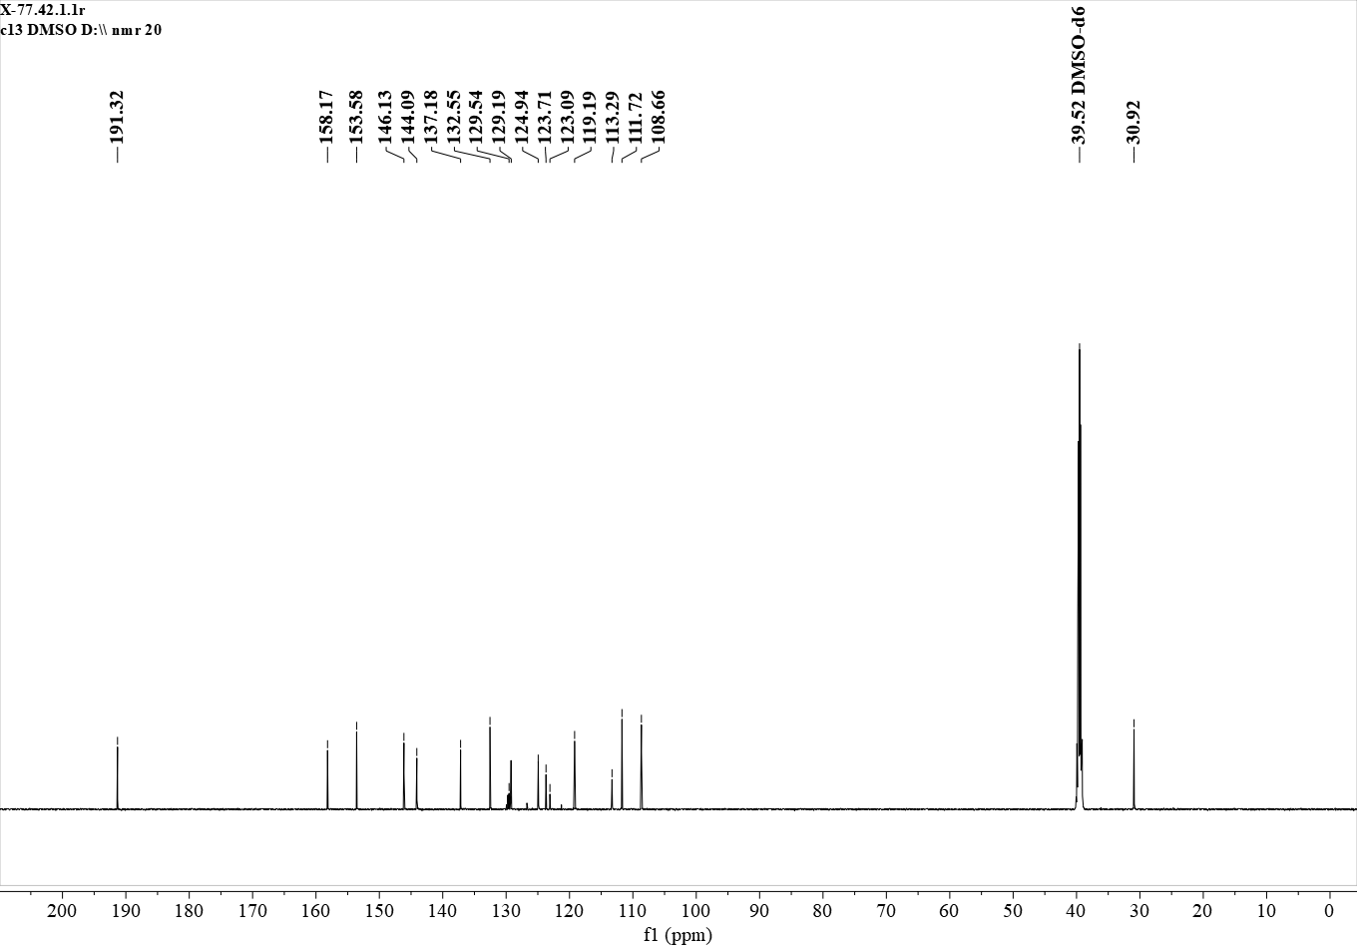
¹³C NMR (151 MHz, DMSO) δ 191.32, 158.17, 153.58, 146.13, 144.09, 137.18, 132.55, 129.54, 129.19, 124.94, 123.71, 123.09, 119.19, 113.29, 111.72, 108.66, 30.92.

Figure S34. ¹³C NMR spectrum of B5

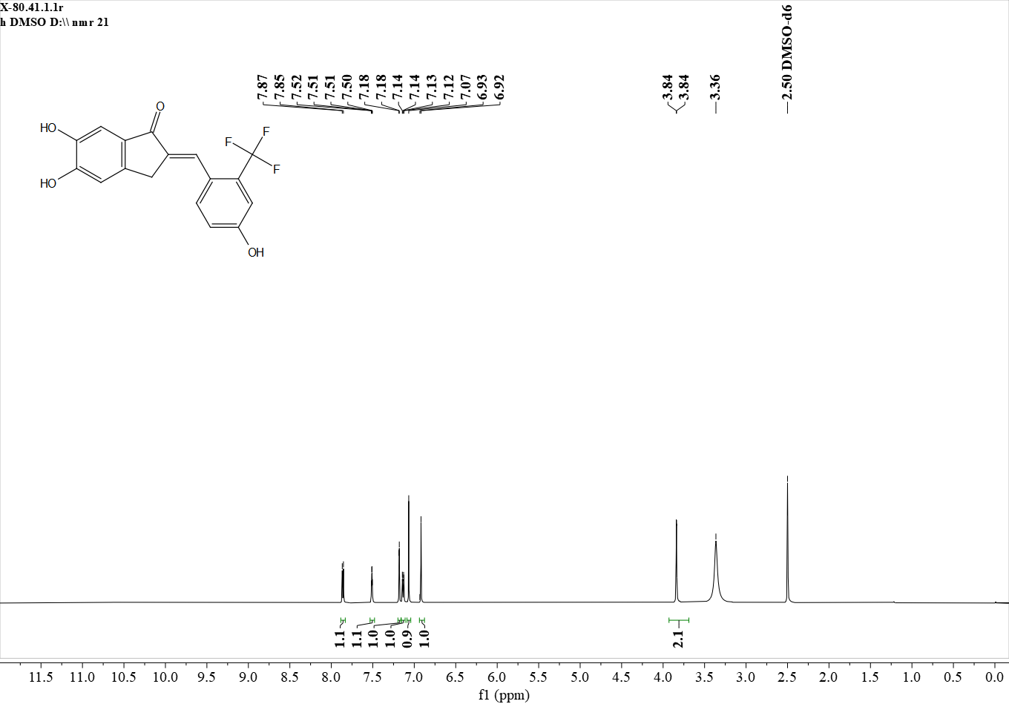
¹H NMR (600 MHz, DMSO) δ 7.86 (d, J = 8.6 Hz, 1H), 7.51 (s, 1H), 7.18 (s, 1H), 7.13 (d, J = 8.6 Hz, 1H), 7.07 (s, 1H), 6.92 (s, 1H), 3.84 (s, 2H).

Figure S35. ¹H NMR spectrum of B6

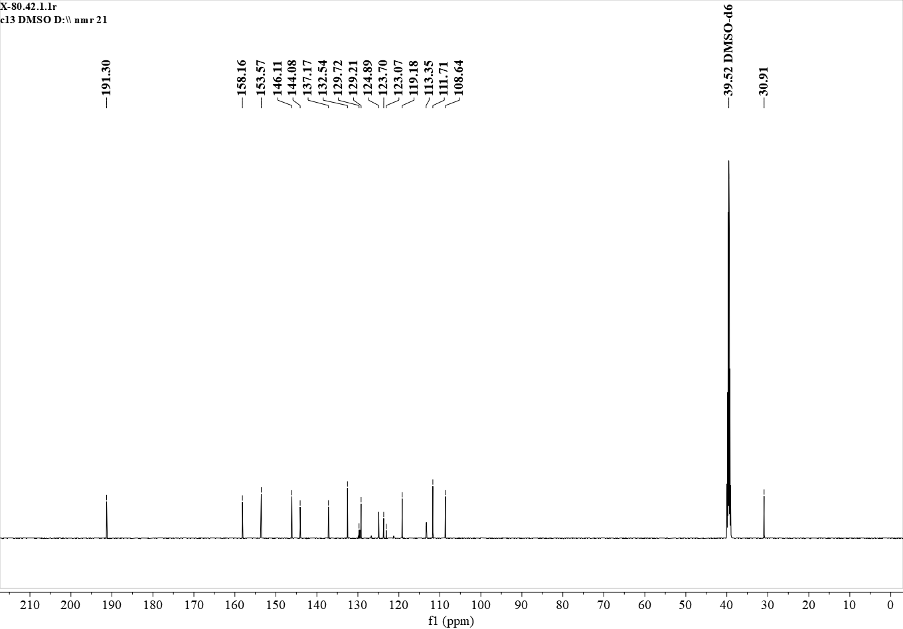
¹³C NMR (151 MHz, DMSO) δ 191.30, 158.16, 153.57, 146.11, 144.08, 137.17, 132.54, 129.72, 129.21, 124.89, 123.70, 123.07, 119.18, 113.35, 111.71, 108.64, 30.91.

Figure S36. ¹³C NMR spectrum of B6

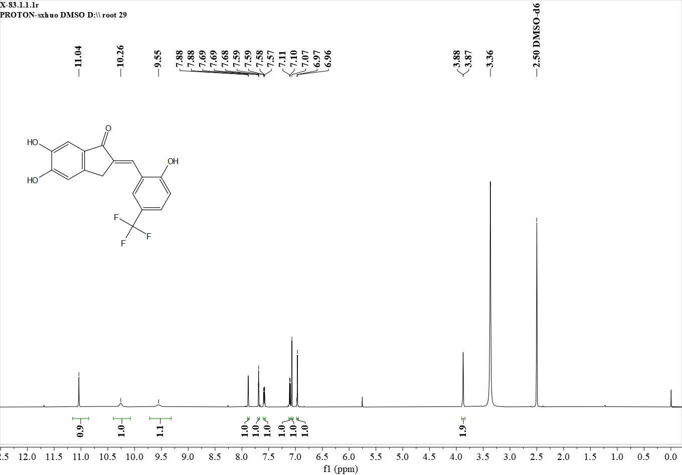
¹H NMR (600 MHz, DMSO) δ 11.04 (s, 1H), 10.26 (s, 1H), 9.55 (s, 1H), 7.88 (s, 1H), 7.69 (s, 1H), 7.58 (d, J = 8.6 Hz, 1H), 7.10 (d, J = 8.6 Hz, 1H), 7.07 (s, 1H), 6.96 (s, 1H), 3.87 (s, 2H).

Figure S37. ¹H NMR spectrum of B7

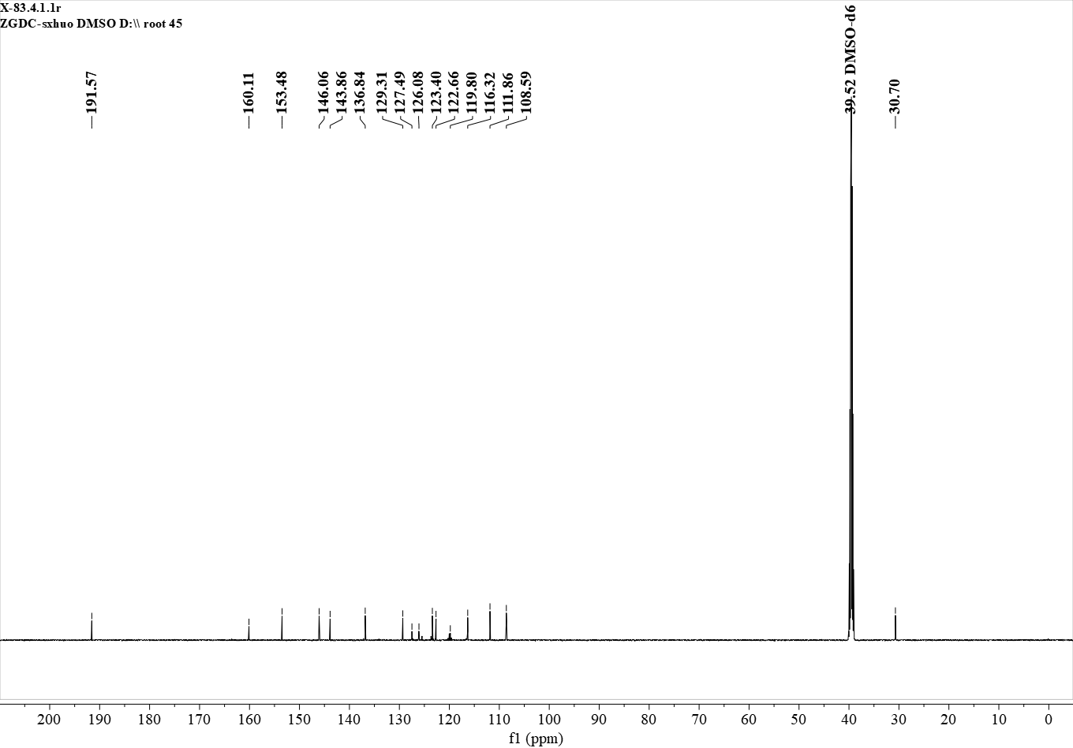
¹³C NMR (151 MHz, DMSO) δ 191.57, 160.11, 153.48, 146.06, 143.86, 136.84, 129.31, 127.49, 126.08, 123.40, 122.66, 119.80, 116.32, 111.86, 108.59, 30.70.

Figure S38. ¹³C NMR spectrum of B7

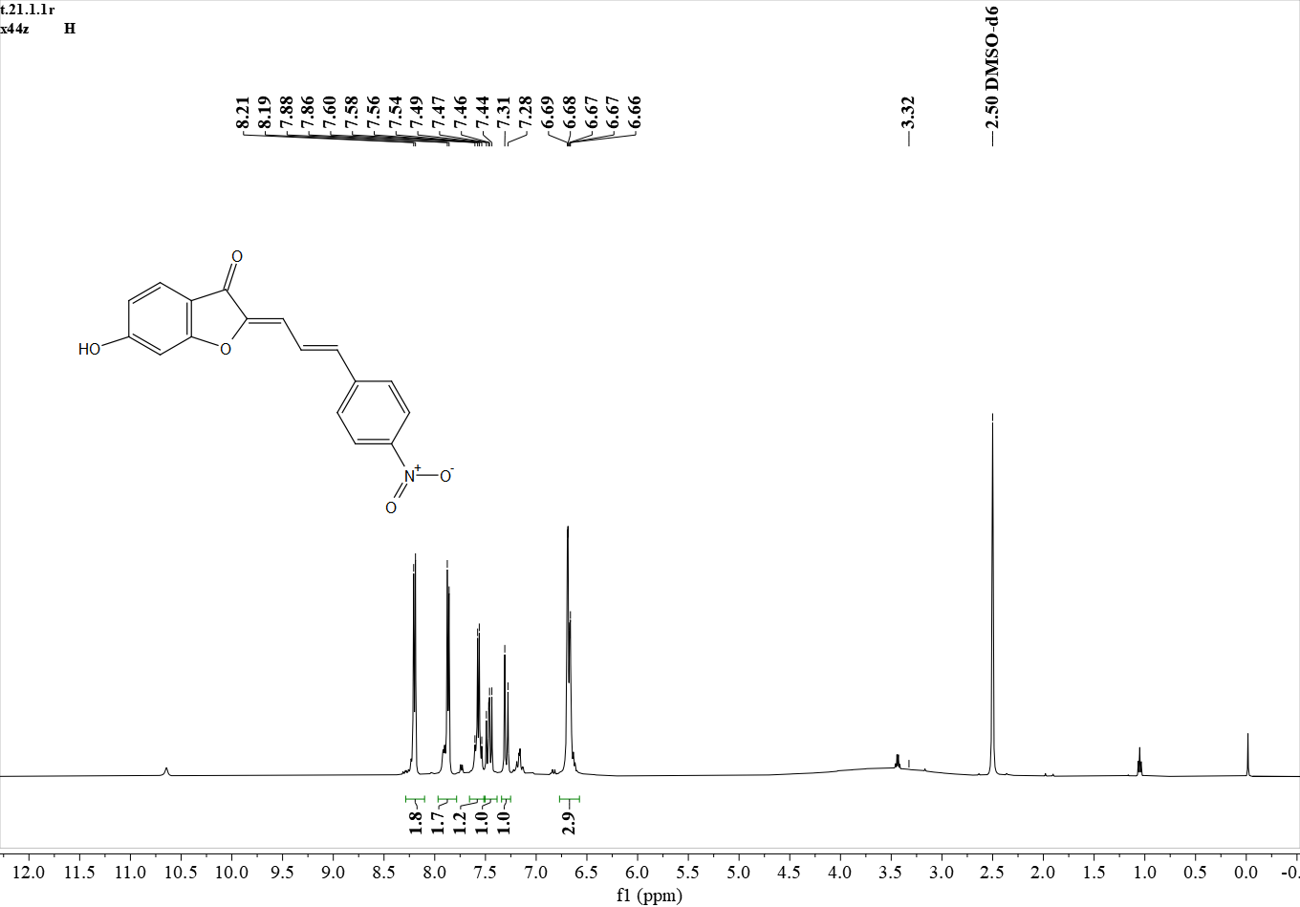
¹H NMR (500 MHz, DMSO) δ 8.20 (d, J = 8.9 Hz, 2H), 7.87 (d, J = 8.9 Hz, 2H), 7.62 – 7.52 (m, 1H), 7.52 – 7.42 (m, 1H), 7.29 (d, J = 15.7 Hz, 1H), 6.68 (d, J = 10.9 Hz, 3H).

Figure S39. ¹H NMR spectrum of C1
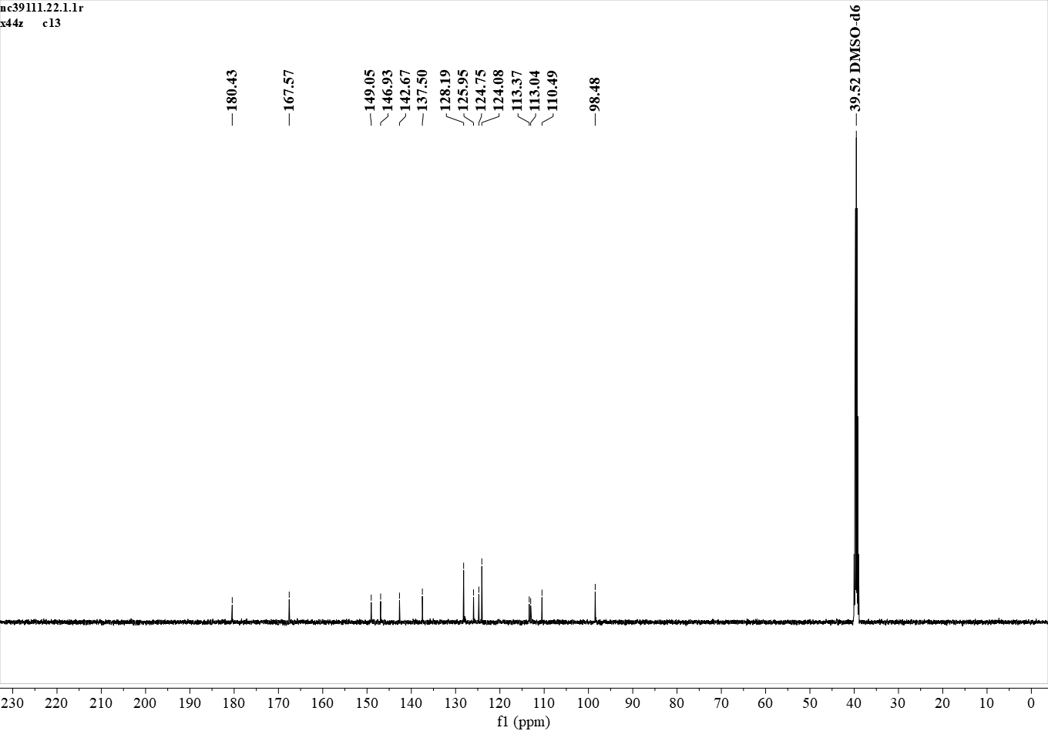
¹³C NMR (126 MHz, DMSO) δ 180.43, 167.57, 149.05, 146.93, 142.67, 137.50, 128.19, 125.95, 124.75, 124.08, 113.37, 113.04, 110.49, 98.48.

Figure S40. ¹³C NMR spectrum of C1

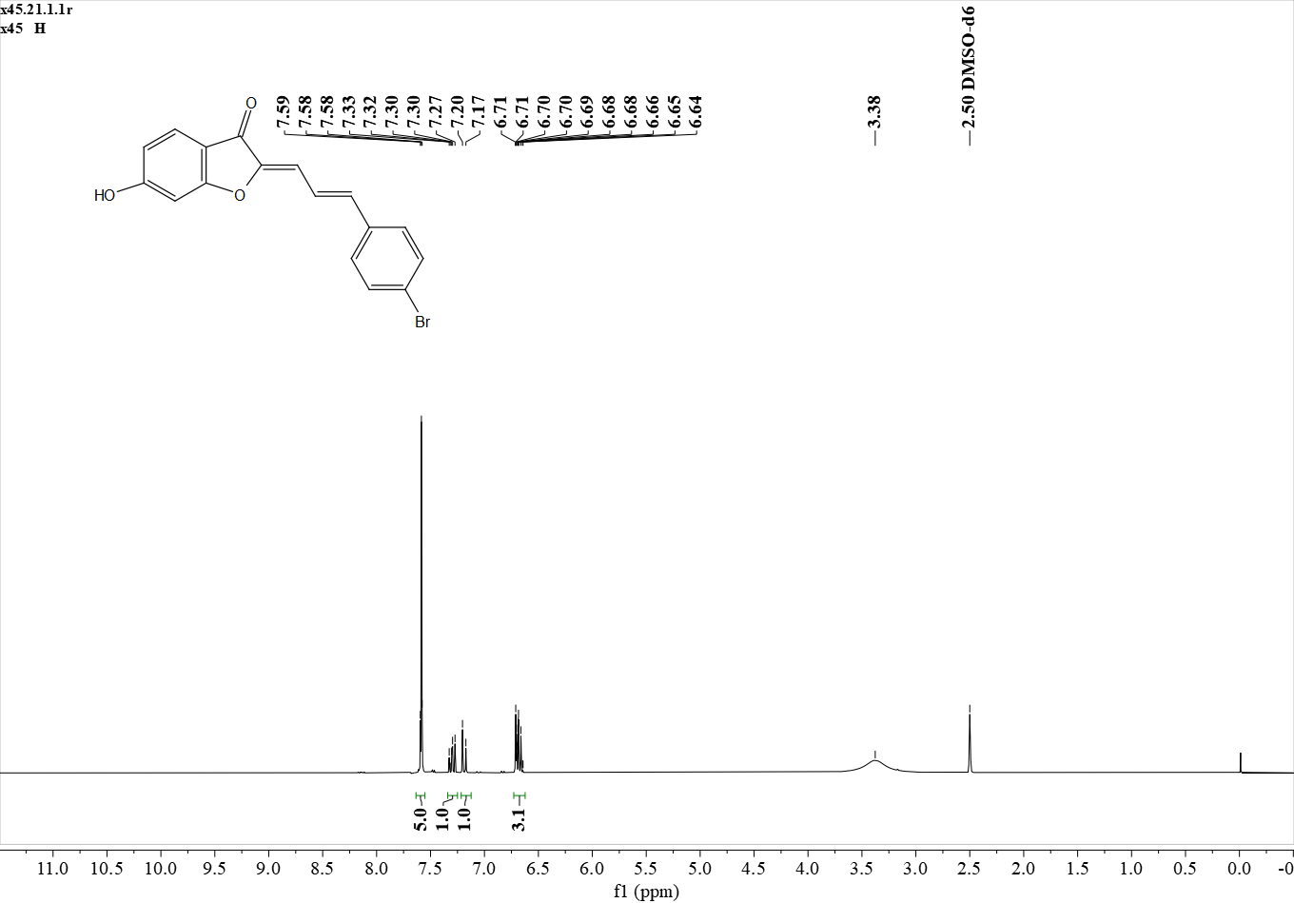
¹H NMR (500 MHz, DMSO) δ 7.58 (d, J = 3.4 Hz, 5H), 7.30 (dd, J = 15.7, 11.3 Hz, 1H), 7.19 (d, J = 15.7 Hz, 1H), 6.73 – 6.63 (m, 3H).

Figure S41. ¹H NMR spectrum of C2
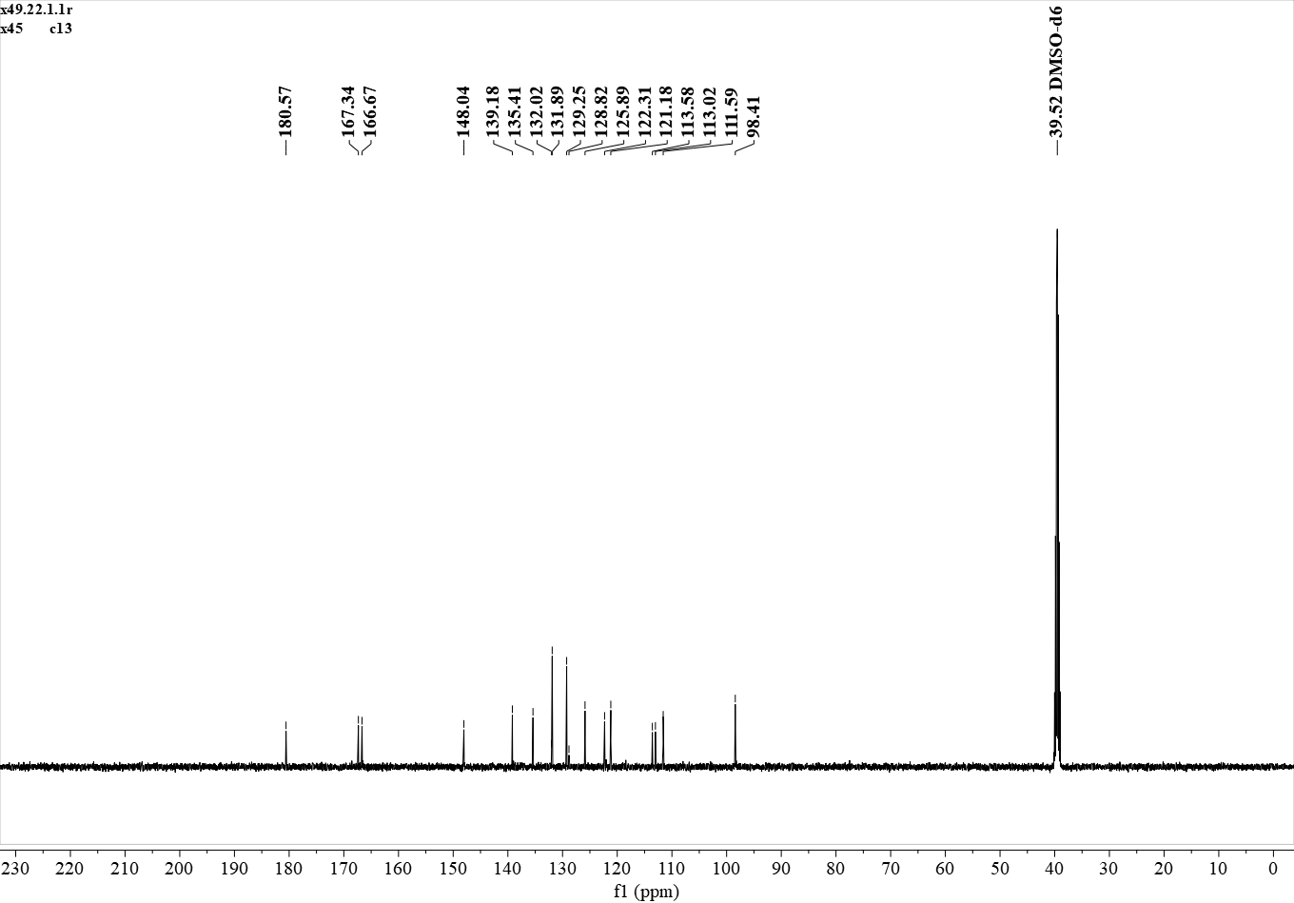
¹³C NMR (126 MHz, DMSO) δ 180.57, 167.34, 166.67, 148.04, 139.18, 135.41, 132.02, 131.89, 129.25, 128.82, 125.89, 122.31, 121.18, 113.58, 113.02, 111.59, 98.41.

Figure S42. ¹³C NMR spectrum of C2

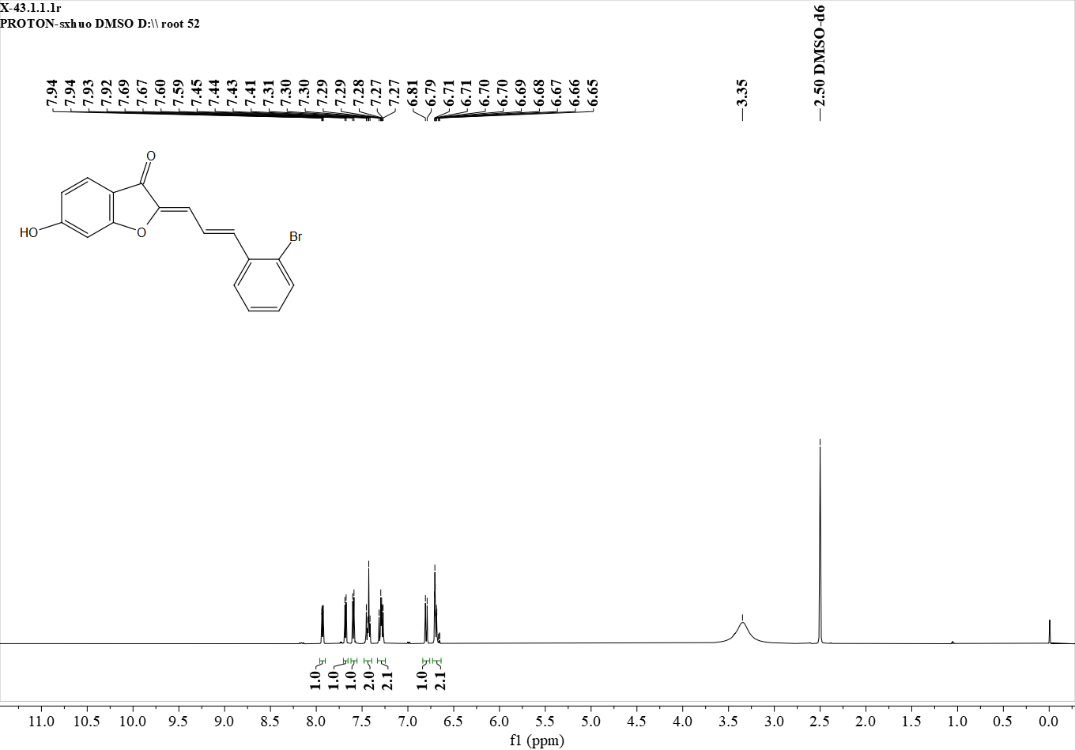
¹H NMR (600 MHz, DMSO) δ 7.93 (d, J = 7.9 Hz, 1H), 7.68 (d, J = 8.0 Hz, 1H), 7.60 (d, J = 8.3 Hz, 1H), 7.48 – 7.40 (m, 2H), 7.33 – 7.25 (m, 2H), 6.80 (d, J = 11.4 Hz, 1H), 6.72 – 6.64 (m, 2H).

Figure S43. ¹H NMR spectrum of C3
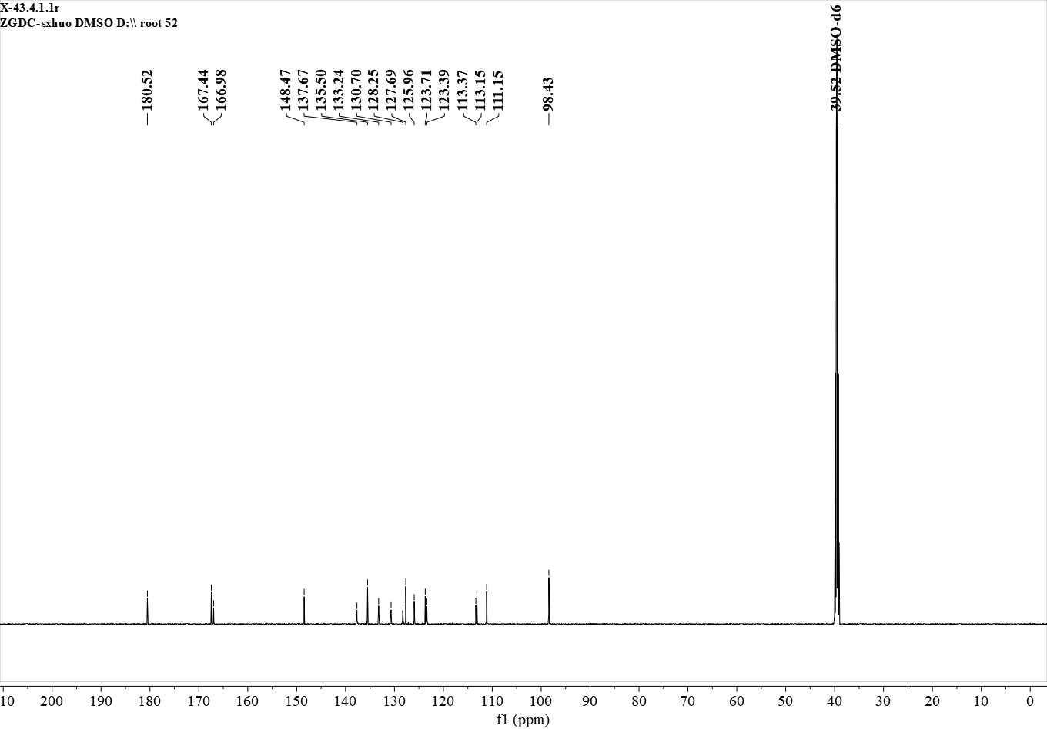
¹³C NMR (151 MHz, DMSO) δ 180.52, 167.44, 166.98, 148.47, 137.67, 135.50, 133.24, 130.70, 128.25, 127.69, 125.96, 123.71, 123.39, 113.37, 113.15, 111.15, 98.43.

Figure S44. ¹³C NMR spectrum of C3

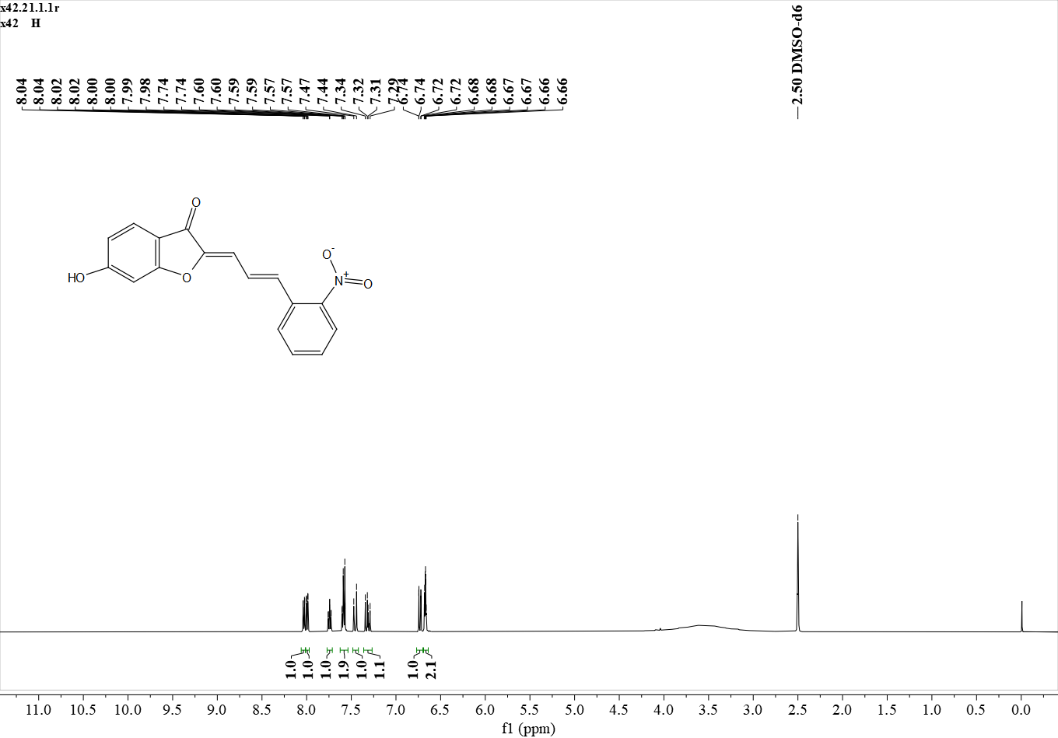
¹H NMR (500 MHz, DMSO) δ 8.03 (d, J = 8.0 Hz, 1H), 7.99 (d, J = 8.2 Hz, 1H), 7.74 (t, J = 7.6 Hz, 1H), 7.62 – 7.52 (m, 2H), 7.46 (d, J = 15.4 Hz, 1H), 7.32 (dd, J = 15.4, 11.4 Hz, 1H), 6.73 (d, J = 11.4 Hz, 1H), 6.67 (m, , 2H).

Figure S45. ¹H NMR spectrum of C4
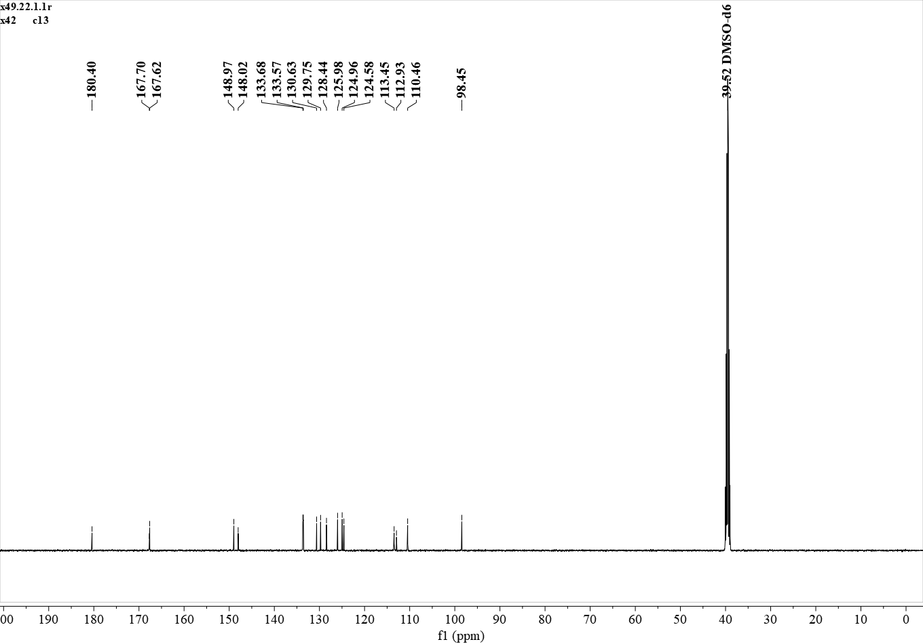
¹³C NMR (126 MHz, DMSO) δ 180.40, 167.70, 167.62, 148.97, 148.02, 133.68, 133.57, 130.63, 129.75, 128.44, 125.98, 124.96, 124.58, 113.45, 112.93, 110.46, 98.45.

Figure S46. ¹³C NMR spectrum of C4

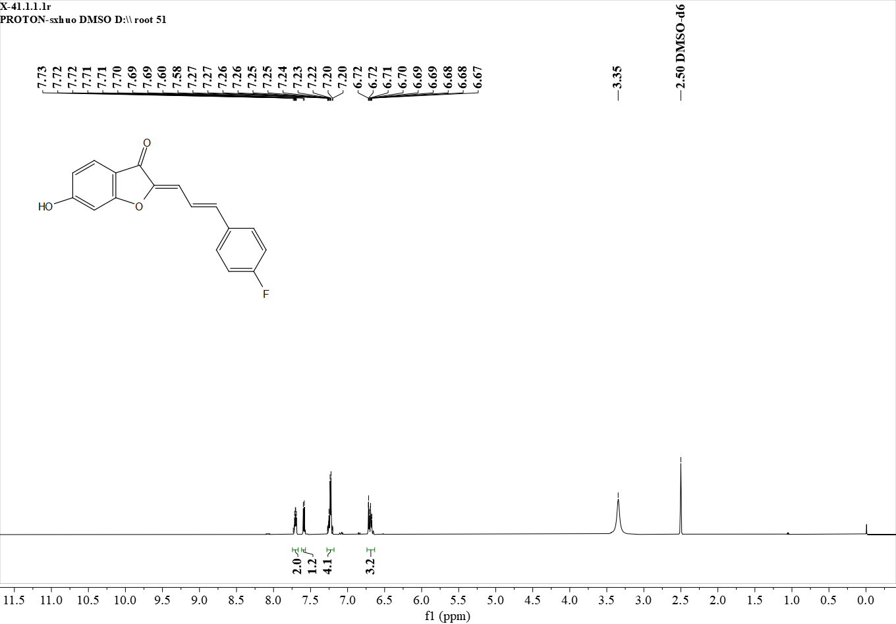
¹H NMR (600 MHz, DMSO) δ 7.75 – 7.67 (m, 2H), 7.59 (d, J = 8.4 Hz, 1H), 7.29 – 7.18 (m, 4H), 6.73 – 6.64 (m, 3H).

Figure S47. ¹H NMR spectrum of C5
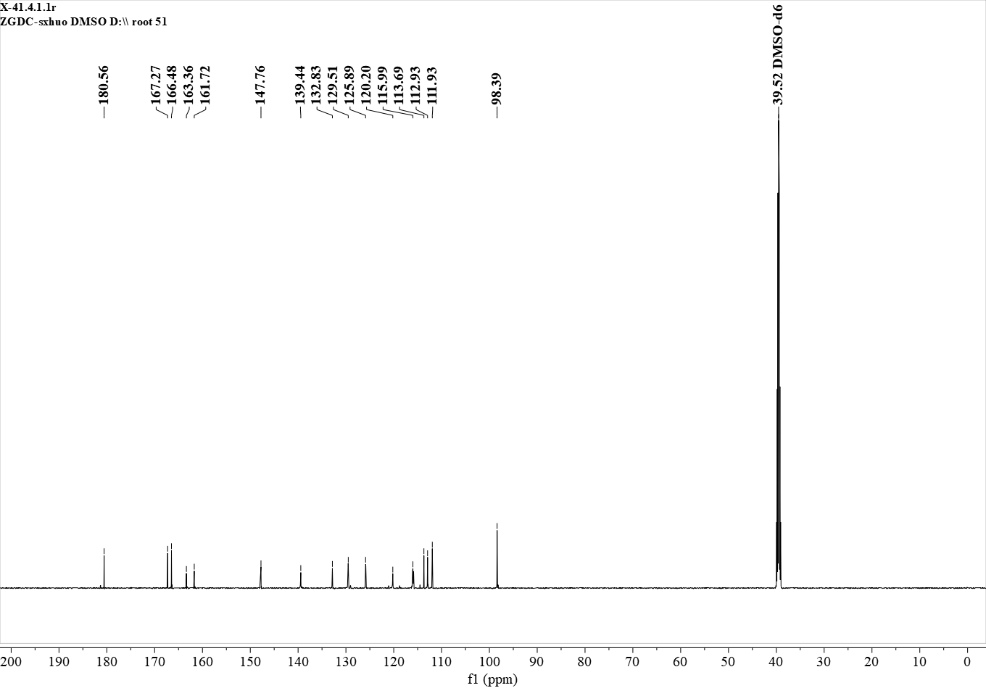
¹³C NMR (151 MHz, DMSO) δ 180.56, 167.27, 166.48, 163.36, 161.72, 147.76, 139.44, 132.83, 129.51, 125.89, 120.20, 115.99, 113.69, 112.93, 111.93, 98.39.

Figure S48. ¹³C NMR spectrum of C5

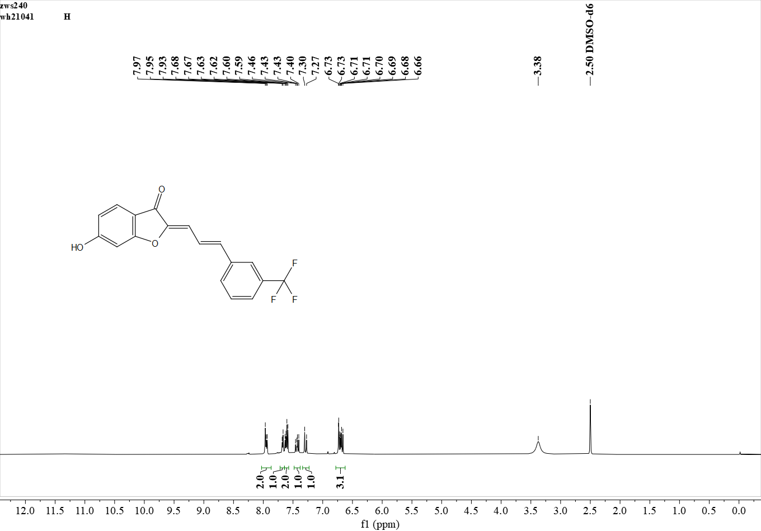
¹H NMR (500 MHz, DMSO) δ 7.98 – 7.92 (m, 2H), 7.67 (s, 1H), 7.67 – 7.55 (m, 2H), 7.43 (t, J = 15.9 Hz, 1H), 7.29 (d, J = 15.8 Hz, 1H), 6.76 – 6.64 (m, 3H).

Figure S49. ¹H NMR spectrum of C6
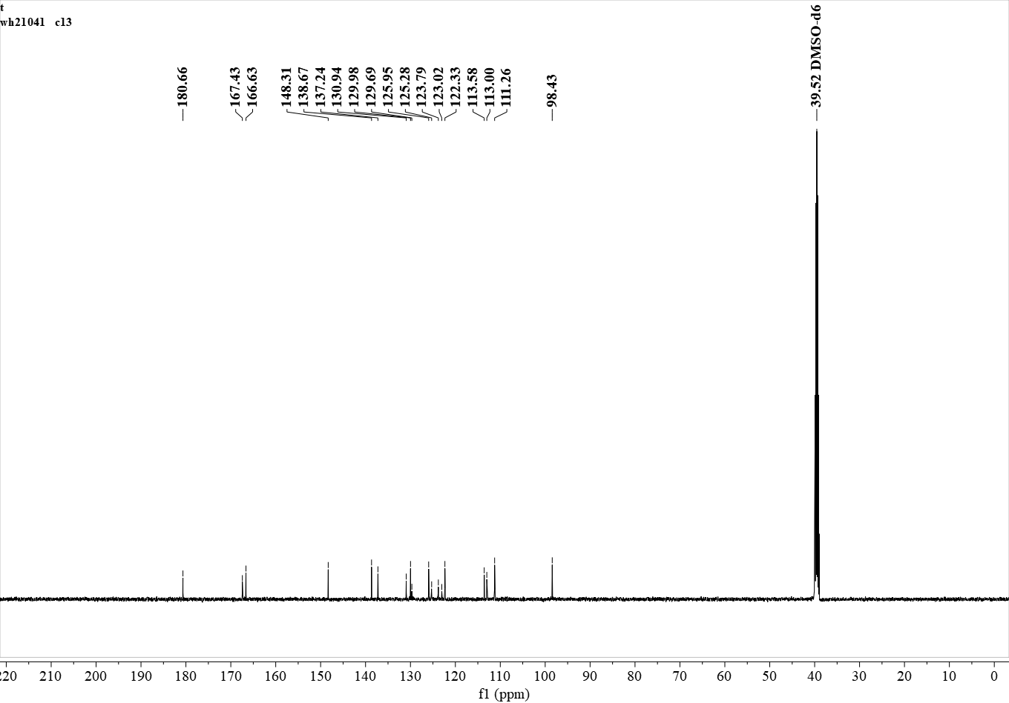
¹³C NMR (126 MHz, DMSO) δ 180.66, 167.43, 166.63, 148.31, 138.67, 137.24, 130.94, 129.98, 129.69, 125.95, 125.28, 123.79, 123.02, 122.33, 113.58, 113.00, 111.26, 98.43.

Figure S50. ¹³C NMR spectrum of C6

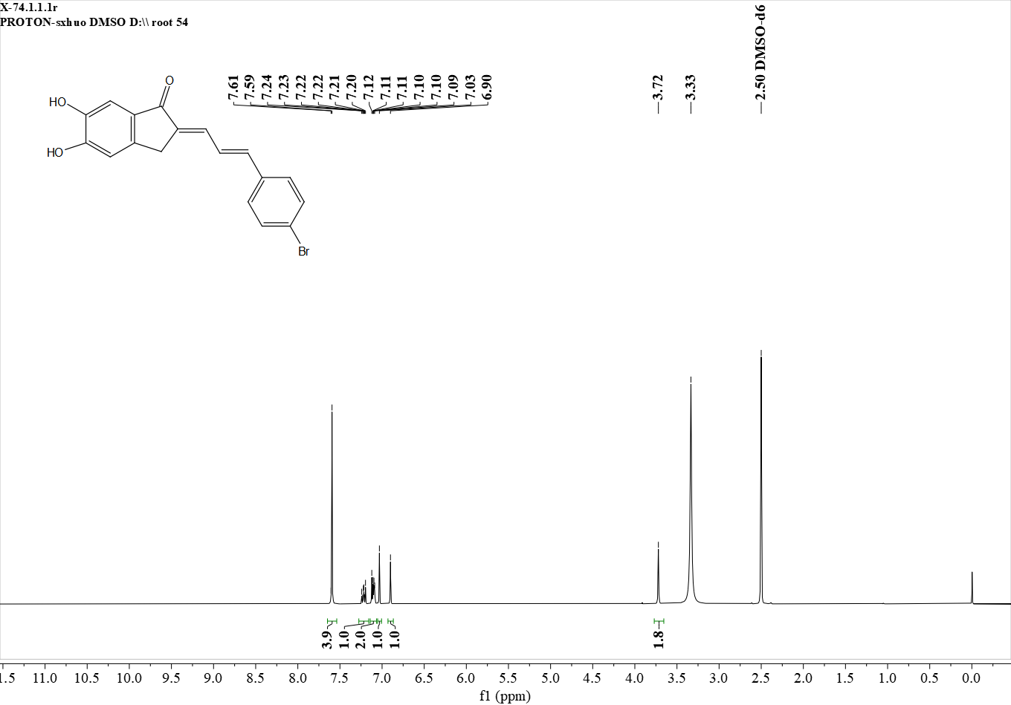
¹H NMR (600 MHz, DMSO) δ 7.61 – 7.58 (m,4H), 7.26 – 7.18 (m, 1H), 7.14 – 7.07 (m, 2H), 7.03 (s, 1H), 6.90 (s, 1H), 3.72 (s, 2H).

Figure S51. ¹H NMR spectrum of D1

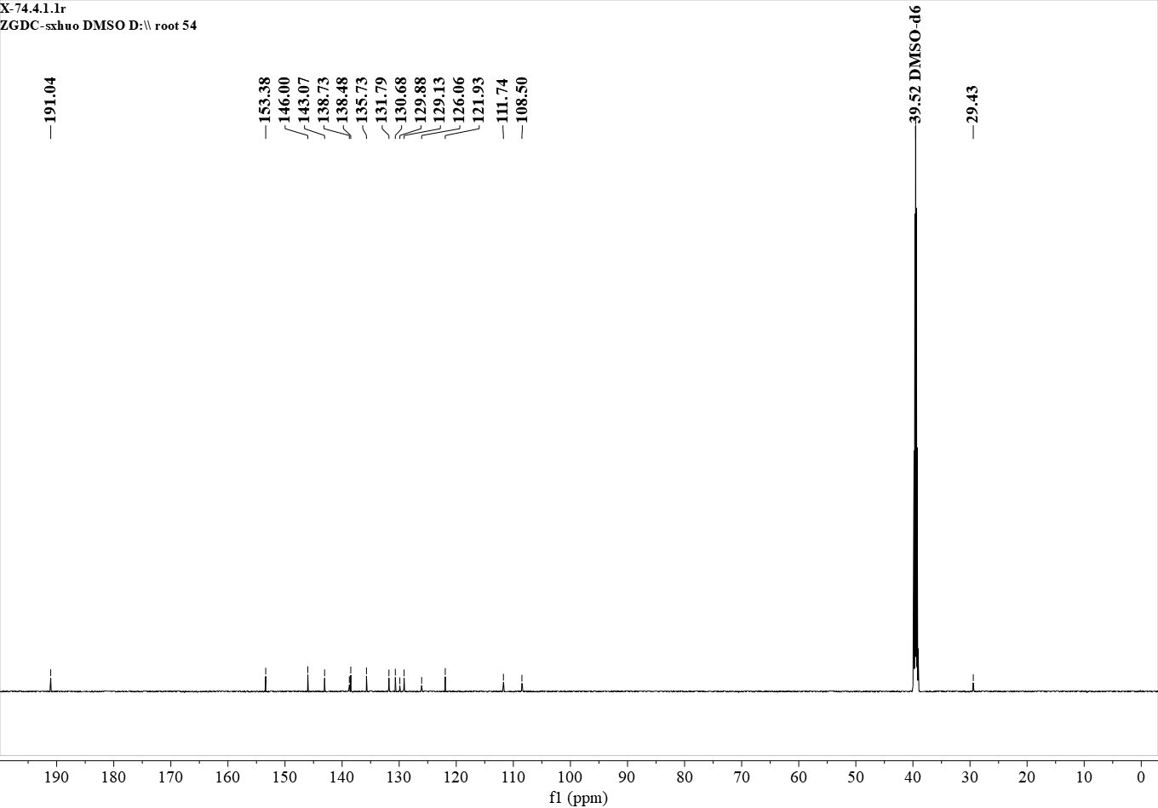
¹³C NMR (151 MHz, DMSO) δ 191.04, 153.38, 146.00, 143.07, 138.73, 138.48, 135.73, 131.79, 130.68, 129.88, 129.13, 126.06, 121.93, 111.74, 108.50, 29.43.

Figure S52. ¹³C NMR spectrum of D1

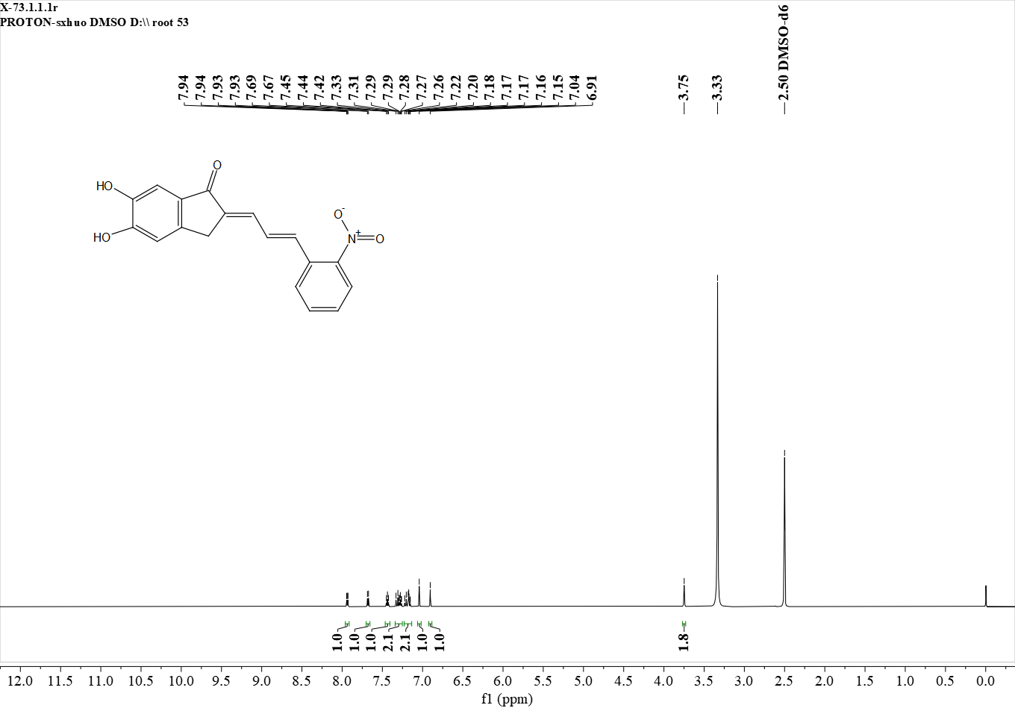
¹H NMR (600 MHz, DMSO) δ 7.94 (d, J = 7.9 Hz, 1H), 7.68 (d, J = 8.0 Hz, 1H), 7.44 (t, J = 7.6 Hz, 1H), 7.35 – 7.25 (m, 2H), 7.23 – 7.13 (m, 2H), 7.04 (s, 1H), 6.91 (s, 1H), 3.75 (s, 2H).
Figure S53. ¹H NMR spectrum of D2

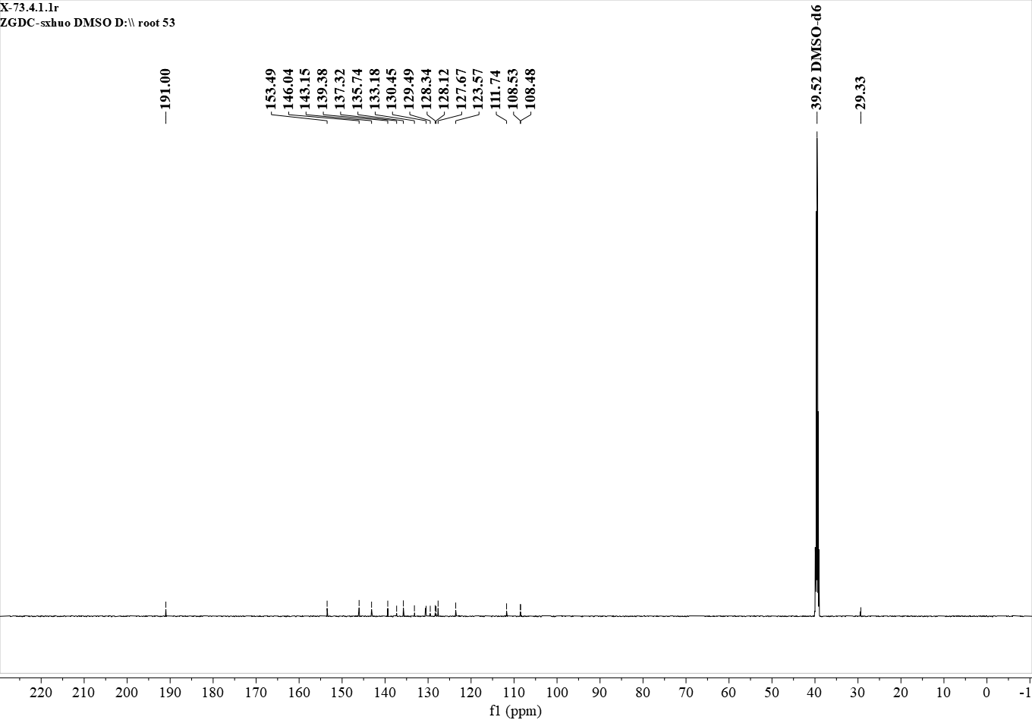
¹³C NMR (151 MHz, DMSO) δ 191.00, 153.49, 146.04, 143.15, 139.38, 137.32, 135.74, 133.18, 130.45, 129.49, 128.34, 128.12, 127.67, 123.57, 111.74, 108.53, 108.48, 29.33.
Figure S54. ¹³C NMR spectrum of D2

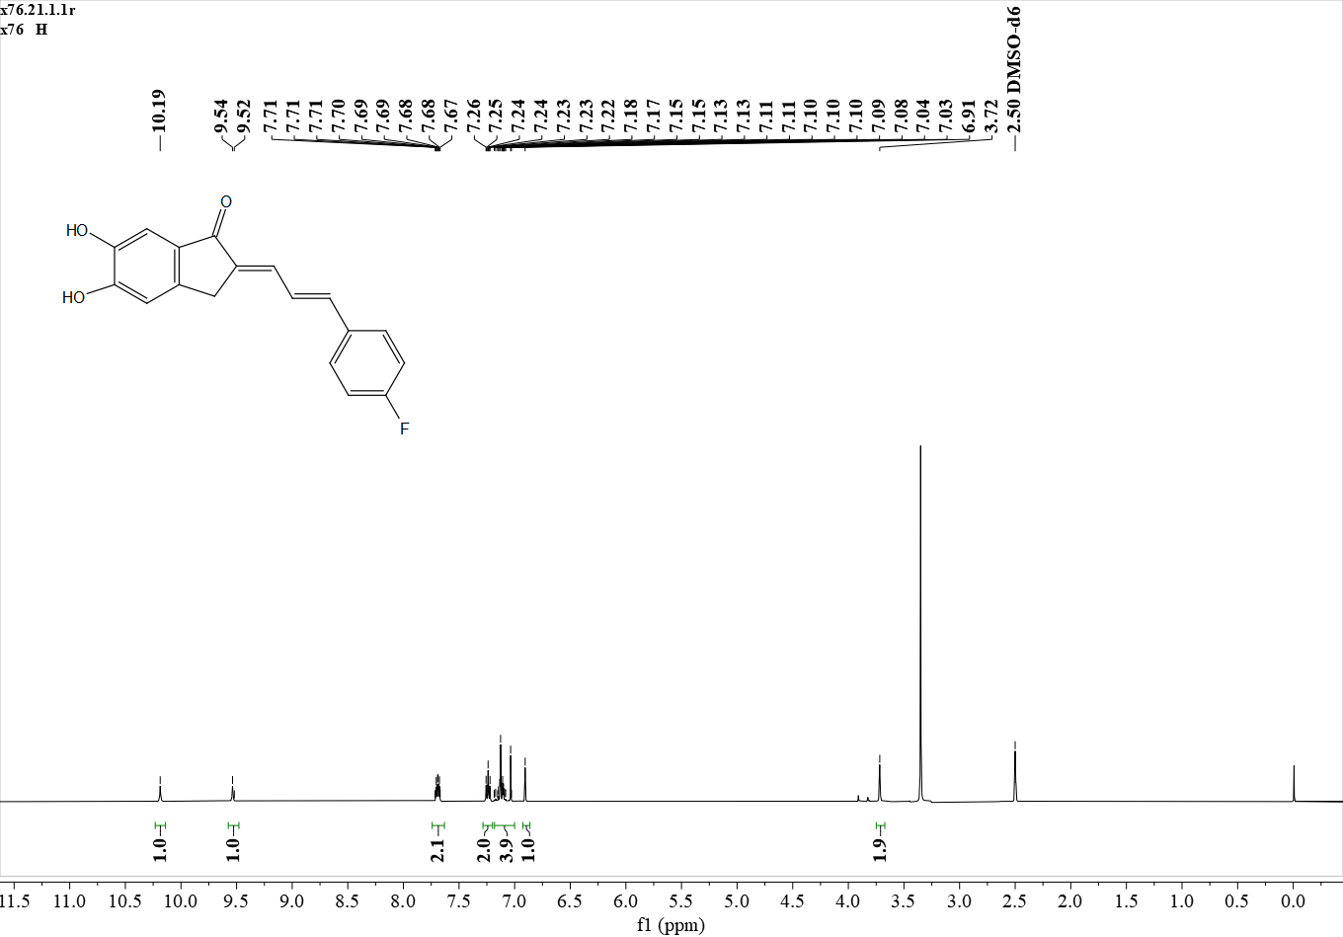
¹H NMR (500 MHz, DMSO) δ 10.19 (s, 1H), 9.54 (s, 1H), 7.74 – 7.65 (m, 2H), 7.29 – 7.20 (m, 2H), 7.17 – 7.04 (m, 4H), 6.91 (s, 1H), 3.72 (s, 2H).

Figure S55. ¹H NMR spectrum of D3
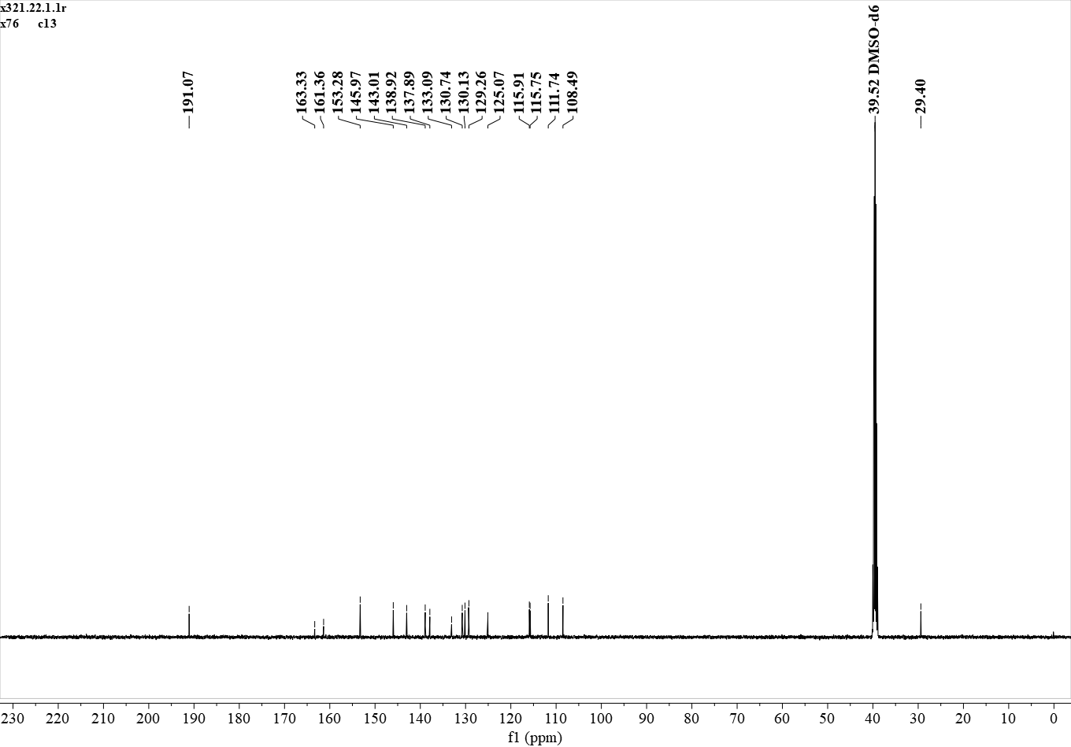
¹³C NMR (126 MHz, DMSO) δ 191.07, 163.33, 161.36, 153.28, 145.97, 143.01, 138.92, 137.89, 133.09, 130.74, 130.13, 129.26, 125.07, 115.91, 115.75, 111.74, 108.49, 29.40.

Figure S56. ¹³C NMR spectrum of D3

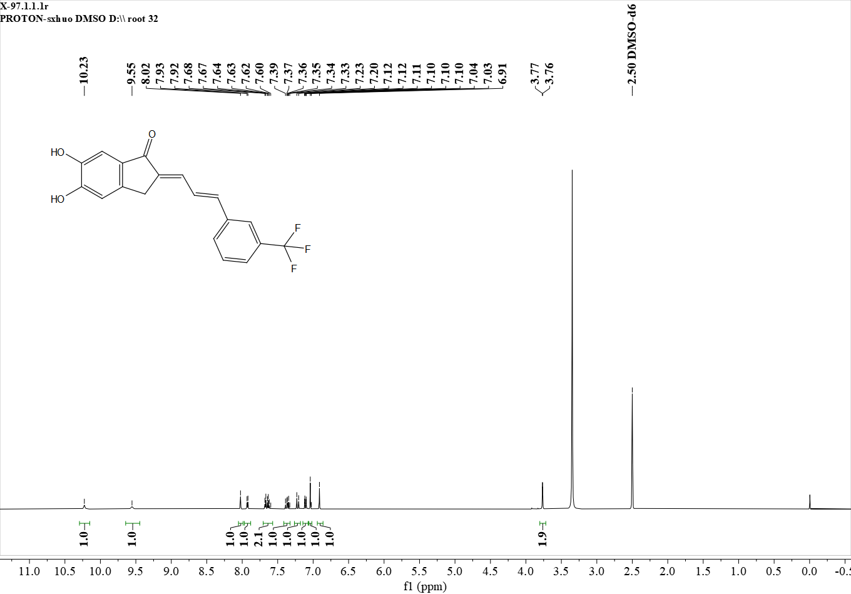
¹H NMR (600 MHz, DMSO) δ 10.23 (s, 1H), 9.55 (s, 1H), 8.02 (s, 1H), 7.93 (d, J = 7.7 Hz, 1H), 7.71 – 7.59 (m, 2H), 7.37 (t, J = 11.4 Hz, 1H), 7.22 (d, J = 15.6 Hz, 1H), 7.11 (dt, J = 11.1, 2.1 Hz, 1H), 7.04 (s, 1H), 6.91 (s, 1H), 3.77 (s, 2H).

Figure S57. ¹H NMR spectrum of D4
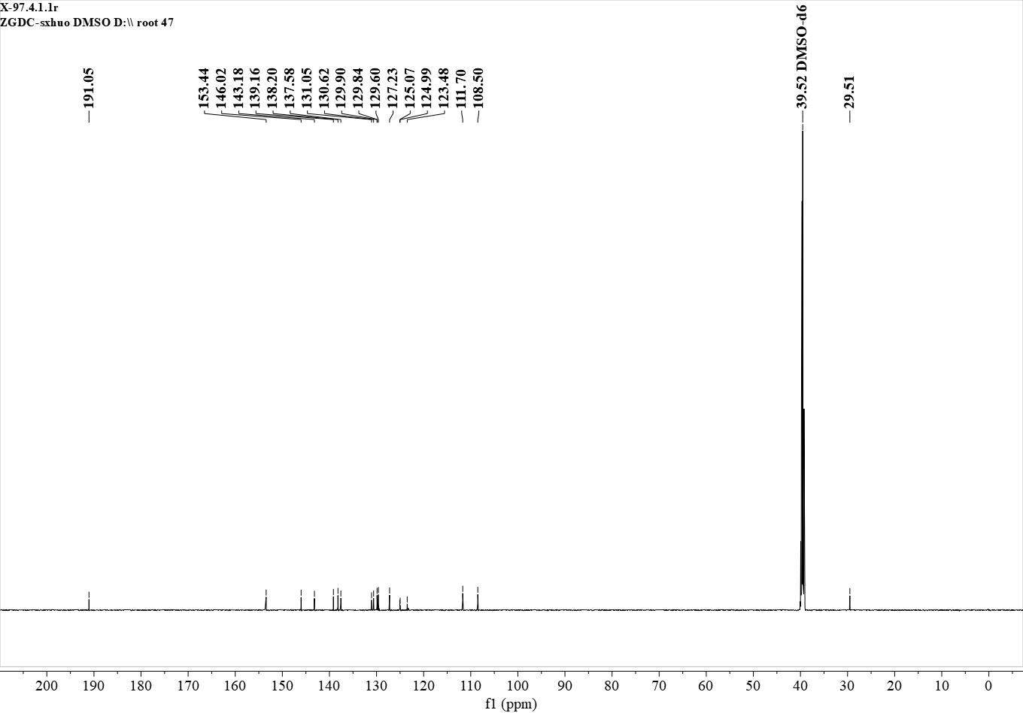
¹³C NMR (151 MHz, DMSO) δ 191.05, 153.44, 146.02, 143.18, 139.16, 138.20, 137.58, 131.05, 130.62, 129.90, 129.84, 129.60, 127.23, 125.07, 124.99, 123.48, 111.70, 108.50, 29.51.

Figure S58. ¹³C NMR spectrum of D4

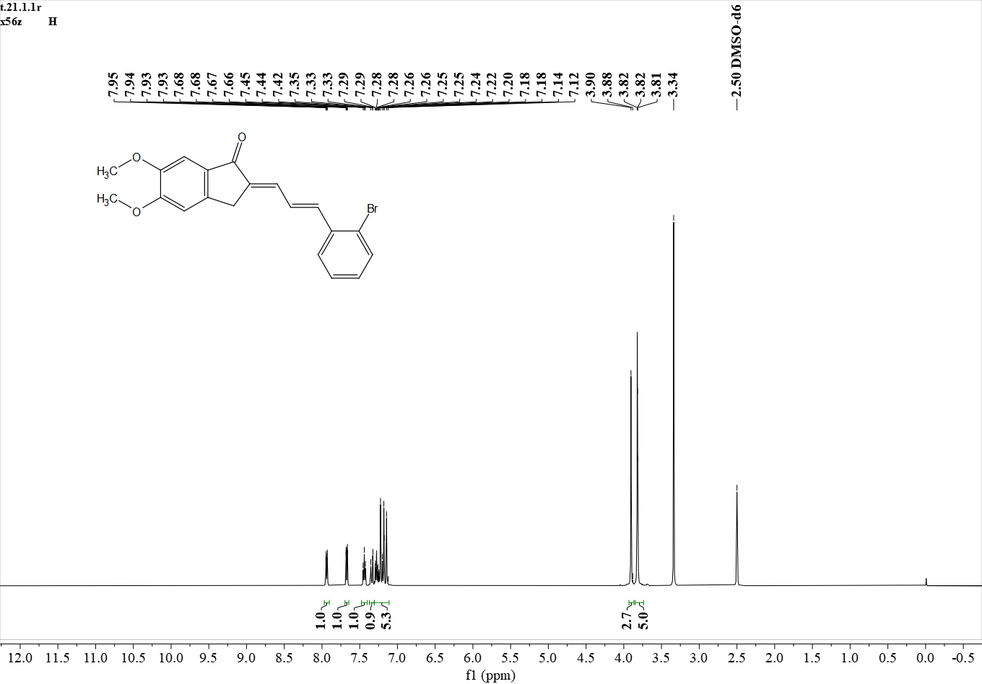
¹H NMR (500 MHz, DMSO) δ 7.94 (d, J = 7.9 Hz, 1H), 7.67 (d, J = 8.0 Hz, 1H), 7.44 (t, J = 7.5 Hz, 1H), 7.37 – 7.13 (m, 6H), 3.90 (s, 3H), 3.82 (s, 5H).

Figure S59. ¹H NMR spectrum of E1
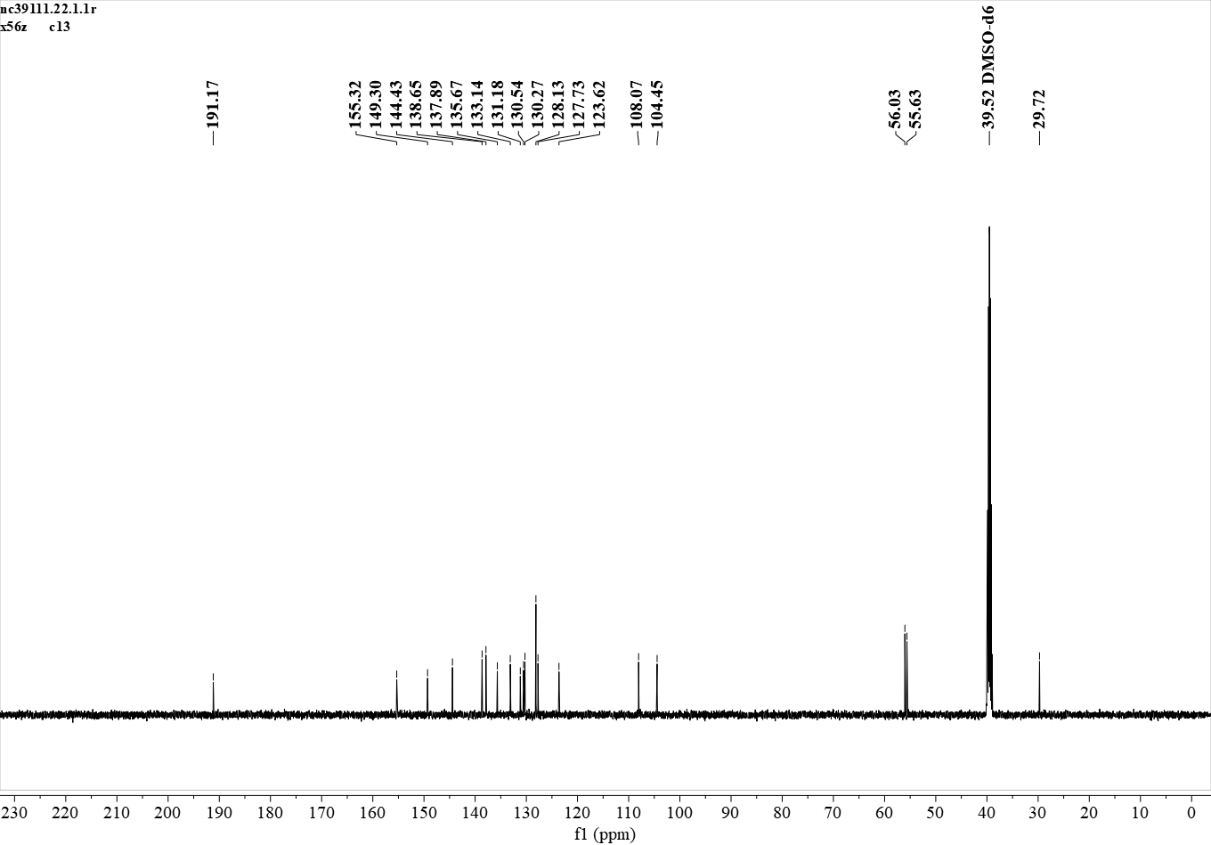
¹³C NMR (126 MHz, DMSO) δ 191.17, 155.32, 149.30, 144.43, 138.65, 137.89, 135.67, 133.14, 131.18, 130.54, 130.27, 128.13, 127.73, 123.62, 108.07, 104.45, 56.03, 55.63, 29.72.
Figure S60. ¹³C NMR spectrum of E1

¹H NMR (400 MHz, dmso) δ 7.75 – 7.67 (m, 2H), 7.30 – 7.21 (m, 2H), 7.17 (t, J = 4.1 Hz, 2H), 3.91 (s, 3H), 3.85 – 3.79 (m, 5H).
Figure S61. ¹H NMR spectrum of E2
¹³C NMR (101 MHz, dmso) δ 191.22, 163.64, 161.18, 155.20, 149.27, 144.32, 139.51, 137.22, 133.04, 131.30, 130.90, 129.44, 124.94, 115.94, 115.72, 108.11, 104.44, 56.04, 55.65, 29.72.
Figure S62. ¹³C NMR spectrum of E2
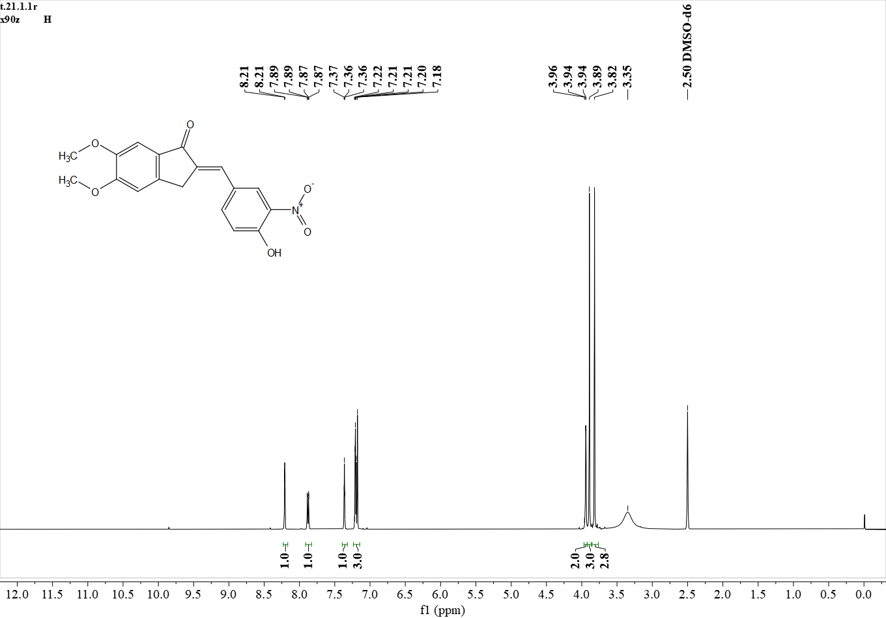
¹H NMR (500 MHz, DMSO) δ 8.21 (s, 1H), 7.88 (d, J = 8.8 Hz, 1H), 7.37 (s, 1H), 7.24 – 7.16 (m, 3H), 3.94 (s, 2H), 3.89 (s, 3H), 3.82 (s, 3H).

Figure S63. ¹H NMR spectrum of E3
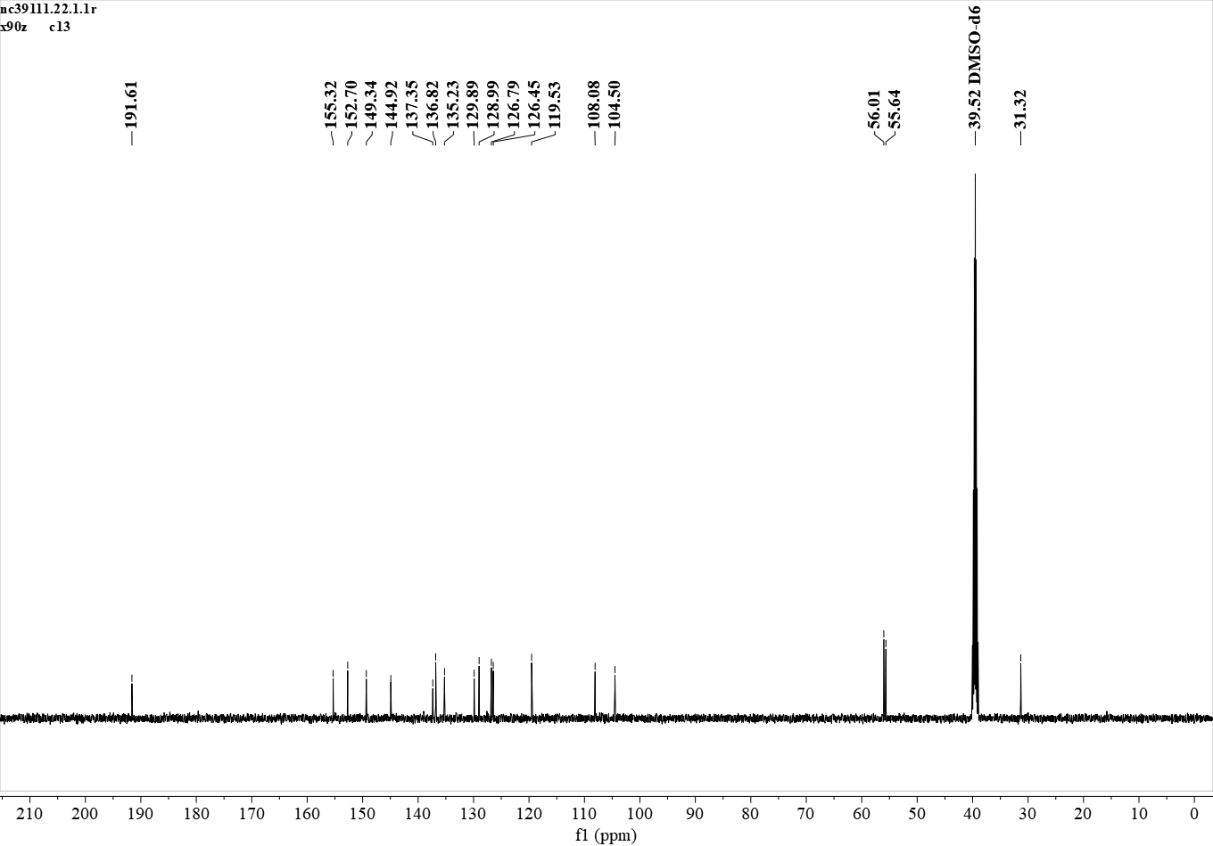
¹³C NMR (126 MHz, DMSO) δ 191.61, 155.32, 152.70, 149.34, 144.92, 137.35, 136.82, 135.23, 129.89, 128.99, 126.79, 126.45, 119.53, 108.08, 104.50, 56.01, 55.64, 31.32.

Figure S64. ¹³C NMR spectrum of E3

Corresponding author. E-mail addresses: niuchao@ms.xJb.ac.cn (N.C.); haji@ms.xjb.ac.cn (H.A.A.)

