Supporting file:
Spectral data of representative compounds:
IR Spectrum of compound (5a)
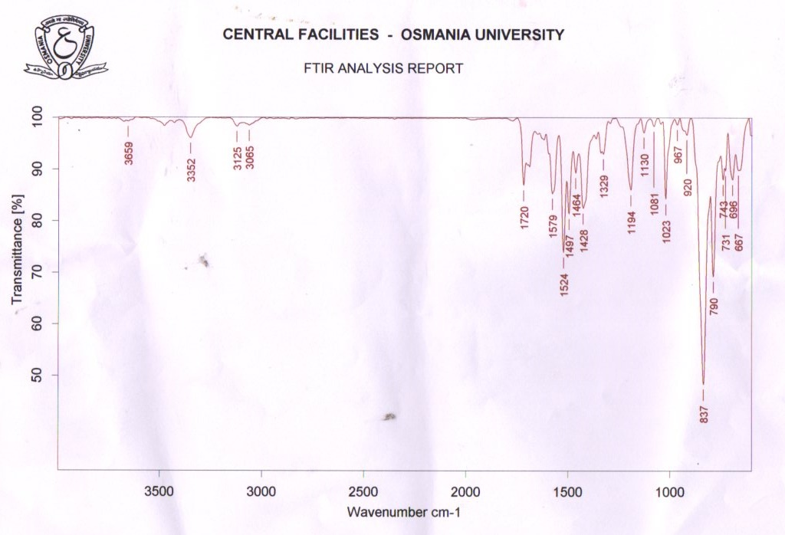

¹H NMR (400 MHz, DMSO-d₆) spectrum of compound (5a)
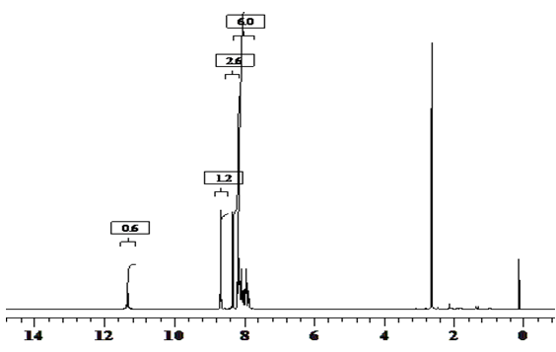

¹³C NMR (400 MHz, DMSO-d₆) spectrum of compound (5a)
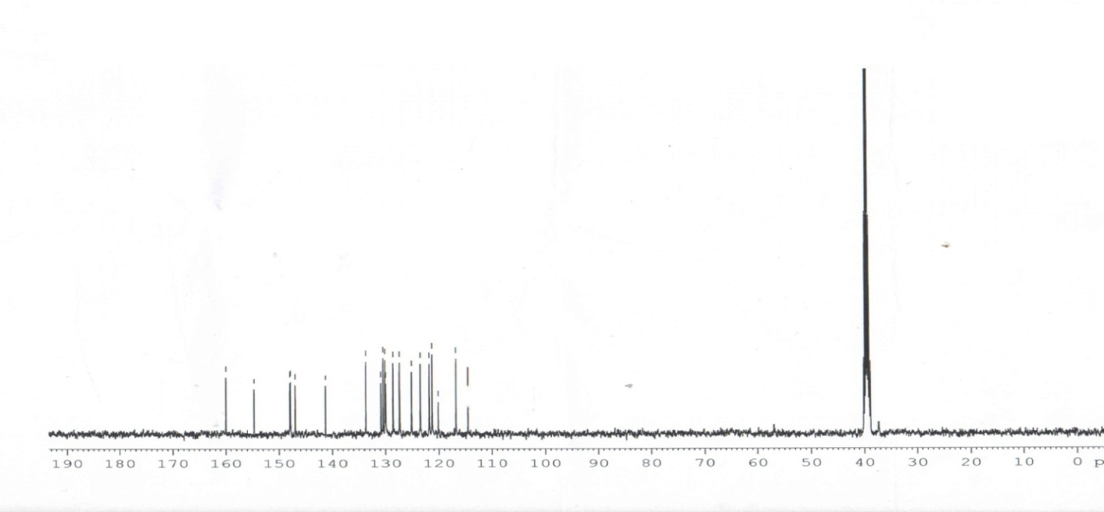

Mass spectrum of compound (5a)
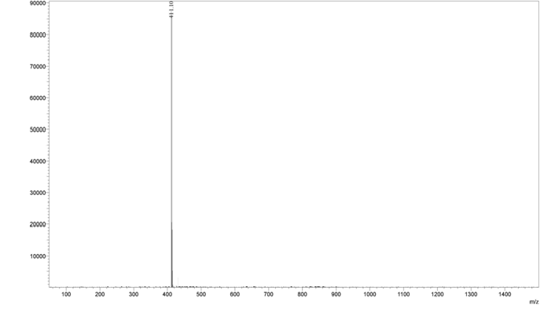
IR Spectrum ofCompound (5b)
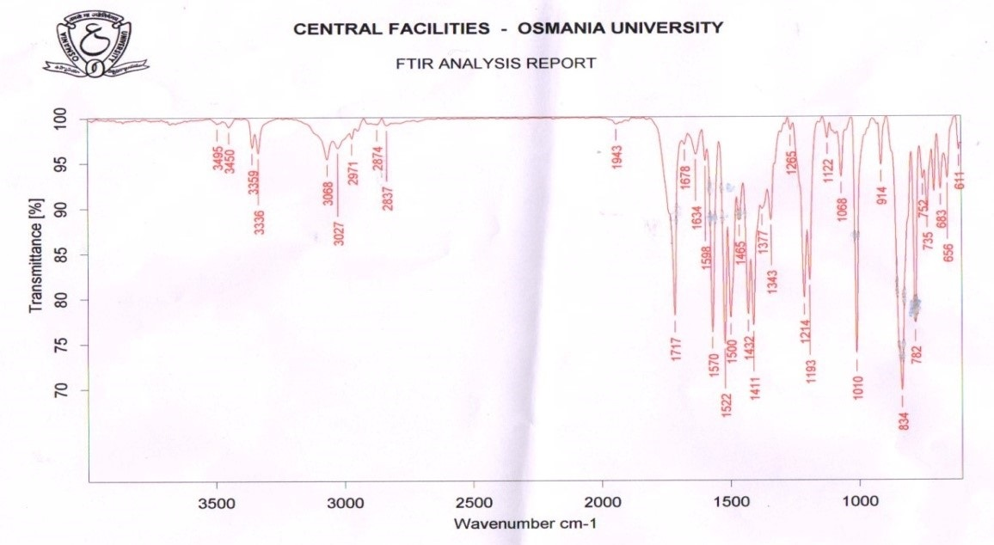

¹H NMR (400 MHz, DMSO-d₆) spectrum of compound (5b)
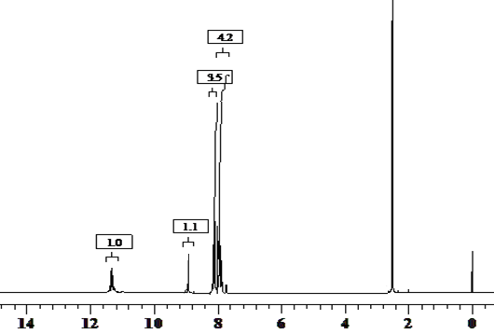

Mass spectrum of compound (5b)
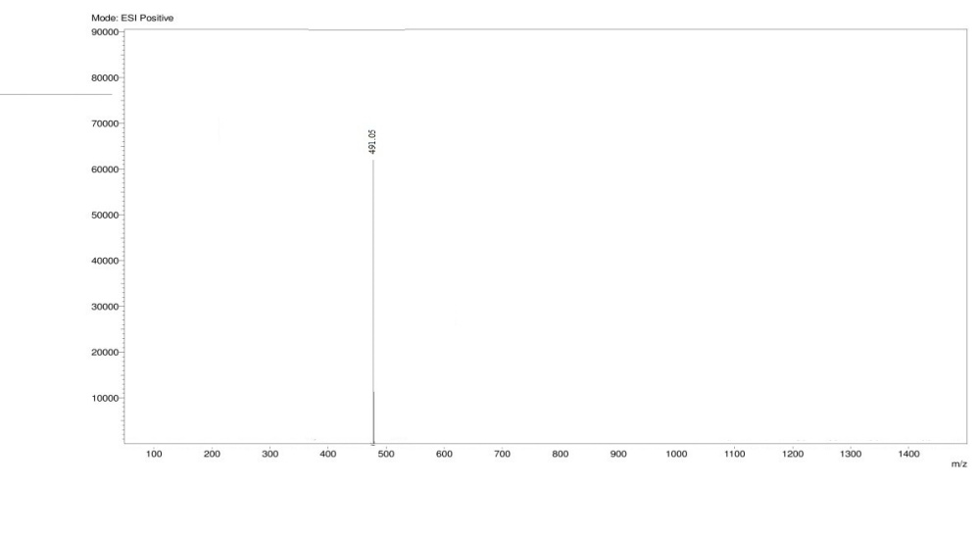

IR Spectrum of Compound (5c)
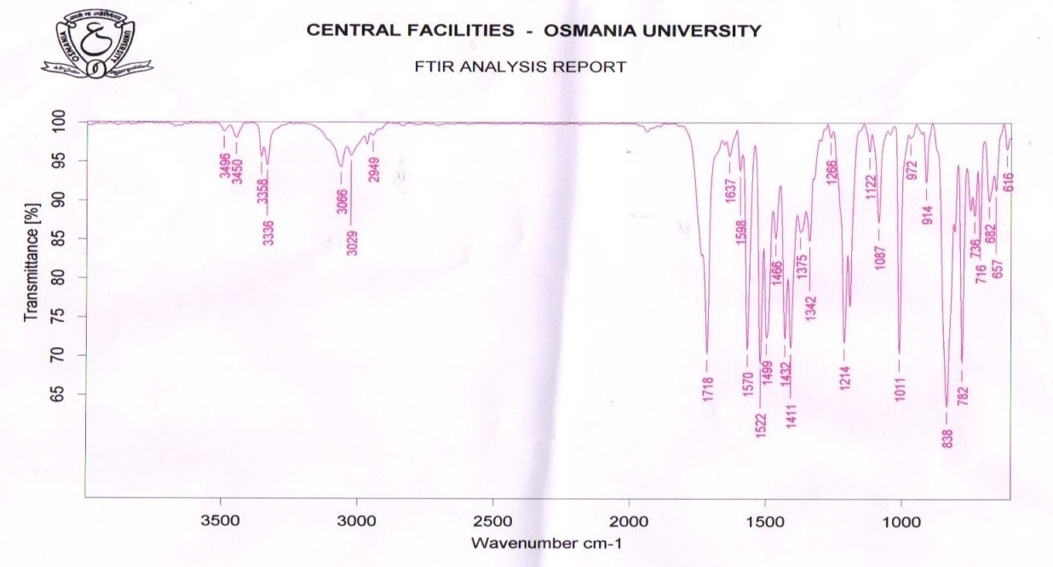

¹H NMR (400 MHz, DMSO-d₆) spectrum of compound (5c)
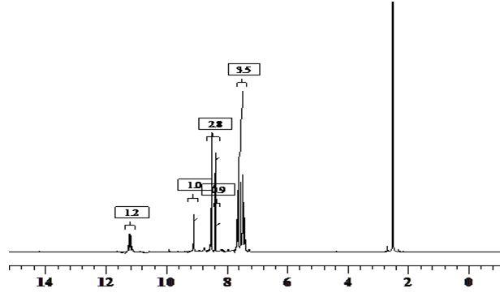

IR Spectrum of compound (5d)
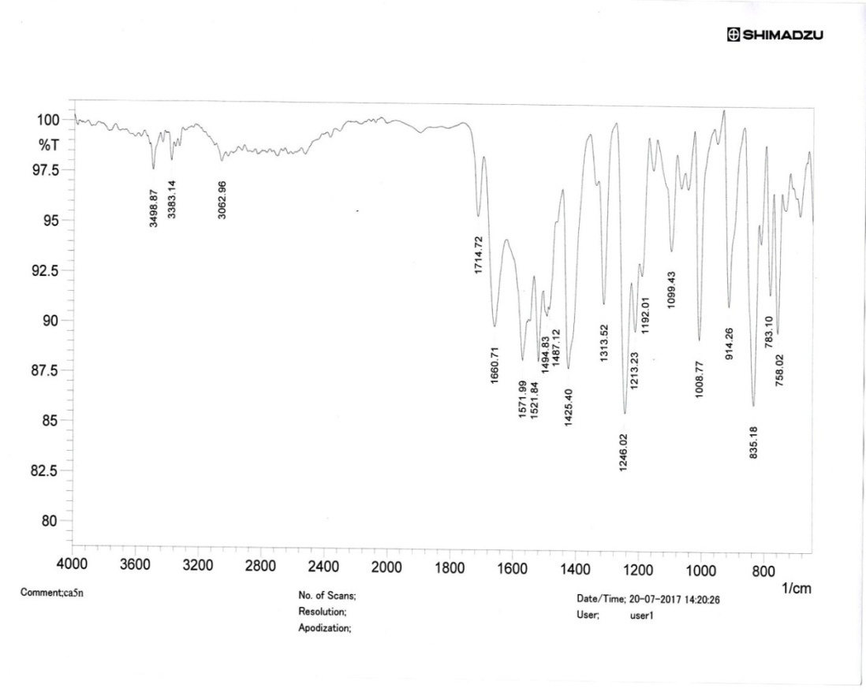

¹H NMR (400 MHz, DMSO-d₆) spectrum of compound (5d)
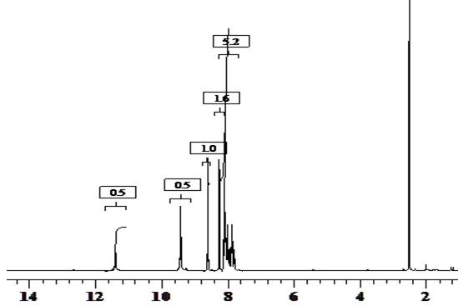

¹³C NMR (400 MHz, DMSO-d₆) spectrum of compound (5d)
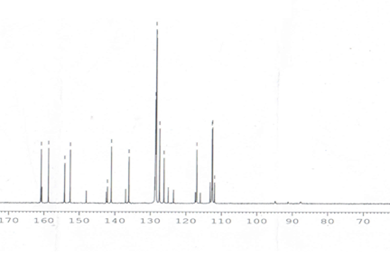

IR Spectrum of compound (5e)
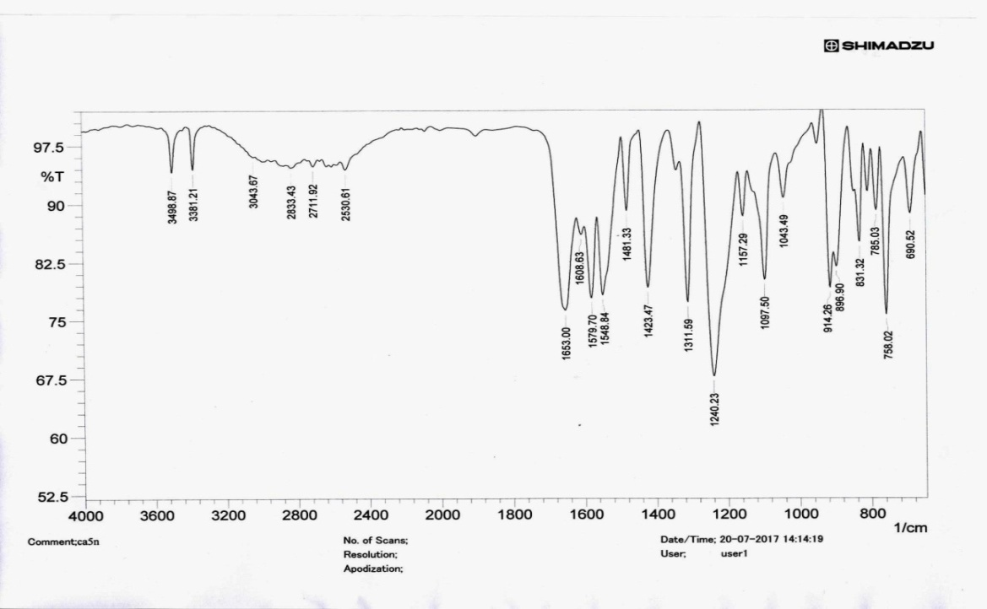

¹H NMR (400 MHz, DMSO-d₆) spectrum of compound (5e)
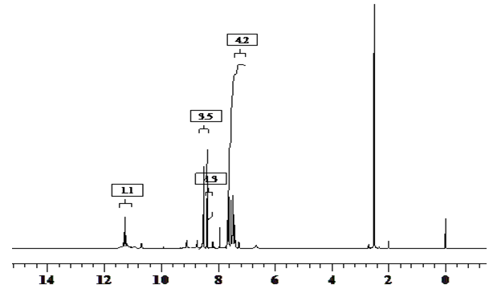

¹³C NMR (400 MHz, DMSO-d₆) spectrum of compound (5e)
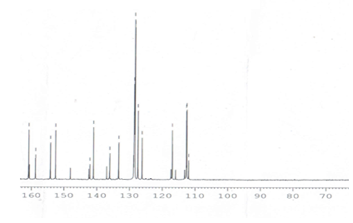

Mass spectrum of compound (5e)
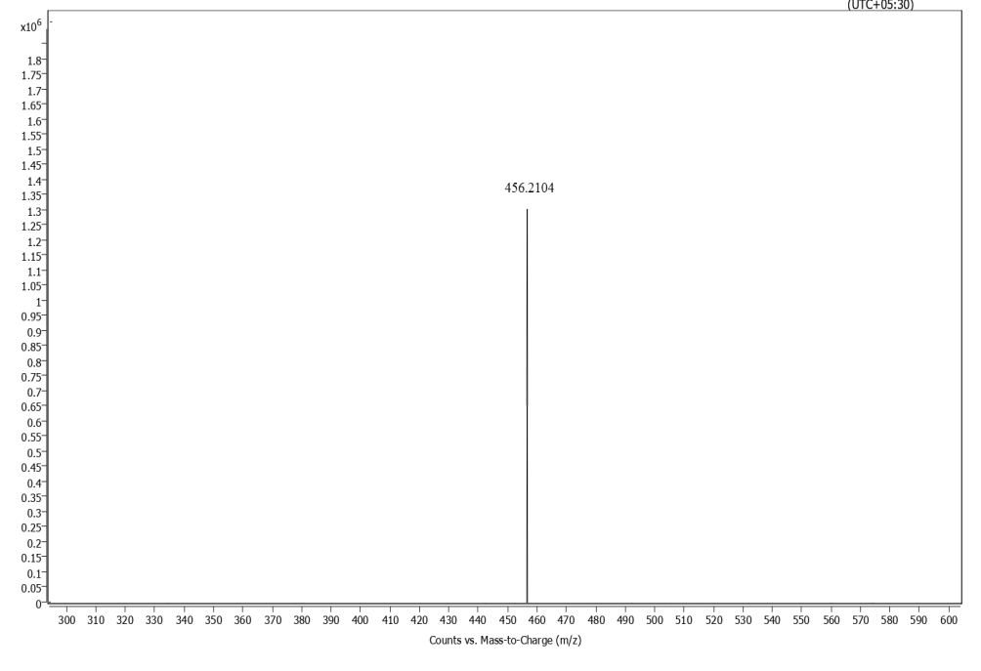

IR Spectrum of compound (5f)
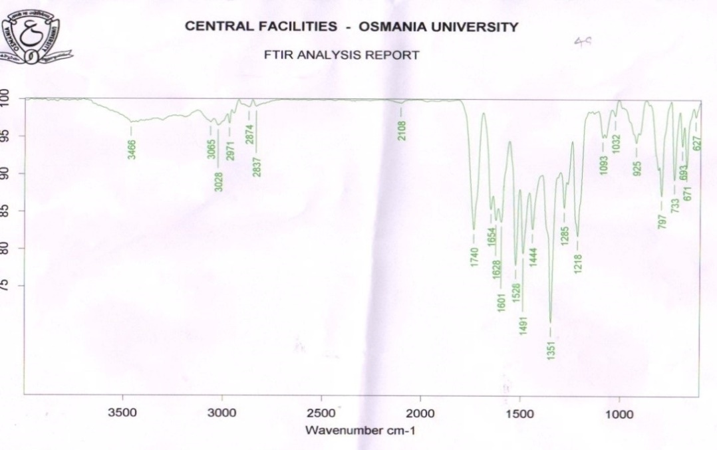

¹H NMR (400 MHz, DMSO-d₆) spectrum of compound (5f)
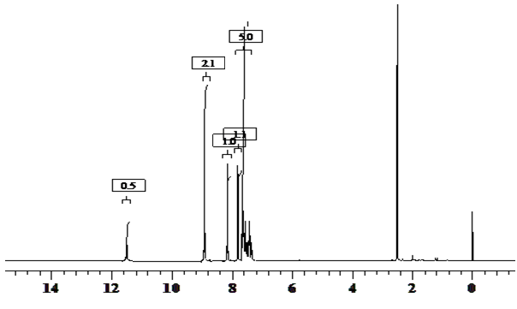

¹³C NMR (400 MHz, DMSO-d₆) spectrum of compound (5f)
