Supplementary information

Bionic Nanotheranostic for Multimodal Imaging-Guided NIR-II-Photothermal Therapy of Lung Cancer

Meng Zhang^{1, 2†}, Yuxuan Zhang^{1, 3, 4†}, Lifeng Hang^{2†},Tao Zhang⁵, Chuangcai Luo^{1, 4}, Wuming Li², Yiqiang Sun⁶, Hua Wen², Yiyu Chen², Guihua Jiang^{1, 2}* and Xiaofen Ma²*
¹ The Second School of Clinical Medicine, Southern Medical University, Guangzhou 510282, China.
² The Department of Medical Imaging, Guangzhou Key Laboratory of Molecular Functional Imaging and Artificial Intelligence for Major Brain Diseases, Guangdong Second Provincial General Hospital, Guangzhou 510317, China
³ Department of Neurosurgery, Institute of Neuroscience, The Second Affiliated Hospital of Guangzhou Medical University, Guangzhou, 510260, China.
⁴ The National Key Clinical Specialty, Department of Neurosurgery, Zhujiang Hospital, Southern Medical University, Guangzhou 510282, China.
⁵ School of Physical and Mathematical Sciences, Nanyang Technological University, 21 Nanyang Link, Singapore 637371, Singapore.
⁶ School of Chemistry and Chemical Engineering, University of Jinan, Jinan 250022, China
†Meng Zhang, Yuxuan Zhang and Lifeng Hang have contributed equally to this work.
*Correspondence: jianggh@gd2h.org.cn, xiaofenma12@163.com
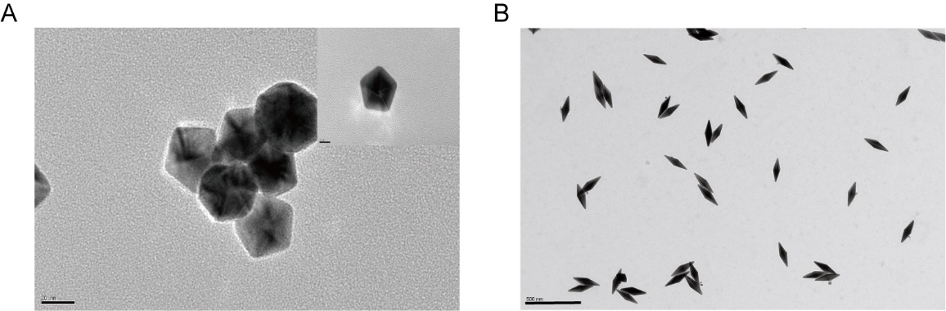
Figure S1. TEM image of gold decahedron (scale bar: 20 nm).

Figure S2. TEM image of Au NBP (scale bar: 500 nm).

Figure S3. TEM image of Au@MnO₂ (scale bar: 50 nm).

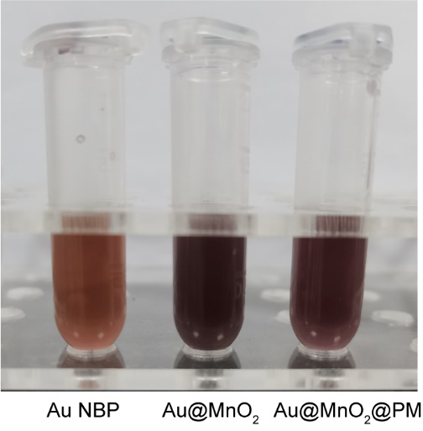
Figure S4. Digital image of Au NBP (left), Au@MnO₂ (middle) and Au@MnO₂@PM (right).

Figure S5. Calculation of photothermal conversion efficiency (η) of AMP.

Calculation of the Photothermal Conversion Efficiency.
Following Roper’s report (J. Phys. Chem. C 2007, 111, 3636), the total energy balance for the system can be expressed by Eq. 1:
$Σ_{i}m_{i}C_{p,i}\frac{dT}{dt}=Q_{NC}+Q_{Dis}−Q_{surr}$ (1)
Where m and C_{p} are the mass and heat capacity of water, respectively, T is the solution temperature, Q_{NC} is the energy inputted by NCs, Q_{Dis} is the baseline energy inputted by the sample cell, and Q_{surr} is heat conduction away from the system surface by air.
The laser-induced source term, represents heat dissipated by electron-phonon relaxation of the plasmons on the AMP surface under the irradiation of 1064 nm laser:
$Q_{NC}=I(1−A^{−1064})η$ (2)
Where I is incident laser power, η is the conversion efficiency from incident laser energy to thermal energy, and A₁₀₆₄ is the absorbance of the AMP at wavelength of 1064 nm. In addition, source term, Q_{Dis}, expresses heat dissipated from light absorbed by the quartz sample cell itself, and it was measured independently to be 113.75 mW using a quartz cuvette cell containing pure water without any AMP. Q_{surr} is linear with temperature for the outgoing thermal energy, as given by Eq. 3
$Q_{surr}=hS(T−T_{surr})$ (3)
Where h is heat transfer coefficient, S is the surface area of the container, and T_{Surr} is ambient temperature of the surroundings.
Once the laser power is defined, the heat input (Q_{NC} + Q_{Dis}) will be finite. Since the heat output (Q_{Surr}) is increased along with the increase of the temperature according to the Eq. 3, the system temperature will rise to a maximum when the heat input is equal to heat output:
$Q_{NC}+Q_{Dis}=Q_{surr−max}=hS(T_{max}−T_{surr})$ (4)
Where the Q_{surr-max} is heat conduction away from the system surface by air when the sample cell reaches the equilibrium temperature, and T_{max} is the equilibrium temperature. The 1064 nm laser heat conversion efficiency (η) can be determined by substituting Eq. 2 for Q_{NC} into Eq. 4 and rearranging to get
$η=\frac{hS\left(T_{max}−T_{surr}\right)−Q_{Dis}}{I(1−{10}^{−A_{1064}})}$ (5)
Where Q_{Dis} was measured independently to be 113.75 mW, the (T_{max}-T_{Surr}) was 24.4 °C according to Figure 1G and 1H, I is 785 mW, A₁₀₆₄ is the absorbance (1) of AMP at 1064 nm (Figure 1F). Thus, only the hS remains unknown for calculating η.
In order to get the hS, a dimensionless driving force temperature, θ is introduced using the maximum system temperature, T_{max}
$θ=\frac{T−T_{surr}}{T_{max}−T_{surr}}$ (6)
and a sample system time constant τ_{s},
$τ_{s}=\frac{Σ_{i}m_{i}C_{p,i}}{hS}$ (7)
which is substituted into Eq. 1 and rearranged to yield
$\frac{dθ}{dt}=\frac{1}{τ_{s}}[\frac{Q_{NC}+Q_{Dis}}{hS\left(T_{max}−T_{surr}\right)}−θ]$ (8)
At the cooling stage of the aqueous dispersion of the AMP, the light source was shut off, the Q_{NC} +Q_{Dis} = 0, reducing the Eq. 9
$dt=−τ_{s}\frac{dθ}{θ}$ (9)
and integrating, giving the expression
$τ=−τ_{s}lnθ$ (10)
finally, find the value of photothermal conversion efficiency (η)
$η=\frac{hS\left(T_{max}−T_{surr}\right)−Q_{Dis}}{I(1−{10}^{−A_{1064}})}$= $\frac{(20.16×24.4 mW−113.7 mW)}{(785mW×(1−{10}^{−1.0804})}$= 52.07%

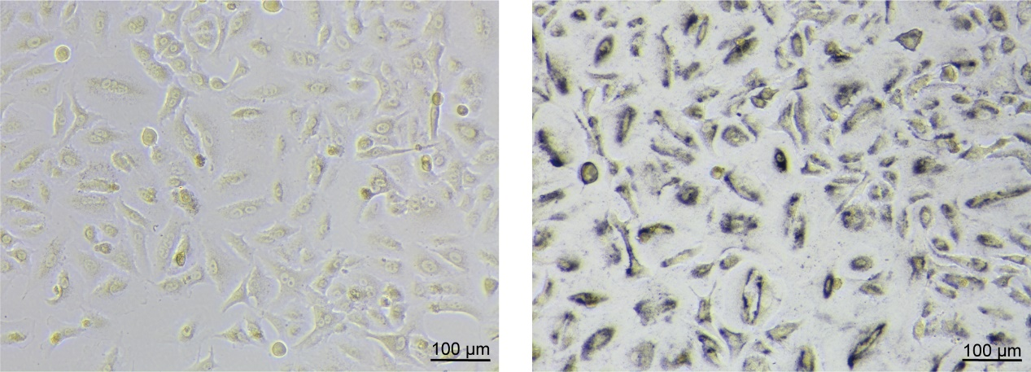
Figure S6. Optical microscopy images were taken 24 hours after the addition of PBS (left) and AMP (right) to A549 cell culture medium. Scale bar: 100 μm

Figure S7. Corresponding infrared thermal images (1064 nm laser doses: 1.0 W cm⁻²)

Figure S8. CT images of different concentrations of AMP at 120kV (left) and corresponding CT value (right).

Table S1. Photothermal performance of recently reported photothermal agents employed in NIR-II window.
Photothermal agents | PTCE | Photothermal agents | PTCE
AMPs (this work) | 0.520 | Ti₃C₂/CA₄@PLEL nanohydrogel¹ | 0.414
Au/Ag NRs² | 0.288 | Au-Au nanocoral³ | 0.672
Au NPL@TiO₂⁴ | 0.420 | anti-STR-CO-GNSs⁵ | 0.319
Au@MOF-DOX⁶ | 0.302 | PLNP-Bi₂S₃⁷ | 0.44
Au NSs⁸ | 0.130 | TA-Si-Au⁹ | 0.241
PTCE, photothermal conversion efficiency.
1 Tao, N. et al. Minimally Invasive Antitumor Therapy Using Biodegradable Nanocomposite Micellar Hydrogel with Functionalities of NIR-II Photothermal Ablation and Vascular Disruption. ACS Appl Bio Mater 3, 4531-4542, doi:10.1021/acsabm.0c00465 (2020).
2 Mei, Z. et al. Activatable NIR-II photoacoustic imaging and photochemical synergistic therapy of MRSA infections using miniature Au/Ag nanorods. Biomaterials 251, 120092, doi:10.1016/j.biomaterials.2020.120092 (2020).
3 Jia, J. et al. Fine‐Tuning the Homometallic Interface of Au‐on‐Au Nanorods and Their Photothermal Therapy in the NIR‐II Window. Angewandte Chemie International Edition 59, 14443-14448, doi:10.1002/anie.202000474 (2020).
4 Gao, F. et al. Titania-coated 2D gold nanoplates as nanoagents for synergistic photothermal/sonodynamic therapy in the second near-infrared window. Nanoscale 11, 2374-2384, doi:10.1039/c8nr07188h (2019).
5 Manivasagan, P. et al. Antibody-conjugated and streptomycin-chitosan oligosaccharide-modified gold nanoshells for synergistic chemo-photothermal therapy of drug-resistant bacterial infection. J Adv Res 48, 87-104, doi:10.1016/j.jare.2022.08.009 (2023).
6 Deng, X. et al. Yolk–Shell Structured Au Nanostar@Metal–Organic Framework for Synergistic Chemo-photothermal Therapy in the Second Near-Infrared Window. Nano Letters 19, 6772-6780, doi:10.1021/acs.nanolett.9b01716 (2019).
7 Meng, Y. et al. Photothermal conversion performance and acid-induced aggregation of PLNP-Bi(2)S(3) composite nanoplatforms. Dalton Trans 51, 5285-5295, doi:10.1039/d1dt04215g (2022).
8 Song, C. et al. Gold nanostars for cancer cell-targeted SERS-imaging and NIR light-triggered plasmonic photothermal therapy (PPTT) in the first and second biological windows. Journal of Materials Chemistry B 7, 2001-2008, doi:10.1039/c9tb00061e (2019).
9 Sun, L. N. et al. Silicon nanowires decorated with gold nanoparticles via in situ reduction for photoacoustic imaging-guided photothermal cancer therapy. Journal of Materials Chemistry B 7, 4393-4401, doi:10.1039/c9tb00147f (2019).

