Supplementary Information

for

Self-eating in the plaque: nanogels with covalently bound and releasable trehalose for autophagy stimulation in atherosclerosis

Yuan Zhong ^{1,†}, Ali Maruf ^{2,3,†}, Kai Qu ¹, Małgorzata Milewska ^{2,3}, Ilona Wandzik ^{2,3,*}, Nianlian Mou ¹, Yu Cao ¹, Wei Wu ^{1,*}

¹ Key Laboratory for Biorheological Science and Technology of Ministry of Education, State and Local Joint Engineering Laboratory for Vascular Implants, Bioengineering College, Faculty of Medicine, Chongqing University, Chongqing 400030, China
² Department of Organic Chemistry, Bioorganic Chemistry and Biotechnology, Faculty of Chemistry, Silesian University of Technology, Krzywoustego 4, 44-100 Gliwice, Poland
³ Biotechnology Center, Silesian University of Technology, Krzywoustego 8, 44-100 Gliwice, Poland
† The authors contribute equally to this work
* Corresponding authors. E-mail addresses: david2015@cqu.edu.cn (WW), ilona.wandzik@polsl.pl (IW)

Formulation of nanogels
Table S1. Formulation of nanogels based on moles and mass feeding.

Samples | Formulation based on moles and mass  (mmol (mg))
Samples | TreA | HEA | AM | 4-AMBA | 4-AMBA-sulfo-NHS | MBA
TNG | 0.385 (152.7) | - | 0.496 (35.3) | 0.085 (13.4) | - | 0.130 (20.0)
HEA₁NG | - | 0.385 (44.8) | 0.496 (35.3) | 0.085 (13.4) | - | 0.130 (20.0)
HEA₂NG | - | 1.315 (152.7) | 0.496 (35.3) | 0.085 (13.4) | - | 0.130 (20.0)
NHS-TNG | 0.385 (152.7) | - | 0.496 (35.3) | 0.085 (13.4) | 0.011 (4.0) | 0.130 (20.0)

Synthesis of 4-acrylamidobutanoic acid 3-sulfo-N-hydroxysuccinimide ester sodium salt (4-AMBA-Sulfo-NHS)
4-AMBA-Sulfo-NHS was synthesized based on the method reported by Tsuji et al. (2019) for the synthesis of homologous N-sulfosuccinyl-6-hexyloylacrylamide sodium salt. Briefly, sulfo-NHS (434.3 mg, 2.0 mmol) and 4-AMBA (314.3 mg, 2.0 mmol) were placed in a 25-mL round-bottom flask and dissolved in anhydrous DMF (6 mL) under argon atmosphere while stirring. The flask was then cooled in an ice bath for 15 min. Solution of DCC (833.6 mg, 4.0 mmol) in 2.0 mL of anhydrous DMF was added dropwise into the mixture and kept 1 h in an ice bath, followed by another 20 h at room temperature. On the next day, the reaction mixture was kept in 4 ºC refrigerator for 30 min following filtration of the solution with a celite filter (thickness: 8 mm) and washed with 3 mL of DMF. The product was then precipitated with 140 mL of diethyl ether, centrifuged at 14610 ×g (4 ºC, 2 min) and washed four times with 20 mL of diethyl ether. The fine powder (4-AMBA-Sulfo-NHS) was then air dried overnight and rotary-dried for 2 h at 35 ºC (10 mbar).
Reference: S. Tsuji, Y. Aso, H. Ohara, and T. Tanaka, “Polymeric water-soluble activated esters: synthesis of polymer backbones with pendant N-hydoxysulfosuccinimide esters for post-polymerization modification in water,” Polym J, vol. 51, no. 10, pp. 1015–1022, Oct. 2019, doi:10.1038/s41428-019-0221-4.

Schematic diagram of the synthesis route of 4-acrylamidobutanoic acid 3-sulfo-N-hydroxysuccinimide ester sodium salt
Figure S1. Schematic diagram of the synthesis route of 4-acrylamidobutanoic acid 3-sulfo-N-hydroxysuccinimide ester sodium salt.

¹H (600 MHz) and ¹³C NMR (150 MHz) spectra of 4-acrylamidobutanoic acid 3-sulfo-N-hydroxysuccinimide ester sodium salt
Figure S2. ¹H (600 MHz) and ¹³C NMR (150 MHz) spectra of 4-acrylamidobutanoic acid 3-sulfo-N-hydroxysuccinimide ester sodium salt.
¹H NMR (DMSO-d₆, 600 MHz) δ [ppm]: 8.18 (t, J = 5.6 Hz, 1H, –NHC(O)–); 6.20 (dd, J = 17.1, 10.2 Hz, 1H, –CH=CH₂); 6.08 (dd, J = 17.1, 2.2 Hz, 1H, –CH=CH₂ trans); 5.58 (dd, J = 10.2, 2.2 Hz, 1H, –CH=CH₂ cis); 3.95 (bs, 1H, >CHSO₃Na); 3.24–3.08 (m, 3H, –NHCH₂–, –CH₂CHSO₃Na); 2.86 (dd, J = 18.4, 2.4 Hz, 1H, –CH₂CHSO₃Na); 2.75–2.65 (m, 2H, –CH₂C(O)O–); 1.83–1.73 (m, 2H, –CH₂CH₂CH₂–). ¹³C NMR (DMSO-d₆, 150 MHz) δ [ppm]: 168.77, 165.33 (2x –C(O)N<, –C(O)O–); 164.67 (–NHC(O)–); 131.68 (–CH=CH₂); 125.03 (–CH=CH₂); 56.27 (>CHSO₃Na); 37.57 (–NHCH₂–); 30.91 (–CH₂CHSO₃Na); 27.86 (–CH₂C(O)O–); 24.26 (–CH₂CH₂CH₂–).

Actual conjugated trehalose
Figure S3. Actual conjugated trehalose compared to the recipe. TreA feeding and free trehalose feeding were determined based on the recipe. Actual conjugated trehalose was determined by enzymatic assay. Data are presented as mean ± SD (n = 4).

Hemolysis profile of TNG
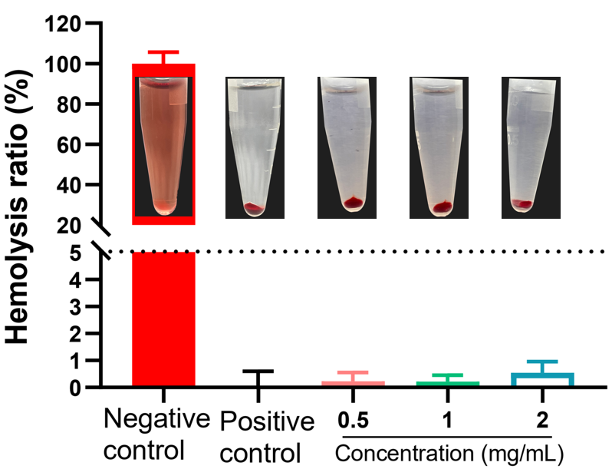
Figure S4. Hemolysis profile of TNG at different concentrations (0.5, 1.0, and 2.0 mg/mL) in red blood cells. Data are presented as mean ± SD (n = 3).

Cytotoxicity profile of TNG

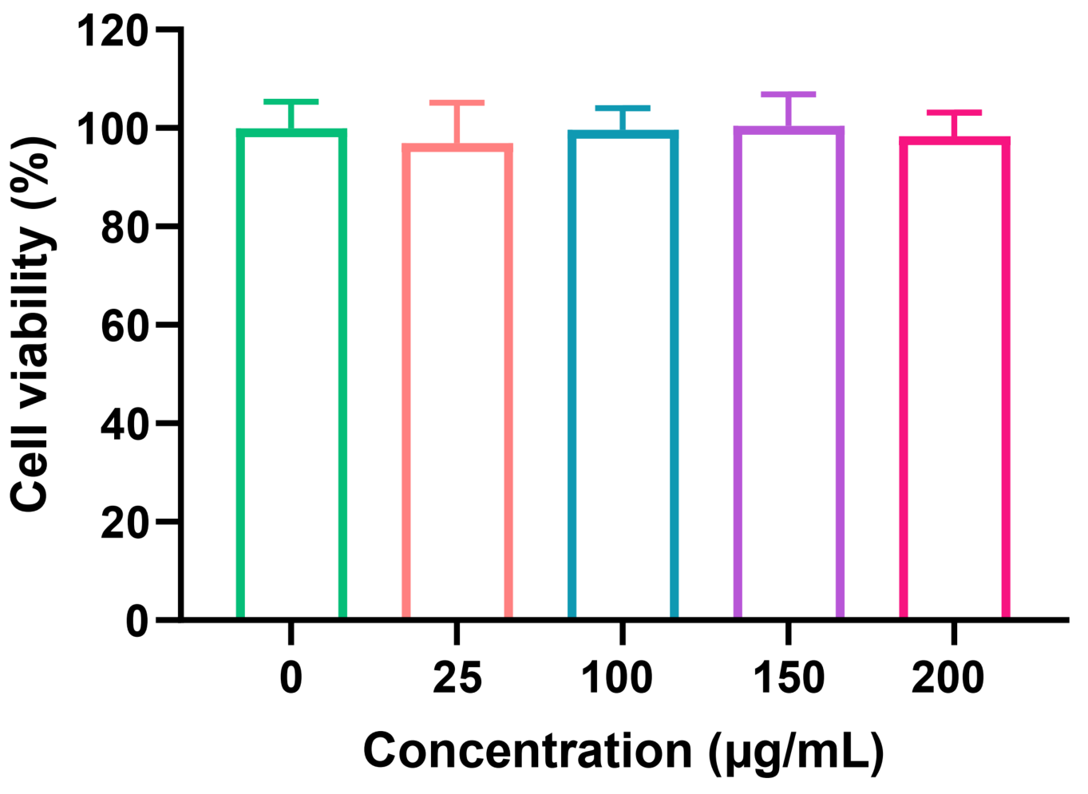
Figure S5. HUVECs viability after treatments with TNG at different concentrations (0, 25, 100, 150, and 200 µg/mL) for 24 h. Data are presented as mean ± SD (n = 5).

