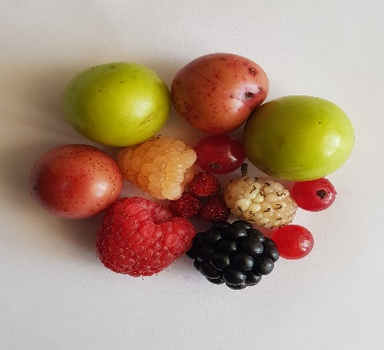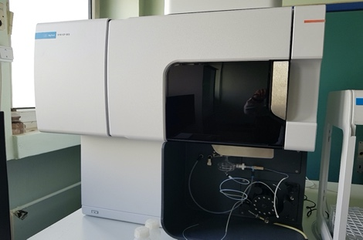
-Al
-As
-Ba

Graphical Abstract: In this study, the accumulated amounts of elements and heavy metals in wild-grown fruits were investigated.

