An Unprecedented Crystalline La(II)-Chalcogenide LaMg₆Ga₆S₁₆ with Multifunctional Properties
Yujie Zhang, Jiale Chen, Hongping Wu, Zhanggui Hu, Jiyang Wang, Yicheng Wu and Hongwei Yu*

CONTENTS
Figure S1 (Experimental and calculated XRD patterns) 2
Figure S2 (EDS spectra) 3
Figure S3 (Powder XRD patterns of in-situ variable-temperature and different
reaction temperature) 4
Figure S4 (Moisture-stable LaMg₆Ga₆S₁₆) 5
Figure S5 (Excitation-dependent PL spectrum of La₂S₃) 6
Figure S6 (Crystal orientation) 7
Figure S7 (Birefringence determination of LaMg₆Ga₆S₁₆ crystal) 8
Figure S8 (NLO properties of LaMg₆Ga₆S₁₆ and other important IR NLO crystals) 9
Table S1 (Crystallographic Data and Refinement Details) 10
Table S2 (Atomic coordinates, displacement parameters and BVS) 11
Table S3 (Selected bond distances and angles) 12
Table S4 (Induced polarizability of MgS₆ and GaS₄ groups) 16
Table S5 (NLO properties of LaMg₆Ga₆S₁₆ and some reported chalcogenides) 17
References 18

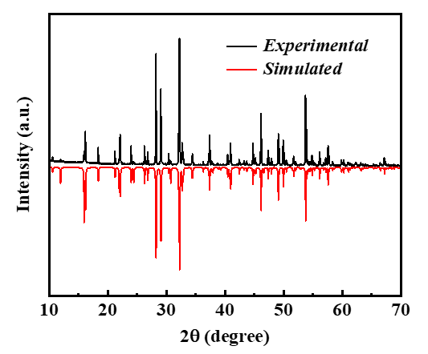
Figure S1. Experimental and calculated XRD patterns for LaMg₆Ga₆S₁₆.

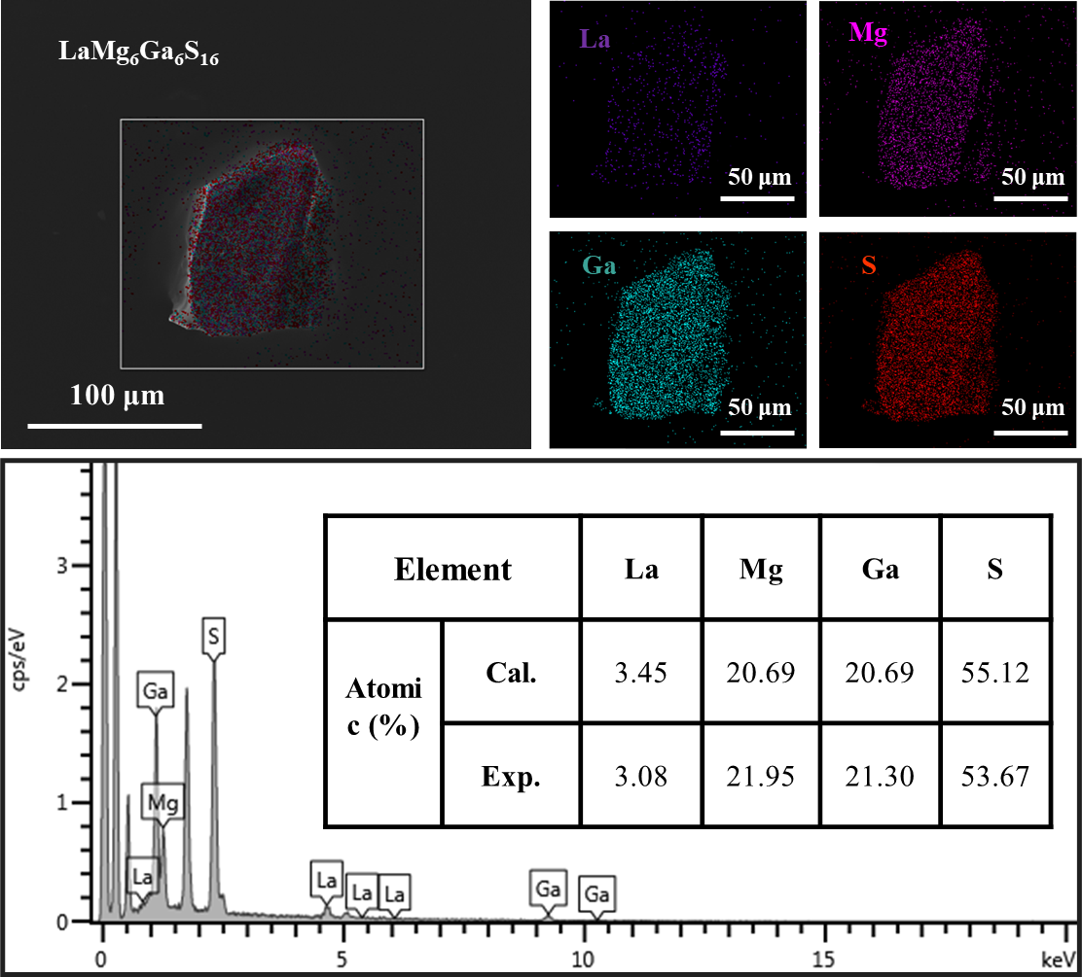
Figure S2. The EDS spectra of LaMg₆Ga₆S₁₆.

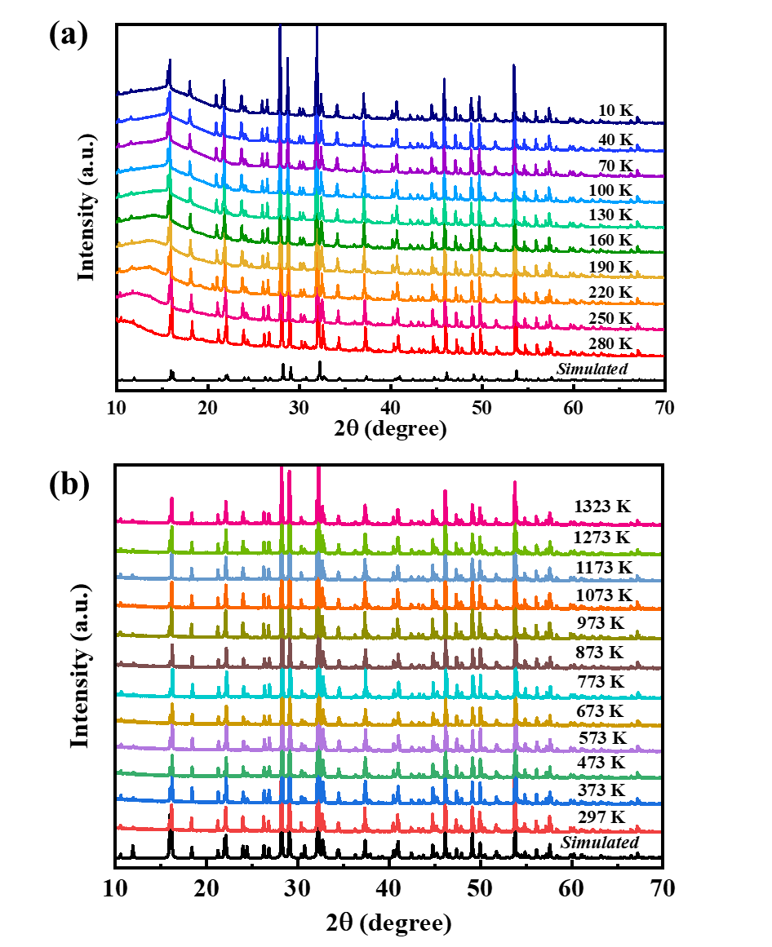
Figure S3. In-situ variable-temperature powder XRD (a) and variable-temperature powder XRD (b) of the LaMg₆Ga₆S₁₆.

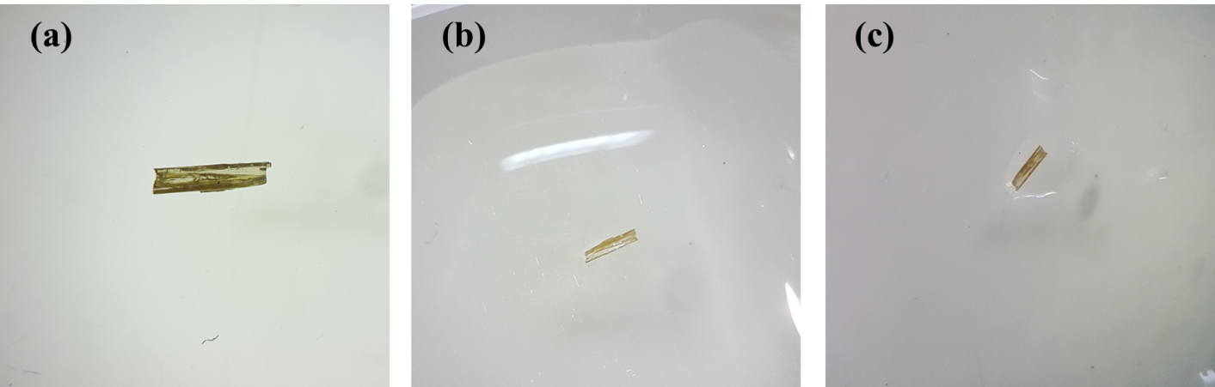
Figure S4. The moisture-stable LaMg₆Ga₆S₁₆: the crystal was soaked in the water for 7d (a) before soaking; (b) soaking in the water; (c) after soaking.

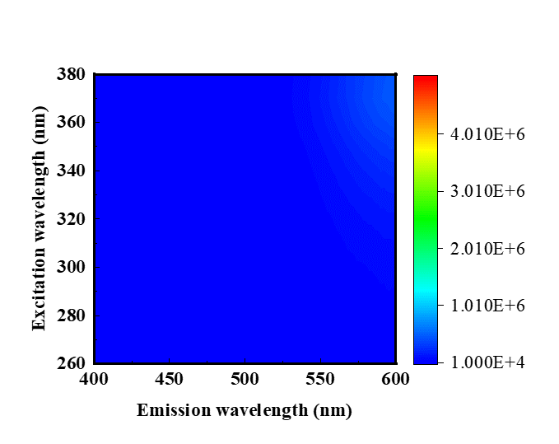
Figure S5. Excitation-dependent PL spectra of La₂S₃ at the room temperature.

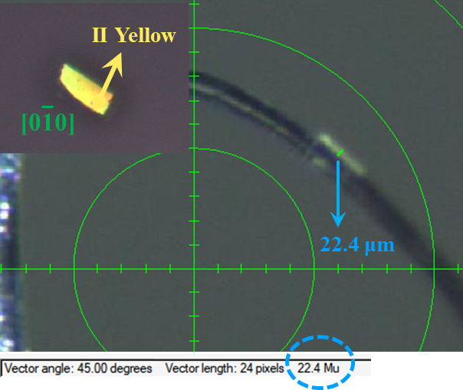

Figure S6. Thickness of LaMg₆Ga₆S₁₆ crystal, inset: crystal for birefringence determination and its interference color observed in the cross-polarized light.
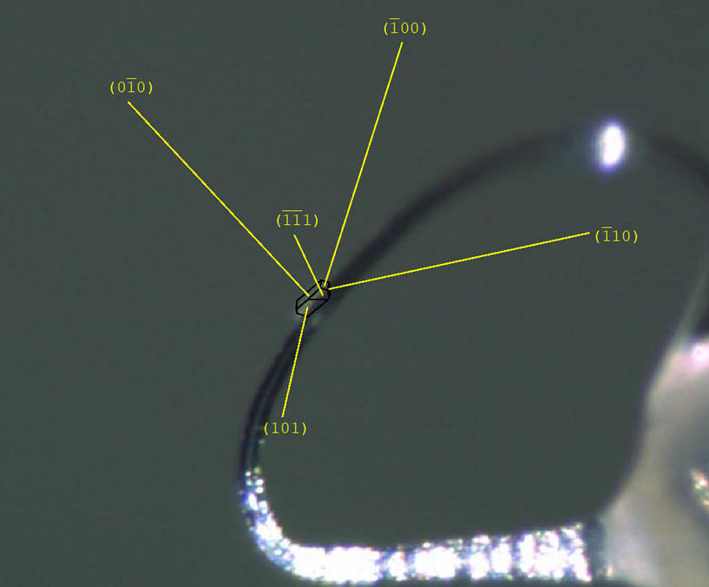

Figure S7. The crystal orientation of the LaMg₆Ga₆S₁₆ was indexed by using a Bruker SMART APEX III.

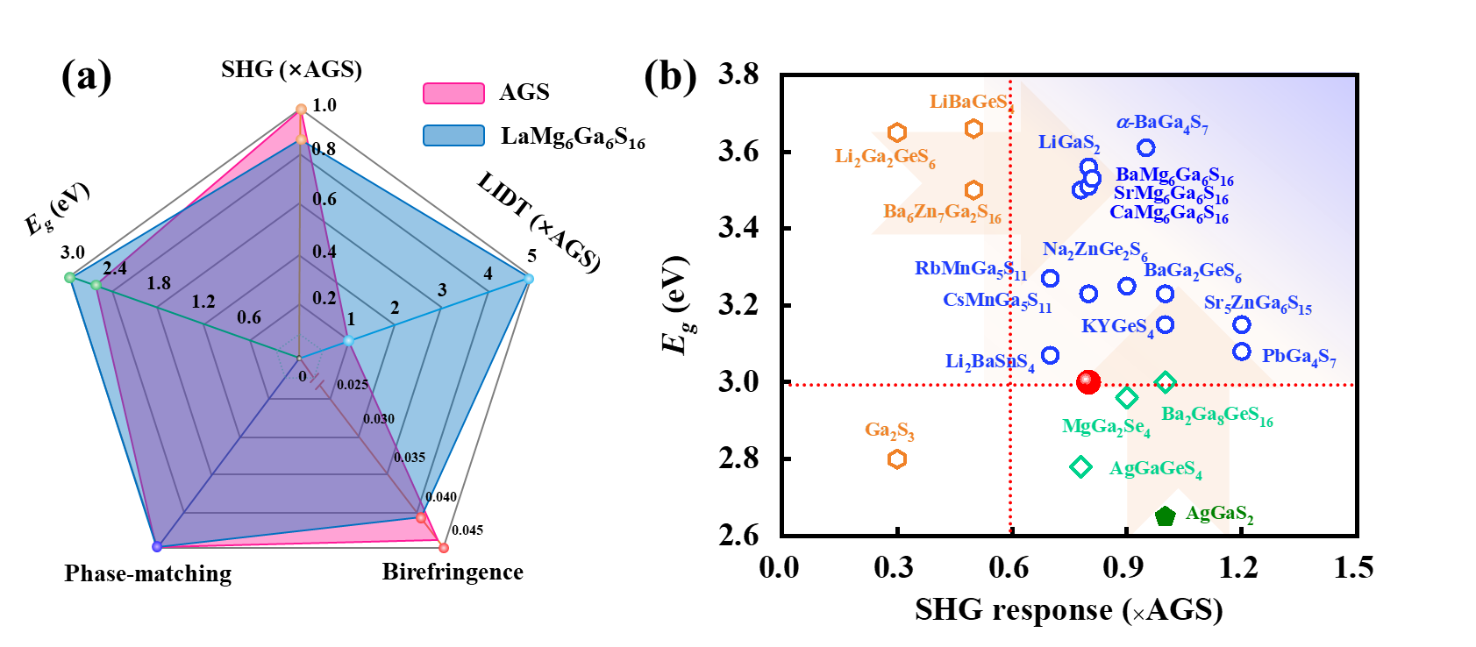

Figure S8. The well-balanced NLO properties of LaMg₆Ga₆S₁₆ (a); Comparison of SHG response and band gap of LaMg₆Ga₆S₁₆ with AGS and other reported chalcogenides (b). Explanation: compared with commercial chalcopyrite-type AGS and other important IR NLO crystals, LaMg₆Ga₆S₁₆ exhibits well-balanced NLO properties, including wide transmission region and band gaps, high LIDT, moderate birefringence as well as large PM SHG responses.

Table S1. Crystallographic Data and Refinement Details for LaMg₆Ga₆S₁₆.
Empirical formula | LaMg₆Ga₆S₁₆
Formula weight | 3648.16
Temperature (K) | 297(2)
Crystal system | Hexagonal
Space group | P6
Z | 1
a (Å) | 16.7154(5)
c (Å) | 7.4147(3)
V (Å³) | 1794.15(13)
D_{c} (g cm⁻³) | 3.376
μ (mm⁻¹) | 9.949
F(000) | 1713
Radiation | Mo-K_{α} (λ = 0.71073)
2θ range(°) | 2.44 to 25.34
Reflections collected | 9331
Indep. Reflns/ Rint | 2340/0.0393
GOOF on F² | 1.184
R₁, wR₂ (I >2σ(I))ª | 0.0423, 0.1211
R₁, wR₂ (all data) | 0.0495, 0.1283
largest diff. peak and hole (e·Å⁻³) | 4.134, -2.213
ªR₁ = Σ||F_{o}|—|F_{c}||/Σ|F_{o}|, ^{b}wR₂ = Σw(F_{o}²—F_{c}²)²/Σw(F_{o}²)²]^{1/2}.

Table S2. Atomic coordinates ( × 10⁴) and equivalent isotropic displacement parameters (Å² × 10³) for LaMg₆Ga₆S₁₆. U_{eq} is defined as one-third of the trace of the orthogonalized U_{ij} tensor.
Atom | BVSª | Wyckoff | x | y | z | U_{eq}(Å)
La(1) | 2.13 | 1c | 3333 | 6667 | 10000 | 44(1)
La(2) | 1.96 | 1a | 0 | 0 | 10000 | 44(1)
La(3) | 2.10 | 1e | 6667 | 3333 | 10000 | 46(1)
Mg(1) | 2.05 | 3k | 4292(9) | 1271(8) | 5000 | 30(3)
Mg(2) | 2.04 | 3j | 4206(10) | 1332(10) | 10000 | 39(3)
Mg(3) | 1.94 | 3k | 2019(7) | 2432(8) | 5000 | 25(2)
Mg(4) | 1.96 | 3j | 2075(8) | 2571(10) | 10000 | 35(3)
Mg(5) | 1.87 | 3k | 3791(7) | 4736(7) | 5000 | 28(3)
Mg(6) | 1.80 | 3j | 3829(7) | 4658(9) | 10000 | 42(4)
Ga(1) | 3.00 | 6l | 5603(2) | 7034(2) | 7482(4) | 26(1)
Ga(2) | 2.97 | 6l | -318(2) | 1872(2) | 7468(4) | 26(1)
Ga(3) | 2.97 | 6l | 4702(2) | 3573(2) | 7474(4) | 25(1)
S(1) | 2.05 | 6l | 5050(4) | 2450(5) | 7545(7) | 27(1)
S(2) | 2.18 | 6l | -106(4) | 3335(4) | 7510(20) | 27(1)
S(3) | 1.95 | 6l | 876(4) | 1628(5) | 7513(8) | 27(1)
S(4) | 1.98 | 6l | 3264(4) | 3371(4) | 7510(20) | 25(1)
S(5) | 1.96 | 6l | 4134(5) | 5868(5) | 7506(7) | 27(1)
S(6) | 1.93 | 3k | -1278(7) | 1346(7) | 5000 | 27(2)
S(7) | 1.82 | 3j | 5375(7) | 4503(7) | 10000 | 27(2)
S(8) | 2.02 | 3j | 5837(7) | 7925(7) | 10000 | 31(2)
S(9) | 2.02 | 3k | 5957(5) | 7963(7) | 5000 | 24(2)
S(10) | 2.03 | 3k | 5286(6) | 4542(7) | 5000 | 26(2)
S(11) | 1.84 | 3j | -1222(7) | 1237(7) | 10000 | 33(2)
ªBond valence state was calculated using the empirical formula V_{i}=ΣS_{ij}=Σexp[(r₀−r_{ij})/0.37], where S_{ij} is the bond valence associated with bond lengths r_{ij} and r₀.^{1, 2, 3, 4}

Table S3. Selected distances (Å) and angles (degrees) for LaMg₆Ga₆S₁₆.
La(1)-S(5)#1 | 2.963(7) | Mg(2)-S(11)#8 | 2.834(18)
La(1)-S(5) | 2.963(7) | Mg(3)-S(3)#15 | 2.522(10)
La(1)-S(5)#2 | 2.963(7) | Mg(3)-S(3) | 2.522(10)
La(1)-S(5)#3 | 2.963(7) | Mg(3)-S(6)#8 | 2.587(15)
La(1)-S(5)#4 | 2.963(7) | Mg(3)-S(4) | 2.643(15)
La(1)-S(5)#5 | 2.963(7) | Mg(3)-S(4)#15 | 2.643(15)
La(2)-S(3) | 2.994(7) | Mg(3)-S(9)#3 | 2.705(14)
La(2)-S(3)#1 | 2.994(7) | Mg(4)-S(4) | 2.548(16)
La(2)-S(3)#6 | 2.994(7) | Mg(4)-S(4)#1 | 2.548(16)
La(2)-S(3)#7 | 2.994(7) | Mg(4)-S(3) | 2.597(11)
La(2)-S(3)#8 | 2.994(7) | Mg(4)-S(3)#1 | 2.597(11)
La(2)-S(3)#9 | 2.994(7) | Mg(4)-S(11)#8 | 2.635(17)
La(3)-S(1)#10 | 2.967(6) | Mg(4)-S(8)#3 | 2.650(17)
La(3)-S(1)#11 | 2.967(6) | Mg(5)-S(5) | 2.505(10)
La(3)-S(1)#1 | 2.967(6) | Mg(5)-S(5)#15 | 2.505(10)
La(3)-S(1) | 2.967(6) | Mg(5)-S(9)#3 | 2.607(14)
La(3)-S(1)#12 | 2.967(6) | Mg(5)-S(10) | 2.675(16)
La(3)-S(1)#13 | 2.967(6) | Mg(5)-S(4)#15 | 2.727(15)
Mg(1)-S(10)#13 | 2.508(13) | Mg(5)-S(4) | 2.727(15)
Mg(1)-S(2)#14 | 2.552(16) | Mg(6)-S(5) | 2.596(12)
Mg(1)-S(2)#8 | 2.552(16) | Mg(6)-S(5)#1 | 2.596(12)
Mg(1)-S(1) | 2.560(10) | Mg(6)-S(8)#3 | 2.597(18)
Mg(1)-S(1)#15 | 2.560(10) | Mg(6)-S(4)#1 | 2.627(16)
Mg(1)-S(6)#8 | 2.793(15) | Mg(6)-S(4) | 2.627(16)
Mg(2)-S(1)#1 | 2.482(11) | Mg(6)-S(7) | 2.723(18)
Mg(2)-S(1) | 2.482(11) | Ga(1)-S(5) | 2.245(6)
Mg(2)-S(2)#8 | 2.572(16) | Ga(1)-S(2)#5 | 2.278(6)
Mg(2)-S(2)#7 | 2.572(16) | Ga(1)-S(9) | 2.287(7)
Mg(2)-S(7)#13 | 2.628(16) | Ga(1)-S(8) | 2.297(7)
Ga(2)-S(3) | 2.228(6) | S(1)#10-La(3)-S(1)#11 | 75.7(2)
Ga(2)-S(2) | 2.290(6) | S(1)#10-La(3)-S(1)#1 | 86.30(16)
Ga(2)-S(6) | 2.299(7) | S(1)#11-La(3)-S(1)#1 | 133.49(8)
Ga(2)-S(11) | 2.309(7) | S(1)#10-La(3)-S(1) | 133.49(7)
Ga(3)-S(1) | 2.226(7) | S(10)#13-Mg(1)-S(2)#14 | 88.1(3)
Ga(3)-S(4) | 2.253(6) | S(10)#13-Mg(1)-S(2)#8 | 88.1(3)
Ga(3)-S(10) | 2.315(7) | S(2)#14-Mg(1)-S(2)#8 | 93.8(7)
Ga(3)-S(7) | 2.333(6) | S(10)#13-Mg(1)-S(1) | 95.6(4)
S(5)#1-La(1)-S(5) | 77.2(3) | S(2)#14-Mg(1)-S(1) | 176.2(5)
S(5)#1-La(1)-S(5)#2 | 85.18(19) | S(2)#8-Mg(1)-S(1) | 85.5(3)
S(5)-La(1)-S(5)#2 | 134.00(9) | S(10)#13-Mg(1)-S(1)#15 | 95.6(4)
S(5)#1-La(1)-S(5)#3 | 134.00(9) | S(2)#14-Mg(1)-S(1)#15 | 85.5(3)
S(5)-La(1)-S(5)#3 | 85.18(19) | S(2)#8-Mg(1)-S(1)#15 | 176.2(5)
S(5)#2-La(1)-S(5)#3 | 134.00(9) | S(1)-Mg(1)-S(1)#15 | 94.9(5)
S(5)#1-La(1)-S(5)#4 | 85.18(19) | S(10)#13-Mg(1)-S(6)#8 | 162.5(6)
S(5)-La(1)-S(5)#4 | 134.00(9) | S(2)#14-Mg(1)-S(6)#8 | 80.0(3)
S(5)#2-La(1)-S(5)#4 | 85.17(19) | S(2)#8-Mg(1)-S(6)#8 | 80.0(3)
S(5)#3-La(1)-S(5)#4 | 77.2(3) | S(1)-Mg(1)-S(6)#8 | 96.2(3)
S(5)#1-La(1)-S(5)#5 | 134.00(9) | S(1)#15-Mg(1)-S(6)#8 | 96.2(3)
S(5)-La(1)-S(5)#5 | 85.18(19) | S(1)#1-Mg(2)-S(1) | 94.3(6)
S(5)#2-La(1)-S(5)#5 | 77.2(3) | S(1)#1-Mg(2)-S(2)#8 | 174.2(6)
S(5)#3-La(1)-S(5)#5 | 85.17(19) | S(1)-Mg(2)-S(2)#8 | 86.7(3)
S(5)#4-La(1)-S(5)#5 | 134.00(9) | S(1)#1-Mg(2)-S(2)#7 | 86.7(3)
S(3)-La(2)-S(3)#1 | 76.0(2) | S(1)-Mg(2)-S(2)#7 | 174.2(6)
S(3)-La(2)-S(3)#6 | 86.04(18) | S(2)#8-Mg(2)-S(2)#7 | 91.6(7)
S(3)#1-La(2)-S(3)#6 | 133.60(8) | S(1)#1-Mg(2)-S(7)#13 | 88.8(4)
S(3)-La(2)-S(3)#7 | 133.60(8) | S(1)-Mg(2)-S(7)#13 | 88.8(4)
S(3)#1-La(2)-S(3)#7 | 86.04(18) | S(2)#8-Mg(2)-S(7)#13 | 85.5(4)
S(3)#6-La(2)-S(3)#7 | 133.60(8) | S(2)#7-Mg(2)-S(7)#13 | 85.5(4)
S(3)-La(2)-S(3)#8 | 86.05(18) | S(1)#1-Mg(2)-S(11)#8 | 103.2(4)
S(3)#1-La(2)-S(3)#8 | 133.60(8) | S(1)-Mg(2)-S(11)#8 | 103.2(4)
S(3)#6-La(2)-S(3)#8 | 86.04(18) | S(2)#8-Mg(2)-S(11)#8 | 82.1(4)
S(3)#7-La(2)-S(3)#8 | 76.0(2) | S(2)#7-Mg(2)-S(11)#8 | 82.1(4)
S(3)-La(2)-S(3)#9 | 133.60(8) | S(7)#13-Mg(2)-S(11)#8 | 162.1(6)
S(3)#1-La(2)-S(3)#9 | 86.05(18) | S(3)#15-Mg(3)-S(3) | 95.2(4)
S(3)#6-La(2)-S(3)#9 | 76.0(2) | S(3)#15-Mg(3)-S(6)#8 | 94.4(4)
S(3)#7-La(2)-S(3)#9 | 86.04(18) | S(3)-Mg(3)-S(6)#8 | 94.4(4)
S(3)#8-La(2)-S(3)#9 | 133.60(8) | S(3)#15-Mg(3)-S(4) | 176.4(5)
S(1)#11-La(3)-S(1) | 86.30(16) | S(3)-Mg(3)-S(4) | 87.6(3)
S(1)#1-La(3)-S(1) | 75.7(2) | S(6)#8-Mg(3)-S(4) | 87.6(3)
S(1)#10-La(3)-S(1)#12 | 86.30(16) | S(3)#15-Mg(3)-S(4)#15 | 87.6(3)
S(1)#11-La(3)-S(1)#12 | 133.49(8) | S(3)-Mg(3)-S(4)#15 | 176.4(5)
S(1)#1-La(3)-S(1)#12 | 86.30(16) | S(6)#8-Mg(3)-S(4)#15 | 87.6(3)
S(1)-La(3)-S(1)#12 | 133.49(8) | S(4)-Mg(3)-S(4)#15 | 89.5(6)
S(1)#10-La(3)-S(1)#13 | 133.49(8) | S(3)#15-Mg(3)-S(9)#3 | 98.6(4)
S(1)#11-La(3)-S(1)#13 | 86.30(16) | S(3)-Mg(3)-S(9)#3 | 98.6(4)
S(1)#1-La(3)-S(1)#13 | 133.49(8) | S(6)#8-Mg(3)-S(9)#3 | 160.6(5)
S(1)-La(3)-S(1)#13 | 86.30(16) | S(4)-Mg(3)-S(9)#3 | 78.8(3)
S(1)#12-La(3)-S(1)#13 | 75.7(2) | S(11)#8-Mg(4)-S(8)#3 | 167.4(6)
S(4)-Mg(4)-S(4)#1 | 92.9(7) | S(5)#1-Mg(6)-S(8)#3 | 90.0(4)
S(4)-Mg(4)-S(3) | 88.1(3) | S(5)-Mg(6)-S(4)#1 | 171.6(6)
S(4)#1-Mg(4)-S(3) | 174.9(7) | S(5)#1-Mg(6)-S(4)#1 | 89.3(3)
S(4)-Mg(4)-S(3)#1 | 174.9(7) | S(8)#3-Mg(6)-S(4)#1 | 81.5(4)
S(4)#1-Mg(4)-S(3)#1 | 88.1(3) | S(5)-Mg(6)-S(4) | 89.3(3)
S(3)-Mg(4)-S(3)#1 | 90.5(5) | S(5)#1-Mg(6)-S(4) | 171.5(6)
S(4)-Mg(4)-S(11)#8 | 89.4(4) | S(8)#3-Mg(6)-S(4) | 81.5(4)
S(4)#1-Mg(4)-S(11)#8 | 89.4(4) | S(4)#1-Mg(6)-S(4) | 89.3(7)
S(3)-Mg(4)-S(11)#8 | 85.7(4) | S(5)-Mg(6)-S(7) | 104.4(4)
S(3)#1-Mg(4)-S(11)#8 | 85.7(4) | S(5)#1-Mg(6)-S(7) | 104.4(4)
S(4)-Mg(4)-S(8)#3 | 82.0(4) | S(8)#3-Mg(6)-S(7) | 159.3(7)
S(4)#1-Mg(4)-S(8)#3 | 82.0(4) | S(4)#1-Mg(6)-S(7) | 83.8(4)
S(3)-Mg(4)-S(8)#3 | 103.1(4) | S(4)-Mg(6)-S(7) | 83.8(4)
S(3)#1-Mg(4)-S(8)#3 | 103.1(4) | S(5)-Ga(1)-S(2)#5 | 113.7(2)
S(5)-Mg(5)-S(5)#15 | 95.8(5) | S(5)-Ga(1)-S(9) | 113.3(3)
S(5)-Mg(5)-S(9)#3 | 96.6(4) | S(2)#5-Ga(1)-S(9) | 105.2(4)
S(5)#15-Mg(5)-S(9)#3 | 96.6(4) | S(5)-Ga(1)-S(8) | 108.3(3)
S(5)-Mg(5)-S(10) | 102.5(4) | S(2)#5-Ga(1)-S(8) | 108.0(5)
S(5)#15-Mg(5)-S(10) | 102.5(4) | S(9)-Ga(1)-S(8) | 108.1(3)
S(9)#3-Mg(5)-S(10) | 151.3(6) | S(3)-Ga(2)-S(2) | 121.4(3)
S(5)-Mg(5)-S(4)#15 | 173.9(5) | S(3)-Ga(2)-S(6) | 117.4(3)
S(5)#15-Mg(5)-S(4)#15 | 89.0(3) | S(2)-Ga(2)-S(6) | 97.2(4)
S(9)#3-Mg(5)-S(4)#15 | 79.0(3) | S(3)-Ga(2)-S(11) | 110.1(3)
S(10)-Mg(5)-S(4)#15 | 80.2(4) | S(2)-Ga(2)-S(11) | 101.3(5)
S(5)-Mg(5)-S(4) | 89.0(3) | S(6)-Ga(2)-S(11) | 107.5(3)
S(5)#15-Mg(5)-S(4) | 173.9(5) | S(1)-Ga(3)-S(4) | 125.6(3)
S(9)#3-Mg(5)-S(4) | 79.0(3) | S(1)-Ga(3)-S(10) | 114.3(3)
S(10)-Mg(5)-S(4) | 80.2(4) | S(4)-Ga(3)-S(10) | 99.2(4)
S(4)#15-Mg(5)-S(4) | 86.0(7) | S(1)-Ga(3)-S(7) | 107.5(3)
S(5)-Mg(6)-S(5)#1 | 90.9(5) | S(4)-Ga(3)-S(7) | 102.3(5)
S(5)-Mg(6)-S(8)#3 | 90.0(4) | S(10)-Ga(3)-S(7) | 106.0(3)
Symmetry transformations used to generate equivalent atoms:
#1 x,y,-z+2 #2 -y+1,x-y+1,-z+2 #3 -x+y,-x+1,z
#4 -x+y,-x+1,-z+2 #5 -y+1,x-y+1,z #6 -y,x-y,z
#7 -x+y,-x,-z+2 #8 -x+y,-x,z #9 -y,x-y,-z+2
#10 -x+y+1,-x+1,-z+2 #11 -x+y+1,-x+1,z #12 -y+1,x-y,-z+2
#13 -y+1,x-y,z #14 -x+y,-x,-z+1 #15 x,y,-z+1

Table S4 The space groups and the flexibility indices (F) of GaS₄ and MgS₆ groups in AgGaS₂, LiGaS₂, α-BaGa₄S₇, CaMg₆Ga₆S₁₆, and LaMg₆Ga₆S₁₆.
Compounds | Space groups | GaS₄/MgS₆ groups | F
AgGaS₂ | I42d | GaS₄ | 0.212
LiGaS₂ | Pna2₁ | GaS₄ | 0.220
α-BaGa₄S₇ | Pmn2₁ | GaS₄ | 0.216
CaMg₆Ga₆S₁₆ | P6 | GaS₄ | 0.220-0.224
CaMg₆Ga₆S₁₆ | P6 | MgS₆ | 0.140-0.149
LaMg₆Ga₆S₁₆ | P6 | GaS₄ | 0.220-0.222
LaMg₆Ga₆S₁₆ | P6 | MgS₆ | 0.138-0.149

As the SHG response of a material is relevant to the polarizability of the NLO-active anionic groups, the induced polarizability of [MgS₆] and [GaS₄] groups were quantified based on the calculation of empirical “flexibility index” F by the bond valence method.⁴ As displayed in Table 6, the magnitudes of the induced dipole moment of [GaS₄] groups are comparable with other chalcogenides with large SHG responses, e.g., AgGaS₂, LiGaS₂, BaGa₄S₇, and CaMg₆Ga₆S₁₆. Meanwhile, the [MgS₆] octahedra make also non-negligible contributions to the induced dipole moments in LaMg₆Ga₆S₁₆. These illustrate that these NLO-active groups will induce large polarizations under the external field perturbation, thereby making a positive contribution to the SHG response.

Table S5. NLO properties in LaMg₆Ga₆S₁₆ and other reported chalcogenides.
Compound | Space group | d_{ij} (× AGS, pm/V) | LIDT(× AGS) | PM/NPM | ∆n@1064 nm | Band gap (eV)
Ga₂S₃⁵ | Cc | 0.3 | 30 | NPM | 0.025@1064 nm | 2.80
AgGaS₂⁶ | I42m | d₃₆ = 13.4 | 1 | PM | 0.044@1064 nm | 2.56
α-BaGa₄S₇⁷ | Pmn2₁ | 0.9 | 3 | PM | 0.111@1064 nm | 3.54
PbGa₄S₇⁸ | Pc | 1.2 |  | PM |  | 3.08
SnGa₄S₇⁹ | Pc | 1.3 | 19 | PM |  | 3.10
MgGa₂Se₄¹⁰ | I4 | 0.9 | 3 | PM | 0.048@546 nm | 2.96
AgGaGeS₄¹¹ | Fdd2 | 0.9 | 2.5 | PM |  | 2.78
Na₂ZnGe₂S₆¹² | Cc | 0.9 | 6 | PM |  | 3.25
Na₂BaGeS₄¹³ | R3c | 0.3 | 8 | PM | 0.037@1064 nm | 3.70
Na₂BaSnS₄¹³ | I42d | 0.5 | 5 | PM | 0.070@1064 nm | 3.27
Li₂Ga₂GeS₆¹⁴ | Fdd2 | 0.8 |  | PM |  | 2.95
KYGeS₄¹⁵ | P2₁ | 1.0 |  | PM | 0.120@1064 nm | 3.15
RbMn₃Ga₅S₁₁¹⁶ | Pc | 0.7 | 31.1 | PM | 0.017@2050 nm | 3.27
CsMn₃Ga₅S₁₁¹⁶ | Pc | 0.8 | 29.1 | PM | 0.016@2050 nm | 3.23
Sr₅ZnGa₆S₁₅¹⁷ | Ama2 | 1.2 | 16 | PM | 0.047@2090 nm | 3.15
Ba₆Zn₇Ga₂S₁₆¹⁸ | R3 | 0.5 | 28 | PM |  | 3.50
Ba₂Ga₈GeS₁₆¹⁹ | P6₃mc | 1.0 | 22 | PM |  | 3.00
BaGa₂GeS₆²⁰ | R3 | 1.0 |  |  |  | 3.23
LaMg₆Ga₆S₁₆ | P6 | 0.8 | 5 | PM | 0.041@1064 nm | 3.50

References
1. Wang, J.; Cheng, Y.; Wu, H.; Hu, Z.; Wang, J.; Wu, Y.; Yu, H. Sr₃[SnOSe₃][CO₃]: A Heteroanionic Nonlinear Optical Material Containing Planar pi-conjugated [CO₃] and Heteroleptic [SnOSe₃] Anionic Groups. Angew. Chem. Int. Ed. 61, e202201616 (2022).
2. Brown I, Altermatt D. Bond-valence parameters obtained from a systematic analysis of the Inorganic Crystal Structure Database. Acta Crystallogr. A 41, 244-247 (2010).
3. Brown I. Recent Developments in the Methods and Applications of the Bond Valence Model. Chem. Rev. 109, 6858-6919 (2009).
4. Jiang X, et al. The role of dipole moment in determining the nonlinear optical behavior of materials: ab initio studies on quaternary molybdenum tellurite crystals. J. Mater. Chem. C 2, 530-537 (2014).
5. Zhang M, Jiang X, Zhou L, Guo G. Two phases of Ga₂S₃: promising infrared second-order nonlinear optical materials with very high laser induced damage thresholds. J. Mater. Chem. C 1, 4754-4760 (2013).
6. Okorogu A, et al. Tunable middle infrared downconversion in GaSe and AgGaS₂. Opt. Commun. 155, 307-312 (1998).
7. Lin X, Zhang G, Ye N. Growth and Characterization of BaGa4S₇: A New Crystal for Mid-IR Nonlinear Optics. Cryst. Growth. Des. 9, 1186-1189 (2009).
8. Li X, Kang L, Li C, Lin Z, Yao J, Wu Y. PbGa₄S₇: a wide-gap nonlinear optical material. J. Mater. Chem. C 3, 3060-3067 (2015).
9. Luo Z, et al. SHG Materials SnGa₄Q₇ (Q = S, Se) Appearing with Large Conversion Efficiencies, High Damage Thresholds, and Wide Transparencies in the Mid-Infrared Region. Chem. Mater. 26, 2743-2749 (2014).
10. Wang P, et al. The Combination of Structure Prediction and Experiment for the Exploration of Alkali-Earth Metal-Contained Chalcopyrite-Like IR Nonlinear Optical Material. Adv. Sci. 9, 2106120 (2022).
11. Petrov V, Badikov V, Shevyrdyaeva G, Panyutin V, Chizhikov V. Phase-matching properties and optical parametric amplification in single crystals of AgGaGeS₄. Opt. Mater. 26, 217-222 (2004).
12. Li G, Wu K, Liu Q, Yang Z, Pan S. Na₂ZnGe₂S₆: A New Infrared Nonlinear Optical Material with Good Balance between Large Second-Harmonic Generation Response and High Laser Damage Threshold. J. Am. Chem. Soc. 138, 7422-7428 (2016).
13. Wu K, Yang Z, Pan S. Na₂BaMQ₄ (M=Ge, Sn; Q=S, Se): Infrared Nonlinear Optical Materials with Excellent Performances and that Undergo Structural Transformations. Angew. Chem. Int. Ed. 55, 6713-6715 (2016).
14. Kim Y, et al. Characterization of New Infrared Nonlinear Optical Material with High Laser Damage Threshold, Li₂Ga₂GeS₆. Chem. Mater. 20, 6048-6052 (2008).
15. Mei D, et al. Breaking through the “3.0 eV wall” of energy band gap in mid-infrared nonlinear optical rare earth chalcogenides by charge-transfer engineering. Mater. Horiz. 8, 2330-2334 (2021).
16. Chen M, Zhou S, Wei W, Wu X, Lin H, Zhu Q. Phase Matchability Transformation in the Infrared Nonlinear Optical Materials with Diamond-Like Frameworks. Adv. Opt. Mater. 10, 2102123 (2022).
17. Lin H, et al. Sr₅ZnGa₆S₁₅: a new quaternary non-centrosymmetric semiconductor with a 3D framework structure displaying excellent nonlinear optical performance. Inorg. Chem. Front. 5, 1458-1462 (2018).
18. Li Y, Liu P, Wu L. Ba₆Zn₇Ga₂S₁₆: A Wide Band Gap Sulfide with Phase-Matchable Infrared NLO Properties. Chem. Mater. 29, 5259-5266 (2017).
19. Liu B, et al. Syntheses, Structures, and Nonlinear-Optical Properties of Metal Sulfides Ba₂Ga₈MS₁₆ (M = Si, Ge). Inorg. Chem. 54, 976-981 (2015).
20. Yin W, et al. BaGa₂MQ₆ (M = Si, Ge; Q = S, Se): a new series of promising IR nonlinear optical materials. Dalton. Trans. 41, 5653-5661 (2012).

