Supplement materials

Supplement Figure 1 Species specificity test of LAMP assay by Phenol red (a) and QIAxcel (b) Advanced system (QIAGEN). LAMP reactions were carried out on 65°C for 30 min in triplicate. House mouse (Mus musculus), brown rat (Rattus norvegicus), and pig (Sus scrofa domestica) DNA samples were used as domestic animals and female and male human DNA samples were used as positive and negative control, respectively.
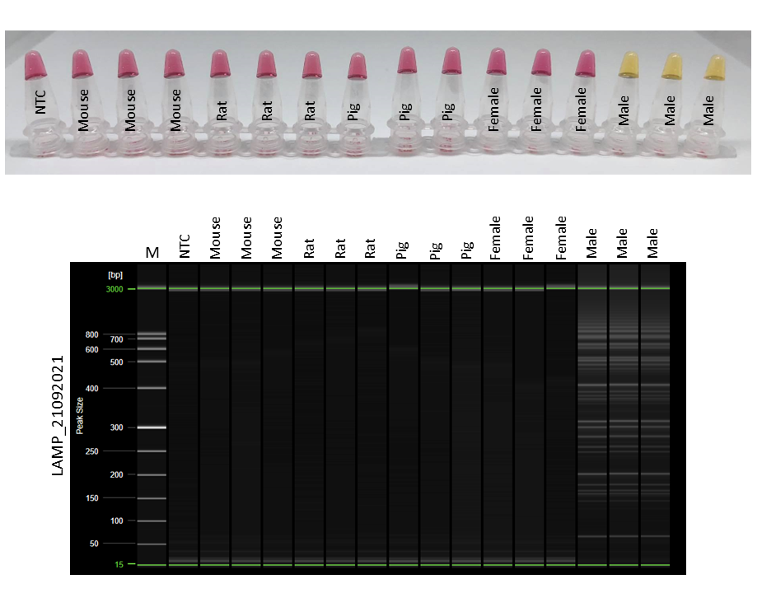
b
a
Supplement table 1 Efficiency of acid phosphatase (AP) test when compared to Y-STR profiling in 92 sexual assault samples.
 | Y-STR (+) | Y-STR (-) | Total | Efficiency
AP (+) | 28 | 32 | 60 | Sensitivity 80%  PPV 46.7%  Specificity 43.9%  NPV 78.1%  Accuracy 57.6%
AP (-) | 7 | 25 | 32
Total | 35 | 57 | 92

Supplement table 2 Efficiency of microscopic examination (ME) when compared to Y-STR profiling in 92 sexual assault samples.
 | Y-STR (+) | Y-STR (-) | Total | Efficiency
ME (+) | 16 | 0 | 16 | Sensitivity 45.7%  PPV 100%  Specificity 100%  NPV 75%  Accuracy 79.3%
ME (-) | 19 | 57 | 76
Total | 35 | 57 | 92

Supplement table 3 Chi square test between AP test and Y-STR profiling in 92 sexual assault samples.
Results | Observed frequency (O) | Expected frequency (E) | (O-E)²/E
AP +, STR + | 28 | 22.83 | 1.17
AP +, STR - | 32 | 37.17 | 0.72
AP -, STR + | 7 | 12.17 | 2.20
AP -, STR - | 25 | 19.83 | 1.35
Total |  |  | X² = 5.44
Supplement table 4 Chi square test between ME test and Y-STR profiling in 92 sexual assault samples.
Results | Observed frequency (O) | Expected frequency (E) | (O-E)²/E
ME +, STR + | 16 | 6.01 | 16.14
ME +, STR - | 0 | 9.91 | 9.91
ME -, STR + | 19 | 28.91 | 3.40
ME -, STR - | 57 | 47.09 | 2.09
Total |  |  | X² = 31.54

Supplement Table 5 DNA concentrations and results of AP, ME, LAMP test and Y-STR profiling of eight swabbing samples from a case study. Yellow highlight indicated positive result from each test.
No | Sample | DNA conc. (ng/µl) | AP | ME | LAMP | Y-STR profiling
 |  |  |  |  |  | No of typable Y-STRs | % of typable Y-STRs
1 | Perianal 1 | 0.62 | - | - | - | 4/25 | 16
2 | Perianal 2 | 0.64 | - | - | - | 7/25 | 28
3 | Endocervical 1 | 1.17 | + | - | + | 4/25 | 16
4 | Endocervical 2 | 0.96 | + | - | - | 3/25 | 12
5 | Internal vaginal 1 | 2.22 | - | - | + | 8/25 | 32
6 | Internal vaginal 2 | 0.54 | - | - | - | 1/25 | 4
7 | Anal 1 | 1.05 | - | - | + | 25/25 | 100
8 | Anal 2 | 1.55 | - | - | + | 16/25 | 64

