Mechanistic evaluation of enhanced graphene toxicity to Bacillus induced by humic acid adsorption

1. Supplementary methods
1.1. Materials and chemicals
1.2. Adsorption of HA on GNSs
1.3. Characterizations
1.4. Oxidative stress
1.5. Cell morphology
1.6. LDH assay
1.7. MDA content
1.8. GSH/GSSG ratio
1.9. ATP content
1.10. Oxygen consumption analysis
1.11. Extracellular ROS level
1.12. DNA oxidation
1.13. Proteomics and transcriptomics
1.14. Band structure calculation
1.15. Statistical analysis
2. Supplementary data and figures
2.1. Adsorption of HA on GNSs
2.2. Characterizations of GNSs-HA
2.3. Oxidative stress
2.4. Membrane damage
2.5. Disturbance of oxidative phosphorylation
2.6. ATP synthesis
2.7. Electron transfer between B. tropicus and graphenes
2.8. Oxidation of bacterial components
2.9. Mechanisms and implications
1. Supplementary methods
1.1. Materials and chemicals
Graphene nanosheets (GNSs) were purchased from XFNANO Materials Tech Co., Ltd. (Nanjing, China). Bacillus tropicus (B. tropicus) was provided by Heilongjiang Provincial Key Laboratory of Environmental Microbiology and Recycling of Argo-Waste in Cold Region (Daqing, China). Escherichia coli k12 (E. coli k12) was purchased from BeNa Culture Collection (Beijing, China). Staphylococcus aureus (S. aureus) was provided by Shenyang Institute of Applied Ecology, Chinese Academy of Sciences. Bacillus subtilis (B. subtilis) was provided by Molecule and Microbial Natural Product laboratory (Dr. Liwei Liu, Ningbo University). HCl and NaOH were purchased from Tianjin Kemio Chemical Reagent Co., Ltd. 2,7-Dichlorodihydrofluorescein diacetate (DCFH-DA) was purchased from Beijing Puyihua Tech Co., Ltd. (Beijing, China). Hydrogen peroxide (H₂O₂) and ethyl alcohol were purchased from Tianjin Damao Chemical Reagent Factory. Ammonia was purchased from Shenyang Xinhua Reagent Factory. PBS buffer was purchased from Beijing Solarbio Science &Technology Co., Ltd. Melatonin and HEPES buffer were purchased from Shanghai Macklin Biochemical Co., Ltd. 1,2-Dioleoyl-sn-glycero-3-phosphocholine (DOPC) and Teflon (PTFE) were purchased from Sigma-Aldrich (USA). A Pt wire counter electrode and Ag/AgCl reference electrode were purchased from Wuhan Gaoshi Ruilian Technology Co., Ltd.
Humic acid (HA) was purchased from Sigma-Aldrich (USA) and underwent the following treatment before use. HA was dissolved in 0.01 M NaOH solution under ultrasonication, followed by adjusting the solution pH to 7.0 with 1.0 M HCl. The solution was centrifuged at 7000 g for 30 min, and then the supernatant was left standing overnight. HA was dialyzed through a dialysis membrane (1000 Da, Bluescape Scientific) to remove the chloride ions, and nitrate was used as a tracer agent to test chloride ions. The concentration of HA was quantified by UV absorbance at 254 nm (UV-2700, Shimadzu Corporation).
1.2. Adsorption of HA on GNSs
The batch equilibration technique was conducted to monitor the adsorption of HA on GNSs. A specific amount of GNSs was mixed with HA solution (pH=7) in a 20 mL glass vial sealed with Teflon-lined screw cap. For adsorption kinetics experiments, the final concentration of HA and GNSs in the mixture were 10 and 200 μg mL⁻¹, respectively. For the adsorption isotherm experiments, 1-50 μg mL⁻¹ of HA and 200 μg mL⁻¹ of GNSs were used. The solution pH was adjusted to 7.0 in all the groups and the vials were shaken at 150 rpm for 24 h to reach equilibrium. The mixture was centrifuged at 4000 rpm for 30 min, and then the concentration of HA in the supernatant was determined by UV absorbance at 254 nm. The precipitate obtained from the group of 50 mg mL⁻¹ HA was defined as the complex of GNSs and HA (GNSs-HA), which was collected and stored in a sealed sample vial followed by lyophilization. All adsorption experiments were repeated at least three times and the results were reported as mean values.
The experimental data of adsorption kinetics were analyzed by fitting with quasi-first-order dynamics model (Equation 1) and quasi-second-order dynamics model (Equation 2).
(1)
(2)
Where Q_{t} (mg g⁻¹) and Q_{e} (mg g⁻¹) are the adsorption capacity of GNSs at t (min) and equilibrium time respectively; K₁ and K₂ (g mg⁻¹ min⁻¹) are the rate constants of quasi-first order and quasi-second-order dynamics models, respectively.
The sorption isotherms were fitted to the Langmuir model (Equation 3) and Freundlich model (Equation 4).
(3)
(4)
Where Q_{max} (mg g⁻¹) is the theoretical maximum adsorption capacity, Q_{m} (mg g⁻¹) is the theoretical saturated adsorption capacity, C_{e} (μg mL⁻¹) is the remaining adsorbent in the solution, and K_{L} (L mg⁻¹) is the Langmuir model constant; K_{F} (L mg⁻¹) and n are the Freundlich model constants.
1.3. Characterizations
X-ray photoelectron spectroscopy (XPS) measurement was conducted on a ESCALAB250 (Thermo VG) with a monochromated Al Kα X-ray source. The infrared spectra were recorded by Fourier transform infrared spectroscopy (FTIR, Thermo Scientific) in the region of 400−4000 cm⁻¹ with a resolution of 2 cm⁻¹. The morphology of GNSs and GNSs-HA were observed by scanning electron microscopy (SEM, S3400 II, Hitachi, Japan). The thickness and lateral size were characterized by atomic force electron microscopy (AFM, Agilent 5100, USA) in tapping mode in air. Raman spectra of GNSs and GNSs-HA were obtained by Raman spectroscopy (Thermo, Themol DXR, USA) with an excitation wavelength of 780 nm and scanning range from 60 to 1200 cm⁻¹.
1.4. Oxidative stress
B. tropicus (10⁹ CFU mL⁻¹) was co-cultured with GNSs and GNSs-HA (1, 10, 50, 100, 200 μg mL⁻¹) for 2 and 12 h at 37 ℃. The bacterial cells were centrifuged at 10,000 rpm for 10 min, and then stained with 2,7-dichlorofluorescin-diacetate (DCFH-DA, 10 μM) for 30 min at 37 °C. After staining, the cells were collected by centrifugation at 10,000 rpm for 10 min, and then washed three times with PBS (pH=7.05) to remove excess dye. The fluorescence was visualized by inverted fluorescent microscopy (DMI300B, Leica, Germany) and quantified by a flow cytometer (BD FACSCalibur, USA).
1.5. Cell morphology
The morphologies of B. tropicus before and after treatment with GNSs or GNSs-HA were observed by SEM. After exposure to GNSs or GNSs-HA (100 μg mL⁻¹) for 12 h, the bacterial cells were centrifuged at 800 rpm for 5 min to remove most GNSs and GNSs-HA from the suspension. The bacterial cells were then collected by centrifugation at 10,000 rpm for 10 min, followed by washing three times with PBS. The bacterial cells were fixed with glutaraldehyde and gradually dehydrated with series concentrations of ethyl alcohol (50%, 70%, 90%, 100%) for 10 min, followed by lyophilization before visualization by SEM.
1.6. LDH assay
The release of lactate dehydrogenase (LDH) was quantified by a LDH cytotoxicity detection kit (Yuchun Bio-tech Inc., China). The bacterial suspension was treated with different concentrations of GNSs and GNSs-HA (0, 1, 10, 50, 100, 200 μg mL⁻¹) for 12 h at 37 ℃. The mixtures were then centrifuged at 10000 rpm for 10 min, and the supernatant was mixed with the reagents according to the manufacturer instructions. The LDH release was measured by microplate reader at 450 nm.
1.7. MDA content
The content of malondialdehyde (MDA) was quantified using a commercial kit (Nanjing jiancheng, China). After treatment with GNSs and GNSs-HA (1, 10, 50, 100, 200 μg mL⁻¹) for 12 h at 37 ℃, the bacterial cells were harvested and disrupted by an ultrasonic processor. After centrifugation, thiobarbituric acid (TBA) was added and the mixture was incubated for 40 min at 95 ℃, and then cooled to room temperature. The absorbance of supernatant at 532 nm was determined by a microplate reader.
1.8. GSH/GSSG ratio
The concentrations of glutathione (GSH) and glutathione disulfide (GSSG) were measured by a commercial kit (Beyotime Biotechnology, China). After treatment with GNSs and GNSs-HA (1, 10, 50, 100, 200 μg mL⁻¹) for 12 h at 37 ℃, the bacterial cells were harvested by centrifugation, followed by washing with PBS. After adding the protein removal reagent (40 μL), the samples were rapidly frozen with liquid nitrogen, thawed in water bath at 37 ℃, crushed with grinding pestle, and placed in ice bath for 5 min. The supernatants were acquired by centrifugation for 5 min at 10000 rpm. The contents of GSH and GSSG were determined according to the manufacturer instructions and the absorbance at 412 nm was measured by microplate reader to calculate the ratio of GSH to GSSG (GSH/GSSG).
1.9. ATP content
The content of adenosine triphosphate (ATP) was quantified using a commercial kit (Biosharp, China). After treatment with GNSs and GNSs-HA (100 μg mL⁻¹) for 12 h at 37 ℃, the bacterial cells were mixed with an ATP extracting solution, and then disrupted by an ultrasonic processor. The supernatants were harvested by centrifugation for 5 min at 10,000 rpm, placed on ice before testing, and mixed with the reagents following the manufacturer instructions.
1.10. Oxygen consumption analysis
To measure the oxygen consumption rate, 100 mL of bacterial suspension with an initial concentration of 10⁵ CFU mL⁻¹ was cultured for 12 h before use. The cells were then harvested by centrifugation (10000 rpm at 4 ℃ for 10 min), washed twice with PBS, and resuspended in 100 mL PBS (pH 7.0). GNSs and GNSs-HA (2000 μg mL⁻¹, 0.5 mL) were added to the bacterial suspension (9.5 mL) to obtain a final concentration at 100 μg mL⁻¹ and were then co-cultured for 30 min at 37 ℃. The real time oxygen content was then measured every 5 min by portable dissolved oxygen analyzer (OHAUS STARTER 400D), and the oxygen consumption rate (%) was represented as follows:
(t = 5, 10, 15, 20, 25 min) (5)
1.11. Extracellular ROS level
A volume of 100 mL of bacterial suspension (initial concentration of 10⁵ CFU mL⁻¹) was incubated for 12 h. The bacterial cells were harvested by centrifugation (10000 rpm at 4 ℃ for 10 min), washed twice, and resuspended in 100 mL PBS buffer (PH 7.0). GNSs and GNSs-HA suspensions (2000 μg mL⁻¹, 0.5 mL) were added to the bacterial suspension (9.5 mL) in the presence or absence of melatonin (1 μg mL⁻¹). The following control groups were prepared: PBS (10 mL), bacterial suspension (9.5 mL) + PBS (0.5 mL), PBS (9.5 mL) + GNSs (0.5 mL), PBS (9.5 mL) + GNSs-HA (0.5 mL), bacterial suspension (9.5 mL) + H₂O₂ (0.5 mL). All groups were incubated for 30 min at 37 ℃ and then centrifuged at 10,000 rpm for 10 min. DCFH-DA (10 μM) was added to the supernatants and the mixtures were incubated for 30 min at 37 °C. The fluorescence intensity was then quantified by using a microplate reader.
1.12. DNA oxidation
The degree of DNA oxidation was evaluated by measuring the content of 8-hydroxy-desoxyguanosine (8-OHdG) using a commercial kit (Beyotime Biotechnology). After treatment with GNSs and GNSs-HA (100 μg mL⁻¹) for 12 h at 37 ℃, the bacterial cells were harvested, washed with PBS once, and resuspended in PBS. The OD₆₀₀ values of all bacterial suspensions were adjusted to 0.3 by microplate reader. The samples were prepared according to kit instructions, and the absorbance was measured at 450 nm by microplate reader.
1.13. Proteomics and transcriptomics
Bacterial cells were incubated with GNSs or GNSs-HA (100 μg mL⁻¹) for 60 min, and the mixtures were centrifuged at 800 rpm for 5 min to remove the agglomerated materials. The suspension was then centrifuged at 10,000 rpm for 10 min to collect the bacterial cells, which were rinsed by PBS three times before transfer to an RNase and DNase free centrifuge tube. The samples were sent to Shanghai Personal Biotechnology Co., Ltd. for prokaryotic transcriptome sequencing and proteomic analysis using Illumina MiSeq sequencing platform or Liquid Chromatography Coupled to Tandem Mass Spectrometry (LC-MS/MS) analysis, respectively (Thermo Scientific). FPKM (fragments per kilobases per million fragments) was used to standardize the levels of gene expression, so as to calculate the transcript abundance. The differentially expression genes (DEGs) were identified by the following standard: the expression difference multiple |log2 Fold Change| > 1 and P < 0.05. All DEGs were mapped to the Kyoto Encyclopedia of Genes and Genomes database (KEGG) and Gene Ontology database (GO). After sequencing, all raw reads were uploaded to the NCBI Sequence Read Archive (SRA, https://submit.ncbi.nlm.nih.gov/subs/sra/) database (Accession number: PRJNA977448). The differentially abundant proteins (DAPs) were identified with the following standard: the expression difference multiple |log2 Fold Change| > 2 and P < 0.05. All DAPs were mapped to KEGG and GO.
1.14. Band structure calculation
The valence band and band gap of HA and GNSs-HA were determined by XPS and UV diffuse reflectance spectroscopy. The band gap diagram was drawn with (αhv)² as the y-axis and hv as the x-axis (hv = hc/λ, c: lightspeed, λ: wavelength of light). The straight line portion in the curve was extrapolated to the x-axis (y = 0), and the intersection point correspond to the band gap value. The conduction band was calculated by the following formula:
Conduction band (eV) = Valence band (eV) – Band gap (eV) (6)
1.15. Statistical analysis
All experiments were performed at least in triplicate and the data were presented as the mean ± standard deviation. Significant differences were determined by the independent t test or one-way analysis of variance (ANOVA). A value of p < 0.05 was considered statistically significant.

2. Supplementary data and figures
2.1. Adsorption of HA on GNSs
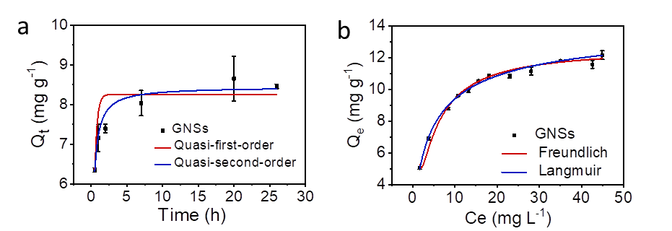
Figure S1. Adsorption kinetics (a) and adsorption isotherms (b) of HA on GNSs at pH 7 and 25 ℃.
The adsorption kinetics of HA on GNSs were well fitted with the pseudo-second-order model,¹ with R² of 0.98 (Figure S1a). This indicates that chemical adsorption played a dominant role, involving either electron sharing or electron transfer between HA and GNSs.² Adsorption process reached equilibrium within 10 h. Adsorption isotherm was better fitted to the Langmuir model (R²=0.99) (Figure S1b), indicating a single layer adsorption process, which was driven by the π - π and hydrophobic interactions between HA and GNSs.³ The theoretical saturated adsorption capacity was calculated to be 14.35 mg g⁻¹.

2.2. Characterizations of GNSs-HA
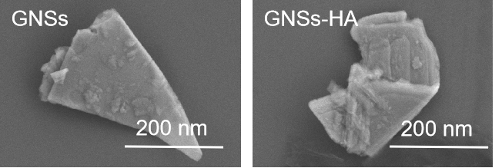
Figure S2. SEM images of GNSs and GNSs-HA.

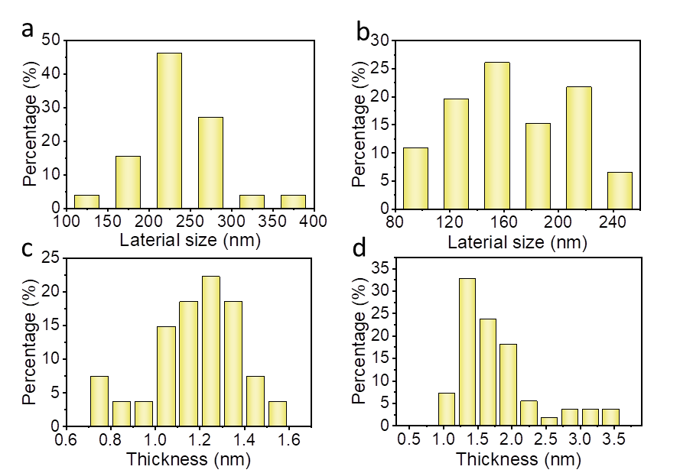
Figure S3. Lateral size distribution of GNSs (a) and GNSs-HA (b); Thickness distribution of GNSs (c) and GNSs-HA (d).

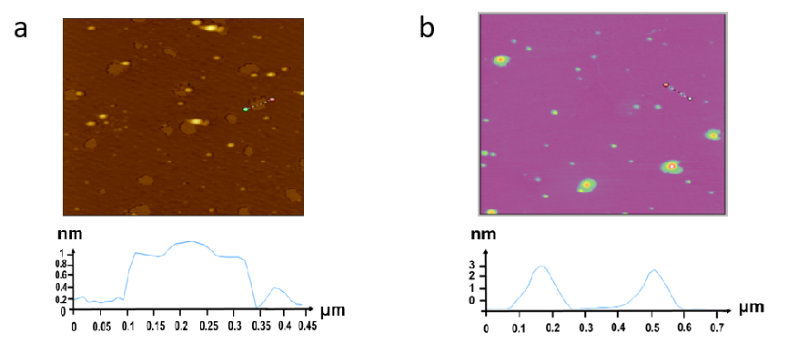
Figure S4. AFM images of GNSs (a) and GNSs-HA (b).

Figure S5. FTIR spectra of HA, GNS, and GNSs-HA.

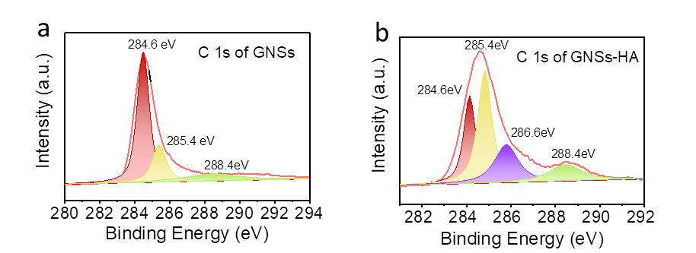
Figure S6. XPS spectra of GNSs (a) and GNSs-HA (b).

Figure S7. Raman spectra of GNSs and GNSs-HA.

After HA adsorption, the smooth lamellar structure of GNSs became rough and uneven (Figure S2), with the average lateral size decreasing from 236.9 ± 50.2 to 169.0 ± 64.0 nm, and the average thickness increasing from 1.1 ± 0.3 to 1.7 ± 0.7 nm (Figure S3 and S4). The interactions between GNSs and HA were further explored by Fourier transform infrared spectroscopy (FTIR), X-ray photoelectron spectroscopy (XPS), and Raman spectroscopy. Compared to the bare GNSs, newly emerged peaks located at ∼3841 and ~3654 cm⁻¹ were observed in the FTIR spectrum of GNSs-HA, due to the stretching vibrations of -OH and -COOH groups in HA (Figure S5).^{4, 5} In the XPS spectrum of GNSs, there were three peaks at 284.6, 285.4, and 288.4 eV (Figure S6a), assigned to C-C, C-OH, and O-C=O groups, respectively, ⁶ indicating that GNSs were slightly oxidized. In contrast, the intensity of C-OH and O-C=O peaks were much stronger and a new peak at 286.6 eV (assigned to C-O) appeared after HA adsorption (Figure S6b).
Raman spectroscopy further isolated changes of the layered structure of GNSs with HA hybridization. Two prominent peaks located at ∼1580 and ∼1313 cm⁻¹ were observed in the Raman spectrum of GNSs (Figure S7), corresponding to the sp² (G) and sp³ (D) hybridized carbon atoms of GNSs, respectively. The I_{D}/I_{G} ratio, representing the structural change of GNSs, decreased from 0.95 to 0.82 after HA adsorption, indicating the disorder degree of GNSs decreased and the crystalline degree increased, thereby improving conductivity.⁷ Moreover, the decreased I_{D}/I_{G} ratio also indicates the existence of the π-π interaction between GNSs and HA, which promotes electronic shuttling between the two analytes.⁸

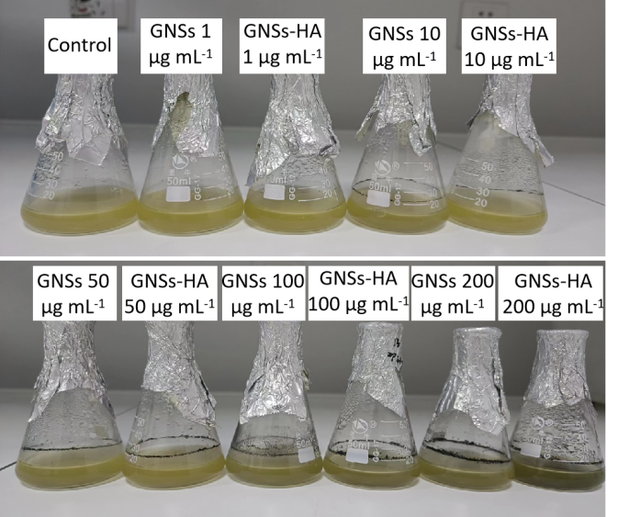
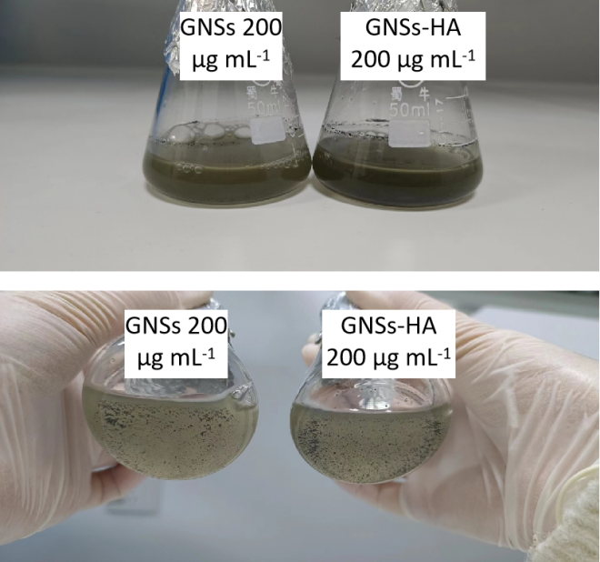
Figure S8. Photos of B. tropicus suspensions co-cultured with different concentrations of GNSs and GNSs-HA.

2.3. Oxidative stress
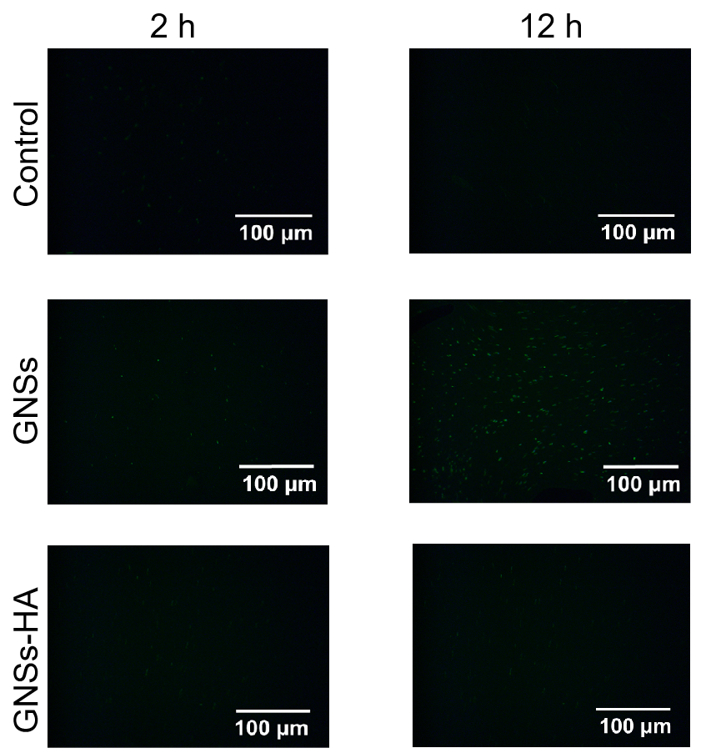
Figure S9. ROS intensity for B. tropicus after 2 or 12 h-exposure to GNSs or GNSs-HA (100 μg mL⁻¹).

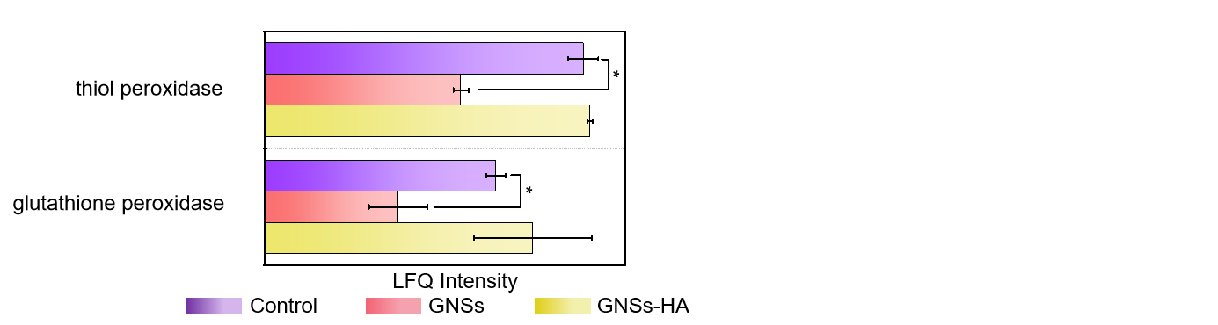
Figure S10. Content of thiol peroxidase and glutathione peroxidase in B. tropicus after GNSs and GNSs-HA treatments.

ROS-dependent oxidative stress is one of the main mechanisms underlying bacterial toxicity from 2D nanomaterials.⁹ Compared to the controls, the proteins that promote GSH oxidation, such as thiol peroxidase (WP_000024528.1) and glutathione peroxidase (WP_000219429.1), were significantly decreased with GNSs (Figure S10), indicating that the oxidation of GSH to GSSG was suppressed. However, the GSH/GSSG ratio decreased instead. Therefore, the oxidation of GSH with GNSs is likely a result of greater ROS.^{10, 11} Interestingly, GNSs-HA did not cause excess ROS in B. tropicus, but still induced GSH oxidation. It has been reported that graphene family, including graphite, graphite oxide, graphene oxide, can act as a conductive bridge over the insulating lipid bilayer to release the cellular energy (2GSH - 2e⁻ = GSSG + 2H⁺).⁹ Therefore, GNSs-HA might have induced GSH oxidation through a non-ROS-dependent pathway.

2.4. Membrane damage
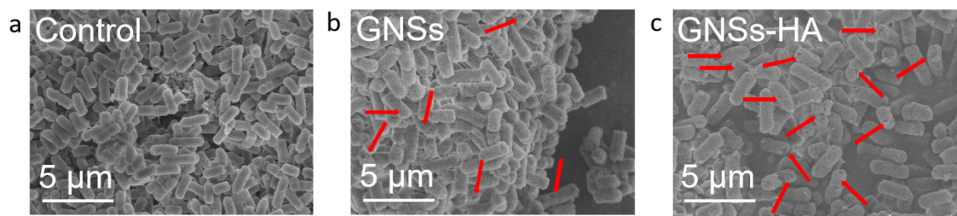
Figure S11. SEM images of B. tropicus before (a) and after GNSs (b) or GNSs-HA (c) treatments at 100 μg mL⁻¹.

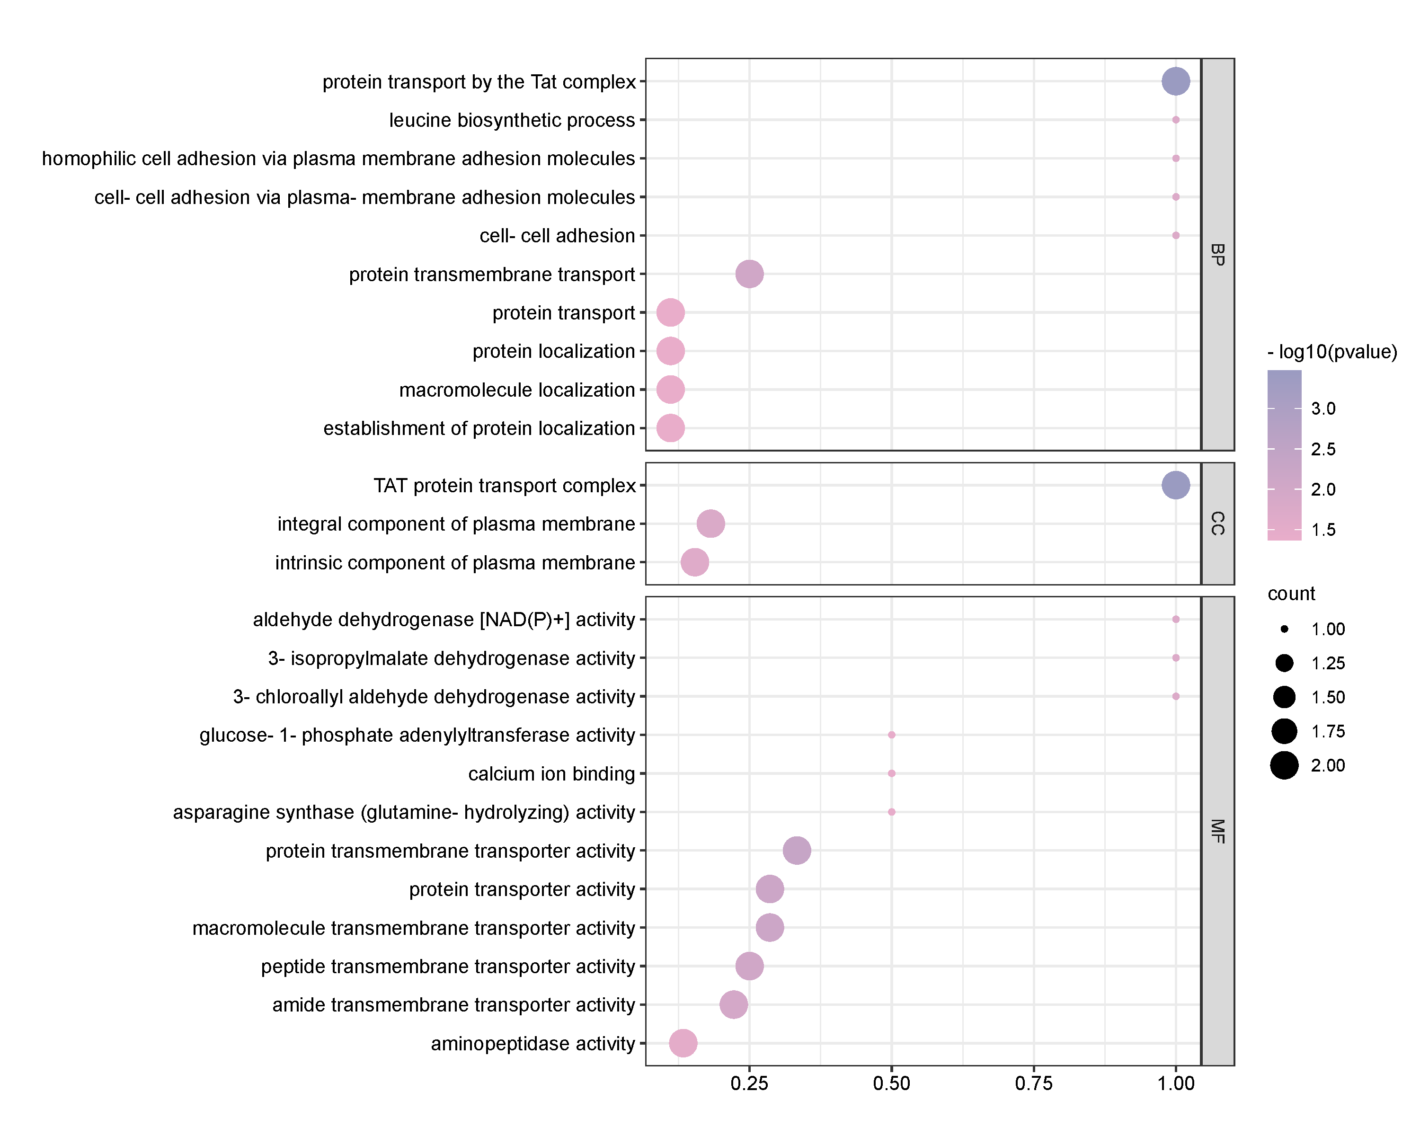Figure S12. Bubble diagram of GO function enrichment of the DAPs in GNSs-HA treatment group.

The proteomic data showed that significant changes in integral component of plasma membrane (GO:0005887) and intrinsic component of plasma membrane (GO:0031226) were observed in B. tropicus treated with GNSs-HA but not GNSs (Figure S12), demonstrating GNSs-HA induced membrane disruption at the protein level.
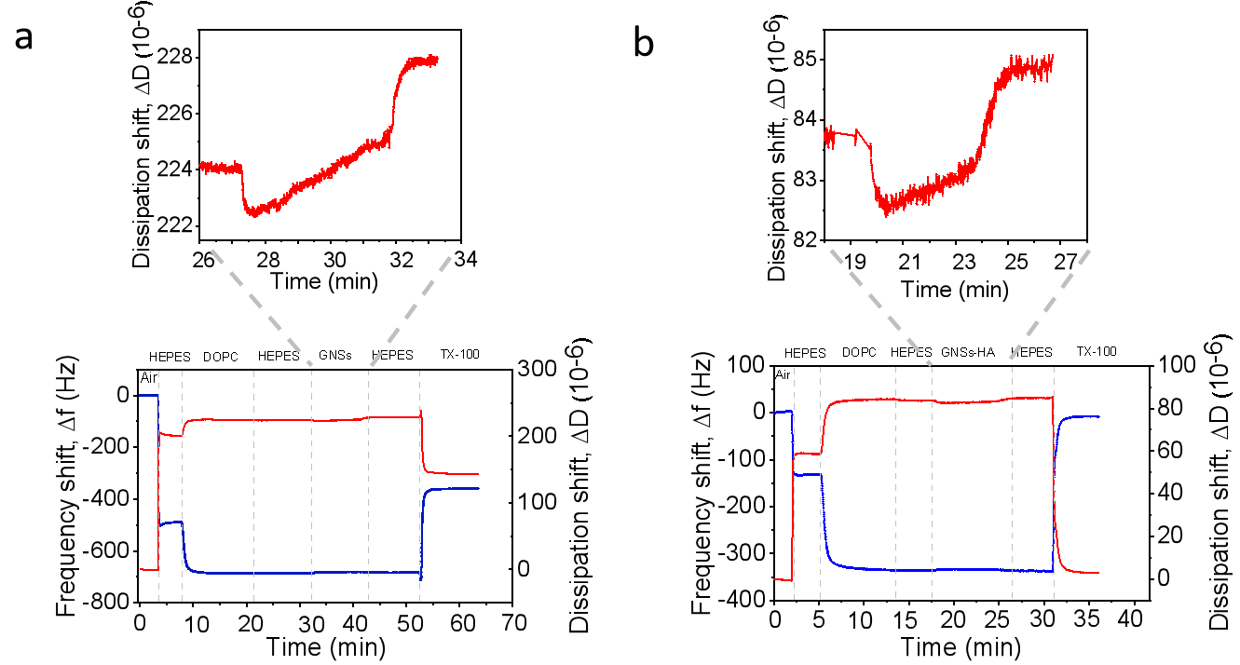
Figure S13. Frequency (blue) and dissipation (red) variations of the DOPC vesicles after adding 100 µg mL⁻¹ of GNSs (a) and GNSs-HA (b) suspensions monitored by QCM-D.

In general, 2D nanomaterials disrupt cell membrane either through physical damage or by inducing chemical reactions as mediated by oxidative stress.¹²⁻¹⁴ Given that HA adsorption has been shown to mitigate physical damage to biological membrane,¹⁵ quartz crystal microbalance with dissipation (QCMD) was used to compare the physical membrane damage caused by GNSs and GNSs-HA on model lipid membranes composed of zwitterionic 1,2-dioleoyl-sn-glycero-3-phosphocholine (DOPC). N-2-hydroxyethylpiperazine-N-ethane-sulphonicacid (HEPES) was introduced as a buffer and a DOPC solution was injected, causing a decrease in frequency and increase in dissipation due to deposition on the sensor. After removing the unattached DOPC vesicles by HEPES, GNSs or GNSs-HA suspensions were passed through the channel, which increased frequency and decreased dissipation, indicating water leakage from the vesicles induced by the membrane damage.¹⁶ Importantly, GNSs elicited a more obvious frequency increase than GNSs-HA (Figure S13), demonstrating greater physical damage to the membrane.
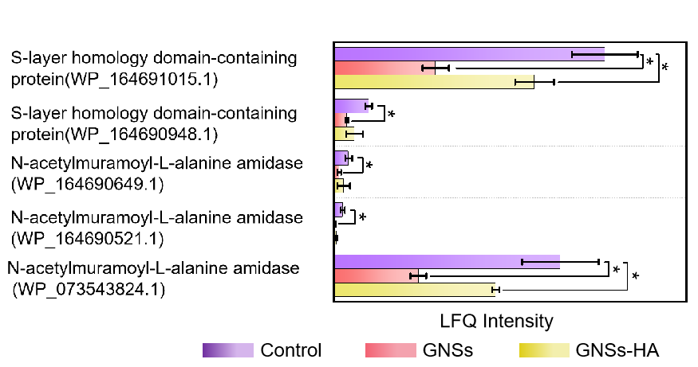
Figure S14. Expression of SLPs after GNSs and GNSs-HA treatments.

2.5. Disturbance of oxidative phosphorylation
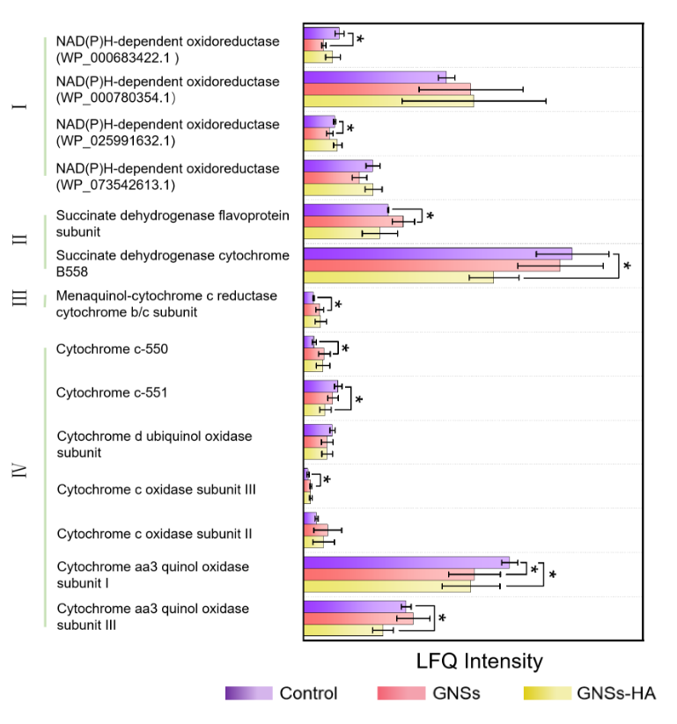Figure S15. Expression of respiratory chain related proteins after GNSs and GNSs-HA treatments.
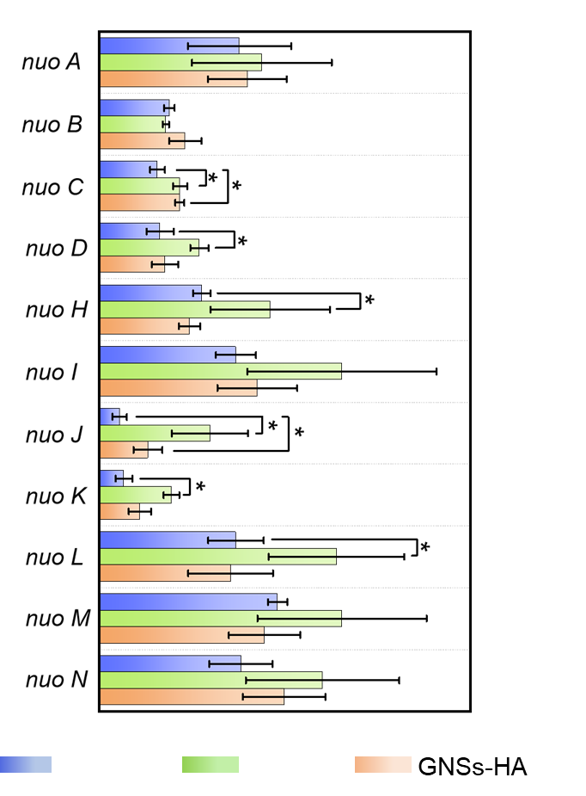
Figure S16. Expression of respiratory chain related genes after GNSs and GNSs-HA treatments.

As most electron transfer related proteins are located on the plasma membrane,¹⁷ the membrane integrity is closely related to respiratory ETC function. The ETC consists of several protein complexes, including complex I (NADH-ubiquinone oxidoreductase), complex II (succinate dehydrogenase), complex Ⅲ (ubiquinol-cytochrome c reductase), and complex Ⅳ (cytochrome oxidase complex). The ETC combines with complex V (ATP synthetase) to constitute the oxidative phosphorylation system, which plays a crucial role in generating ATP to sustain cellular activity.¹⁸⁻²⁰
Multi-omics analyses were used to investigate the effect of GNSs and GNSs-HA on the oxidative phosphorylation system (Figure 3a and S15). In complex I, NAD(P)H-dependent oxidoreductase (WP_000683422.1, WP_025991632.1), was down-regulated in the GNSs group compared to the control. In complex II, succinate dehydrogenase flavoprotein subunit was up-regulated with GNSs, while succinate dehydrogenase cytochrome B558 (WP_000678354.1) was down-regulated with GNSs-HA. Menaquinol-cytochrome c reductase cytochrome b/c subunit (WP_000554603.1), a main component of complex III, was up-regulated with GNSs exposure. Obvious changes in complex Ⅳ were observed with both GNSs and GNSs-HA. GNSs down-regulated aa3 quinol oxidase subunit I (WP_000762372.1) and up-regulated cytochrome c-550 (WP_000828141.1) and cytochrome c oxidase subunit III, while GNSs-HA down-regulated aa3 quinol oxidase subunit I (WP_000762372.1), cytochrome aa3 quinol oxidase subunit III (WP_000729317.1), and cytochrome c-551 (WP_000727964.1). With GNSs, complex Ⅴ, such as F0F1 ATP synthase subunit alpha (WP_000027518.1), was significantly up-regulated, and the F0F1 ATP synthase subunit delta (WP_000064683.1), F0F1 ATP synthase subunit epsilon (WP_000847211.1), and F0F1 ATP synthase subunit B (WP_001142618.1) were significantly down-regulated; importantly, there were no such changes with GNSs-HA. However, the transcriptomic data showed that the expression of genes related to complex I, including nuo L, nuo K, nuo J, nuo H, nuo D and nuo C, were significantly upregulated under GNSs exposure (Figure S16). This upregulation may be due to a stress response at the transcriptional level as a function of decreased complex I.

2.6. ATP synthesis
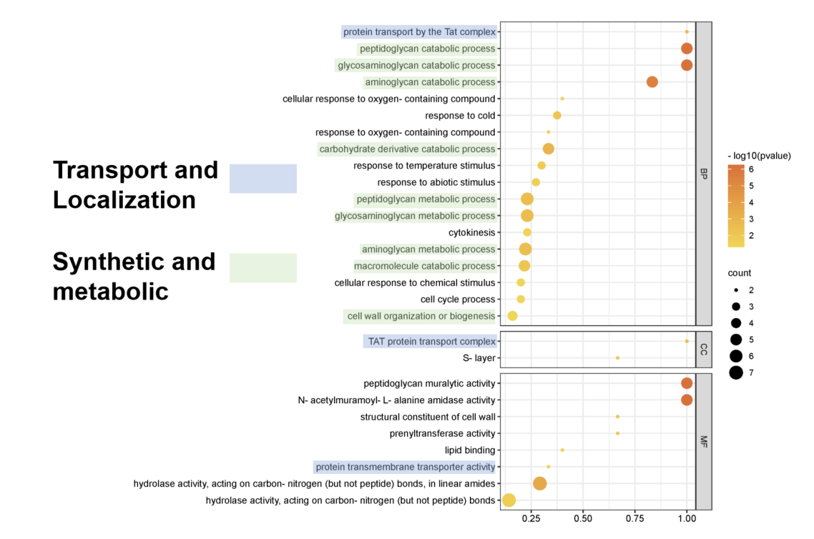Figure S17. Bubble diagram of GO function enrichment of the DAPs in the GNSs treatment group.

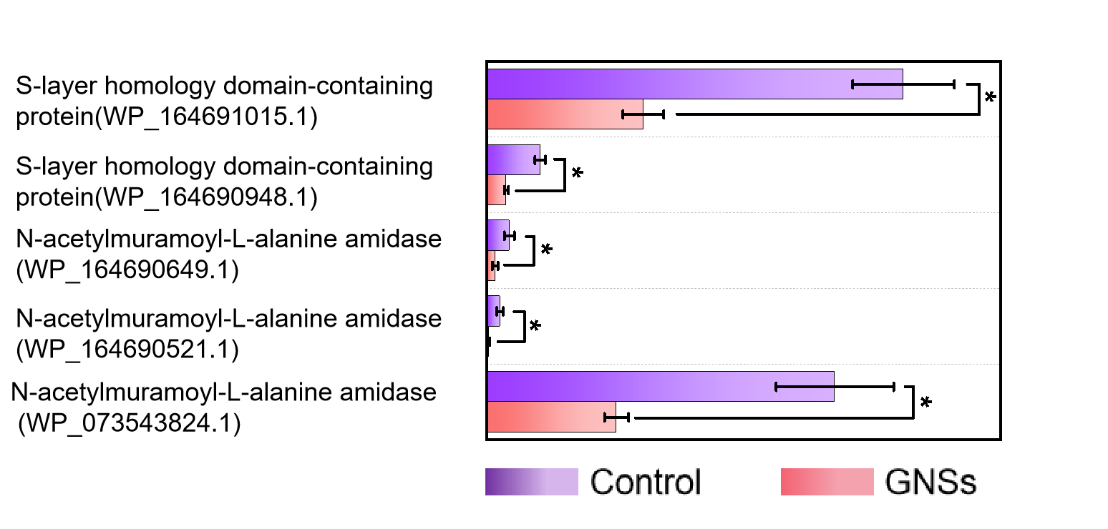
Figure S18. Proteins related to the synthetic metabolic pathways in GNSs treatment group.

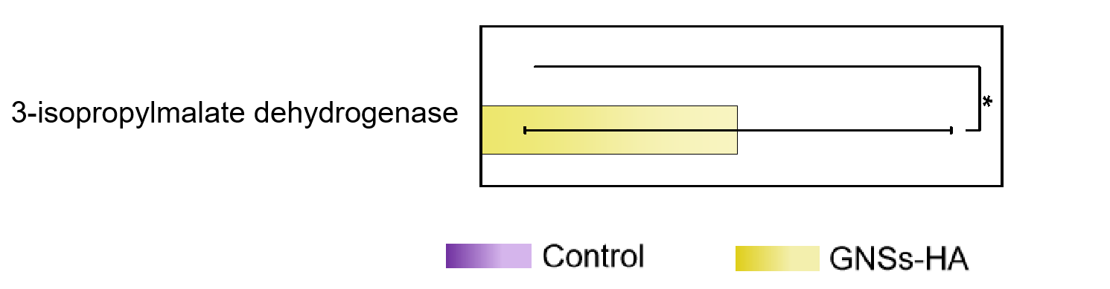
Figure S19. Proteins related to the synthetic metabolic pathway in the GNSs-HA treatment group.

GO enrichment analysis of proteomics data showed that the differentially abundant proteins (DAPs) were enriched in 662 GO terms, with 28 significantly enriched GO terms (p<0.05) from GNSs (100 μg mL⁻¹). These mainly involved metabolic pathways, including catabolic processes related to glycosaminoglycan (GO:0006027), peptidoglycan (GO:0009253), aminoglycan (GO:0006026), carbohydrate derivatives (GO:1901136), and macromolecules (GO:0009057), as well as metabolic processes related to peptidoglycan (GO:0000270), glycosaminoglycan (GO:0030203), and aminoglycan (GO:0006022) (Figure S17). Five DAPs associated with metabolism-related pathways were significantly down-regulated with GNSs treated (Figure S18). GO enrichment analysis of proteomics data revealed that DAPs were enriched in 334 GO terms, with 26 significantly enriched GO terms (p<0.05) in response to GNSs-HA (100 μg mL⁻¹) treatment (Figure S12). Interestingly, only one pathway related to metabolism, specifically the leucine biosynthetic process (GO:0009098), showed significant changes. One DAPs associated with metabolism-related pathways were up-regulated with GNSs-HA treated (Figure S19).

2.7. Electron transfer between B. tropicus and graphenes
The maximum dynamic current density with GNSs was 1 mA cm⁻², which is significantly lower than with GNSs-HA (4.5 mA cm⁻²) (Figure 2d). The Tafel slopes of GNSs and GNSs-HA were 48.8 and 32 mV per decade, respectively (Figure 2e). The lower Tafel slope of GNSs-HA demonstrates that electron transfer was more efficient at a constant overpotential.²¹ Based on electrochemical impedance spectroscopy (EIS) analysis (Figure 2f), HA adsorption decreased the high-frequency semicircle diameter from 35.05 to 34.08, indicating a lower electrochemical impedance.²² In the cyclic voltammetry (CV) curves (Figure 2g,h), the oxidation and reduction peaks with GNSs-HA were stronger than GNSs group, confirming a more efficient electron transfer between GNSs-HA and B. tropicus.

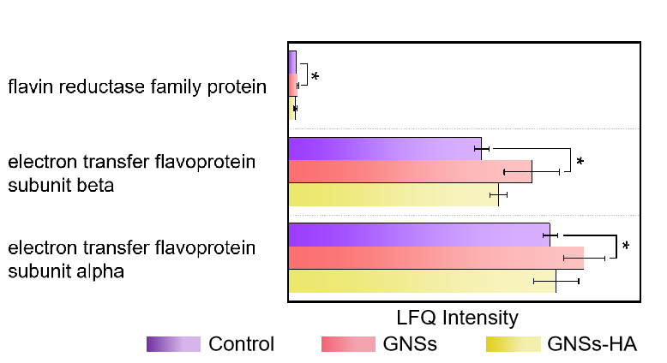
Figure S20. Content of electron transfer related proteins after GNSs or GNSs-HA treatments.

2.8. Oxidation of bacterial components
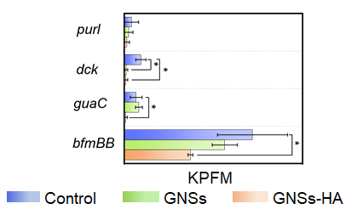
Figure S21. Expression of purine metabolism related genes after GNSs and GNSs-HA treatments.

Several genes related to purine metabolism (Ko00230) were significantly altered under GNSs-HA stress, including the downregulation of bfmBB (I6G77_RS13160), guaC (gene-I6G77_RS19635), dck (I6G77_RS19920), and purl (gene-I6G77_RS21545) (Figure S22).

2.9. Mechanisms and implications
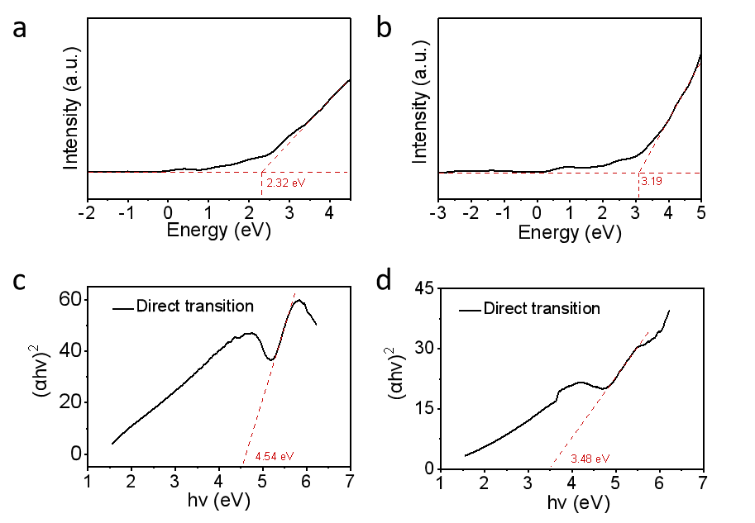
Figure S22. XPS valence band spectra of HA (a) and GNSs-HA (b); Plot of bandgap of HA (c) and GNSs-HA (d).

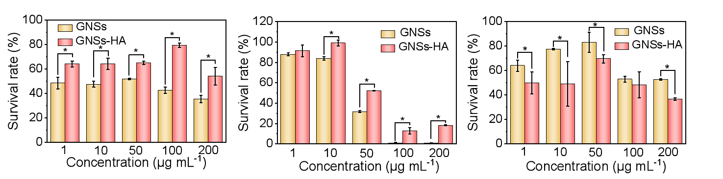
Figure S23. The effect of different concentrations of GNSs and GNSs-HA on the survival rate of E. coli k12 (a), S. aureus (b), and B. subtillis (c).

References
1. Wang, J., Yue, D., Cui, D., Zhang, L. & Dong, X. Insights into Adsorption of Humic Substances on Graphitic Carbon Nitride. Environ. Sci. Technol. 55, 7910-7919 (2021).
2. Ho, Y.S. Review of second-order models for adsorption systems. J. hazard. Mater. 136, 681-689 (2006).
3. Wang, F. et al. Interaction mechanisms of antibiotic sulfamethoxazole with various graphene-based materials and multiwall carbon nanotubes and the effect of humic acid in water. Carbon 114, 671-678 (2017).
4. Cai, W. et al. Natural antioxidant functionalization for fabricating ambient-stable black phosphorus nanosheets toward enhancing flame retardancy and toxic gases suppression of polyurethane. J. hazard. Mater. 387, 121971 (2020).
5. Peng, H., Wang, D. & Fu, S. Tannic acid-assisted green exfoliation and functionalization of MoS2 nanosheets: Significantly improve the mechanical and flame-retardant properties of polyacrylonitrile composite fibers. Chem. Eng. J. 384, 123288 (2020).
6. Deng, C.-H. et al. Graphene–CdS nanocomposite inactivation performance toward Escherichia coli in the presence of humic acid under visible light irradiation. Chem. Eng. J. 284, 41-53 (2016).
7. Chen, W. et al. Black Phosphorus Nanosheets as a Neuroprotective Nanomedicine for Neurodegenerative Disorder Therapy. Adv. Mater. 30, 1703458 (2018).
8. Das, N.M., Singh, A.K., Ghosh, D. & Bandyopadhyay, D. Graphene oxide nanohybrids for electron transfer-mediated antimicrobial activity. Nanoscale Adv. 1, 3727-3740 (2019).
9. Liu S, Z.T., Hofmann M, Burcombe E, Wei J, Jiang R, Kong J, Chen Y. Antibacterial Activity of Graphite,Graphite Oxide, Graphene Oxide, and Reduced Graphene Oxide: Membrane and Oxidative Stress. ACS Nano 5, 6971-6980 (2011).
10. Smirnova, G.V., Oktyabrsky, O.N. Glutathione in Bacteria. Biochemistry 70, 1199-1211 (2005).
11. Zhao, H., Zhang, C., Wang, Y., Chen, W. & Alvarez, P.J.J. Self-Damaging Aerobic Reduction of Graphene Oxide by Escherichia coli: Role of GO-Mediated Extracellular Superoxide Formation. Environ. Sci. Technol. 52, 12783-12791 (2018).
12. Feng, Y. et al. Interaction of Graphitic Carbon Nitride with Cell Membranes: Probing Phospholipid Extraction and Lipid Bilayer Destruction. Environ. Sci. Technol. 56, 17663-17673 (2022).
13. Hu, X., Ouyang, S., Mu, L., An, J. & Zhou, Q. Effects of Graphene Oxide and Oxidized Carbon Nanotubes on the Cellular Division, Microstructure, Uptake, Oxidative Stress, and Metabolic Profiles. Environ. Sci. Technol. 49, 10825-10833 (2015).
14. Zhou, Q. & Hu, X. Systemic Stress and Recovery Patterns of Rice Roots in Response to Graphene Oxide Nanosheets. Environ. Sci. Technol. 51, 2022-2030 (2017).
15. Zhao, J. et al. Humic acid mitigated toxicity of graphene-family materials to algae through reducing oxidative stress and heteroaggregation. Environ. Sci.-Nano 6, 1909-1920 (2019).
16. Zhang, X. et al. Size Effect on the Cytotoxicity of Layered Black Phosphorus and Underlying Mechanisms. Small 13 (2017).
17. Meyer, T.E., Cusanovich, M.A. Discovery and characterization of electron transfer proteins in the photosynthetic bacteria. Photosynthesis Res. 76, 111-126 (2003).
18. BA Haddock, C.J. Bacterial respiration. Bacteriological Rev. 41 (1977).
19. Llorente-Garcia, I. et al. Single-molecule in vivo imaging of bacterial respiratory complexes indicates delocalized oxidative phosphorylation. Biochim. Biophys. Acta 1837, 811-824 (2014).
20. Trounce, I. Genetic control of oxidative phosphorylation and experimental models of defects. Hum. Reprod. 15, 18-27 (2000).
21. Costentin, C. & Savéant, J.-M. Catalysis of Electrochemical Reactions by Surface-Active Sites: Analyzing the Occurrence and Significance of Volcano Plots by Cyclic Voltammetry. ACS Catal. 7, 4876-4880 (2017).
22. Shi, T. et al. Nanohole-boosted electron transport between nanomaterials and bacteria as a concept for nano-bio interactions. Nat. Commun. 12, 493 (2021).

