Supplementary Material
1. Characteristic viscosity molecular weight
The characteristic viscosity molecular weight was determined using the method of J. Qiu et al. [37] with minor modifications. Briefly, sample solutions were fixed at concentrations of 1, 1.25, 1.5, 2, and 2.5 mg/mL and each set of solutions was centrifuged at 5000 rpm and filtered through a membrane of 0.45 μm. The time T_{s} for different samples to pass through the viscometer was recorded at 25°C using an Ubbelohde viscometer (Φ type, 0.4–0.5 mm aperture, taper: 3.792x 10⁻³ mm² s⁻², Hui Chuang Glass Products Co. Ltd., Shanghai, China). The Huggins -Kraemer equation was used to plot [η_{s p}/c] versus c or Ln η_{r} versus c to obtain the characteristic viscosity [η] values. The curves were extrapolated to zero concentration [38].
η_{r} = T_{s/}T₀ (5)
η_{s p} = η_{r} -1 (6)
η_{s p} /c = [η] + k[η]² c (7)
Lnη_{r}/c = [η] + ß[η]² c (8)
[η] = K∙ Mw^{α} (9)
where η _{r} is the relative viscosity, T_{s} is the sample solution efflux time, T₀ is the solvent efflux time, η _{s p} is the incremental viscosity, c is the concentration of the sample solution (g/mL), [η] is the characteristic viscosity, and Mw is the mean relative molecular weight of the viscosity, and K and α are constants that do not depend on Mw. At 25°C, the values of K and α were found to be 3.06 × 10 ⁻¹¹ cm³/g and 1.697, respectively.
Table captions:
Table S1 Viscosity parameters of EPS.
Table S2 Viscosity parameters of MEPS.
Table S3 Viscosity parameters of VEPS.
Table S4 Estimation of average molecular weight of three polysaccharides
Table S1 Viscosity parameters of EPS.

Relative concentration C | Ƞ sp/C | LN ƞr/C | Ƞ sp | Ƞ r
0.4 | 0.0684 | 0.0322 | 0.0274 | 1.0274
0.5 | 0.0727 | 0.0286 | 0.0364 | 1.0364
0.6 | 0.0763 | 0.0241 | 0.0458 | 1.0458
0.8 | 0.0846 | 0.0149 | 0.0677 | 1.0677
1 | 0.0933 | 0.0057 | 0.0933 | 1.0933

Table S2 Viscosity parameters of MEPS.
Relative concentration C | Ƞ sp/C | LN ƞr/C | Ƞ sp | Ƞ r
0.4 | 0.0226 | 0.0178 | 0.0091 | 1.0091
0.5 | 0.0233 | 0.0173 | 0.0117 | 1.0117
0.6 | 0.0239 | 0.0167 | 0.0143 | 1.0143
0.8 | 0.0249 | 0.0156 | 0.0199 | 1.0199
1 | 0.0261 | 0.0148 | 0.0261 | 1.0261

Table S3 Viscosity parameters of VEPS.

Relative concentration C | Ƞ sp/C | LN ƞr/C | Ƞ sp | Ƞ r
0.4 | 0.0241 | 0.0123 | 0.0096 | 1.0096
0.5 | 0.0255 | 0.0107 | 0.0127 | 1.0127
0.6 | 0.0271 | 0.0095 | 0.0162 | 1.0162
0.8 | 0.0298 | 0.0065 | 0.0238 | 1.0238
1 | 0.0326 | 0.0037 | 0.0326 | 1.0326

 | EPS | MEPS | VEPS
Characteristic viscosity [η] | 0.0518 | 0.0204 | 0.0184
Average molecular weight (Da) | 272135 | 157964 | 145955
HPGPC analysis molecular weight (Da) | 265745 | 135413 | 113113
Table S4 Estimation of average molecular weight of three polysaccharides

Figure Captions
Fig. S1 ln sp /c logarithmic viscosity ratios of the three products (EPS, MEPS, and VEPS) and fitting formulae. (a) Linear fitting equation for EPS; (b) linear fitting equation for MEPS; and (c) linear fitting equation for VEPS

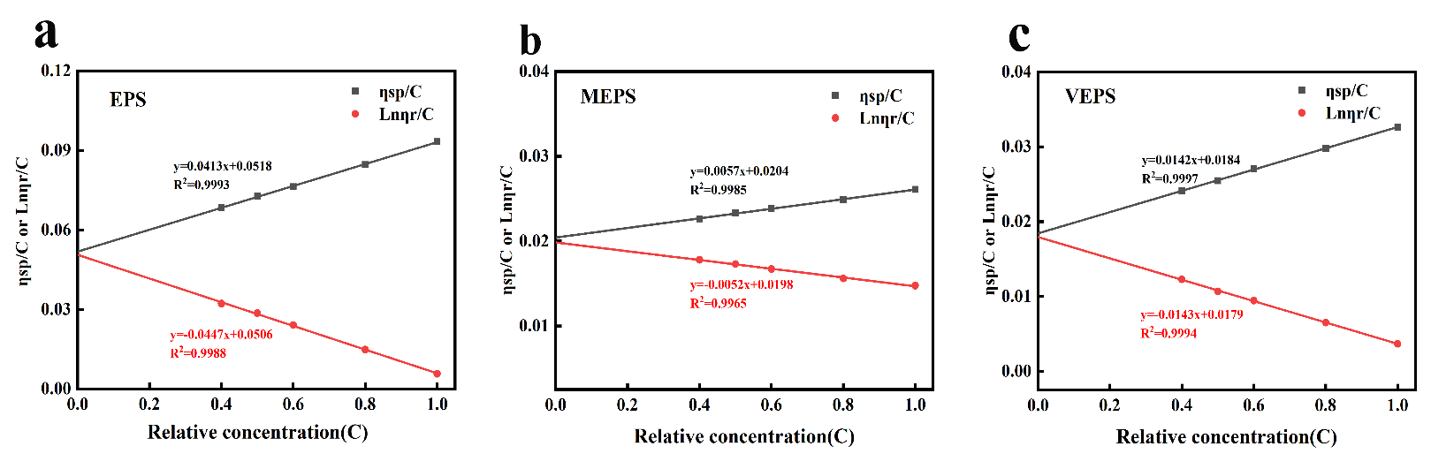
Fig. S1 ln sp /c logarithmic viscosity ratios of the three products (EPS, MEPS, and VEPS) and fitting formulae. (a) Linear fitting equation for EPS; (b) linear fitting equation for MEPS; and (c) linear fitting equation for VEPS

