Supplementary Figures
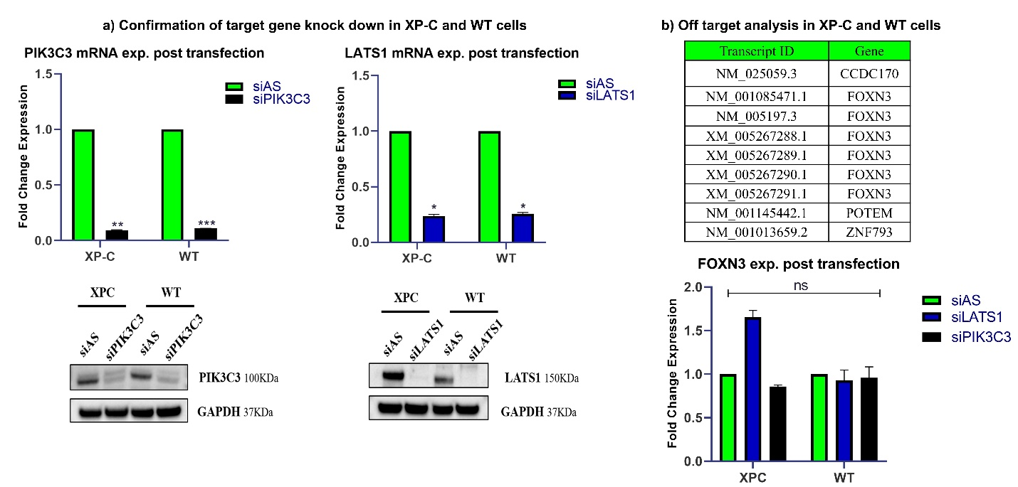
Supplementary Figure 1 Both siLATS1 and siPIK3C3 efficiently downregulate their targets with no common off-targets.
a) Confirmation of target gene knock down in XP-C and WT cells at mRNA and protein level. b) Off-target analysis in XP-C and WT cells using GESS bioinformatics tools and PCR validation that eliminated any doubt of off targets for one gene of interest.

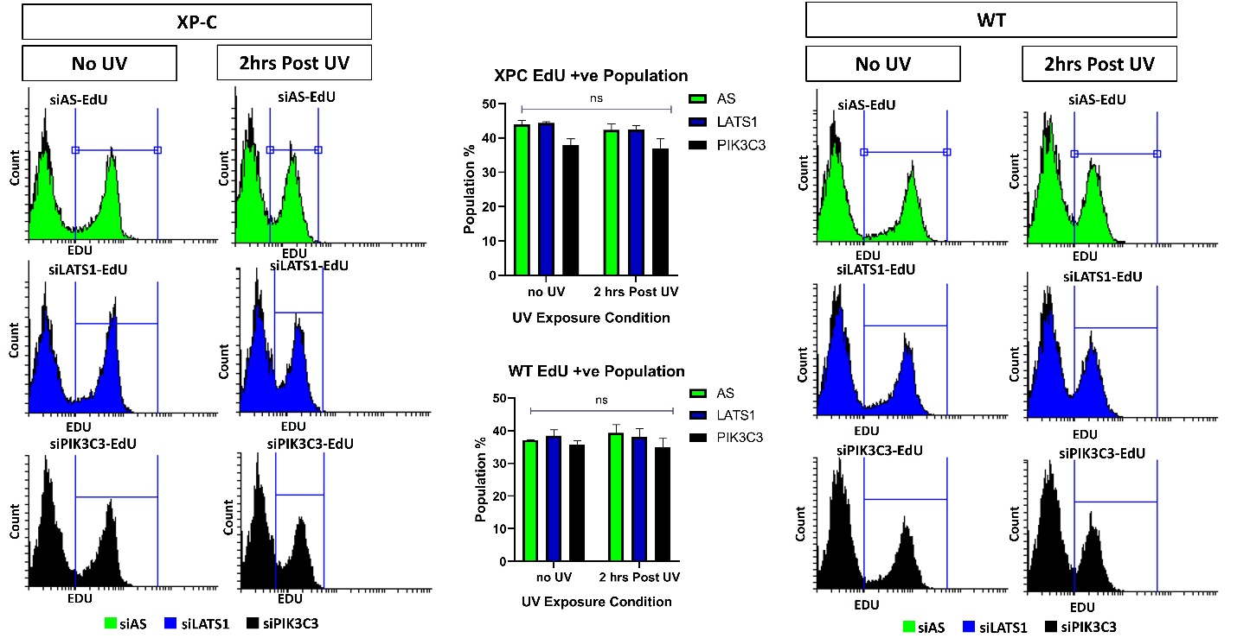
Supplementary Figure2 Same EdU incorporation is evident between siPIK3C3, siLLAST1 and siAS transfected XP-C and WT cell lines.
No difference is seen between the EdU positive populations in the different treatment condition at either 2 or 4 hours post UV.
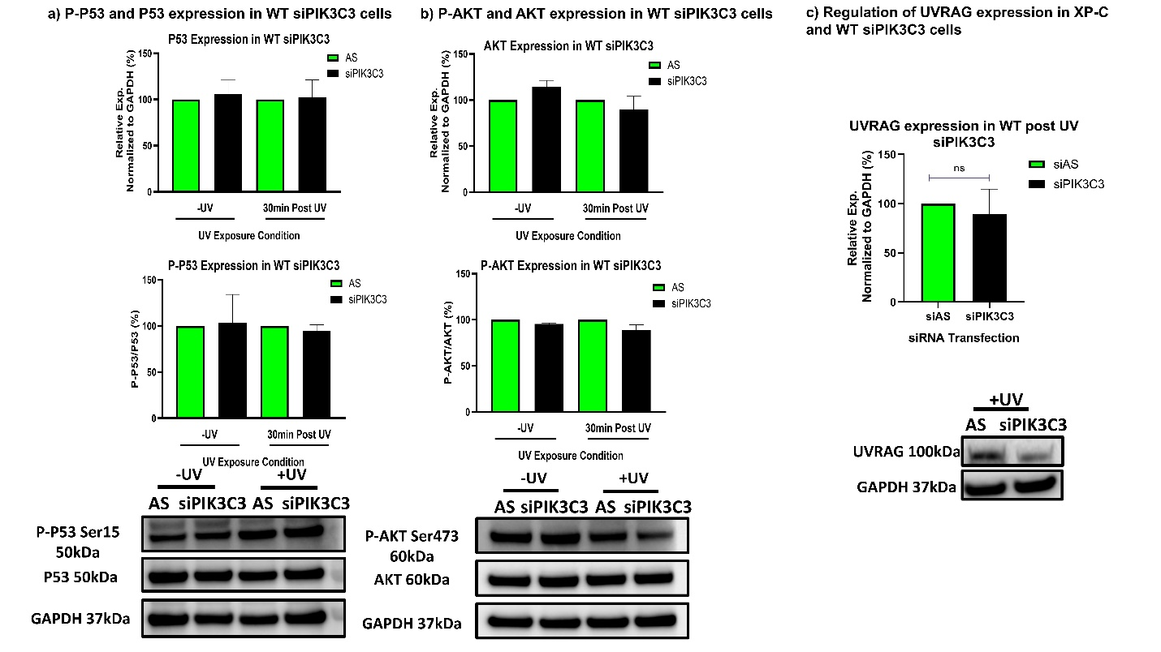
Supplementary Figure3 Downregualtion of PIK3C3 in WT cells manifest differential expression levels of P53, P-P53 Ser15, AKT, P-AKT Ser473 and UVRAG compared to XP-C cells.
a) WT cells showed no significant difference for both phosphorylated proteins profile and expression levels of P53. b) No difference was detected for the expression levels and phosphorylation of AKT. c) Regulation of UVRAG expression in WT. c) UVRAG expression was non-significantly downregulated in WT cells upon siPIK3C3 transfection.

