Supplement:
Climate-induced severe water scarcity events as harbinger of global grain price

Miroslav Trnka^{1,2}, Jan Meitner ^{1,2}, Jan Balek^{1,2}, Song Feng³, Juliana Arbelaez Gaviria ^{1,2,4}, Milan Fischer^{1,2}, Esther Boere^{4,5}, Petr Havlík⁴, Kurt-Christian Kersebaum^{1,6,7}, Claas Nendel^{6,8}, Margarita Ruiz-Ramos⁹, Daniela Semerádová^{1,2}, Mikhail A. Semenov ¹⁰, Markéta Poděbradská^{1,2}, Jan Esper^{1,11}, Ulf Büntgen^{1,12, 13}, Max Torbenson¹¹, Jáchym Brzezina¹, Zdeněk Žalud^{1,2}, Gabriel Katul¹⁴, Jørgen E. Olesen^{1,15,16}

¹Global Change Research Institute CAS, Bělidla 986/4b, Brno, 603 00, Czech Republic, +420 725 950 927; mirek_trnka@yahoo.com

²Department of Agrosystems and Bioclimatology, Mendel University in Brno, Zemědělská 1, Brno 613 00, Czech Republic
³Department of Geosciences, University of Arkansas, Fayetteville, Arkansas, USA, +1 479-575-4748

⁴International Institute for Applied Systems Analysis (IIASA), Schlossplatz 1, A-2361 Laxenburg, Austria

⁵ Vrije Universiteit, VU University Amsterdam, De Boelelaan 1085, 1081 HV Amsterdam, The Netherlands

⁶Leibniz Centre for Agricultural Landscape Research (ZALF), Müncheberg, Germany

⁷Georg August University, Göttingen, Germany

⁸University of Potsdam, Institute of Biochemistry and Biology, Potsdam, Germany

⁹CEIGRAM, Universidad Politécnica de Madrid, 28040 Madrid, Spain
¹⁰Rothamsted Research, Harpenden, Herts, AL5 2JQ, UK
¹¹ Department of Geography, Johannes Gutenberg University, Becherweg 21, 55099 Mainz, Germany
¹²Department of Geography, University of Cambridge, Downing Place, CB2 3EN, UK, +44 1223 760564
¹³Swiss Federal Research Institute WSL, Zürcherstrasse 111, 8903 Birmensdorf, Switzerland
¹⁴ Department of Civil and Environmental Engineering, Duke University, 121 Hudson Hall, Box 90287, Durham, NC 27708-0287
¹⁵Department of Agroecology, Aarhus University, Blichers Allé 20, 8830 Tjele, Denmark, +45 40821659
¹⁶iCLIMATE Interdisciplinary Centre for Climate Change, Aarhus University, Frederiksborgvej 399, 4000 Roskilde, Denmark

Supplementary Table S1. Definitions of severe water scarcity (SWS) used. All conditions must be fulfilled for the evaluated climate grid cell to be categorized as experiencing severe or extreme water scarcity during a given year. The sensitive period (SP) was defined as the four months prior to the harvest of a particular crop. The standardized precipitation evapotranspiration index (SPEI) is employed as it encodes the imbalance between precipitation and potential evapotranspiration. This imbalance captures the duration and severity of a drought event from hydroclimatic variables at large (i.e. climate grid) scales.

 | Description | SPEI threshold for SWS
SPEI: 1 month  Indicating intensive short-term anomaly | SPEI-1 is lower than Threshold_2 (Th_2) for at least one month | Th_1s = not used  Th_2s = -2.0
SPEI: 3 months  Indicating an unusually dry growing season | SPEI-3 is lower than Threshold_1 (Th_1) for at least ¾ of the SP and below Threshold_2 (Th_2) for at least one month | Th_s1 = 0  Th_s2 = -1.5
SPEI: 12 months  Indicating a long-term water anomaly | SPEI-12 is lower than Threshold_1 (Th_1) for at least ¾ of the SP and below Threshold_2 (Th_2) for at least one month during the SP | Th_s1 = 0  Th_s2 = -1.5

Supplemental Table S2. Overview of the best performing linear models for estimating the wheat price index (WPI) based on the area affected by severe water scarcity. The aggregated values indicate the combined performance of the models as the ensemble is expanded by adding additional models to Model_1. The bootstrapping results are part of Fig. 2b.

Name | Full name of model | RMSE | Coefficient of determination | Aggregated RMSE | Aggregated coefficient of determination | Model parameters | Weight in the final model
Model_1 | Arable_w3_lag2 | 31.9 | 0.65 | 31.9 | 0.65 | y=10.410x-62.607 | 0.2673267
Model_2 | WhA10Ex_w3_lag2 | 32.2 | 0.65 | 29.1 | 0.71 | y=5.558x+83.912 | 0.1683168
Model_3 | WhA10Ex_w3_lag1 | 32.6 | 0.64 | 27.9 | 0.73 | y=5.841x+71.766 | 0.2871287
Model_4 | Arable_w2_lag1 | 35.4 | 0.57 | 28.2 | 0.73 | y=11.597x-26.120 | 0.1188119
Model_5 | WhA10Ex _w3_lag3 | 37.6 | 0.52 | 27.9 | 0.73 | y=5.106x+98.764 | 0.1584158

Supplementary Table S3. List of the CMIP5 global circulation models (GCMs) used in this study with brief descriptions. The historical run (i.e., 1850‒2005) and the runs of three future emissions scenarios (i.e., RCP2.6, RCP4.5 and RCP8.5; 2006‒2100) are used from each model. “*” indicates that the simulations under all three future RCPs are available. Otherwise, only RCP4.5 and RCP8.5 are available. The first ensemble run is used if a model is associated with multiple ensemble runs.
 | Model name | Resolution (long. by lat.) | Origin
1* | BCC-CSM1.1 | 2.815 × 2.815 | Beijing Climate Center, China
2* | CanESM2 | 2.815 × 2.815 | Canadian Centre for Climate, Canada
3* | CCSM4 | 1.25 × 0.9 | National Center for Atmospheric Research, USA
4 | CESM1-BGC | 1.25 × 0.9 | National Center for Atmospheric Research, USA
5* | CESM1-CAM5 | 1.25 × 0.9 | National Center for Atmospheric Research, USA
6 | CMCC-CM | 0.75 × 0.75 | Centro Euro-Mediterraneo per i Cambiamenti, Italy
7 | CMCC-CMS | 1.875 × 1.875 | Centro Euro-Mediterraneo per i Cambiamenti, Italy
8* | CNRM-CM5 | 1.40 × 1.40 | Centre National de Recherches Meteorologiques, France
9* | CSIRO-Mk3.6 | 1.875 × 1.875 | Commonwealth Scientific and Industrial Research, Australia
10* | FGOALS-g2 | 2.815 × 3.0 | Institute of Atmospheric Physics, CAS, China
11* | GFDL-CM3 | 2.5 × 2.0 | Geophysical Fluid Dynamics Laboratory, USA
12* | GFDL-ESM2G | 2.5 × 2.0 | Geophysical Fluid Dynamics Laboratory, USA
13* | GFDL-ESM2 M | 2.5 × 2.0 | Geophysical Fluid Dynamics Laboratory, USA
14* | GISS-E2-H | 2.5 × 2.0 | NASA Goddard Institute for Space Studies, USA
15* | GISS-E2-R | 2.5 × 2.0 | NASA Goddard Institute for Space Studies, USA
16 | HadGEM2-CC | 1.875 × 1.25 | Met Office Hadley Centre, UK
17* | HadGEM2-ES | 1.875 × 1.25 | Met Office Hadley Centre, UK
18 | INM-CM4 | 2.0 × 1.5 | Institute for Numerical Mathematics, Russia
19* | IPSL-CM5A-LR | 3.75 × 1.875 | Institut Pierre-Simon Laplace, France
20* | IPSL-CM5A-MR | 2.5 × 1.25 | Institut Pierre-Simon Laplace, France
21 | IPSL-CM5B-LR | 3.75 × 1.875 | Institut Pierre-Simon Laplace, France
22* | MIROC5 | 1.40 × 1.40 | Atmosphere and Ocean Research Institute, Japan
23* | MIROC-ESM | 2.815 × 2.815 | Japan Agency for Marine-Earth Science and Technology, Japan
24* | MIROC-ESM-CHEM | 2.815 × 2.815 | Japan Agency for Marine-Earth Science and Technology, Japan
25* | MPI-ESM-LR | 1.875 × 1.875 | Max Planck Institute for Meteorology, Germany
26* | MRI-CGCM3 | 1.125 × 1.125 | Meteorological Research Institute, Japan
27 | NorESM1-M | 2.5 × 1.875 | Norwegian Climate Centre, Norway

Supplementary Table S4. Overview of the CMIP6 global circulation models (GCMs) used in this study (with brief descriptions). The historical run (i.e., 1850‒2014) and the runs of three future emissions scenarios (i.e., SSP1-2.6, SSP2-4.5 and SSP5-8.5; 2015‒2100) are used from each model. “*” indicates that the simulations under all three future SSPs are available. Otherwise, only SSP2-4.5 and SSP5-8.5 are available. The first ensemble run is used if a model is associated with multiple ensemble runs.
 | Model name | Resolution (long. by lat.) | Origin
1* | ACCESS-CM2 | 1.875×1.250 | Commonwealth Scientific and Industrial Research Organization, Australia
2* | ACCESS-ESM1-5 | 1.875×1.250 | Commonwealth Scientific and Industrial Research Organization, Australia
3* | AWI-CM-1-1-MR | 0.938 × 0.935 | Alfred Wegener Institute, Germany
4* | BCC-CSM2-MR | 1.125 × 1.121 | Beijing Climate Center, China
5* | CanESM5 | 2.813×2.789 | Canadian Centre for Climate Modeling and Analysis, Canada
6* | CanESM5-CanOE | 2.813×2.789 | Canadian Centre for Climate Modeling and Analysis, Canada
7* | CAS-ESM2-0 | 1.406×1.417 | Chinese Academy of Sciences, China
8* | CESM2-WACCM | 1.250×0.942 | National Center for Atmospheric Research, USA
9* | CMCC-CM2-SR5 | 1.250×0.942 | Centro Euro-Mediterraneo sui Cambiamenti Climatici, Italy
10* | CMCC-ESM2 | 1.250×0.942 | Centro Euro-Mediterraneo sui Cambiamenti Climatici, Italy
11* | EC-Earth3 | 0.703×0.702 | EC-Earth Consortium, Europe
12 | EC-Earth3-CC | 0.703×0.702 | EC-Earth Consortium, Europe
13* | FGOALS-f3-L | 1.250×1.000 | Chinese Academy of Sciences, China
14* | FGOALS-g3 | 2.000×2.084 | Chinese Academy of Sciences, China
15* | GFDL-ESM4 | 1.250×1.000 | Geophysical Fluid Dynamics Laboratory, USA
16* | GISS-E2-1-G | 2.500×2.000 | NASA GISS, USA
17* | HadGEM3-GC31-LL | 1.875×1.250 | Met Office Hadley Centre, UK
18* | INM-CM4-8 | 2.000×1.500 | Institute for Numerical Mathematics, Russia
19* | INM-CM5-0 | 2.000×1.500 | Institute for Numerical Mathematics, Russia
20* | IPSL-CM6A-LR | 2.500×1.268 | Institut Pierre Simon Laplace, France
21* | KACE-1-0-G | 1.875×1.250 | Korea Meteorological Administration, Korea
22* | KIOST-ESM | 1.875×1.895 | Korea Institute of Ocean Science and Technology, Korea
23* | MIROC-ES2L | 2.813×2.789 | The University of Tokyo, Japan
24* | MIROC6 | 1.406×1.401 | The University of Tokyo, Japan
25* | MPI-ESM1-2-HR | 0.938×0.935 | Max Planck Institute for Meteorology, Germany
26* | MPI-ESM1-2-LR | 1.875×1.865 | Max Planck Institute for Meteorology, Germany
27* | MRI-ESM2-0 | 1.125×1.121 | Meteorological Research Institute, Japan
28* | NorESM2-LM | 2.500×1.895 | Norwegian Climate Center, Norway
29* | NorESM2-MM | 1.250×0.942 | Norwegian Climate Center, Norway
30* | TaiESM1 | 1.250×0.942 | Academia Sinica, Taiwan
31* | UKESM1-0-LL | 1.875×1.250 | Met Office Hadley Centre, UK

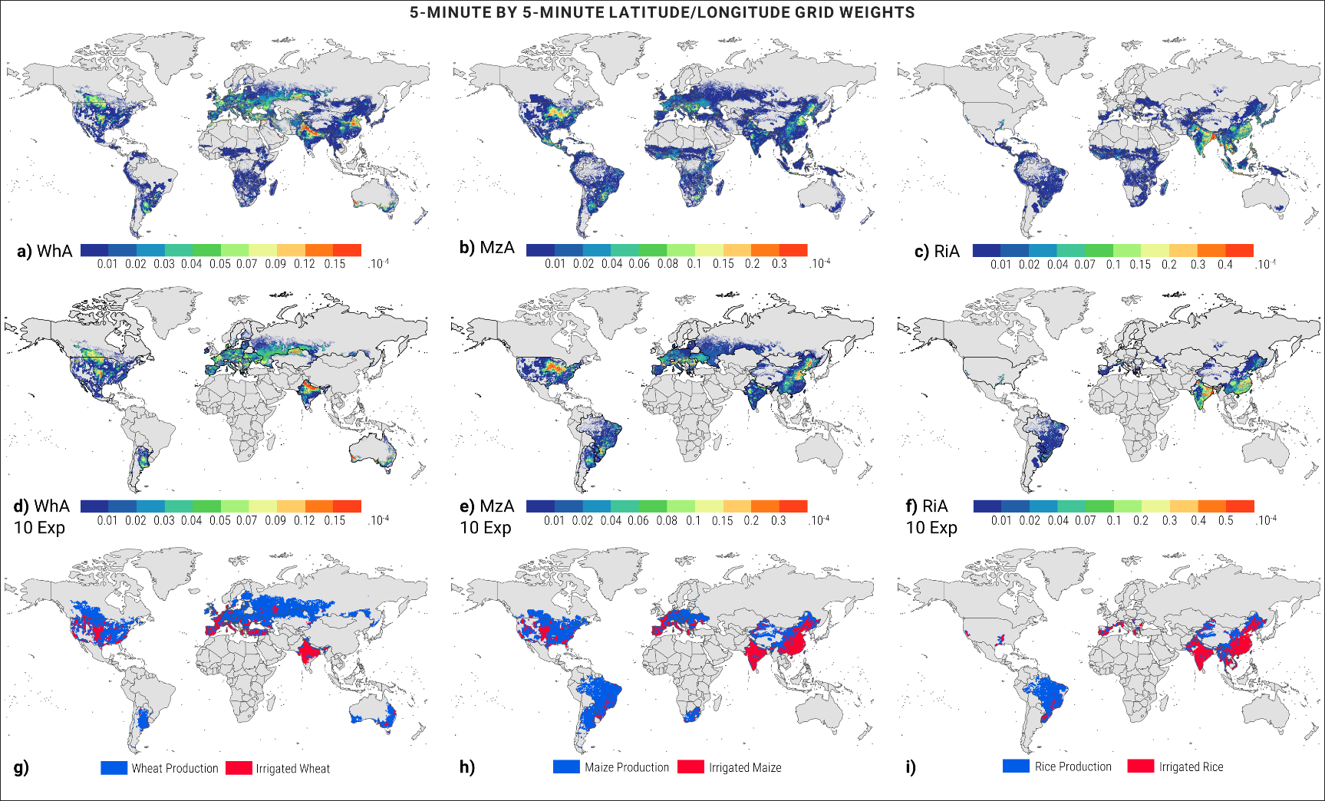
Supplemental Figure S1. Weights of the grids used in this study. a-c) Wheat, maize and rice grids: Grids where the given crop is grown, based on Ramankutty et al. (55), with the weights based on the overall proportion of arable land; d-f) the weights were assigned based on the share of the wheat-, maize- and rice-growing area in the grid in relation to the crop-growing area of the top ten exporters; g-i) indication of the main producing areas and potentially irrigated area of the given crop.
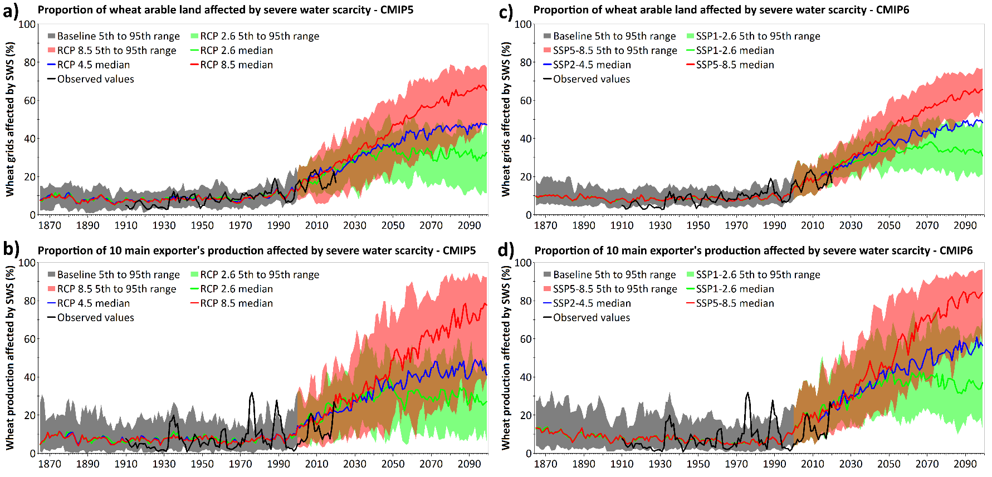

Supplemental Figure S2. Time series of severe water scarcity (SWS) for the entire wheat-growing area (a, c) and area of wheat cultivation of the top 10 wheat exporters (b-d) for the baseline climate and projections based on the CMIP5 (a, b) and CMIP6 (c, d) GCM models.

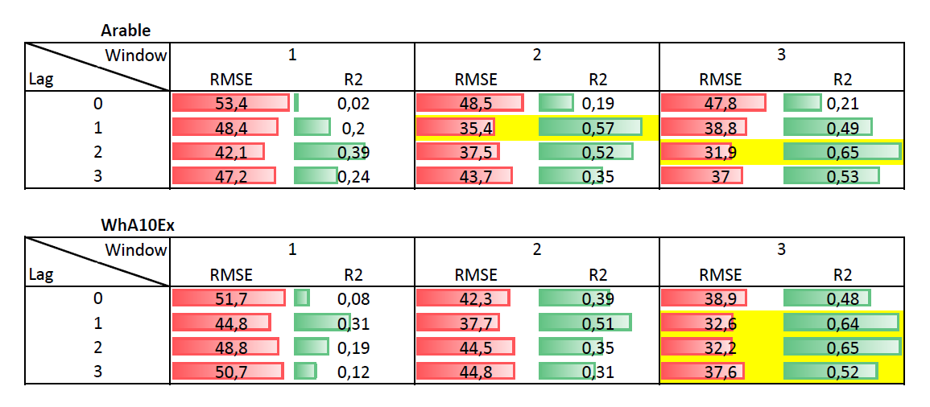
Supplemental Figure S3. Matrix of the tested SWS vs. wheat price index models. The yellow marked combinations yielded the best possible ensemble with the highest explained variability and lowest MBE and RMSE. The final models (marked in yellow) are listed in Table S4.

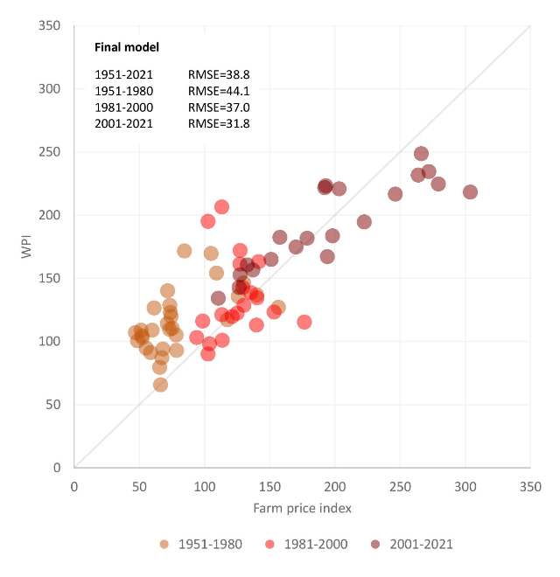
Supplemental Figure S4. Left: Reported farm price index and estimated wheat price index (WPI), which was modeled based on the final model ensemble for the 1951-2021 period with the RMSE of the model estimates provided for 3 periods and the entire 71 years. Right: The same figure but with the colors marking the total arable land area affected by SWS during the three-year window.

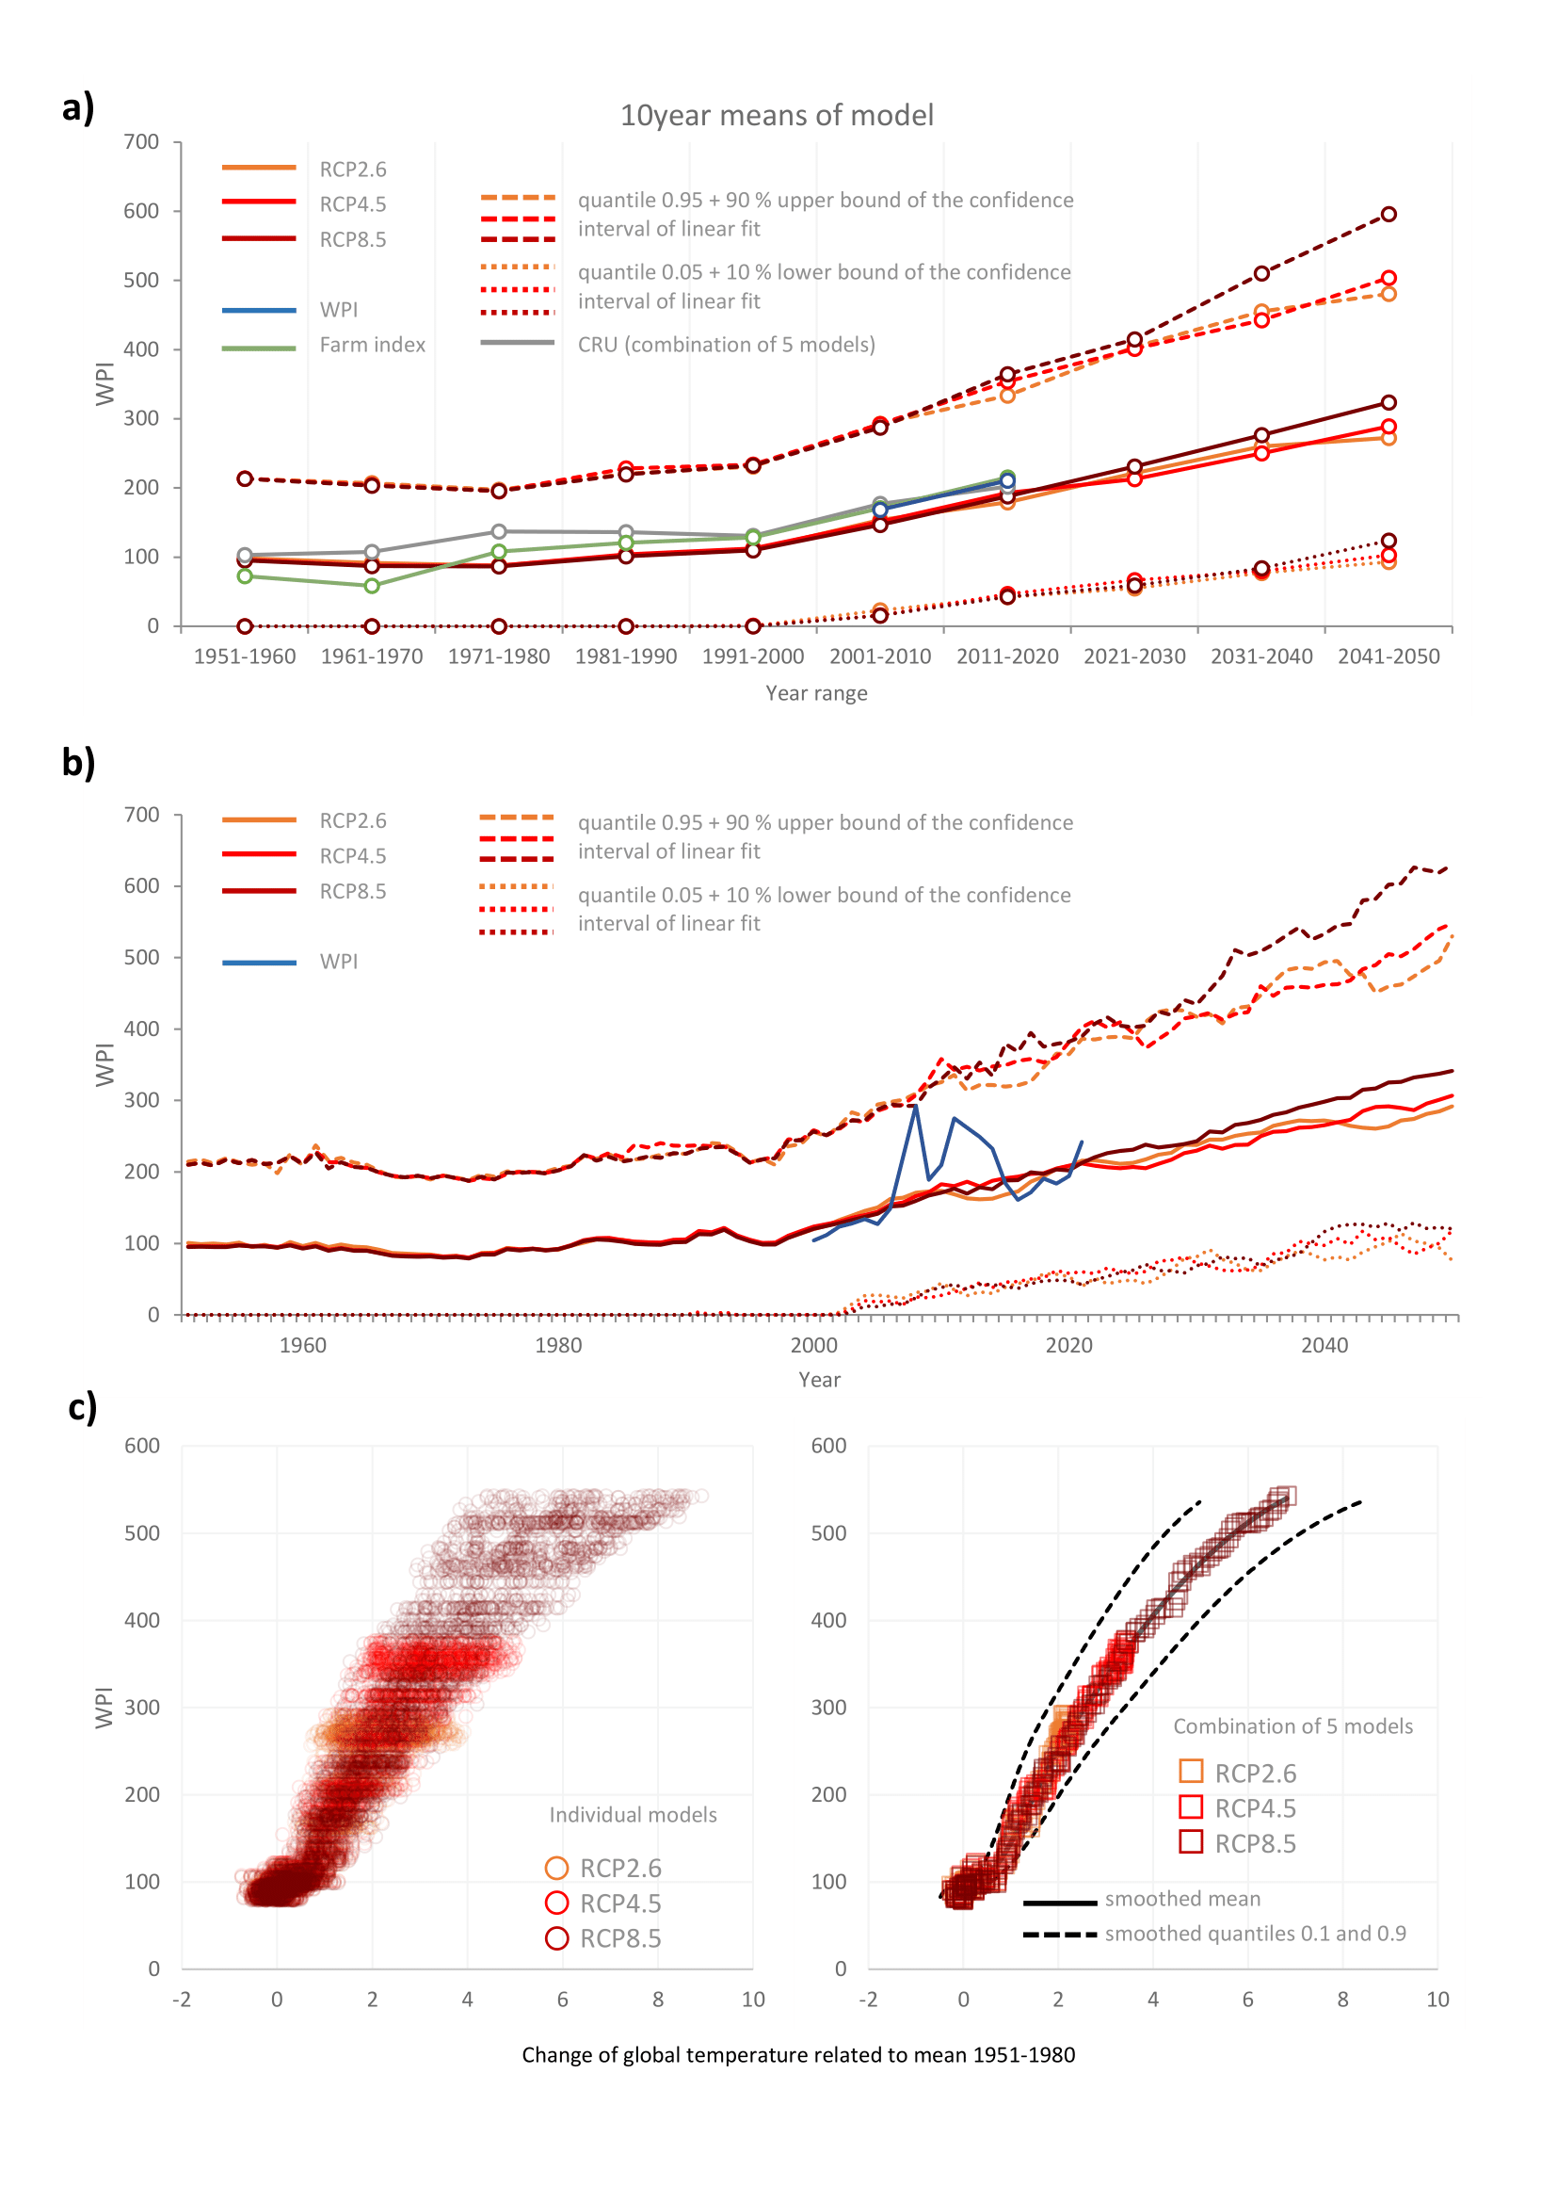
Supplementary Figure S5. Same as Figure 3 but based on the CMIP5 ensemble of GCM models.

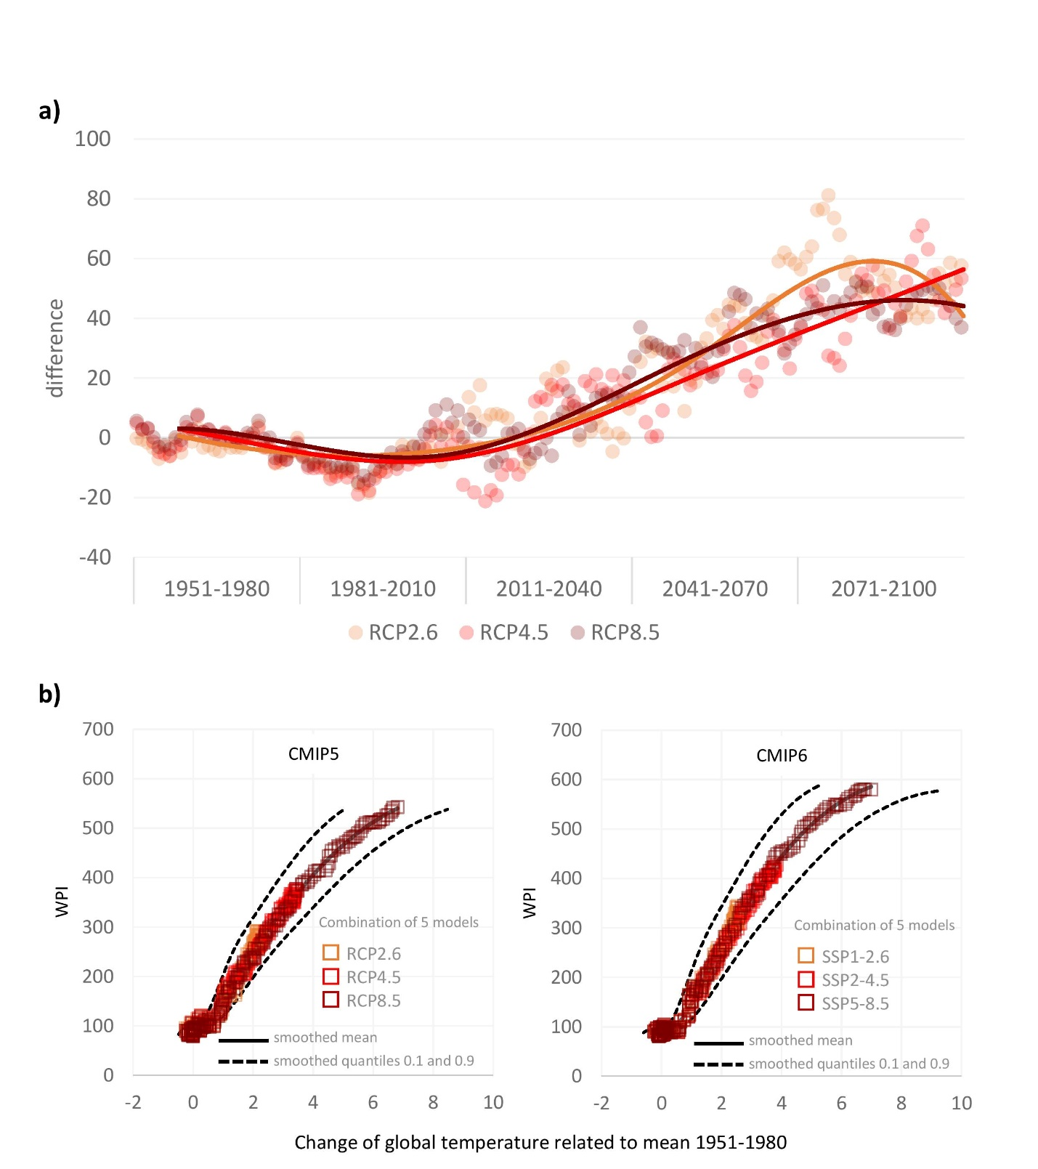
Supplemental Figure S6. Comparison of the wheat price index estimates based on the CMIP5 and CMIP6 GCM model ensembles. a) Difference between the wheat price index (WPI) values estimated by CMIP6 and CMIP5; b-c) relationship between the global mean temperature change and WPI.

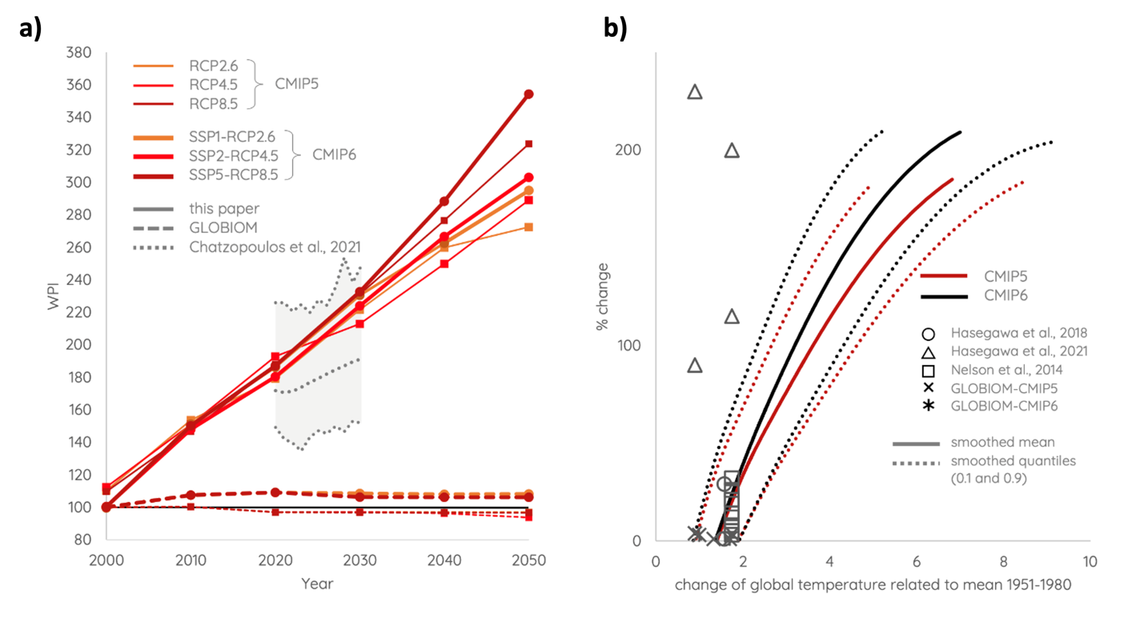

Supplement Figure S7. Comparison of the literature on the wheat price index. a) WPI values estimated by climate change scenarios for CMIP5 and CMIP6 in this paper, Global Biosphere Management Model (GLOBIOM) data vs. the literature between 2000 and 2050. b) Percentage of change in the WPI related to the baseline of this study and the literature for the different levels of global warming (change of global temperature related to mean 1951 - 1980)
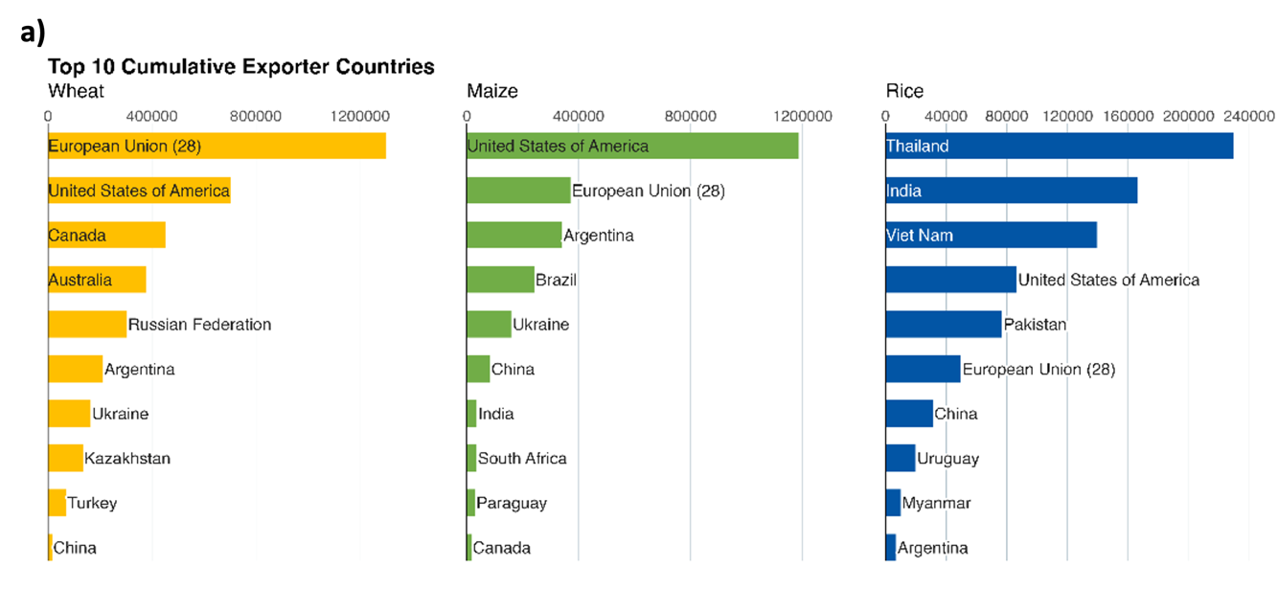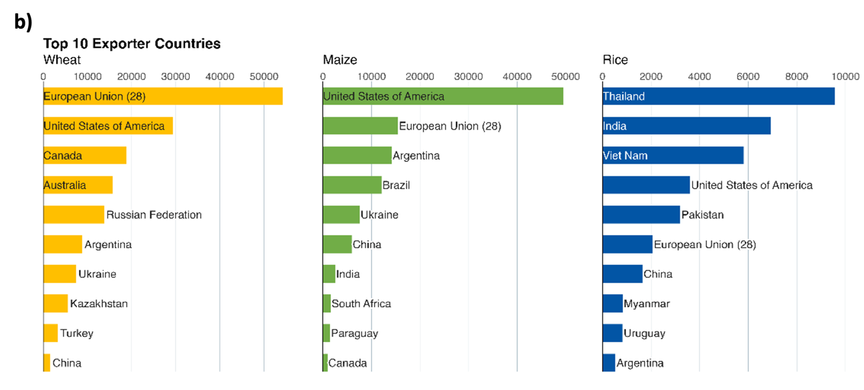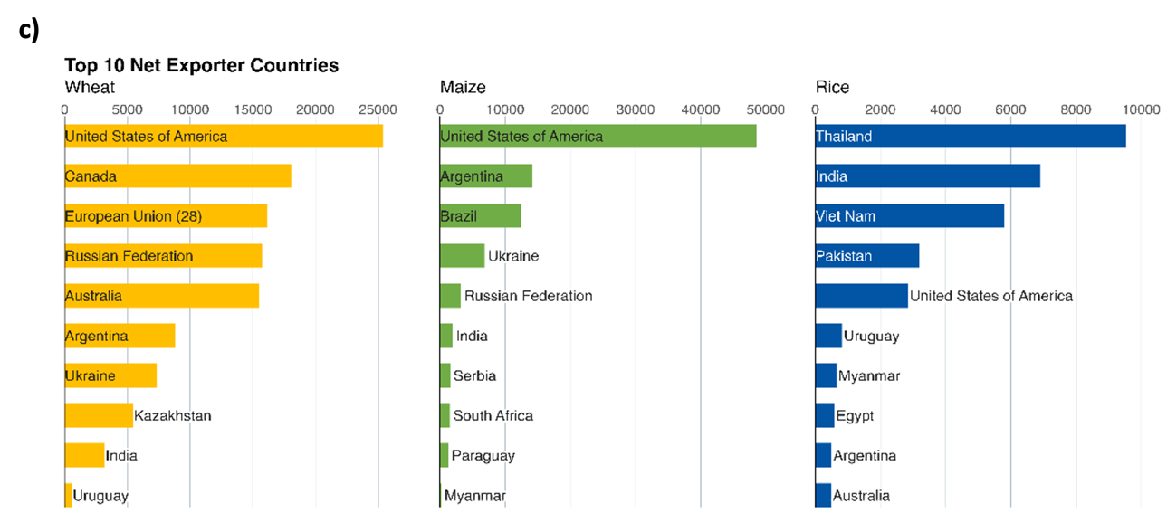
Supplementary Figure S8. Top 10 key player countries in the wheat, maize and rice market between 2000 and 2019 from FAOSTAT. a) Top 10 cumulative exporter countries: sum of total export quantities between 2000 and 2019. b) Top 10 exporter countries: mean of the total export quantities between 2000 and 2019. c) Top 10 net exporter countries: mean of the total export minus total import quantities between 2000 and 2019.

ORCID and contacts of all co-authors
Name | Email | ORCID number | Phone
Miroslav Trnka^{1,2} | mirek_trnka@yahoo.com | 0000-0003-4727-8379 | +420 725 950 927
Jan Meitner ^{1,2}, | meitner.j@czechglobe.cz | 0009-0008-5628-909X | +420730164640
Jan Balek^{1,2}, | balek.j@czechglobe.cz | 0000-0002-2753-3777 | +420607554092
Song Feng³,
Juliana Arbelaez Gaviria ^{1,2,4}, | Arbelaez.j@czechglobe.cz | 0000-0001-8440-1933 | +420 774510248
Milan Fischer^{1,2}, | fischer.m@czechglobe.cz | 0000-0002-7841-9317 | +420 732 342 022
Esther Boere^{4,5}, | Boere@iiasa.ac.at | 0000-0003-3863-8731 | +436607323840
Petr Havlik⁴, | havlikpt@iiasa.ac.at | 0000-0001-5551-5085 | +432236807511
Kurt-Christian Kersebaum^{1,6,7}, | ckersebaum@zalf.de | 0000-0002-3679-8427 | +493343282394
Claas Nendel^{6,8}, | claas.nendel@zalf.de | 0000-0001-7608-9097 | +49 33432 82-355
Margarita Ruiz-Ramos⁹, | margarita.ruiz.ramos@upm.es | 0000-0003-0212-3381 | +34 910671100
Daniela Semerádová^{1,2}, | d.semeradova@gmail.com | 0000-0002-2699-7924 | +420728070691
Mikhail A. Semenov ¹⁰, | mikhail.semenov@rothamsted.ac.uk | 0000-0002-1561-7113 | +44 7577888035
Markéta Poděbradská^{1,2} | Podebradska.m@czechglobe.cz | 0000-0002-3121-4904 | +420737953726
Jan Esper^{1,11}, | esper@uni-mainz.de | 0000-0003-3919-014X | +491716231222
Ulf Büntgen^{1,12, 13}, | Ulf.buentgen@geog.cam.ac.uk | 0000-0002-3821-0818 | +44 1223 760564
Max Torbenson¹¹, | mtorbens@uni-mainz.de | 0000-0003-2720-2238 | +4915751033279
Jáchym Brzezina¹, | Jachym.brzezina@gmail.com | 0000-0002-6649-0351 | +420737387741
Zdeněk Žalud^{1,2}, | zalud@mendelu.cz | 0000-0003-1882-9901 | +420725950925
Gabriel Katul | gaby@duke.edu | 0000-0001-9768-3693 | +01 9196138033
Jørgen E. Olesen¹ | jeo@agro.au.dk | 0000-0002-6639-1273 | +45 40821659

