Supplementary material

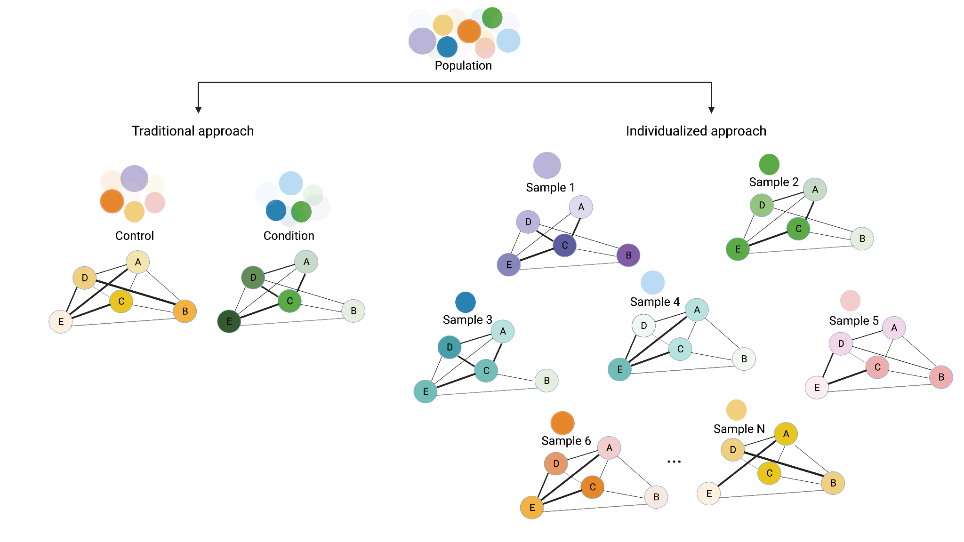
FIGURE S1 | Approaches considered in network analysis in samples: Traditional coexpression networks allow the generation of networks in groups of samples or the whole population to compare cases versus control networks and study specific networks for disease subtypes. However, recent publications have reported a new individualized coexpression networks approach that allows the study of interactions among genes in samples that could trigger changes at the level of pathways. Using new coexpression network strategies has made it possible to study gene expression patterns that differ in individuals and compare them with another level of resolution. After the above, it is still necessary to study how the variability between individuals or cell types can allow us to find differentiated molecular mechanisms and could help in the search for new treatments.

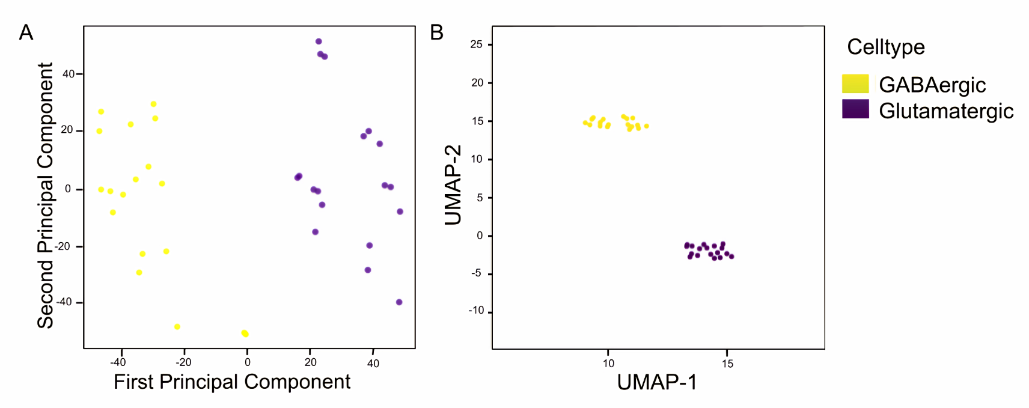
FIGURE S2| Dimensional reduction analysis using expression information of glutamatergic and gabaergic cell types. We developed an analysis in 2 cell types where each point indicates a cell; GABAergic cells are shown as yellow dots and Glutamatergic in indigo dots. (A) Separating the data points associated with the two different cell types suggests that the analysis captures variation relevant to the type. (B) Results of UMAP clustering using transcriptomic information of glutamatergic and gabaergic cell types. Separating the data points of two different cell types suggests that the analysis captures variation relevant to cell type.

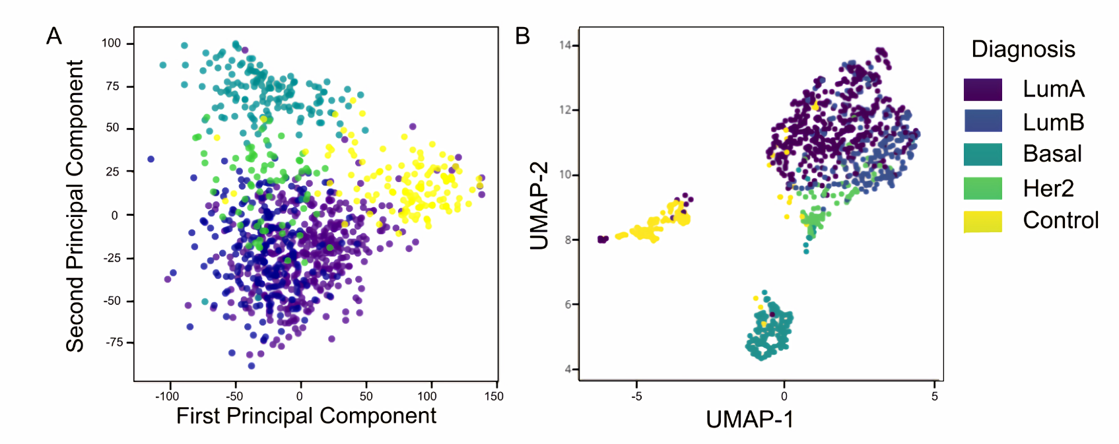
FIGURE S3 | Dimensional reduction analysis using transcriptomic data of Breast cancer dataset.
Analysis was realized in 4 breast cancer subtype: LumA (Luminal A, purple), LumB (Luminal B, blue), basal (turquoise), and Her2 positive (green) and control samples (yellow). (A) PCA of the breast cancer subtypes using transcriptomic data: the plot shows two principal components in this analysis's x and y-axis. The separation of the data points associated with the control and subtypes suggests that the analysis partially captures gene expression variation relevant to the subtypes of the disease. Evaluation of recovered K-means clustering through individualized network distance measurements using Adjusted Rand score and Adjusted Mutual Information. In the bottom, we can see an evaluation of recovered K-means clustering through individualized network distance measurements using Adjusted Rand score and Adjusted Mutual Information.
(B) UMAP representation of four breast cancer subtypes and a control group using distance metrics among individualized coexpression networks. Analysis partially captures gene expression variation relevant to the subtypes of the disease. Evaluation of recovered K-means clustering through individualized network distance measurements using Adjusted Rand score and Adjusted Mutual Information. In the bottom, we can see an evaluation of recovered K-means clustering through individualized network distance measurements using Adjusted Rand score and Adjusted Mutual Information.

