Evaluation of satellite remote sensing-based crop evapotranspiration models over a semi-arid irrigated agricultural farm
TRIDIV GHOSH ¹, DEBASHIS CHAKRABORTY ^{1, *}, BAPPA DAS ², VINAY K SEHGAL ¹, JOYDEEP MUKHERJEE ¹, DEBASISH ROY ¹, POOJA RATHORE¹, RAJKUMAR DHAKAR ¹
¹ Division of Agricultural Physics, ICAR-Indian Agricultural Research Institute, New Delhi
² ICAR-Central Coastal Agricultural Research Institute, Old Goa-403402, Goa
* Corresponding author, EMAIL: debashisiari@gmail.com

Description of the Models used in the study

The Surface Energy Balance Algorithm for Land (SEBAL) model
The SEBAL) is a satellite-based image-processing model which calculates the instantaneous actual evapotranspiration (ET) from a remote sensing image in terms of the latent heat flux (LE). During satellite overpass, LE is calculated for each pixel of the remote sensing image as a leftover from the surface energy balance/budget equation (Eq. 1) (Bastiaanssen et al., 1998)
$LE=R_{n}-H-G$ (1)
Where LE is the latent heat flux (W/m²), Rn is the net radiant flux at the surface (W/m²), G is the soil heat flux (W/m²), and H is the sensible heat flux to the air (W/m²).
For each pixel of the remote sensing image, the model calculates surface energy balance (Eq. 1) and the resistances for momentum, heat, and water vapour transport (Teixeira et al., 2009). Each element of Eq. (1) is calculated by the SEBAL model using land surface data like the normalized difference vegetation index (NDVI), leaf area index, and the surface temperature (Ts), emissivity (ε), and surface albedo (α). In this study, Landsat 8/9 was used to derive the land surface characteristics required by SEBAL using satellite radiances in the visible, near-infrared, and thermal infrared ranges of the electromagnetic spectrum.
Net radiation ($Rn)$ is the actual rate of radiant energy received at the earth surface, which is divided into G, H, and LE. It is expressed mathematically as the difference of all incoming radiant fluxes to all outgoing radiant fluxes and is expressed as
$Rn=\left(1-α \right)Rs↓+RL↓+RL↑+(1-ε_{s})RL↓$ (2)
where $R_{s}↓$ represents the incoming short-wave radiation (W/m²),$α$ is the surface short-wave albedo (dimensionless), $RL↓$ and $RL↑$ are the incoming and outgoing long-wave radiations (W/m²), and $ε_{s}$ means the surface emissivity (dimensionless). $R_{s}↓$ , $RL↓$ and $RL↑$ were computed using standard algorithms described by Allen et al (2011). The albedo (α) was calculated using Eq. 3. We used the "Olmedo" coefficients (Olmedo et al., 2016) which are 0.246, 0.146, 0.191, 0.304, 0.105, and 0.008 for Landsat 8/9 bands 2, 3, 4, 5, 6, and 7.
$α = \sum{W_{band}*r_{band}}$ (3)
W_{band} and r_{band} are the weight/ coefficient and reflectance for specified bands, respectively.
The emissivity ($ε_{s})$ was calculated based on albedo, NDVI, and LAI; if the NDVI <0 and albedo <0.47, then $ε_{s}$ = 0.99, else if LAI >= 3, then $ε_{s}$ = 0.98 and if LAI <3 then $ε_{s}=0.97+(LAI*0.0033)$. The LAI was calculated using an empirical equation given by Allen et al. (2007) (Eq. 4).
$LAI=abs\left(-\frac{\ln\left(\frac{0.69-SAVI}{0.59}\right)}{0.91}\right)$ (4)
Where, SAVI represents the soil-adjusted vegetation index (Huete et al., 1988) (dimensionless) which was calculated using the Landsat band 4 (Red) and 5 (NIR) using the following (Eq. 5)
$SAVI=(1+L)\frac{\left(NIR-R\right)}{NIR+R+L}$ (5)
Where L is a soil correction factor (L = 0.5).
Soil heat flux (G, W/m²) was estimated using a standard empirical equation proposed by Bastiaanssen et al. (2000) (Eq. 6).
$G=Rn *\left(Ts -273.15 \right)(0.0038 \text{+ 0.0074}α\text{)(1 - 0.98NDVI}\text{4}\text{)}$ (6)
where NDVI represents the normalized difference vegetation index (dimensionless) which was calculated using the Landsat band 4 (Red) and 5 (NIR) using the following equation:
NDVI = (NIR - R)/(NIR + R ) (7)
An amount of heat loss to the air caused by a temperature gradient is known as the sensible heat flux (H). It is expressed mathematically as the function of temperature gradient and surface roughness. The surface roughness is determined by wind speed (u). H was calculated using a classical expression (Eq. (8)) found by Farah and Bastiaanssen (2001).
$H=\frac{ρ_{air}CpdT}{r_{ah}}$ (8)
where dT is the difference in near-surface temperature (K) between two near-surface heights, r_{ah} is the aerodynamic resistance (s/m) to heat transport between two near-surface heights, and,$ρ_{air}$ is the air density (kg/m³), cp is the specific heat at constant pressure (J/kg-K),
The two anchor pixels (hot and cold pixels) were identified and selected to estimate dT in equation (8). These pixels represent the extremes of temperature and humidity. In SEBAL, a cold pixel is assumed to be in open water or a fully covered, well-irrigated crop field where surface temperatures (Ts) are roughly the same as air temperatures (Ta). A hot pixel can also be considered a dry, wide field of crops with a zero latent heat flux (LE). For any given pair of Ts, albedo, and NDVI images, the cold and hot pixels were automatically identified and selected using the functions coldTs() and hotTs() provided in the "sebkc" package (Owusu, 2018; available online: https://rdrr.io/github/gowusu/sebkc/).
The r_{ah} was calculated by extrapolating the wind speed from the blending height (typically 200 m) above the ground and using a Monin-Obukhov equation for iterative stability correction. (Monin and Obukhov, 1954). Allen et al. (2011, 2007) provided a detailed description of the procedure.
Instantaneous Evaporative Fraction (EF)
The instantaneous evaporative fraction (EF) is calculated as the ratio of the instantaneous latent heat flux to the net energy (Eq. (9)). When soil moisture and atmospheric moisture conditions are in equilibrium; it is a measure of actual evaporative demand relative to potential evaporative demand (Sun et al., 2011).
$EF= \frac{LE}{LE+H}=\frac{LE}{R_{n}-G}$ (9)
According to Hoedjes and colleagues (2008), EF values remain nearly constant during daylight hours. EF can be used to extrapolate ET from the satellite overpass time to 24-hour (daily) or more extended periods of time, acting as a temporal integration parameter. According to Peng et al. (2013), a daytime evaporative fraction can best be represented between 11:00 AM and 2:00 PM local time. Since the Landsat local overpass time (10:15 AM and 10:30 AM) almost precisely corresponds to these hours and the assumption holds for our study as well.
Daily Actual ET (AET)
The soil heat flux (G) can be disregarded for timescales of one day or longer (such as monthly, seasonal, and yearly), which means the net available energy ($Rn-G$) in the denominator of Eq. (9) reduces to the net radiation (Rn). Therefore, by rearranging Eq. (9) and converting latent heat flux (W/m²) into evapotranspiration (mm/day), the actual evapotranspiration (ET) at the daily time scale can be estimated as shown in Eq. (10).
$ET= \frac{86400 *{10}^{3} }{λ * ρw}EF*Rn$ (10)
Where EF is the evaporative fraction (dimensionless), Rn is the daily average net radiation (W/m²), $ρw$ is the density of water (1000 kg/m³), 86,400*10³ converts metres per second (m/s) to millimetres per day (mm/day), and $λ$ is the latent heat of vaporisation (J/kg), which denotes the amount of heat required to evaporate one kilogramme of water. The calculation of $λ$ was done as a function of the surface temperature using the standard procedure described by Allen et al (2007). EF to ET conversions were done using Eq. 10, and will not be repeated for the following models.

Surface Energy Balance Index (SEBI)
A Surface Energy Balance Index (SEBI) was proposed by Menenti and Choudhury (1993) to estimate ET from EF in dry and wet regions. Based on the extremes in the SEB, relative evaporation is calculated by scaling observed surface temperatures within a maximal range of surface temperatures, thereby providing theoretical upper and lower bounds on the differences between the surface and air temperatures. Since soil water availability for a particular set of boundary layer characteristics is limited, evaporation is assumed to be zero for dry-condition. Therefore, the sensible heat flux density (maximum surface temperature) reaches its maximum value during dry conditions. Ts, max is inverted from the bulk transfer equation, which is expressed as:
${Ts}_{max}= \frac{{rah}_{hot}}{ρ*cp}*({Rn}_{hot}- G_{hot})$ (11)
Where ${rah}_{hot}$is the aerodynamic resistance in s/m at the hot pixel, ${Rn}_{hot}$ and $G_{hot}$ are the net radiation and ground heat flux at hot pixel, respectively.
From Eq. (11), we can compute the minimum surface temperature in the wet region by computing the potential ET assuming no internal resistance.
${Ts}_{min}= \frac{{rah}_{cold}}{ρ*cp}*\left({Rn}_{cold}-G_{cold}\right)-\frac{\frac{1}{γ}*(e_{s}-e_{a})}{1+\frac{∆}{γ}}$ (11)
Here, the ${rah}_{cold}$, ${Rn}_{cold}$, and $G_{cold}$ represents aerodynamic resistance, net radiation, and ground heat flux at the cold pixel, respectively. $∆$ is the slope of the saturation vapor pressure, and γ is the psychrometric constant equal to 0.066 kPa C⁻¹, e_{a} and e_{s} are actual and saturation vapour pressure, respectively, $ρ$ is the density of air, γ is the psychrometric constant.
To calculate the relative EF, the observed surface temperature must be interpolated between the maximum and minimum surface temperatures as follows:
$EF=1-\frac{\frac{dT}{r_{ah}}-\frac{{Ts}_{min}}{{rah}_{cold}}}{\frac{{Ts}_{max}}{{rah}_{hot}}-\frac{{Ts}_{min}}{{rah}_{cold}}}$ (12)
$dT= \frac{H-r_{ah}}{ρ*cp}$ (13)

Surface Energy Balance System (SEBS)
Su (2002) proposes the Surface Energy Balance System (SEBS) for estimating atmospheric turbulent fluxes and the EF using satellite earth observation data and meteorological data at appropriate scales. Unlike in SEBAL, where anchor pixels delineate the energy balance boundary conditions, the SEBS model does not require the selection of hot and cold pixels. In SEBS, sensible heat flux (H) is calculated iteratively by solving the relationships for the frictional velocity layers, the difference (∆𝛳, K) between the near-surface potential air temperature (Ta) and Ts, and the Monin-Obukhov length. To compute EF, the SEBS algorithm uses relative evaporation (EF_{r}) derived from H at dry (H_{dry}) and wet limits (H_{wet}) (Eq. (14)) (Su, 2002). Evaporation occurs at a potential rate at H_{wet}, and H is at its lowest value. The Penman-Monteith parameterization Eq. (Eq. (17), (Monteith, 1965)) is used to calculate it, with the bulk internal resistance set to zero. Likewise, H is at its maximum value (LE = 0) at H_{dry}. It corresponds to fields where soil moisture is limited for evaporation to occur.
${EF}_{r}=1-\frac{H-H_{wet}}{H_{dry}-H_{wet}}$ (14)
$EF= \frac{{EF}_{r}-{LE}_{wet}}{R_{n}-G}=\frac{LE}{R_{n}-G}$ (15)
$H_{dry}=({Rn}_{hot}-G_{hot})$ (16)
$H_{wet}=\frac{{(Rn}_{cold}-G_{cold})- \frac{\left(ρ*c_{p}\right)}{{rah}_{cold}}*\frac{e_{s}-e_{a}}{γ}}{1+\frac{∆}{γ}}$ (17)
Where, ${Rn}_{hot}$ and $G_{hot}$ represents the net radiation and ground heat flux at the hot pixel, respectively.${Rn}_{cold}$ and $G_{cold}$ represents the net radiation and ground heat flux at the cold pixel, respectively, $ρ$ is the density of air, γ is the psychrometric constant, and Δ is the rate of change of saturation vapour pressure with temperature, e_{a} and e_{s} are actual and saturation vapour pressure respectively, ${rah}_{cold}$ is the aerodynamic resistance (s/m) to heat transport between two near-surface heights at cold pixel.
Simplified-Surface Energy Balance Index (S-SEBI)
ET is estimated from remote sensing data by assessing the SEB using surface properties such as albedo, vegetation cover, and Ts. Here the latent heat flux (LE) which is calculated as
$LE=EF (R_{n}-G)$ (18)
where EF is the evaporative fraction which can be calculated as
$EF= \frac{T_{hot}-T_{s}}{T_{hot}-T_{cold}}$ (19)
Where, $T_{hot}$ and $T_{cold}$ represent the temperature of hot and cold pixels, respectively, and Ts is the temperature of the individual pixel (K). The S-SEBI model, T_{hot} and T_{cold} are determined based on the linear regression of Ts and surface albedo (α) (Eq. 20 and 21). The establishment of the linear regression between Ts and albedo and the determination of coefficients were thoroughly explained by Roerink et al. (2000).
$T_{hot}= a_{1}+αb_{1}$ (20)
$T_{cold}= a_{2}+αb_{2}$ (21)
where α stands for surface albedo; $a_{1}$, $b_{1}$, $a_{2}$ and $b_{2}$ are the regression coefficients for the dry and wet boundary, respectively. It is important to note that in S-SEBI, T_{cold} represents the cold edge (where H = 0) and T_{hot} represents the hot edge where all available energy (Rn - G) is assumed equal to H. The hot and cold edges together create a trapezoidal space.

Simplified Surface Energy Balance (SSEB)
The SSEB model (Senay et al. 2011) uses satellite-derived surface temperature images and meteorological data to calculate the actual ET at the Earth's surface. In contrast to the SEBAL model (Bastiaanssen et al. 1988), the SSEB model does not require computing the sensible heat flux (H), so it can be categorised as a partial energy balance model. The model calculates ET fractions from land surface temperature (Ts) data sets assuming that hot pixels experience little or no ET. The hot and cold pixels are chosen by using an NDVI image as a guide to identifying dry and bare areas for the hot pixels. Similarly, cold pixels are selected from well-watered, well-vegetated areas or nearby water bodies. The ET fraction (ET_{f}) is calculated for each pixel “x” by applying Eq. (22)
${ET}_{f}=\frac{T_{H}-T_{x}}{T_{H}-T_{S}}$ (22)
Where T_{H} is the average of the representative 3 hot pixels selected for hot “bare” areas.; T_{C} is the average of representative 3 cold pixels selected from the irrigated fields; and Tx is the LST value for any given pixel in the image chosen from the irrigated fields, and Tx is the LST value for any given pixel in the image.
The actual ET (AET) was calculated by the product of ${ET}_{f}$ and ET_{m}, where ET_{m} is the maximum ET (Eq. (22,23)
$AET= {ET}_{f}×{ET}_{m}$ (22)
$ETm= k_{max}*{ET}_{0}$ (23)
Where ${ET}_{0}$ is the reference ET determined from weather data, and the multiplier, $k_{max}$ is advised to be 1.2 to estimate ET for tall, full cover crops like alfalfa, corn, and wheat (Senay et al., 2011).

Two Source Energy Balance (TSEB)
In the TSEB model (Kustas and Norman, 1997; Norman et al., 1995a), the residuals of the surface energy balance are used to estimate instantaneous and daily ET. ET is calculated using the TSEB model by dividing the available energy at the surface into turbulent fluxes (Eq. (24,25)). Kustas et al. (2013) use series resistance characterization of soil and canopy to create the land surface representation. To estimate turbulent heat fluxes, the model simultaneously solves two equations of continuity for sensible and latent heat fluxes in soil and canopy and two equations of energy balance for soil and canopy (Eq. (26,27)).
$R_{n}^{s}=H_{s}+{LE}_{s}+G$ (24)
$R_{n}^{c}=H_{c}+H_{s}$ (25)
$H=H_{c}+H_{s}$ (26)
$LE={LE}_{c}+{LE}_{s}$ (27)
where Rn is net radiation (W/m²), G represents soil heat flux (W/m²), H represents sensible heat flux (W/m²), LE represents the latent heat flux that represents the energy required for ET (W/m²), and the superscripts “c” and “s” represent the canopy and soil components, respectively.
The sensible heat fluxes from soil ($H^{s}$) and canopy ($H^{c}$) are computed using a series resistance network with soil and vegetation in parallel mode (Eq. (30,31)).
$H^{s}=ρc_{p}\frac{T_{s}-T_{ac}}{R_{s}}$ (30)
$H^{c}=ρc_{p}\frac{T_{c}-T_{ac}}{R_{x}}$ (31)
$H=ρc_{p}\frac{T_{ac-}T_{a}}{R_{a}}$ (32)
where $ρc_{p}$ is the volumetric heat capacity of air (J/m³ K), $T_{c}$, $T_{a}, T_{s}$, and $T_{ac}$are the temperatures of the canopy, air, soil, and air temperature within the canopy boundary layer, respectively,$R_{x}$ is the resistance in the boundary layer near the canopy (s/m), $R_{s}$ is the resistance to heat flux in the boundary layer immediately above the soil surface (s/m), $R_{a}$ is the aerodynamic resistance $R_{x}$ was calculated according to Norman et al. (1995) and $R_{a}$and $R_{s}$were calculated according to Kustas and Norman (1999).
Initial estimation of $T_{c}$ has usually used a form of the Penman-Monteith equation which is supported by Colaizzi et al. 2012 (Eq. 32).
$T_{cI}=T_{a}+\frac{R_{n}^{c}R_{a}γ^{*}}{ρc_{p}(∆+γ^{*})}-[\frac{e_{s}-e_{a}}{∆+γ^{*}}]$ (32)
Where $γ^{*}=γ\left(1+\frac{R_{c}}{R_{a}}\right)$, $R_{c}$ is the bulk canopy resistance (s/m), $e_{s}$ and $e_{a}$are the saturation and actual vapor pressures of the air, respectively (kPa), and all other terms are as defined previously. We used $R_{c}$ = 50 s/m during the daytime, $R_{c}$= 200 (s/m) during the night time, as described by Colaizzi et al. (2012).
Finally, the ${LE}^{C}$ and ${LE}^{s}$ calculated using Equation (33, 34); the net radiation over canopy and soil was calculated using the equation (35,36)
${LE}^{C}= R_{n}^{c}-H_{c}$ (33)
${LE}^{s}= R_{n}^{s}-G-H_{s}$ (34)
$R_{n}^{c}=R_{n}*R_{n}^{s}$ (35)
$R_{n}^{s}=R_{n}*e^{(0.9*log⁡(1-f_{c})}$ (36)
Where, $f_{c}$ is the fractional vegetation cover calculated by following Norman et al. (1995).
Weather condition during the study period
The research was carried out during the rabi seasons of 2021-22 and 2022-23. Fig. 3.2 depicts the meteorological conditions [mean temperature, mean relative humidity (RH), net radiation, reference evapotranspiration (ET₀) and rainfall] that prevailed during the study period. During the first season (November 20, 2021 to April 15, 2022), the mean daily temperature ranged between 9.6 and 32 °C, RH ranges between 3.4.5 to 95%, net radiation ranged between 32.6 and 226.3 W m⁻², and total rainfall was 181.5 mm, 141.3 mm of which fell in January. From November 20, 2022 to April 15, 2023, the average daily temperature varied from 8.2 to 28.7 °C, the net radiation varied from 36.3 to 231.2 W m⁻², ET₀ from 0.8 to 8 mm d⁻¹, and total rainfall was 144.5 mm, with 105.4 mm falling in March. There were total 13 and 10 rainfall events during first and second season, respectively.

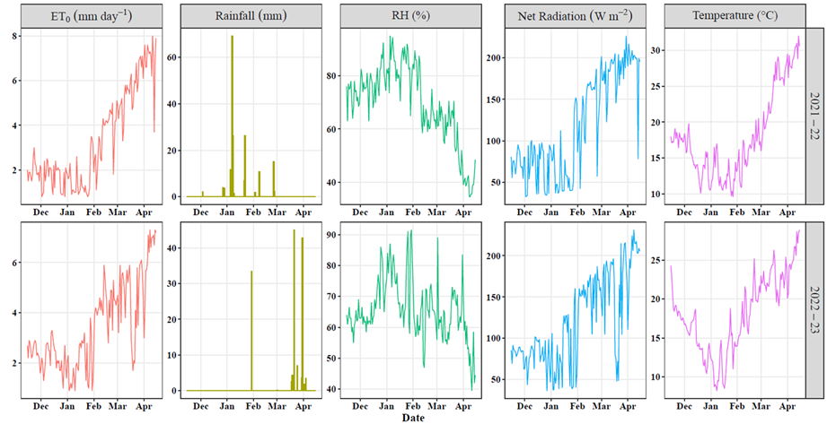
Supplementary Fig. 1. Daily weather (Mean Temperature, Net Radiation, Rainfall, Relative Humidity (RH), Reference Evapotranspiration (ET)) over the crop growing season (a) Rabi 2021-22, (b) 2022-23
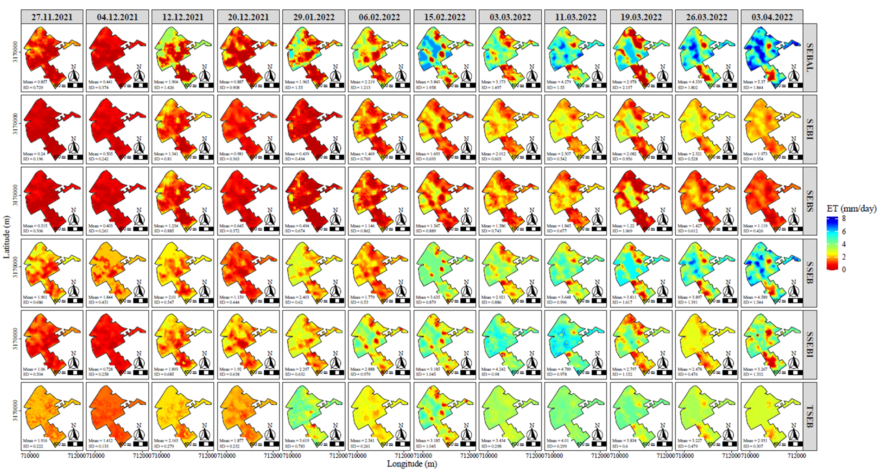
Supplementary Fig. 2. Spatial variation of crop evapotranspiration estimated by surface energy balance models over IARI farm in rabi season 2021-22 [SEBAL= Surface Energy Balance Algorithm for Land, SEBI= Surface Energy Balance Index, SEBS= Surface Energy Balance System, SSEB= Simplified Surface Energy Balance, SSEBI= Simplified-Surface Energy Balance Index, TSEB= Two Source Energy Balance]
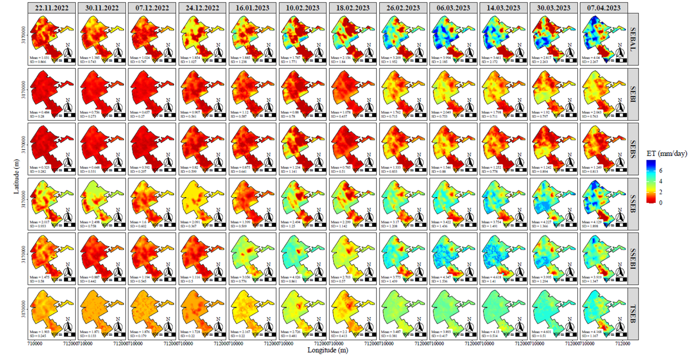
Supplementary Fig. 3. Spatial variation of crop evapotranspiration estimated by surface energy balance models over IARI farm in rabi season 2021-22 [SEBAL= Surface Energy Balance Algorithm for Land, SEBI= Surface Energy Balance Index, SEBS= Surface Energy Balance System, SSEB= Simplified Surface Energy Balance, SSEBI= Simplified-Surface Energy Balance Index, TSEB= Two Source Energy Balance]

