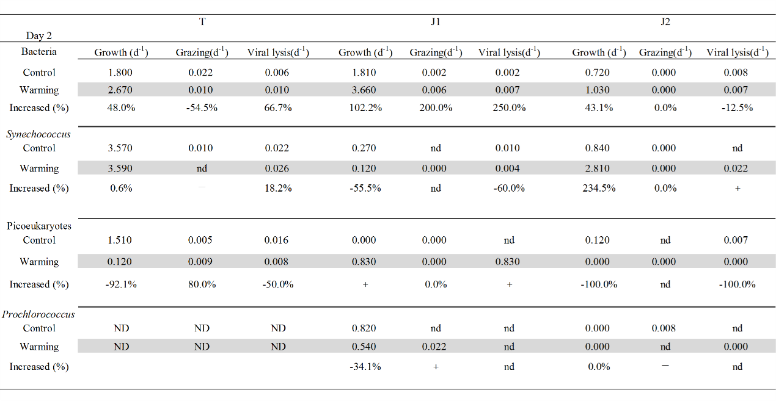
Table 1 Bacterial, Synechococcus spp., picoeukaryotes and Prochlorococcus spp. growth, grazing and viral lysis rates in the controls, warmed (grey) treatments and relative increased % ((warming-control/control)x100%) on day 2 at station T, J1, and J2, respectively. +: positive trends, but cannot calculate the values, ˗:negative trends, ND: no data, nd: non-determined.
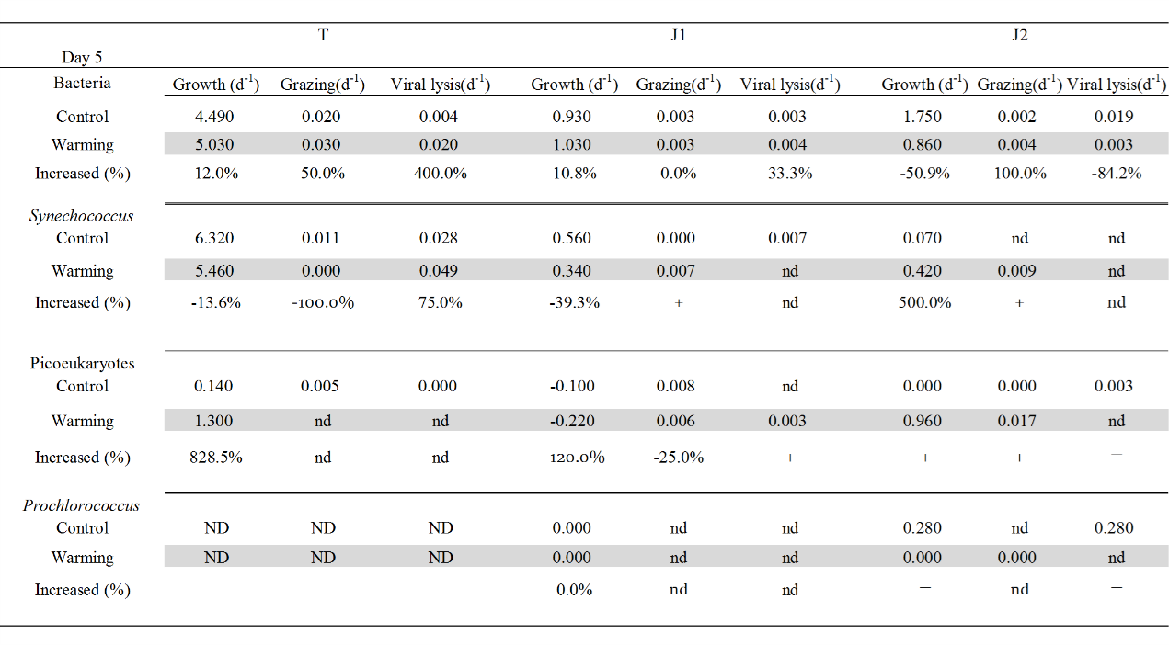
Table 2 Bacterial, Synechococcus spp., picoeukaryotes and Prochlorococcus spp. growth, grazing and viral lysis rates in the controls, warmed (grey) treatments and relative increased % ((warming-control/control)x100%) on day 5 at station T, J1, and J2, respectively. +: positive trends, but cannot calculate the values, ˗:negative trends, ND: no data, nd: non-determined.

