sFig. 1 Venn diagrams showing the number of a subset of exclusive and shared genes expressed by silkworm between non-infected or infected embryos and larvae. A: Venn diagrams showing the number of a subset of exclusive and shared genes expressed by silkworm between non-infected or infected 5-day embryos and 1-day larvae; B: Venn diagrams showing the number of a subset of exclusive and shared genes expressed by silkworm between non-infected or infected 5-day embryos and 5-day larvae; C: Venn diagrams showing the number of a subset of exclusive and shared genes expressed by silkworm between non-infected or infected 5-day embryos and 10-day larvae.
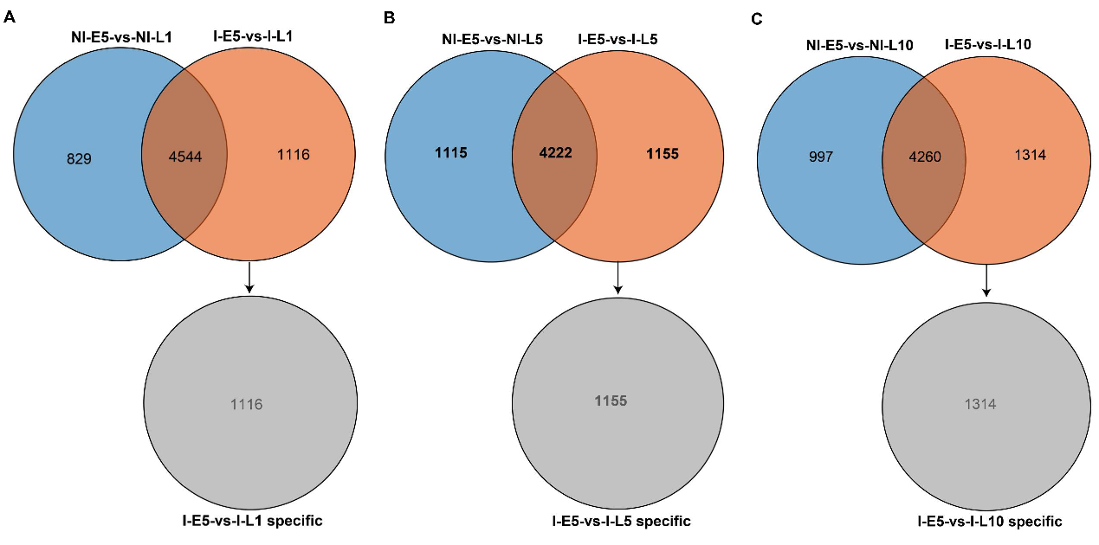
sFig. 2 Subset of the carbon metabolism, biosynthesis of amino acids, and sphingolipid metabolism pathway in N. bombycis between embryos and larvae. A: Pentose phosphate pathway; B: Fructose and mannose metabolism; C: Starch and sucrose metabolism; D: Sphingolipid metabolism; E: Glycolysis/gluconeogenesis; F: Biosynthesis of amino acids. A red font represents the genes that were upregulated, and a green font represents the genes that were downregulated in larvae compared to those in embryos during N. bombycis infection.
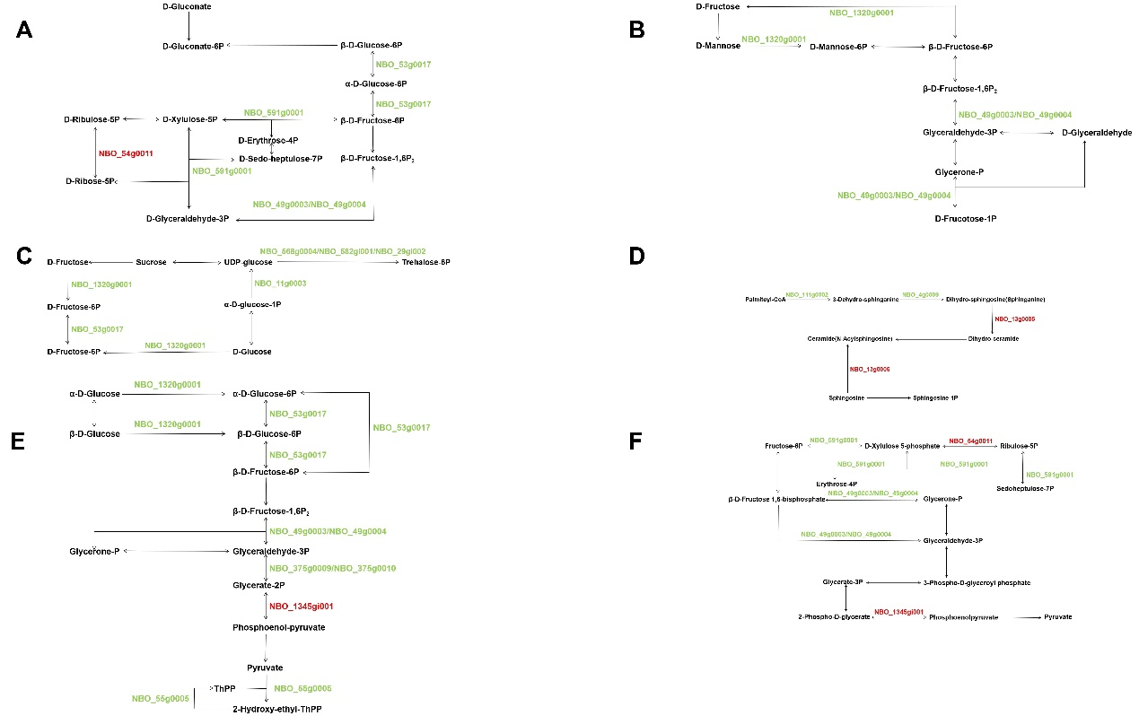
sFig. 3 Subset of the arachidonic acid metabolism, linoleic acid metabolism, and fat digestion and absorption in silkworm between embryos and larvae during N. bombycis infection. A: Arachidonic acid metabolism; B: Linoleic acid metabolism; C: Fat digestion and absorption. A red font represents the genes that were upregulated, and a green font represents the genes that were downregulated in larvae compared to those in embryos during N. bombycis infection.
