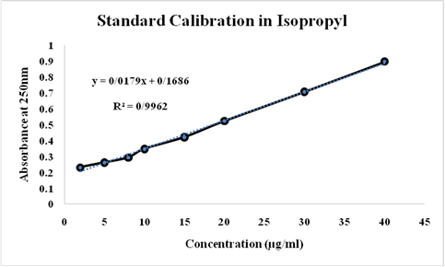
Fig. 1S. Standard calibration of the essential oil containing B. persicum in isopropyl

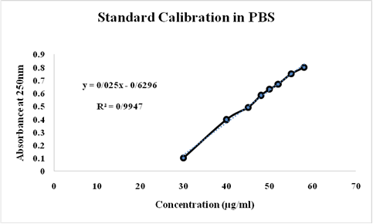
Fig. 2S. Standard calibration of the essential oil containing B. persicum in PBS

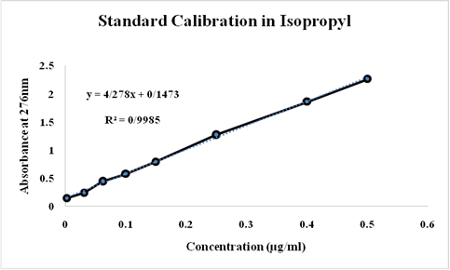
Fig. 3S. Standard calibration of the essential oil containing T. ammi in isopropyl

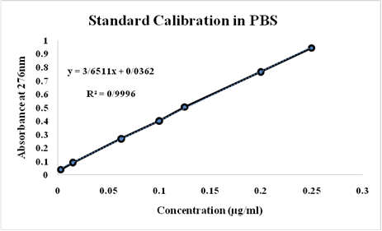
Fig. 4S. Standard calibration of the essential oil containing T. ammi in PBS

