Shaping Carbon into Carbon Matrices with Tuneable Diameter and Photoluminescent Properties

A. La Torre,*¹

- ALT Carbotecnologia srls and Carbastrial limited, Via Del Nuovo Tiro a Segno 15/1 Pescara, Italy, virtual office at 16 Bridge Street Kington Herefordshire HR5 3DJ, UK.
- University of Nottingham, School of Chemistry, University Park, Nottingham, NG72RD, UK.

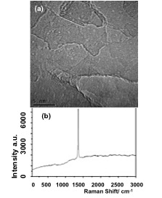
Figure S1: (a) Bright field TEM images of an FLBN flake, the scale bar is 5 nm; (b) Raman spectrum of the FLBN flake.

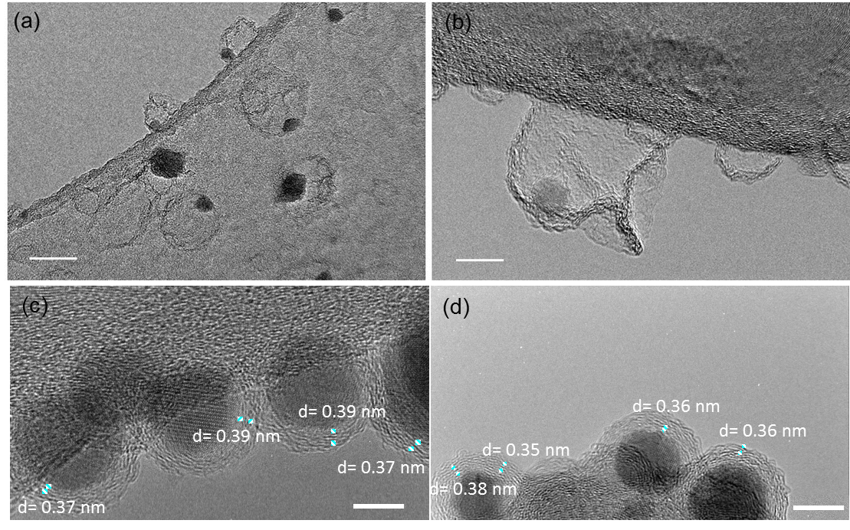

Figure S2: TEM images of semifilled (a-b) and filled carbon matrices (c-d). Scale bars are 5 nm. The d spacings of the carbon matrices are ~4-12% larger than those of graphite.
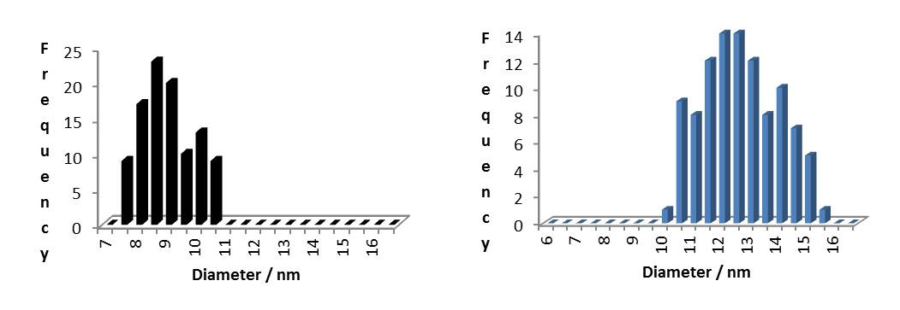
Figure S3: Size distribution in black of carbon matrices CNC1 (8.7 ± 1.0 nm) and CNC2 (12,4 ± 1.3 nm)

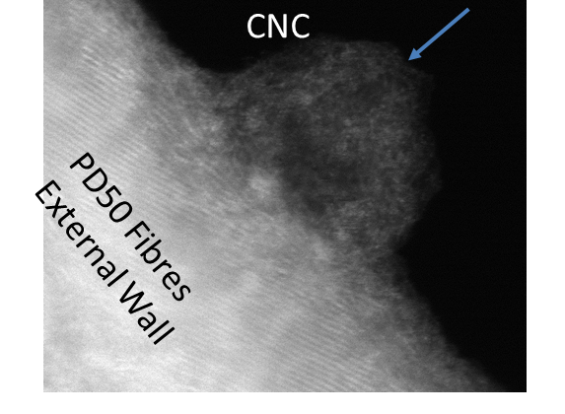
Figure S4: CNCs on PD50 (CNF) Fibres. Images of the carbon matrices grown on carbon nanofibres CNC@CNF using the same procedure reported in the experimental section. A carbon support was used instead of a BN sheet.

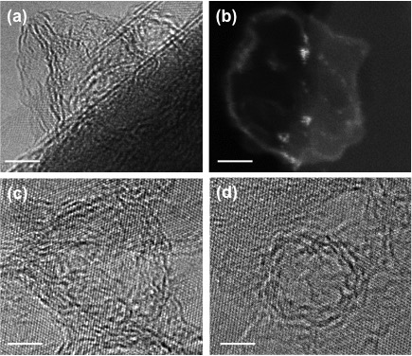

Figure S5: (a) AC-HRTEM image of an individual carbon matrix viewed side-on. (b) The AC-STEM image shows an individual carbon matrix in the top-view orientation. (c) HRTEM image of the carbon matrix side view. The HRTEM imaging of carbon in top-view orientations reveals a hemispherical morphology and a layered structure of their sidewall, consisting of 3-4 atomic layers of carbon. The scale bars are 5 nm in a-d.

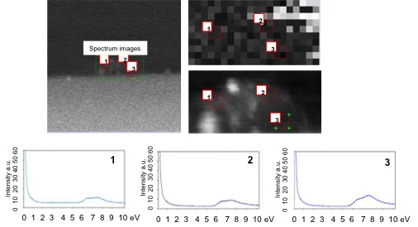
Figure S6: Low-energy EELS of carbon matrices (extracted spectrum) at 360 °C.

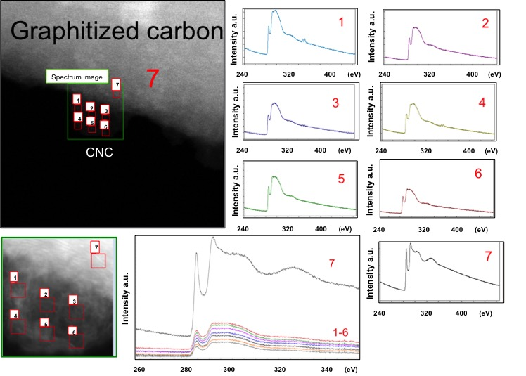

Figure S7: EELS of CNF@CNC. Measurements from 1 to 6 are for CNCs, and 7 is for carbon nanofiber CNFs.

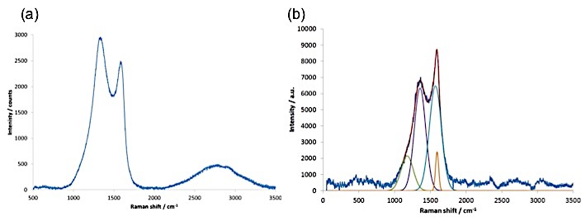
Figure S8: (a) Raman spectrum of FLBN@CNC2, (b) Raman spectral fitting based on 4 Gaussian bands of FLBN@CNC1. In measurement (a), spectra were collected by recording 64 acquisitions of 5 seconds duration for each spectral window. The broad overtone observed in figure a might be ascribable to the formation of carbon nitride species at the interface of carbon matrices and boron nitride species.

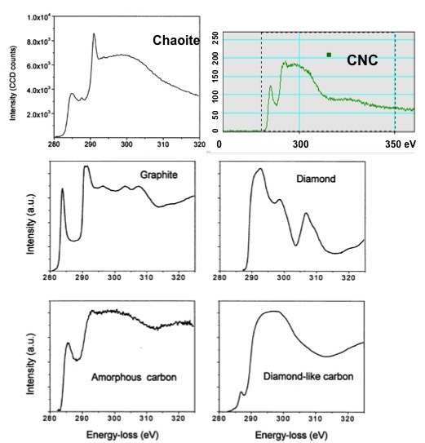

Figure S9: EELS spectra of CNCs compared with the well-known form of carbon. The EELS for the other forms of carbon were taken from reference 15.

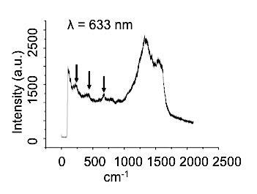

Figure S10: Raman spectrum of CNC1 showing the typical feature of sp¹ carbon between 200-700 cm⁻¹.

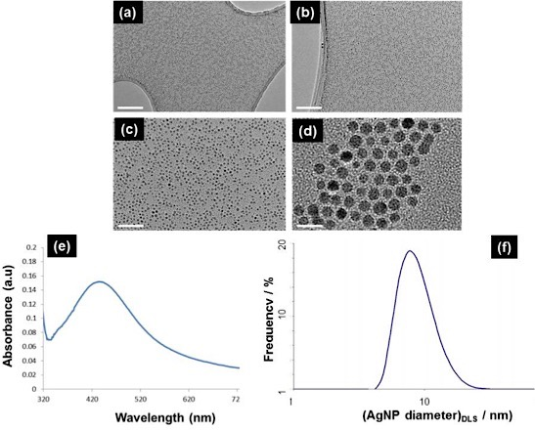

Figure S11: (a-d) TEM images of silver nanoparticles, (e) UV‒vis of silver nanoparticles, (f) DLS of silver nanoparticles that is in good agreement with the size analysis carried out with TEM.

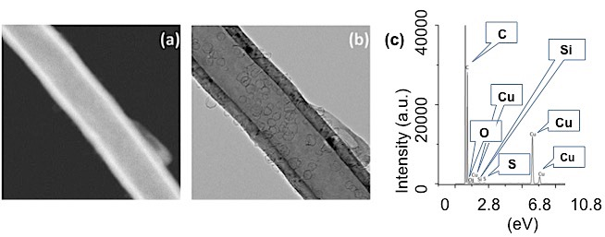
Figure S12: (a-b) TEM images of the carbon matrices grown of carbon nanofibres. (c) EDX of the carbon matrices grown on carbon fibres after HCl treatment. The absence of silver is clear.

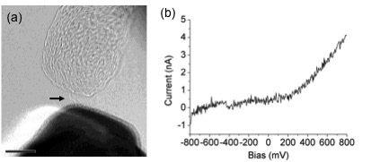

Figure S13: The bottom electrode is Au, and the bottom electrode is carbon. (a) TEM images of a chain unravelled by a gold electrode, (b) I/V curves. The current voltage is asymmetric. The scale bar is 5 nm.

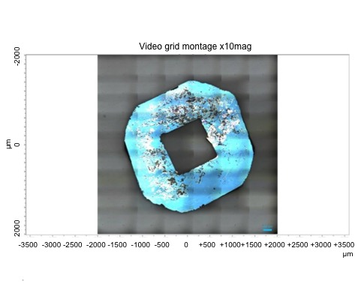
Figure S14: Optical microscope image of a film of carbon matrices grown on a Si₃N₄ support.
The grayish areas represent the carbon matrices. Conversely, the light blue area is the support.
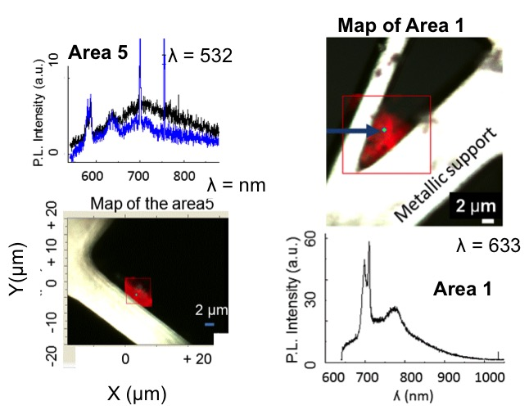

Figure S15: Area 5 Raman modes of CNC1 with wavelengths at 532. In area 1 Raman modes and PL with a wavelength of 633 nm, the photo activity of the matrices was observed at 774 nm.

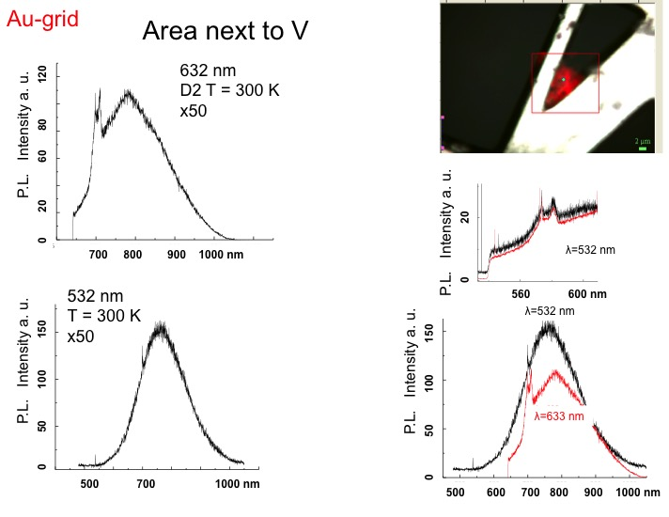

Figure S16: PL and Raman modes of CNC1 carbon matrices.

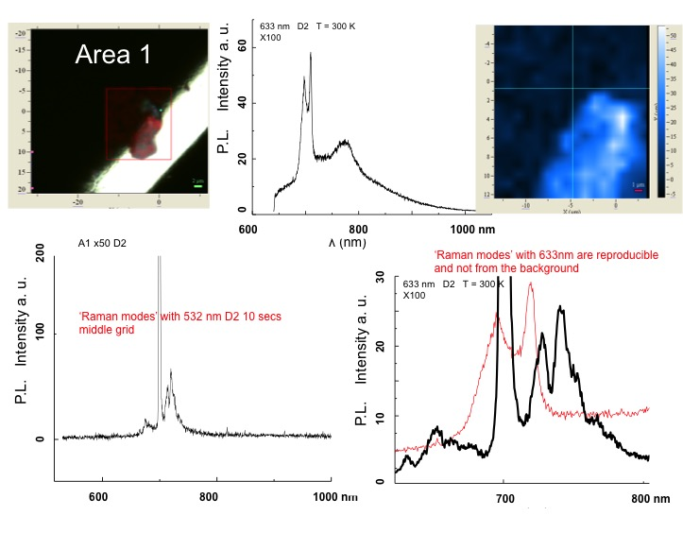
Figure S17: PL and Raman modes of CNC1 carbon matrices.

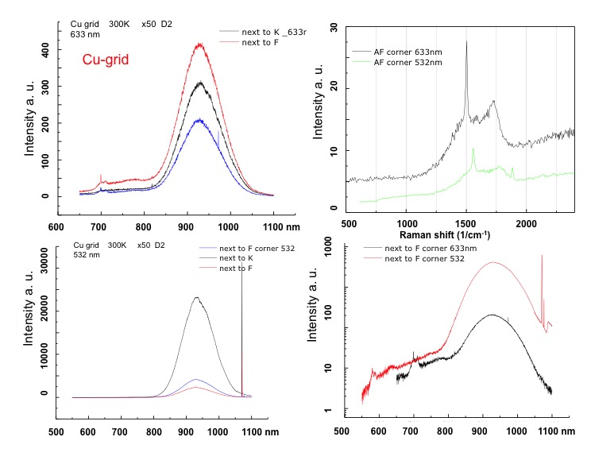
Figure S18: PL and Raman modes of CNC2 carbon matrices.

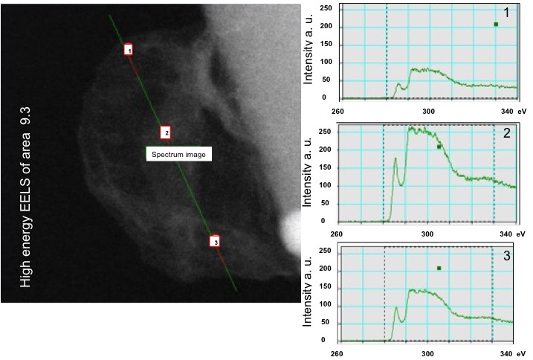

Figure S19: High-energy EELS of area 9.3.

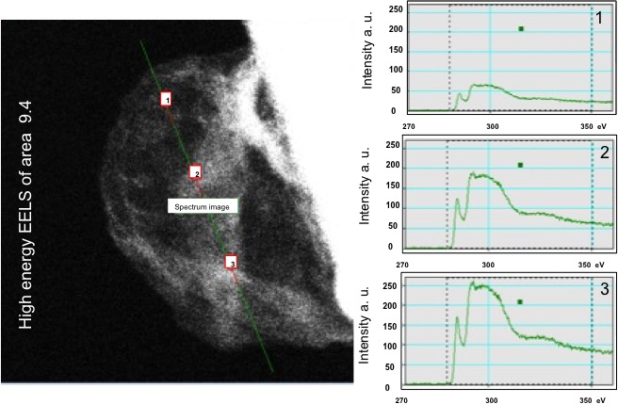

Figure S20: High-energy EELS of area 9.4.
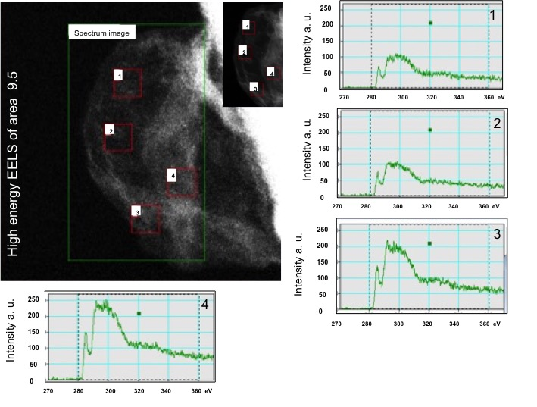

Figure S21: High-energy EELS of area 9.5.

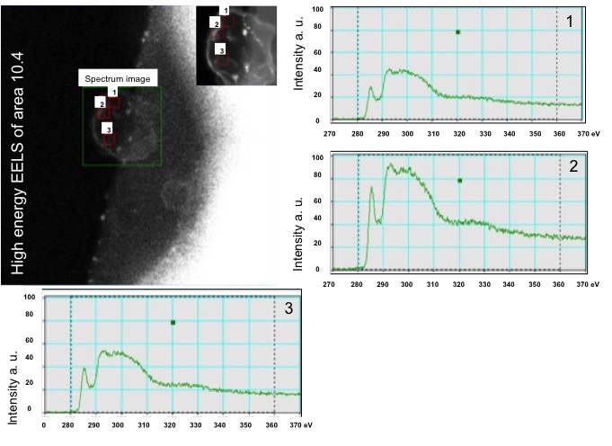

Figure S22: High-energy EELS of area 10.4.

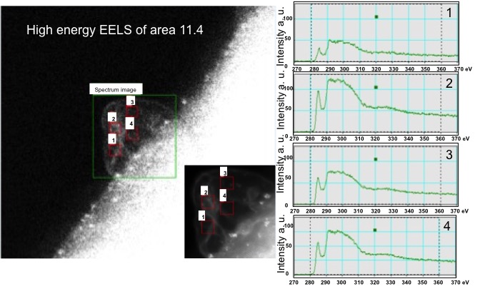
Figure S23: High-energy EELS of area 11.4.

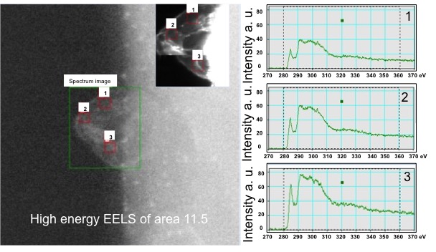

Figure S24: High-energy EELS of area 11.5.

