Modeling of in-hospital VEM duration-dependent cost distribution

We based the assessment of the duration-dependent cost of in-hospital VEM on the study of Slater et al., 2019. They presented data on the distribution of in-hospital VEM duration for a group of 5271 patients (38% children) who underwent in-hospital VEM lasting up to one week. In their work, 25.6% of the patients were monitored for one day or less, 25% for two days, 19.9% for three days 15.6% for four days, and 13.9% for five to seven days. The mean cost of in-hospital VEM was 13821 USD, and the range within a 95% confidence interval was 12844 – 14873 USD. The day-to-day cost distribution was not reported. Therefore, to estimate the distribution we proceeded with a modeling approach.
We assumed that the cost includes a duration-independent part and a duration-dependent part.

The total cost of In-hospital VEM of n days duration = duration-independent cost + n*duration-dependent cost (18)

To model the day-to-day distribution of in-hospital VEM cost we used a function optimization.
One of the parameters for optimization was the ratio between a duration-dependent cost and the total cost (duration-dependent + duration-independent) across five different monitoring durations (from 1 to 5-7 days). To estimate this ratio, we performed 10000 iterations where in each iteration we increased the ratio by 0.0001. We started with 0.0001 on the first iteration and reached 1 on the last one. Another parameter for optimization was the mean duration of in-hospital VEM between 5 and 7 days. This was calculated through 20 iterations that modeled the mean duration between 5.1 and 7.0 days with a 0.1-day step. These two iteration processes were performed simultaneously and dependently. For each iteration, we reconstructed the distribution of the mean cost across all days based on the ratio. Then, at each iteration, we calculated the sum of the absolute difference in the mean and standard deviation between the estimated and the actual values, i.e., those reported by Slater et al, 2019. This value represented the value of function optimization. The optimal ratio between duration-dependent and total cost was associated with the minimal value of this function.
After modeling the in-hospital day-to-day cost distribution, we compared the HVEM and the in-hospital VEM cost distributions. We then modeled the HVEM cost distribution for the same population reported by Slater and colleagues (2019) (5271 patients, 38% children). Thus, for the same population, both in-hospital VEM and HVEM cost distribution was modeled. We considered here the case when 50% of the data is manually screened by the EEG technician. The HVEM model included the added cost of in-hospital VEM for patients who did not achieve the HVEM goal and were referred for in-hospital VEM. The principles of this model are described in the "Modelling HVEM cost for DRE pre-surgery workup" subsection. Adults and children are considered here in the same cohort. However, our model separates adults and children in regard to the time needed to achieve the HVEM goal in DRE pre-surgery workup (3 seizures on different days). Two sample Student T-test was applied to compare HVEM and in-hospital VEM.

Figure S1. Function optimization for estimation of in-hospital VEM cost distribution.

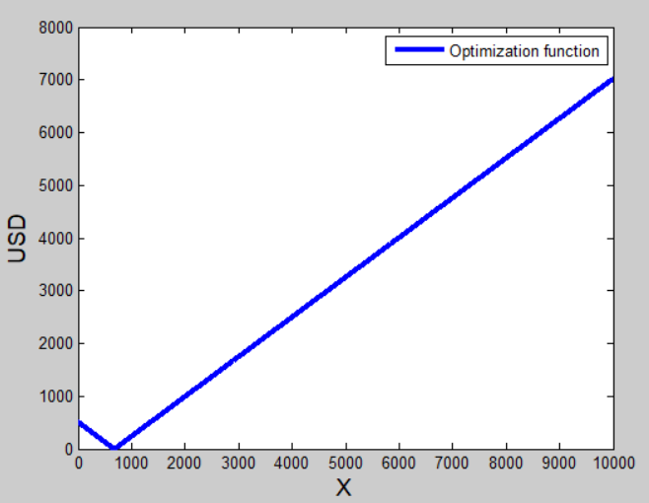

The function optimization for estimation of the ratio between duration dependent and total cost of in-hospital VEM.
X-axis: X/10000 = estimated ratio between duration dependent and total cost. Total cost is the sum of duration-dependent and duration-independent costs.
X = 10000 *duration dependent cost/total cost
Y-axis: error in estimated ratio. The error is calculated as the sum of the two parameters: an absolute value of the difference between the estimated and reported mean cost across the 7 days of in-hospital VEM AND the absolute value of the difference between the estimated and reported standard deviation.
Y = absolute value of (estimated mean cost – reported mean cost) + absolute value of (estimated standard deviation – reported standard deviation)
The ratio producing a minimal mismatch between the estimated and reported average cost corresponds to X=698, which means that the ratio between duration-dependent cost and total cost of 698/10000 (about 0.07) corresponds with a minimal error of 0.005 USD. See text for details.

The minimal difference (0.005 USD) between the ratio-based estimated average total cost and the actual average total cost (reported by Slater et al., 2019) of in-hospital VEM was achieved when the ratio between the duration-dependent and total cost parts was 0.07 (Supplementary Material Figure S1). The mean duration of in-hospital VEM between 5 and 7 days was 5.5 days. Therefore, we used this ratio to estimate the day-to-day changes in the cost of in-hospital VEM. According to our model, the cost of one day of in-hospital VEM was 13208 USD, and for 5-7 days was 14791 USD. The in-hospital VEM cost distribution according to monitoring duration is presented in Table S3 in Supplementary Material and in Figure S2.

Table S3. Modeled distribution of the cost of in-hospital VEM over the days of monitoring based on the patients' population described in Slater et al, 2019.
Duration, days | 1 | 2 | 3 | 4 | 5-7
Cost, USD | 13208 | 13560 | 13912 | 14264 | 14791

USD – United States Dollar

The above results suggest that for the health care system, the per-patient expenditure of one day of in-hospital VEM for DRE patients is higher than the mean cost of HVEM-in-hospital VEM combination, providing that the duration of HVEM is minimum 2-3 weeks. The difference between costs of in-hospital VEM and HVEM-DRE was significant: the p-value was less than 0.001 from the 1st to the 8th week (both when HVEM was more expensive than in-hospital VEM at the first week and when HVEM was cheaper, between the 2nd and 8th weeks). The mean cost dynamics of the 5271 patients' population is demonstrated in Figure 2 (yellow line) and in Table S1 in Supplementary Material.
Figure S2. Cost distribution of the in-hospital VEM over the days of monitoring.
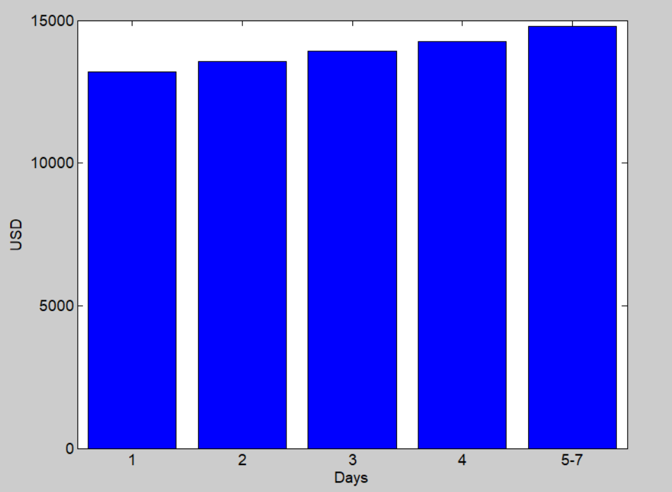
The in-hospital VEM cost distribution as a function of VEM duration. The last bar corresponds to a duration of 5 to 7 days.

The estimated cost of in-hospital VEM changed relatively little (less than 20%) with the increasing duration of the monitoring. The cost covering the medical staff, both nurse and physician, as well as electrode attachment is included in the first day’s expenses. This is in line with the findings of Slater, who showed that the 95% confidence interval (two standard deviations below and above the mean) was also less than 20% of the mean cost (Slater et al. 2019). Moreover, patients with frequent seizures do not require a prolonged study. However, the EEG interpretation workload can be high because of the burden of captured events. In summary, this indicates that even short in-hospital VEM is more expensive than HVEM. On the other hand, it is possible that for patients with several seizures during the day, the short VEM in the daycare institution can be a reasonable alternative for both in-hospital VEM and HVEM. This requires further studies. The cost differences between HVEM and in-hospital VEM were significant for DRE patients in pre-surgery workup (HVEM-DRE).
Of note, our model of in-hospital VEM does not completely fit the coding and billing policy as issued by the Centers for Medicare & Medicaid Services (CMS) in 2020.
(https://www.aan.com/siteassets/home-page/tools-and-resources/practicing-neurologist--administrators/billing-and-coding/cpt--em/20-eeg-summary-final_tr.pdf)
According to the CMS policy, the physician’s work associated with in-hospital VEM of one-day duration is evaluated as 5.9 Relative Value Units (RVU). For four days duration, it is 11.6 RVU (about twice as much). This means that the in-hospital VEM data presented by Slater et al, 2019 is less duration-dependent than CMS policy. Further studies are required for a better understanding of the daily distribution of in-hospital VEM cost and workload. Even if our model overestimates the in-hospital cost of short-lasting monitoring of 1-2-days duration, it is less likely to overestimate the in-hospital VEM cost for patients with DRE, since their stay is generally longer (Schulze-Bonhage et al, 2022).

