Combining photocatalytic and electrocatalytic oxidation for degradation of progesterone with V₂O₅ and carbon coated titanium anode: Optimization and degradation mechanism
Salman Farissi, Utukuri Gopi, Gaara Ajith, Harikrishnan Palasseri, Tejomurtula Prasanthi, Anbazhagi Muthukumar, *Muthukumar Muthuchamy
Department of Environmental Science, Central University of Kerala, Periye-671320, Kasaragod, Kerala, India.
*mmuthukumar@cukerala.ac.in

Supplementary material

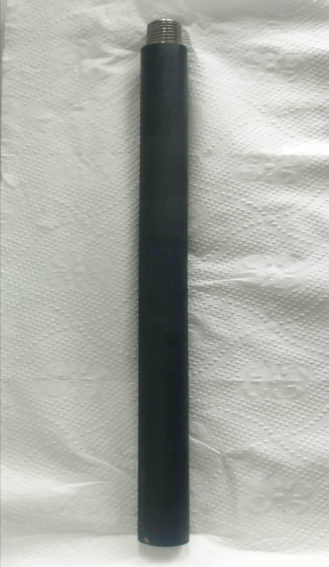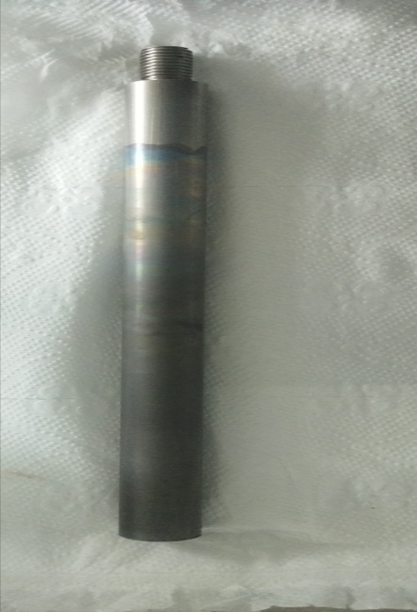
(a) (b)
S1 Pictures of (a) C/Ti anode (b) Ti cathode

S2 Effect of catalyst concentration on COD removal

