Supplementary Figure 1. Participants’ accuracy score on the Map Task, per trial.
Note. The errors bars indicate the standard error.
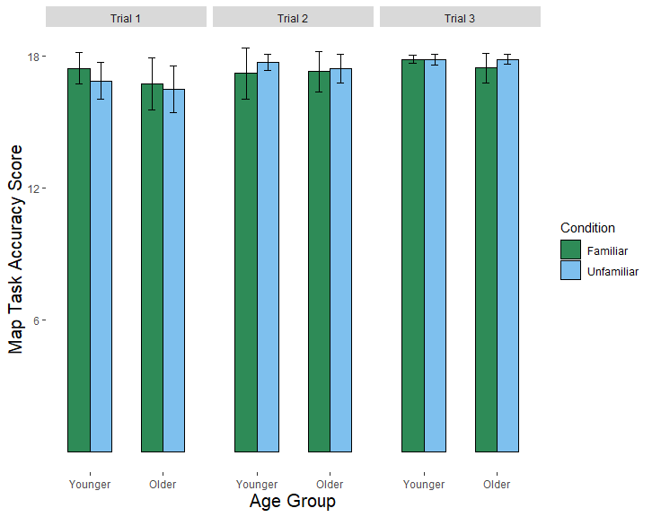

Supplementary Figure 2. Example set-up of the familiar and unfamiliar conditions.
