Genome-wide characterization and evolutionary analysis of the AP2/ERF gene family in lettuce (Lactuca sativa)

Sunchung Park^{1,*}, Ainong Shi², Lyndel W. Meinhardt¹, and Beiquan Mou³
¹U.S. Department of Agriculture, Agricultural Research Service, Beltsville, MD 20705, USA
²Horticulture Dept., University of Arkansas, Fayetteville, AR 72701, USA
³U.S. Department of Agriculture, Agricultural Research Service, Salinas, CA 93905, USA

Supplementary information
Supplementary Figure S1
Supplementary Table S1-6

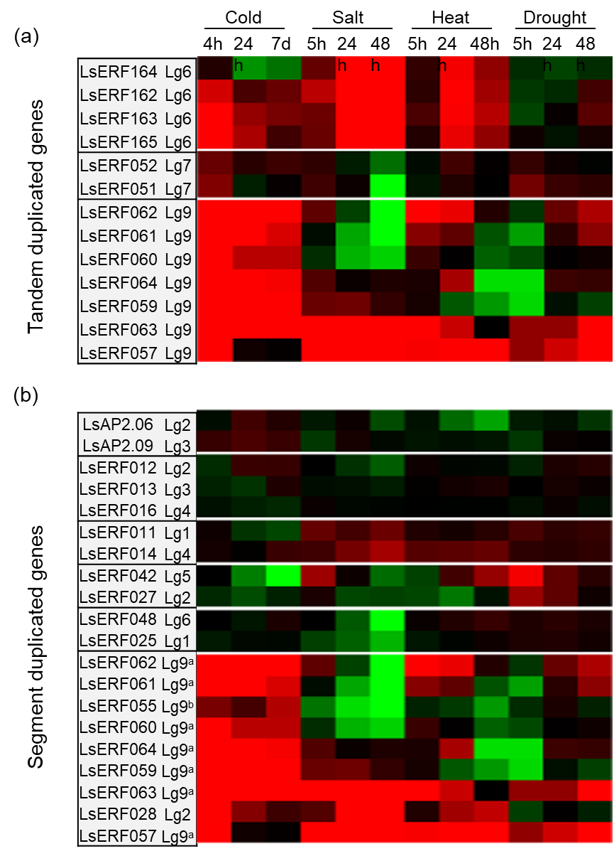
Figure S1. The heatmap showing the expression patterns of tandemly (a) and segmentally (b) duplicated genes in response to cold, heat, salt, and drought. Each row corresponds to a specific gene, and each column represents a stress condition. The color intensity indicates the level of gene expression: red for upregulation and green for downregulation, relative to the control condition.
Supplementary Tables
Table S1. List of all 224 AP2/ERF genes in lettuce
Table S2. List of plant species from Asterid or Rosid subclasses used in this study
Table S3. BLASTP results of Lettuce AP2/ERF genes against Arabidopsis and Rice
Table S4. List of orthologous groups among ten plant species
Table S5. List of a pair of genes determined as tandem duplicates
Table S6. List of a pair of genes determined as segmental duplicates
Table S7. Ka/Ks ratios for pairwise comparisons among the duplicated AP2/ERF genes
Table S8. Expression signals and false discovery rate (q-value) of AP2/ERF genes

