Supplemental Information

Figure S1. Time series of influenza cases during 2013 to 2019.

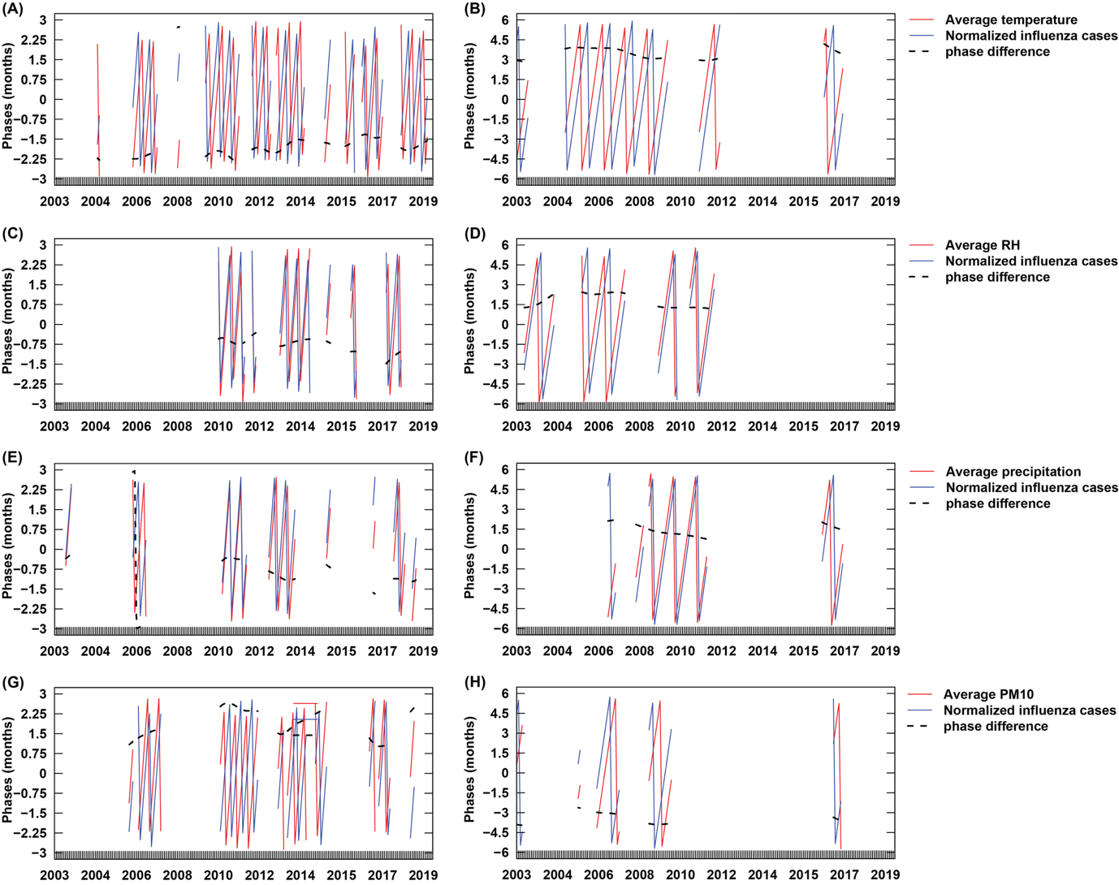
Figure S2. Phase differences between PM10, temperature, relative humidity (RH), precipitation, and influenza incidence at a periodicity of 6 and 12 months.

Figure S3. The correction coefficient between influenza cases (per 10,000 population), PM10 (μg/m³), average temperature (ºC), average relative humidity (%), and average precipitation (mm) at lag 0-5 months in Bangkok.

Figure S4. The number of cases obtained from the final model (red line) with 95% confidence intervals (ribbons) compared to the influenza cases (dark blue dots).

Table S1. Phase differences (6 months)
Pairs | Angle difference (degree) | Mean difference (months) | Median difference (months)
PM10 – Influenza | 114 | 1.89 | 1.88
Temperature – Influenza | –102 | –1.71 | –1.85
RH – Influenza | –47 | –0.78 | –0.70
Precipitation – Influenza | –54 | –0.90 | –0.96

Table S2. Phase differences (12 months)
Pairs | Angle difference (degree) | Mean difference (months) | Median difference (months)
PM10 – Influenza | –104 | –3.46 | –3.54
Temperature – Influenza | 104 | 3.47 | 3.53
RH – Influenza | 53 | 1.76 | 1.53
Precipitation – Influenza | 42 | 1.40 | 1.31

Table S3. Tolerance and variance inflation factors (VIF) of PM10 and meteorological factors
Variables | Tolerance | VIF
PM10 | 0.1713 | 5.8369
Temperature | 0.2559 | 3.9074
RH | 0.1946 | 5.1385
Precipitation | 0.2402 | 4.1638
PM10_lag1 | 0.1565 | 6.3889
Temperature_lag1 | 0.2242 | 4.4598
RH_lag1 | 0.1799 | 5.5589
Precipitation_lag1 | 0.2247 | 4.4509
PM10_lag2 | 0.1501 | 6.6621
Temperature_lag2 | 0.2274 | 4.3974
RH_lag2 | 0.1898 | 5.27
Precipitation_lag2 | 0.2228 | 4.489
PM10_lag3 | 0.1482 | 6.7485
Temperature_lag3 | 0.2362 | 4.2338
RH_lag3 | 0.1785 | 5.6037
Precipitation_lag3 | 0.2228 | 4.4889
PM10_lag4 | 0.1423 | 7.0253
Temperature_lag4 | 0.2528 | 3.9558
RH_lag4 | 0.1624 | 6.159
Precipitation_lag4 | 0.2147 | 4.6586
PM10_lag5 | 0.1589 | 6.2939
Temperature_lag5 | 0.3169 | 3.1559
RH_lag5 | 0.1845 | 5.4196
Precipitation_lag5 | 0.2533 | 3.9472

Table S4. Set of the factor GAM with fixed offset, month, and year.
Smoothing effect | Edf | Ref. df | P-value | Deviance explained (%) | Adg.R² | AIC
S(PM10) | 9.346 | 11.427 | 0.000*** | 82.222 | 0.527 | 2998.233
S(PM10_lag1) | 1.004 | 1.008 | 0.126 | 82.579 | 0.531 | 2994.798
S(PM10_lag2) | 1.002 | 1.003 | 0.002** | 83.066 | 0.571 | 2988.258
S(PM10_lag3) | 1.001 | 1.002 | 0.173 | 82.459 | 0.540 | 2995.921
S(PM10_lag4) | 1.001 | 1.002 | 0.591 | 82.313 | 0.539 | 2997.680
S(PM10_lag5) | 1.002 | 1.004 | 0.118 | 82.506 | 0.557 | 2995.555
S(Temperature) | 3.145 | 3.805 | 0.051 | 83.033 | 0.519 | 2992.552
S(Temperature_lag1) | 2.938 | 3.590 | 0.000*** | 83.886 | 0.531 | 2981.432
S(Temperature_lag2) | 3.306 | 3.975 | 0.005** | 83.951 | 0.592 | 2983.709
S(Temperature_lag3) | 3.526 | 4.178 | 0.029* | 83.280 | 0.640 | 2990.337
S(Temperature_lag4) | 1.011 | 1.020 | 0.230 | 82.120 | 0.512 | 2998.552
S(Temperature_lag5) | 2.778 | 3.422 | 0.228 | 82.785 | 0.525 | 2994.458
S(RH) | 1.002 | 1.003 | 0.001*** | 82.998 | 0.570 | 2988.576
S(RH_lag1) | 3.214 | 3.905 | 0.003** | 83.706 | 0.545 | 2985.131
S(RH_lag2) | 1.004 | 1.007 | 0.391 | 82.225 | 0.528 | 2998.148
S(RH_lag3) | 2.453 | 3.068 | 0.212 | 82.611 | 0.522 | 2995.908
S(RH_lag4) | 3.418 | 4.101 | 0.124 | 82.962 | 0.611 | 2993.979
S(RH_lag5) | 1.355 | 1.628 | 0.032* | 82.965 | 0.552 | 2991.305
S(Precipitation) | 1.925 | 2.431 | 0.082 | 82.969 | 0.596 | 2991.917
S(Precipitation_lag1) | 1.357 | 1.630 | 0.000*** | 84.037 | 0.589 | 2977.649
S(Precipitation_lag2) | 1.004 | 1.008 | 0.008** | 82.848 | 0.561 | 2991.276
S(Precipitation_lag3) | 1.002 | 1.004 | 0.684 | 82.307 | 0.540 | 2997.691
S(Precipitation_lag4) | 2.209 | 2.773 | 0.612 | 82.600 | 0.535 | 2996.881
S(Precipitation_lag5) | 1.172 | 1.321 | 0.415 | 82.447 | 0.526 | 2996.661
Indicates p-values: *P ≤ 0.05, **P ≤ 0.01, and ***P ≤ 0.001

Table S5. Set of the gam selection. The models were fixed offset and random effects.
(Intercept) | PM10_lag2 | Precipitation_lag1 | Precipitation_lag2 | RH_lag5 | RH | Temperature_lag1 | Temperature_lag2 | df | AIC | ΔAIC
-8.942422 | + | + | NA | + | + | NA | + | 28 | 2957.821 | 0
-8.940470 | + | + | NA | NA | + | NA | + | 27 | 2958.691 | 0.869
-8.946058 | + | + | NA | + | + | + | + | 31 | 2959.081 | 1.259
-8.940247 | + | + | + | + | NA | + | NA | 27 | 2959.347 | 1.525
-8.946763 | + | + | + | + | + | + | + | 32 | 2959.504 | 1.683

The computer code for GAM in R is described below:
M1.global.nb=gam(Cases ~
s(PM10_lag2,k=df)+
s(Precipitation_lag1,k=df)+
s(Precipitation_lag2,k=df)+
s(Temperature_lag1,k=df)+
s(Temperature_lag2,k=df)+
s(RH,k=df)+
s(RH_lag5,k=df)+
offset(log(Population))+
s(Year,k=df3)+
s(Month,bs="cc",k=df2),
na.action = "na.fail",
data=dataModel2,family = nb(),method="REML")
summary(M1.global.nb)

gam_dredge<- dredge(M1.global.nb,evaluate=TRUE,
fixed= ~ offset(log(Population))
+s(Year,k=df3)
+s(Month,bs="cc",k=df2),
rank="AIC",
trace = T)
M.final=gam(Cases~
s(PM10_lag2,k=df)+
s(Precipitation_lag1,k=df)+
s(Temperature_lag2,k=df)+
s(RH,k=df)+
offset(log(Population))+
s(Year,k=df3)+
s(Month,bs="cc",k=df2),
na.action = "na.fail",
data=dataModel2,family = nb(),method="REML")

