Table 2 -Questions, answers, and assertiveness of the students involved.

 |  | Assertiveness in every round
Question | Answers | 1st | 2nd | 3rd
1. (Enem - 2009) Relative humidity is the term used to describe the amount of water vapor contained in the atmosphere. It is defined by the ratio between the actual moisture content of an air parcel and the amount of moisture that the same air parcel can store at the same temperature and pressure when it is saturated with vapour, that is, with 100% relative humidity.  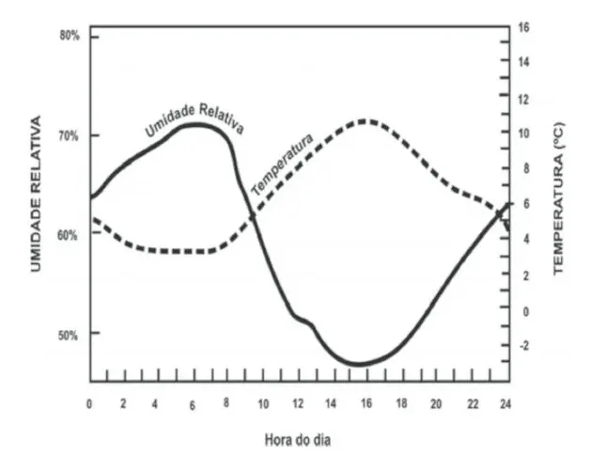 | - Insolation is a factor that causes variation in the relative humidity of the air.  - The relative humidity of the air indicates, in absolute terms, the amount of water vapor in the cloud.  - Air acquires more water vapor as it heats up.  - The presence of relative humidity in the air is directly proportional to the air temperature. | 10% | 57% | 71%
2. Consider the comic strip, in which the ambient temperature is lower than the characters' body temperature. The discomfort mentioned by the character in the strip is due to the fact that, on humid days:   | - the temperature of the water vapor present in the air is high.  - sweat is more difficult to evaporate from the body.  - the rate of absorption of radiation by the body becomes higher.  - the air becomes a bad conductor and makes the heat release process difficult. | 22% | 40% | 52%
3. Tick T or F  ( ) The higher the air humidity, the lower the thermal amplitude (difference between the highest and lowest temperature).  ( ) Rainfall tends to be lower in regions with higher humidity.  ( ) In hot places with higher air humidity, there is an increase in “stuffyness”, thus, the thermal sensation is higher than the actual temperature of the environment. | - V, F, V  - V, V, V  - F, F, F  - V, V, F | 76%
4. There is a relationship between the rainfall regime in Brazil and the Amazon Forest. About this relationship, mark the incorrect alternative: | - The Amazon Forest, through evapotranspiration, emits all the moisture, which consequently condenses in the form of rain.  - The presence of the “Flying Rivers” is the link between the rainfall regime in Brazil and the Amazon Forest. The Flying Rivers are very humid air currents that turn into rain.  - The evaporation rate of the Amazon rainforest is representative, but not enough. The rain is basically influenced by the air masses originating from the oceans together with the Forest  - There are no incorrect alternatives. | 48% | 65% | 70%
5. On the influence of sea conditions and air masses on atmospheric humidity, mark the correct alternative: | - In coastal areas, air humidity tends to be lower, given the reduced rate of evaporation of ocean water.  - In continental regions, air humidity tends to be lower, since the air in these areas is drier due to the low rate of water evaporation.  - An air mass laden with moisture tends to cause less rain in the region to which it is directed.  - Dry air masses tend to cause rain in the regions affected by them. | 82%
Source- Author

