Appendices
Appendix 1: Selected conceptual frameworks
Figure 1: Margaret E. Kruk and colleagues' resilience indicators
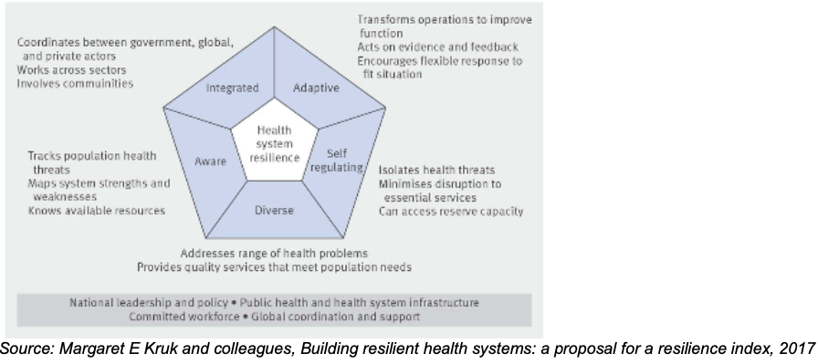

Figure 2: Conceptual framework for understanding resilience, tailored to low- and middle-income country contexts
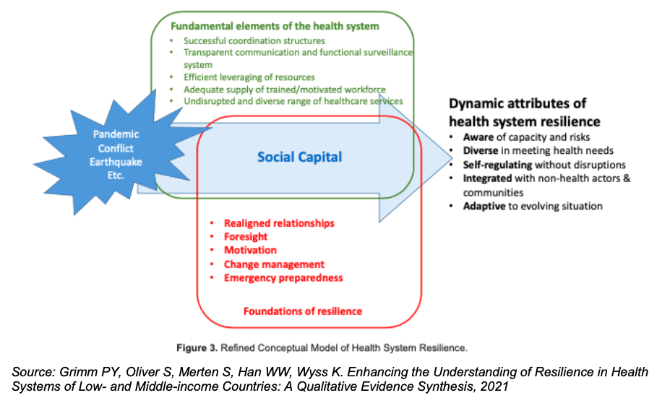

Figure 3: Resilience building strategies by health system function and by shock cycle stage
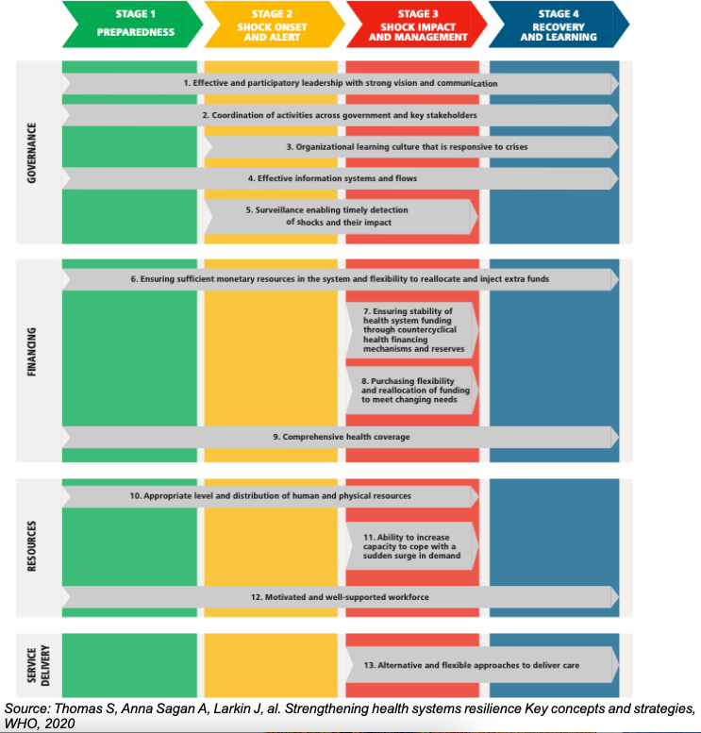

Appendix 3: Supplementary Notes
The impetus for this thesis on health systems resilience within the field of health policy and systems research (HPSR) in the Caribbean region stems, among other things, from the lack of evidence and research on this topic.
Indeed, the United Nations Educational, Scientific and Cultural Organisation (UNESCO) has published a report on science in 2015 detailing scientific publication trends for the Caribbean Community (CARICOM) countries. For instance, the cumulative count of such publications over the period 2008-2014 was respectively estimated at 11, 43, and 218 for Saint Lucia, Dominica, and Haiti. For its part, the United States (a scientific partner to the region) has published approximately 322,000 scientific papers in 2014(UNESCO, 2016). Adam and colleagues pointed out in their 2011 paper that only 4% of health policy and systems research in low- and middle-income countries was conducted by national researchers. A blatant lack of relevant and/or usable health statistics exists in Haiti and to some extent in the other islands. Healthcare professionals are treating a diverse population with characteristics and conditions that differ, at best, from the textbooks upon which they are drawing their guidelines (Adam et al., 2011; Direction d’Épidémiologie, des Laboratoires et de la Recherche (DELR), 2020; UNESCO, 2016).
It is worth highlighting here the vulnerabilities of the region, whether in terms of the lack of evidence to support its governance and its ability to respond to its population' s health needs, or in its exposure to natural disasters. Scientific publications on HSR and health policy and systems research are very limited across the Caribbean region(Adam et al., 2011; UNESCO, 2016). This low productivity remains in part attributable to a persistent lack of funding for such research in the region(Adam et al., 2011; UNESCO, 2016). Nevertheless, the needs are considerable. Accordingly, UNESCO has called for more investment, as well as the establishment and/or revitalisation of a strong interregional research and collaboration culture(UNESCO, 2016).
In parallel to this lack of funding, country capacity and capability to conduct research constitutes another major challenge. In practice, only few scientists carry out research. One explanation for this lies in the lack of expertise (competence). Indeed, very few researchers are also willing to mentor students in this field(Adam et al., 2011; Direction d’Épidémiologie, des Laboratoires et de la Recherche (DELR), 2020; UNESCO, 2016). In Haiti, relatively speaking, few local faculty members hold a PhD degree. Moreover, there is no established educational plan to acquire a university chair or a doctoral degree in this field(Direction d’Épidémiologie, des Laboratoires et de la Recherche (DELR), 2020).
Having established this, health system reforms and strengthening, as well as context-specific health system resilience building, also require qualified researchers. The latter should be able to undertake relevant studies and train future scientists. The above-mentioned paucity of resources calls for reflection on several aspects (such as adequacy of care, weighting of social and non-medical determinants in health policies) but also on individual and sectoral accountability and participation in the decision-making process. We therefore all share a collective duty in creating resilient systems to safeguard the overall health and well-being of these communities. In doing so, we will secure their "Right" to achieve their optimum health (Organisation Mondiale de la Santé, 1946). A stance advocated by Laura E. Downey and colleagues in their 2021 publication, under the title "Global health system resilience is in everyone's interest"(Downey et al., 2021).
Consequently, this doctoral research project, which falls within the emerging field of health policy and systems research, aims to contribute to addressing this need and bridging this gap. It offers a timely window into this unexplored territory and thus has the potential to further develop the literature in this weakly covered academic discipline within the region. In addition, it might contribute to raising awareness amongst young researchers and might encourage further public investment in research from regional governments. Communities across the region will also benefit from this project as a result of improved and strengthened health systems. Ultimately, meaningful, and sustainable development is unlikely to take place without health(Sagan et al., 2021). In conclusion, we expect this project to help foster further inter-university and scientific partnerships between Belgium and the Caribbean region.

References
Adam, T., Saad, A., Bigdeli, M., Ghaffar, A., & Røttingen, J.-A. (2011). Trends in Health Policy and Systems Research over the Past Decade: Still Too Little Capacity in Low-Income Countries. PLoS ONE, 6(11), e27263. https://doi.org/10.1371/journal.pone.0027263
Direction d’Épidémiologie, des Laboratoires et de la Recherche (DELR). (2020). Politique Nationale de Recherche en Santé. Ministère de la Santé Publique et de la Population. https://mspp.gouv.ht/site/downloads/Politique%20Nationale%20de%20Recherche%20en%20Santé%20%20MSPP%2021%20janvier%202020%20VF.pdf
Downey, L. E., Harris, M., Jan, S., Miraldo, M., Peiris, D., & Buse, K. (2021). Global health system resilience is in everyone’s interest. BMJ, 375. https://doi.org/10.1136/bmj.n3043
Organisation Mondiale de la Santé. (1946). Constitution de l’Organisation Mondiale de la Santé. OMS. https://apps.who.int/gb/bd/PDF/bd47/FR/constitution-fr.pdf?ua=1
Sagan, A., Webb, E., Azzopardi-Muscat, N., de la Mata, I., McKee, M., & Figueras, J. (2021). Health systems resilience during COVID-19: Lessons for building back better. World Health Organization. Regional Office for Europe. https://apps.who.int/iris/handle/10665/348493
UNESCO. (2016). Rapport de l’UNESCO sur la science: Vers 2030. UNESCO. https://unesdoc.unesco.org/ark:/48223/pf0000246417

