Title: Albumin versus Balanced Crystalloid for the early resuscitation of sepsis: a randomised feasibility trial.
The ABC-Sepsis Trial: Supplementary figures and tables

Author list: Alasdair J Gray^{1,2}; Katherine Oatey³; Julia Grahamslaw¹; Sian Irvine³; John Cafferkey¹; Titouan Kennel³; John Norrie³; Tim Walsh²; Nazir Lone²; Daniel Horner^{4,5}; Andy Appelboam⁶; Peter Hall³; Richard JE Skipworth⁷; Derek Bell⁸; Kevin Rooney^{9,10}; Manu Shankar-Hari¹¹; Alasdair R Corfield^{9,10.} on behalf of the ABC investigators.

Author affiliations:

¹Emergency Medicine Research Group, Royal Infirmary of Edinburgh, Edinburgh, United Kingdom
²Usher Institute, University of Edinburgh, Edinburgh, United Kingdom
³ Edinburgh Clinical Trials Unit, Usher Institute, University of Edinburgh, Edinburgh, United Kingdom
⁴ Northern Care Alliance NHS Foundation Trust, Salford, United Kingdom
⁵ Division of Infection, Immunity and Respiratory Medicine, University of Manchester, Manchester, United Kingdom
⁶Academic Department of Emergency Medicine, Royal Devon University Healthcare NHS Foundation Trust, Exeter, United Kingdom
⁷Clinical Surgery, University of Edinburgh, Royal infirmary of Edinburgh, Edinburgh, United Kingdom
⁸Faculty of Medicine, School of Public Health, University College, London
⁹Royal Alexandra Hospital, Paisley, United Kingdom
¹⁰University of Glasgow, Glasgow, United Kingdom
¹¹Institute for Regeneration and Repair, University of Edinburgh, Edinburgh, United Kingdom

Corresponding Author:
Alasdair J Gray
Usher Institute, University of Edinburgh, Edinburgh, United Kingdom
alasdair.gray@ed.ac.uk
https://orcid.org/0000-0003-1460-8327

Supplementary figure S1. Expected and actual recruitment

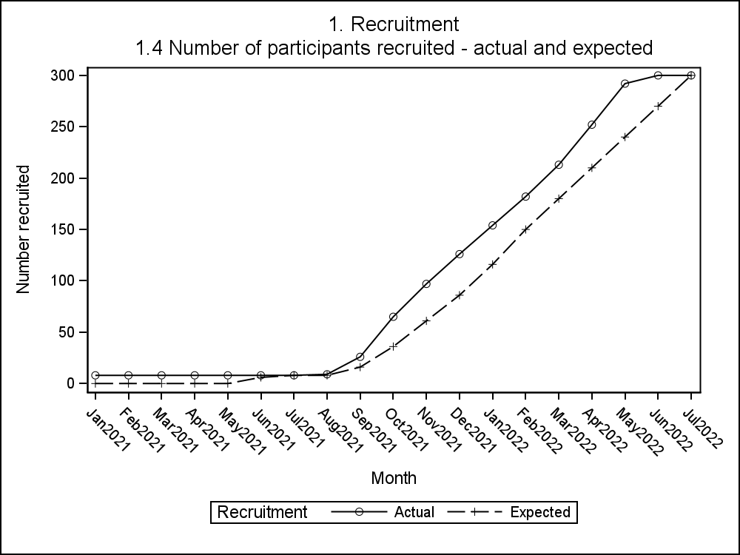

Supplementary figure S2. Proportion of participants receiving crossover intravenous fluid, and volume administered in each arm in the first six hours after randomisation.

Supplementary Figure S3
Figure S3A. Cumulative allocated intravenous fluid administration in the first 24 hours after randomisation

Figure S3B. Cumulative total intravenous fluid administration in the first 24 hours after randomisation

Supplementary Table S1. Study inclusion and exclusion criteria

Inclusion Criteria | Exclusion criteria
- Clinically suspected or proven infection resulting in principal reason for acute illness;  - NEWS2 score ≥5;  - Hospital presentation within last 12hrs;  - Clinician decision has been made that immediate (within 1 hour of assessment) intravenous fluid resuscitation is needed;  - Ability to obtain informed consent. | - >1 litre of intravenous crystalloid fluid or any intravenous HAS administered prior to eligibility assessment;  - Clinically judged to require immediate surgery (within one hour of eligibility assessment);  - Chronic renal replacement therapy;  - Known allergy/adverse reaction to HAS;  - Known contraindications to balanced crystalloid as per reference SmPC;  - Known adverse reaction to blood products;  - Palliation/end of life care (explicit decision by patient/family/carers in conjunction with clinical team that any active treatment beyond symptomatic relief is not appropriate);  - Religious beliefs precluding HAS administration;  - Previous recruitment in the trial;  - Known recent severe traumatic brain injury (within 3 months);  - Patients with permanent incapacity;  - Known to have participated in interventional phase of another CTIMP study within the last 30 days.
CTIMP: clinical trial of investigational medical product;
HAS: 5% human albumin solution;
NEWS2: national early warning 2 score;
SmPC: Summary of Product Characteristics

Supplementary Table S2. Trial Outcomes

Primary Endpoint
- Recruitment rate from screening logs
- 30-day mortality

Secondary Endpoints
- In-hospital mortality and 90-day mortality;
- Time to start of IMP;
- Data completeness;
- Study withdrawal;
- Volume of randomised fluid delivered in each arm in the first 6hrs and 24hrs;
- Proportion of participants needing critical care intervention: Intravenous vasopressors, renal replacement therapy and invasive ventilation;
- Proportion of patients who receive any other fluid apart from intervention or control in first 6 hrs after recruitment;
- Proportion of patients admitted to critical care (HDU/ICU); length of stay in critical care (HDU/ICU);
- Length of hospital stay;
- Proportion of patients readmitted in first 90 days after discharge;
- Proportion of patients developing any of:
  - Acute kidney injury (Defined by NICE (https://cks.nice.org.uk/acute-kidney-injury#!scenario);
  - Pulmonary oedema (Radiology diagnosis or requirement for rescue management (new diuretic use)); and
  - Allergy or anaphylaxis (Requirement for rescue management (antihistamines, adrenaline, intravenous fluids, steroids));
- Health Related Quality of life (EQ-5D-5L) at 7 and 180 days for the first 50 patients;
- Secondary care costs at 30 days (calculated from readmissions and length of stay at ward level and in critical care (HDU/ICU).

IMP: Investigational Medicinal Product
HDU: High Dependency Unit
ICU: Intensive Care Unit
NICE: National Institute of Clinical Excellence

Supplementary Table S3. Study Assessments
 | Screening | Baseline  (Day 0) | Day 1-6 | Day 7 | Discharge | Day 30# | Day 90# | Day 180
Consent | X
Eligibility | X
Randomisation |  | X
Demographics/Medical History/estimated weight |  | X
Routine blood results* |  | X | X | X
Routine urine and other culture results |  | X
Vital Signs/lactate** |  | X
IMP administration/adherence |  | X
Interventions |  | X
Mortality |  |  |  |  | X | X | X
Length of stay/  Ward/HDU/ICU stay |  |  |  |  | X |  | X
Readmissions |  |  |  |  |  |  | X
Acute kidney injury/ Pulmonary oedema/  Allergy/anaphylaxis |  |  |  |  | X
Adverse Events |  | X | X | X
EQ-5D-5L*** ª |  | X |  | X |  |  |  | X

* Daily (+/- 12 hours) for any routine bloods collected up to 7 days. If bloods (or individual parameters) are not requested by the clinical team, this will not be recorded as a deviation.
**Both vital signs and lactate, if measured, will be recorded prior to treatment starting and at 1,3,5 and 7 hours after randomisation (+/-30mins). Lactates up to 24hours post-randomisation, if measured, will be recorded at 9,11,13,15,17,19,21,23 hours (+/-30mins).
***First 50 participants only.
# As Day 30 and Day 90 follow up is collected from the medical records it can be reviewed and recorded in the eCRF up to 7 days after the time point, so it captures all admissions/events up to and including Day 30 and 90.

ª Janssen MF, Bonsel GJ, Luo N. Is EQ-5D-5L Better Than EQ-5D-3L? A Head-to-Head comparison of descriptive systems and value sets from seven countries/regions. Pharmacoeconomics. 2018;36(6):675-697.

Supplementary table 4. Presumed primary site of infection

Source of infection |  | Treatment allocation |  | All
 |  | 5% Human Albumin Solution (N=150) | Balanced crystalloid (N=150) | All
Chest | N | 95 | 87 | 182
Chest | % | 63 | 58 | 61
Urine | N | 16 | 33 | 49
Urine | % | 11 | 22 | 16
CNS | N | 1 | 0 | 1
CNS | % | 1 | 0 | 0
Skin | N | 9 | 2 | 11
Skin | % | 6 | 1 | 4
Abdomen | N | 13 | 9 | 22
Abdomen | % | 9 | 6 | 7
Unknown | N | 12 | 10 | 22
Unknown | % | 8 | 7 | 7
Other | N | 3 | 9 | 12
Other | % | 2 | 6 | 4
Missing | N | 1 | 0 | 1
 | % | 1 | 0 | 0
All | N | 150 | 150 | 300

Supplementary Table S5. Pre-existing chronic conditions

 | 5% Human Albumin Solution (N=150) | Balanced crystalloid (N=150) | All
Cancer
No | 130 (86.7%) | 131 (87.3%) | 261 (87.0%)
Yes | 20 (13.3%) | 19 (12.7%) | 39 (13.0%)
Stroke
No | 135 (90.0%) | 139 (92.7%) | 274 (91.3%)
Yes | 15 (10.0%) | 11 (7.3%) | 26 (8.7%)
MI
No | 123 (82.0%) | 129 (86.0%) | 252 (84.0%)
Yes | 27 (18.0%) | 21 (14.0%) | 48 (16.0%)
PVD
No | 142 (94.7%) | 136 (90.7%) | 278 (92.7%)
Yes | 8 (5.3%) | 14 (9.3%) | 22 (7.3%)
Heart failure
No | 137 (91.3%) | 127 (84.7%) | 264 (88.0%)
Yes | 13 (8.7%) | 23 (15.3%) | 36 (12.0%)
COPD
No | 113 (75.3%) | 113 (75.3%) | 226 (75.3%)
Yes | 37 (24.7%) | 37 (24.7%) | 74 (24.7%)
Chronic kidney disease
No | 133 (88.7%) | 129 (86.0%) | 262 (87.3%)
Yes | 17 (11.3%) | 21 (14.0%) | 38 (12.7%)
Dementia
No | 146 (97.3%) | 145 (96.7%) | 291 (97.0%)
Yes | 4 (2.7%) | 5 (3.3%) | 9 (3.0%)
Diabetes type 1
No | 148 (98.7%) | 148 (98.7%) | 296 (98.7%)
Yes | 2 (1.3%) | 2 (1.3%) | 4 (1.3%)
Diabetes type 2
No | 111 (74.0%) | 119 (79.3%) | 230 (76.7%)
Yes | 39 (26.0%) | 31 (20.7%) | 70 (23.3%)

Numbers are n(%), mean (SD) or median [Q1-Q3]

Supplementary table S6. Baseline blood results

 | 5% Human Albumin Solution (N=150) | Balanced crystalloid (N=150) | All
ALT (U/L)
Mean (SD) | 52.3 (122.7) | 44.0 (99.4) | 48.2 (111.5)
Median [Q1-Q3] | 21.0 [14.0-36.0] | 23.0 [13.5-39.5] | 22.0 [14.0-38.0]
N | 137 | 136 | 273
Albumin (g/l)
Mean (SD) | 31.5 (6.8) | 31.2 (6.0) | 31.3 (6.4)
Median [Q1-Q3] | 32.0 [27.0-36.0] | 32.0 [28.0-35.0] | 32.0 [28.0-36.0]
N | 125 | 125 | 250
Urea (mmol/L)
Mean (SD) | 9.5 (6.9) | 9.4 (5.2) | 9.5 (6.1)
Median [Q1-Q3] | 7.2 [4.9-11.1] | 8.3 [5.4-12.2] | 7.6 [5.2-12.0]
N | 130 | 130 | 260
Creatinine (µmol/L)
Mean (SD) | 122.1 (106.5) | 118.9 (70.4) | 120.5 (90.5)
Median [Q1-Q3] | 87.5 [67.0-134.0] | 93.5 [75.5-132.0] | 90.0 [72.0-132.0]
N | 146 | 140 | 286
eGFR (mL/min/1.73m²)
Mean (SD) | 56.0 (24.8) | 50.5 (18.9) | 53.3 (22.2)
Median [Q1-Q3] | 60.0 [39.0-77.0] | 54.0 [40.0-60.0] | 56.0 [39.0-60.0]
N | 119 | 115 | 234
Hb (g/l)
Mean (SD) | 128.5 (22.5) | 127.9 (19.9) | 128.2 (21.2)
Median [Q1-Q3] | 130.0 [114.0-144.0] | 129.0 [114.0-142.0] | 129.0 [114.0-143.0]
N | 146 | 144 | 290
Platelets (x10^9/L)
Mean (SD) | 251.9 (115.3) | 250.6 (137.1) | 251.3 (126.3)
Median [Q1-Q3] | 232.0 [172.0-303.0] | 223.0 [169.0-304.0] | 228.0 [171.0-304.0]
N | 145 | 141 | 286
WCC (x10^9/L)
Mean (SD) | 13.4 (7.1) | 14.9 (7.9) | 14.2 (7.5)
Median [Q1-Q3] | 12.4 [8.6-17.0] | 13.8 [9.1-18.8] | 13.0 [8.9-17.8]
N | 145 | 141 | 286
Neutrophils (x10^9/L)
Mean (SD) | 11.4 (6.8) | 12.9 (7.0) | 12.1 (6.9)
Median [Q1-Q3] | 10.3 [6.4-14.8] | 11.6 [7.7-16.6] | 10.7 [7.4-15.7]
N | 145 | 140 | 285
CRP (mg/l)
Mean (SD) | 127.5 (122.6) | 141.5 (132.2) | 134.5 (127.4)
Median [Q1-Q3] | 100.0 [36.0-184.0] | 89.0 [40.0-218.0] | 95.0 [37.0-209.0]
N | 142 | 141 | 283
Glucose (mmol/L)
Mean (SD) | 8.0 (3.5) | 7.7 (2.8) | 7.8 (3.2)
Median [Q1-Q3] | 7.0 [5.8-9.2] | 6.9 [5.9-9.1] | 6.9 [5.9-9.1]
N | 100 | 89 | 189

Numbers are n(%), mean (SD) or median [Q1-Q3]

Supplementary table S7. Pre-specified subgroup analyses on the primary outcome

Supplementary table S8. Intravenous fluid in the first 24 hours after randomisation

 | 5% Human Albumin Solution (N=150) |  | Balanced crystalloid (N=150) | All
Intervention fluid (ml)
Mean (SD) | 1022 (698.8) |  | 2272 (1426) | 1643 (1282)
Median [Q1-Q3] | 750.0 [500.0-1500] |  | 2000 [1000-3000] | 1250 [750.0-2000]
N | 147 |  | 145 | 292
Intervention fluid (0-24 hours) per patient weight (ml/kg)
Mean (SD) | 13.7 (10.1) | 31.8 (21.2) |  |  | 22.6 (18.8)
Median [Q1-Q3] | 10.0 [6.3-19.3] | 26.5 [16.9-41.2] |  |  | 17.5 [8.5-29.5]
N | 144 | 139 |  |  | 283
Total cross-over fluid (ml)
Mean (SD) | 1262 (802.8) |  | 1188 (1214) | 1259 (817.4)
Median [Q1-Q3] | 1000 [750.0-2000] |  | 625.0 [500.0-1875] | 1000 [700.0-2000]
N | 76 |  | 4 | 80
Other crystalloid fluid (ml)
Mean (SD) | 28.5 (175.1) |  | 36.0 (148.2) | 32.4 (161.2)
Median [Q1-Q3] | 5.6 [2.9-17.1] |  | 8.1 [4.1-17.8] | 6.7 [3.3-17.6]
N | 88 |  | 96 | 184
Total fluid (ml)
Mean (SD) | 2104 (1194) |  | 2750 (1600) | 2427 (1446)
Median [Q1-Q3] | 2000 [1250-2885] |  | 2500 [1500-3500] | 2250 [1450-3192]
N | 148 |  | 148 | 296
Total fluid (0-24 hours) per patient weight (ml/kg)
Mean (SD) | 28.3 (18.8) | 38.3 (23.3) |  |  | 33.3 (21.7)
Median [Q1-Q3] | 25.6 [15.0-37.3] | 34.5 [21.4-48.8] |  |  | 29.1 [16.9-44.9]
N | 145 | 142 |  |  | 287

Numbers are n(%), mean (SD) or median [Q1-Q3]
Supplementary table S9. Adverse and Serious Adverse event summary (n = 300)

 | Patients (N=30) | Events (N=49)
Serious
No | 23 (76.7%) | 40 (81.6%)
Yes | 7 (23.3%) | 9 (18.4%)
Outcome
Resolved | 27 (90%) | 43 (87.8%)
Ongoing | 3 (10%) | 6 (12.2%)
Causality
Unrelated | 30 (100%) | 49 (100%)
Expectedness
Expected | 9 (30%) | 15 (30.6%)
Unexpected | 5 (16.7%) | 6 (12.2%)
N/A | 16 (53.3%) | 28 (57.1%)
Severity
Mild | 20 (66.7%) | 31 (63.3%)
Moderate | 5 (16.7%) | 11 (22.4%)
Severe | 5 (16.7%) | 7 (14.3%)

Supplementary table S10. Quality of life for the first 50 participants

 | 5% Human Albumin Solution | Balanced crystalloid | All
Eq5D at baseline
Mean (SD) | 0.6 (0.4) | 0.5 (0.3) | 0.5 (0.4)
Median [Q1-Q3] | 0.8 [0.2-0.9] | 0.5 [0.2-0.8] | 0.6 [0.2-0.8]
N | 19 | 26 | 45
Eq5D at 7 days
Mean (SD) | 0.4 (0.4) | 0.5 (0.3) | 0.4 (0.3)
Median [Q1-Q3] | 0.4 [0.1-0.8] | 0.5 [0.2-0.7] | 0.4 [0.2-0.8]
N | 19 | 27 | 46
Eq5D at 180 days
Mean (SD) | 0.4 (0.4) | 0.4 (0.3) | 0.4 (0.3)
Median [Q1-Q3] | 0.4 [0.1-0.8] | 0.5 [0.2-0.7] | 0.4 [0.2-0.7]
N | 20 | 28 | 48

Numbers are n(%), mean (SD) or median [Q1-Q3]

