Supplementary information
Article title: Coupling normothermic machine perfusion with mesenchymal stem cell bioreactors: benefits exerted on the rat liver

Table of Contents
1. Supplementary methods 3
1.1. Isolation of adipose tissue-derived mesenchymal stem cells 3
1.2. MSCs in vitro culturing before bioreactor preparation 3
1.3. Liverless perfusion procedure 3
1.4. Bio-molecular analysis performed on bioreactor supernatants and perfusate samples collected during liverless-NMP 4
1.4.1. Perfusate sample processing 4
1.4.2. Human Indoleamine 2,3-Dioxygenase (IDO) 4
1.4.3. Human caspase-cleaved keratin 18 (CK18) 4
1.4.4. Total nitric oxide (NO) metabolites 4
1.4.5. Analysis of extracellular vesicles (EVs) released in the perfusate 5
1.5. MSC flow-citometry 5
1.6. Animals and sample size calculation 5
1.7. Anesthesia, Surgery, In-situ Perfusion, and liver procurement 6
1.8. Liver normothermic perfusion 6
1.9. Comparative analysis of perfusates collected during liverless-NMP and liver NMP 7
1.9.1. Processing of perfusate samples collected during liver NMP 7
1.9.2. Human IL-4, IL-6, IL-10, IL-13, IL-1ra, IL-36-beta, Galectin-3 and CCL-2/MCP-1 8
1.9.3. Human Galectin-9 8
1.9.4. Human IL-8, IL-33, and IL-18 8
1.10. Bio-molecular analysis of perfusate samples collected during liver NMP 8
1.10.1. Succinate 9
1.10.2. NADH 9
4.6.2 Molecules relevant to tissue damage, inflammation and resolution 9
1.10.3. Rat Tissue Inhibitor of Metalloproteinase 1 (TIMP-1) 10
1.10.4. Rat IL-13, Hepatocyte growth factor (HGF) 10
1.11. Evaluations performed on liver biopsies 10
1.11.1. Wet-to-Dry Ratio 10
1.11.2. ATP content Assessment 10
1.11.3. Tissue NAD+/NADH content measurement 11
2. Supplementary results 12
2.1. Preliminary characterization of MSCs isolated from adipose tissue 12
2.2. Transmembrane pressure during liverless NMP 12
2.3. Gas analysis during liverless NMP 12
2.4. Hemodynamics parameters during liver NMP 12
2.5. Gas analysis of perfusate samples collected during liver NMP 12
2.6. Analysis of the bile produced during liver NMP 13
2.7. NAD+/NADH evaluation 13
2.8. Characterization of the MSCs harvested from the bioreactors after liver NMP 13
3. Supplementary Tables 14
Supplementary Table 1. Gas analysis of bioreactor supernatants 14
Supplementary Table 2. Experimental design 15
Supplementary Table 3. Timings of sample collection during liver NMP 16
4. Supplementary Figures 17
Supplementary Figure 1. Transmembrane pressure during liverless NMP 17
Supplementary Figure 2. Gas analysis during liverless-NMP 18
Supplementary Figure 3. Hemodynamics parameters during liver-NMP 19
Supplementary Figure 4. Gas analysis of perfusate samples collected during liver-NMP 20
Supplementary Figure 5. NAD+ and NADH content in liver homogenates and perfusate samples 22
5. References 23

Supplementary methods

Isolation of adipose tissue-derived mesenchymal stem cells
Subcutaneous adipose tissue (SAT) of the abdominal region was collected during abdominoplasty (Ethical Committee for Clinical Research approval number: 2892P, 10/06/2013). SAT was minced and digested in collagenase type II solution (1 mg/mL) (Merck KGaA, Darmstadt, Germany) at 37 °C in a water bath with medium shaking for 1 hour. The digested AT was mixed by pipetting, serially centrifuged at 350g for 10 min and filtered through 100 µm cell strainer (Falcon, BD, NJ, USA) to remove collagen fibers and debris. Red blood cells were removed by 5 min incubation of cellular pellet with standard lysis buffer. Cells of the stromal vascular faction (SVF) were counted in a Neubauer chamber upon Trypan Blue (0.4%) staining, seeded in DMEM F12 10 % FBS (Gibco, Thermo Fisher Scientific, Waltham, MA USA) and grown at 37 °C and 5% CO2. MSC(AT) were obtained by subculturing, expanded in MEM Alpha Medium 5% hPL (Gibco) and used at passages 2–8 (P2–P8) to reduce variability.

MSCs in vitro culturing before bioreactor preparation
Human adipose tissue-derived MSCs were cultured at a concentration of 2*105 in 14 mL in αMEM medium (Gibco, Thermo Fisher Scientific, Waltham, MA USA) added with 5% Human platelet lysate (SCM142, Merck KGaA, Darmstadt, Germany), 2 mM L-glutamine, 100 U/ml penicillin, 100 μg/ml streptomycin, and 100 μg/ml Amphotericin B (Thermofisher Scientific, Waltham, Massachusetts, USA). Cells were expanded for 14 days, with medium substitution every 2 days. At 80% confluence, cells were enzymatically harvested and counted.

Liverless perfusion procedure
Liverless perfusion experiments were performed using a customized circuit. It consists of a heated glass reservoir (Hugo Sachs Elektronik-Harvard apparatus, March, Germany), PVC tubing (BD Switzerland Sarl, Eysins, Switzerland), a peristaltic pump (Ismatec, Wertheim, Germany), a single-use membrane oxygenator (Micro-1, Kewei Rising Medical, Shenzhen, China) and a heated bubble trap (Hugo Sachs Elektronik-Harvard apparatus). The perfusion fluid was prepared using the following reagents: Williams Medium E (Thermofisher Scientific, Waltham, Massachusetts, USA), human albumin (Grifols S.A. Barcelona, Spain), L-glutamine (Gibco, Thermo Fisher Scientific), Antibiotic-Antimycotic (Streptomycin, Amphotericin B, Penicillin, Gibco, Thermo Fisher Scientific), insulin (Humalog, Eli Lilly, Utrecht, Netherlands), N-acetylcysteine (Zambon Italia, Bresso, Italy), and sodium taurocholate (Organox, Oxford, UK).
Then, 46.2 mL of Oxyglobin® (HBO2 Therapeutics, Boston, USA), a veterinary-licensed bovine-derived haemoglobin, was added to the solution to reach a final volume of 120 mL. After bioreactors connection to the circuit, the perfusion fluid was pumped inside the fibers at a flow of 20 ml/min, and outside the cave fibers at a flow of 5 ml/min in the opposite direction to allow a better fluid exchange between the different compartments.

Bio-molecular analysis performed on bioreactor supernatants and perfusate samples collected during liverless-NMP
Perfusates were used to assess the concentration of the following molecules of human origin: Indoleamine 2,3-Dioxygenase (IDO), caspase-cleaved keratin 18 (CK18), Galectin-9, Interleukin (IL)-8, IL-33, IL-18, IL-1ra, and nitric oxide (NO).

Perfusate sample processing
Perfusate samples were centrifugated at 2000 rpm for 10 min at 4°C (Haereus Multifuge X3R, Thermo Fisher Scientific Inc., Cambridge, UK). Supernatants were collected and purified with Amicon Ultra 100K centrifugal filter devices (MilliporeSigma, Frankfurter, Germany) to avoid colorimetric interferences possibly given by Oxyglobin®. Briefly, 500 µL of each sample were loaded onto the columns and centrifuged at 13500 rpm for 15 min (Haereus Multifuge X3R). Next, eluates were collected and stored at -80°C for subsequent biomolecular analysis.

Human Indoleamine 2,3-Dioxygenase (IDO)
The amount of Indoleamine 2,3-Dioxygenase (IDO), was investigated in perfusates and supernatants using a Human Elisa Kit (Invitrogen, California, USA). Standards were prepared with a serial dilution ranging from 200 ng/mL to 0.819 ng/mL. Absorbance readings at 450 nm was performed using a multi-mode microplate reader (Synergy HTX, Biotek U.S, Winooski, VT, USA).

Human caspase-cleaved keratin 18 (CK18)
The M30 Elisa kit (VLVbio AB, Nacka, Stockholm, Sweden) is a one-step immunoassay for quantitative determination of the apoptosis-associated caspase-cleaved keratin 18. The M30 antibody recognizes a neo-epitope exposed after caspase cleavage of K18 fragments containing the K18Asp396 neo-epitope. Standard curve range was from 1.56 mU/ml to 100 mU/ml. Absorbance readings at 450 nm was performed using a multi-mode microplate reader (Synergy HTX).

Total nitric oxide (NO) metabolites
Concentration of nitric oxide (NO) was evaluated through assessment of total NO metabolites (nitrites and nitrates) content using Griess reagent. A colorimetric commercially available kit with a detection range of 10–100 μM was utilized (Sigma-Aldrich). Samples were loaded into Amicon Ultra 10 K centrifugal filter devices (Millipore, Burlington, MA, USA) and then subjected to 15-min centrifugation at 14.000 g (Haereus Multifuge X3R). Next, protein- and hemoglobin-free eluates were added to a nitrate reductase according to manufacturer’s instructions. Absorbance readings at 450 nm was performed using a multi-mode microplate reader (Synergy HTX).

Analysis of extracellular vesicles (EVs) released in the perfusate
EVs were isolated from perfusate samples using qEV/35nm size exclusion chromatography columns (Izon Science, Medford, MA), which preferentially isolates EVs between 35-350nm. Isolated EVs then underwent size and concentration measurements by nanosight tracking analysis using a Nanosight NS300 (Malvern Instruments, UK).

MSC flow-citometry
Cytofluorimetric analysis was set up as follows: cells were washed with cold FACS buffer and collected by centrifugation (350g, 10 min). Next, cells were incubated in the dark for 10 min at RT with the following monoclonal mouse anti-human fluorochrome-conjugated antibodies against the indicated surface markers, in different combinations: CD29, CD73, CD90, CD105, CD45, CD31, CD34 (BD Biosciences, San Jose, CA, USA). Biomarkers were selected based on the Guidelines for Standardization and quality assessment for clinical grade MSCs from human adipose tissue formulated by T. Debnath and coworkers ¹.
Labeled cells were acquired and analyzed by a FACSCantoTM Flow Cytometer (BD Biosciences) using the BD FACSDivaTM software to characterize MSCs (CD29+, CD73+, CD90+, CD105+, CD45-, CD31-, CD34-).

Animals and sample size calculation
Animals received humane care in compliance with the European Union Directive 2010/63/EU and the Italian Legislative Decree 26/2014. Experiments were planned according to the Planning Research and Experimental Procedures on Animals: Recommendations for Excellence (PREPARE) guidelines and performed in compliance with the 3R principles ^{2,3}.
An “a priori” power analysis was carried out to estimate the minimum number of animals needed to reliably detect the expected effect size. Given the well-known negative effects of reperfusion on mitochondrial oxidative phosphorylation, ATP liver content was used as reference variable to explore the effects exerted by the MSCs-bioreactor-based perfusion. Details on sample size calculation are listed below:
• number of groups: 3 (Native, NMP, NMP+bioreactor);
• statistical test: one-way or two-way repeated measures ANOVA;
• expected effect size: 0.45;
• expected standard deviation of residuals: 0.20;
• desired power: 0.80;
• alpha error: 0.05.
The analysis provided a minimum number of 5 livers for each experimental group. The final number needed to perform the whole study was therefore 15.

Anesthesia, Surgery, In-situ Perfusion, and liver procurement
All experiments were performed in sterile conditions. Rats were anesthetized using Isoflurane (Abbott, Chicago, Illinois, USA) 3-4% (1-2 L/min O2 flow) in a rat anesthetic induction chamber for 10 min. When unresponsive to pain, rats were placed onto the operating table, enduring spontaneous breathing with a mask that insufflate O2 and Isoflurane 3-4% (Abbott).
The surgical procedure began with a xifo-pubic and bilateral subcostal incision. The hepatic pedicle was then exposed, and the bile duct was dissected. Bile duct was distally ligated with an 8-0 nylon tie, then a customized cannula (tip: 24 G cannula Braun, Bethlehem, PA, USA; tube: PE-50, BD-Clay Adams, Becton, UK) was inserted at the end of the choledotomy; the cannula was secured with a proximal 8-0 nylon tie. Then, the pyloric vein was ligated (8-0 nylon) and transected, and then the main trunk of the portal vein was dissected distally. The portal vein was encircled with three 5-0 silk tie; then unfractioned heparin (2 IU/g diluted in 1 mL of saline from Fresenius Medical Care, Bad Homburg corder Hohe, Germany) was administered by tail intravenous injection. After three min, portal vein was ligated distally to the splenic vein insertion and a 16 G cannula was inserted by venipuncture until the tip of the cannula reached the portal bifurcation. A blood retrograde flush was performed, and the in-situ perfusion system was connected. Then, the cannula was secured with a two-silk tie and gently retracted to avoid obstruction of the right lobe portal vein branch. Rapid sternotomy was performed, the heart was removed, and the inferior vena cava was transected. In-situ cold perfusion (4°C) was started with 35 mL of Celsior solution (IGL, Lissieu, France) at a pressure of 30 cmH2O. At the end of in-situ cold perfusion, hepatectomy was completed and the liver graft was stored in 4°C Celsior (IGL) solution for 30 min. At the end of cold storage, backtable was completed, while maintaining the liver on a refrigerated surface.

Liver normothermic perfusion
At the end of SCS, the liver was placed onto the modified glass chamber to let the liver laid on the diaphragmatic surface on a modeled ad hoc, perforated parafilm. The liver was then connected to the primed circuit through the portal vein cannula, while the bile duct cannula was connected to a 1.5 mL tube in order to collect bile during reperfusion. The chamber was closed to maintain humidity. We carefully avoided air embolism during priming and liver connection. The membrane oxygenator was ventilated with a 200 mL/min gas flow, with 50% FiO2 and 5% FiCO2.
The NMP-protocol was maintained for 280 min and included two phases: 1) the rewarming phase, lasting 40 min and 2) the normothermic phase, lasting 240 min. During the “rewarming” phase, the system reaches the temperature of 37°C. Portal flow was set at 5 mL/min and was increased every five minutes up to 30 mL/min, or until the portal pressure reaches 8 cmH2O. In the normothermic phase, temperature was maintained at 37°C and portal flow remained unchanged.
Perfusion fluid volume was maintained at 100 mL throughout the procedure. To prevent the accumulation of MetaOxyglobin, from the beginning of normothermic phase a fixed volume of perfusate was replaced with fresh perfusion fluid at 20 mL/h flow rate. Waste flow rate was 10 mL/h from 0 h to 2 h, while it was increased to 14 ml/h from 2 h to 4 h to adjust for the volume of perfusate collected for biomolecular analysis.
Hemodynamics parameters were monitored using the Powerlab 16/35 system (ADInstruments, Dunedin, New Zeland) and LabChart 8 pro (ADInstruments). Portal vein and pre-membrane oxygenator pressures were recorded every 5 min during rewarming, and every hour during normothermic machine perfusion. Vascular resistances were calculated as mean portal vein pressure divided by blood flow of the portal vein (mL/min). Temperature was monitored using a thermo probe located between the lobes of the liver.

Comparative analysis of perfusates collected during liverless-NMP and liver NMP
Perfusates collected during liverless NMP and liver NMP were used to assess the concentration of the following molecules of human origin: IDO, IL-4, IL-6, IL-8, IL-10, IL-13, IL-1ra, IL-18, IL-33, IL-36-beta, Galectin-3, Galectin-9, and CCL-2/MCP-1.

Processing of perfusate samples collected during liver NMP
Samples were centrifugated at 2000 rpm for 10 min at 4°C (CentrifugeX3R Heraeus). Supernatants were collected and stored at −80°C for further analysis, whereas cell pellets were washed using 15 mL of PBS 1X (MilliporeSigma, Frankfurter, Germany) vortexed, and then centrifuged for 10 min at 4°C. Afterwards, pellets were resuspended in 7-15 mL, depending on the volume of perfusate, of erythrocyte lysis buffer (0.155 M NH4Cl, 10 mM KHCO3, 0.1 mM Na2EDTA, pH 7.4; all from MilliporeSigma) and incubated for 15 min at 4°C. A 10-min centrifugation at 2000 rpm was then performed. Pellets were suspended in 0,5-4 mL of PBS 1X (MilliporeSigma) for cell count and characterization using the Scepter cell counter (Millipore Corporation, Billerica, MA, USA).
To avoid colorimetric interferences possibly given by Oxyglobin®, perfusates were purified with Amicon Ultra 100K centrifugal filter devices (MilliporeSigma). Briefly, 500 µL of each sample were loaded onto the columns and centrifuged at 13500 rpm for 15 min (CentrifugeX3R Heraeus).

Human IL-4, IL-6, IL-10, IL-13, IL-1ra, IL-36-beta, Galectin-3 and CCL-2/MCP-1
The concentration of Human IL-4, IL-6, IL-10, IL-13, IL-1ra, IL-36-beta, Galectin-3 and CCL-2/MCP-1 was measured by means Luminex® xMAP Technology with a custom-designed immunoassays (R&D Systems). Briefly, 100 µL from each antibody-bead vial were added to a Mixing Bottle and then brought to a final volume of 1 mL with the kit-specific Assay Buffer. Fifty µL of standards, controls and samples were added to the appropriate wells, then each well was brought to a final volume of 100 µL with 50 µL of Mixed Beads. The plate was incubated in the dark for 2 h with gentle agitation at RT. Plate was washed 3 times for every new step; then Biotin and Streptavidin were added subsequently to the wells. Lastly, 100 µL of Wash Buffer were added for fluorescence detection.

Human Galectin-9
Concentration of Human Galectin-9 was investigated in perfusate samples before and during NMP with an ELISA kit. (R&D Systems, Bio-Techne, Minneapolis, USA). Standards were prepared with a serial dilution ranging from 10 ng/mL to 0.156 ng/mL. Absorbance was read at 450 nm (Synergy HTX).

Human IL-8, IL-33, and IL-18
Pre-configured Ella® (Bio-Techne) cartridges were used to investigate Human IL-8, IL-33, and IL-18.
Samples were loaded onto an Ella cartridge for the run. All sample specific information were entered into the Simple Plex Runner software. The cartridge was inserted into the device and the run was started. At the end of the assay, the results of triplicate measurements in relative fluorescence units, mean signal values, SD and coefficient of the variance (CV) were automatically displayed for each analyte.

Bio-molecular analysis of perfusate samples collected during liver NMP
After perfusate processing as reported in the paragraph 1.8.1, samples were used to assess the following parameters: alanine-aminotransferase (ALT), Lactate dehydrogenase, (LDH), NO, rat biomarkers of liver injury, rat biomarkers of endothelial activation, rat inflammation-related mediators, and rat molecules involved in inflammation resolution and liver cell regeneration.

Succinate
Perfusate succinate was assessed using the Succinate Colorimetric Assay Kit (Sigma-Aldrich, Frankfurter, Germany). Perfusates were deproteinized using Amicon Ultra 10K centrifugal filter devices (MilliporeSigma). Standards were prepared directly in wells adding from 10µL to 2µL of the 1mM Standard Solution, therefore with a scale that ranged from 10 nmol/well to 2 nmol/well. After a 30-min incubation at 37°C, absorbance was read at 450 nm (Synergy HTX).

NADH
NADH concentration in perfusates was analyzed trough fluorescence intensity, as described elsewhere ⁴. A pre-weighed NADH vial was purchased from Sigma Chemical Company (St. Louis, MO). A stock solution of 10 mg/ml was prepared using Na-bicarbonate buffer, pH 9. A standard curve ranging from 250 to 2.5 ng/ml was then prepared using filtered perfusate/medium. Seventy-five µL of each sample were then added in duplicates to the wells. Fluorescence was determined using a 340 nm excitation filter and a 440 nm emission filter using a multiplate reader (Synergy HTX).

4.6.2 Molecules relevant to tissue damage, inflammation and resolution
Soluble proteins relevant to liver damage, vascular damage and immune activation were evaluated by means of Luminex® xMAP Technology (Luminex 200; Luminex, Austin, CA,USA) with the following custom-designed immunoassays (EDM Millipore Corporation, Billerica, MA, USA): 1) Rat Liver Injury Magnetic Bead Panel (Arginase-1: ARG1, 5'-nucleotidase: 5’-NT, Glutathione Transferase Alpha: GST-alpha; Sorbitol dehydrogenase: SDH); 2) Rat Vascular Injury Magnetic Panels (Adiponectin; Caveolin 1:CAV-1, Connective Tissue Growth Factor: CTGF, Tissue Plasminogen Activator Inhibitort-1: t-PAI-1, soluble Intercellular Adhesion Molecule-1: sICAM-1, Soluble endothelial leukocyte adhesion molecule-1: sE-Selectin, Alpha-1-acid glycoprotein: AGP, Alpha-2-Macroglobulin: A2M, Haptoglobin); 3) Rat Cytokine/Chemokine Magnetic Bead Panel (Macrophage Inflammatory Protein-1alpha MIP-1alpha; Interleukin-4: IL-4, Interleukin-6: IL-6, Interleukin-10: IL-10, Interferon-gamma: IFN-gamma, Interleukin-18: IL-18, Chemokine C-C motif ligand 2/Monocyte Chemoattractant Protein-1: CCL2/MCP-1, Interferon gamma-induced protein 10: IP-10, C-X-C motif chemokine ligand 1/Cytokine-Induced Neutrophil Chemoatractant-1: CXCL1/CINC-1, Vascular Endothelial Growth Factor: VEGF, C-X-C Motif Chemokine Ligand 5, CXCL5/LIX, Tumor Necrosis Factor- alpha: TNF- alpha, Chemokine C-C motif ligand 5/regulated on activation, normal T cell expressed and secreted: CCL5/RANTES).
Briefly, 150 µL from each antibody-bead vial were added to a Mixing Bottle and then brought to a final volume of 3 mL with the kit-specific Assay Buffer. Twenty-five µL of standards, controls and samples were added to the appropriate wells, then each well was brought to a final volume of 75 µL with 25 µL of Assay Buffer and 25µL of Mixed Beads. The plate was incubated in the dark for 2 hours with gentle agitation at RT. Plate was washed 3 times, then Detection Antibodies and Streptavidin-Phycoerythrin were added to the wells. Lastly, 150 µL of Sheath Fluid were added for subsequent fluorescence detection using a Luminex 200 (Luminex, Austin, CA, USA).

Rat Tissue Inhibitor of Metalloproteinase 1 (TIMP-1)
The amount of the Tissue Inhibitor of Metalloproteinase 1 (TIMP-1), was investigated in perfusate samples using a Rat TIMP-1 Immunoassay (R&D Systems). Standards were prepared with a serial dilution ranging from 2400 pg/mL to 37.5 pg/mL. Absorbance was read at 450 nm with wavelength correction at 540 nm (Synergy HTX).

Rat IL-13, Hepatocyte growth factor (HGF)
The amount of IL-13 was investigated in perfusates using an ELISA kit (Abcam, Cambridge, UK). Standards were prepared with a serial dilution ranging from 5000 pg/mL to 78.125 pg/mL. Absorbance readings at 450 nm was performed using a multi-mode microplate reader (Synergy HTX).
HGF was investigated in perfusates using a Rat HGF Immunoassay (R&D Systems). Standards were prepared with a serial dilution ranging from 4000 pg/mL to 62.5 pg/mL. Absorbance was read at 450 nm with wavelength correction at 540 nm (Synergy HTX).

Evaluations performed on liver biopsies

Wet-to-Dry Ratio
Biopsies were weighted on an analytical balance (Sartorius AG, Göttingen, Germany) before and after desiccation in an oven at 50 ◦C for 48 h. Thereafter, wet/dry ratios (W/D) were calculated as an index of edema.

ATP content Assessment
Snap frozen liver samples were homogenized in trichloroacetic acid (MilliporeSigma) at a concentration of 50 mg/mL. Supernatants were collected and then diluted 1:30 using 0.1 M Tris-acetate, pH 7.75 (Millipore Sigma). Next, 10 µL of each sample were dispensed in a blank 96-well plate and 90 µL of luciferase (Enliten ATP Assay System, Promega, Madison, WI, USA) were automatically added during the analysis in the Luminometer (Glomax Luminometer; Promega). Bioluminescent signals were immediately detected. ATP concentration was calculated by means of a standard curve that ranged from 10⁻⁴ M to 10⁻¹⁰ M (rATP 10 mM; Promega).

Tissue NAD+/NADH content measurement
NAD+/NADH content was assessed using a Colorimetric Assay Kit (Sigma-Aldrich). Snap frozen liver samples were homogenized at a concentration of 50 mg/mL. Standards anged from 10 nmol/well to 2 nmol/well. Absorbance was read at 450 nm (Synergy HTX).

Supplementary results

Preliminary characterization of MSCs isolated from adipose tissue
Flow cytometry analysis were performed to characterize the immunophenotype of MSCs isolated from adipose tissue and then cultured in vitro (from P1 to P8).
The analysis revealed a consistent expression of MSC-specific markers as CD90, CD73, CD105 and CD29 on the membrane of the majority of MSCs (91-99%) independently on the in vitro subculturing passage and on the cell cycle staging. On the contrary MSCs were negative for hematological lineage-specific marker (CD45) and endothelial lineage-specific marker (CD31) and downregulated by in vitro culturing the expression of CD34 progressively starting from P2.

Transmembrane pressure during liverless NMP
Filter pressure drop (ΔP filter) remained low during the perfusion and Transmembrane Pressure (TMP) was stable, suggesting no clotting or clogging issues over 4h (Supplementary Figure 1).

Gas analysis during liverless NMP
Although pH values increased over the liverless procedure, they remained slightly under the physiological range (Supplementary Figure 2). A rise of K+ and Cl- concentration was likewise revealed. Finally, Na+ and Ca++ did not change during the liverless NMP.

Hemodynamics parameters during liver NMP
Hemodynamics monitoring indicated that portal pressures and vascular resistances increased over the NMP procedure (p<0.001), but remained below 8 mmHg without adjustments of flow rate.
No differences in both portal pressures and vascular resistances were detected across experimental groups (p=0.713 and p=0.624, respectively; Supplementary Figure 3).

Gas analysis of perfusate samples collected during liver NMP
A trend towards perfusate pH stabilization was observed in the bioreactor-based perfusion starting from 2 h post-reperfusion, while a progressive pH decrease was observed in the NMP group (NMP+bioreactor: from 6.941±0.02 to 7.048±0.017; NMP: from 6.973±0.021 to 6.992±0.021, p=0.045 at 4 h).
Lactate uptake was calculated with the following formula: (Cstart - Cend) / Cend where C stands for concentration. Total lactate uptake was similar between groups (NMP+bioreactor: 1.36±0.25 vs 1.2±0.30, p=0.837).
The results of electrolyte assessment are shown in Supplementary Figure 4. A higher amount of K+ was revealed in the standard NMP procedure compared to NMP+bioreactor procedure. On the other hand, the concentration of Ca++ and Cl- was higher in the NMP+bioreactor group, even if the concentration of both electrolytes slightly varies throughout reperfusion. Na+ concentration is not statistically different between groups.

Analysis of the bile produced during liver NMP
The following bile parameters were similar between the NMP+bioreactor and the NMP group: △pH (NMP+ bioreactor vs NMP: 0.028±0.040 vs 0.082±0.020; p=0.340), △HCO3- (3.30±1.71 mmol/L vs 4.0±0.64 mmol/L; p=0.730), and △glucose (49.8±13.99 mg/dl vs 26.4±20.17 mg/dl; p=0.350).

NAD+/NADH evaluation
The NMP+bioreactor group registered a higher amount of both NAD total and NADH content in tissue homogenates with respect to Natives and the NMP group (Supplementary Figure 5). In general, perfusion procedures lead to a higher concentration of NAD+/NADH (One way ANOVA, Tukey’s post hoc test. p value vs the Native group: ***<0.001; p value vs the NMP group: #<0.05; ###<0.001).
The NADH content released in perfusate by livers subjected to the bioreactor-based perfusion was higher compared to that of the NMP group and remained stable throughout reperfusion (Two-way RM ANOVA, Tukey’s post hoc test. p value vs the NMP group: ***<0.001).

Characterization of the MSCs harvested from the bioreactors after liver NMP
MSCs recovered from the cell bioreactor at the end of the perfusion experiments displayed similar vitality and morphology compared with the original cells. The immunophenotype of MSCs described by flow cytometry completely overlapped before and after NMP experiments and no differences were detected in the presence or in the absence of the liver organ in the perfusion system

Supplementary Tables

Supplementary Table 1. Gas analysis of bioreactor supernatants
Samples were collected immediately after bioreactor delivery at the Center for Preclinical Research, Fondazione IRCCS Ca' Granda Ospedale Maggiore Policlinico, Milan, Italy.

Parameter | Complete medium | Bioreactor supernatants (n=10)
pH | 7,49 | 7.03±0.09
K+, mmol/L | 4,8 | 4.05±0.3
Na+, mmol/L | 135 | 137.54±10.51
Ca++, mmol/L | 0,99 | 0.93±0.01
Cl-, mmol/L | 121 | 125.54±1.23
Lactate, mmol/L | 0,7 | 6.65±0.36
Glucose, mg/dl | 101 | 25.72±3.25

Supplementary Table 2. Experimental design
 | Procedure
Experimental group  (n=5) | Anesthesia | Liver procurement | In situ perfusion | SCS  (30min) | NMP (240min)
Native | √ | √
SCS | √ | √ | √ | √
NMP | √ | √ | √ | √ | √
NMP+bioreactor | √ | √ | √ | √ | √

Supplementary Table 3. Timings of sample collection during liver NMP
 |  |  | Wash-out | Rewarming phase | Normothermic phase
Sample |  | Evaluation | 5 min | 40 min | 1 h | 2 h | 3 h | 4 h
Perfusate
 | 0.5 ml pre-liver | Gas analysis |  | √ | √ | √ | √ | √
 | 0.5 ml post-liver | Gas analysis | √ | √ | √ | √ | √ | √
 | 4 ml pre-liver | Bio-molecular analysis | √ | √ | √ | √ | √ | √
 | 4 ml post-liver | Bio-molecular analysis | √ | √ | √ | √ | √ | √
 | 3 ml post-liver | Biochemical tests | √ | √ | √ |  |  | √
Bile |  | Gas analysis |  | √ | √ | √ | √ | √
Tissue biopsy |  | Bio-molecular analysis |  |  |  |  |  | √

Supplementary Figures

Supplementary Figure 1. Transmembrane pressure during liverless NMP

Filter pressure drop (ΔP filter) and Transmembrane Pressure (TMP) were monitored during 4h perfusion to asses preassure parameters stability. Filter pressure drop (ΔP filter) stayed low and Transmembrane Pressure (TMP) remaied stable troughout perfusion.

Supplementary Figure 2. Gas analysis during liverless-NMP
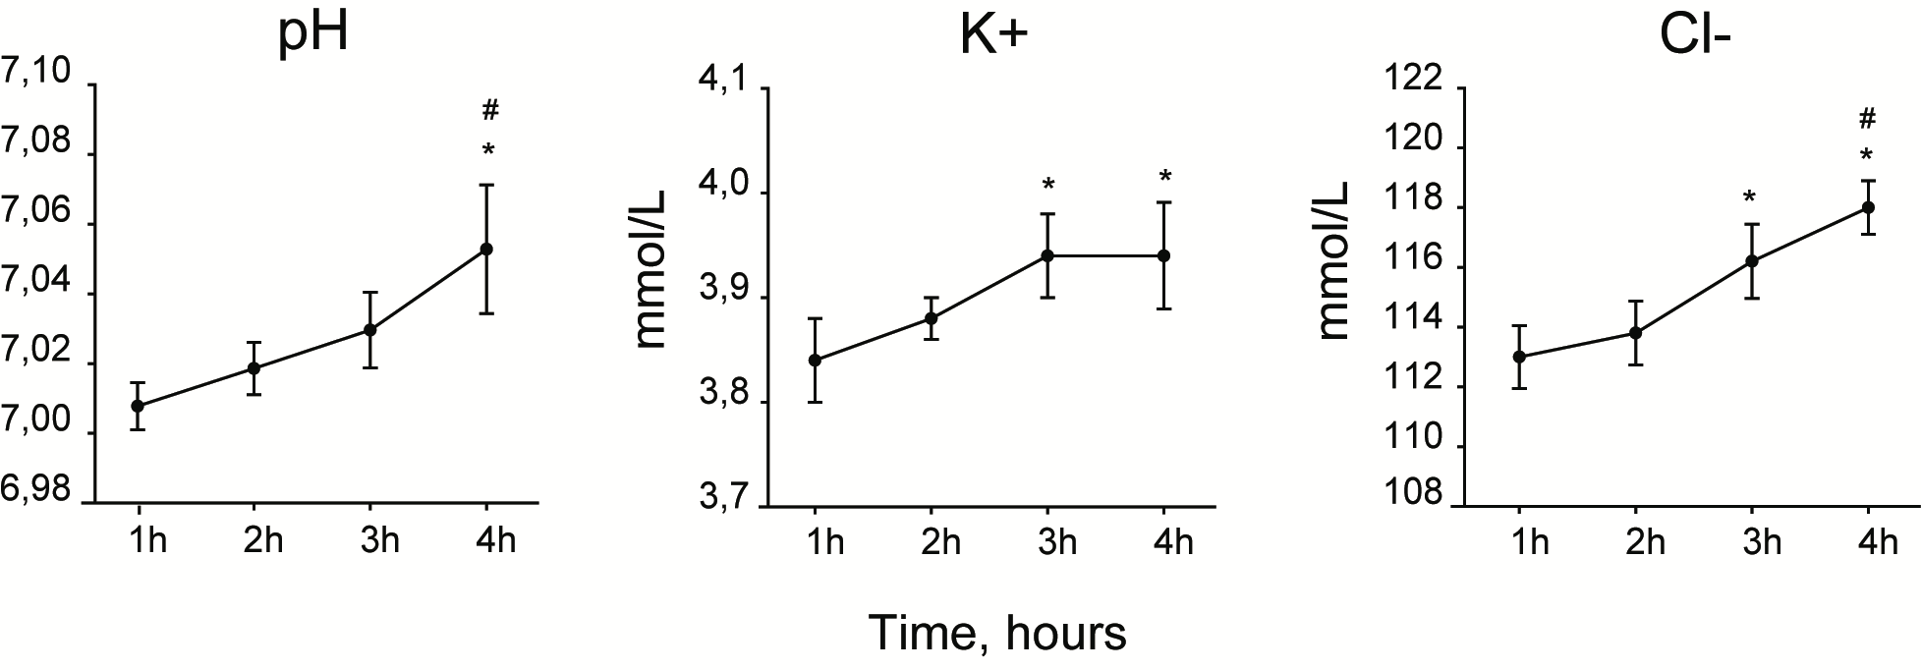
Perfusates gas-analysis during 4h liverless-NMP showed a rise in pH levels, as well as an increased release of K+ and Cl-. One-way RM ANOVA, p vs 1 h: *<0.05, p vs 2 h: #<0.05.

Supplementary Figure 3. Hemodynamics parameters during liver-NMP

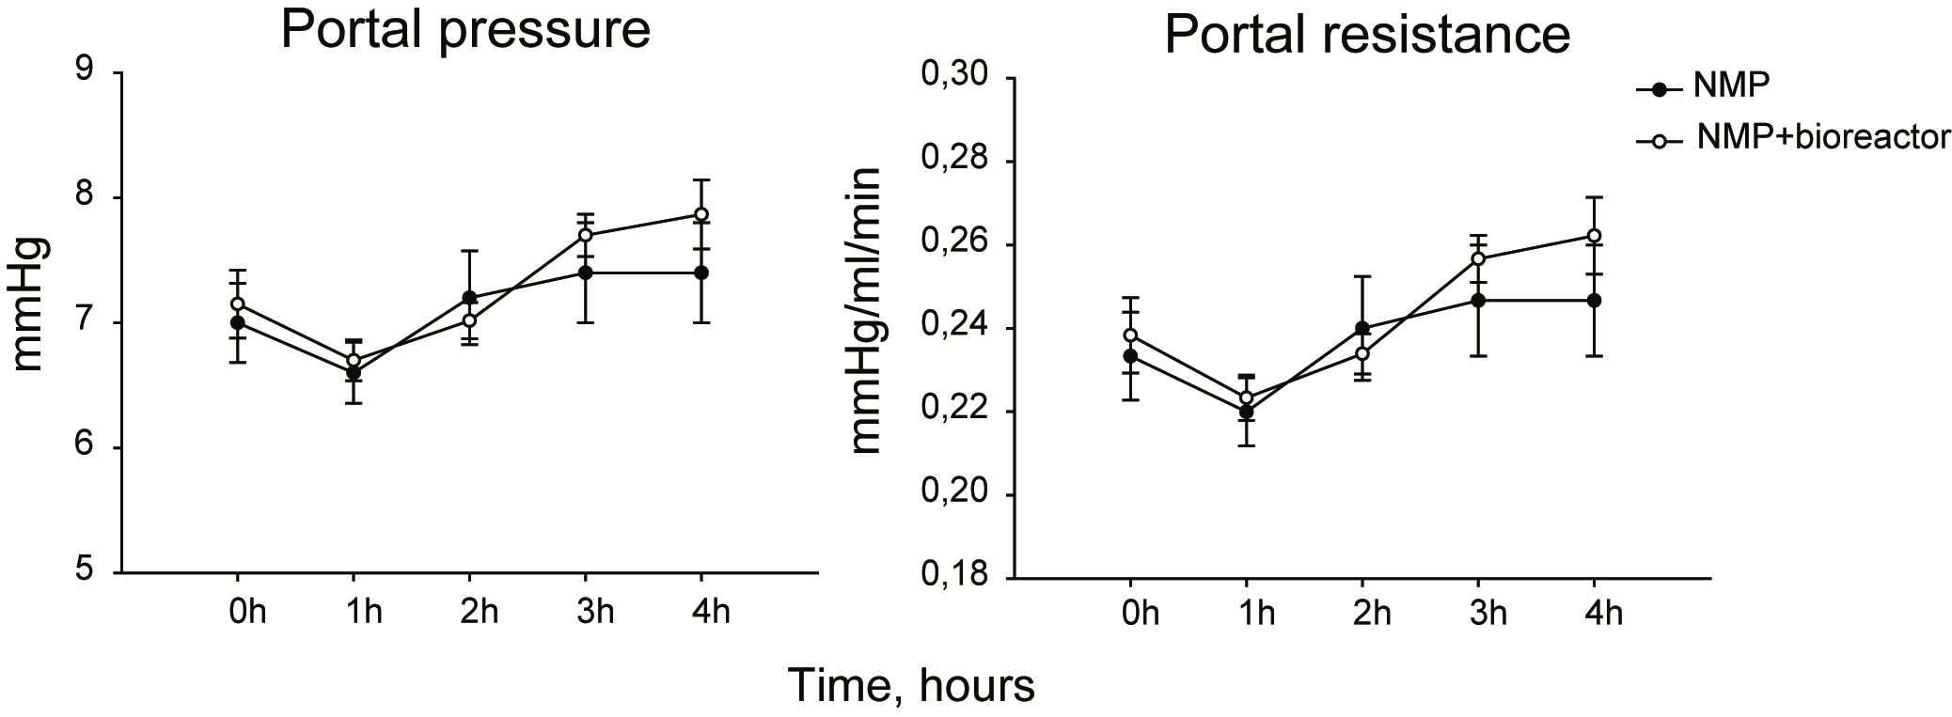
Hemodynamics parameters were monitored duting 4h liver-NMP. Portal pressures and vascular resistances increased over the procedure, remaining below 8 mmHg.
No statistically significant differences were detected between experimental groups. Two-way RM ANOVA, portal preassure: p=0.713; vascular resistance: p=0.624.

Supplementary Figure 4. Gas analysis of perfusate samples collected during liver-NMP

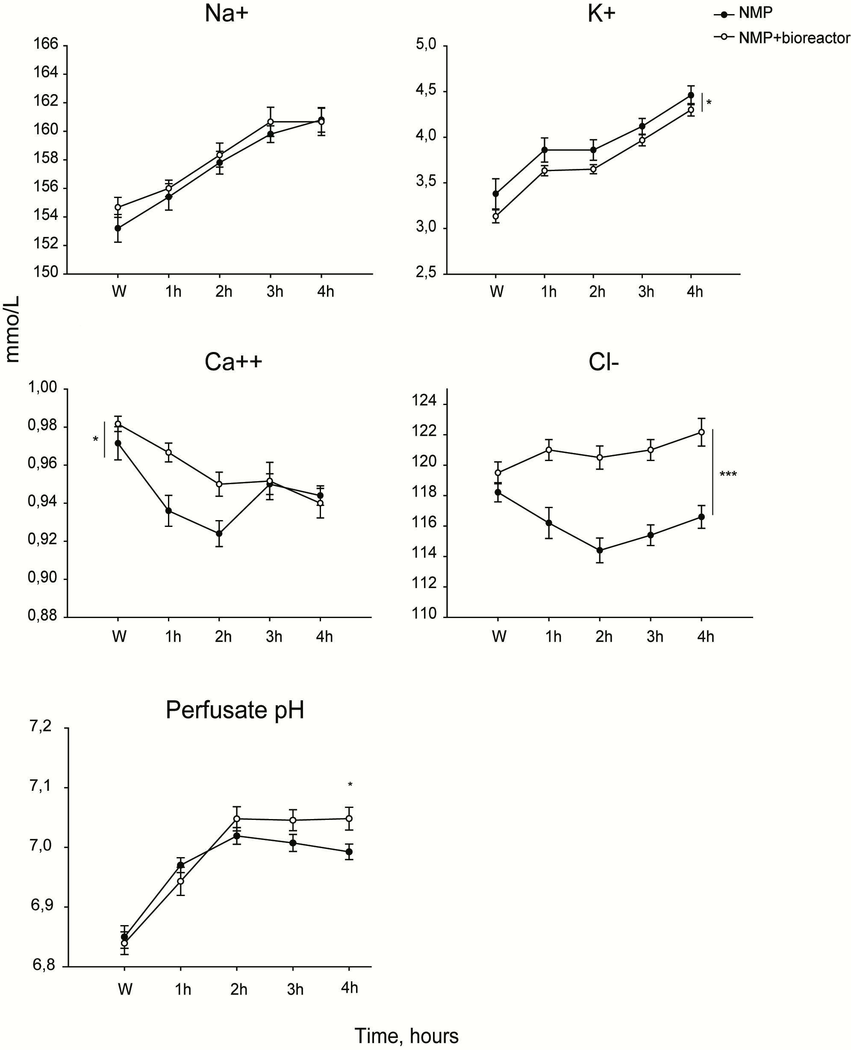

Perfusates gas-analysis during 4h liver-NMP showed an increased release of Na+ and K+ troughout the procedure in both experimental groups; NMP+bioreactor potassium levels is statistically lower with respect to the NMP group. Two-way RM ANOVA, p vs NMP: *<0.05. W, wash-out.
Perfusate pH showed a stabilization trend in the NMP+bioreactor group starting from 2 h post-reperfusion, while a progressive pH decrease was observed in the NMP group. Two-way RM ANOVA, p vs NMP at 4 h: 0.045.

Supplementary Figure 5. NAD+ and NADH content in liver homogenates and perfusate samples

NAD total and NADH contents were evaluated in liver biopsies taken at the end of surgery for the Native group, or at the end of the NMP procedure for the NMP group and the NMP+bioreactor group. The NMP+bioreactor group registered a greater amount of both NAD total and NADH content in tissue homogenates with respect to Natives and the NMP group. One way ANOVA, Tukey’s post hoc test. p value vs Native : ***<0.001; p value vs NMP : #<0.05; ###<0.001.
NADH content was measured in perfusate samples of the NMP experimental group and the NMP+bioreactor experimental group troughout normothermic perfusion. The amount of NADH released in perfusates by the NMP+bioreactor group livers was higher compared to the NMP group, remaining stable throughout reperfusion (Two-way RM ANOVA, Tukey’s post hoc test. p value vs NMP: ***<0.001). W, wash-out.

References
1. Debnath, T. & Chelluri, L. K. Standardization and quality assessment for clinical grade mesenchymal stem cells from human adipose tissue. Hematol. Transfus. Cell Ther. 41, 7–16 (2019).
2. Balls, M. It’s Time to Reconsider The Principles of Humane Experimental Technique. ATLA Altern. to Lab. Anim. 48, 40–46 (2020).
3. Russell, W. M. S. & Burch, R. L. The Principles of Humane Experimental Technique. Methuen Co., Ltd. (1959) doi:10.1017/CBO9781107415324.004.
4. Hast, P. Determination of NADH Concentrations with the SynergyTM 2 Multi-Detection Microplate Reader using Fluorescence or Absorbance. (2007).

