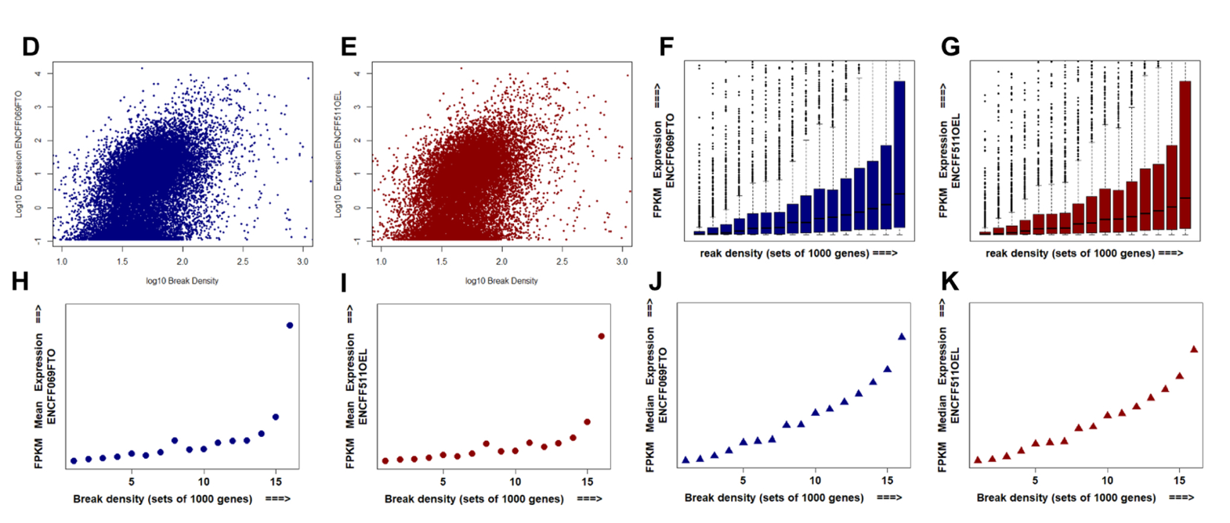
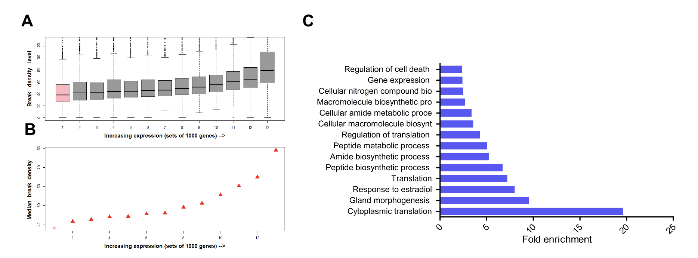
Supplementary Figures

Supplementary Figure 1: DSBs are enriched at highly expressed genes. A. Boxplot showing the correlation between break density and expression level, genes were grouped into 13 groups with increasing expression, the 13th group being the group with the highest mean expression. B. Median of break density positively correlates with break density. A zoomed log scaled scatter plot showing the correlation between expression levels and TOP1 level, each dot represents a gene. C. Gene ontology analysis of the 400 top broken genes in MCF-7 cells. D and E. A zoomed log scaled scatter plot showing a positive correlation between break density and expression levels; each dot represents a gene, and for each gene break density and expression were measured and normalized to gene size. F and G. Boxplot showing the correlation between break density and expression level. H and I. Mean expression (TPM) positively correlates with break density. J and K. Median expression (TPM) positively correlates with break density.

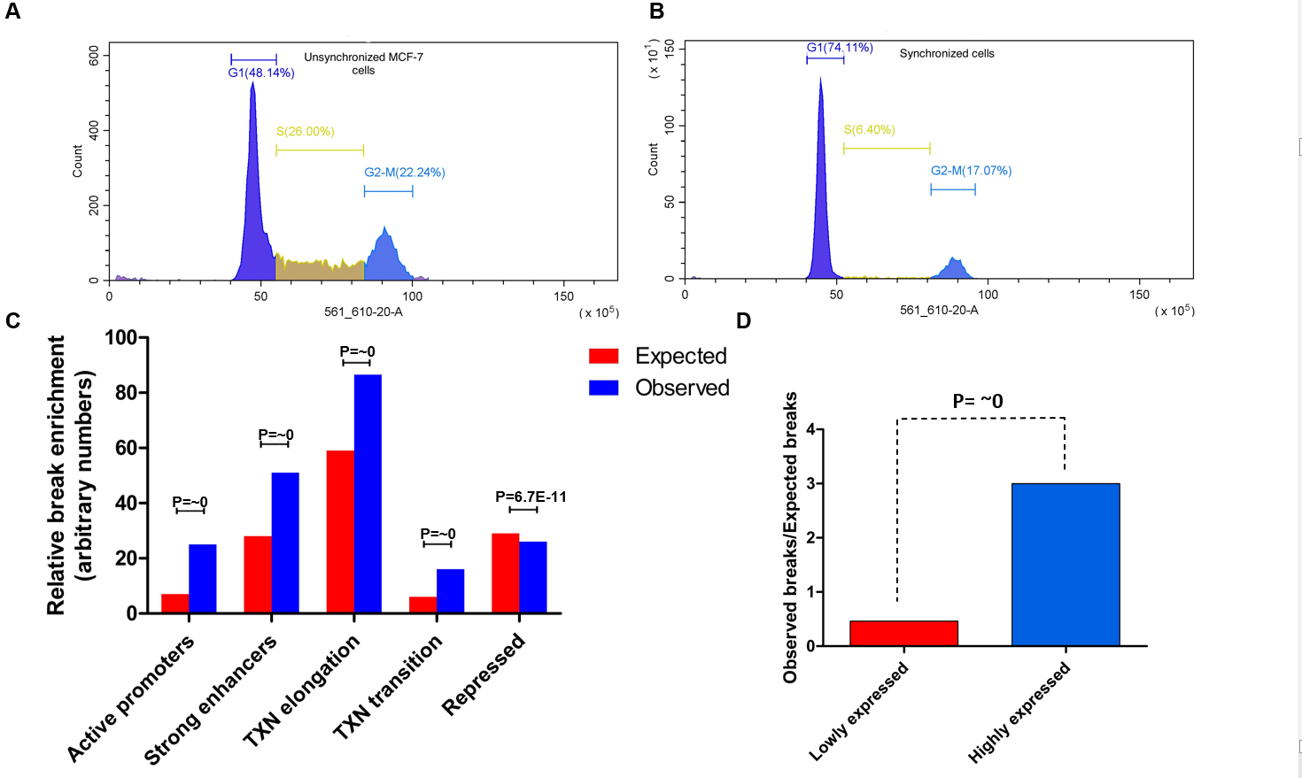
Supplementary Figure 2: breaks are enriched at active regions in non-cycling MCF-7 cells. A-B. Cell cycle analysis for MCF-7 cells unsynchronized (A) and MCF-7 cells serum starved for 48 hours (B). C. The distribution of DSBs in synchronized breast cancer MCF7 cells along ChromHMM-defined chromatin states of HMEC, bar height is break enrichment relative to other chromatin states. D. Ratio of observed breaks vs expected breaks at highly and lowly expressed genes.

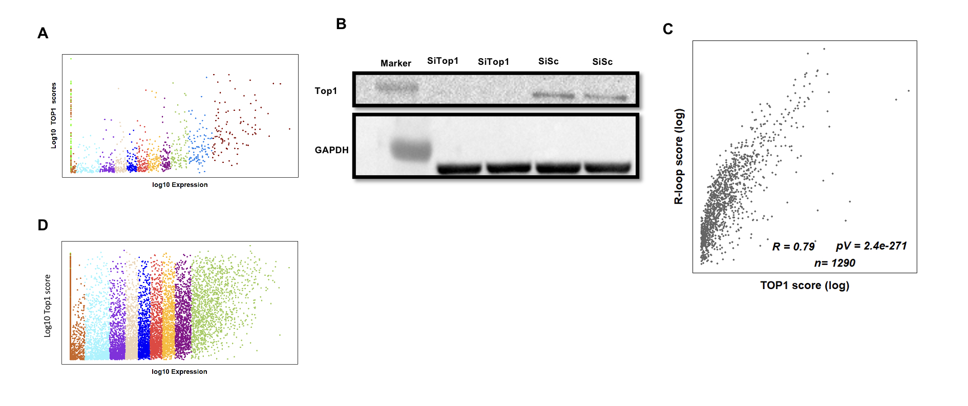
Log10 R-loops score

Supplementary Figure 3: Transcriptional DSBs are associated with TOP1 and R-loops. A. A log scaled scatter plot showing positive correlation between expression and TOP1 levels; each dot represents a gene, and each color represents a gene group. B. Validation of TOP1 knockdown by Western Blot. C. A log scaled scatter plot showing the correlation between R loops and TOP1 levels, each dot represents a gene. DRIP data was extracted from GSE81851. D. A log scaled scatter plot showing positive correlation between expression and R-loop levels; each dot represents a gene, and each color represents a gene group.

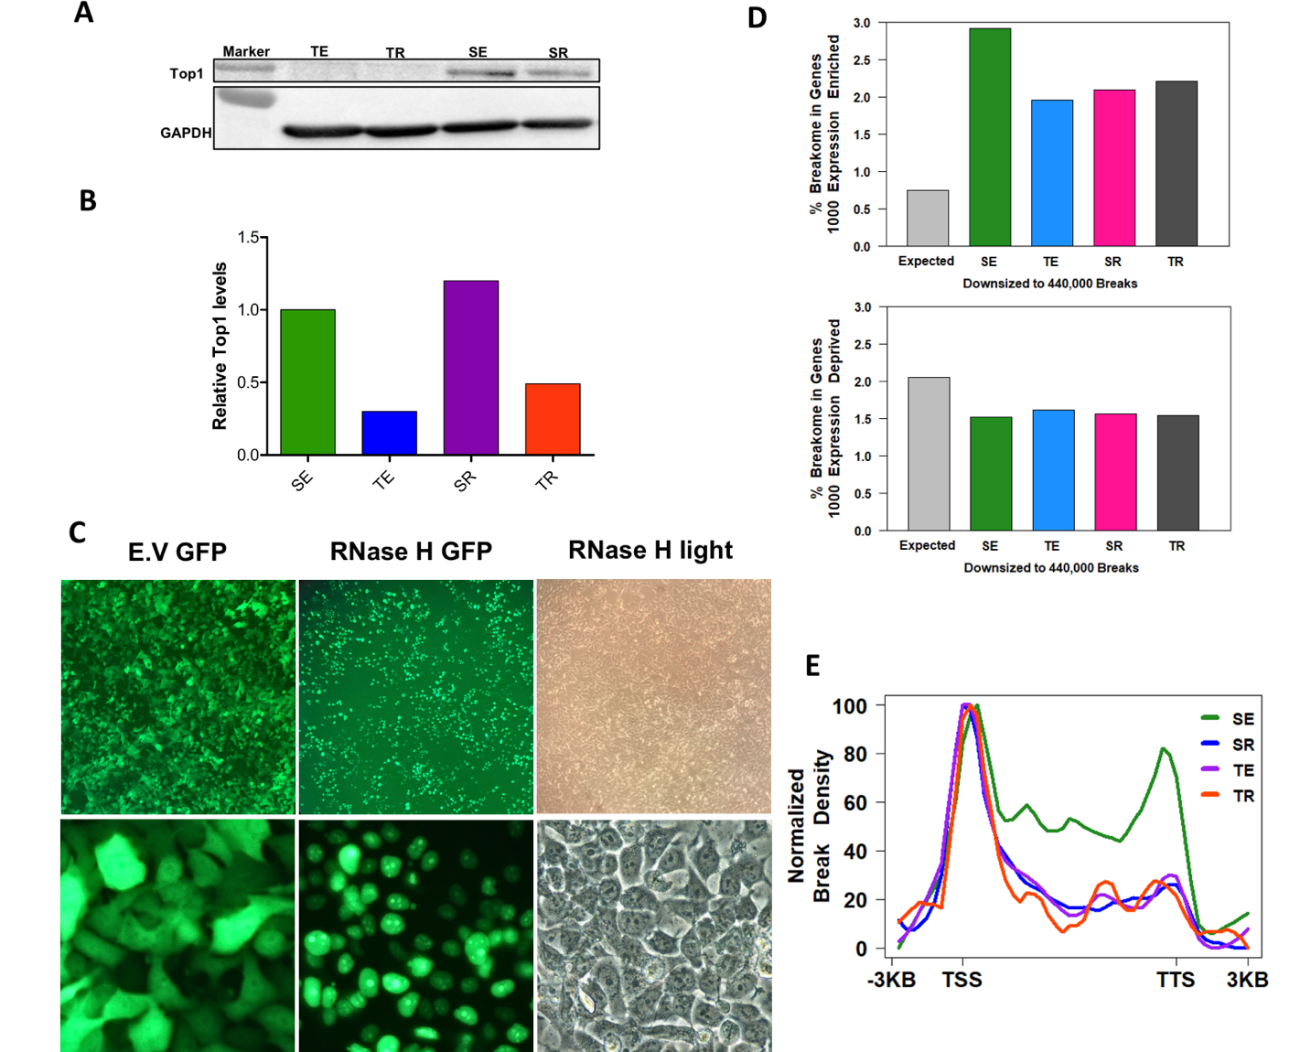
Supplementary Figure 4: RNase H1 overexpression and TOP1 knockdown decrease break enrichment at gene body of highly expressed genes. A. Validation of TOP1 knockdown using western blotting. B. Quantification of relative TOP1 levels after TOP1 knockdown. C. GFP pictures for RNase H1-GFP overexpression. D. Breakome percentage in 1000 most transcribed genes (top) and 1000 least transcribed genes (bottom) with the different manipulations, expression data was extracted from encode projects ENCFF069FTO_FPKM and ENCFF511OEL_FPKM for MCF7. E. Plot showing break density at gene body of the 1000 highest transcribed genes with the different manipulations. P-values were calculated using chi-square test.
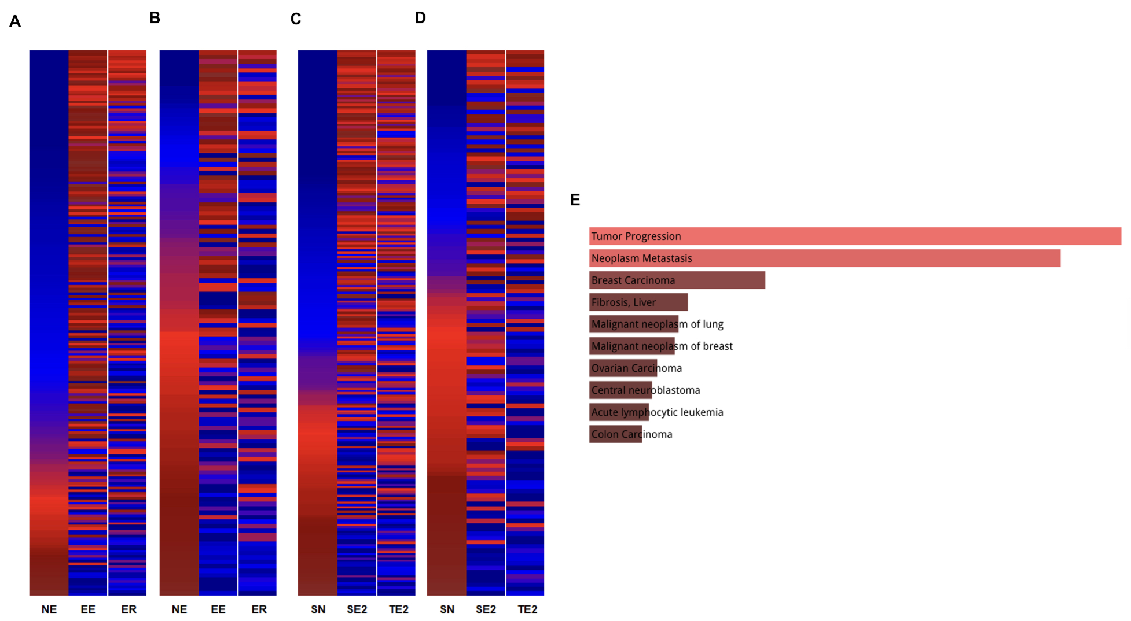
Supplementary Figure 5: Estradiol associated DSBs are mediated by R-loops and TOP1. A. and B. Color coded heatmap showing the change in break density between control (NE), cells incubated with estradiol (EE), cells incubated with estradiol and overexpressing RNase H1 (ER), for estrogen positive responsive genes (E) and negative responsive genes (F). C. And D. Color coded heatmap showing the change in break density between control (SN), cells incubated with estradiol (SE2), cells knocked down for TOP1 (TN), for estrogen positive responsive genes (G) and estrogen negative responsive genes (H). E. Disease related pathways for estradiol responsive genes using DisGeNET database ²⁷.

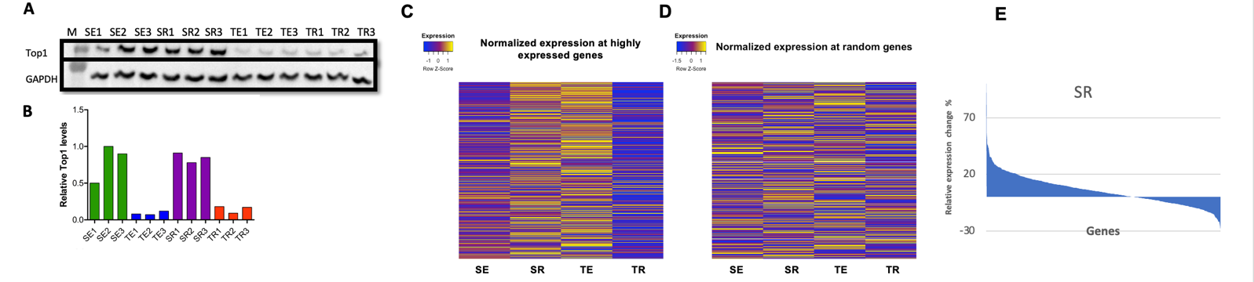
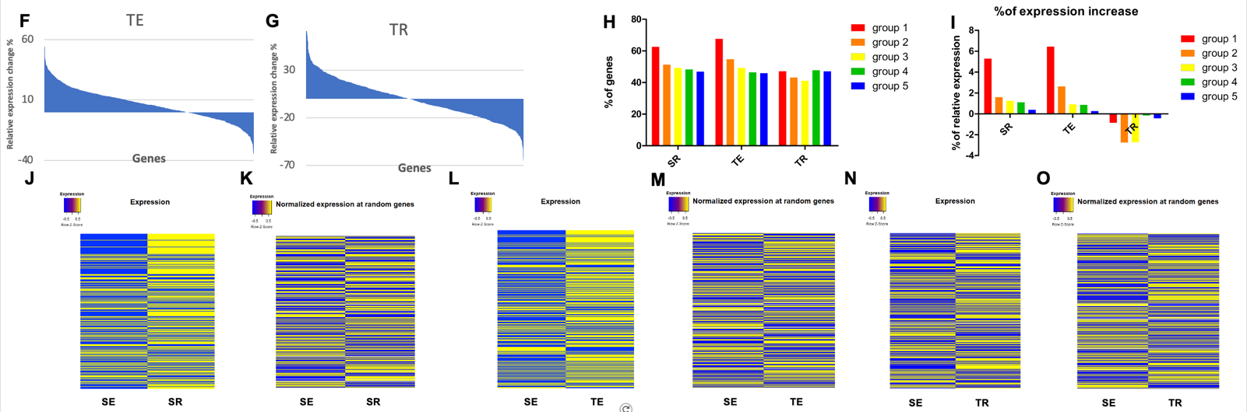
Supplementary Figure 6: Transcriptional DSBs might be impeding transcription. A. Validation for TOP1 knockdown using Western Blotting. B. Quantification of relative TOP1 levels after TOP1 knockdown. C-D. color coded heatmap showing the change of normalized expression counts after TOP1 KD and/or RNase H OE at highly expressed genes (C) and randomly selected genes (D). E-G. Area chart showing the proportion of the genes with a decrease or increase in expression with each treatment. H. Percentage of genes that exhibited an increase in their normalized expression counts with RNase H1 overexpression (SR), TOP1 knockdown (TE), or both manipulations (TR), the top 5000 genes were sorted into 5 groups (1000 gene each) according to expression, the first group being the group with the top 1000 expressed genes. I. Percentage of normalized expression counts change with RNase H1 overexpression (SR), TOP1 knockdown (TE), or both manipulations (TR), the top 5000 genes were sorted into 5 groups (1000 gene each) according to expression, the first group being the group with the top 1000 expressed genes. J-O. color coded heatmap showing the change of normalized expression counts at genes with decreased breaks and randomly selected genes for reference.

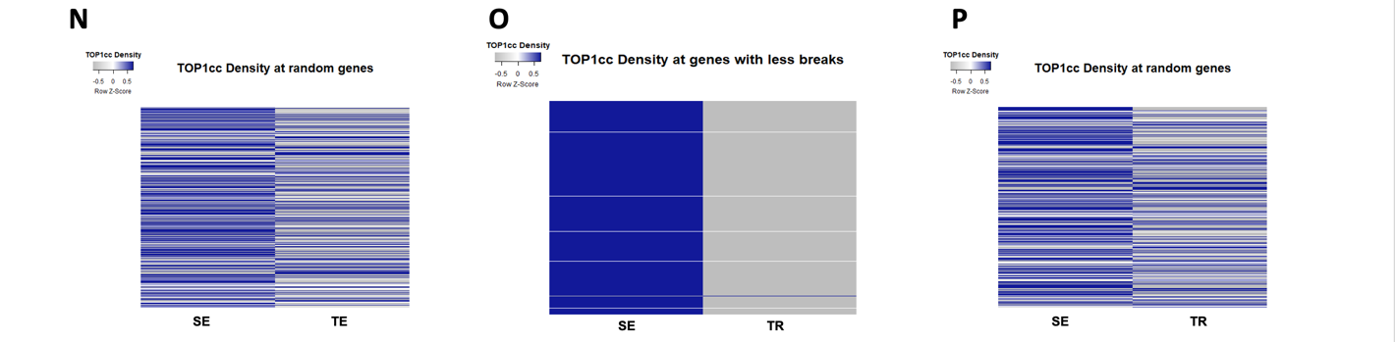
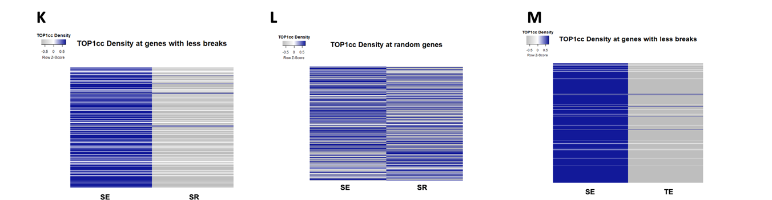
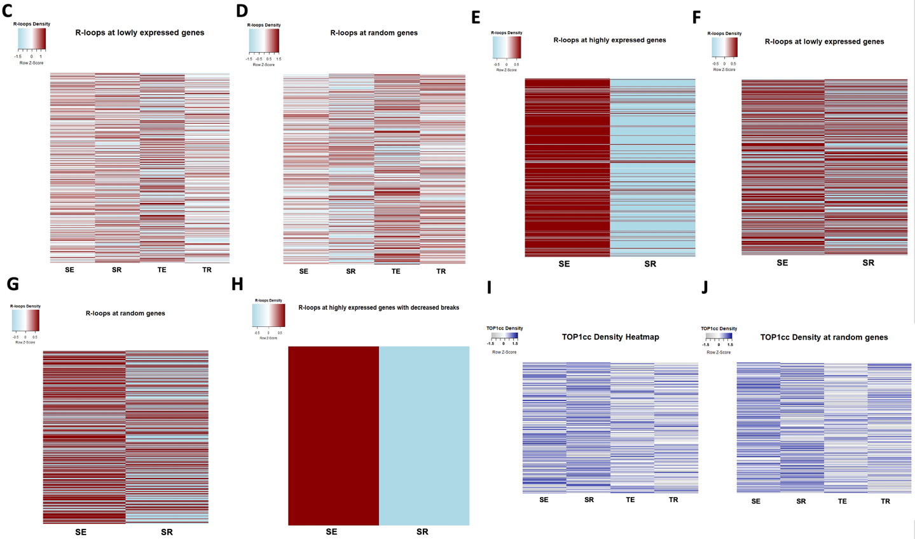
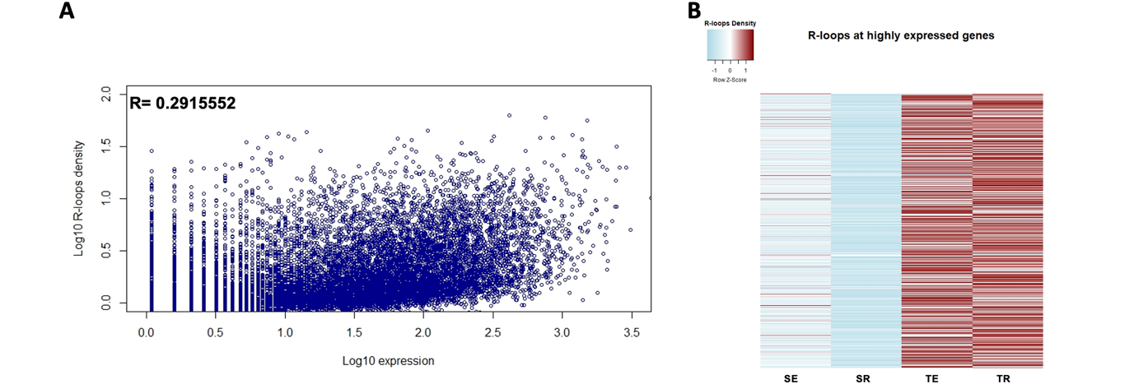
Supplementary Figure 7: RNase H OE decreases R-loops at highly expressed genes. A. scatter plot showing the correlation between R-loops and transcriptional levels. B. color coded heatmap showing the change of DRIP signal after RNAse H OE (SR) TOP1 KD (TE) and the combined manipulation (TR) at highly expressed genes. C. color coded heatmap showing the change of DRIP signal after RNase H OE at lowly expressed genes. D. color coded heatmap showing the change of DRIP signal after RNase H OE at randomly selected genes. E. color coded heatmap showing the change of DRIP signal after RNase H OE at highly expressed genes. F. color coded heatmap showing the change of DRIP signal after RNase H OE at lowly expressed genes. G. color coded heatmap showing the change of DRIP signal after RNase H OE at randomly selected genes. H. color coded heatmap showing the change of DRIP signal after RNase H OE at highly expressed genes with decreased breaks. I. color coded heatmap showing TOP1cc density at lowly expressed genes. J-P. color coded heatmap showing TOP1cc density at the specified gene sets.

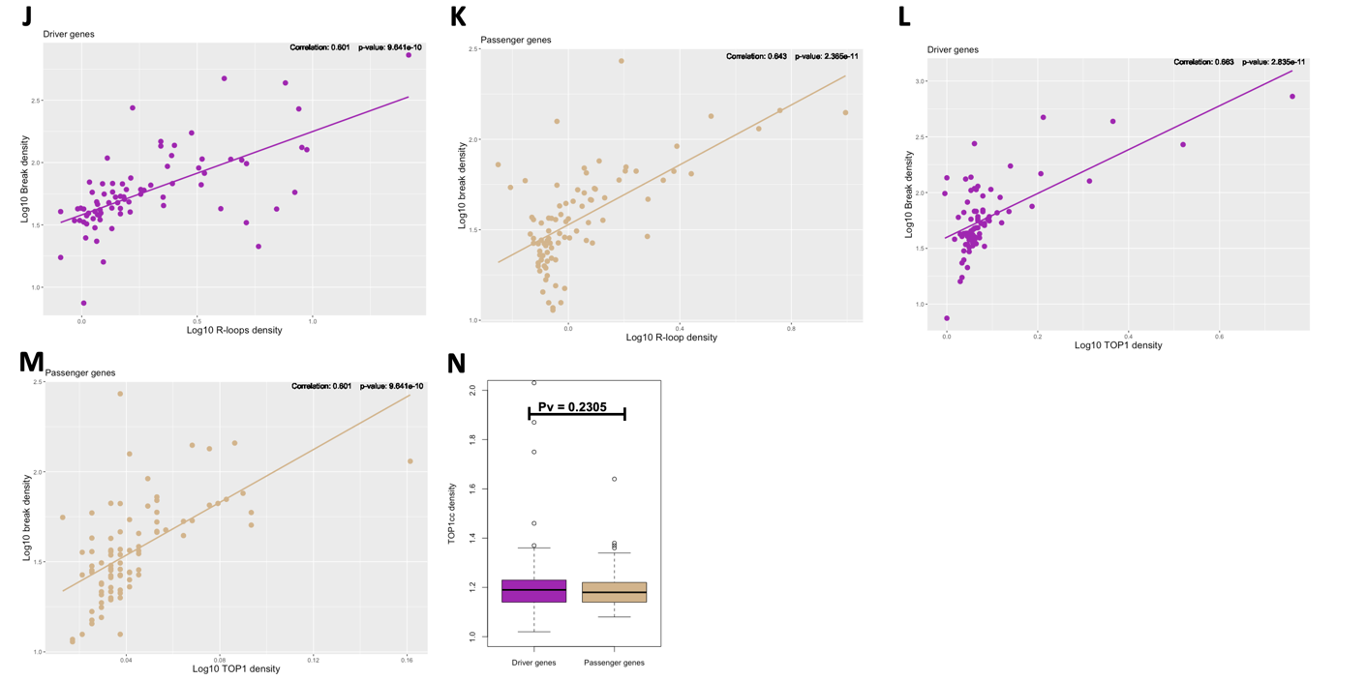
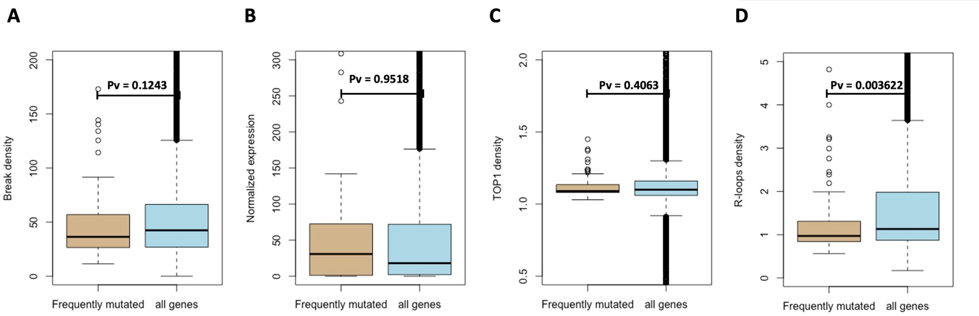
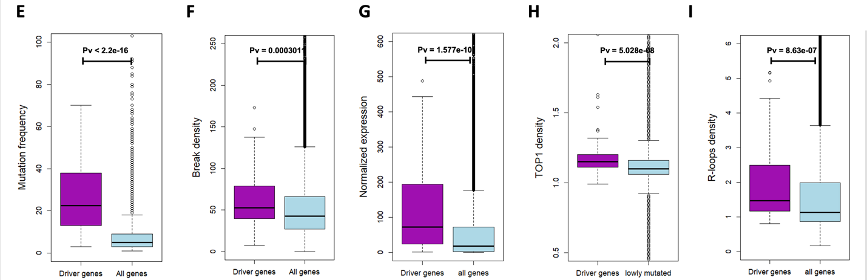
Supplementary Figure 8: Driver genes and cancer genes are enriched with transcriptional DSBs. A. Boxplot of break density at frequently mutated genes and the broader gene population. B. Boxplot of Normalized expression at frequently mutated genes and the broader gene population. C. Boxplot of TOP1 density at frequently mutated genes and the broader gene population. D. Boxplot of R-loops density at frequently mutated genes and the broader gene population. E. Boxplot of mutation frequency at driver genes and the broader gene population. F. Boxplot of break density at driver genes and the broader gene population. G. Boxplot of normalized expression at driver genes and the broader gene population. H. Boxplot of TOP1 density at driver genes and the broader gene population. I. Boxplot of R-loops density at driver genes and the broader gene population. J. log-scaled scatter plot demonstrating the correlation between break density and R-loops density at driver genes. K. log-scaled scatter plot demonstrating the correlation between break density and R-loops density at passenger genes. L. log-scaled scatter plot demonstrating the correlation between break density and TOP1 density at driver genes. M. log-scaled scatter plot demonstrating the correlation between break density and TOP1 density at passenger genes. N. Boxplot of TOP1cc density at driver genes and passenger genes.
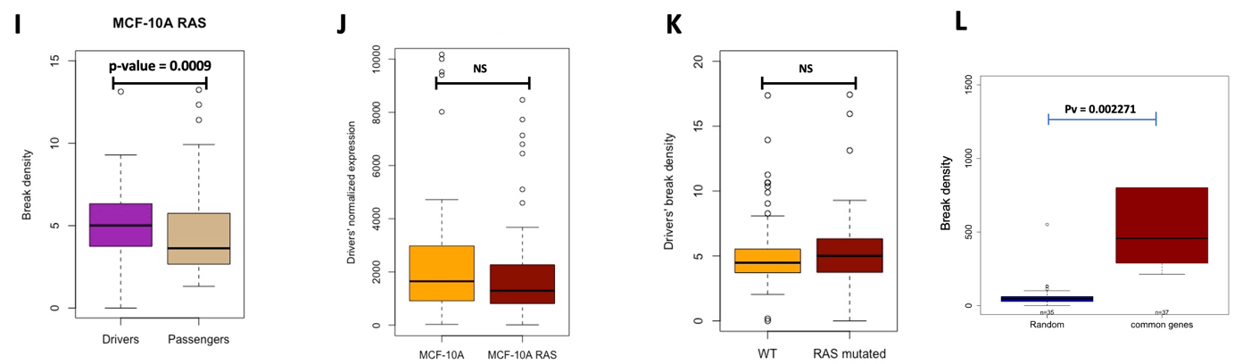
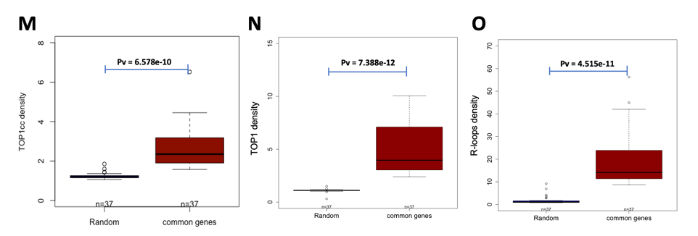
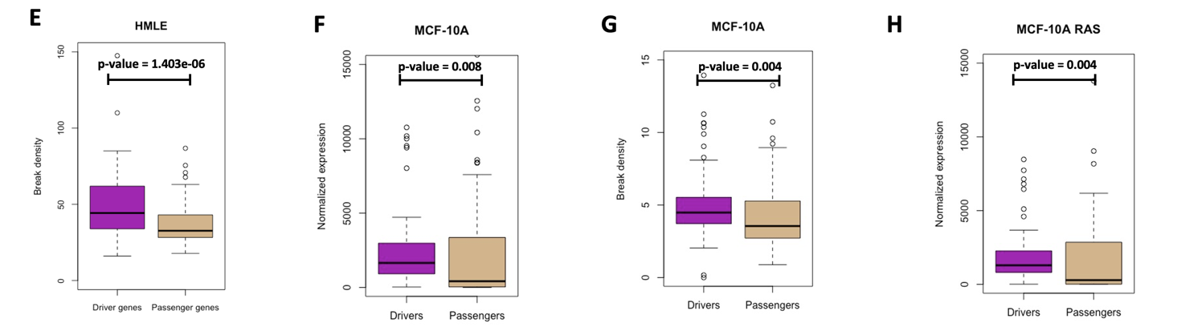
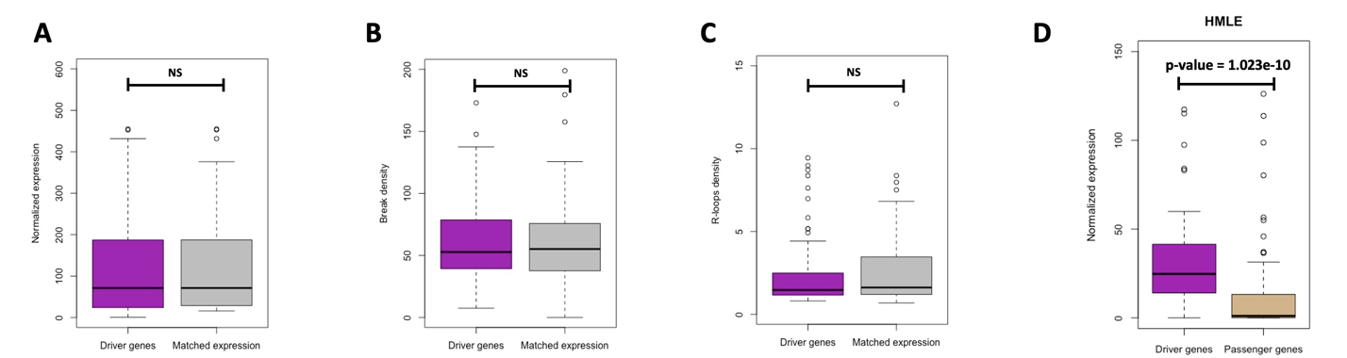

Supplementary Figure 9: physiological DSBs as an early event of carcinogenesis. A. Boxplot of normalized expression at driver genes and genes matched for expression. B. Boxplot of break density at driver genes and genes matched for expression. C. Boxplot of R-loops density at driver genes and genes matched for expression. D. Boxplot of normalized expression of driver genes and passenger genes in HMLE cells. E. Boxplot of break density of driver genes and passenger genes in HMLE cells. D. Boxplot of normalized expression of driver genes and passenger genes in MCF-10A cells. E. Boxplot of break density of driver genes and passenger genes in MCF-10A cells. F. Boxplot of normalized expression of driver genes and passenger genes in MCF-10A cells. G. Boxplot of break density of driver genes and passenger genes in MCF-10A cells. H. Boxplot of normalized expression of driver genes and passenger genes in RAS mutated MCF-10A cells. I. Boxplot of break density of driver genes and passenger genes in RAS mutated MCF-10A cells. J. Driver genes normalized expression in MCF-10A and RAS mutated MCF-10A cells. K. Driver genes break density in MCF-10A and RAS mutated MCF-10A cells. L-O. Boxplot of break density (L), TOP1cc density (M), TOP1 density (N), and R-loops density (O) at intersected genes of Figure 7Q and randomly selected genes. S. Boxplot comparing driver genes to non-driver genes matched for expression in expression, break density, and R-loops respectively.

