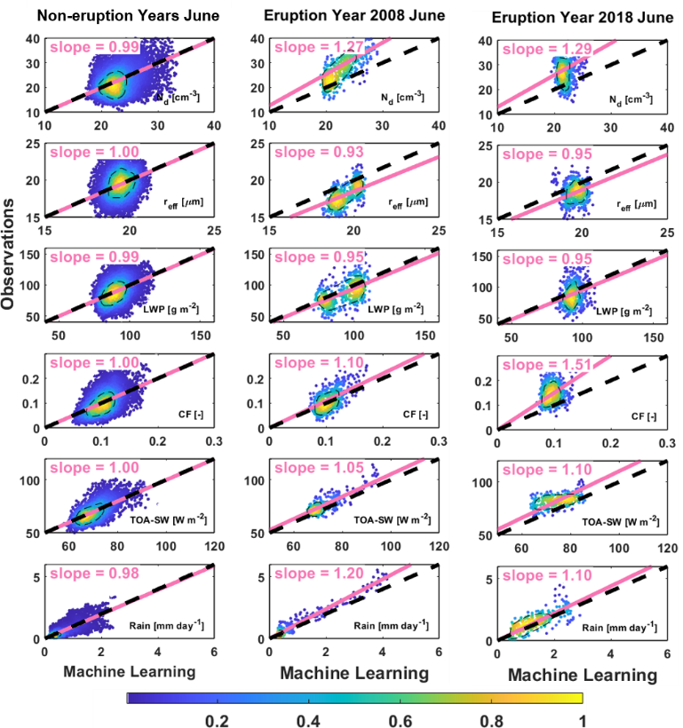
a
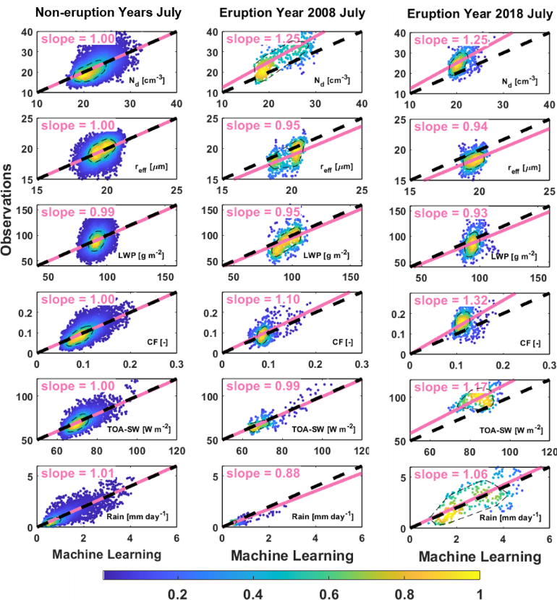
b
Extended Data Fig. 1 | Validation of machine-learning surrogates against observations. Panel (a) June and (b) July. Left subpanels show validations in non-eruption years, demonstrating the very good agreement between machine-learning surrogates and observations, with regression (pink lines) very close to the 1:1 black lines and 80% of the data (black dash circle) around the 1:1 lines. Middle subpanels show results for eruption year 2008 and right subpanels show results for eruption year 2018, highlighting the differences between machine-learning surrogates and observations. The following variables are shown from top to bottom: cloud droplet number concentration (N_{d}), droplet effective radius (r_{eff}), in-cloud liquid water path (LWP), cloud fraction (CF, or cloud cover), outgoing shortwave radiation (SW) at the top of the atmosphere (TOA), and daily precipitation (Rain). Color indicates the normalized data density function with a maximum value of one.

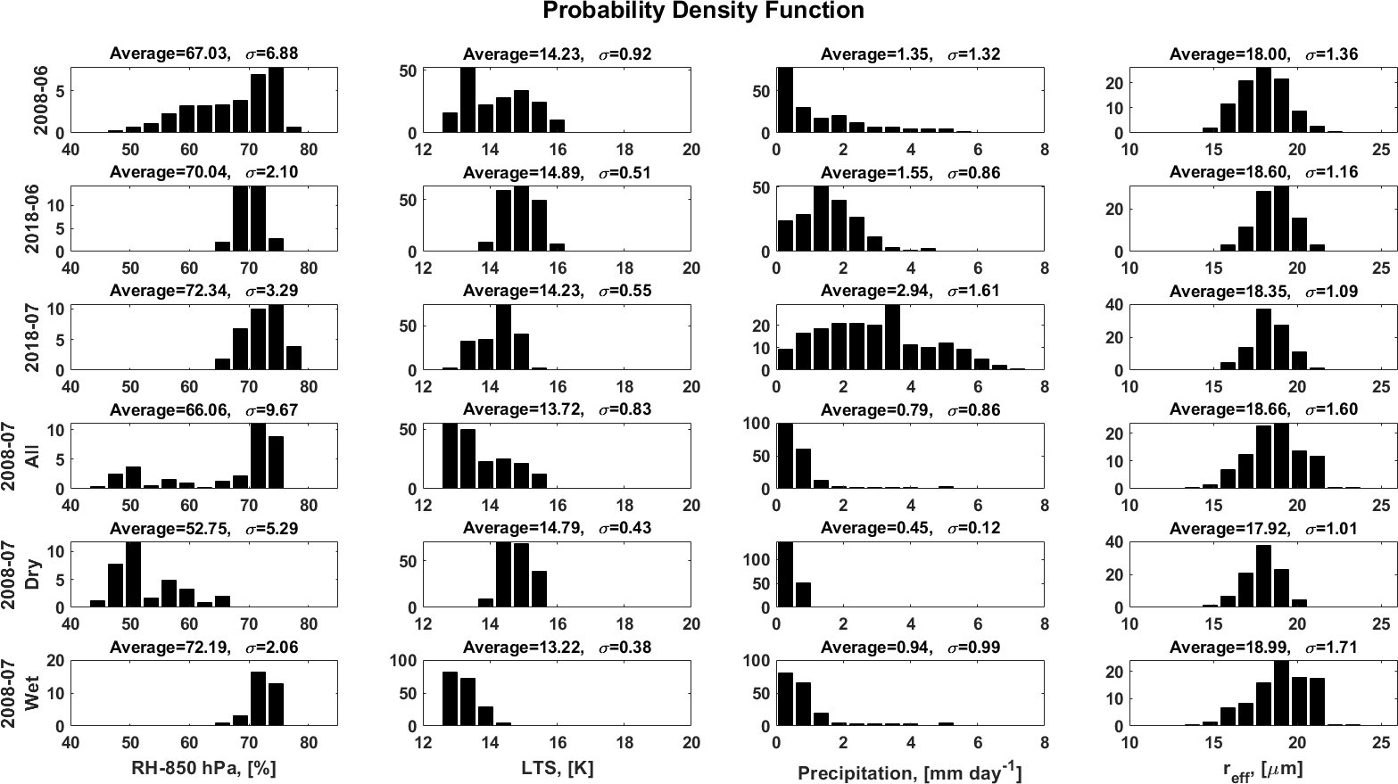
Extended Data Fig. 2 | Probability density function of meteorological and cloud properties in each case. Bar charts of the probability distribution is shown in the bar chart, with average and standard deviation marked on the top. Relative humidity (RH) > 75% indicates very humid condition, RH < 50% indicates very dry conditions²⁷; lower-tropospheric stability (LTS) < 14 K indicates unstable conditions, and cloud droplet effective radius (r_{eff}) > 14 µm indicates precipitating clouds¹⁷.

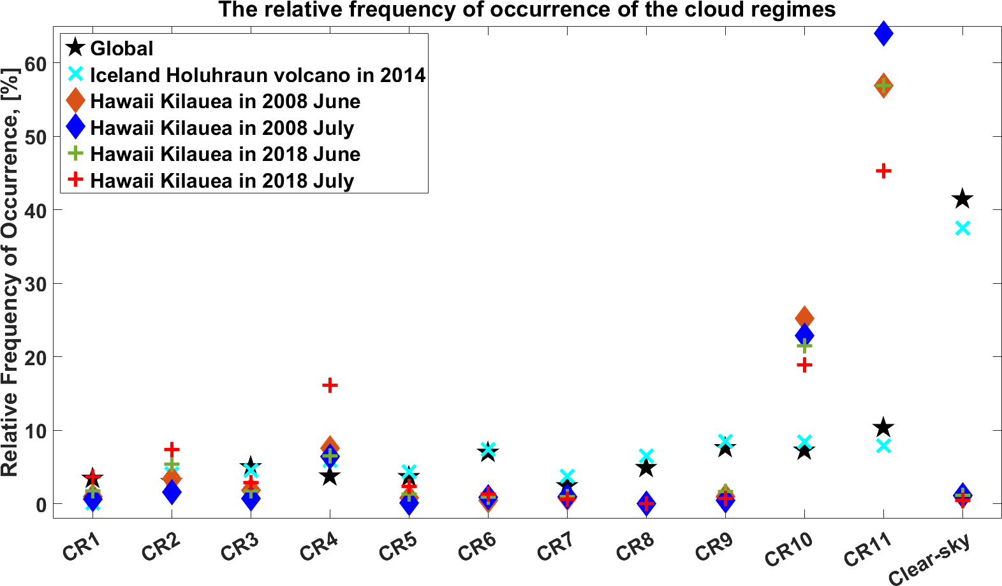
Extended Data Fig. 3 | Spectrum of cloud regime (CR) relative frequency of occurrence. CR-10 represents shallow oceanic convective clouds, and CR-11 represent small broken clouds with small cloud fraction. More details and original data of cloud regimes please refer to ref.⁵⁷.

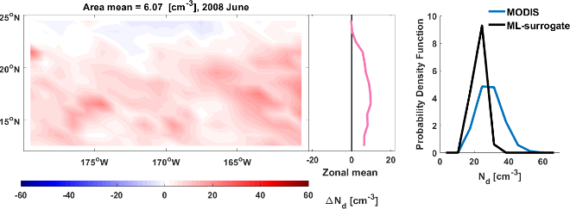  a | 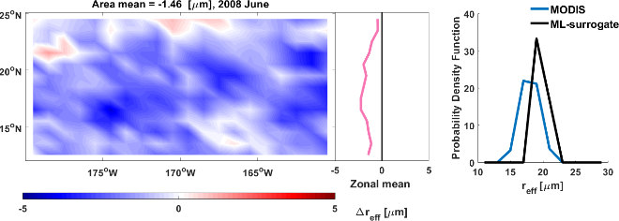  b
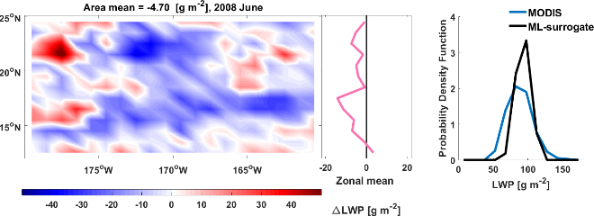  c | 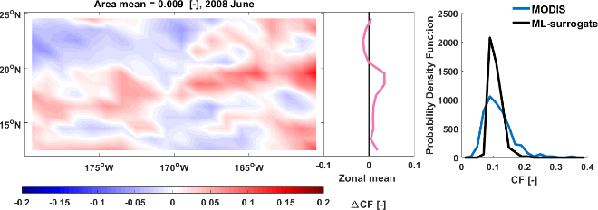  d
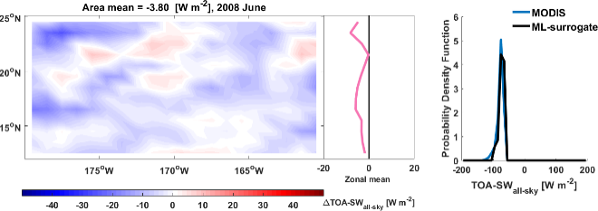  e | 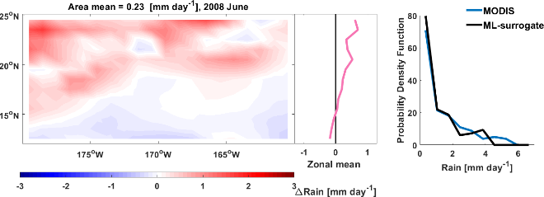  f
Extended Data Fig. 4 | Aerosol-cloud interactions in June 2008. The colors indicate the differences between volcanic aerosol perturbation and normal conditions, i.e., observations – machine-learning surrogate. Zonal mean values and probability distribution function are also provided in the middle and right subpanels. The panels show (a) N_{d}, (b) r_{eff}, (c) in-cloud LWP, (d) CF, (e) TOA downward shortwave radiation with blue color indicating cooling and red indicating warming, and (f) rainfall.

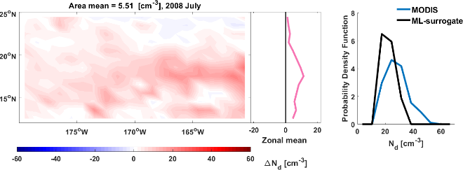  a  b | 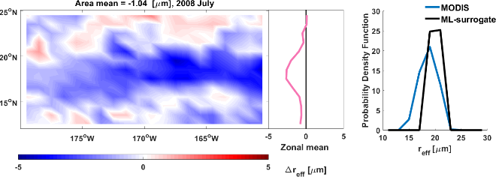  d
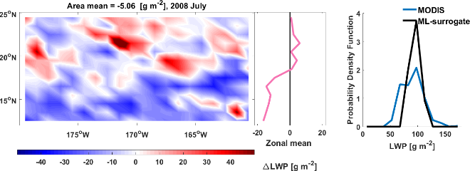  c | 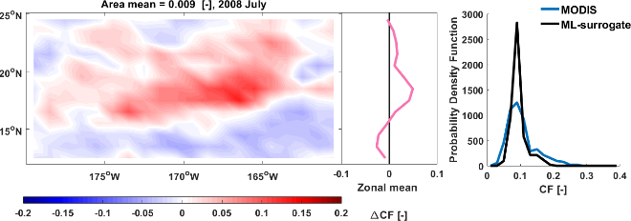
e  Insiginificant | 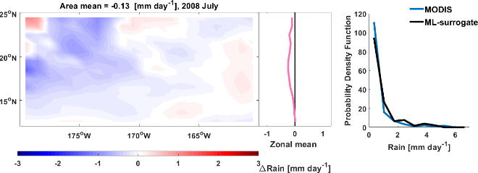  f
Extended Data Fig. 5 | Aerosol-cloud interactions in July 2008. Similar to Extended Data Fig. 4 but for July 2008. Note that the change in TOA incoming shortwave radiation (e) does not pass the significance test, and therefore is marked as “insignificant” here.

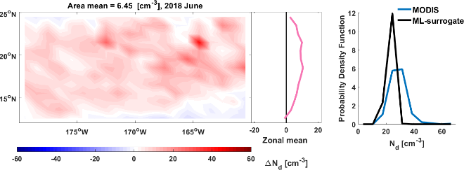  b  a | 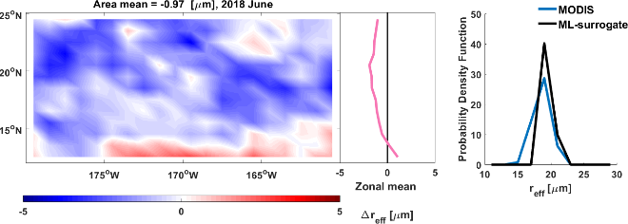  d
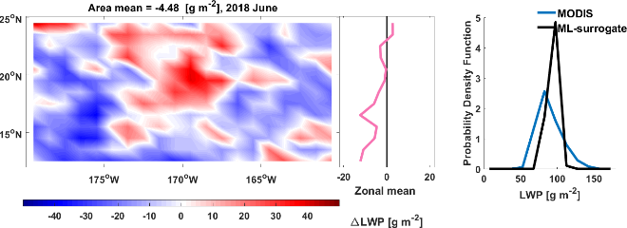  c | 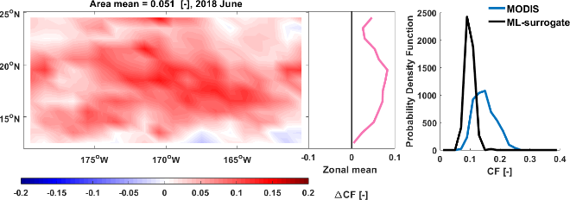
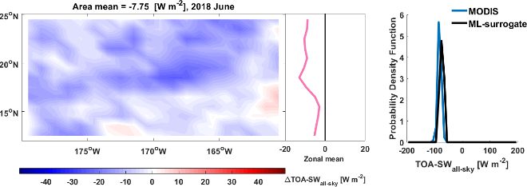  e | 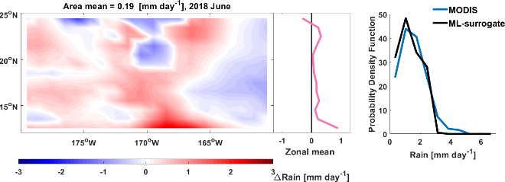  f
Extended Data Fig. 6 | Aerosol-cloud interactions in June 2018. Similar to Extended Data Fig. 4, but for June 2018.

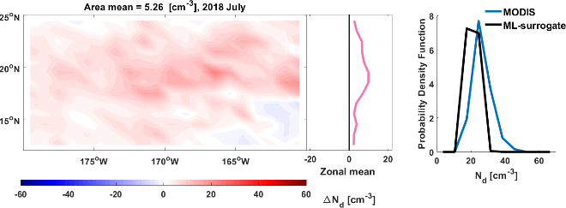  a | 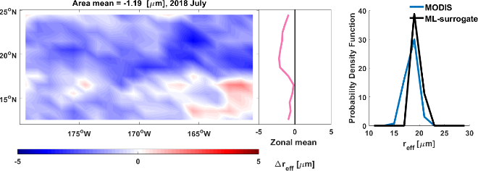  b
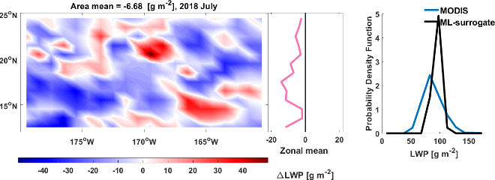  c  d | 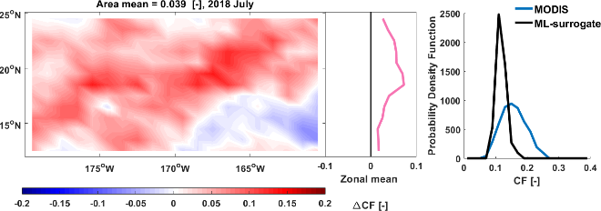
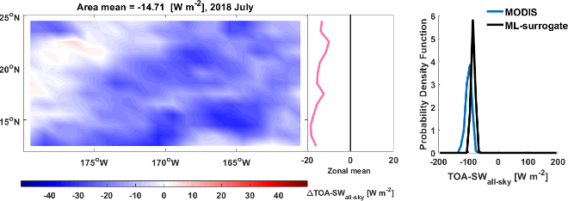  e | 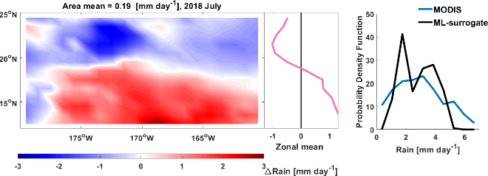  f
Extended Data Fig. 7 | Aerosol-cloud interactions in July 2018. Similar to Extended Data Fig. 4, but for July 2018.

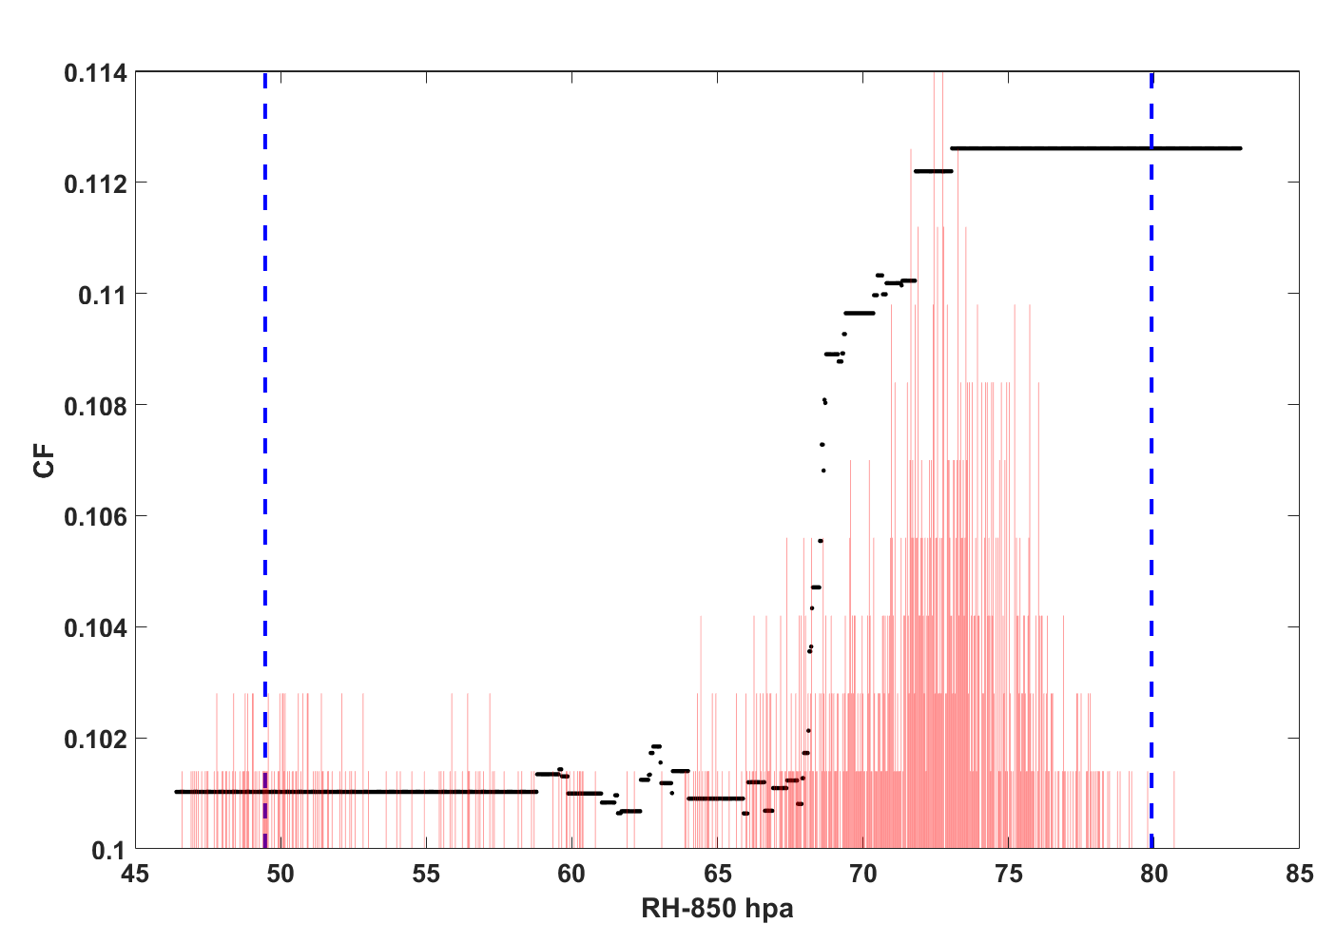
Extended Data Fig. 8 | Partial dependence of cloud fraction (CF, also known as cloud cover) on 850 hPa RH, the other predictors are fixed at average values. The RH range of the training dataset is marked with blue dash lines, and the probability distribution of RH in July 2008 is indicated by the red bars.

