Supplementary figures
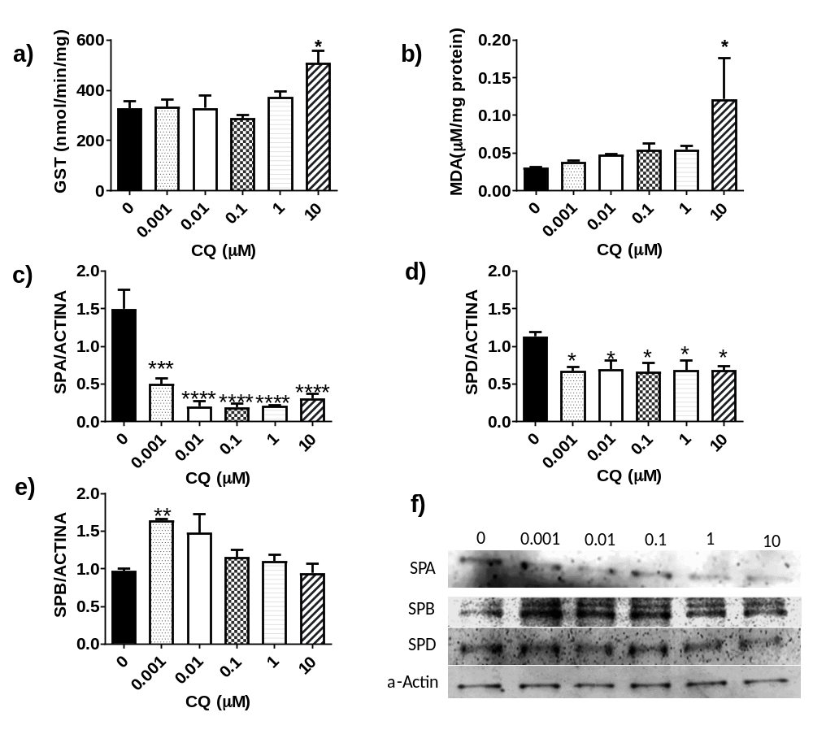

S1 Oxidative chloroquine effects on A549 cell line. a) GST activity, b) MDA protein levels, c) SPA protein levels and d) SPB protein levels, e) SPD protein levels and f) Representative blots for protein extracts from A549 cells exposed to different concentrations of CQ. Values are means ± SEM from three independent experiments by triplicate. One-way. ANOVA and Dunnet’s test post-hoc. Significance is reported as: *P < 0.05; **P < 0.01; ***P < 0.001; ****P < 0.0001

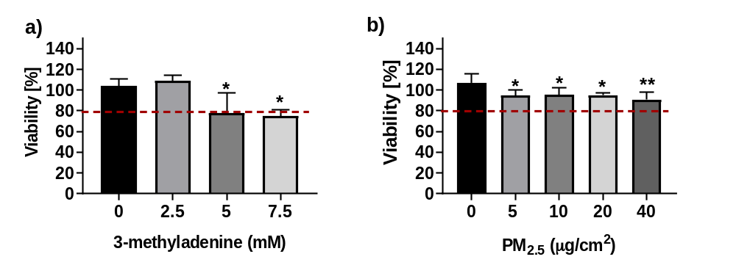

S2 Viability effects on A549 cell line exposed to 3-methyladedine. MTT viability assay was measured 24 hr after exposure to different concentrations of 3MA. a) GST activity, b) MDA protein levels. Values are means ± SEM from three independent experiments by triplicate. One-way. ANOVA and Dunnet’s test post-hoc. Significance is reported as: *P < 0.05; **P < 0.01

