Supplementary Materials

Demographic characteristics
Our recruited sample showed that the majority of both female (94.04%) and male (95.52%) participants were currently enrolled in university or higher degree education. A higher proportion of males (83.24%) than females (69.34%) reported being students, while the majority of both females (81.70%) and males (88.53%) reported being single. In terms of residential location, a smaller proportion of females (58.72%) than males (71.51%) lived in urban areas with a population greater than 500,000 people. Additionally, lower proportion of females (31.91%) than males (41.34%) reported living alone (see Table 2).
Only age and relationship status were found to have significant correlations with both mean loneliness (age: r=-.10, p<.05; relationship status: r=-.14, p<.001) and mean happiness (age: r=.11, p<.05; relationship status: r=.21, p<.001) among the demographic variables of age, gender, education level, occupation, relationship status, residence, and cohabitants (see Table 3). Additionally, education level exhibited a significant negative correlation only with mean loneliness (r=-.12, p<.001). While the results obtained may not be directly generalizable, they can still provide valuable insights into the factors that need to be controlled during the main data analysis.

Descriptive signals
Of all the days when signals were recorded, 82.29% showed people having online or offline communication with others and 66.32% had face-to-face offline communication and 56.26% had online communication. However, out of 418 total participants, 140 participants (71 males, 68 females) reported no online communication for more than 10.5 days (half of the experiment duration) and 78 participants (38 males, 40 females) reported no offline communication for more than 10.5 days. And 30 participants (15 males,15 females) reported no communication neither online nor offline for more than 10.5 days. In terms of social app usage, the majority of responses (68.50%) reported using it for more than 1 hour, with 35.95%
reporting more than 2 hours, and only 2.26% reporting almost no use of it. Additionally, out of the 418 participants, 39 males and 68 females reported using social apps for more than 2 hours on more than 10.5 days during the experiment. Taken together, these findings reveal the current status of young people having lower levels of direct communication, both online and offline. Nevertheless, it is worth noting the prevalent use of social applications.

Results of Linear Mixed Model
The day-level correlation analysis revealed the descriptive statistics of the variables, including their means and standard deviations (see Supplementary Table 1). It was also observed that there were no significant high correlations between the variables, indicating that they can be safely included in the same linear mixed model (LMM). This is particularly important as it eliminates concerns regarding multicollinearity, a common issue when variables are highly correlated.

Furthermore, the LMM analysis compared the models with and without covariates (see Supplementary Table 2, 3). Interestingly, the inclusion of covariates did not result in substantial differences in the outcomes. This implies that the presence or absence of control variables had minimal impact on the specific results obtained from the analysis. Consequently, it suggests that the influence of these additional factors on the overall findings is negligible.

Overall, these findings contribute to a better understanding of the analysis in daily engagement.

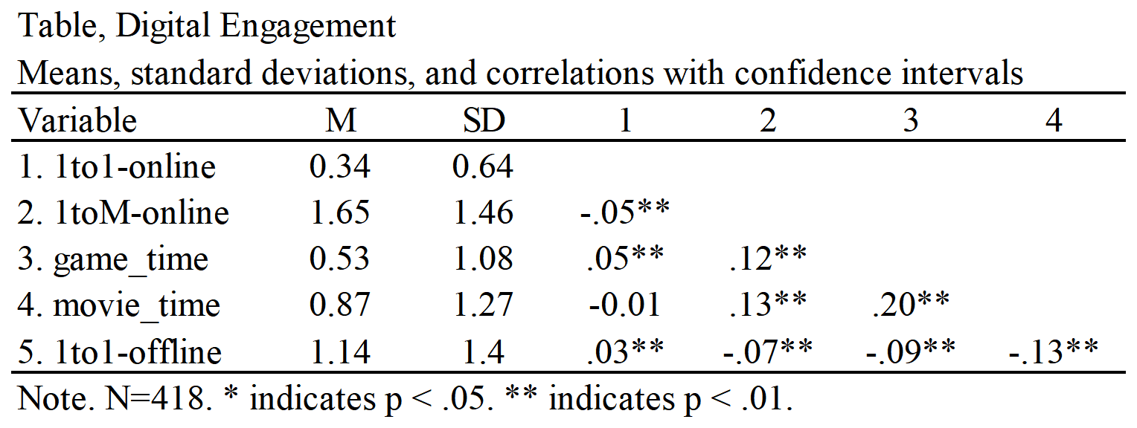
Supplementary Table 1. Day-level correlation of daily activities.
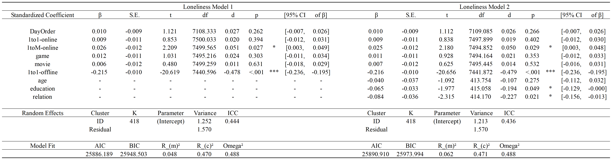 Supplementary Table 2. LMM in loneliness. Model 1 did not include a covariate, while Model 2 included covariate variables. The inclusion of the covariate in Model 2 didn’t substantially change the magnitude of the effects of daily activities.

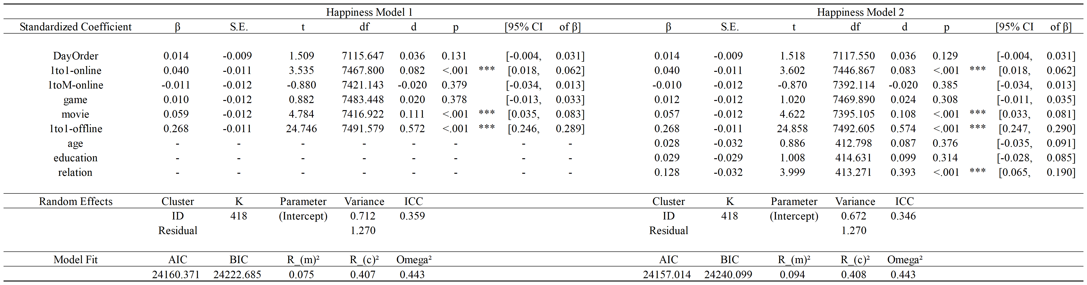
Supplementary Table 3. LMM in happiness. Model 1 did not include a covariate, while Model 2 included covariate variables. The inclusion of the covariate in Model 2 didn’t substantially change the magnitude of the effects of daily activities.

Results of Mediation Analysis
Prior to conducting the multilevel mediation analysis, we performed an LMM with 1to1-offline communication as the dependent variable. This analysis further confirmed the significant negative correlation between the duration of digital use and the duration of 1to1-offline.
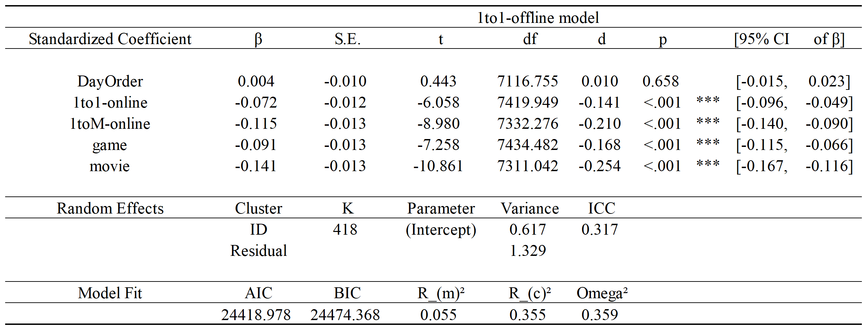
Supplementary Table 4. LMM in offline communication. All types of digital use showed negative effect on the duration of 1to1-offline communication.

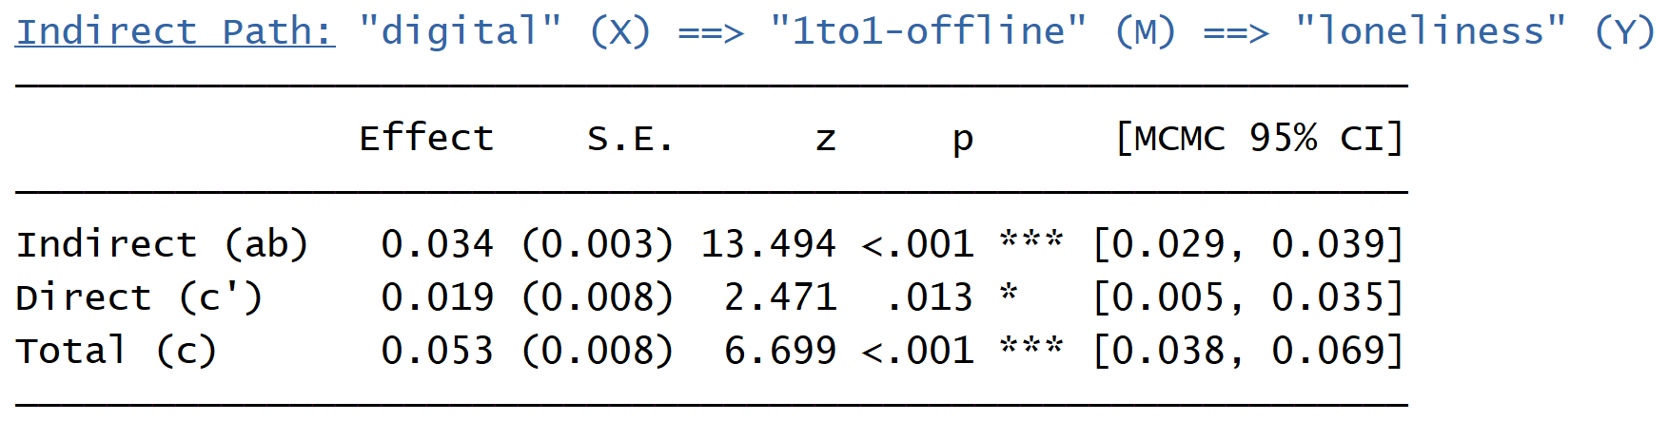
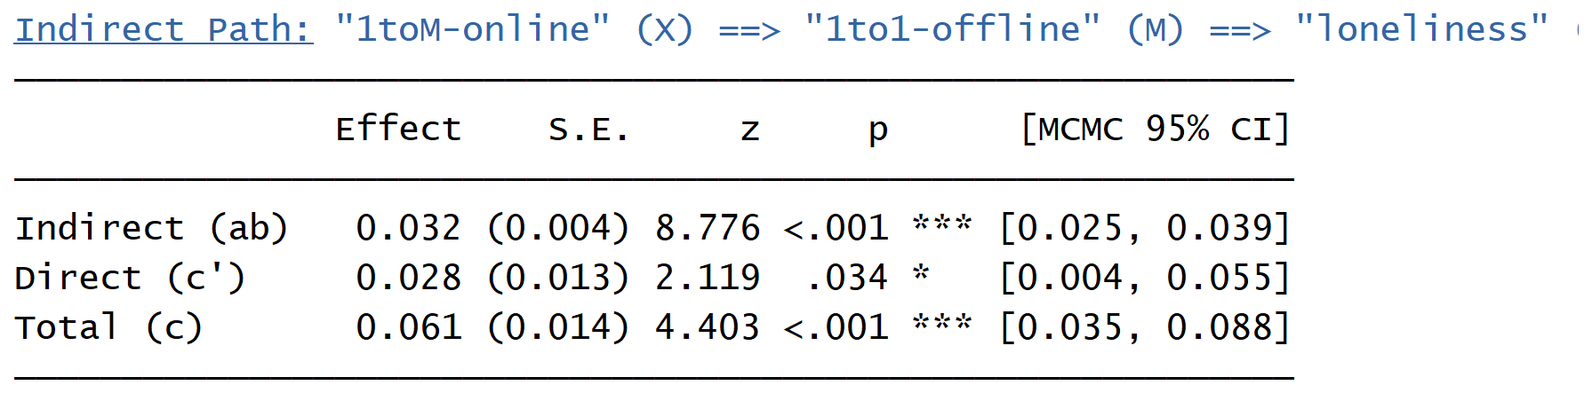
Supplementary Table 5. Multilevel mediation in loneliness. In the impact of total digital use and 1toM-online on loneliness, the overall effects were significant, and the mediating effect of 1to1-offline was also significant.

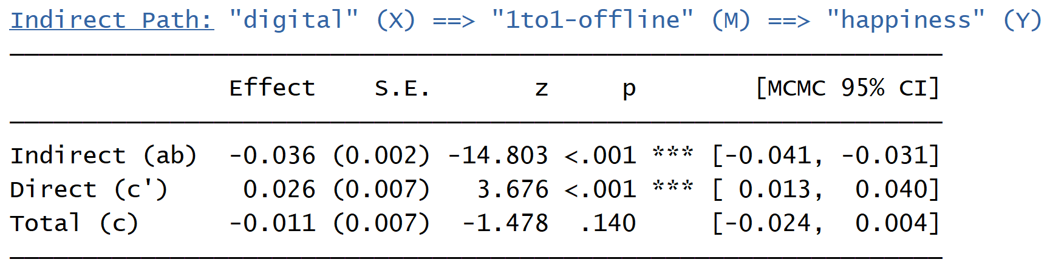
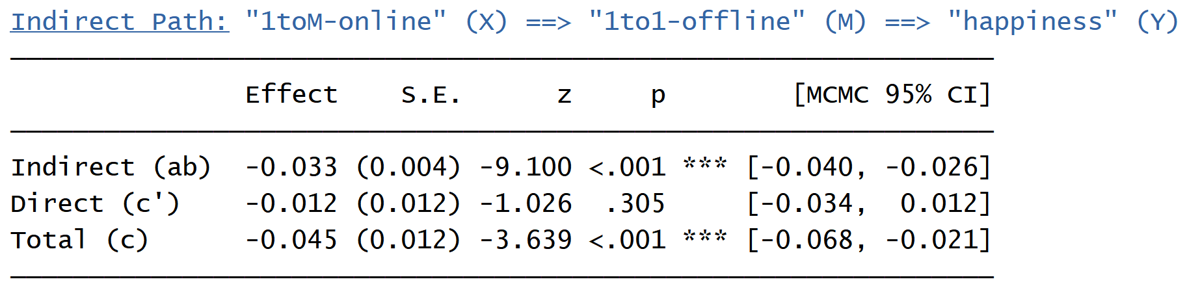
Supplementary Table 6. Multilevel mediation in happiness. In the impact of total digital use and 1toM-online on happiness, the mediating effect of 1to1-offline were both significant. But the overall effect of total digital use on happiness did not reach statistical significance.

Results of Network Analysis in Full Data
The supplementary results reaffirm the main findings of the study when conducting MLVAR analysis on the entire data (n=418). Specifically, it was found that there is a significant negative correlation between different types of digital use and 1to-offline communications. This finding supports the previous conclusions and highlights the consistent relationship between digital engagement and offline communication patterns.

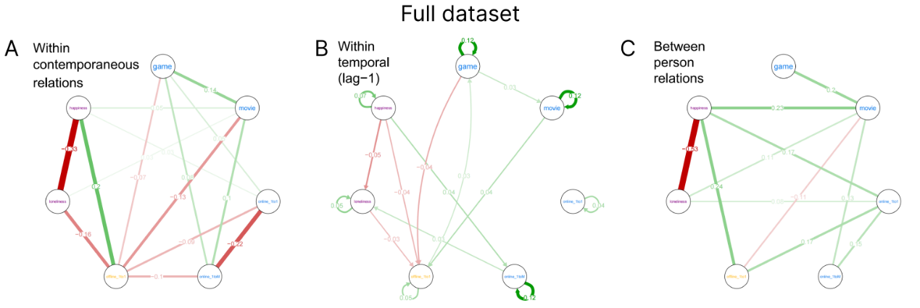
Supplementary Figure 1. MLVAR analysis in full dataset (n=418). (A) showed an undirected network revealing within-person same-day (contemporaneous) relationships among variables, (B) provided a directed temporal network revealing within-person time-lagged (t=1, previous day) relationships among variables, and (C) represented an undirected between-person network identifying variables that fluctuate at the between-person level. Only relationships that reach significance (p<0.05) were shown. The value showed the specific effect size of relationships. The green line indicated a positive relationship, while the red line indicated a negative one.

