Table 1. Specific definitions and measurements of demographic variables.

Table 2. Comparison of demographic variables.
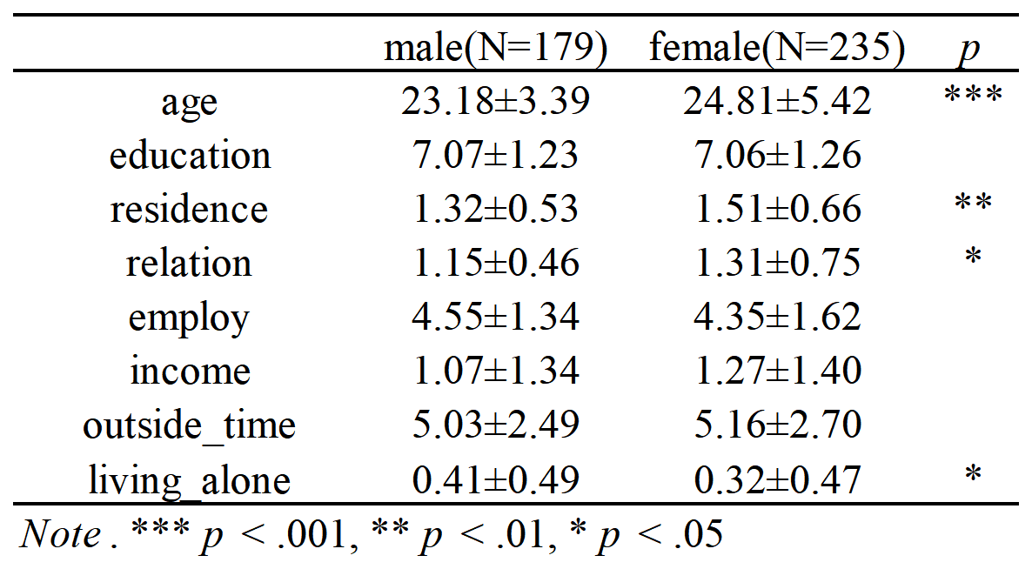

Table 3. Correlation of demographic variables and daily mood.
