Supplementary figure 5. Copper / Zinc ratio (A) and median of metals (B) function of time to death

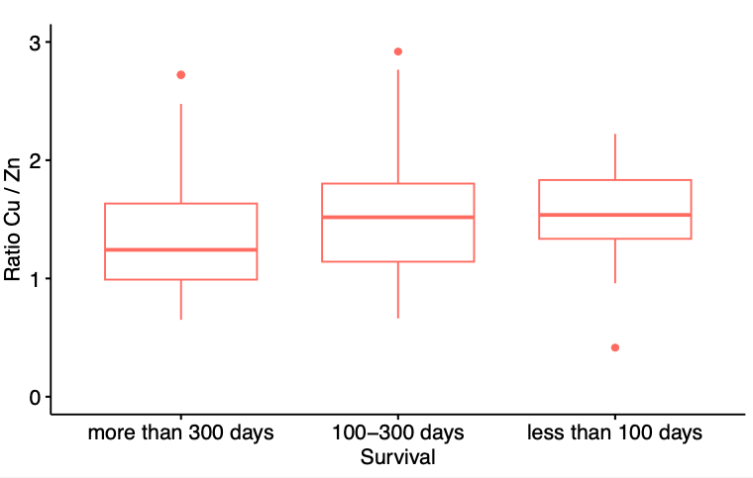

(B)