Impact of ambient temperature on respiratory disease: a case-crossover study in Seoul

Hyewon Lee^{1,2}, Hee-Young Yoon³
¹Department of Health Administration and Management, College of Medical Sciences, Soonchunhyang University, Asan, Republic of Korea
²Department of Software Convergence, Soonchunhyang University Graduate School, Asan, Republic of Korea
³Division of Allergy and Respiratory Diseases, Department of Internal Medicine, Soonchunhyang University Seoul Hospital, Seoul, Republic of Korea

Fig. S1. Sensitivity analysis conducted for the association between maximum ambient temperature and emergency department visits for various subtypes of respiratory diseases.
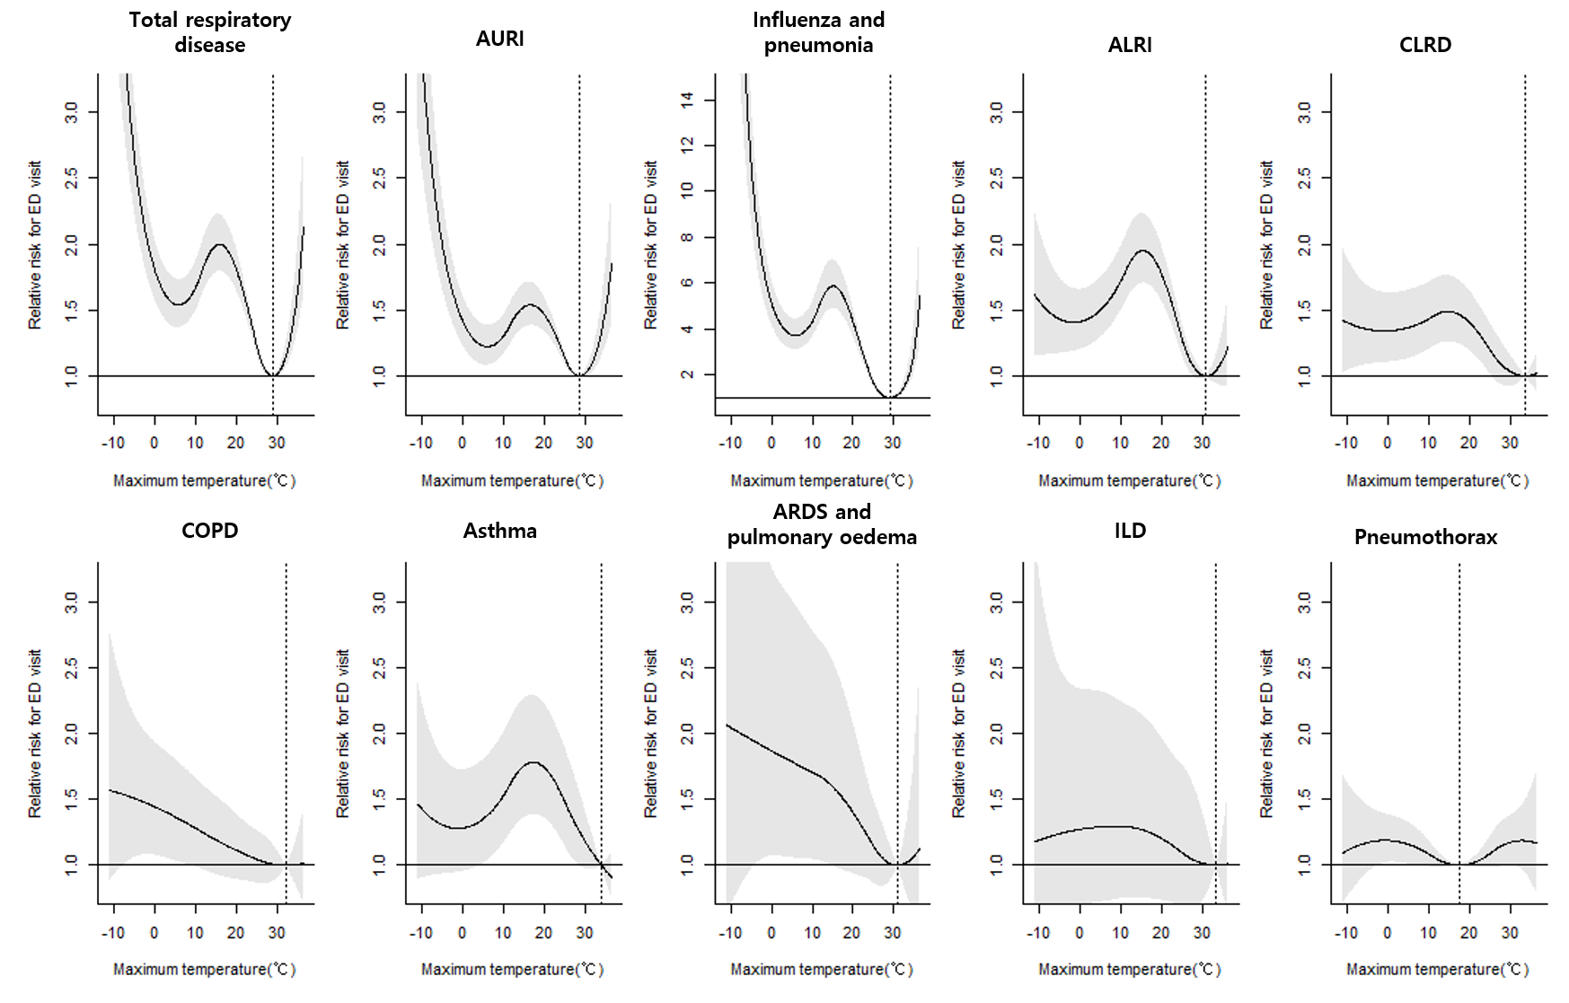

Dotted vertical lines indicate MinRT, while the solid line with shaded area represents relative risk with 95% confidence intervals.
ED, emergency department; MinRT, minimum risk temperature; AURI, acute upper respiratory infection; ALRI, acute lower respiratory infection; CLRD, chronic lower respiratory disease; COPD, chronic obstructive pulmonary disease; ARDS, acute respiratory distress syndrome; ILD, interstitial lung disease
Fig. 2. Sensitivity analysis conducted for the association between minimum ambient temperature and emergency department visits for various subtypes of respiratory diseases.
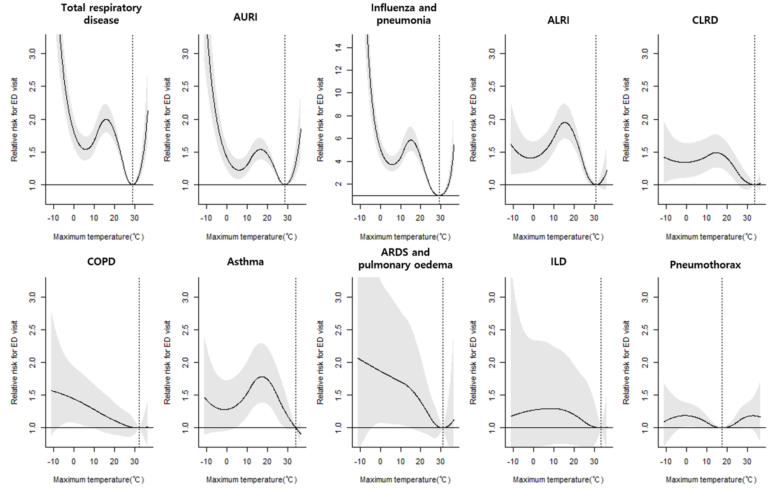
Dotted vertical lines indicate MinRT, while the solid line with shaded area represents relative risk with 95% confidence intervals.
ED, emergency department; MinRT, minimum risk temperature; AURI, acute upper respiratory infection; ALRI, acute lower respiratory infection; CLRD, chronic lower respiratory disease; COPD, chronic obstructive pulmonary disease; ARDS, acute respiratory distress syndrome; ILD, interstitial lung disease

Fig. S3. Sensitivity analysis of mean ambient temperature and emergency department visits for various respiratory disease subtypes over 0-7 lag days.
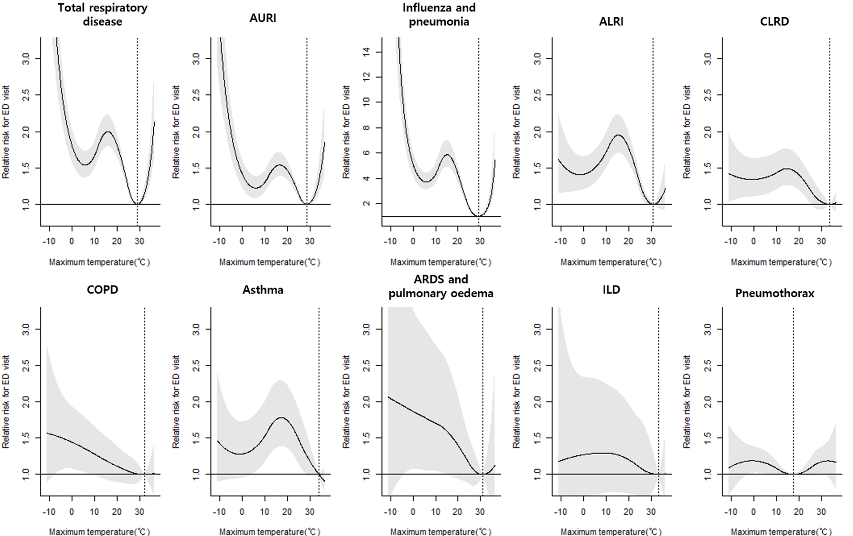
Dotted vertical lines indicate MinRT, while the solid line with shaded area represents relative risk with 95% confidence intervals.
ED, emergency department; MinRT, minimum risk temperature; AURI, acute upper respiratory infection; ALRI, acute lower respiratory infection; CLRD, chronic lower respiratory disease; COPD, chronic obstructive pulmonary disease; ARDS, acute respiratory distress syndrome; ILD, interstitial lung disease

Fig. S4. Sensitivity analysis of mean ambient temperature and emergency department visits for various respiratory disease subtypes over 0-14 lag days.
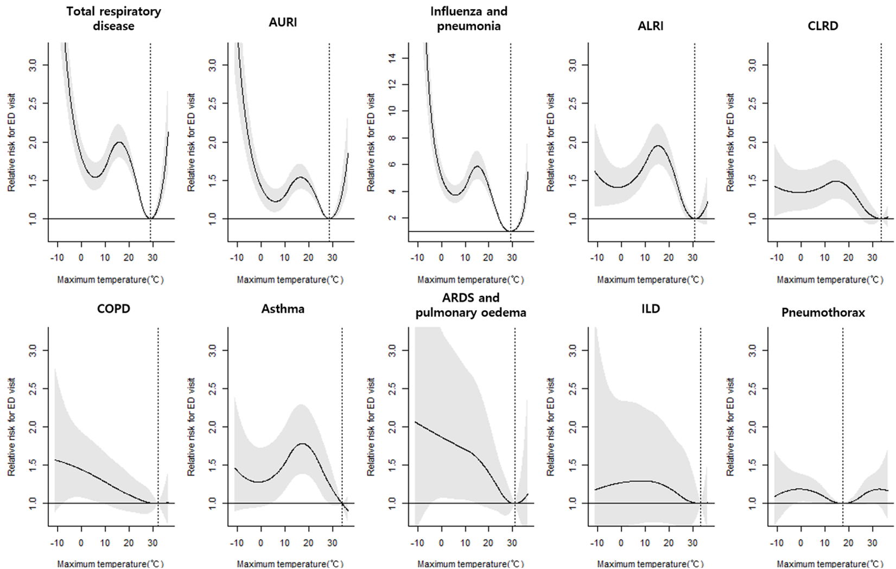
Dotted vertical lines indicate MinRT, while the solid line with shaded area represents relative risk with 95% confidence intervals.
ED, emergency department; MinRT, minimum risk temperature; AURI, acute upper respiratory infection; ALRI, acute lower respiratory infection; CLRD, chronic lower respiratory disease; COPD, chronic obstructive pulmonary disease; ARDS, acute respiratory distress syndrome; ILD, interstitial lung disease

Fig. S5 Sensitivity analysis of mean ambient temperature and emergency department visits for various respiratory disease subtypes over 0-28 lag days.
Dotted vertical lines indicate MinRT, while the solid line with shaded area represents relative risk with 95% confidence intervals.
ED, emergency department; MinRT, minimum risk temperature; AURI, acute upper respiratory infection; ALRI, acute lower respiratory infection; CLRD, chronic lower respiratory disease; COPD, chronic obstructive pulmonary disease; ARDS, acute respiratory distress syndrome; ILD, interstitial lung disease

Fig. S6. Sensitivity analysis of the association between mean ambient temperature and emergency department visits for various subtypes of respiratory diseases, adjusted for PM₁₀ concentration.
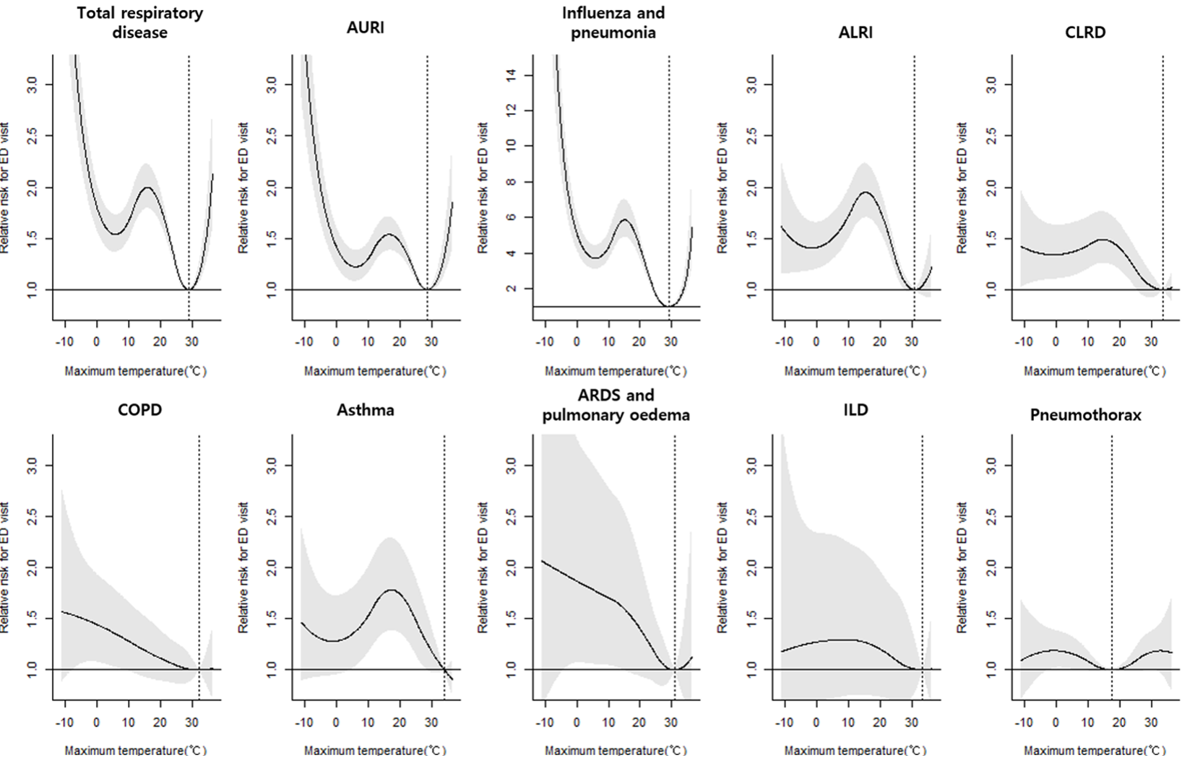
Dotted vertical lines indicate MinRT, while the solid line with shaded area represents relative risk with 95% confidence intervals.
PM₁₀, particulate matter 10 or less in diameter; RR, relative risk; MinRT, minimum risk temperature; AURI, acute upper respiratory infection; ALRI, acute lower respiratory infection; CLRD, chronic lower respiratory disease; COPD, chronic obstructive pulmonary disease; ARDS, acute respiratory distress syndrome; ILD, interstitial lung disease

Fig. S7. Sensitivity analysis of the association between mean ambient temperature and emergency department visits for various subtypes of respiratory diseases, adjusted for PM_{2.5} concentration.
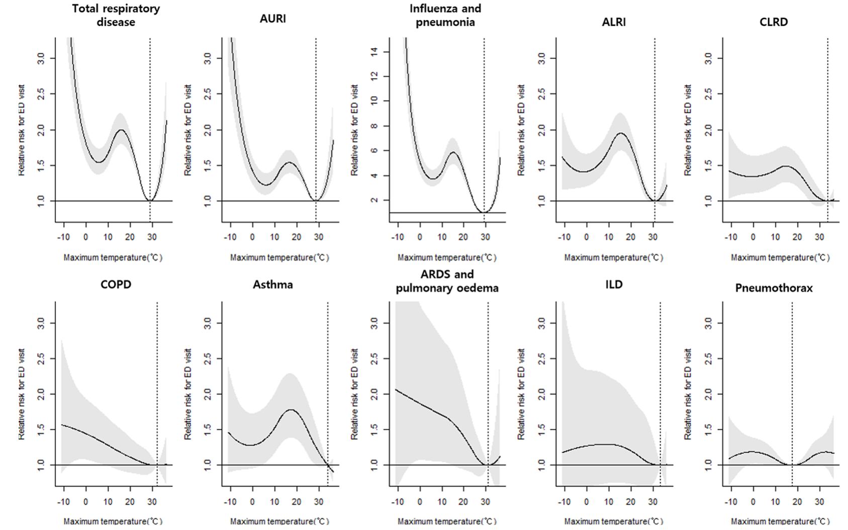
Dotted vertical lines indicate MinRT, while the solid line with shaded area represents relative risk with 95% confidence intervals.
PM_{2.5}, particulate matter 2.5 or less in diameter; RR, relative risk; MinRT, minimum risk temperature; AURI, acute upper respiratory infection; ALRI, acute lower respiratory infection; CLRD, chronic lower respiratory disease; COPD, chronic obstructive pulmonary disease; ARDS, acute respiratory distress syndrome; ILD, interstitial lung disease

Fig. S8. Sensitivity analysis of the association between mean ambient temperature and emergency department visits for various subtypes of respiratory diseases, adjusted for NO₂ concentration.
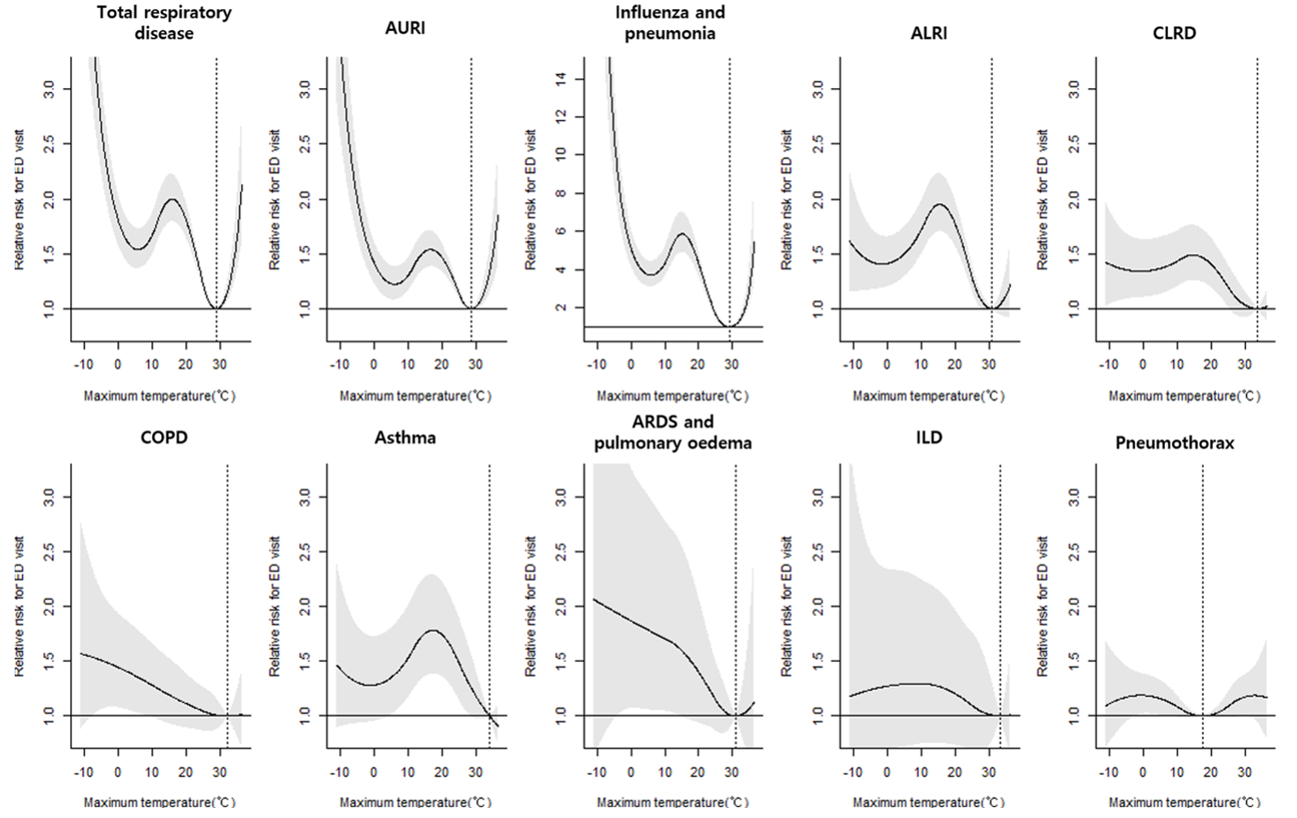
Dotted vertical lines indicate MinRT, while the solid line with shaded area represents relative risk with 95% confidence intervals.
NO₂, nitrogen dioxide; RR, relative risk; MinRT, minimum risk temperature; AURI, acute upper respiratory infection; ALRI, acute lower respiratory infection; CLRD, chronic lower respiratory disease; COPD, chronic obstructive pulmonary disease; ARDS, acute respiratory distress syndrome; ILD, interstitial lung disease

Fig. S9. Sensitivity analysis of the association between mean ambient temperature and emergency department visits for various subtypes of respiratory diseases, adjusted for O₃ concentration.
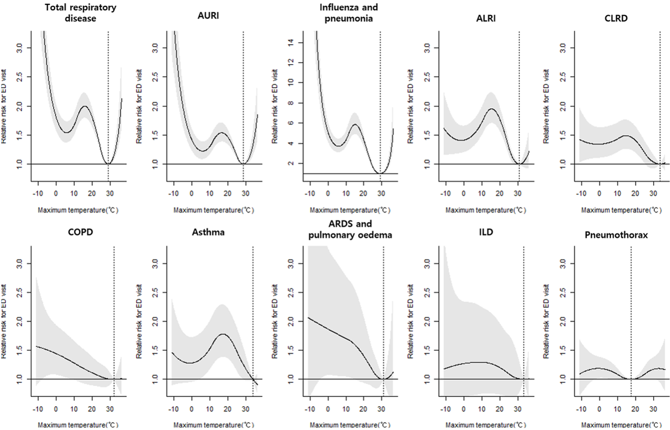
Dotted vertical lines indicate MinRT, while the solid line with shaded area represents relative risk with 95% confidence intervals.
O₃, ozone; RR, relative risk; MinRT, minimum risk temperature; AURI, acute upper respiratory infection; ALRI, acute lower respiratory infection; CLRD, chronic lower respiratory disease; COPD, chronic obstructive pulmonary disease; ARDS, acute respiratory distress syndrome; ILD, interstitial lung disease

Fig. S10. Sensitivity analysis of the association between mean ambient temperature and emergency department visits for various subtypes of respiratory diseases, adjusted for SO₂ concentration.
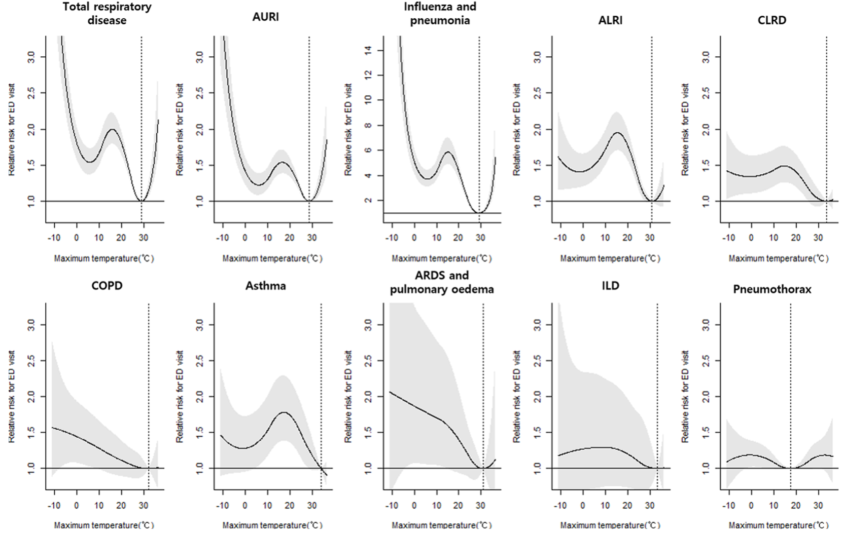
Dotted vertical lines indicate MinRT, while the solid line with shaded area represents relative risk with 95% confidence intervals.
SO₂, sulfur dioxide; RR, relative risk; MinRT, minimum risk temperature; AURI, acute upper respiratory infection; ALRI, acute lower respiratory infection; CLRD, chronic lower respiratory disease; COPD, chronic obstructive pulmonary disease; ARDS, acute respiratory distress syndrome; ILD, interstitial lung disease

Fig. S11. Sensitivity analysis of the association between mean ambient temperature and emergency department visits for various subtypes of respiratory diseases, adjusted for CO concentration.
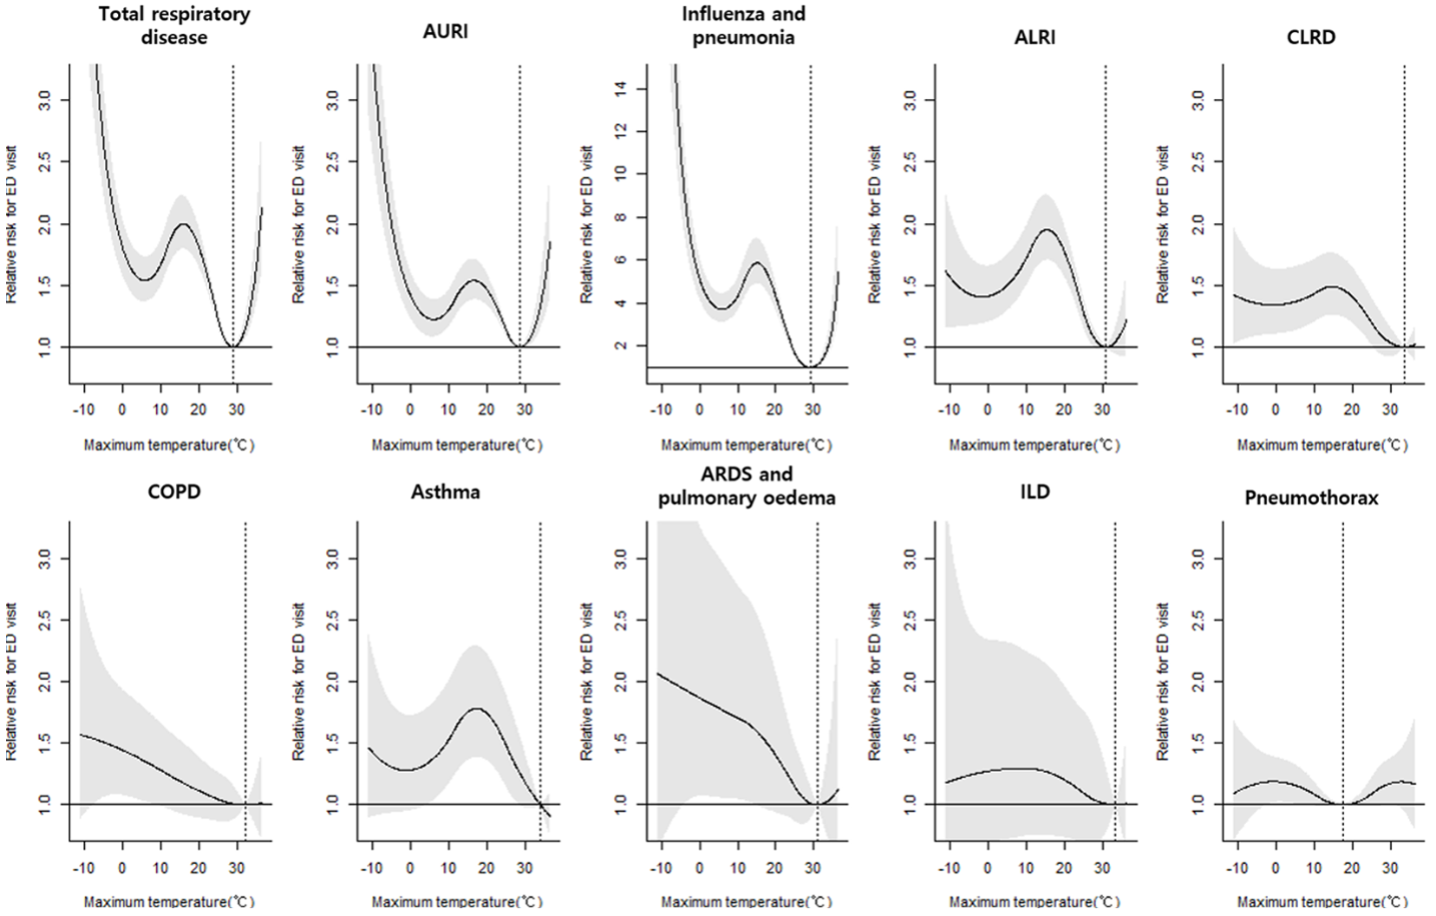
Dotted vertical lines indicate MinRT, while the solid line with shaded area represents relative risk with 95% confidence intervals.
CO, carbon monoxide; RR, relative risk; MinRT, minimum risk temperature; AURI, acute upper respiratory infection; ALRI, acute lower respiratory infection; CLRD, chronic lower respiratory disease; COPD, chronic obstructive pulmonary disease; ARDS, acute respiratory distress syndrome; ILD, interstitial lung disease

