Supplementary Information
Table S1. Loadings for all traits in the first three axes of principle component analysis for each of and across all treatments of emergence time (ET1-4) at day 50 of plant growth. Abbreviations for all traits are in Table 1.
Table S2. Loadings for all traits in the first three axes of principle component analysis for each of and across all treatments of emergence time (ET1-4) at day 70 of plant growth. Abbreviations for all traits are in Table 1.
Table S3. Loadings for all traits in the first three axes of principle component analysis for each of and across all (low, medium and high) density treatments at day 50 of plant growth. Abbreviations for all traits are in Table 1.
Table S4. Loadings for all traits in the first three axes of principle component analysis for each of and across all (low, medium and high) density treatments at day 70 of plant growth. Abbreviations for all traits are in Table 1.
Figure S1. Mean values (±SE) of the mass (A, C, E) and allocation (B, D, F) of various organs for plants that emerged in spring (ET1), late spring (ET2), summer (ET3) and late summer (ET4) at day 50 (A, B), 70 (C, D) and the final (E, F) stages. Different letters indicate significant difference between between ET treatments within each stage (ANCOVA, LSD, p < 0.05).
Figure S2. Mean values (±SE) of morphological traits for stem (A, B), leaf (C, E, G, I) and root (D, F, H, J) organs of plants that emerged in spring (ET1, black), late spring (ET2, light gray), summer (ET3, white) and late summer (ET4, dark gray) at day 50, 70 and final stages. Different lowercase letters indicate significant difference between ET treatments within each stage (ANCOVA, LSD, p < 0.05).
Figure S3. Original and adjusted mean values (±SE) of mass (A, C, E) and allocation (B, D, F) of different organs for plants at low, medium and high densities at day 30 (A, B), 50 (C, D) and 70 (E, F) of growth. Different letters indicate significant difference between density treatments within each growth stage (ANCOVA, LSD, P < 0.05). Abbreviations for all traits are in Table 1.
Figure S4. Mean values (±SE) of morphological traits for plants at low (white), medium (gray) and high (black) densities at day 50 and 70 of growth. Different letters indicate significant difference between density treatments within each growth stage (ANCOVA, LSD, P < 0.05). Abbreviations for all traits are in Table 1.

Table S1. Loadings for all traits in the first three axes of principle component analysis for each of and across all treatments of emergence time (ET1-4) at day 50 of plant growth. Abbreviations for all traits are in Table 1.
 |  | ET 1 |  |  | ET 2 |  |  | ET 3 |  |  | ET 4 |  |  | All
Attribute | Axis 1 | Axis 2 | Axis 3 | Axis 1 | Axis 2 | Axis 3 | Axis 1 | Axis 2 | Axis 3 | Axis 1 | Axis 2 | Axis 3 | Axis 1 | Axis 2 | Axis 3
Variance accounted for (%) | 31.15 | 22.18 | 16.62 | 45.42 | 13.77 | 12.32 | 43.54 | 21.75 | 13.24 | 38.56 | 24.52 | 10.50 | 33.17 | 20.12 | 14.02
TM | 0.428 | -0.024 | 0.101 | 0.337 | -0.009 | 0.108 | 0.347 | 0.231 | 0.020 | 0.245 | 0.353 | -0.162 | 0.381 | 0.140 | -0.142
RMR | -0.232 | -0.102 | 0.398 | -0.132 | 0.463 | 0.308 | 0.029 | -0.486 | -0.217 | -0.269 | 0.158 | -0.423 | -0.179 | -0.075 | 0.364
SMR | 0.203 | -0.144 | -0.524 | -0.309 | 0.312 | 0.129 | 0.172 | -0.432 | -0.008 | 0.235 | -0.388 | -0.106 | 0.116 | -0.430 | 0.207
PMR | 0.098 | 0.496 | 0.062 | -0.081 | -0.436 | 0.247 | 0.111 | 0.014 | 0.453 | -0.381 | 0.106 | 0.054 | -0.066 | 0.275 | 0.525
LMR | 0.090 | 0.165 | 0.405 | 0.273 | -0.334 | -0.324 | -0.009 | -0.144 | 0.585 | 0.379 | -0.134 | 0.092 | -0.027 | -0.231 | -0.555
REMR | -0.300 | 0.223 | 0.109 | 0.216 | -0.101 | 0.508 | -0.105 | 0.431 | -0.358 | 0.294 | 0.108 | 0.176 | 0.062 | 0.433 | -0.332
SL | 0.381 | -0.033 | -0.027 | 0.295 | 0.317 | 0.037 | 0.356 | 0.174 | -0.008 | 0.369 | -0.001 | -0.068 | 0.379 | -0.228 | 0.089
RL | 0.195 | -0.055 | 0.128 | 0.149 | 0.041 | -0.161 | 0.205 | 0.127 | -0.095 | -0.200 | 0.114 | -0.427 | 0.266 | 0.124 | 0.285
RD | 0.400 | -0.035 | 0.144 | 0.344 | 0.183 | 0.086 | 0.380 | 0.005 | -0.011 | 0.320 | 0.146 | -0.267 | 0.383 | -0.210 | 0.043
SD | 0.390 | -0.122 | 0.315 | 0.342 | 0.239 | 0.026 | 0.376 | 0.041 | 0.033 | 0.291 | 0.242 | -0.189 | 0.399 | -0.191 | 0.037
LRL | -0.160 | -0.080 | 0.463 | -0.232 | -0.187 | 0.474 | 0.232 | -0.256 | -0.207 | 0.195 | -0.147 | 0.148 | 0.082 | 0.129 | -0.048
LRN | 0.014 | 0.352 | -0.038 | 0.221 | 0.263 | -0.005 | 0.224 | 0.022 | -0.401 | 0.027 | 0.424 | 0.146 | 0.212 | -0.134 | -0.046
PL | 0.315 | 0.387 | 0.059 | 0.309 | -0.090 | 0.044 | 0.358 | 0.120 | 0.085 | 0.135 | 0.380 | 0.215 | 0.396 | 0.145 | 0.012
PA | -0.123 | 0.446 | -0.139 | 0.220 | -0.096 | 0.426 | -0.164 | 0.427 | 0.143 | -0.104 | 0.392 | -0.356 | 0.199 | 0.385 | 0.083
LN | 0.037 | 0.383 | -0.039 | 0.234 | -0.249 | 0.092 | 0.335 | 0.081 | 0.189 | 0.077 | 0.258 | 0.481 | 0.177 | 0.349 | -0.074

Table S2. Loadings for all traits in the first three axes of principle component analysis for each of and across all treatments of emergence time (ET1-4) at day 70 of plant growth. Abbreviations for all traits are in Table 1.
 |  | ET 1 |  |  | ET 2 |  |  | ET 3 |  |  | All
Attribute | Axis 1 | Axis 2 | Axis 3 | Axis 1 | Axis 2 | Axis 3 | Axis 1 | Axis 2 | Axis 3 | Axis 1 | Axis 2 | Axis 3
Variance accounted for (%) | 37.68 | 18.10 | 12.33 | 32.02 | 26.26 | 11.27 | 30.59 | 22.89 | 14.68 | 28.13 | 21.04 | 13.39
TM | 0.379 | -0.044 | -0.152 | 0.120 | 0.417 | -0.039 | 0.061 | -0.399 | 0.344 | 0.397 | 0.187 | 0.147
RMR | 0.085 | -0.275 | 0.405 | 0.325 | 0.018 | 0.005 | 0.068 | 0.245 | 0.101 | -0.233 | 0.039 | -0.298
SMR | -0.231 | -0.202 | 0.466 | 0.331 | -0.258 | 0.145 | -0.022 | 0.042 | -0.271 | 0.021 | -0.498 | -0.143
PMR | -0.325 | 0.271 | -0.072 | -0.014 | -0.004 | -0.644 | 0.388 | 0.157 | 0.193 | -0.056 | -0.105 | 0.542
LMR | -0.367 | 0.188 | -0.045 | 0.135 | -0.432 | -0.152 | 0.396 | 0.203 | 0.101 | -0.282 | -0.217 | 0.415
REMR | 0.365 | 0.030 | -0.308 | -0.256 | 0.341 | 0.313 | -0.359 | -0.272 | -0.071 | 0.176 | 0.473 | -0.155
SL | 0.367 | -0.193 | 0.062 | 0.387 | 0.094 | 0.210 | -0.208 | 0.378 | -0.098 | 0.383 | -0.208 | -0.217
RL | 0.110 | 0.257 | 0.555 | -0.055 | -0.292 | 0.473 | 0.184 | 0.105 | -0.433 | -0.180 | -0.104 | -0.189
RD | 0.243 | -0.256 | 0.149 | 0.257 | 0.357 | 0.023 | -0.297 | 0.319 | 0.214 | 0.405 | -0.059 | -0.092
SD | 0.203 | 0.252 | -0.013 | 0.254 | 0.350 | 0.074 | -0.298 | 0.322 | 0.188 | 0.360 | -0.124 | 0.005
LRL | -0.014 | 0.384 | -0.133 | -0.188 | 0.183 | -0.320 | 0.064 | -0.020 | 0.603 | -0.064 | 0.388 | 0.291
LRN | 0.268 | -0.002 | -0.072 | 0.264 | 0.204 | -0.052 | 0.072 | 0.401 | 0.148 | 0.272 | 0.120 | 0.122
PL | 0.186 | 0.302 | 0.189 | 0.376 | -0.077 | 0.043 | 0.020 | -0.311 | 0.213 | 0.253 | 0.089 | 0.277
PA | -0.176 | -0.359 | -0.310 | -0.310 | 0.014 | 0.166 | 0.392 | 0.111 | 0.188 | -0.223 | 0.396 | -0.080
LN | 0.191 | 0.415 | 0.071 | 0.246 | -0.180 | -0.182 | 0.400 | 0.097 | 0.050 | 0.097 | -0.177 | 0.323

Table S3. Loadings for all traits in the first three axes of principle component analysis for each of and across all (low, medium and high) density treatments at day 50 of plant growth. Abbreviations for all traits are in Table 1.
 |  | Low |  |  | Medium |  |  | High |  |  | All
Attribute | Axis 1 | Axis 2 | Axis 3 | Axis 1 | Axis 2 | Axis 3 | Axis 1 | Axis 2 | Axis 3 | Axis 1 | Axis 2 | Axis 3
Variance accounted for (%) | 33.25 | 19.09 | 14.44 | 36.34 | 24.28 | 10.87 | 34.58 | 20.73 | 15.05 | 40.66 | 12.60 | 11.88
TM | 0.215 | 0.462 | -0.146 | 0.384 | -0.194 | 0.123 | 0.410 | -0.067 | 0.105 | 0.358 | -0.077 | -0.101
RMR | -0.312 | 0.121 | -0.121 | -0.166 | 0.433 | 0.150 | -0.281 | -0.095 | 0.323 | -0.096 | 0.259 | 0.523
SMR | -0.207 | 0.470 | -0.069 | -0.076 | 0.425 | 0.163 | 0.205 | -0.129 | -0.536 | -0.118 | -0.588 | 0.187
PMR | 0.413 | -0.157 | -0.079 | 0.226 | 0.371 | -0.227 | 0.147 | 0.485 | 0.111 | 0.316 | -0.105 | 0.152
LMR | 0.213 | -0.471 | -0.141 | 0.070 | -0.444 | -0.297 | 0.176 | 0.116 | 0.439 | 0.069 | 0.268 | -0.649
REMR | 0.137 | 0.071 | 0.564 | -0.004 | -0.152 | 0.543 | -0.295 | 0.245 | 0.116 | 0.079 | 0.362 | 0.189
RL | 0.334 | 0.007 | 0.162 | 0.141 | 0.347 | -0.099 | 0.151 | -0.091 | 0.086 | 0.254 | -0.102 | 0.244
RD | 0.302 | 0.249 | -0.188 | 0.389 | -0.008 | 0.116 | 0.381 | -0.069 | 0.132 | 0.372 | -0.038 | -0.042
LRL | 0.294 | -0.005 | -0.174 | -0.146 | -0.130 | -0.383 | -0.194 | -0.086 | 0.475 | 0.215 | 0.369 | -0.014
LRN | 0.185 | 0.032 | 0.272 | -0.115 | -0.128 | 0.501 | -0.056 | 0.339 | -0.019 | 0.225 | 0.284 | 0.132
SL | 0.277 | -0.029 | 0.148 | 0.324 | -0.133 | 0.145 | 0.332 | -0.081 | -0.032 | 0.180 | -0.313 | -0.239
SD | -0.033 | -0.003 | 0.429 | 0.406 | -0.030 | 0.125 | 0.348 | -0.155 | 0.292 | 0.296 | -0.095 | -0.037
PL | 0.272 | 0.291 | -0.344 | 0.381 | 0.164 | -0.152 | 0.338 | 0.329 | 0.127 | 0.362 | -0.172 | -0.010
PA | -0.006 | 0.368 | 0.334 | 0.231 | 0.191 | 0.108 | -0.054 | 0.482 | -0.106 | 0.240 | -0.006 | 0.251
LN | 0.321 | 0.125 | 0.115 | 0.299 | -0.016 | -0.099 | 0.117 | 0.393 | -0.122 | 0.359 | 0.038 | 0.039

Table S4. Loadings for all traits in the first three axes of principle component analysis for each of and across all (low, medium and high) density treatments at day 70 of plant growth. Abbreviations for all traits are in Table 1.
 |  | Low |  |  | Medium |  |  | High |  |  | All
Attribute | Axis 1 | Axis 2 | Axis 3 | Axis 1 | Axis 2 | Axis 3 | Axis 1 | Axis 2 | Axis 3 | Axis 1 | Axis 2 | Axis 3
Variance accounted for (%) | 36.24 | 14.66 | 13.03 | 33.53 | 22.84 | 13.74 | 38.2 | 17.8 | 13.2 | 35.10 | 26.87 | 10.18
TM | 0.412 | 0.017 | 0.031 | 0.374 | -0.210 | 0.078 | 0.388 | 0.006 | -0.173 | 0.392 | 0.043 | -0.143
RMR | -0.234 | -0.393 | -0.146 | -0.317 | 0.099 | 0.179 | -0.058 | -0.379 | 0.436 | -0.136 | -0.212 | 0.491
SMR | -0.090 | -0.405 | 0.142 | -0.323 | 0.268 | 0.181 | -0.248 | -0.317 | 0.267 | -0.273 | -0.260 | 0.241
PMR | -0.346 | 0.225 | 0.161 | 0.040 | 0.471 | -0.069 | -0.309 | 0.316 | -0.030 | -0.180 | 0.517 | 0.180
LMR | -0.360 | 0.168 | 0.148 | -0.039 | 0.487 | -0.040 | -0.354 | 0.241 | -0.038 | -0.283 | 0.431 | 0.110
REMR | 0.062 | 0.349 | -0.471 | -0.064 | -0.438 | -0.261 | 0.379 | 0.065 | -0.192 | 0.231 | -0.212 | -0.263
RL | -0.150 | 0.208 | 0.296 | -0.096 | -0.275 | -0.211 | 0.097 | 0.093 | 0.572 | 0.054 | -0.089 | 0.410
RD | -0.053 | 0.074 | 0.424 | 0.279 | -0.050 | 0.475 | 0.222 | -0.347 | 0.085 | 0.222 | 0.051 | 0.427
LRL | 0.279 | 0.169 | 0.225 | 0.267 | 0.211 | -0.272 | -0.004 | 0.378 | 0.148 | 0.236 | 0.378 | 0.029
LRN | 0.138 | -0.307 | 0.117 | -0.191 | -0.243 | 0.392 | 0.265 | 0.003 | -0.067 | 0.234 | -0.144 | 0.381
SL | 0.398 | -0.163 | -0.087 | 0.357 | 0.001 | -0.046 | 0.357 | -0.217 | -0.041 | 0.337 | -0.208 | -0.053
SD | 0.293 | -0.290 | 0.343 | 0.164 | -0.023 | 0.576 | 0.198 | 0.164 | 0.197 | 0.261 | 0.011 | 0.219
PL | 0.240 | 0.225 | 0.079 | 0.304 | 0.190 | 0.058 | 0.175 | 0.342 | -0.004 | 0.297 | 0.301 | 0.051
PA | -0.152 | -0.059 | 0.395 | -0.330 | 0.053 | 0.131 | -0.173 | -0.233 | -0.487 | -0.223 | 0.100 | -0.111
LN | 0.259 | 0.379 | 0.261 | 0.313 | 0.053 | 0.042 | 0.250 | 0.276 | 0.175 | 0.326 | 0.263 | 0.065

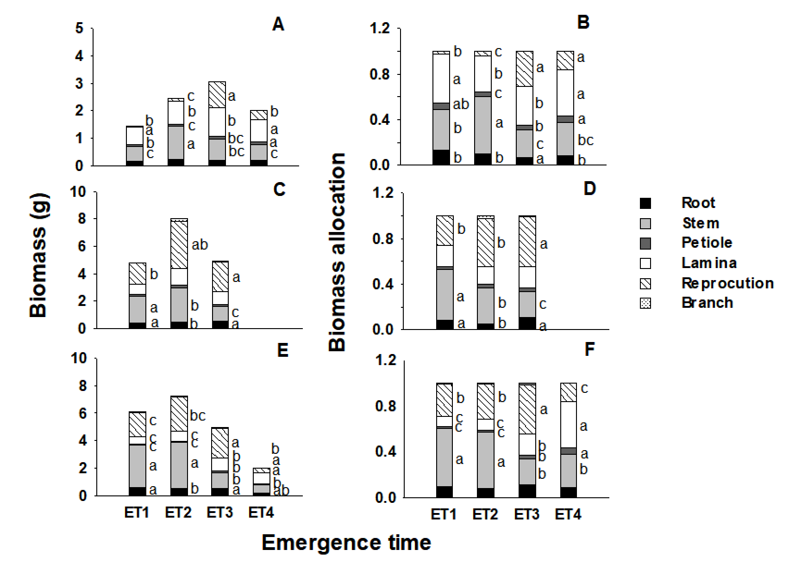
Figure S1. Mean values (±SE) of the mass (A, C, E) and allocation (B, D, F) of various organs for plants that emerged in spring (ET1), late spring (ET2), summer (ET3) and late summer (ET4) at day 50 (A, B), 70 (C, D) and the final (E, F) stages. Different letters indicate significant difference between between ET treatments within each stage (ANCOVA, LSD, P < 0.05).

Figure S2. Mean values (±SE) of morphological traits for stem (A, B), leaf (C, E, G, I) and root (D, F, H, J) organs of plants that emerged in spring (ET1, black), late spring (ET2, light gray), summer (ET3, white) and late summer (ET4, dark gray) at day 50, 70 and final stages. Different lowercase letters indicate significant difference between ET treatments within each stage (ANCOVA, LSD, P < 0.05).

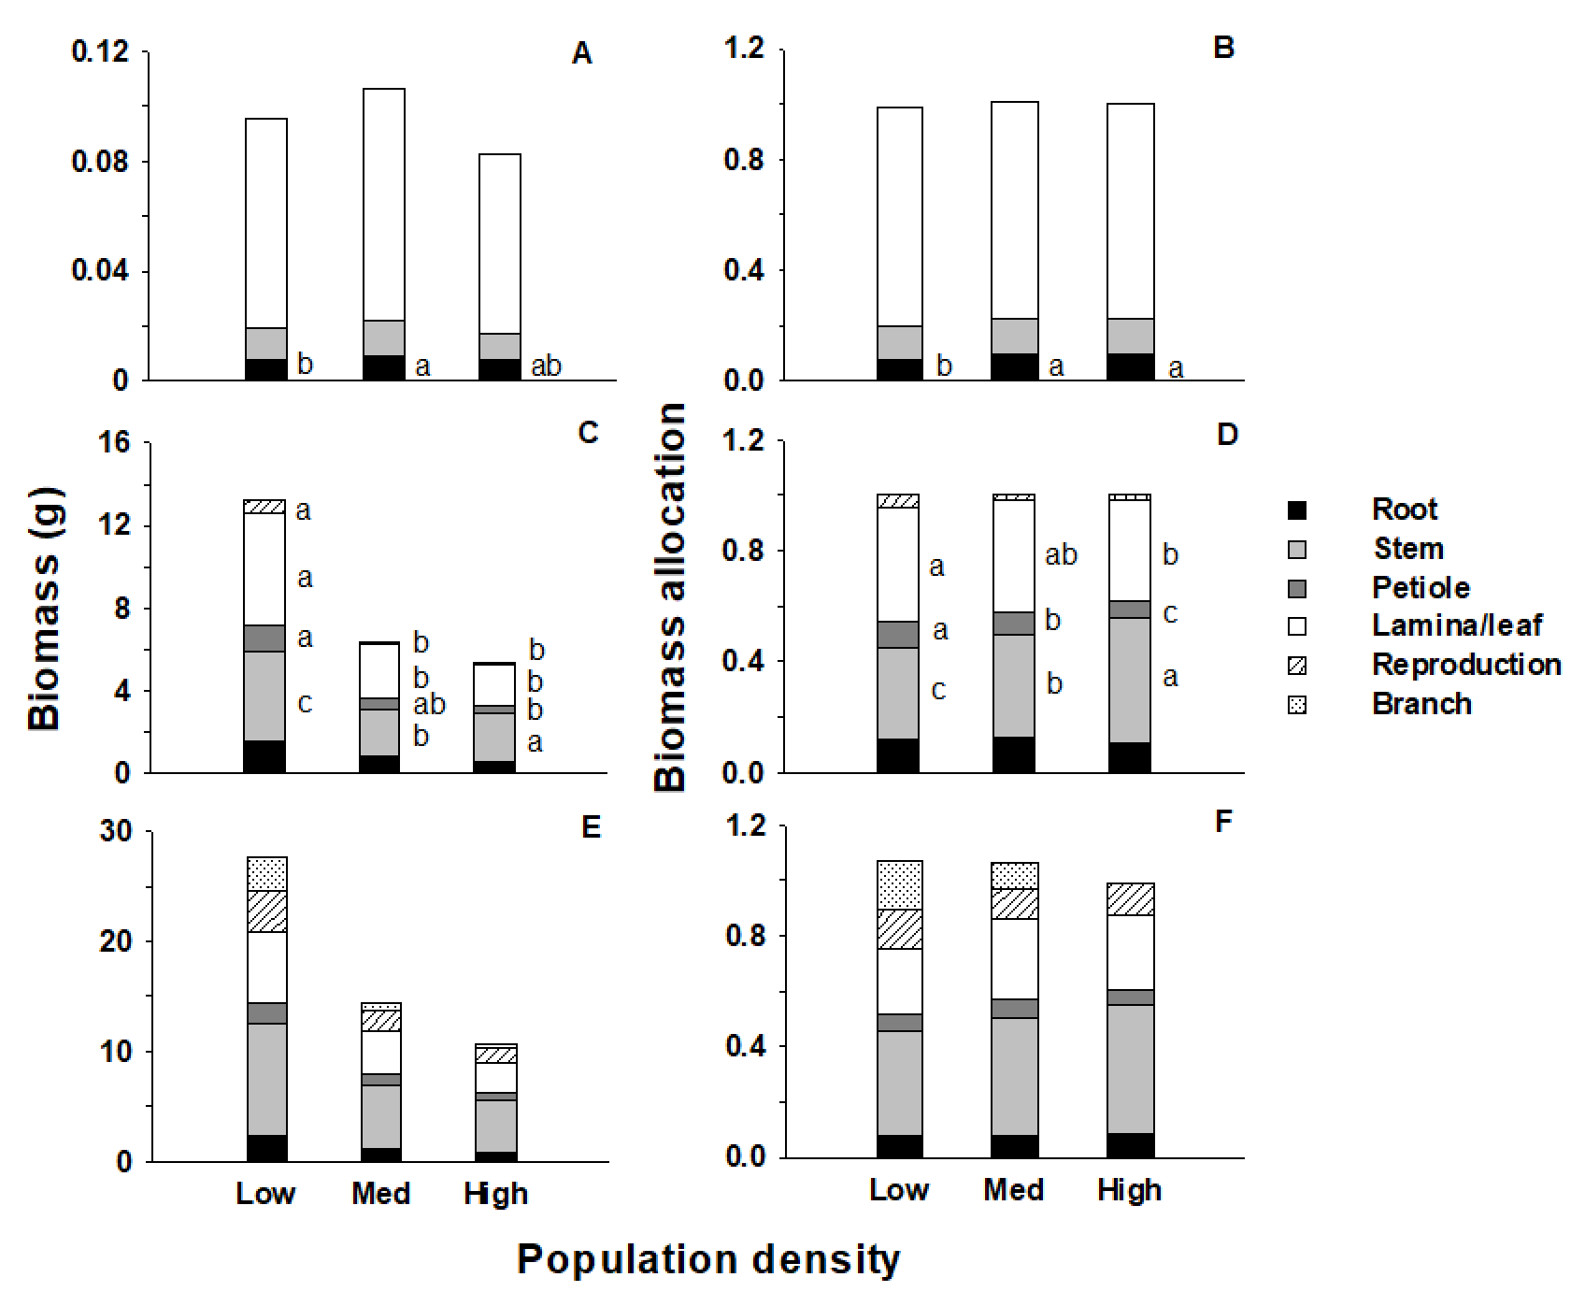
Figure S3. Original and adjusted mean values (±SE) of mass (A, C, E) and allocation (B, D, F) of different organs for plants at low, medium and high densities at day 30 (A, B), 50 (C, D) and 70 (E, F) of growth. Different letters indicate significant difference between density treatments within each growth stage (ANCOVA, LSD, P < 0.05). Abbreviations for all traits are in Table 1.

Figure S4. Mean values (±SE) of morphological traits for plants at low (white), medium (gray) and high (black) densities at day 50 and 70 of growth. Different letters indicate significant difference between density treatments within each growth stage (ANCOVA, LSD, P < 0.05). Abbreviations for all traits are in Table 1.

