Ascertainment of covariates in the current study and their method
Information on age, sex, race and ethnicity, education level, family income-to-poverty ratio, insurance status and medical conditions was collected during household interview.
Smoking status was classified as current smoking (An individual who has consumed over 100 cigarettes in their lifespan and who smokes daily or occasionally), former smoking (A lifetime smoker of at least 100 cigarettes; however, he/she was not smoking at the time of their interview), and non-smoking (smoked no more than 100 cigarettes during their lifetime).
History of cardiovascular disease (CVD) were defined by the participants’ response to a series of questions as a part of the standardized questionnaire: CHF: “Has a doctor or other health professional ever told you that you had congestive heart failure?”; Stroke: “Has a doctor or other health professional ever told you that you had a stroke?”; CAD: “Has a doctor or other health professional ever told you that you had coronary heart disease?”, “Has a doctor or other health professional ever told you that you had angina, also called angina pectoris?”, “Has a doctor or other health professional ever told you that you had a heart attack (also called myocardial infarction).
Measurements of height, weight, and blood pressure were performed following a standardized protocol. Body mass index (BMI) was calculated as weight in kilograms divided by height in meters squared (kg/m²).
Diabetes mellitus was defined as having a hemoglobin A1c level ≥ 6.5% or serum glucose level ≥ 200 mg/dl or yes to any of the following question “Other than during pregnancy, have you ever been told by a doctor or health professional that you have diabetes or sugar diabetes?”, “Are you taking insulin now”, “Are you now taking diabetic pills to lower blood sugar”.
Serum concentrations of total cholesterol (TC), HDL-C and creatinine were examined by laboratory tests
Estimated glomerular filtration rate (eGFR) was computed according to the Chronic Kidney Disease Epidemiology Collaboration (CKD-EPI) equation (16) and CKD was defined as an eGFR < 60 ml/min/1.73 m².
10-year ASCVD risk was calculated by race, gender, age, systolic blood pressure (treated or untreated status), TC, HDL-C, diabetes, and smoking status, and 10-year ASCVD risk ≥10% was defined as having elevated 10-year ASCVD risk.
Supplementary Table 1. Crude Percentage of Adults with hypertension subtypes According to the 2017 ACC/AHA Guideline From 1999-2000 to 2017-2018
Hypertension subtypes | 1999-2000 | 2001-2002 | 2003-2004 | 2005-2006 | 2007-2008 | 2009-2010 | 2011-2012 | 2013-2014 | 2015-2016 | 2017-2018
HTN | 55 (53.3-56.7) | 52 (50.4-53.5) | 54.9 (53.3-56.5) | 50.1 (48.5-51.6) | 53.5 (52-54.9) | 52.6 (51.2-54) | 53.1 (51.5-54.6) | 52.3 (50.9-53.8) | 54.5 (53-56) | 59 (57.5-60.5)
TAM | 24.5 (23-25.9) | 22.5 (21.2-23.8) | 28.2 (26.7-29.6) | 26 (24.7-27.4) | 31.1 (29.8-32.5) | 30.7 (29.4-32) | 30.6 (29.2-32) | 30.8 (29.4-32.1) | 32.1 (30.7-33.4) | 34.5 (33.1-36)
Controlled BP | 8.1  (7.1-9) | 8.7 (7.8-9.6) | 12 (10.9-13) | 11.7 (10.7-12.7) | 14.7 (13.7-15.7) | 14.8 (13.8-15.8) | 14.2 (13.2-15.3) | 16.2 (15.2-17.3) | 14.9 (13.8-15.9) | 13.3 (12.2-14.4)
Controlled BP with TAM | 5.7 (4.9-6.4) | 6.5 (5.7-7.3) | 9.2 (8.3-10.1) | 9.4 (8.5-10.3) | 12.8 (11.9-13.8) | 12.9 (12-13.9) | 11.8 (10.8-12.8) | 13.2 (12.2-14.2) | 12.9 (11.9-13.9) | 11.8 (10.8-12.9)
HTN I | 21.3 (19.9-22.7) | 21.3 (20-22.5) | 19.9 (18.6-21.2) | 19.4 (18.2-20.6) | 18.8 (17.7-19.9) | 20 (18.9-21.1) | 21.2 (20-22.4) | 19.1 (18-20.2) | 20.5 (19.3-21.7) | 21.9 (20.6-23.2)
TAM | 5.9 (5.1-6.7) | 5.6 (4.9-6.3) | 6.7 (5.9-7.5) | 6.4 (5.6-7.1) | 7.2  (6.5-8) | 7.5 (6.8-8.2) | 8.3 (7.5-9.2) | 7.5 (6.7-8.2) | 7.4 (6.6-8.1) | 8.1  (7.3-9)
HTN II | 16.7 (15.4-18) | 14.7 (13.6-15.8) | 14.7 (13.6-15.8) | 13.5 (12.4-14.6) | 14.5 (13.5-15.5) | 13.2 (12.2-14.1) | 12.8 (11.8-13.9) | 12.6 (11.7-13.6) | 14.2 (13.2-15.2) | 16.6 (15.5-17.8)
TAM | 7.3 (6.4-8.2) | 6.7  (6-7.5) | 7.1 (6.3-7.9) | 6.9 (6.1-7.7) | 7.5 (6.7-8.3) | 7.3  (6.5-8) | 7.1 (6.4-7.9) | 7.2 (6.4-7.9) | 8.3 (7.5-9.1) | 9.4 (8.5-10.3)
HTN III | 8.8 (7.9-9.8) | 7.2  (6.4-8) | 8.3 (7.4-9.2) | 5.4 (4.7-6.1) | 5.4 (4.8-6.1) | 4.6  (4-5.2) | 4.8 (4.1-5.4) | 4.3 (3.8-4.9) | 4.9 (4.3-5.6) | 7.2  (6.4-8)
TAM | 5.5 (4.8-6.3) | 3.7 (3.1-4.2) | 5.1 (4.4-5.8) | 3.3 (2.8-3.9) | 3.5  (2.9-4) | 3.0 (2.5-3.4) | 3.3 (2.8-3.9) | 2.9 (2.4-3.4) | 3.5  (3-4.1) | 5.2 (4.5-5.8)
ISH | 22.7 (21.3-24.1) | 19.6 (18.3-20.8) | 22.8 (21.4-24.1) | 19.9 (18.7-21.2) | 19.1 (18-20.2) | 18.3 (17.2-19.4) | 17.7 (16.5-18.8) | 18.8 (17.6-19.9) | 21.1 (19.9-22.3) | 19.5 (18.3-20.7)
TAM | 10.4 (9.3-11.4) | 8.4 (7.5-9.3) | 11.5 (10.5-12.5) | 9.8 (8.8-10.7) | 10.6 (9.7-11.5) | 10.8 (9.9-11.7) | 10.1 (9.2-11) | 10.6 (9.7-11.5) | 11.7 (10.8-12.7) | 11.3 (10.3-12.3)
IDH | 9.3 (8.3-10.3) | 9.8 (8.9-10.7) | 7.4 (6.5-8.2) | 7.0 (6.2-7.8) | 7.9 (7.2-8.7) | 8.7 (7.9-9.5) | 9.1  (8.2-10) | 6.1 (5.4-6.8) | 6.2 (5.5-6.9) | 9.0 (8.1-9.9)
TAM | 1.7 (1.3-2.2) | 1.6  (1.2-2) | 1.4  (1-1.7) | 1.5 (1.1-1.8) | 1.8 (1.4-2.2) | 2.0  (1.6-2.4) | 2.4 (1.9-2.8) | 1.4 (1.1-1.7) | 1.4 (1.1-1.8) | 2.4 (1.9-2.9)
SDH | 14.8 (13.6-16) | 13.8 (12.7-14.8) | 12.7 (11.7-13.8) | 11.4 (10.4-12.4) | 11.7 (10.7-12.6) | 10.8 (9.9-11.7) | 12 (11.1-13) | 11.2 (10.3-12.2) | 12.3 (11.3-13.2) | 17.2 (16-18.3)
TAM | 6.7 (5.8-7.5) | 5.9 (5.2-6.7) | 6.1 (5.3-6.8) | 5.4 (4.7-6.1) | 5.8 (5.1-6.4) | 4.9 (4.3-5.6) | 6.3  (5.6-7) | 5.5 (4.9-6.2) | 6.1 (5.3-6.8) | 9.0 (8.1-9.9)
HTN with 10-year ASCVD risk ≥10% | 37.7 (36-39.3) | 34.1 (32.6-35.5) | 37.9 (36.4-39.5) | 32.5 (31.1-34) | 37.0 (35.6-38.4) | 35.4 (34-36.7) | 34.2 (32.8-35.7) | 33.2 (31.9-34.6) | 35.7 (34.3-37.1) | 40.1 (38.5-41.6)
TAM | 20.7 (19.3-22.1) | 18.5 (17.3-19.7) | 22.4 (21.1-23.7) | 21.0 (19.7-22.2) | 24.8 (23.6-26.1) | 24.6 (23.4-25.9) | 24.1 (22.8-25.4) | 23.5 (22.3-24.7) | 24.9 (23.6-26.1) | 27.7 (26.3-29.1)
Controlled BP | 4.3  (3.6-5) | 4.9 (4.2-5.5) | 7.3 (6.5-8.1) | 6.8  (6-7.6) | 9.2  (8.3-10) | 9.6 (8.7-10.4) | 8.3 (7.5-9.2) | 9.2 (8.4-10.1) | 8.7 (7.8-9.5) | 8.3 (7.4-9.1)
Controlled BP with TAM | 3.9 (3.2-4.5) | 4.5 (3.9-5.2) | 6.6 (5.8-7.4) | 6.4 (5.6-7.2) | 8.6 (7.8-9.4) | 9.2 (8.4-10.1) | 7.9 (7.1-8.7) | 8.8  (8-9.6) | 8.3 (7.5-9.1) | 7.9 (7.1-8.8)
HTN with CVD history | 8.5 (7.6-9.5) | 7.8 (7-8.7) | 10.8 (9.8-11.7) | 8.7 (7.9-9.6) | 9.4 (8.5-10.2) | 9.0 (8.2-9.8) | 8.5 (7.7-9.3) | 8.4 (7.6-9.2) | 9.2  (8.3-10) | 10.5 (9.5-11.4)
TAM | 6.0 (5.2-6.8) | 5.7  (5-6.4) | 8.3 (7.4-9.1) | 6.8  (6-7.6) | 7.9 (7.1-8.7) | 7.9 (7.1-8.7) | 7.3 (6.5-8.1) | 7.1 (6.4-7.9) | 7.4 (6.7-8.2) | 8.8 (7.9-9.7)
Controlled BP | 1.9 (1.4-2.3) | 2.1 (1.6-2.5) | 2.9 (2.3-3.4) | 3.0 (2.5-3.5) | 3.3 (2.8-3.8) | 3.8 (3.2-4.3) | 2.8 (2.3-3.3) | 3.6 (3.1-4.2) | 3.6  (3.0-4.1) | 3.4  (2.8-4.0)
Controlled BP with TAM | 1.7 (1.3-2.1) | 1.9 (1.5-2.3) | 2.6 (2.1-3.1) | 2.7 (2.2-3.2) | 3.2 (2.7-3.7) | 3.7 (3.2-4.3) | 2.6 (2.1-3.1) | 3.5 (3.0-4.0) | 3.3 (2.8-3.8) | 3.2 (2.7-3.8)
HTN with Diabetes | 10.1 (9-11.1) | 9.6 (8.7-10.6) | 10.7 (9.7-11.6) | 10.2 (9.2-11.1) | 13.7 (12.7-14.7) | 12.7 (11.8-13.7) | 13.3 (12.3-14.3) | 12.7 (11.7-13.6) | 15.2 (14.2-16.3) | 17.3 (16.1-18.4)
TAM | 6.4 (5.6-7.2) | 6.5 (5.7-7.3) | 8.3 (7.4-9.2) | 7.4 (6.6-8.2) | 10.6 (9.7-11.5) | 10.3 (9.4-11.1) | 9.9 (9.0-10.8) | 10.1 (9.3-11.0) | 11.8 (10.9-12.8) | 13 (11.9-14)
Controlled BP | 1.6 (1.2-2.0) | 2.0 (1.6-2.5) | 2.9 (2.4-3.4) | 2.8 (2.3-3.3) | 4.6 (4.0-5.3) | 4.5 (3.9-5.1) | 3.8 (3.2-4.4) | 4.5 (3.9-5.1) | 5.0 (4.3-5.6) | 5.2 (4.5-5.9)
Controlled BP with TAM | 1.5 (1.1-1.9) | 1.8 (1.4-2.2) | 2.8 (2.2-3.3) | 2.7 (2.2-3.2) | 4.4 (3.8-5.0) | 4.4 (3.8-4.9) | 3.5 (3.0-4.1) | 4.3 (3.7-4.9) | 4.8 (4.1-5.4) | 5.0 (4.3-5.6)
HTN with CKD | 4.0 (3.3-4.7) | 7.1 (6.3-8.0) | 9.1 (8.2-10.0) | 8.8 (8.0-9.7) | 7.7 (7.0-8.5) | 7.9 (7.1-8.6) | 7.4 (6.6-8.2) | 7.7 (7.0-8.5) | 6.9 (6.1-7.6) | 8.4 (7.5-9.3)
TAM | 3.1 (2.5-3.6) | 5.2 (4.5-5.9) | 6.7 (5.9-7.5) | 6.6 (5.9-7.4) | 6.4 (5.7-7.1) | 6.5 (5.8-7.2) | 6.1 (5.4-6.8) | 6.6 (5.9-7.3) | 5.7 (5.0-6.3) | 7.0 (6.2-7.8)
Controlled BP | 0.6 (0.4-0.9) | 1.5 (1.1-1.9) | 2.2 (1.7-2.7) | 2.5 (2.0-2.9) | 2.7 (2.2-3.1) | 2.8 (2.4-3.3) | 2.3 (1.9-2.8) | 3.1 (2.6-3.6) | 2.5 (2.0-3.0) | 2.8 (2.3-3.3)
Controlled BP with TAM | 0.6 (0.3-0.9) | 1.4 (1.1-1.8) | 2.0 (1.5-2.4) | 2.3 (1.8-2.7) | 2.6 (2.2-3.1) | 2.7 (2.3-3.2) | 2.3 (1.8-2.7) | 3.0 (2.5-3.5) | 2.3 (1.9-2.8) | 2.8 (2.2-3.3)
HTN, Hypertension; TAM, taking antihypertensive medication; ISH, isolated systolic hypertension; IDH, isolated diastolic hypertension; SDH, systolic- diastolic hypertension; ASCVD, atherosclerotic cardiovascular disease; BP, blood pressure; CVD, cardiovascular disease; CKD, chronic kidney disease.

Supplementary Table 2. Crude Percentage of Adults with hypertension subtypes According to the 2003 JNC7 Guideline From 1999-2000 to 2017-2018
Hypertension subtypes | 1999-2000 | 2001-2002 | 2003-2004 | 2005-2006 | 2007-2008 | 2009-2010 | 2011-2012 | 2013-2014 | 2015-2016 | 2017-2018
HTN | 40.8 (39.1-42.5) | 38.1 (36.6-39.6) | 43.3 (41.7-44.9) | 38.4 (36.9-39.9) | 43.1 (41.7-44.5) | 41 (39.6-42.4) | 41.3 (39.9-42.8) | 42.1 (40.7-43.5) | 42.5 (41.1-44) | 46.4 (44.8-47.9)
TAM | 24.5 (23-25.9) | 22.5 (21.2-23.8) | 28.2 (26.7-29.6) | 26 (24.7-27.4) | 31.1 (29.8-32.5) | 30.7 (29.4-32) | 30.6 (29.2-32) | 30.8 (29.4-32.1) | 32.1 (30.7-33.4) | 34.5 (33.1-36)
Controlled BP | 12.9 (11.8-14.1) | 13.3 (12.3-14.4) | 17 (15.8-18.2) | 16.7 (15.5-17.8) | 20 (18.8-21.2) | 20 (18.9-21.1) | 20.1 (18.9-21.3) | 21.8 (20.6-23) | 20 (18.8-21.1) | 18.8 (17.6-20)
Controlled BP with TAM | 9.6 (8.6-10.6) | 9.6 (8.6-10.5) | 12.9 (11.9-14) | 13.2 (12.1-14.2) | 17 (16-18.1) | 17.5 (16.4-18.5) | 16.7 (15.6-17.8) | 17.5 (16.4-18.6) | 17 (15.9-18.1) | 16.3 (15.2-17.5)
HTN I | 16.7 (15.4-18) | 14.7 (13.6-15.8) | 14.7 (13.6-15.8) | 13.5 (12.4-14.6) | 14.5 (13.5-15.5) | 13.2 (12.2-14.1) | 12.8 (11.8-13.9) | 12.6 (11.7-13.6) | 14.2 (13.2-15.2) | 16.6 (15.5-17.8)
TAM | 7.3 (6.4-8.2) | 6.7 (6.0-7.5) | 7.1 (6.3-7.9) | 6.9 (6.1-7.7) | 7.5 (6.7-8.3) | 7.3 (6.5-8.0) | 7.1 (6.4-7.9) | 7.2 (6.4-7.9) | 8.3 (7.5-9.1) | 9.4 (8.5-10.3)
HTN II | 6.2 (5.4-7.0) | 5.1 (4.5-5.8) | 5.7 (5.0-6.4) | 3.8 (3.2-4.4) | 4.0 (3.4-4.5) | 3.4 (2.9-3.9) | 3.8 (3.3-4.4) | 3.5 (3.0-4.0) | 3.7 (3.2-4.3) | 5.4 (4.7-6.1)
TAM | 3.9 (3.3-4.6) | 2.5 (2.0-3.0) | 3.3 (2.7-3.8) | 2.3 (1.8-2.7) | 2.4 (2.0-2.8) | 2.2 (1.7-2.6) | 2.6 (2.1-3.0) | 2.3 (1.9-2.7) | 2.6 (2.1-3.1) | 3.7 (3.1-4.3)
HTN III | 2.6 (2.1-3.2) | 2.0 (1.6-2.5) | 2.6 (2.1-3.1) | 1.6 (1.2-2.0) | 1.5 (1.1-1.8) | 1.2 (0.9-1.5) | 0.9 (0.7-1.2) | 0.9 (0.6-1.1) | 1.2 (0.9-1.5) | 1.8 (1.4-2.2)
TAM | 1.6 (1.2-2.0) | 1.1 (0.8-1.4) | 1.8 (1.4-2.3) | 1.1 (0.8-1.4) | 1.1 (0.8-1.4) | 0.8 (0.6-1.1) | 0.8 (0.5-1.0) | 0.6 (0.3-0.8) | 0.9 (0.6-1.2) | 1.4 (1.1-1.8)
ISH | 18.9 (17.5-20.2) | 16 (14.9-17.2) | 17.5 (16.2-18.7) | 13.8 (12.8-14.9) | 14.8 (13.8-15.9) | 12.9 (11.9-13.8) | 12.4 (11.4-13.4) | 12.9 (12-13.9) | 14.5 (13.4-15.5) | 16 (14.8-17.1)
TAM | 10.1 (9-11.1) | 7.9 (7.1-8.8) | 9.6 (8.7-10.6) | 7.8 (6.9-8.6) | 8.4 (7.6-9.2) | 7.9 (7.1-8.7) | 7.8 (7.0-8.6) | 8.1 (7.3-8.9) | 9.5 (8.6-10.3) | 10.3 (9.4-11.3)
IDH | 2.2 (1.7-2.7) | 2.3 (1.9-2.8) | 1.9 (1.5-2.4) | 1.8 (1.4-2.2) | 2.0 (1.6-2.4) | 1.8 (1.4-2.1) | 2.1 (1.6-2.5) | 1.3 (0.9-1.6) | 1.4 (1.1-1.8) | 2.4 (1.9-2.9)
TAM | 0.6 (0.4-0.9) | 0.8 (0.5-1.0) | 0.6 (0.3-0.8) | 0.6 (0.4-0.9) | 0.8 (0.5-1.0) | 0.6 (0.4-0.8) | 0.7 (0.5-1.0) | 0.5 (0.3-0.7) | 0.7 (0.4-0.9) | 1.1 (0.8-1.4)
SDH | 4.4 (3.7-5.1) | 3.5 (2.9-4.1) | 3.6 (3.0-4.2) | 3.3 (2.7-3.8) | 3.1 (2.6-3.6) | 3.1 (2.6-3.6) | 3.2 (2.6-3.7) | 2.8 (2.3-3.2) | 3.2 (2.7-3.7) | 5.4 (4.7-6.1)
TAM | 2.1 (1.6-2.6) | 1.7 (1.3-2.1) | 2.0 (1.6-2.5) | 1.9 (1.4-2.3) | 1.8 (1.4-2.2) | 1.7 (1.4-2.1) | 1.9 (1.5-2.4) | 1.4 (1.1-1.8) | 1.7 (1.3-2.1) | 3.1 (2.6-3.7)
HTN with 10-year ASCVD risk ≥10% | 31.5 (29.9-33.1) | 29.2 (27.7-30.6) | 32.8 (31.3-34.3) | 28.2 (26.8-29.6) | 32.3 (31-33.7) | 30.9 (29.6-32.2) | 29.8 (28.4-31.2) | 29.2 (27.9-30.5) | 30.9 (29.6-32.3) | 35 (33.5-36.4)
TAM | 20.7 (19.3-22.1) | 18.5 (17.3-19.7) | 23.6 (22.2-24.9) | 21 (19.7-22.2) | 24.8 (23.6-26.1) | 24.6 (23.4-25.9) | 24.1 (22.8-25.4) | 23.5 (22.3-24.7) | 24.9 (23.6-26.1) | 27.7 (26.3-29.1)
Controlled BP | 7.6 (6.7-8.5) | 7.2 (6.4-8.1) | 10.3 (9.3-11.2) | 9.9 (9.0-10.8) | 12.4 (11.4-13.3) | 12.8 (11.8-13.7) | 11.8 (10.8-12.8) | 12.4 (11.5-13.3) | 11.6 (10.6-12.5) | 11.6 (10.6-12.6)
Controlled BP with TAM | 6.9 (6-7.7.0) | 6.4 (5.7-7.2) | 9.1 (8.2-10.0) | 9.1 (8.2-10.0) | 11.6 (10.7-12.5) | 12.3 (11.4-13.2) | 11 (10.1-12) | 11.5 (10.6-12.4) | 10.9 (10-11.8) | 11.1 (10.1-12)
HTN with CVD history | 7.6 (6.7-8.5) | 7.0 (6.2-7.8) | 9.8 (8.8-10.7) | 8.1 (7.3-9.0) | 8.8 (7.9-9.6) | 8.5 (7.7-9.3) | 8.0 (7.2-8.9) | 7.9 (7.1-8.7) | 8.5 (7.7-9.3) | 9.7 (8.8-10.6)
TAM | 6.0 (5.2-6.8) | 5.7 (5.0-6.4) | 8.3 (7.4-9.1) | 6.8 (6.0-7.6) | 7.9 (7.1-8.7) | 7.9 (7.1-8.7) | 7.3 (6.5-8.1) | 7.1 (6.4-7.9) | 7.4 (6.7-8.2) | 8.8 (7.9-9.7)
Controlled BP | 2.5 (1.9-3.0) | 2.5 (2.0-3.0) | 3.5 (2.9-4.1) | 3.5 (3.0-4.1) | 4.0 (3.5-4.6) | 4.5 (3.9-5.1) | 3.4 (2.8-3.9) | 4.3 (3.7-4.9) | 4.2 (3.6-4.8) | 4.2 (3.5-4.8)
Controlled BP with TAM | 2.2 (1.7-2.7) | 2.3 (1.8-2.7) | 3.2 (2.7-3.8) | 3.2 (2.7-3.8) | 3.9 (3.4-4.5) | 4.4 (3.8-5.0) | 3.1 (2.6-3.6) | 4.1 (3.5-4.6) | 3.9 (3.3-4.5) | 3.8 (3.2-4.4)
HTN with Diabetes | 8.7 (7.8-9.7) | 8.4 (7.5-9.3) | 9.9 (9.0-10.9) | 9.1 (8.2-10.0) | 12.3 (11.4-13.3) | 11.9 (10.9-12.8) | 11.8 (10.8-12.7) | 11.5 (10.5-12.4) | 13.7 (12.7-14.7) | 15 (13.9-16.1)
TAM | 6.4 (5.6-7.2) | 6.5 (5.7-7.3) | 8.3 (7.4-9.2) | 7.4 (6.6-8.2) | 10.6 (9.7-11.5) | 10.3 (9.4-11.1) | 9.9 (9.0-10.8) | 10.1 (9.3-11) | 11.8 (10.9-12.8) | 13 (11.9-14)
Controlled BP | 1.6 (1.2-2.0) | 2.0 (1.6-2.5) | 2.9 (2.4-3.4) | 2.8 (2.3-3.3) | 4.6 (4.0-5.3) | 4.5 (3.9-5.1) | 3.8 (3.2-4.4) | 4.5 (3.9-5.1) | 5.0 (4.3-5.6) | 5.2 (4.5-5.9)
Controlled BP with TAM | 1.5 (1.1-1.9) | 1.8 (1.4-2.2) | 2.8 (2.2-3.3) | 2.7 (2.2-3.2) | 4.4 (3.8-5.0) | 4.4 (3.8-4.9) | 3.5 (3.0-4.1) | 4.3 (3.7-4.9) | 4.8 (4.1-5.4) | 5.0 (4.3-5.6)
HTN with CKD | 3.8 (3.1-4.4) | 6.7 (5.9-7.5) | 8.3 (7.4-9.2) | 8.2 (7.3-9.0) | 7.3 (6.5-8.0) | 7.4 (6.7-8.2) | 6.8 (6.1-7.6) | 7.4 (6.7-8.2) | 6.4 (5.7-7.2) | 7.8 (7.0-8.6)
TAM | 3.1 (2.5-3.6) | 5.2 (4.5-5.9) | 6.7 (5.9-7.5) | 6.6 (5.9-7.4) | 6.4 (5.7-7.1) | 6.5 (5.8-7.2) | 6.1 (5.4-6.8) | 6.6 (5.9-7.3) | 5.7 (5.0-6.3) | 7.0 (6.2-7.8)
Controlled BP | 0.6 (0.4-0.9) | 1.5 (1.1-1.9) | 2.2 (1.7-2.7) | 2.5 (2.0-2.9) | 2.7 (2.2-3.1) | 2.8 (2.4-3.3) | 2.3 (1.9-2.8) | 3.1 (2.6-3.6) | 2.5 (2.0-3.0) | 2.8 (2.3-3.3)
Controlled BP with TAM | 0.6 (0.3-0.9) | 1.4 (1.1-1.8) | 2.0 (1.5-2.4) | 2.3 (1.8-2.7) | 2.6 (2.2-3.1) | 2.7 (2.3-3.2) | 2.3 (1.8-2.7) | 3.0 (2.5-3.5) | 2.3 (1.9-2.8) | 2.8 (2.2-3.3)
HTN, Hypertension; TAM, taking antihypertensive medication; ISH, isolated systolic hypertension; IDH, isolated diastolic hypertension; SDH, systolic- diastolic hypertension; ASCVD, atherosclerotic cardiovascular disease; BP, blood pressure; CVD, cardiovascular disease; CKD, chronic kidney disease.

Supplementary Figure 1. Proportion of adults with TAM among all adults with HTN according to 2017 ACC/AHA guideline and 2003 JNC guideline.
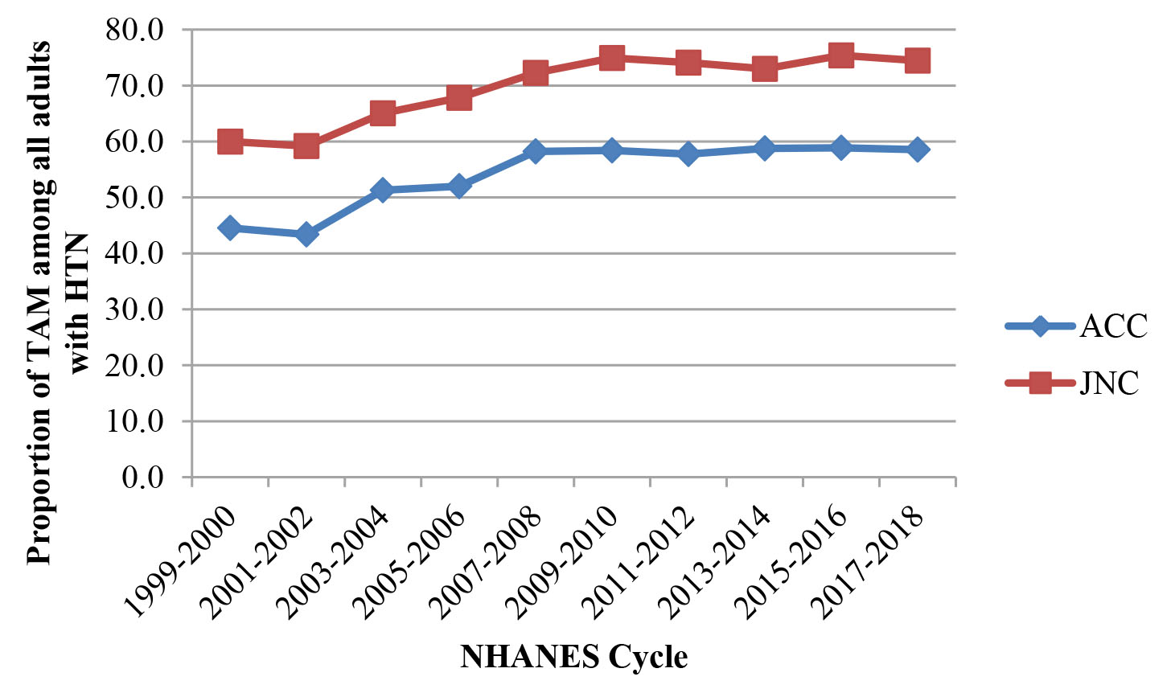

Supplementary Figure 2. Proportion of adults with TAM among all adults with HTN grades according to 2017 ACC/AHA guideline and 2003 JNC guideline.
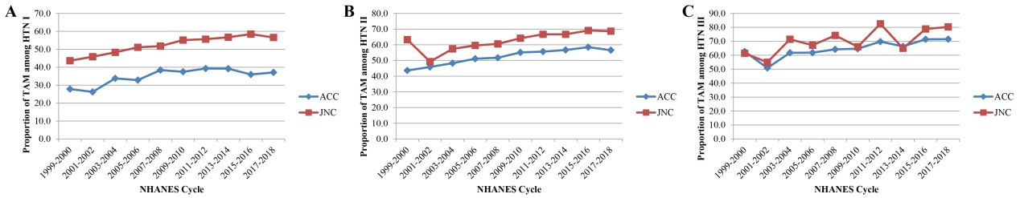

Supplementary Figure 3. Proportion of adults with TAM among all adults with HTN subtypes according to 2017 ACC/AHA guideline and 2003 JNC guideline.
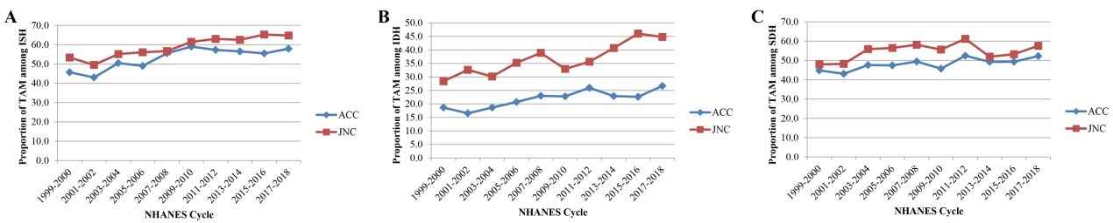

Supplementary Figure 4. Proportion of adults with TAM among all adults with HTN accompanied with other diseases according to 2017 ACC/AHA guideline and 2003 JNC guideline.
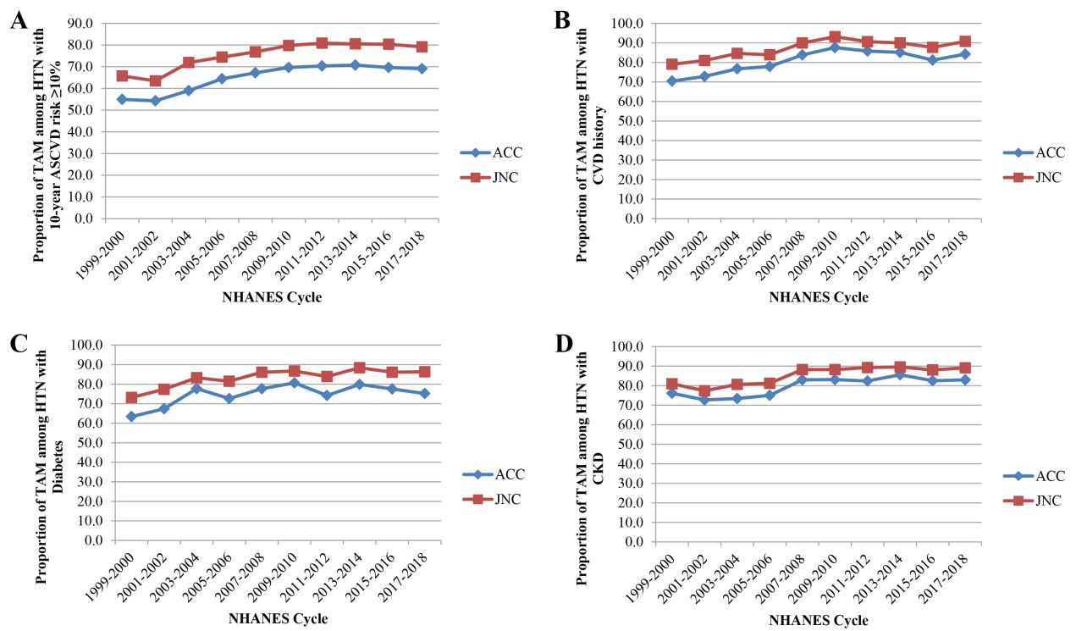

Supplementary Figure 5. Proportion of controlled BP among HTN accompanied with 10-year ASCVD risk ≥ 10% and CVD history according to 2017 ACC/AHA guideline and 2003 JNC guideline.
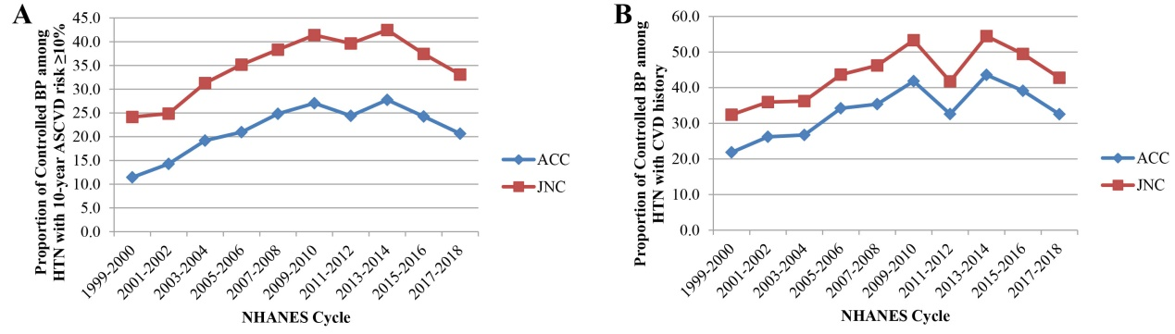

Supplementary Figure 6. Proportion of controlled BP among HTN with ATM according to 2017 ACC/AHA guideline and 2003 JNC guideline.
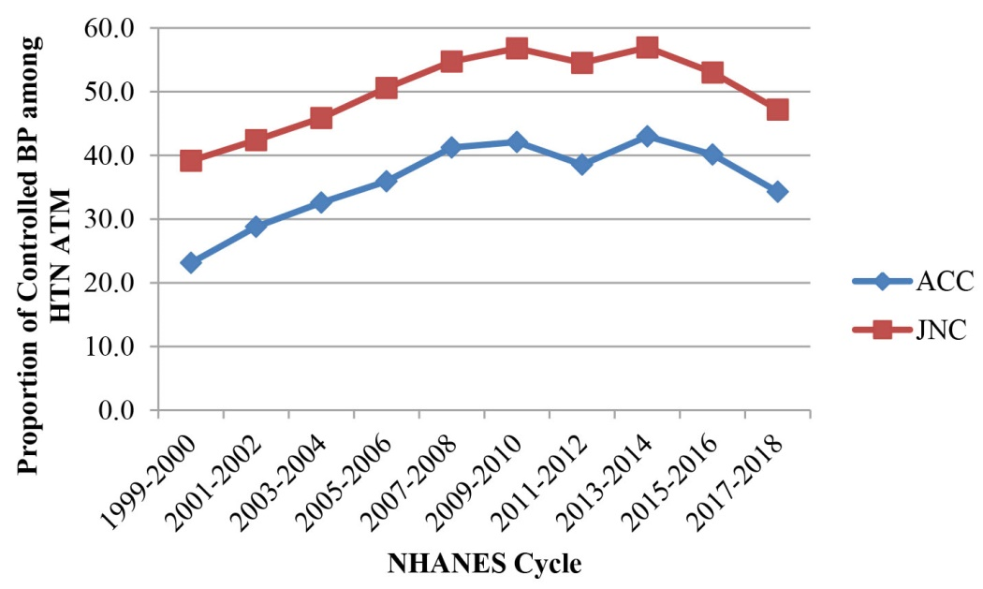

Supplementary Figure 7. Proportion of ATM among HTN with diabetes and CKD according to 2017 ACC/AHA guideline and 2003 JNC guideline.
