Investigation of the release rate of biocide and corrosion resistance of vinyl-, acrylic-, and epoxy-based antifouling paints on steel in marine infrastructures
Adel Jalaieª, Abdolah Afshaar^{a*}, Seyed Borhan Mousavi^{b**}, Mohammad Heidari^{c}
ª Department of Materials Science and Engineering, Sharif University of Technology, Tehran, Iran
^{b} Department of Materials Science and Engineering, Texas A&M University, College Station, TX 77843, USA
^{c} Faculty of Chemical & Petroleum Engineering, University of Tabriz, Tabriz, Iran
*Corresponding 1 email: afshaar@sharif.edu
**Corresponding 2 emails:seyedborhanm@gmail.com, borhanm@tamu.edu

Table S1 Chemical composition of St-37 steel.
Element | Mn | P | S | C | Fe
Percent (wt%) | 0.6 | 0.03 | 0.02 | 0.17 | 0.18
Table S2 Composition of Cu₂O and ZnO biocide paints at different contents and the role of used additives.
Material | Role | wt%
Resin (binder) | Film-forming component of paint | 10, 20, 30, 40, 50, 60, and 70$±$0.1
Cu₂O particles | Biocide activity | 0, 7, 14, 20, 27, 33, and 40$±$0.1
ZnO particles | Biocide activity | 0, 3, 6, 10, 13, 17, and 20$±$0.1
Titanium dioxide (pigment) | Providing the color of the paint | 5$±$0.1
Iron (III) oxide red (pigment) | Providing the color of the paint | 5$±$0.1
Dioctyl phthalate | Providing better pigment dispersion | 5$±$0.1
Talc | Providing the color of the paint | 5$±$0.1
Efka FA 4644 | Dispersing agent | 2$±$0.1
BYK310 | Providing uniform dispersion | 2$±$0.1
Table S3 Specification of artificial seawater.
Material | Concentration (gr/liter)
NaCl | 24.53
MgCl₂.6H₂O | 5.20
Na₂SO₄ | 4.09
CaCl₂ | 1.16
KCl | 0.695
NaHCO₃ | 0.201
H₃BO₃ | 0.207
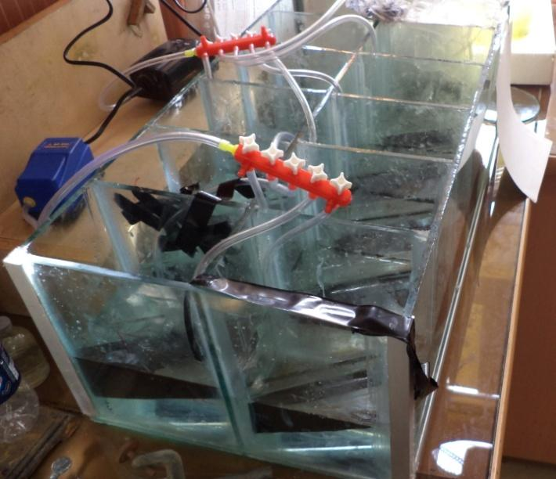
Fig. S1. Real photo of the designed laboratory system.
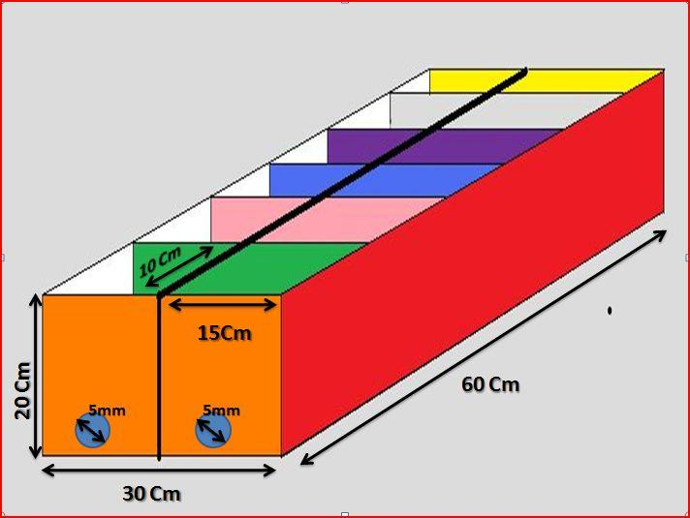
Fig. S2. Schematic of the designed laboratory system.
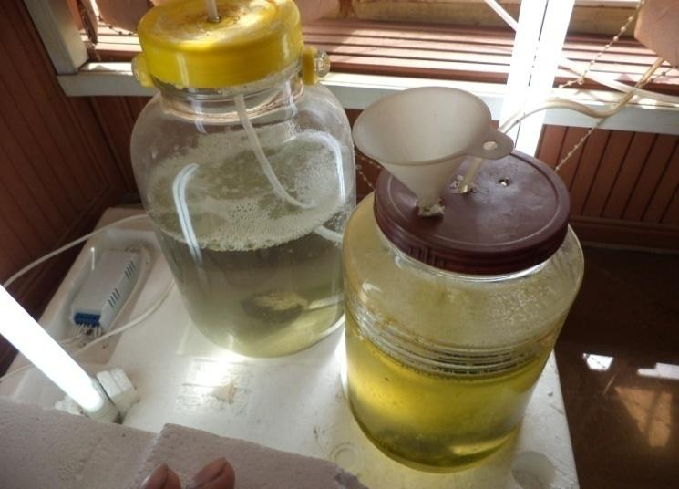
Fig. S3. Real photo of built setup for algae growth.
Table S4 Chemical composition of used water in the algae growth environment.
Material | Concentration (gr/dm³)
K₂HPO₄ | 2
KH₂PO₄ | 3.4
MgSO₄.7H₂O | 2
NaNO₃ | 0.6
CaCl₂.2H₂O | 0.6
NaCl | 0.5
KOH | 3
FeSO₄.7H₂O | 0.5
H₂SO₄ | 0.184
H₃BO₃ | 1
ZnSO₄.7H₂O | 0.3
MnCl₂.4H₂O | 0.05
CuSO₄.5H₂O | 0.06
Co(NO₃)₂.6H₂O | 0.02
Na₂MoO₄.2H₂O | 0.04
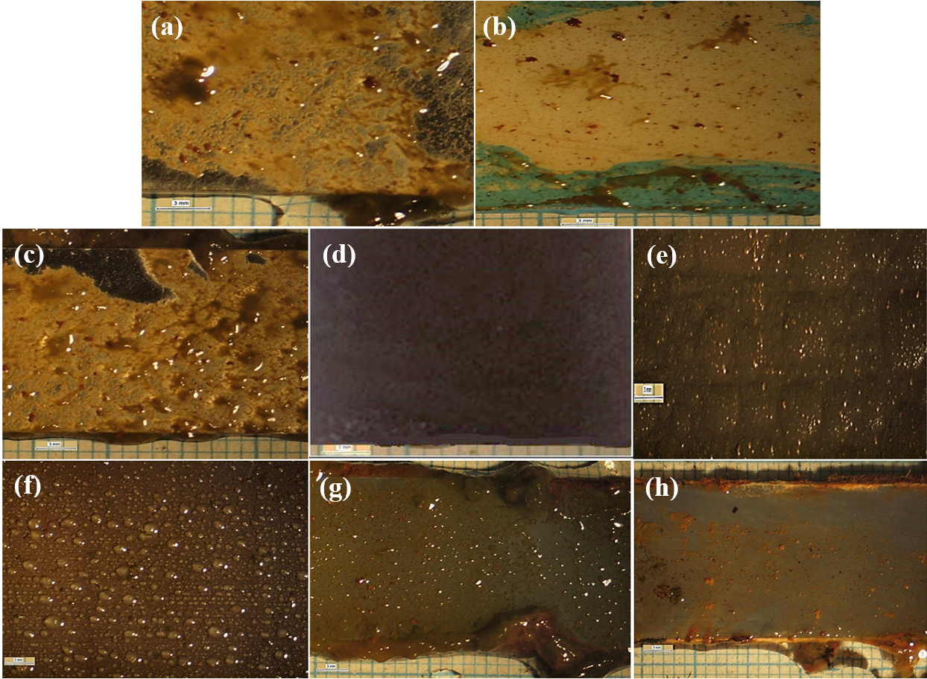
Fig. S4. Real photos after 3 months of sample (a) without antifouling coating, (b) with substrate and without antifouling coating, (c) 20 wt% epoxy-based antifouling coating, (d) 60 wt% epoxy-based antifouling coating, (e) 10 wt% acrylic-based antifouling coating, (f) 30 wt% acrylic-based antifouling coating, (g) 20 wt% vinyl/rosin-based antifouling coating, (h) 50 wt% vinyl/rosin-based antifouling coating.
Table S5 The pencil hardness and König pendulum hardness results of prepared antifouling paints.
Resin | Total biocide content (wt%) | Pencil  Hardness degree | König pendulum  Oscillation time (s)
Acrylic | 10 | B | 65
Acrylic | 30 | H | 67
Acrylic | 40 | 3H | 70
Epoxy | 20 | 5H | 91
Epoxy | 40 | 5H | 127
Epoxy | 60 | 6H | 165
Vinyl/rosin | 20 | 4H | 78
Vinyl/rosin | 40 | 4H | 109
Vinyl/rosin | 50 | B | 65

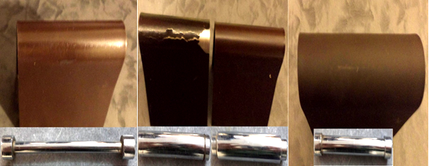
(a) (b) (c)
Fig. S5. Photos of (a) acrylic resin, (b) epoxy resin, (c) vinyl/rosin resin after bending test.
Table S6 Obtained dolly separation force at diverse biocides content of acrylic, epoxy, and vinyl/rosin resins.
Resin | Total biocide content (wt%) | Pin (dolly) separation force (MPa)
Acrylic | 30 | 12/4
Acrylic | 40 | 61/4
Epoxy | 40 | 58/9
Epoxy | 60 | 41/8
Vinyl/rosin | 40 | 61/6
Vinyl/rosin | 50 | 17/7
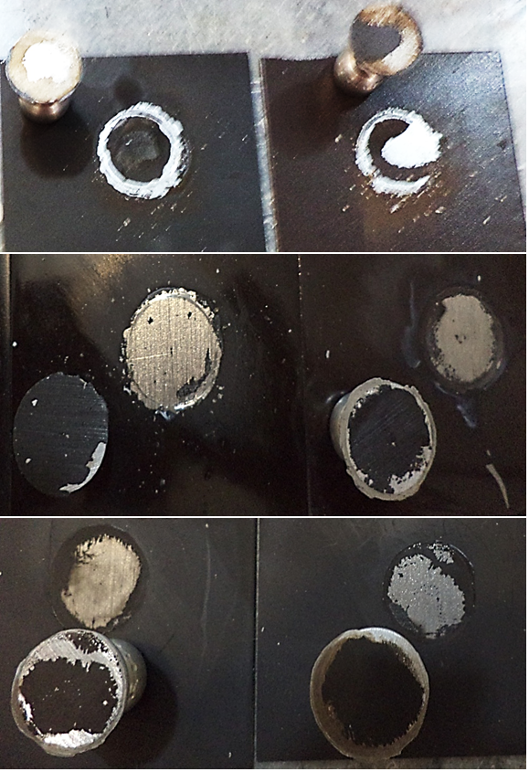
(a) (b)

(c) (d)

(e) (g)
Fig. S6. Photos of (a) 30 wt% acrylic-based antifouling coating, (b) 40 wt% acrylic-based antifouling coating, (c) 40 wt% epoxy-based antifouling coating, (d) 60 wt% epoxy-based antifouling coating, (e) 40 wt% vinyl/rosin-based antifouling coating, (g) 50 wt% vinyl/rosin-based antifouling coating after pull-off test.
Table S7 Gloss test results at diverse biocides content of acrylic, epoxy, and vinyl/rosin resins.
Resin | Total biocide content (wt%) | Lux
Acrylic | 30 | 26
Acrylic | 40 | 20
Epoxy | 40 | 42
Epoxy | 60 | 40
Vinyl/rosin | 40 | 45
Vinyl/rosin | 50 | 38
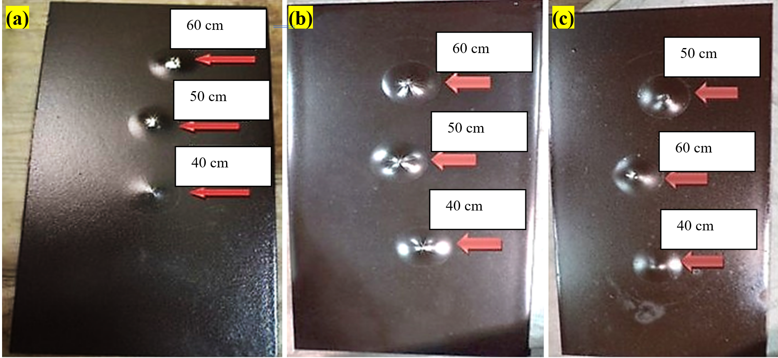
Fig. S7. Photos of (a) acrylic-based antifouling coating, (b) epoxy-based antifouling coating, (c) vinyl/rosin-based antifouling coating after impact resistance test from different heights.
Table S8 Mass loss of the samples after abrasion resistance test.
Resin | Total biocide content (wt%) | Initial weight (g) | Final weight (g) | Mass loss (g)
Acrylic | 30 | 62.847 | 62.83 | 0.017
Epoxy | 60 | 64.196 | 64.18 | 0.016
Vinyl/rosin | 50 | 63.301 | 63.30 | 0.001
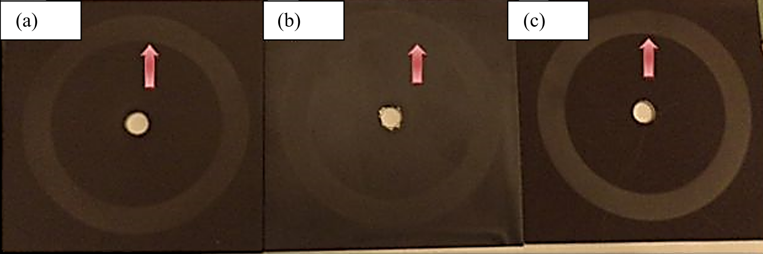
Fig. S8. Photos of (a) acrylic-based antifouling coating, (b) epoxy-based antifouling coating, (c) vinyl/rosin-based antifouling coating after abrasion resistance test.

Table S9 Required force for the scratch resistance of the prepared paints.
Resin | Total biocide content (wt%) | Applied weight (g) | Photo of formed scratch
Acrylic | 30 | 1500 | 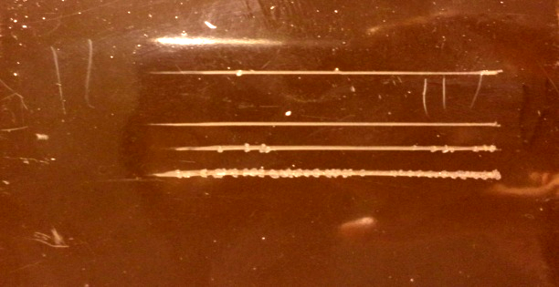
Epoxy | 60 | 3000 | No scratch
Vinyl/rosin | 50 | 2000 | 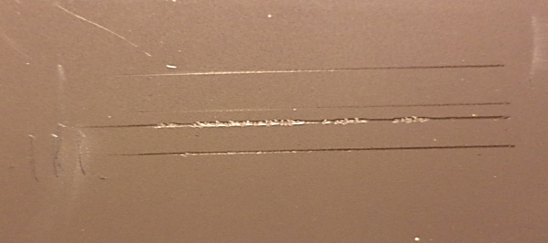
Table S10 Obtained data from the polarization curve of antifouling paints and primer coating.
Resin | E_{corr} (V) | I_{corr}$×{10}^{-6}$ ($\frac{A}{{cm}^{2}}$) | Corrosion rate ($\frac{mm}{year}$)
Primer coating | $-$0.83 | 79 | 3.61
Acrylic 30 wt% | $-$0.39 | 3.2 | 0.128
Epoxy 60 wt% | $-$0.27 | 0.082 | 0.013
Vinyl/rosin 50 wt% | $-$0.58 | 0.47 | 0.0188
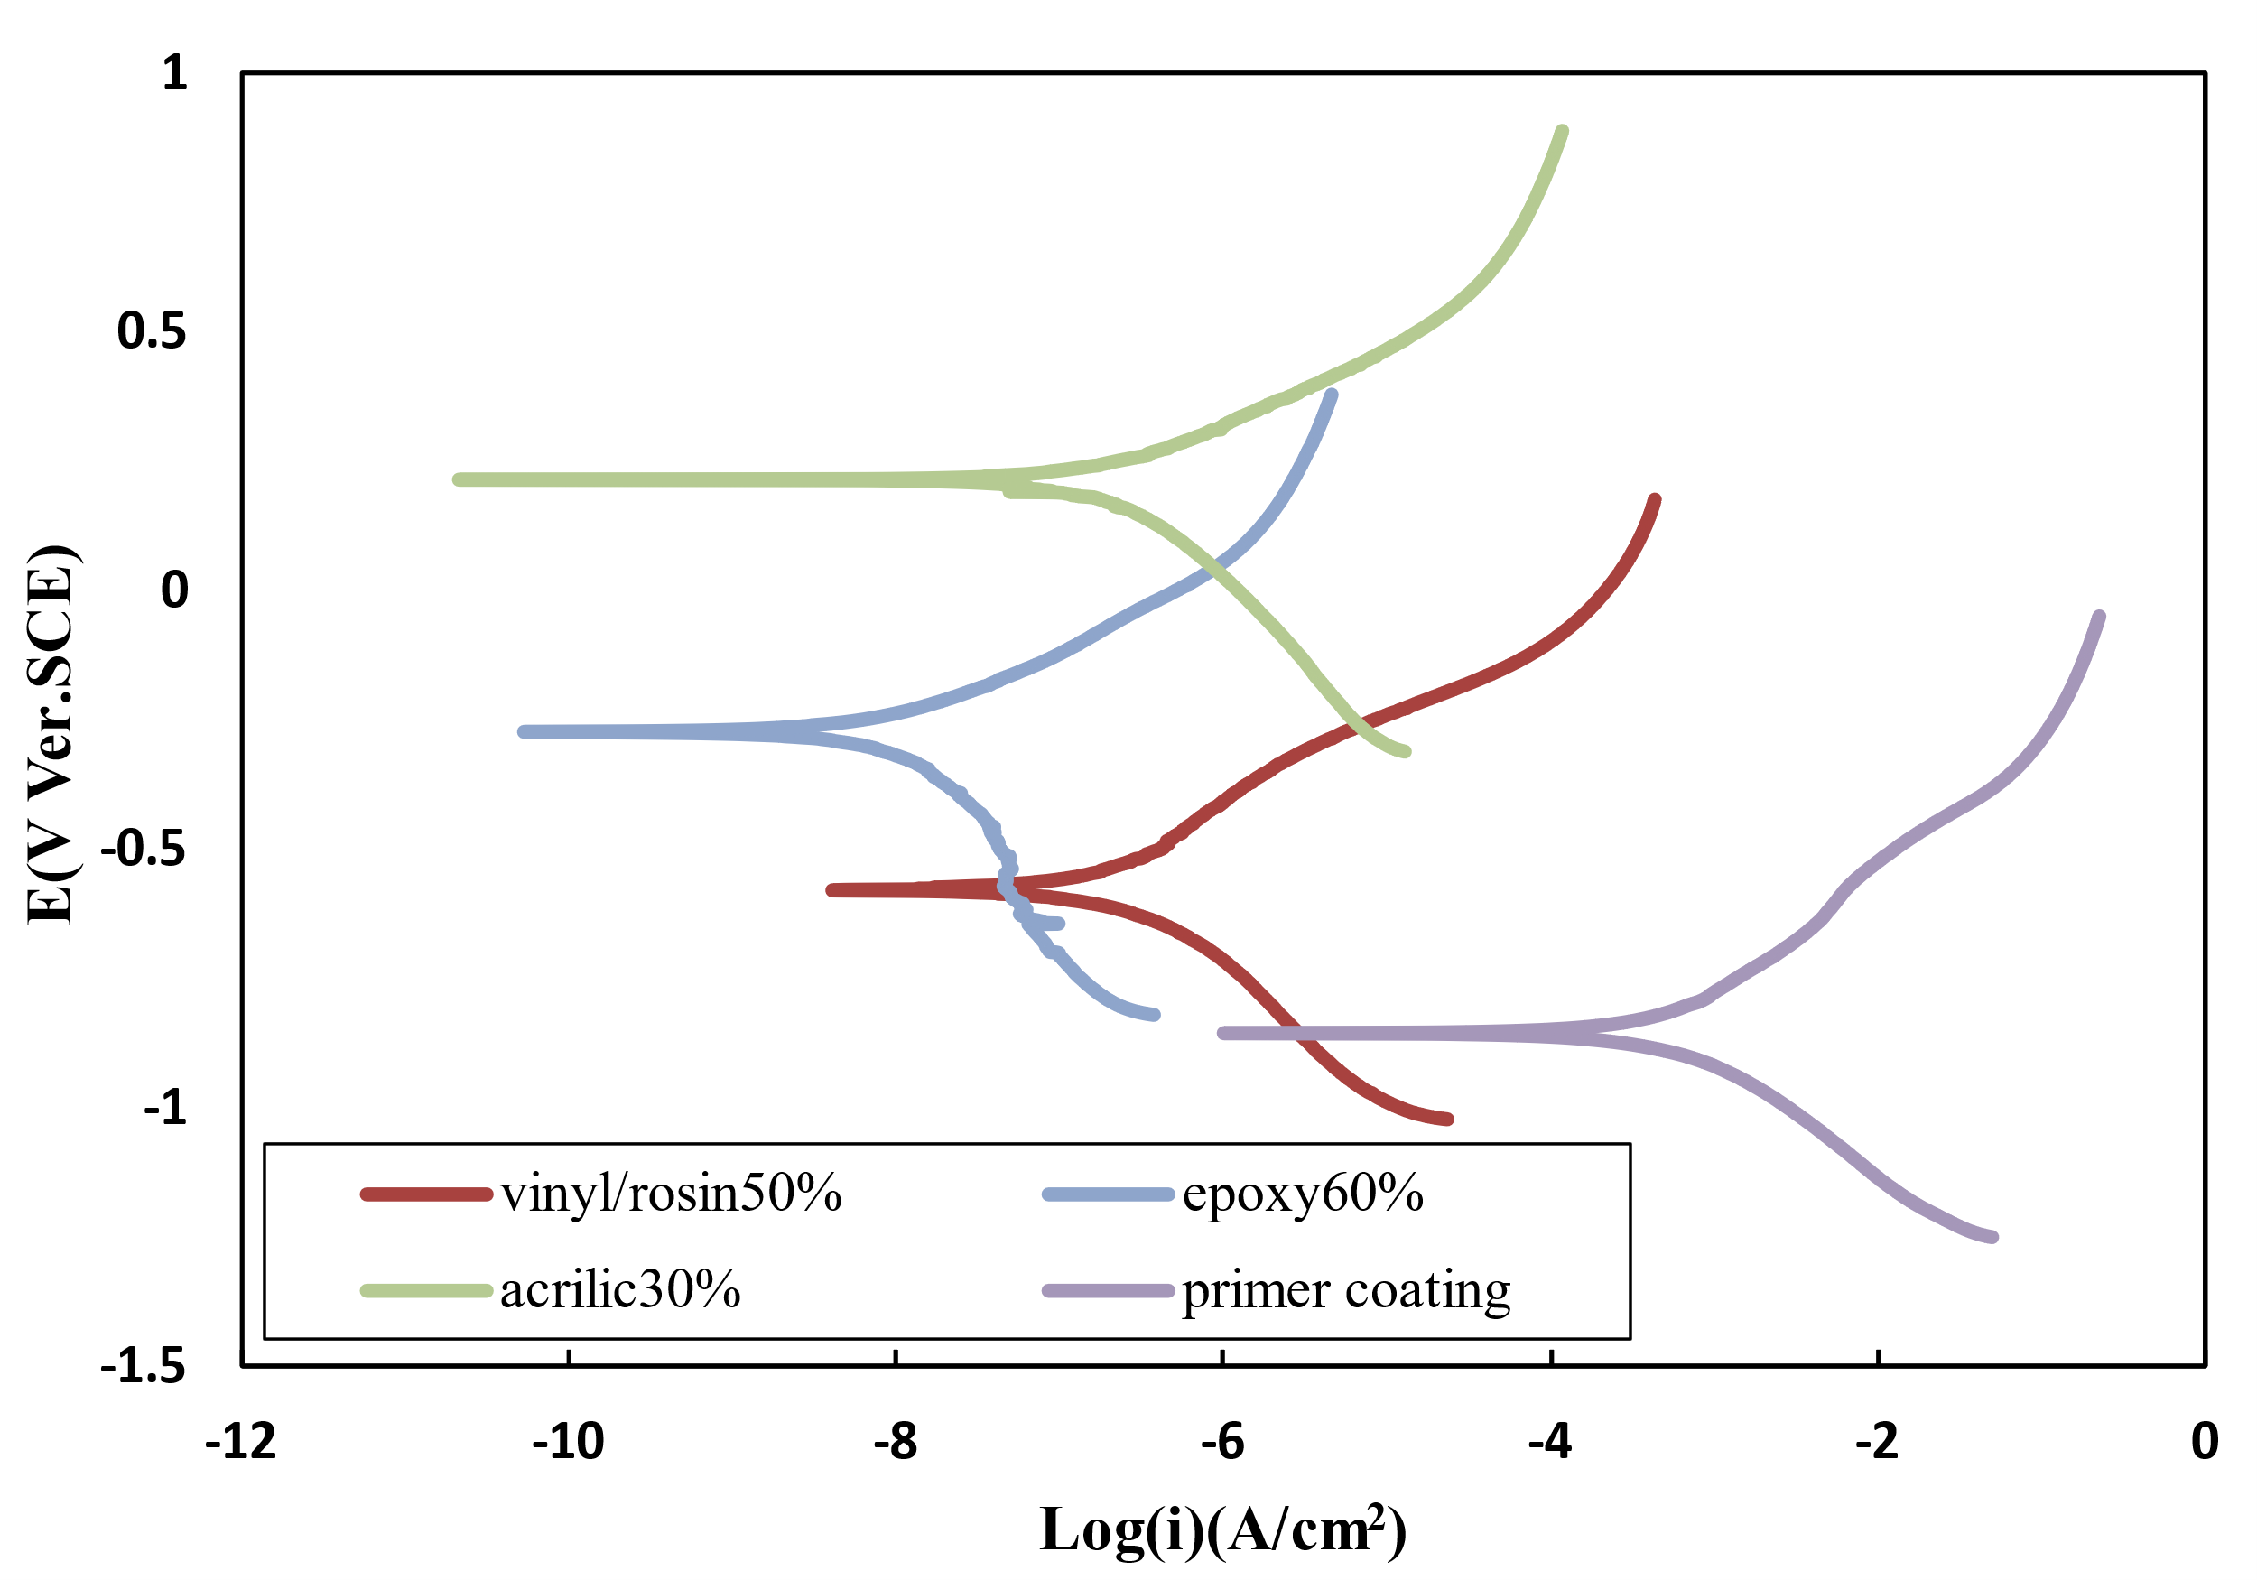
Fig. S9. Polarization curves of antifouling paints at different contents of polyaniline in 3.5% NaCl solution.

Table S11 Obtained data from the polarization curve of antifouling paints containing polyaniline.
Polyaniline concentration (wt%) | E_{corr} (V) | I_{corr}$×{10}^{-6}$ ($\frac{A}{{cm}^{2}}$) | Corrosion rate ($\frac{mm}{year}$)
0 | $-$0.73 | 6.3 | 0.24
10 | 0.11 | 0.0093 | 0.00035
15 | 0.23 | 0.37 | 0.0148
20 | 0.47 | 8.7 | 0.348
30 | $-$0.07 | 3.1 | 0.11
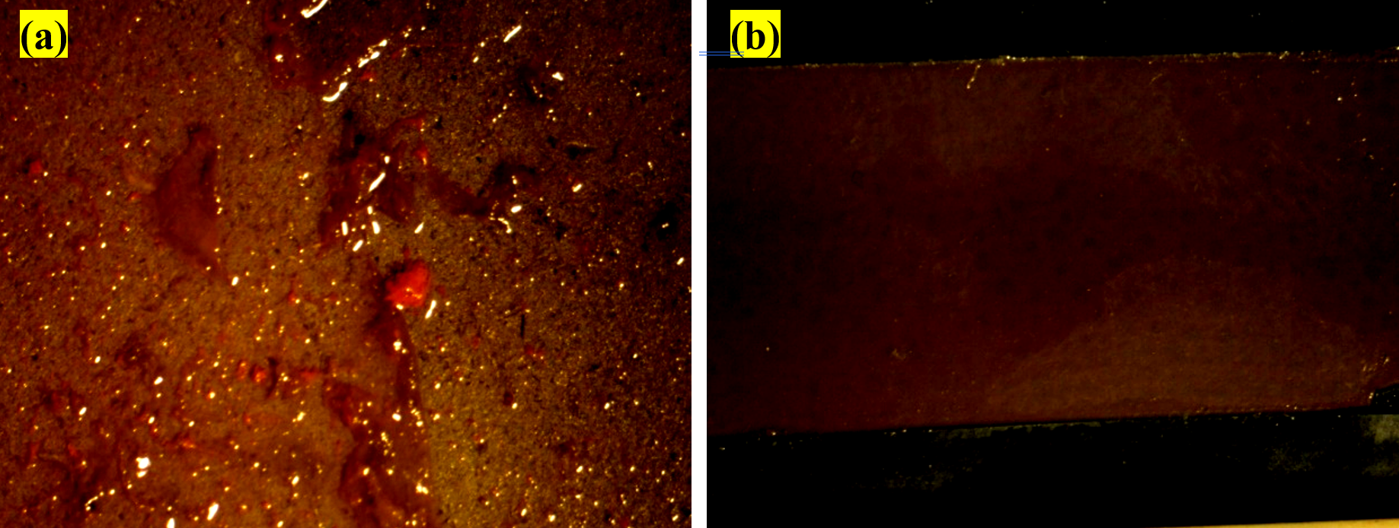
Fig. S10. Photos of sample (a) without polyaniline, (b) containing 10 wt% polyaniline after 3 months.

