Upregulation of HOXA3 by Isoform-Specific Wilms Tumor 1 Drives Chemotherapy Resistance in Acute Myeloid Leukemia
Reid Chen^{1#}, Basil Allen^{1#}, Peter Ryabinin^{2#}, Dan Bottomly^{2#}, Lindsey Savoy^{1#}, Bonnie Goff¹, Anthony Wang¹, Shannon K McWheeny², Haijiao Zhang¹*

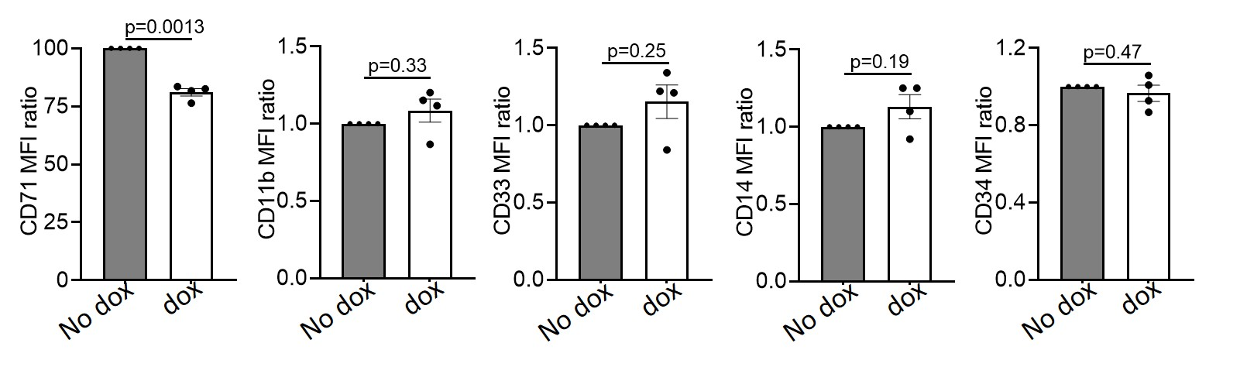
Supplementary Figure 1. The graphs represent the normalized MFI ratio (Dox/no dox) of AML cell lines that overexpress the inducible sWT11+/- vector. Statistical analyses were determined by paired two-tailed t tests.

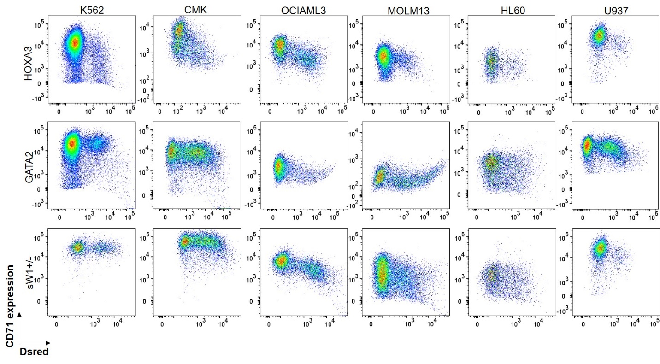Supplementary Figure 2. Representative flow cytometry plot depicting CD71 expression in K562, CMK, OCIAML3, MOLM13, HL60, and U937 cell lines expressing HOXA3, GATA2, or sWT1+/-, and an empty vector (DsRed+).
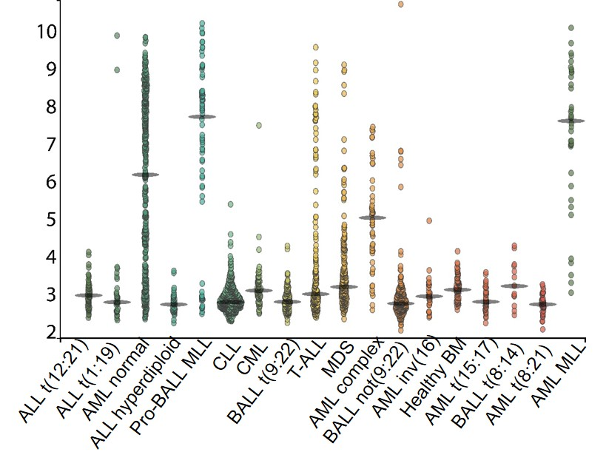
Supplementary Figure 3. The graphs depict HOXA3 expression (MED) in different hematological malignancies modified from Bloodspot Leukemia MILE Study.

