Abstract
The interior biomes of North America are generally projected to experience rapid climatic change, especially with respect to drought indicators like potential evapotranspiration (PET). Focusing on the lake-rich and topographically varied North American boreal biome, we compared gradient-based climate velocity metrics for PET derived from the statistically downscaled ClimateNA product with dynamically downscaled metrics based on the Canadian regional climate model (CRCM5), which includes a 1-D freshwater lake model. We also developed regression tree models to examine the effects of land cover, topography, and geography on these differences. Across a range of global climate models (GCM), we found consistent, large differences in PET velocity–over 100 km/yr in some areas– between CRCM5 and ClimateNA. Within the boreal biome, we found that differences in the spatial gradient of change (mm/km), and hence in the gradient velocity metric (temporal gradient/spatial gradient) of annual PET, were largely explained by the percentage of lake coverage, especially at a broad scale (110-km × 110-km). Elevation effects were not detected. We found that the simple gradient velocity metric was remarkably robust to differences among GCMs in future PET projections, due to the high relative importance of spatial variation in temperature (i.e., spatial gradient), which often exceeded the magnitude of projected future change (i.e., temporal gradient). An important implication of our analysis is that regions surrounding large lakes are likely to be somewhat buffered from the full effects of climate change, serving as potential refugia for boreal ecosystems at a broad spatial scale.

Keywords
Regional climate model, statistical downscaling, dynamical downscaling, climate velocity, boreal lakes

1. Introduction
Future climate projections from general circulation models, AKA global climate models (GCMs), have been used to generate a wide range of climate exposure metrics (e.g., Ordonez et al. 2014, Hamann et al. 2015, Dobrowski and Parks 2016, Carroll et al. 2017), which may be used to assess climate-change vulnerability of species and ecosystems. For these metrics to be relevant for climate-change adaptation over a broad range of geographies, most have used statistically downscaled GCM projections, several gridded versions of which are available at a 1-km resolution (e.g., ClimateNA/SA/EU, CHELSA, WorldClim). Statistical downscaling methods capture important terrain-based variation in climate, but generally assume constant or spatially smoothed rates of change within a given GCM cell (with horizontal dimensions in the range of 1-5 degrees). Furthermore, statistically downscaled projections are constrained by gross simplifications in the GCM’s parameterization of land cover and land use, as well as smoothed orography computed at the GCM’s spatial resolution. Thus, more computationally intensive dynamical downscaling, in the form of regional climate models (RCMs), may generate more accurate local projections, especially in regions where non-linear shifts in climate processes are expected.

Climate models’ physical equations are resolved at the scale of the model. Thus, RCMs allow for the incorporation of land-cover inputs at a finer scale and permit greater heterogeneity in climatic processes compared to GCMs. RCMs that include a lake model such as that of Hostetler (1993) or the FLake model of Mironov et al. (2010), can also account for the moderating effect of large water bodies on local and regional temperature changes, due to the high heat capacity of water (i.e., cooling in summer and warming in winter). This is especially important for interior regions of northern North America that contain large lakes formed by melting glaciers of the late Pleistocene-early Holocene glaciation. Approximately half of the GCMs in the Coupled Model Intercomparison Project 5 (CMIP5, Taylor et al. 2012) ensemble incorporate dynamic lake simulations for the Laurentian Great Lakes (Lakes Superior, Michigan, Ontario, Erie, and Huron), but only four do so at a resolution of 1° or less (Briley et al. 2021). Presumably, other larger northern lakes are captured in a simplistic manner by higher-resolution GCMs, but details are not always clearly reported (Briley et al. 2021). These northern lakes include Great Slave Lake in the Canadian Northwest Territories (traditionally known as Tıdeè, Tinde’e, Tu Nedhé, or Tucho by First Nations in the region), which is the deepest lake in North America (614 m), and at 27,200 km², its surface area exceeds those of Lakes Erie and Ontario. Other large boreal lakes include Great Bear Lake (31,153 km² surface area, 446 m maximum depth), Lake Athabasca (7,850 km², 124 m maximum depth), and Lake Winnipeg (24,514 km² surface area, 36 m maximum depth). Aside from these major lakes, Canada’s boreal forest has been estimated to contain ~1.5 million lakes greater than 0.4 km² (State of Canada's Forests 2004–2005).

Given the large volumes of water they contain, boreal lakes can have significant effects on local air temperatures and on regional water and energy balances (Sellers et al. 1997, Irambona et al. 2016). Generally speaking, lakes buffer temperatures by absorbing and storing heat during summer, and releasing stored heat in the winter, resulting in seasonal inversions and milder surrounding climates (Warren and Vermette 2022). Thermal buffering is aided by the differential heating of land and water, which drives daytime onshore lake breezes that move air from cooler lakes toward warmer land (reversing at night to move air from cooler land toward warmer water). A wide range of climatic and physical factors can affect the magnitude of lake effects. For example, cooling effects can be enhanced near deep lakes, where cold water upwelling can enhance cooling onshore breezes in the opposite direction of prevailing winds (e.g., western shore of Lake Michigan) (Plattner et al. 2006). Around portions of the Laurentian Great Lakes, cooler summer temperatures are apparent in the flora, which include several disjunct populations of arctic species along the north shores of Lake Superior (Soper and Maycock 1963) and boreal forest on the western shore of Lake Michigan (Frelich 2002). As these lakes are often ignored by present-day GCMs, we infer that future climate-change projections and derived climate exposure metrics may overestimate the relative vulnerability of lake-rich portions of the boreal forest region. The extent to which temperature buffering influences would be limited to large and/or deep lakes is unclear.

Another factor that may not be well captured by GCMs in mountain regions is the amplification of warming patterns at high elevations due to a combination of decreases in snow-albedo effects and increases in atmospheric water vapor (Rangwala et al. 2010) and cloud formation (Ceppi and Nowack 2021). Although patterns vary regionally (Pepin et al. 2022), there is evidence of elevation-dependent amplification of warming trends in the observed temperature record (Wang et al. 2016a). However, the coarse resolution of GCMs smooths out influences of topography and snow cover, limiting their ability to accurately reflect climate-change patterns in mountain regions (Giorgi and Mearns 1991, Beniston 1994). As such, the climate-change vulnerability of high elevation regions may be underestimated in GCM outputs.

To evaluate and quantify the validity of these assertions, we compared metrics of climate velocity (Loarie et al. 2009) between statistically and dynamically downscaled GCMs. Climate velocity, which is measured in distance per unit time (generally km/yr) is defined as “the instantaneous local velocity along Earth’s surface needed to maintain constant temperatures” in response to a warming climate (Loarie et al. 2009). Spatial representations of climate velocity have been used to generate maps of climate-change vulnerability (e.g., Burrows et al. 2011) and, conversely, areas of high climate-change resistance potential at continental scales (i.e., macrorefugia) (e.g., Carroll et al. 2017, Stralberg et al. 2020).

Climate velocity can be calculated for multivariate climate types using a nearest-analog method (Hamann et al. 2015) or for a single variable using the gradient method (Loarie et al. 2009). Each approach has its strengths, but we chose to use the simpler gradient method for ease of interpretation, and because partitioning the index into two components (spatial and temporal gradients) provides additional insights. We chose annual potential evapotranspiration (PET; mm) as the climate variable of interest since it is an integrative metric of annual evaporative demand that represents the temperature side of the water balance equation (precipitation - potential evapotranspiration). We also focused on PET because it is a key indicator of drought affecting boreal forest ecosystems—both in terms of direct influences on tree growth (Chen and Luo 2015, Hogg et al. 2017) and mortality (Peng et al. 2011, Michaelian et al. 2010), and indirect impacts of increased wildfire and insect outbreaks (Boucher et al. 2018). Although precipitation is an equally influential determinant of climatic moisture availability, models suggest that future precipitation increases in boreal regions will often be insufficient to compensate for increased evaporative demand, especially in more arid western regions of the boreal forests (Hogg and Hurdle 1995, Price et al. 2013). Thus, PET is a more meaningful drought indicator than precipitation in a climate-change context, especially in cold northern regions, where drought is driven largely by daytime temperatures in the warmest summer months.

The objective of this study was to calculate climate velocity and its components (spatial and temporal gradients) from dynamically downscaled RCM projections, represented by the Canadian Regional Climate Model, v.5 (CRCM5, Martynov et al. 2012), and compare them with equivalent calculations based on statistically downscaled GCMs, represented here by the Climate NA product (Wang et al. 2016b). We computed velocity metrics across North America, but focused our analysis on the boreal biome, given the presumed importance of both lakeshores and high-elevation mountain regions as refugia from climate change in that region (Stralberg et al. 2020).

Our specific objectives were to:
- Evaluate the degree to which the CRCM5 captures contemporary climate patterns in the boreal region of North America;
- Compare spatial patterns of climate velocity and its components (spatial and temporal gradients) based on statistically (ClimateNA) vs. dynamically (CRCM5) downscaled climate projections and multiple GCMs; and
- Identify the most influential physiographic drivers of differences between statistically and dynamically downscaled climate projections, and in particular evaluate the importance of lake coverage and elevation.

2. Methods
2.1. Study Area
Although the extent of the North American Coordinated Regional Downscaling Experiment
( (NA-CORDEX, Mearns et al. 2017) experiment covers most of North America, we focused our analysis on the boreal forest biome (Figure 1), due to its high concentration of lakes. The boreal biome was delineated using the Level II Terrestrial Ecoregions mapped by the Commission for Environmental Cooperation (CEC, 2009). Specifically, we included 3.1 Alaska Boreal Interior, 3.2 Taiga Cordillera, 3.3 Taiga Plains, 3.4 Taiga Shield, 4.1 Hudson Plains, 5.1 Softwood Shield, and 6.1 Boreal Cordillera.

2.2. Climate data
2.2.1. MODIS
We retrieved 1 km × 1 km MODIS Terra satellite daytime land surface temperature measurements for July (MOD11A1.006; Wan et al., 2015) using Google Earth Engine (Gorelick et al. 2017). This product records the temperature of the earth’s topmost surface, whether that be tree canopy, water, grass, or concrete. This is unlike gridded climate products, which are based on spatial interpolations of air temperature measurements from weather stations in open conditions. One or more daytime readings may be averaged, and satellite overpass times vary across space and time.

2.2.2. ERA5
Another source of baseline climate data was the ERA5 HRES reanalysis, with a native resolution of 0.25° × 0.25°(~28 km; Hersbach et al, 2018). These data are available hourly and we used mean 12 pm LST air temperatures at 2 m above the earth’s surface (McElhinny et al, 2020). While the ERA5 product has a coarser spatial resolution than ClimateNA, it is considered a more accurate representation of reality as it is created using data assimilation of observations and gridded numerical weather forecasts rather than simple interpolation from weather stations. Rasters are created by combining observations and models, ensuring there are no gaps in coverage (Herbach et al. 2020). The ERA5 product does not include long-range future climate projections.

2.2.3. ClimateNA
ClimateNA (Wang et al. 2016) is a climate data downscaling tool that takes interpolated weather station data from the 1961-1990 normal period as a historical baseline (2.5-degree resolution) and applies bilinear interpolations of annual weather observations (0.5° resolution) and GCM-projected climate anomalies (1° resolution) to generate monthly gridded surfaces using a modified delta method. Empirical lapse rates are used to produce topographically downscaled outputs. The baseline interpolation represents a composite of two approaches: the PRISM weighted regression method (Daly et al. 2008) in the conterminous U.S. and western Canada, and ANUSPLIN (Hutchinson 2000), as represented by the WorldClim product (Hijmans et al. 2005) elsewhere. We used a 1-km version provided by the AdaptWest project (adaptwest.databasin.org).

2.2.4. Canadian Regional Climate Model v5
The CRCM5 is the fifth-generation Canadian RCM (Martynov et al., 2013; Šeparovic et al., 2013) developed by the ESCER Centre at the Université du Québec à Montréal (UQÀM). It is based on the limited-area version of the numerical weather-prediction GEM model of ECCC, version 3.3.3.1. Surface physical parameterizations include the following: the one-dimensional freshwater lake model (FLake; Martynov et al., 2012) and the Canadian Land Surface Scheme, version 3.5 (CLASS3.5; Verseghy 1991, 2009).

CRCM5 projections were computed at 0.22° of resolution on a rotated lat-lon grid. Data were converted to a Lambert conformal conic projection with a 22-km grid cell resolution to calculate distances and compare datasets. We used this map projection as a balance between distance and area considerations.

2.3. Objective 1. Historical summer temperature patterns
To evaluate how well CRCM5 captures historical climate patterns in the boreal region, especially around lakes and at high elevations, we first compared CRCM5-simulated July daytime mean temperatures with three different representations of observed temperature patterns: remotely sensed land surface temperatures from the MODIS satellite (Wan et al. 2015), numerical weather forecasts assimilated with historical weather data from the ERA5 reanalysis product (Hersbach et al. 2018), and interpolated weather station data from the ClimateNA tool (Wang et al. 2016; Figure 2). Mean temperature was calculated differently for each dataset, depending on available metrics.

For ClimateNA and CRCM5, July daytime mean temperature was calculated as (Tmax + Tmean)/2, where Tmax is the monthly average maximum daily temperature and Tmean is the monthly average daily mean temperature (WMO 2011). For ERA5, 12 pm (local standard time) two-meter temperature was used as a proxy for daytime mean temperature, and for MODIS, all daytime surface temperatures for the month of July (based on the daytime overpass from the Aqua satellite) were used as recorded and averaged.

All four datasets were summarized for the period 1981-2010 except for MODIS, which was only available from 2000 onward, so we used the 2000-2010 time period. All data sources were converted from their native resolution and projected in the same 22-km grid in the Lambert conformal conic projection.

Given that absolute temperature values could not be directly compared, at least not for the MODIS land surface temperature product, we focused on patterns of the spatial temperature gradient. A Pearson correlation statistic was calculated between spatial gradient values from all four combinations of datasets.

2.4. Objective 2. Climate velocity metrics
We compared statistically downscaled GCM outputs from ClimateNA (Wang et al. 2016) with dynamically downscaled simulations from the CRCM5 (Martynov et al. 2012) using a 1981-2010 baseline period. We evaluated two future 30-year time periods (2041-2070 and 2071-2100) and two representative concentration pathways (RCP 4.5 and RCP 8.5). We selected GCM projections from the Coupled Model Intercomparison Project 5 (CMIP5, Taylor et al. 2012) that had been used as inputs for ClimateNA and driving data for CRCM5: CanESM2 (Arora et al. 2011), MPI-ESM-LR (Giorgetta et al. 2013), and CNRM-CM5 (Voldoire et al. 2012). We evaluated six combinations of GCM and downscaling methods (Table 1). The RCM simulations used a single (first) GCM member, while the statistical downscaling used an average of up to the first five members (Wang et al 2016). This resulted in slight differences among the datasets, but should not affect our results since the data analysis considers 30-year mean conditions. CMIP5 data were used because the CMIP6 data sets were not readily available, and the datasets had not all been reviewed at the start of this project.

For both statistically and dynamically downscaled data, we calculated an index of potential evapotranspiration (PET) from monthly temperature and precipitation projections using Hogg’s (1997) modified Penman-Monteith approach. We then calculated the temporal gradient, spatial gradient and velocity of PET projections for each downscaling approach, time period, RCP, and GCM.

We used the ‘VoCC’ package (Garcia Molinos et al. 2019) in R v4.2.2 (R Project Core Team 2022) to implement the gradient velocity method proposed by Loarie et al. (2009) and modified by Burrows et al. (2011). According to this gradient-based approach, climate-change velocity (km/yr) is defined as the temporal gradient, TG (climate units/yr) divided by the spatial gradient SG (climate units/km). This allowed us to compare the different components of climate-change velocity.

We calculated the temporal gradient at the pixel level by dividing the downscaled GCM anomalies––the average model-simulated change between the baseline period (1981-2010) and a given future period (2041-2070 or 2071-2100)––by the number of years according to the midpoints (i.e., 2055 - 1995 = 60 yrs; 2085 - 1995 = 90 yrs). We used the ‘spatGrad’ function to calculate the spatial gradient at the pixel level as the vector sum of pairwise gradients within a 3 × 3 cell neighborhood (Garcia Molinos et al. 2019). For this, we used the mean predicted PET of the baseline period rather than the future projection, as both had very similar patterns. The minimum value of SG was set at 0.03mm/km.

2.5. Objective 3. Regression tree analysis
To compare the differences between ClimateNA and CRCM5 projections, we calculated the difference between the two datasets for each metric, i.e., temporal gradient, spatial gradient and velocity of PET. We then constructed regression trees to identify the most explanatory variables and visualize the hierarchy of their importance. Only grid cells (22-km resolution) containing more than 50% land were included in the model, as we were only interested in climate changes over land and did not want to inflate spatial gradient values by considering areas predominantly covered by water.

Regression trees were constructed using the ‘rpart’ package for R (Therneau et al. 2022) with the dependent variables consisting of the differences between dynamically downscaled (CRCM5) and statistically downscaled (ClimateNA) versions of the three PET metrics (spatial gradient, temporal gradient, and velocity) for three GCM drivers (CanESM2, MPI-ESM-LR, and CNRM-CM5). To highlight more salient effects, regression trees were pruned to three levels. Independent variables were based on the inputs that were used to run the CRCM5 model (Table 2). Given that the variables were direct inputs to CRCM5, our intent was not to test for correlations but rather to describe their relative importances.

In addition to the raw inputs, we calculated derived landscape metrics that we hypothesized would better represent the scale of lake model influences. First we combined lake depth and lake fraction (of total grid cell area) into a more informative lake volume (km³/cell) variable, calculated as follows:

(1) $LakeVolume(km3)=LakeFraction*LakeDepth(km)*22 km*22 km$,

where LakeFraction is the fraction of each cell that is covered by lakes, and LakeDepth is the average depth of all lakes in the 22 km-resolution cell. However, given a paucity of lake depth data across the region, most lake depth values were set to a default of 10 m for the RCM simulations.

To determine if lake depth or lake volume influenced areas larger than a cell, we used the R function ‘focal’ from the ‘raster’ package (Hijmans et al. 2022) to determine 3 × 3 and 5 × 5 cell neighbourhood means for each 22-km cell (prior to masking out cells with > 50% water). Cell neighbourhoods of 3 × 3 and 5 × 5 cells were also used to calculate the elevation range (maximum elevation - minimum elevation) within each cell. Finally, to visualize the importance of key variables geographically, we used the regression tree models to develop simple spatial predictions of the velocity metrics.

3. Results

3.1. Objective 1. Historical summer temperature patterns
The CRCM5 simulation, ERA5 reanalysis data, and MODIS land surface map showed steeper spatial gradients of summer temperature around lakes than the ClimateNA interpolation of weather station data (Figure 1). The MODIS land surface temperature was much more heterogeneous than the other data sources, likely due to differences in the surface where temperature is recorded (e.g.,vegetation vs. exposed ground vs. built structures vs. water) and because it represents actual recorded temperatures rather than modelled or interpolated like the other data sources. This made further comparisons with MODIS less relevant.

For each of the datasets, the highest pairwise correlation was with ERA5 (Table 3). Of all possible combinations of datasets, the CRCM5 simulation and ERA5 had the highest Pearson correlation at 0.761 (Table 3). Since ERA5 is considered to be among the best-possible representations of historical climate (Herbach et al. 2020), the high correlation with CRCM5 can be interpreted as an indication that CRCM5 will successfully reproduce climate patterns into the future–arguably more so than patterns based on statistical downscaling.

Table 3: Pearson correlations of historical spatial gradient (°C/km within a 3 × 3 cell neighbourhood) on a 22-km grid based on July surface temperature metrics from four historical sources: (a) ClimateNA (mean 1981-2010) resampled from native 1-km grid, (b) Canadian Regional Climate Model v. 5 (CRCM5; mean 1981-2010), (c) ERA5 (mean 1981-2010; Hersbach et al, 2018, McElhinny et al, 2020) resampled from native 0.25° × 0.25° grid, and (d) MODIS Terra Land Surface Temperature (mean 2000-2021; Wan et al., 2015) resampled from native 1-km grid.

 | ClimateNA | CRCM5 | ERA5 | MODIS
ClimateNA | 1 | 0.649 | 0.734 | 0.419
CRCM5 | 0.649 | 1 | 0.761 | 0.404
ERA5 | 0.734 | 0.761 | 1 | 0.475
MODIS | 0.419 | 0.404 | 0.475 | 1

3.2. Objective 2. Climate velocity metrics
Patterns were generally similar across GCMs for temporal gradient, spatial gradient, and climate velocity metrics based on CRCM5 simulations for the 2071-2100 time period under RCP 8.5 (Figures 2, S1, S2). The temporal gradient of PET (mm/yr) varied the most across GCMs; it decreased with latitude, but was generally steeper for CRCM5_CanESM2 than for the other two GCMs (CRCM5_MPI-ESM-LR and CRCM5_CNRM-CM5) (Figure 2a,d,g). The spatial gradient (mm/km), however, demonstrated very similar patterns across all three input GCMs, with steeper spatial gradients in mountainous areas, and around lakes, and shallower spatial gradients in the flatter interior regions and in the far north (Figure 2b,e,h). Most important to this analysis, the resulting climate velocity (km/yr) patterns, especially around lakes and across elevation gradients, were similar among the three simulations (Figure 2c,f,i). As such, only CRCM5_CanESM2 was used in additional comparisons for simplicity. Other comparisons using CRCM5_MPI-ESM-LR and CRCM5_CNRM-CM5 can be found in the supplementary material, as well as comparisons for RCP 4.5 / 2071-2100 and RCP 8.5 / 2041-2070 (Figures S1-S8).

Comparing the temporal gradient (mm/yr) for CRCM5 with that for ClimateNA, the former exhibited a steeper gradient (faster increase in PET) throughout much of the interior portion of the continent, and a shallower gradient (slower increase in PET) in coastal regions (Figure 4a-c and Figure S3). With respect to the spatial gradient (mm/km), CRCM5_CanESM2 demonstrated gentle gradients in mountain regions, but much steeper gradients around lakes compared to ClimateNA_CanESM2 (Figure 4d-f and Figure S4). Even the southern shores of the Great Lakes, which already showed steeper spatial gradients than the surrounding area based on ClimateNA, exhibited even steeper spatial gradients with CRCM5. When the temporal gradient was divided by the spatial gradient to obtain climate-change velocity (km/yr), the result was generally lower velocity with CRCM5_CanESM2 than with ClimateNA_CanESM2 in the boreal region, especially east of the Western Cordillera (Figure 4g-i and Figure S5). Conversely, CRCM5-based velocity was generally higher than ClimateNA-based velocity in mountain regions, and throughout much of the eastern United States.

3.3. Objective 3. Regression tree analysis
Results from regression tree analyses for the PET temporal gradient (mm/yr) difference between CRCM5 and ClimateNA indicated that model structures differed substantially across GCMs, time periods and RCPs (Figure S6). Longitude, elevation range within a 5 × 5 cell neighborhood, and grassland percent were the top-level predictors of the PET temporal gradient (mm/yr) difference between CRCM5 and ClimateNA. For the PET spatial gradient (mm/km) difference, model structures were much more similar across GCMs, time periods, and RCPs (Figure S7). Lake % (5 × 5 and/or 3 × 3) was a top predictor in all models, along with elevation, longitude, and ice sheet variables. Given the similarity across GCMs, we focused on CanESM2, RCP 8.5, 2071-2100 for further interpretation (Figure 5). Areas with at least 20% lake coverage in a 3 × 3 cell neighbourhood had spatial gradient values for CRCM5 that were higher by 1.4 mm/km on average compared to ClimateNA (Figure 5a). Areas with at least 30% lake coverage in a 5 × 5 cell neighbourhood had spatial gradients that were even steeper on average (by 2.3 mm/km) with CRCM5 than with ClimateNA.

Spatial gradient model results also indicated a clear divide at a longitude of 124° west, which is roughly where the boreal transitions from relatively flat with many lakes in the east (Canada) to more mountainous with few lakes in the west (Yukon and Alaska) (Figure 5a-b). This western area with few lakes had a spatial gradient that was 0.24 mm/km shallower with CRCM5 than with ClimateNA, and in areas with at least 1.3% ice sheet coverage, the spatial gradient was an additional 1.2 mm/km shallower. East of 124° west longitude, lake % within a 5 × 5 cell neighborhood explained further differences in the spatial gradient; areas with at least 11% lake coverage in a 5 × 5 cell neighborhood had values that were 0.52 mm/km higher on average with CRCM5 compared to ClimateNA. These key splits in the tree are readily visualized by predicting the regression tree model spatially (Figure 5c).

Models were also similar across GCMs, time periods, and RCPs for PET velocity (km/yr) (Figure S8). Focusing on CanESM2, RCP 8.5, 2071-2100, the regression tree only retained two splits (Figure 6). Areas with at least 12% lake coverage in a 5 × 5 cell neighbourhood had velocity values that were lower by 5.6 km/yr on average with CRCM5 compared to ClimateNA (Figure 6a,b).Within areas of lower lake coverage, regions below 56° N latitude had velocity values that were on average 2.7 km/yr lower with CRCM5 compared to ClimateNA (Figure 6a,b). These key splits in the tree are readily visualized by predicting the regression tree model spatially (Figure 6c).

4. Discussion
We used velocity metrics derived from the CRCM5 regional climate model and ClimateNA to compare dynamically and statistically downscaled GCM simulations of future climate-change vulnerability. We specifically focused on annual potential evapotranspiration (PET) as an important drought indicator, and on the North American boreal biome, which is experiencing increased drought pressures as a result of warming temperatures (e.g., Peng et al. 2011, Price et al. 2013). Across a range of GCM inputs, we found consistent, large differences in the velocity of PET–exceeding 100 km/yr in some areas–between CRCM5 and ClimateNA. Within the boreal biome, these differences were largely explained by lake percentage. In general, lake-rich regions produced lower PET velocity with dynamical than with statistical downscaling.

We found that the simple gradient velocity metric was remarkably robust to differences among GCMs in future PET projections. This robustness was due to the high relative importance of spatial variation in temperature (i.e., spatial gradient), which often exceeded the magnitude of projected future change (i.e., temporal gradient), even under the extreme climate-change scenario evaluated here (RCP 8.5). With ClimateNA, a gridded climate product that employs statistical downscaling based on modeled lapse rate (Wang et al. 2016b), the spatial gradient of PET and other temperature variables was primarily driven by terrain. In contrast, the dynamical downscaling approach of CRCM5, which includes a 1-D freshwater lake model (Martynov et al. 2012), resulted in similarly significant spatial gradients around lakes. In order to preserve the underlying GCM outputs, the regional climate model also produced less pronounced elevation-based temperature gradients than ClimateNA, resulting in higher velocity within the topographically diverse (but lake-poor) boreal and taiga cordillera ecoregions.

Contrary to our expectations, we found no significant relationship between elevation and the observed differences in either the temporal or spatial gradients of PET. To the extent that projected summer warming is amplified at high elevations (Nogués-Bravo et al. 2007, Wang et al. 2016; but see Rangwala et al. 2013), this effect may have been partially captured in ClimateNA, through statistical downscaling. We did not detect any additional amplification of PET change (temporal gradient) provided by CRCM5. Indeed, observational studies suggest substantial regional differences in elevation-dependent warming (Pepin et al. 2022). Although the North American Rockies are among the mountainous regions that have demonstrated long-term elevation-dependent summer warming, the boreal region also includes high-latitude mountains that appear to diverge from these patterns (Pepin et al. 2022).

We observed the strongest lake influence on climate velocity patterns at the broadest scale considered (a 110-km × 110-km window). When accounting for lake percentage at this scale, the percentage of lake cover within an individual 22-km grid cell did not appear in any regression models. This finding suggests that major lakes, due to their heat storage capacity and cooling influence on summer temperatures (Scott and Huff 1996, Notaro et al. 2013), could reduce PET velocity over large spatial extents. Lake volume did not provide consistent additional explanatory power, possibly due to lack of precision and absence of depth information for all but the largest lakes. Thus, it was not possible to determine whether these cooling effects were driven by the largest lakes or if the combined influence of many smaller lakes would be similar. However, our maps suggested that the largest differences between dynamical and statistical downscaling were found in close proximity to large, continentally important lakes. Notably, cooling effects were apparent not just with natural lakes but also around large reservoirs in eastern Canada (Québec). Indeed, modeling and empirical studies have indicated that lake breezes from small lakes (< ~50 km diameter) are fundamentally different from large-lake or sea breezes due to the limited amount of cool air and lake area available to drive the lake breeze circulation (Crosman and Horel 2012). The inland penetration of small-lake breezes is typically less than the lake diameter (Segal et al. 1997) and less sensitive to land-lake thermal contrasts than large-lake breezes (Crosman and Horel 2012). Documented lake influences on surrounding forest attributes such as tree growth (Tremblay and Bègin 2000, Sun et al. 2021) and seed maturation (Meunier and Sirois 2007) rates have also largely been limited to large lakes and reservoirs.

Although the effects of lakes on nearby land temperatures and regional climates are generally well described around the Laurentian Great Lakes (e.g., Scott and Huff 1996, Notaro et al. 2013), there have been few studies focused on large boreal lakes (Sellers et al. 1997), and many of those were focused on reservoirs (e.g., Meunier and Sirois 2007). Flux studies have identified summer cooling influences of several kilometers (Sun et al. 1997). However, due to the paucity of weather stations in northern Canada, few of which are located near lakes, the summer cooling (and winter warming) effects of boreal lakes are generally not captured by gridded climate products that are based on interpolated weather station data. As a result, these effects are not reflected in statistically downscaled climate projections, which are most widely used for climate impact assessments. Thus, projected rates of climate change may be overestimated by GCMs in lake-rich regions of the boreal plain and shield ecozones relative to other parts of North America, leading to underestimation of the opportunities for climate-change refugia in these regions. The consistency among patterns observed in RCM simulations and the high-accuracy ERA5 data integration product (Hersbach et al. 2020) lends additional support to this conclusion. Thus, future projections downscaled according to the ERA5 baseline (Noël et al. 2022) may similarly capture these patterns. With improved computing and remote sensing resources, such products are becoming more widely available and could be summarized and distributed in more accessible formats for climate-change impacts assessment purposes.

An important implication of our analysis is that regions surrounding large, deep lakes are likely to be somewhat buffered from the full effects of climate change, serving as refugia for boreal ecosystems at a broad spatial scale, as suggested by Stralberg et al. (2020). In terms of the drought effects that are critical for understanding forest responses to climate change, we did not examine the precipitation side of the water balance equation (CMI = precipitation - PET). Due in part to the increased moisture content of warmer air masses, increases in precipitation are projected for much of the boreal region (Price et al. 2013). In some regions, precipitation levels may be sufficient to maintain a sufficient moisture surplus despite increases in PET. Where this occurs, forests will be less vulnerable to drought and climate-change will likely result in greater productivity (Wang et al. 2023) and shifts in composition toward more thermophilic (mostly deciduous broadleaf) tree species (Boulanger et al. 2022). However, much of the western boreal region is projected to experience negative CMI values by the end of the century (Price et al. 2013), and in some of these regions the buffering of summer temperatures by lakes could be sufficient to retain a positive water balance and reduce the frequency and severity of drought conditions. Given the coarse resolution of this analysis, additional field research and modeling are needed to better understand the scale at which lake buffering of climate-change impacts is likely to occur within the boreal biome.

Finally, an important caveat to our conclusion that large lakes may buffer the effects of climate change is the clear potential for current temperature buffering capacities to be weakened or lost as lake temperatures increase. Warming lake surface water temperatures and earlier ice break-up may lead to lower lake levels and reduced lake mixing (Woolway et al. 2020). Northern lakes, which are experiencing shorter ice duration, decreases in cloud cover, and increased summer air temperature, have been warming most quickly (O’Reilly et al. 2015). Therefore, the cooling properties of lakes may be limited, and the dangers of unchecked warming are real. However, the thermal inertia contained in very large lakes, in particular, suggests that moderating influences should continue to be important for some time, and could strengthen as the thermal contrasts between water and land increase, especially at high latitudes. Strategic conservation and management of boreal lakes, aided by improved climate-change vulnerability metrics, and by long-term monitoring programs, could help reduce the ecological impacts of climate change.

In conclusion, our study provides insights into the assessment of climate-change vulnerability based on GCM projections and climate exposure metrics. While statistically downscaled projections have been widely used, our findings highlight the importance of considering their limitations, particularly in northern regions where weather station coverage is sparse. Our study illustrates the value of using RCMs to improve the reliability of climate exposure metrics, ensuring their applicability for climate-change adaptation across diverse geographies. By acknowledging the strengths and weaknesses of different downscaling approaches, we can enhance our understanding of climate-change vulnerability and develop more effective strategies for climate-change adaptation.
6. Tables and Figures

Table 1. Combinations of climate model downscaling and global climate model (GCM) considered in this study. CRCM5 = Canadian Regional Climate Model, v.5 (Martynov et al. 2012). ClimateNA = statistically downscaled models (Wang et al. 2016).

Model Short Form | Downscaling | GCM | GCM Source/Citation
CRCM5_CanESM2 | CRCM5 | CanESM2 | Arora et al. 2011
CRCM5_MPI-ESM-LR | CRCM5 | MPI-ESM-LR | Giorgetta et al. 2013
CRCM5_CNRM-CM5 | CRCM5 | CNRM-CM5 | Voldoire et al. 2012
ClimateNA_CanESM2 | ClimateNA | CanESM2 | Arora et al. 2011
ClimateNA_MPI_ESM-LR | ClimateNA | MPI-ESM-LR | Giorgetta et al. 2013
ClimateNA_CNRM-CM5 | ClimateNA | CNRM-CM5 | Voldoire et al. 2012

Table 2: Canadian Regional Climate Model v. 5 (CRCM5) input variables used as independent variables in regression tree models. The 3 x 3 and 5 x 5 variables used corresponding cell neighbourhoods to calculate focal cell values (mean lake area fraction and volume, and maximum elevation difference).

Variable | Sources | Native Resolution
Soil (Bedrock Depth (m), Clay Fraction, Sand Fraction) | ECOCLIMAP (Faroux et al. 2013) | 1 km
Land Cover (Grass Area (%), Crop Area (%), Deciduous Tree Area (%), Urban Area (%)) | GLCC (USGS EROS Archive 2018a) | 900 m
Elevation (Elevation (m), Elevation Range (m) 3x3, Elevation Range (m) 5x5, Smoothed Elevation (m)) | GTOPO30 (USGS EROS Archive 2018b) | 900 m
Water (Lake Area (%), Lake Area (%) 3×3, Lake Area (%) 5×5, Lake Volume (km³), Lake Volume (km³) 3×3, Lake Volume (km³) 5×5, Sea Area (%)) | GLCC (USGS EROS Archive 2018a) | 900 m
Geography (Latitude, Longitude) | Derived from 22-km by 22-km grid | 22 km

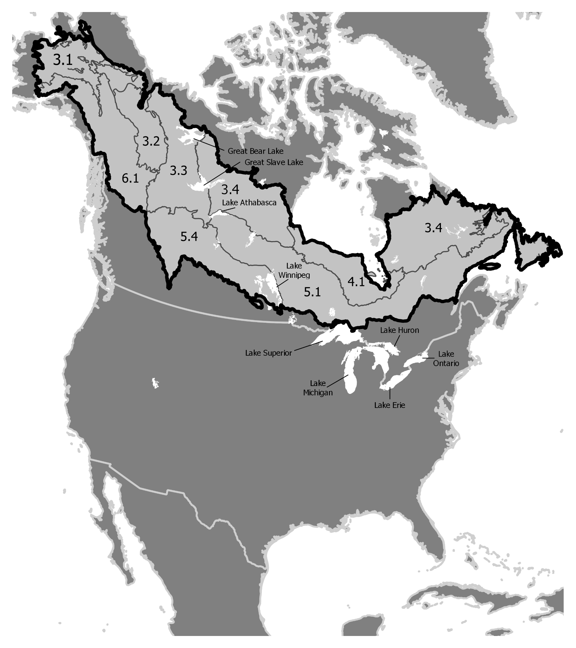
Fig. 1 Study area (North America) with boreal focus region highlighted and major lakes identified. Boreal level II ecoregions considered were 3.1 Alaska Boreal Interior, 3.2 Taiga Cordillera, 3.3 Taiga Plains, 3.4 Taiga Shield, 4.1 Hudson Plains, 5.1 Softwood Shield, and 6.1 Boreal Cordillera (CEC, 2009)

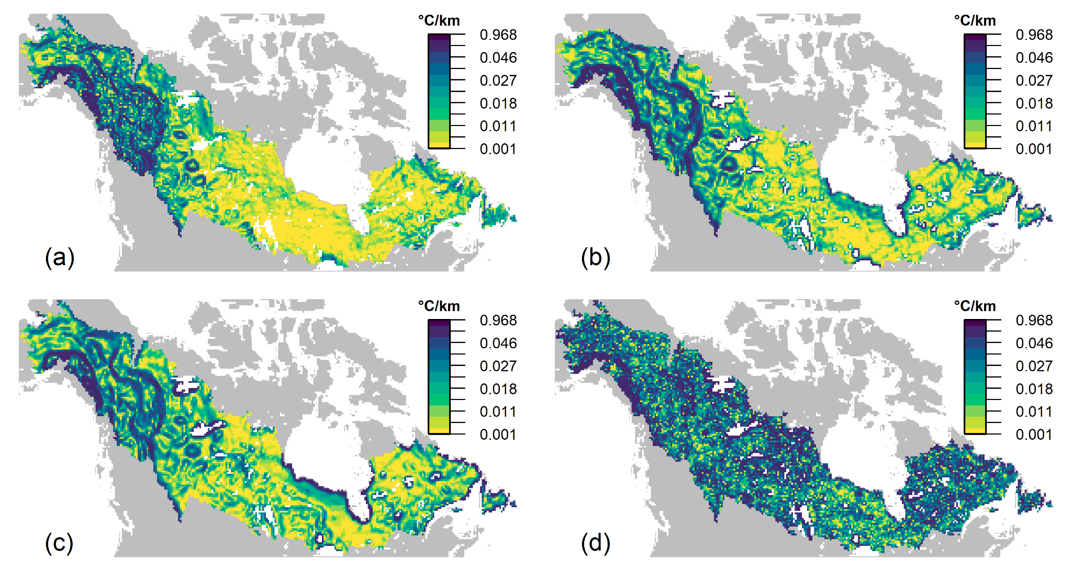
Fig. 2 Comparison of historical spatial gradient (°C/km within a 3 × 3 cell neighbourhood) on a 22-km grid based on summer surface temperature metrics from four historical sources: (a) ClimateNA_CanESM2 (T_{max}+T_{mean})/2 (1981-2010 mean) resampled from native 1-km grid, (b) Canadian Regional Climate Model v. 5 (T_{max}+T_{mean})/2 (CRCM5_CanESM2; 1981-2010 mean), (c) ERA5 12pm LST (mean 1981-2010; Hersbach et al, 2018) resampled from native 0.25° × 0.25° grid, and (d) MODIS Terra Land Surface Temperature (2000-2021 mean; Wan et al., 2015) resampled from native 1-km grid
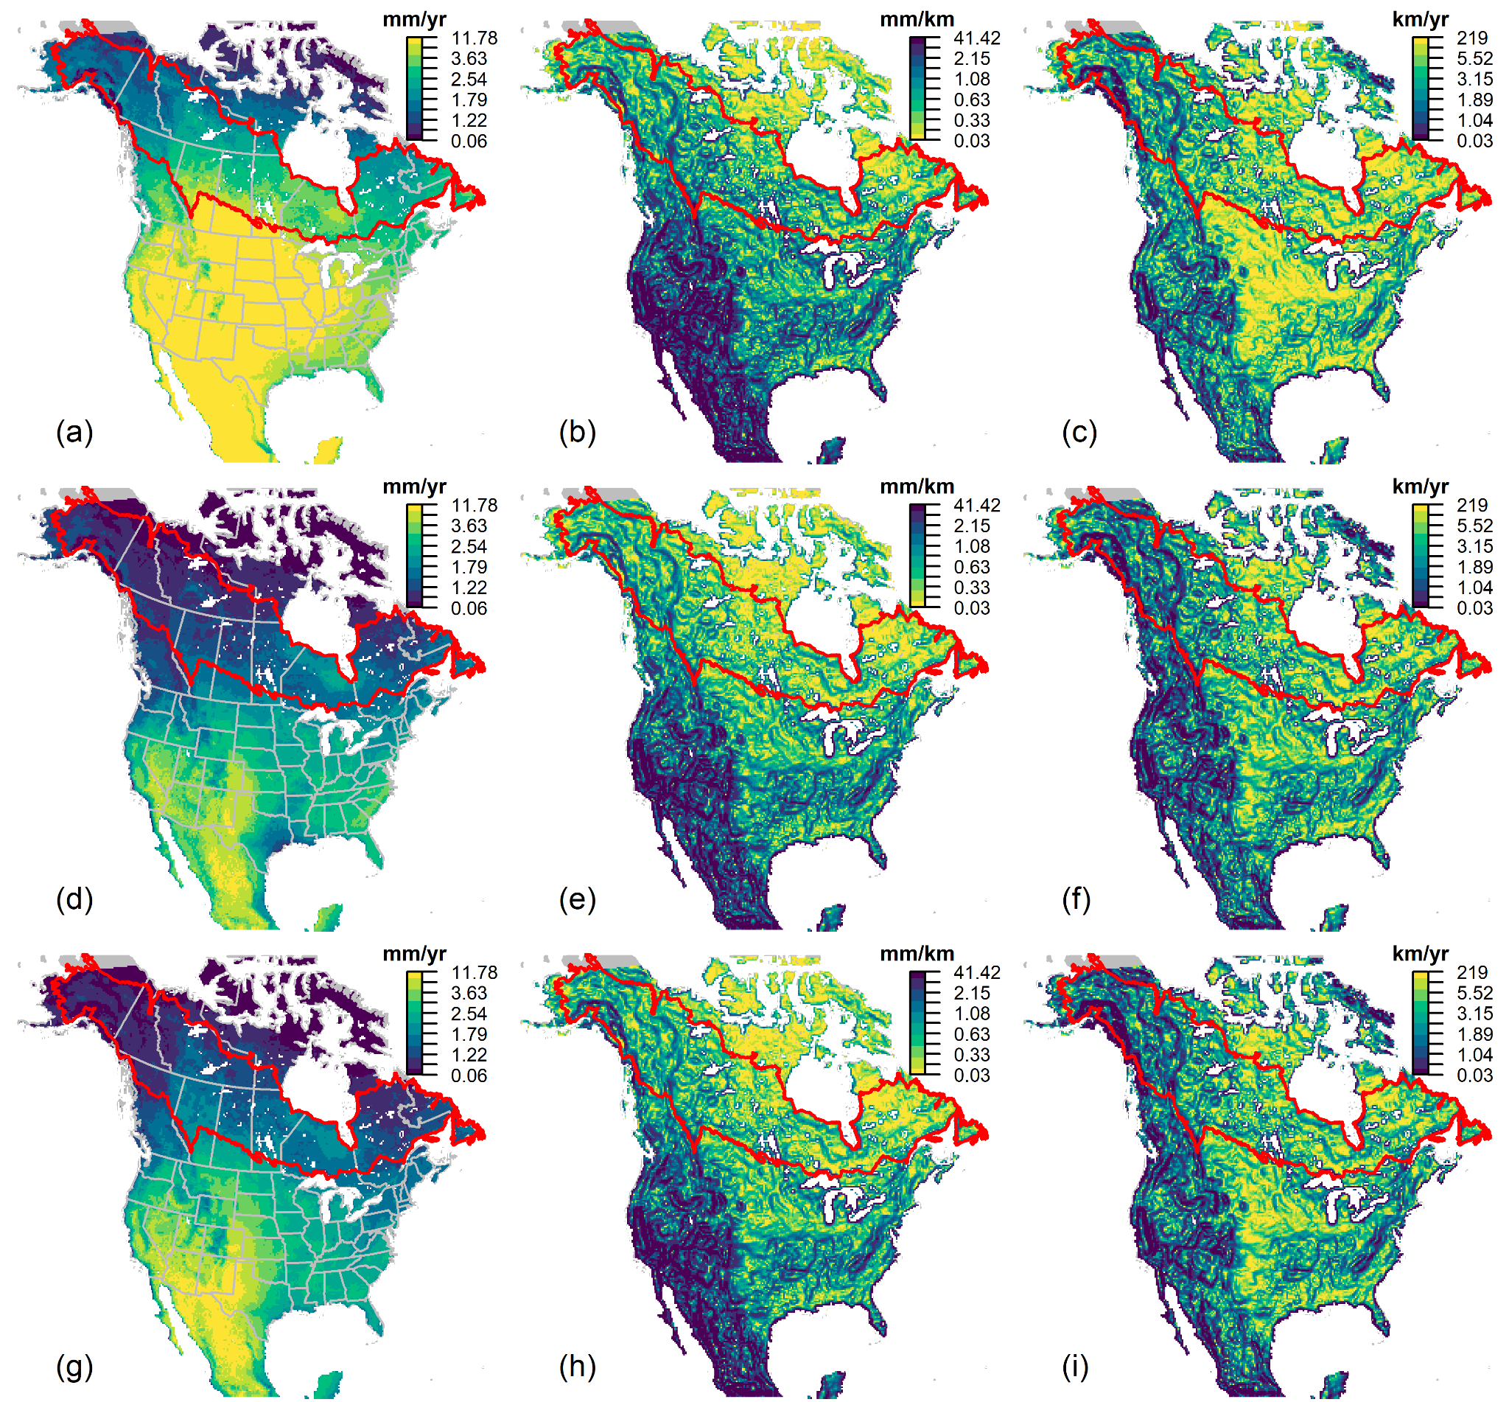
Fig. 3 Comparison of climate velocity components for annual potential evapotranspiration (mm) based on CRCM5. The first column represents the temporal gradient (mm/yr from 1981-2010 to 2071-2100, RCP 8.5); the second column shows the spatial gradient (mean baseline period mm/km over 3 × 3 cell neighbourhood); and the third column depicts velocity (temporal gradient/spatial gradient). Metrics were calculated for each of the three different driving global climate models: CanESM2 (a-c), MPI-ESM-LR (d-f), and CNRM-CM5 (g-i). Boreal forest ecoregions (CEC 2009) are outlined in red

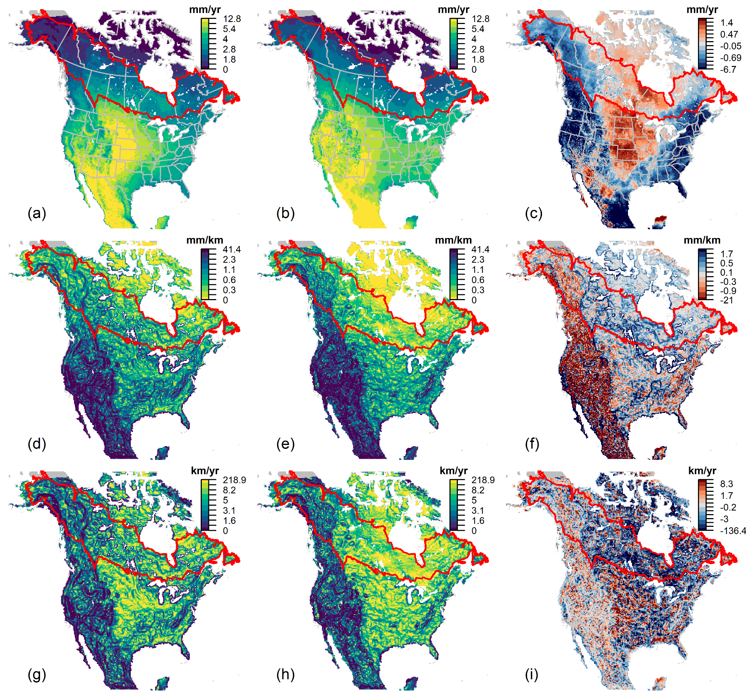
Fig. 4 Comparison of CRCM5_CanESM2 (first column) and ClimateNA_CanESM2 (second column) annual potential evapotranspiration (PET) change patterns and differences (third column). The first row shows the temporal gradient (TG; mm/yr from 1981-2010 to 2071-2100, RCP 8.5), the second row is the spatial gradient (SG; mean baseline period mm/km over 3 by 3 cell neighbourhood), and the third row represents velocity (temporal gradient/spatial gradient) and difference (CRCM5 minus ClimateNA). (a) CRCM5 TG, (b) ClimateNA TG, (c) CRCM5 TG - ClimateNA TG, (d) CRCM5 SG, (e) ClimateNA SG, (f) CRCM5 SG - CimateNA SG , (g) CRCM5 velocity, (h) ClimateNA velocity, and (i) CRCM5 velocity - ClimateNA velocity. Boreal forest ecoregions (CEC 2009) are outlined in red

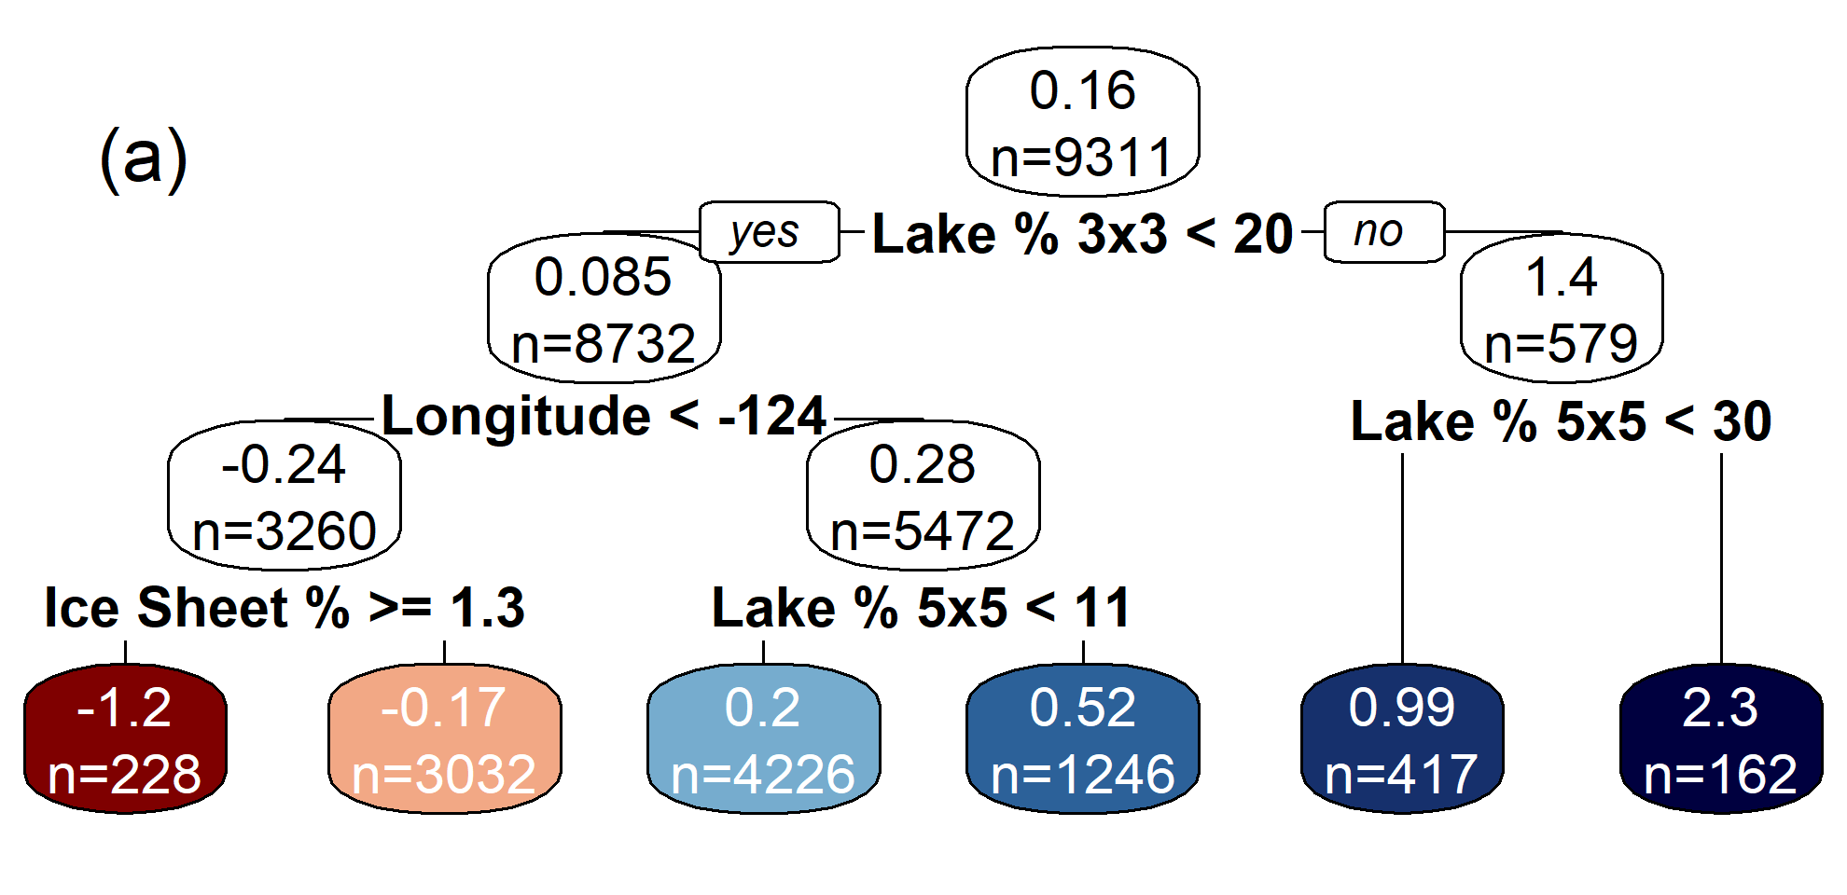
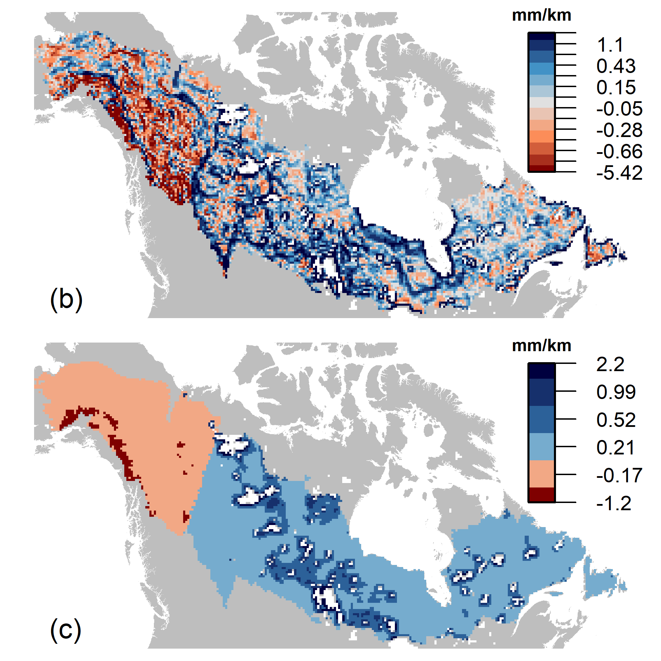
Fig. 5 The spatial gradient (SG) difference between CRCM5_CanESM2 and ClimateNA_CanESM2 for potential evapotranspiration (PET). SG = mean baseline period mm/km within a 3 × 3 cell neighbourhood. (a) Regression tree for the boreal region of North America (CEC 2009) with independent variables listed in Table 1, (b) CRCM5_CanESM2 PET SG minus ClimateNA_CanESM2 PET SG, and (c) PET SG difference as predicted from the regression tree
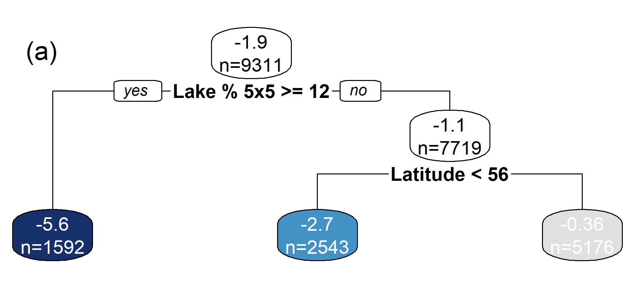
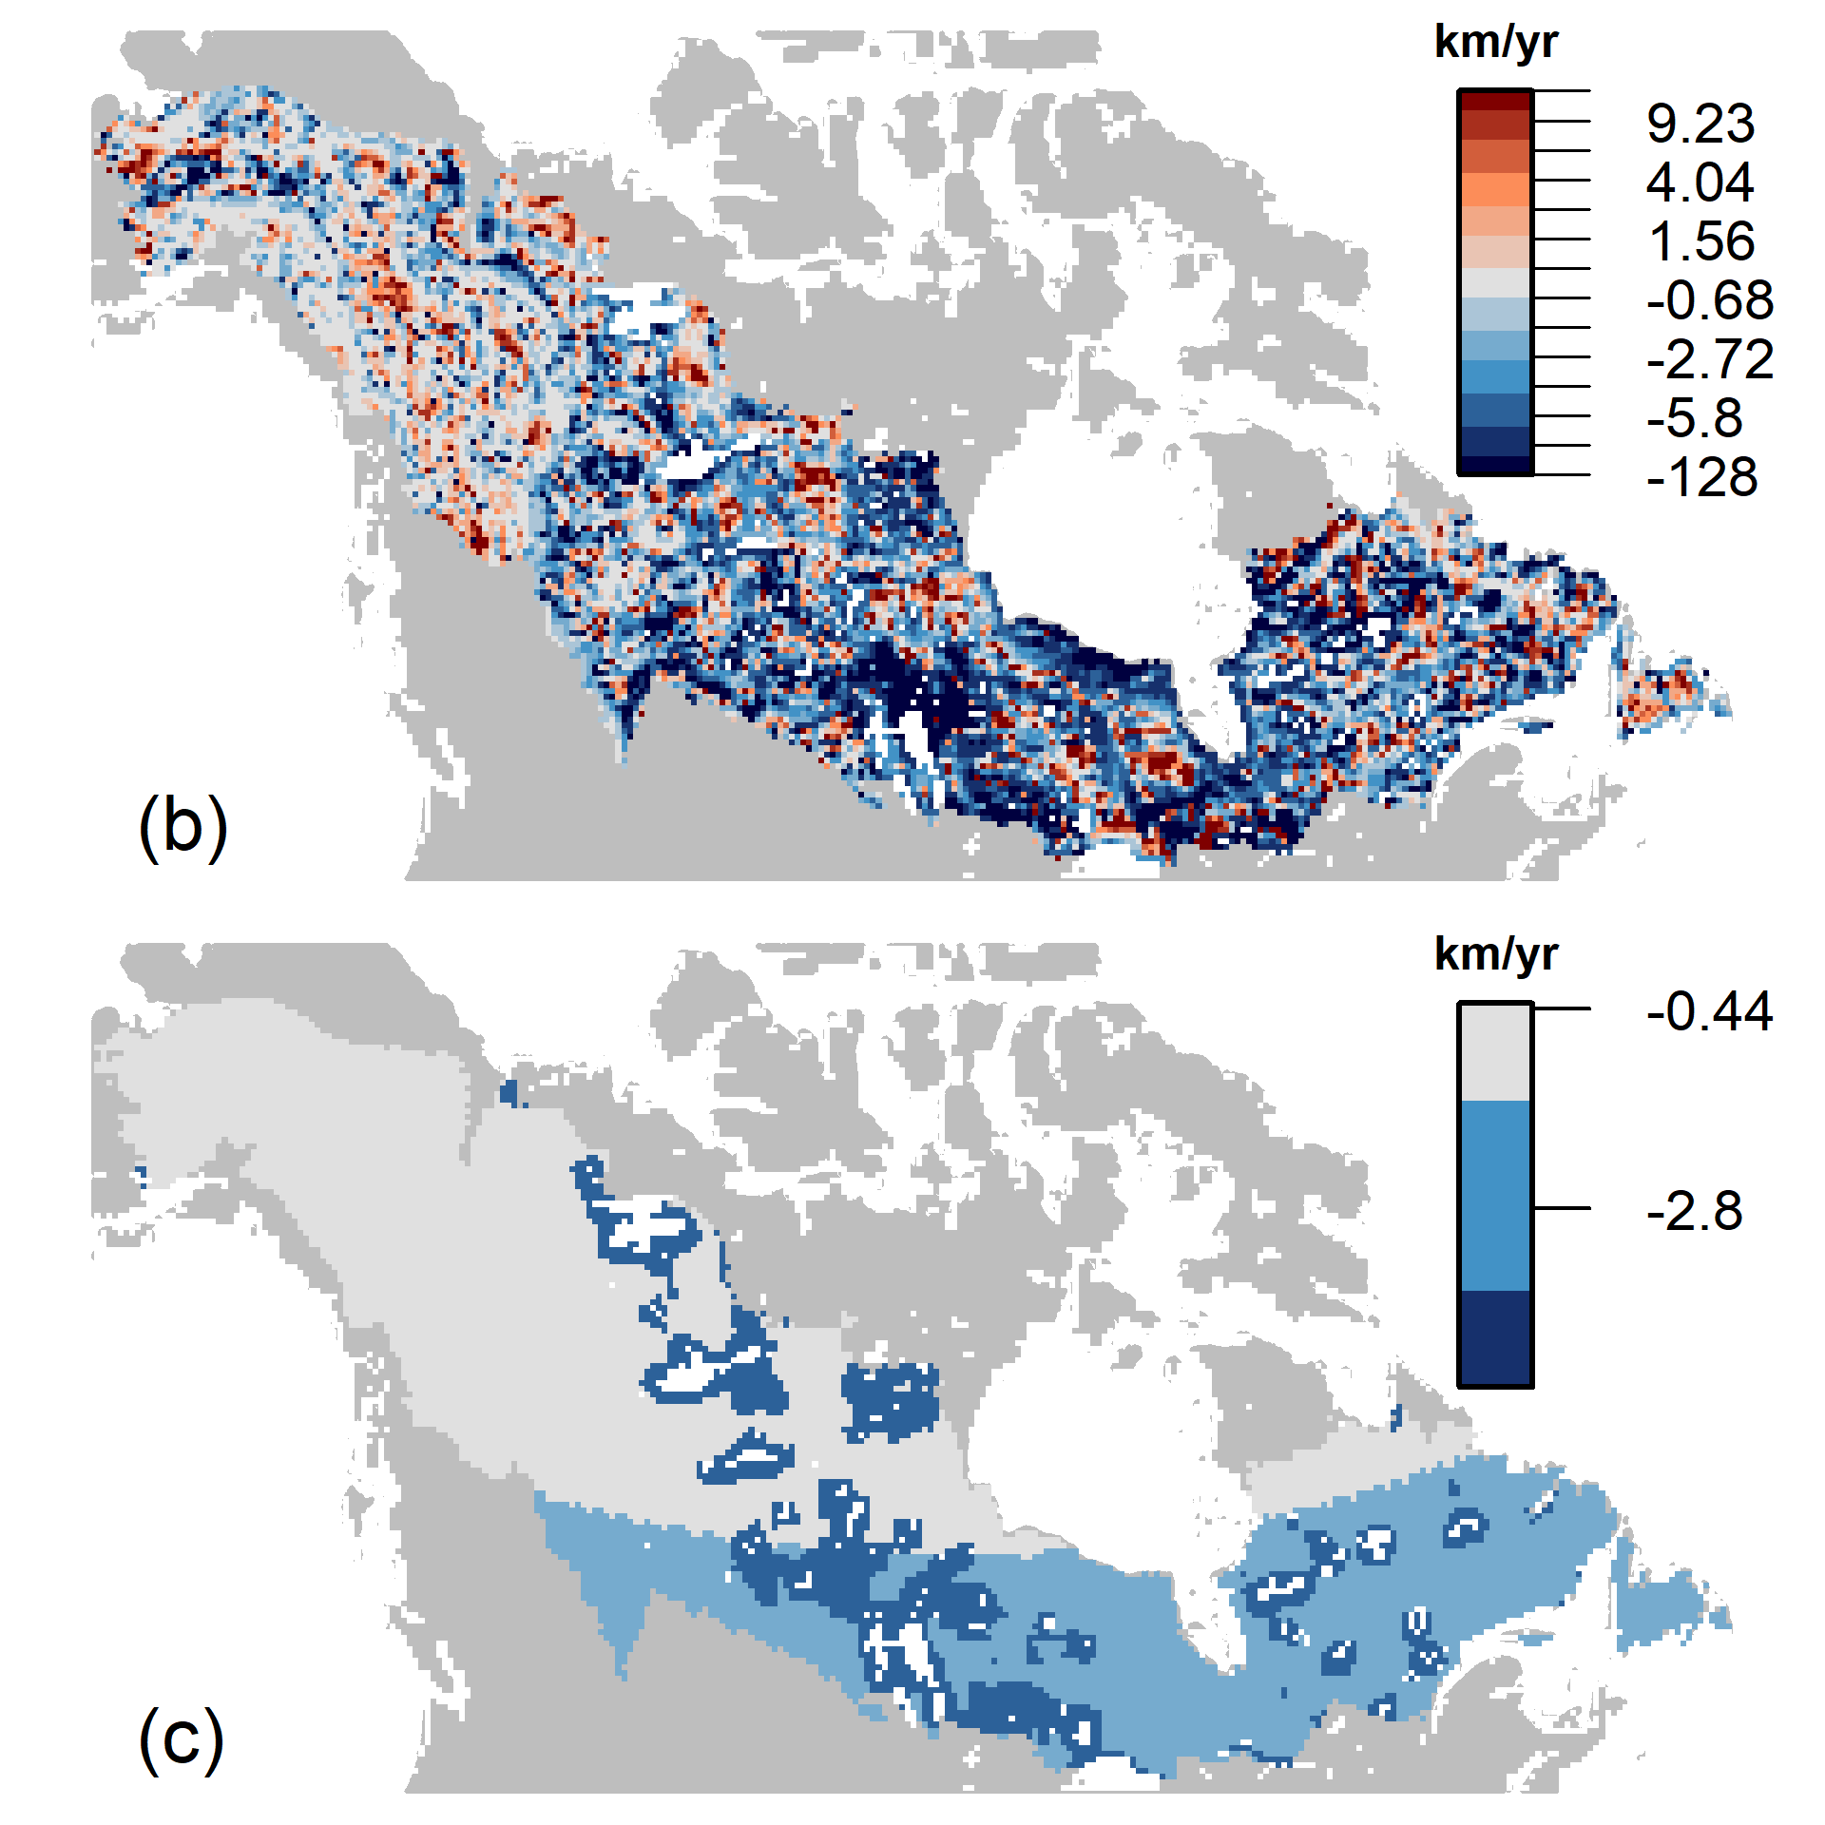
Fig. 6 The climate velocity difference between CRCM5_CanESM2 and ClimateNA_CanESM2 for potential evapotranspiration (PET), 1981-2010 to 2071-2100, RCP 8.5. Climate velocity (km/yr) = spatial gradient (mm/km) / temporal gradient (mm/yr). (a) Regression tree results for the boreal region of North America (CEC 2009) with independent variables listed in Table 1. (b) CRCM5_CanESM2 PET velocity - ClimateNA_CanESM2 PET velocity. (c) PET velocity difference as predicted from the regression tree
Supplementary Information
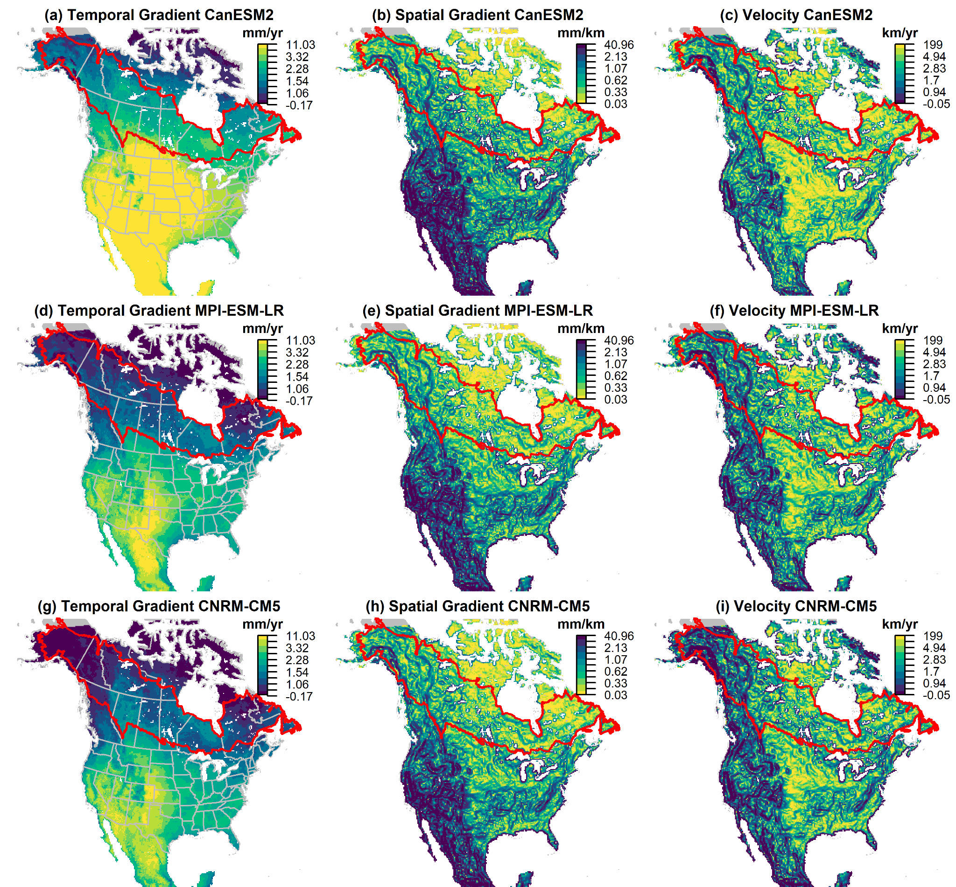
Fig. S1 Comparison of climate velocity components for annual potential evapotranspiration (mm) based on the Canadian Regional Climate Model, v.5 (CRCM5) and RCP 8.5 for the period between 1981-2010 and 2041-2070. The temporal gradient (mm/yr from 1996 to 2055), spatial gradient (mean baseline period mm/km over 3 x 3 cell neighbourhood), and velocity (temporal gradient/spatial gradient) were calculated for each of the three different input global climate models: CanESM2 (a-c), MPI-ESM-LR (d-f), and CNRM-CM5 (g-i). Maps (a) temporal gradient, (b) spatial gradient, and (c) velocity are for CanESM2. Maps (d) temporal gradient, (e) spatial gradient, and (f) velocity are for MPI-ESM-LR. Maps (g) temporal gradient, (h) spatial gradient, and (i) velocity are for CNRM-CM5. Boreal forest ecoregions (CEC, 2009) are outlined in red

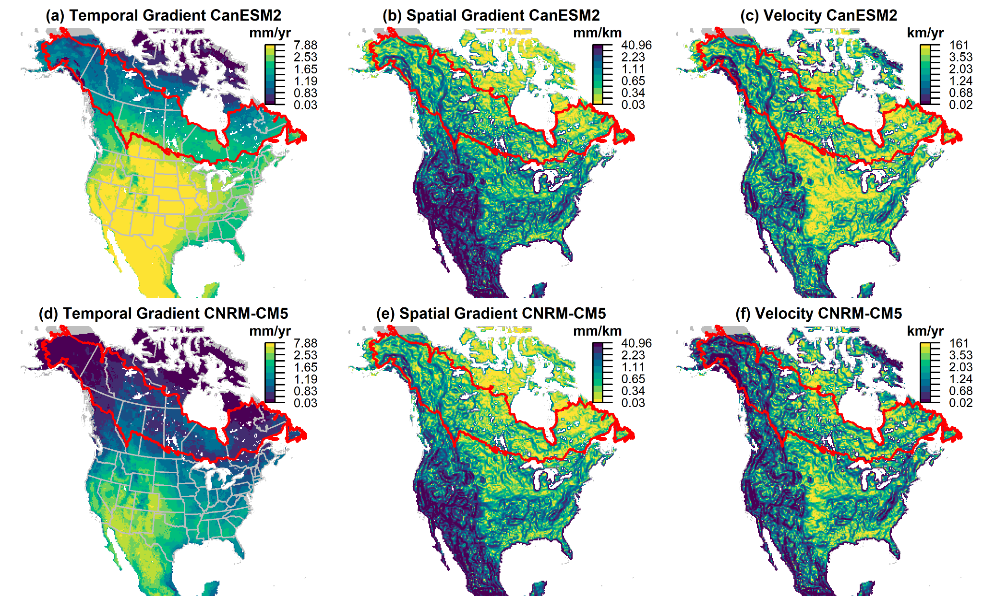

Fig. S2 Comparison of climate velocity components for annual potential evapotranspiration (mm) based on the Canadian Regional Climate Model, v.5 (CRCM5) and RCP 4.5 for the period between 1981-2010 and 2041-2070 The temporal gradient (mm/yr from 1996 to 2055), spatial gradient (mean baseline period mm/km over 3 x 3 cell neighbourhood), and velocity (temporal gradient/spatial gradient) were calculated for each of the three different input global climate models: CanESM2 (a-c), MPI-ESM-LR (d-f), and CNRM-CM5 (g-i). Maps (a) temporal gradient, (b) spatial gradient, and (c) velocity are for CanESM2. Maps (d) temporal gradient, (e) spatial gradient, and (f) velocity are for MPI-ESM-LR. Maps (g) temporal gradient, (h) spatial gradient, and (i) velocity are for CNRM-CM5. Boreal forest ecoregions (CEC, 2009) are outlined in red
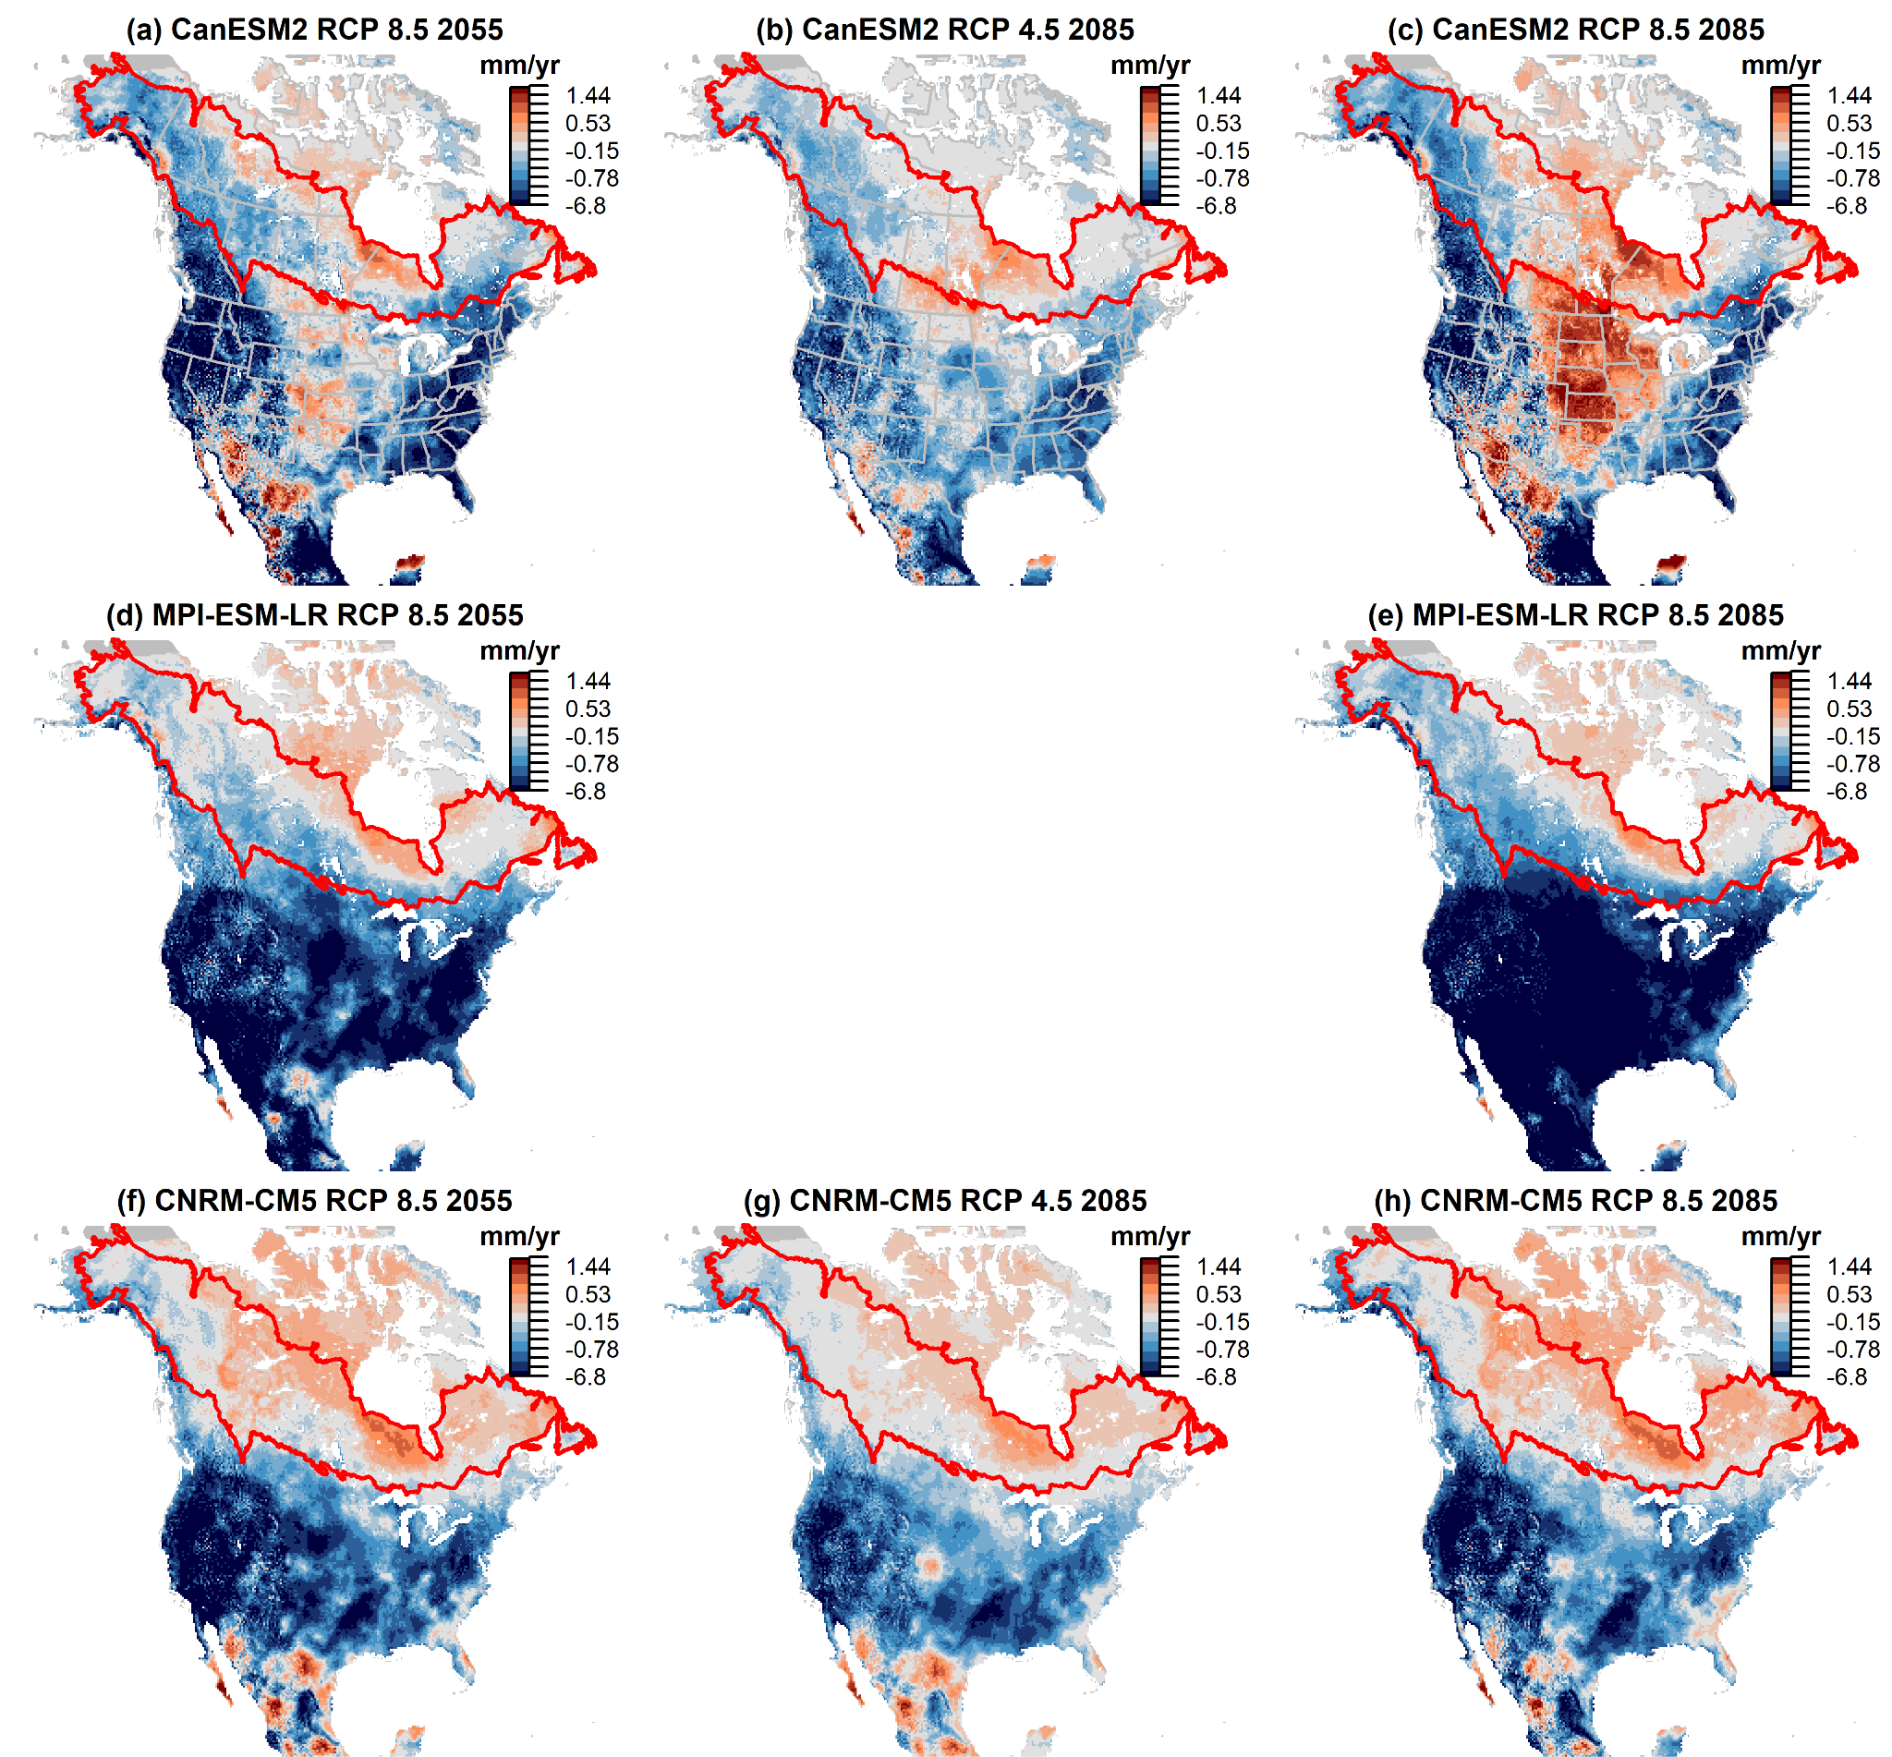
Fig. S3 Comparison of temporal gradient differences (RCM - GCM) for annual potential evapotranspiration (mm/yr) based on the Canadian Regional Climate Model, v.5 (CRCM5) for the period between 1981-2010 and either 2041-2070 or 2071-2100. The temporal gradient (mm/yr from 1995 to either 2055 or 2085) was calculated for each of the three different input global climate models: CanESM2 (a-c), MPI-ESM-LR (d-e), and CNRM-CM5 (f-h). First column: RCP 8.5 2085 (a,d,g), second column: RCP 8.5 2055 (b,e,h) and, third column: RCP 4.5 2085 (c,i). Boreal forest ecoregions (CEC, 2009) are outlined in red

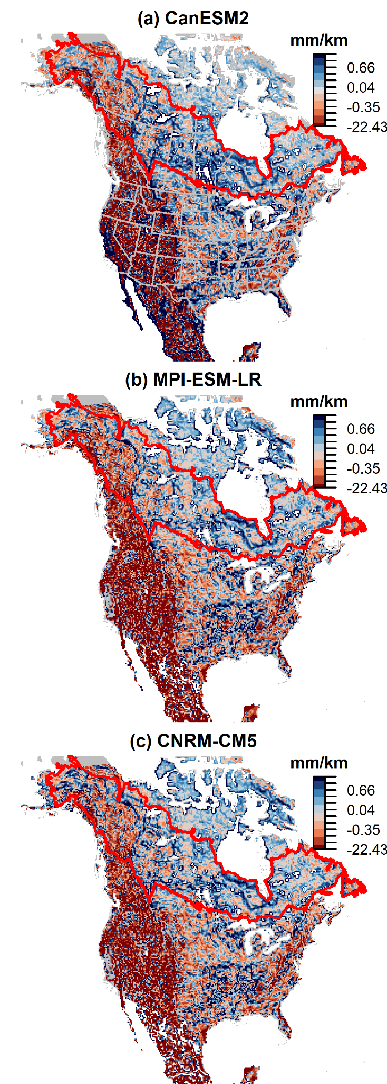
Fig. S4 Comparison of spatial gradient differences (RCM - GCM) for annual potential evapotranspiration (mm) based on the Canadian Regional Climate Model, v.5 (CRCM5) for 1981-2010 and RCP 8.5. The spatial gradient (mm/km) was calculated for each of the three different input global climate models: CanESM2 (a), MPI-ESM-LR (b), and CNRM-CM5 (c)

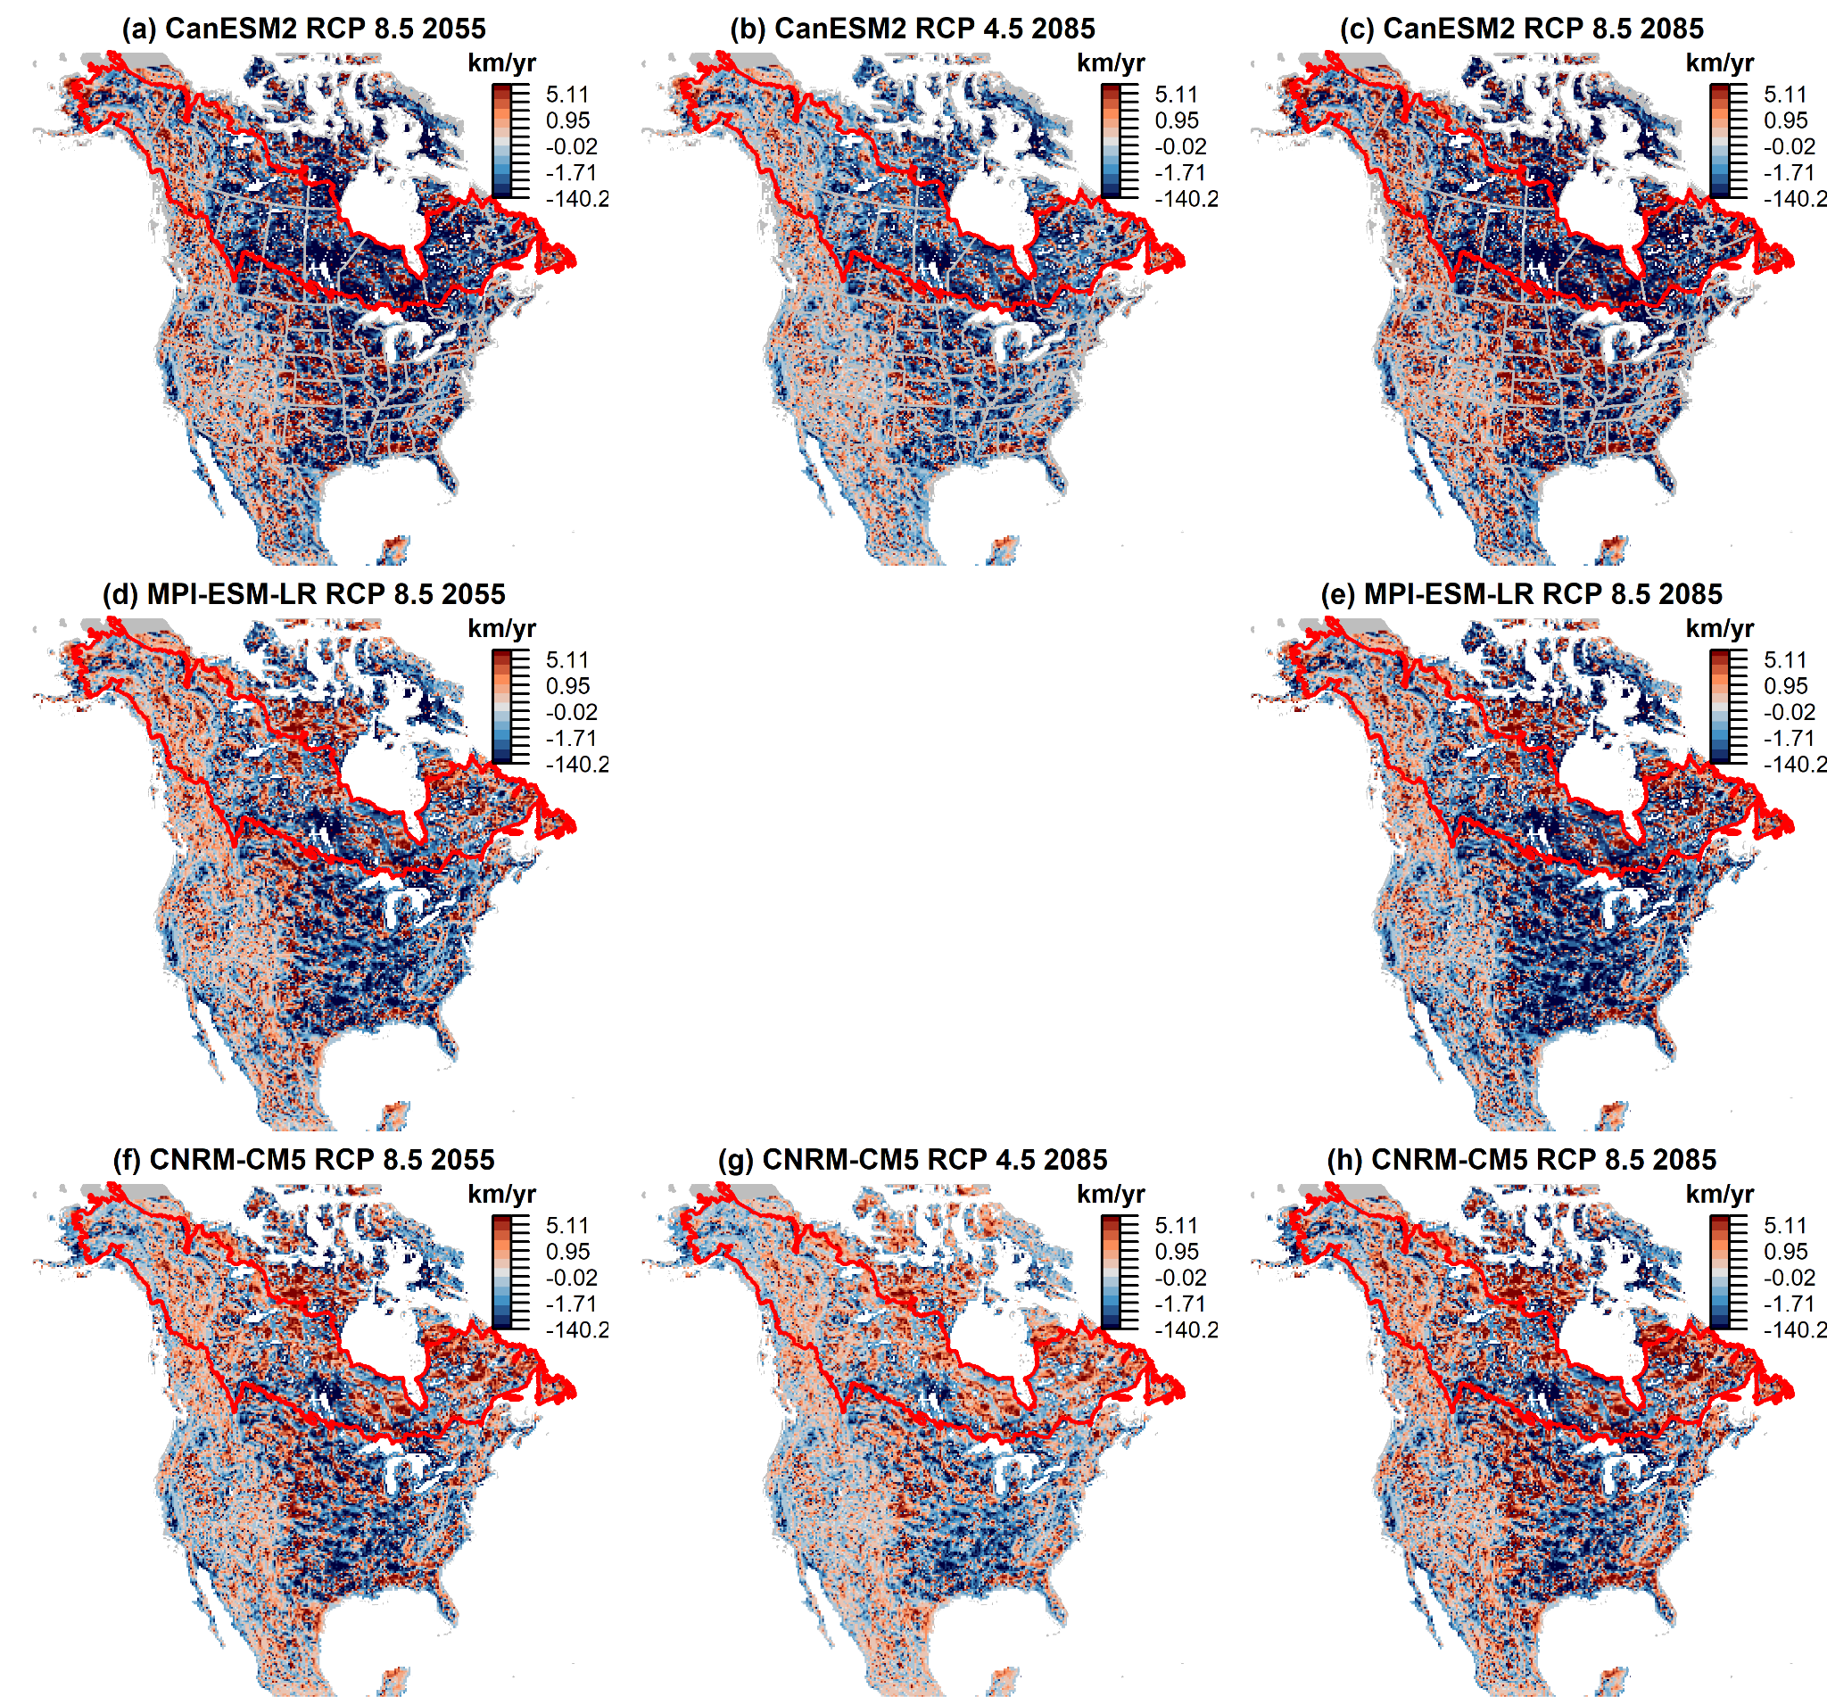
Fig. S5 Comparison of velocity differences for annual potential evapotranspiration (mm) based on the Canadian Regional Climate Model, v.5 (CRCM5) for the period between 1981-2010 and either 2041-2070 or 2071-2100. The velocity (km/yr from 1995 to either 2055 or 2085) was calculated for each of the three different input global climate models: CanESM2 (a-c), MPI-ESM-LR (d-e), and CNRM-CM5 (f-h). First column: RCP 8.5 2085 (a,d,g), second column: RCP 8.5 2055 (b,e,h) and, third column: RCP 4.5 2085 (c,f,g). Boreal forest ecoregions (CEC, 2009) are outlined in red

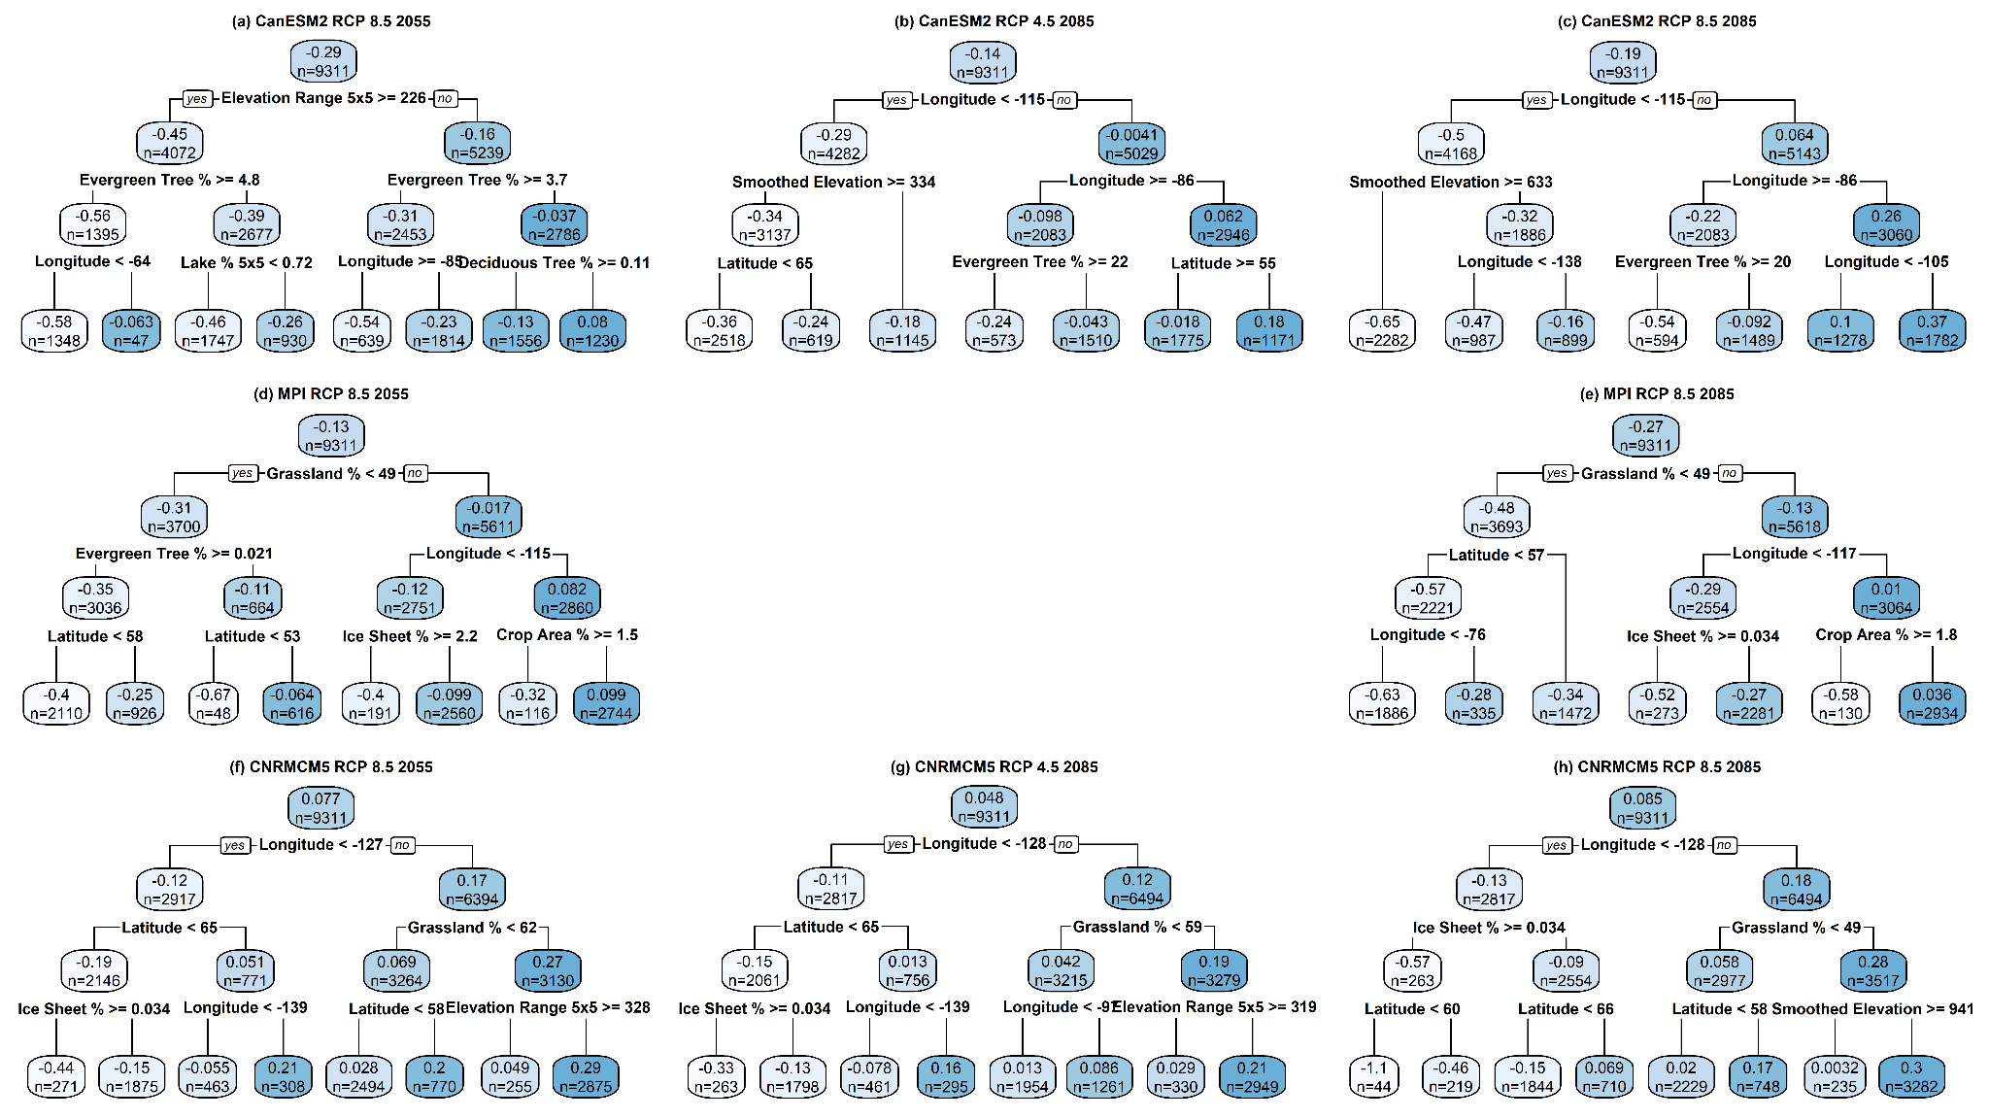
Fig. S6 Comparison of the difference between dynamically downscaled CanESM2 (CRCM5) temporal gradient and statistically downscaled (ClimateNA) temporal gradient of Annual Potential Evapotranspiration (PET) between 1981-2010 and either 2041-2070 or 2071-2100 using either RCP 4.5 or RCP 8.5 as labeled. The temporal gradient (mm/yr from 1995 to either 2055 or 2085) was calculated for each of the three different input global climate models: CanESM2 (a-c), MPI-ESM-LR (d-e), and CNRM-CM5 (f-h). First column: RCP 8.5 2055 (a,d,f), second column: RCP 4.5 2085 (b,g) and, third column: RCP 8.5 2085 (c,e,h)
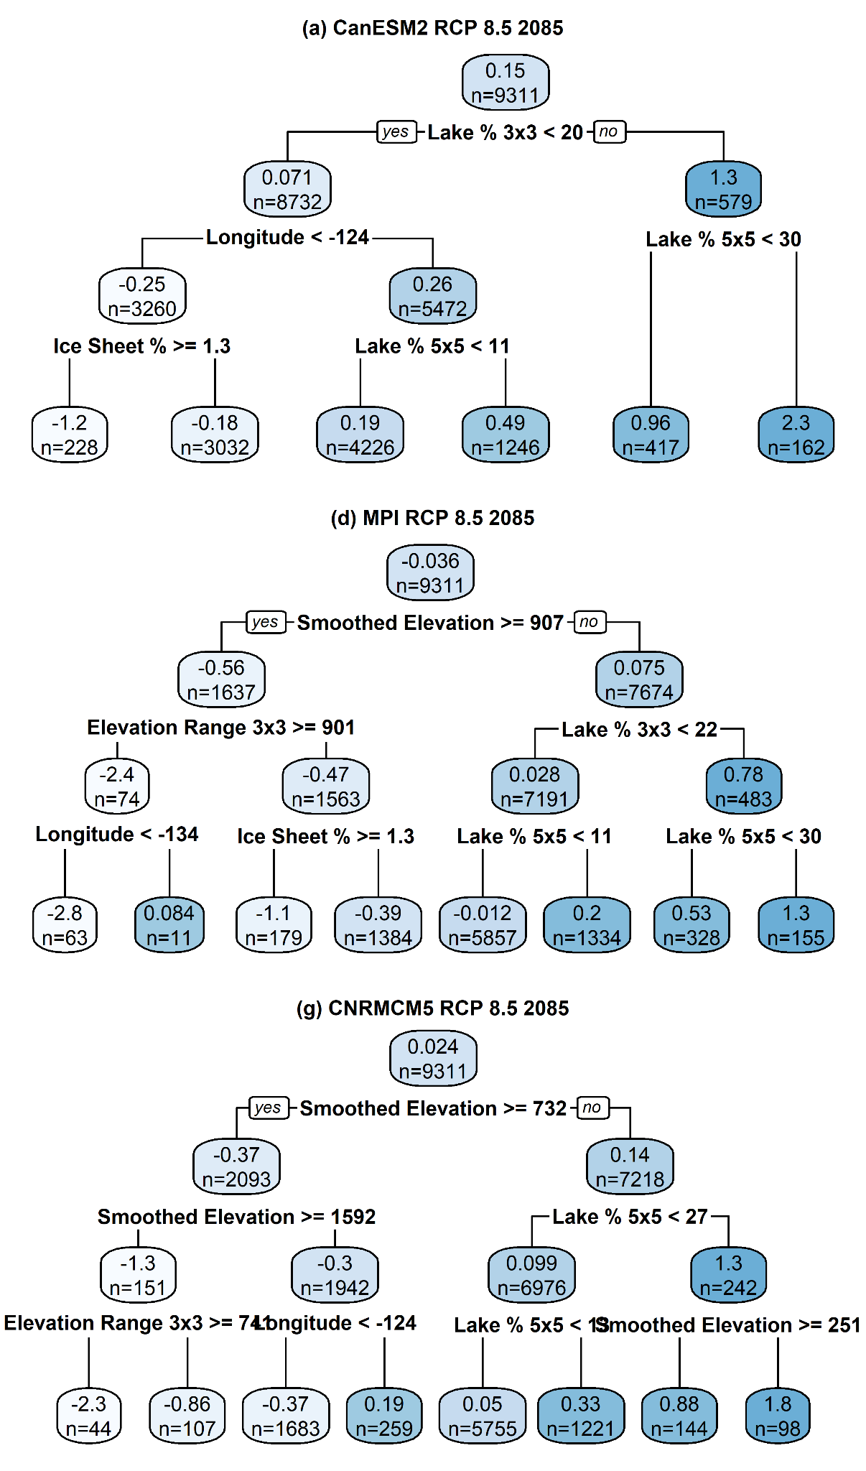
Fig. S7 Comparison of dynamically downscaled CanESM2 (CRCM5) spatial gradient minus statistically downscaled (ClimateNA) spatial gradient for Annual Potential Evapotranspiration (PET) from 1981-2010 for RCP 8.5. The spatial gradient (mm/km) was calculated for each of the three different input global climate models: CanESM2 (a), MPI-ESM-LR (b), and CNRM-CM5 (c)
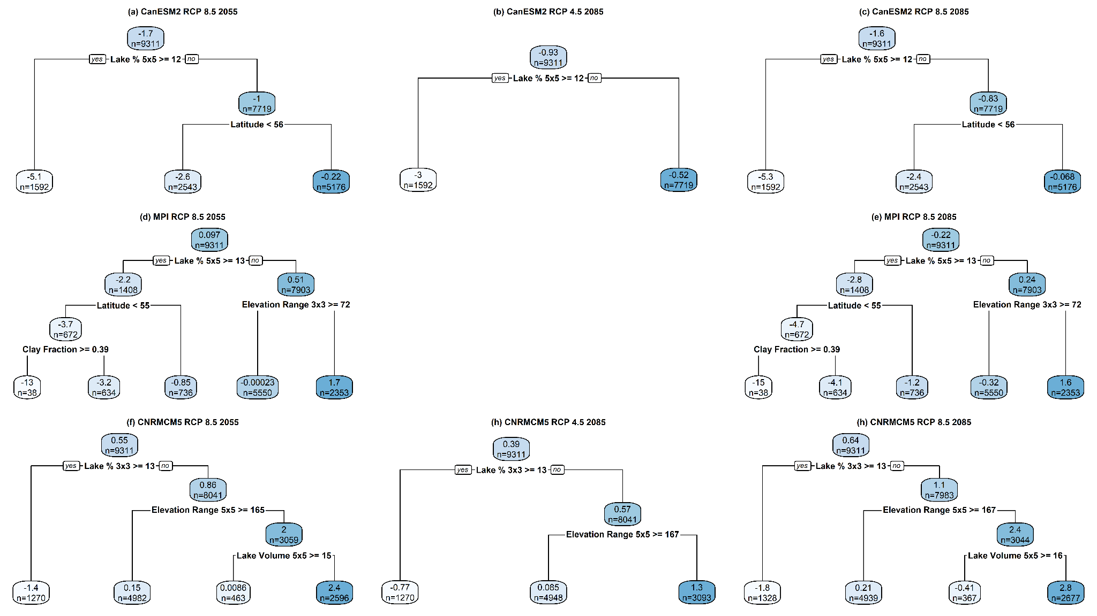
Fig. S8 Comparison of the dynamically downscaled CanESM2 (CRCM5) velocity minus the statistically downscaled (ClimateNA) velocity of Annual Potential Evapotranspiration (PET) between 1981-2010 and either 2041-2070 or 2071-2100 using either RCP 4.5 or RCP 8.5 as labeled. The velocity (km/yr from 1995 to either 2055 or 2085) was calculated for each of the three different input global climate models: CanESM2 (a-c), MPI-ESM-LR (d-e), and CNRM-CM5 (g-i). First column: RCP 8.5 2055 (a,d,f), second column: RCP 4.5 2085 (b,h) and, third column: RCP 8.5 2085 (c,e,h)

