Supplementary material

Simultaneous study of different combinations of ZSM-5 templates and operating conditions in the MTP process; Designing, Modeling and Optimization by RSM-ANN-GA
Neda Kalantari ª, Ali Farzi ^{a,}∗, Faez Hamooni ª, Nagihan Çaylak Delibaş ^{b}, Ali Tarjomannejad ª, Aligholi Niaei ^{a,*}, Dariush Salari ^{c}.
ª Reactor & Catalyst Research Lab., Department of Chemical & Petroleum Engineering, University of Tabriz, Tabriz, Iran
^{b} Department of Physics, Sakarya University, Sakarya, Turkey
^{c} Department of Applied Chemistry, Faculty of Chemistry, University of Tabriz, Tabriz, Iran

Table S1 The ranges set for templates.
Parameter | Levels and ranges
 | -1.5 | -1.0 | 0.0 | 1.0 | 1.5
TPABr/SiO₂ | 0.05 | 0.075 | 0.125 | 0.175 | 0.2
CTAB/SiO₂ | 0 | 0.0066 | 0.02 | 0.033 | 0.04
F127/SiO₂ | 0 | 0.0002 | 0.0006 | 0.001 | 0.0012

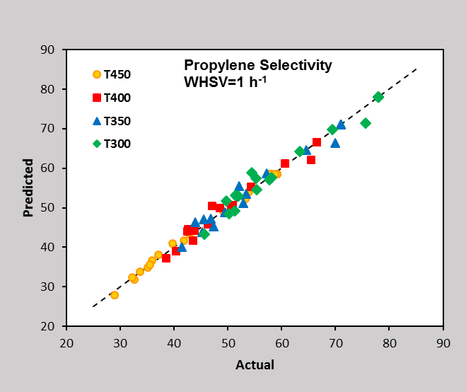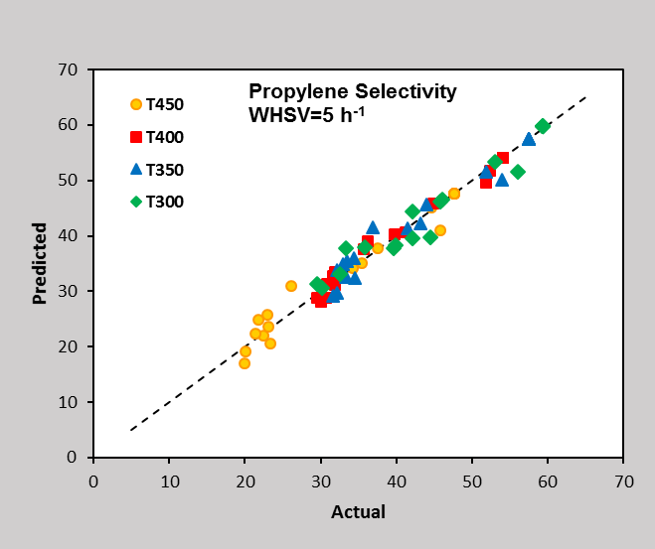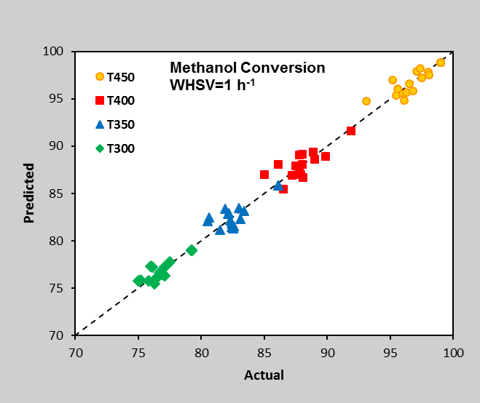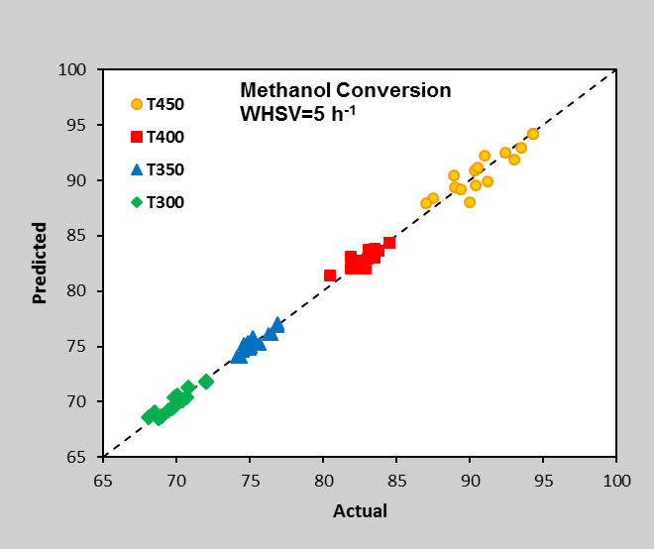
Fig. S1 Comparison of propylene selectivity and methanol conversion for RSM prediction and experimental data
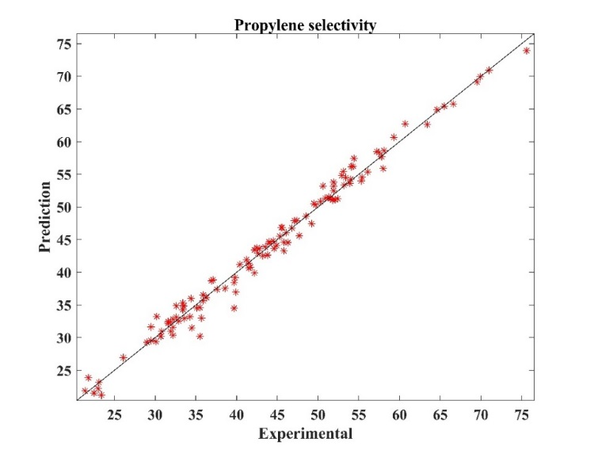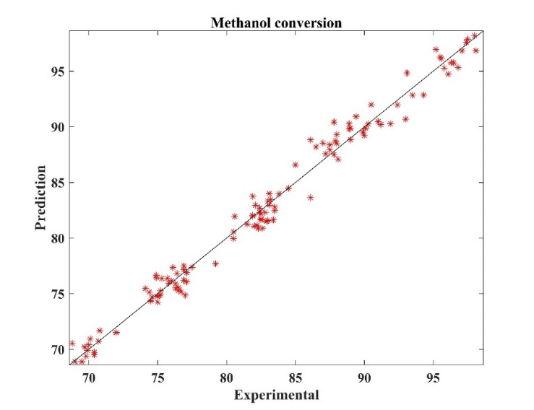
a
b
Fig. S2 Comparison of propylene selectivity and methanol conversion for ANN prediction and experimental data
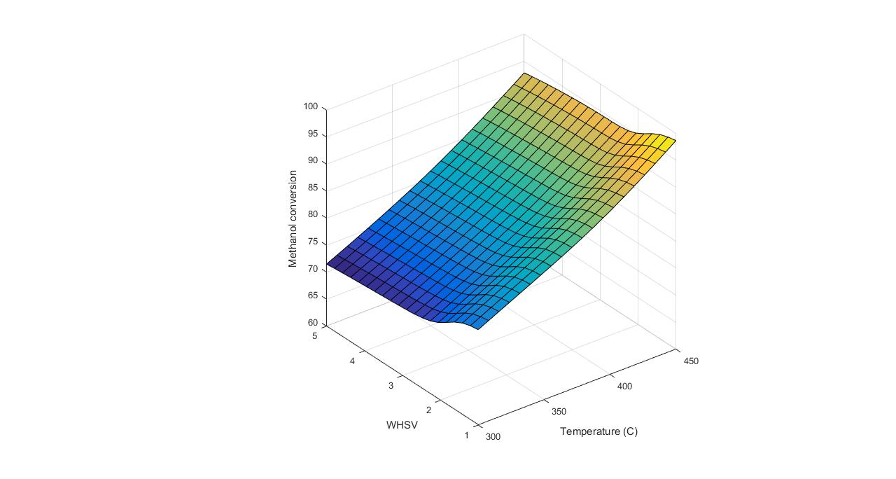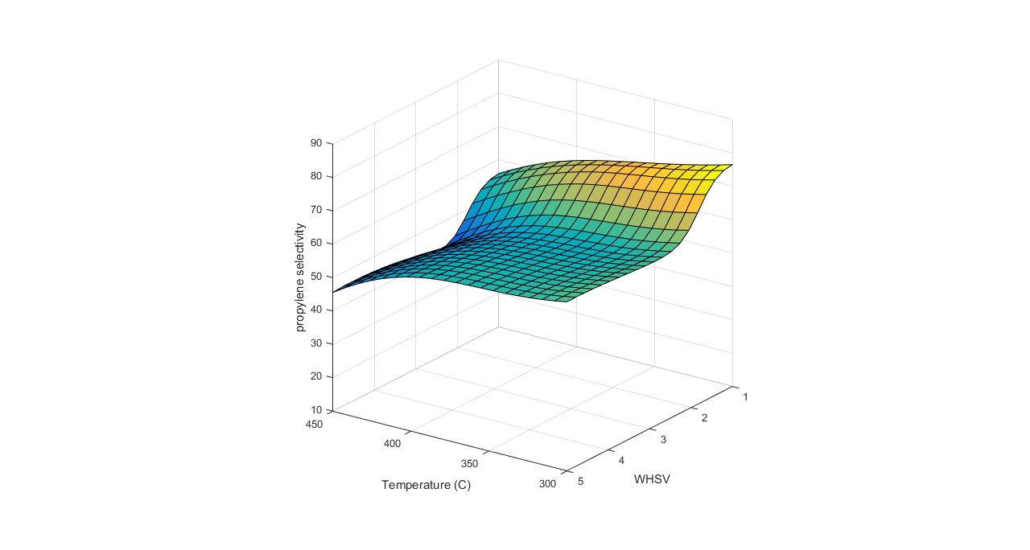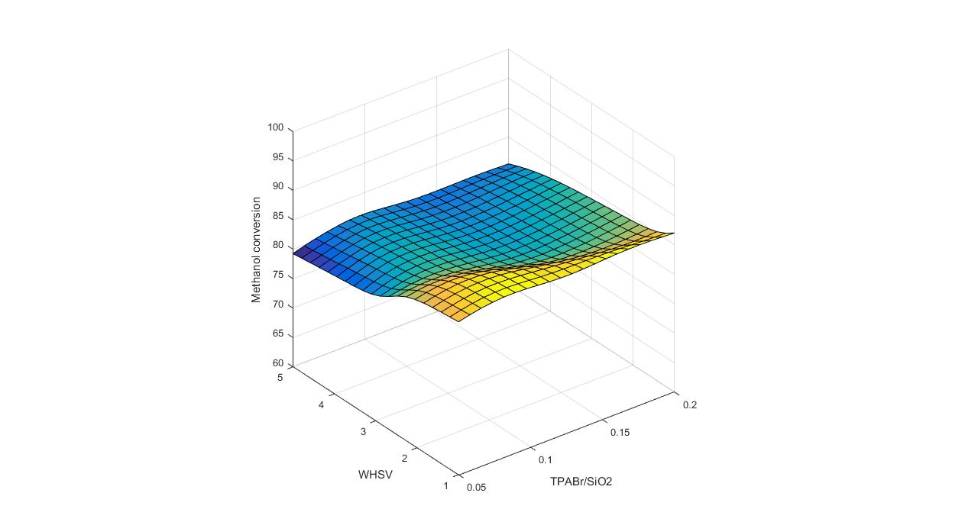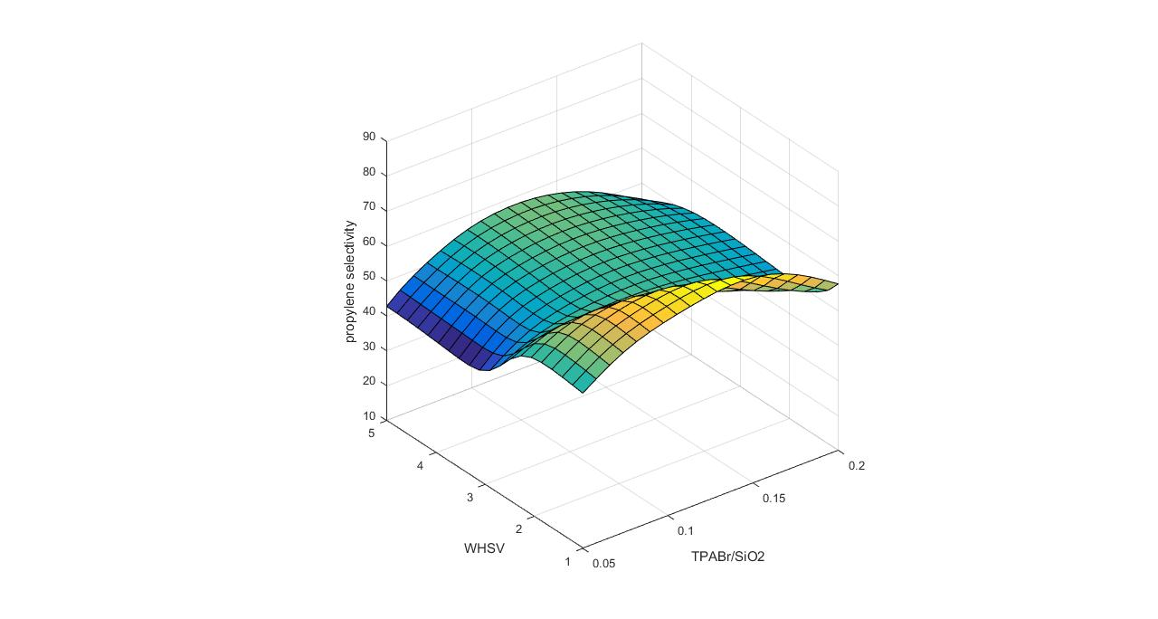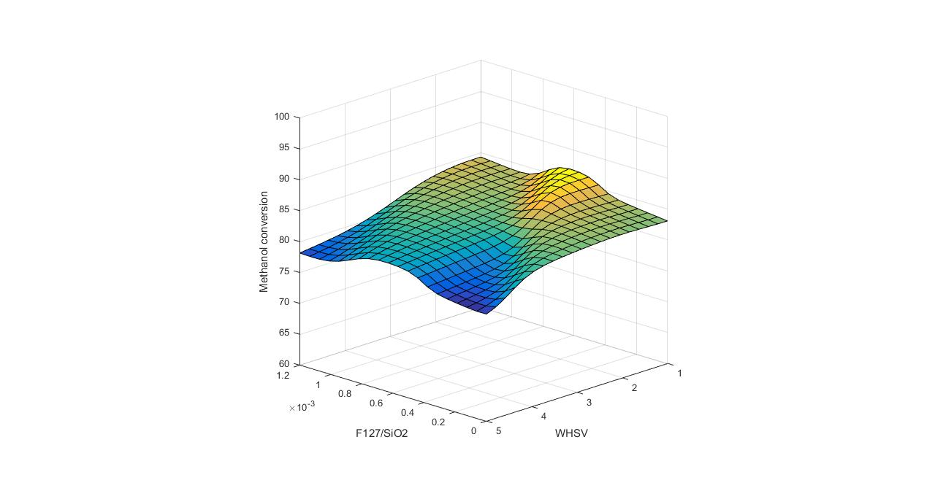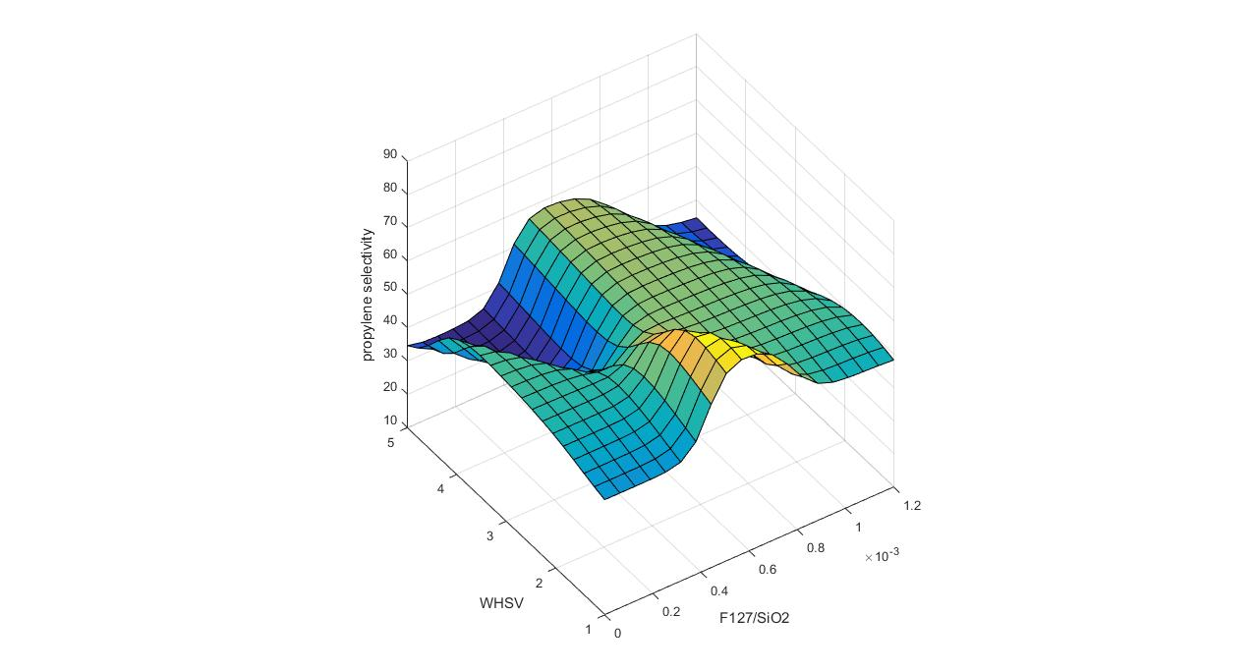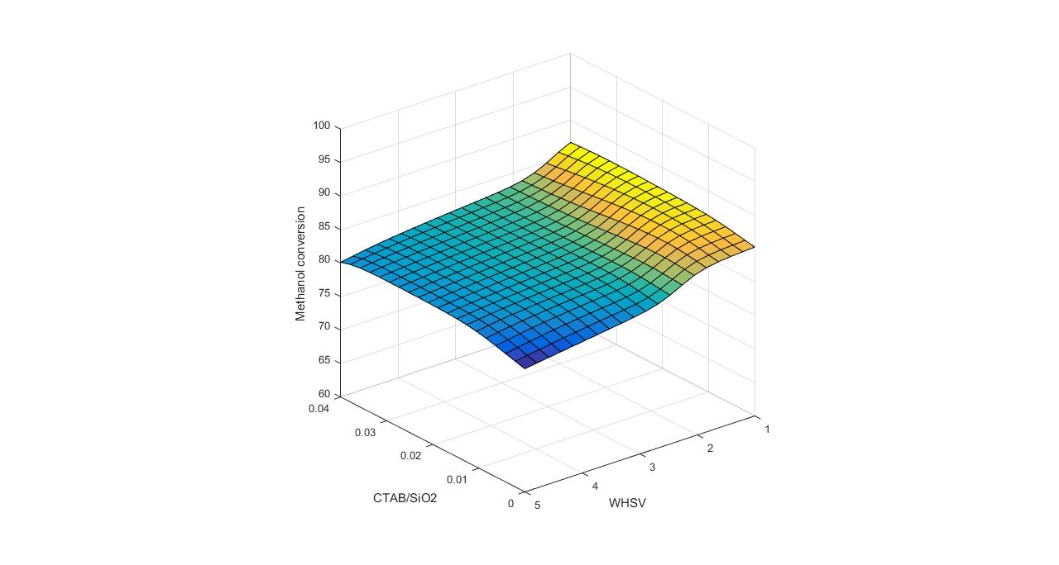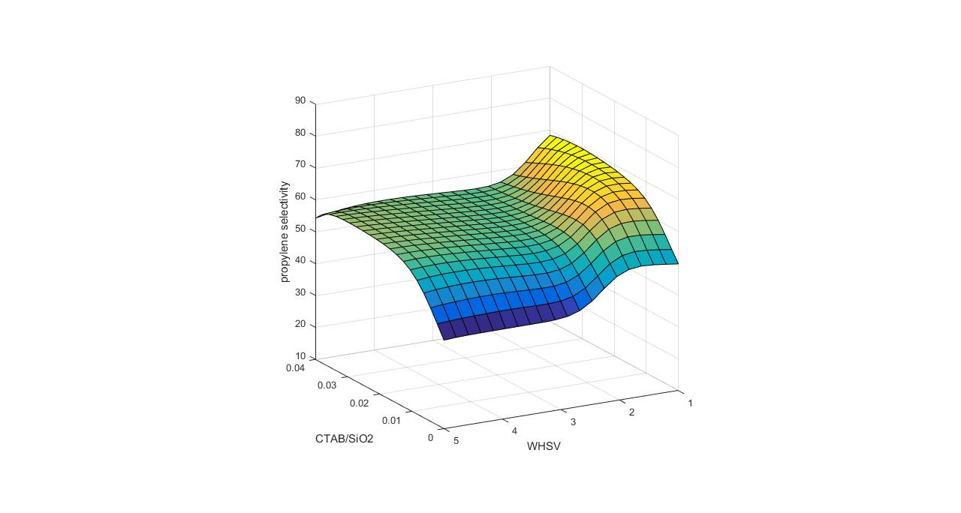
Fig. S3 Methanol conversion and propylene selectivity against variables;
(a) Temperature and WHSV,
(b) TPABr/SiO₂ and WHSV,
(c) F127/SiO₂ and WHSV,
(d) CTAB/SiO₂ and WHSV,
(e) Temperature and TPABr/SiO₂, (f) Temperature and CTAB/SiO₂, (g) TPABr/SiO₂ and CTAB/SiO₂, (h) CTAB/SiO₂ and F127/SiO₂
a
b
c
d
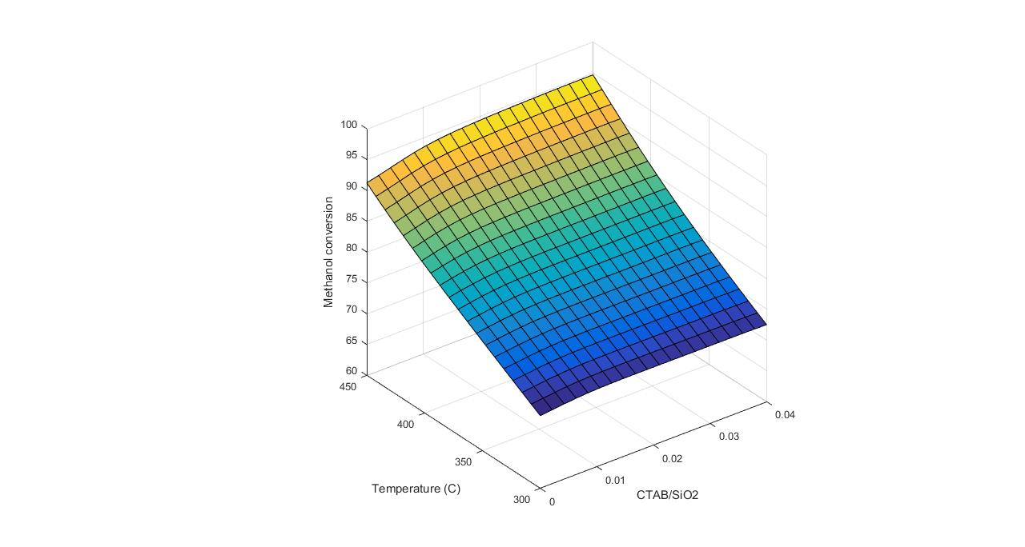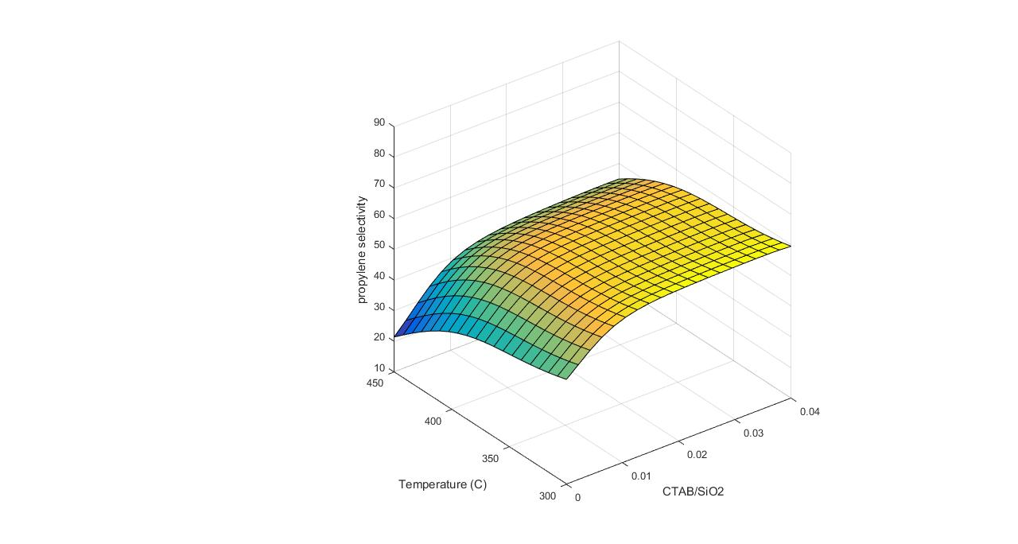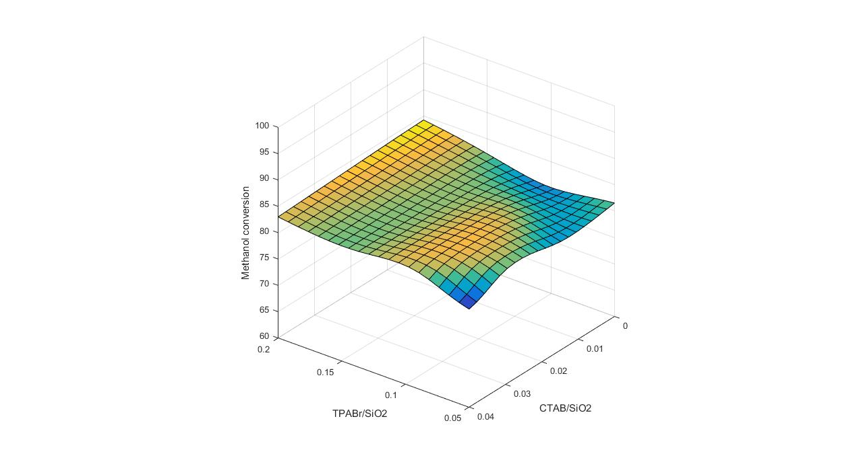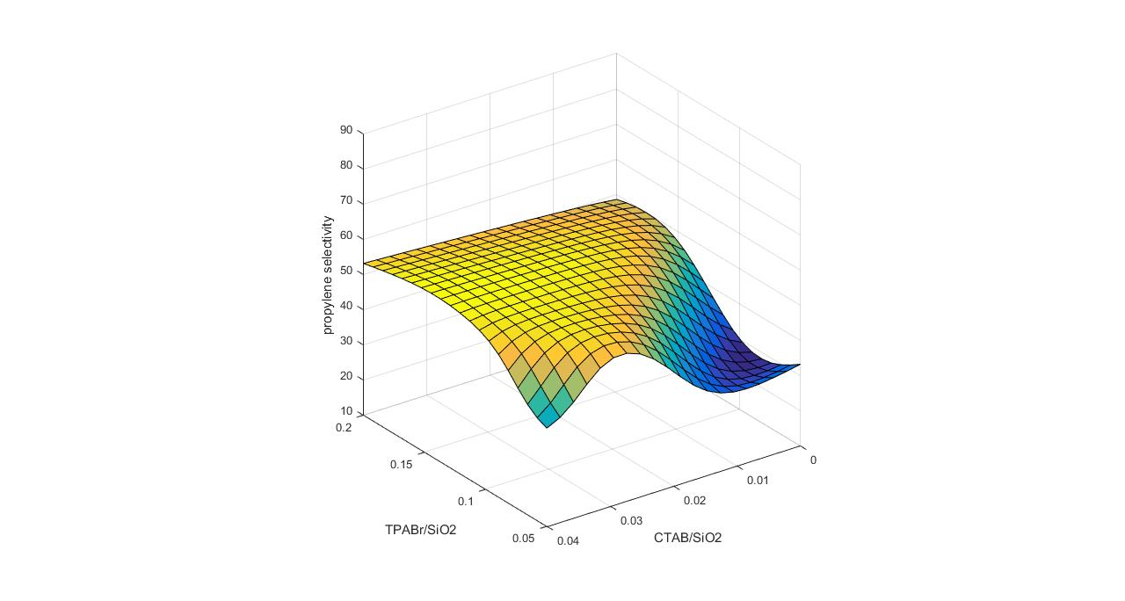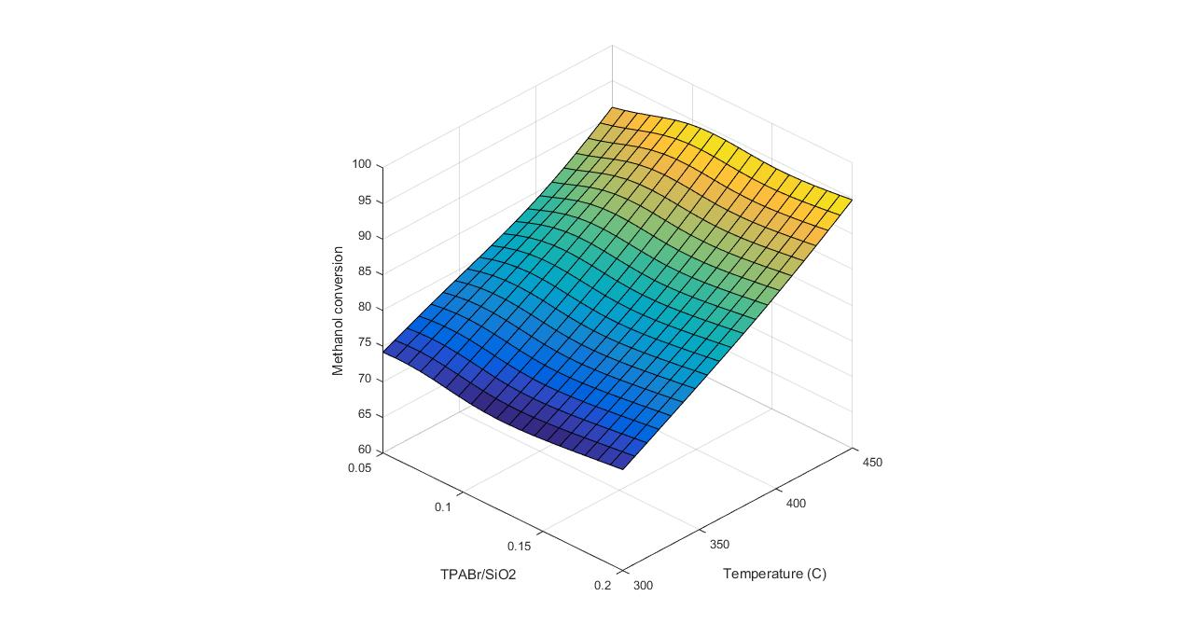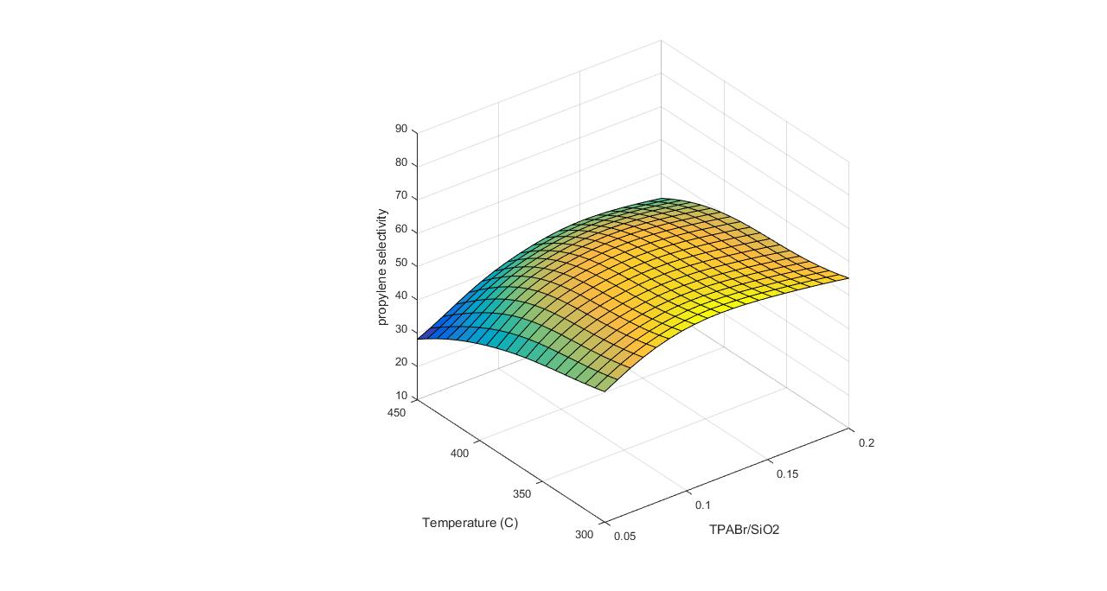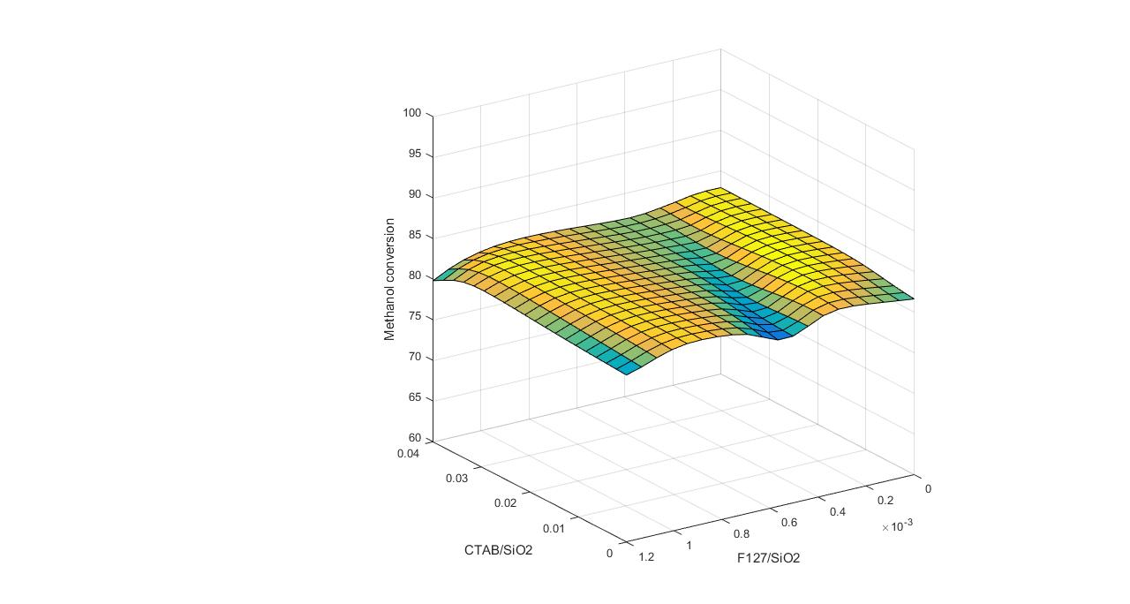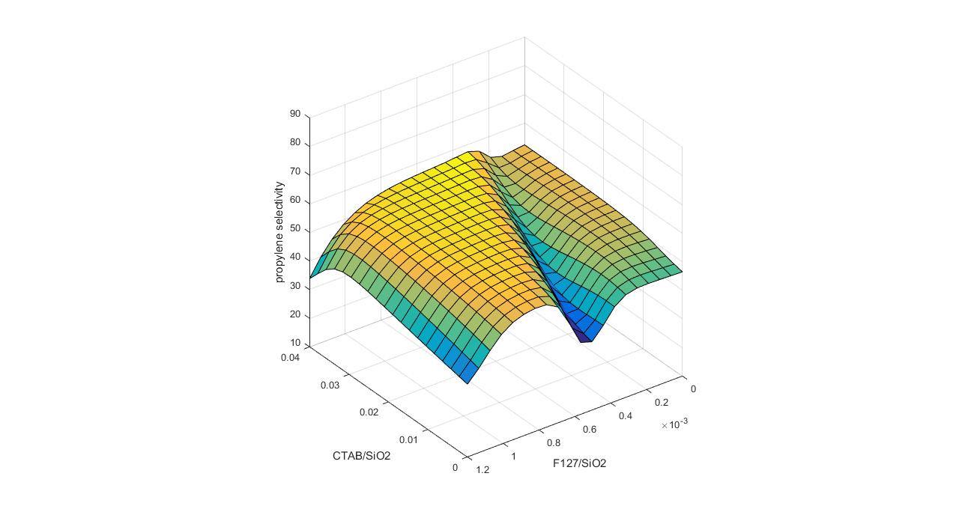
f
g
e
h
Fig. S3 Methanol conversion and propylene selectivity against variables;
(a) Temperature and WHSV,
(b) TPABr/SiO₂ and WHSV,
(c) F127/SiO₂ and WHSV,
(d) CTAB/SiO₂ and WHSV,
(e) Temperature and TPABr/SiO₂, (f) Temperature and CTAB/SiO₂, (g) TPABr/SiO₂ and CTAB/SiO₂, (h) CTAB/SiO₂ and F127/SiO₂

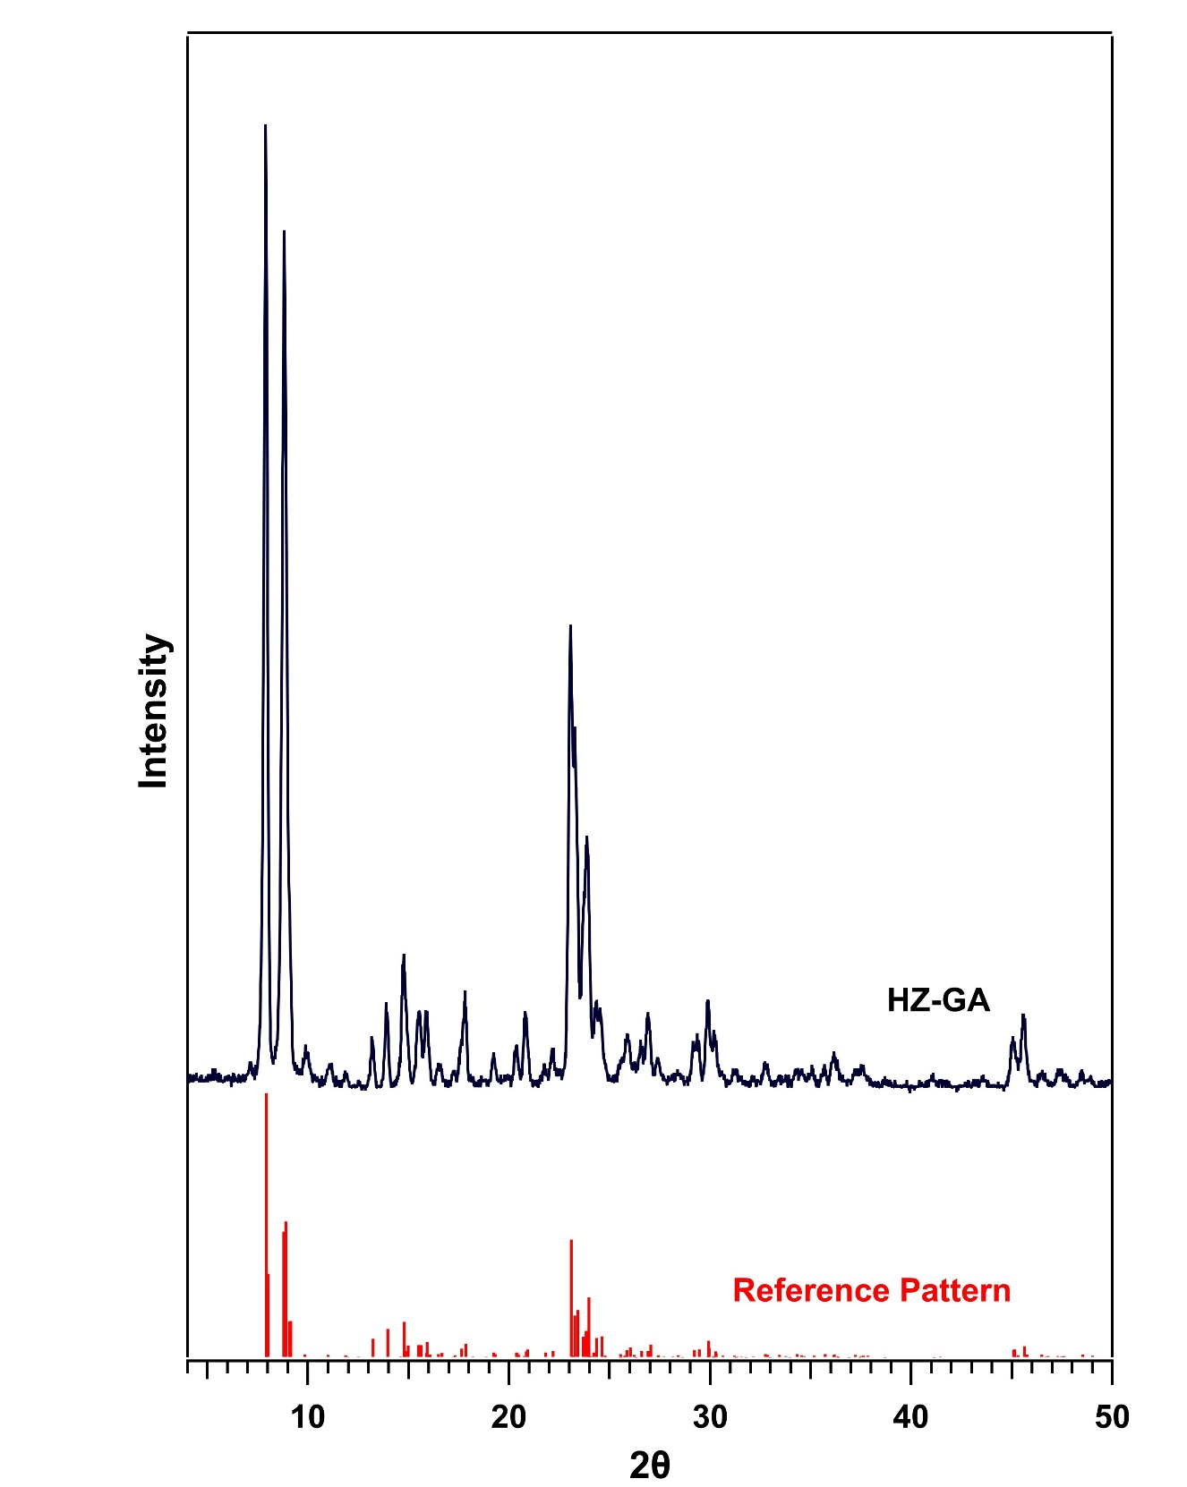
Fig. S4 XRD diffractions of HZ-GA Zeolite and reference pattern [1,2]

Fig. S5 (a) N₂ adsorption-desorption isotherm and (b) BJH pore size distribution of HZ-GA
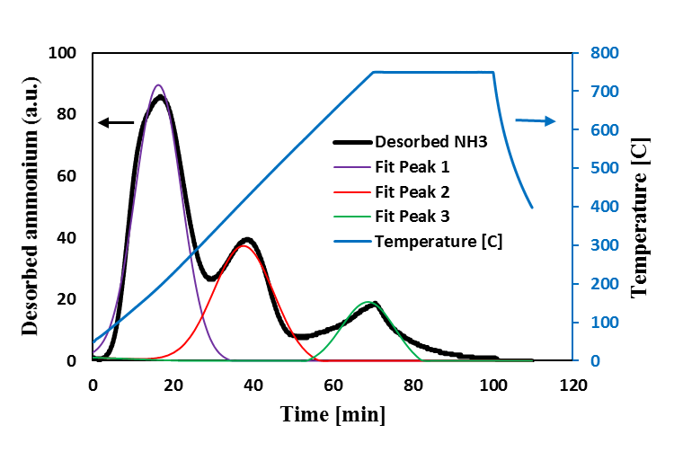
Fig. S6 NH₃-TPD profile of HZ-GA sample

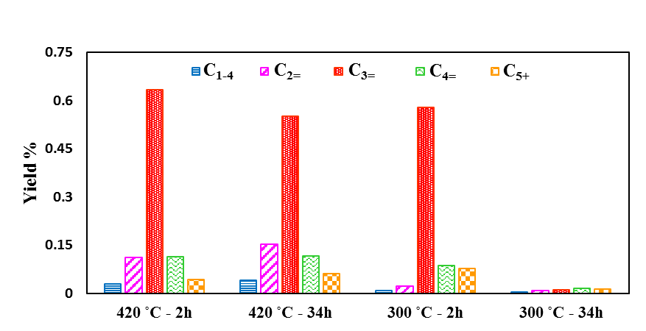
Fig. S7 Comparison of product yields on HZ-GA catalyst at temperatures of 300 ºC and 419 ºC after 2 h and 34 h of reaction time

∗ Corresponding Author(s) E-mail: a-farzi@tabrizu.ac.ir, Phone: +98 4133392420 , Fax: +98 4133338497 aniaei@tabrizu.ac.ir, Phone: +98 4133392417 , Fax: +98 4133338497

