Supplementary Figures S1 to S31 for:

Multiregional transcriptomics identifies congruent consensus molecular subtypes with prognostic value beyond tumor heterogeneity in colorectal cancer

Jonas Langerud^{1,2}, Ina A. Eilertsen¹, Seyed H. Moosavi^{1,2}, Solveig M. K. Klokkerud¹, Ingeborg F. Backe^{1,3}, Merete Hektoen¹, Ole Sjo³, Marine Jeanmougin¹, Sabine Tejpar⁴, Arild Nesbakken^{2,3}, Ragnhild A. Lothe^{1,2}, Anita Sveen^{1,2}

¹Department of Molecular Oncology, Institute for Cancer Research, Oslo University Hospital, Oslo, Norway
²Institute of Clinical Medicine, Faculty of Medicine, University of Oslo, Oslo, Norway
³Department of Gastrointestinal Surgery, Oslo University Hospital, Oslo, Norway
⁴Molecular Digestive Oncology, Department of Oncology, Katholieke Universiteit Leuven, Leuven, Belgium

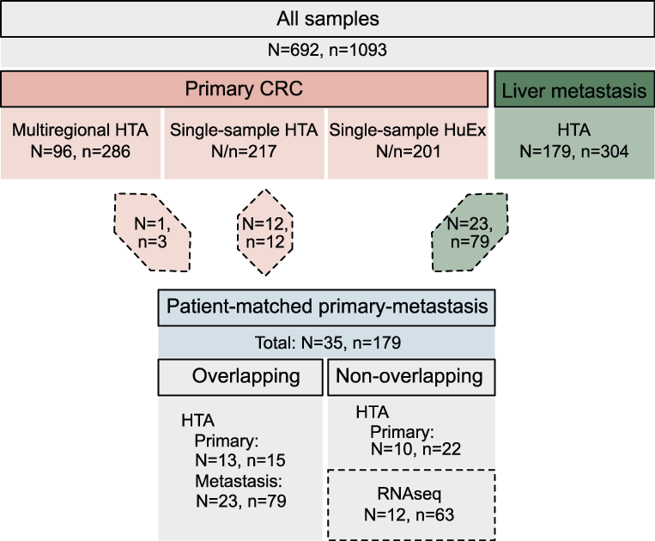

Figure S1. Overview of sample sets and gene expression platforms
Overview of the in-house sample sets analyzed in the study, indicating sample type (primary CRC or liver metastasis) and gene expression platform (HTA or HuEx microarrays or RNA sequencing, RNAseq). Upper case N indicates the number of patients and lower case n the number of samples. Diamond shaped arrows indicate samples included also for patient-matched primary-metastasis comparisons (all overlapping samples were analyzed on HTA), while the remaining matched samples (HTA or RNAseq) were included only for longitudinal comparisons.

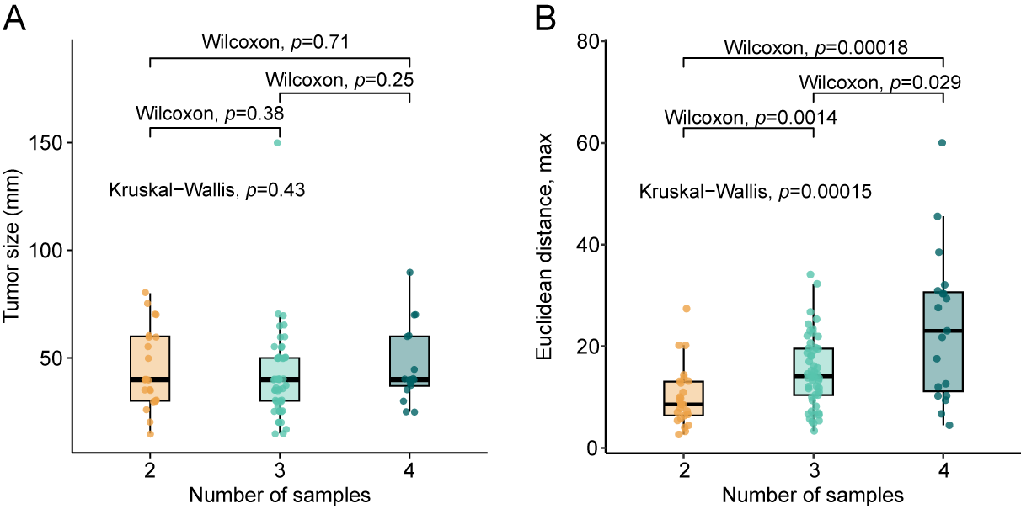

Figure S2. Relationship between sample number, tumor size and general transcriptomic heterogeneity in the multiregional sample set.
Boxplots of A) tumor size (mm) and B) general transcriptomic heterogeneity (estimated as the maximum Euclidean distance of principal components 1-3) according to the number of multiregional samples taken from each of 98 primary tumors. Pairwise Wilcoxon test p-values between groups are shown in addition to the global Kruskal-Wallis test.

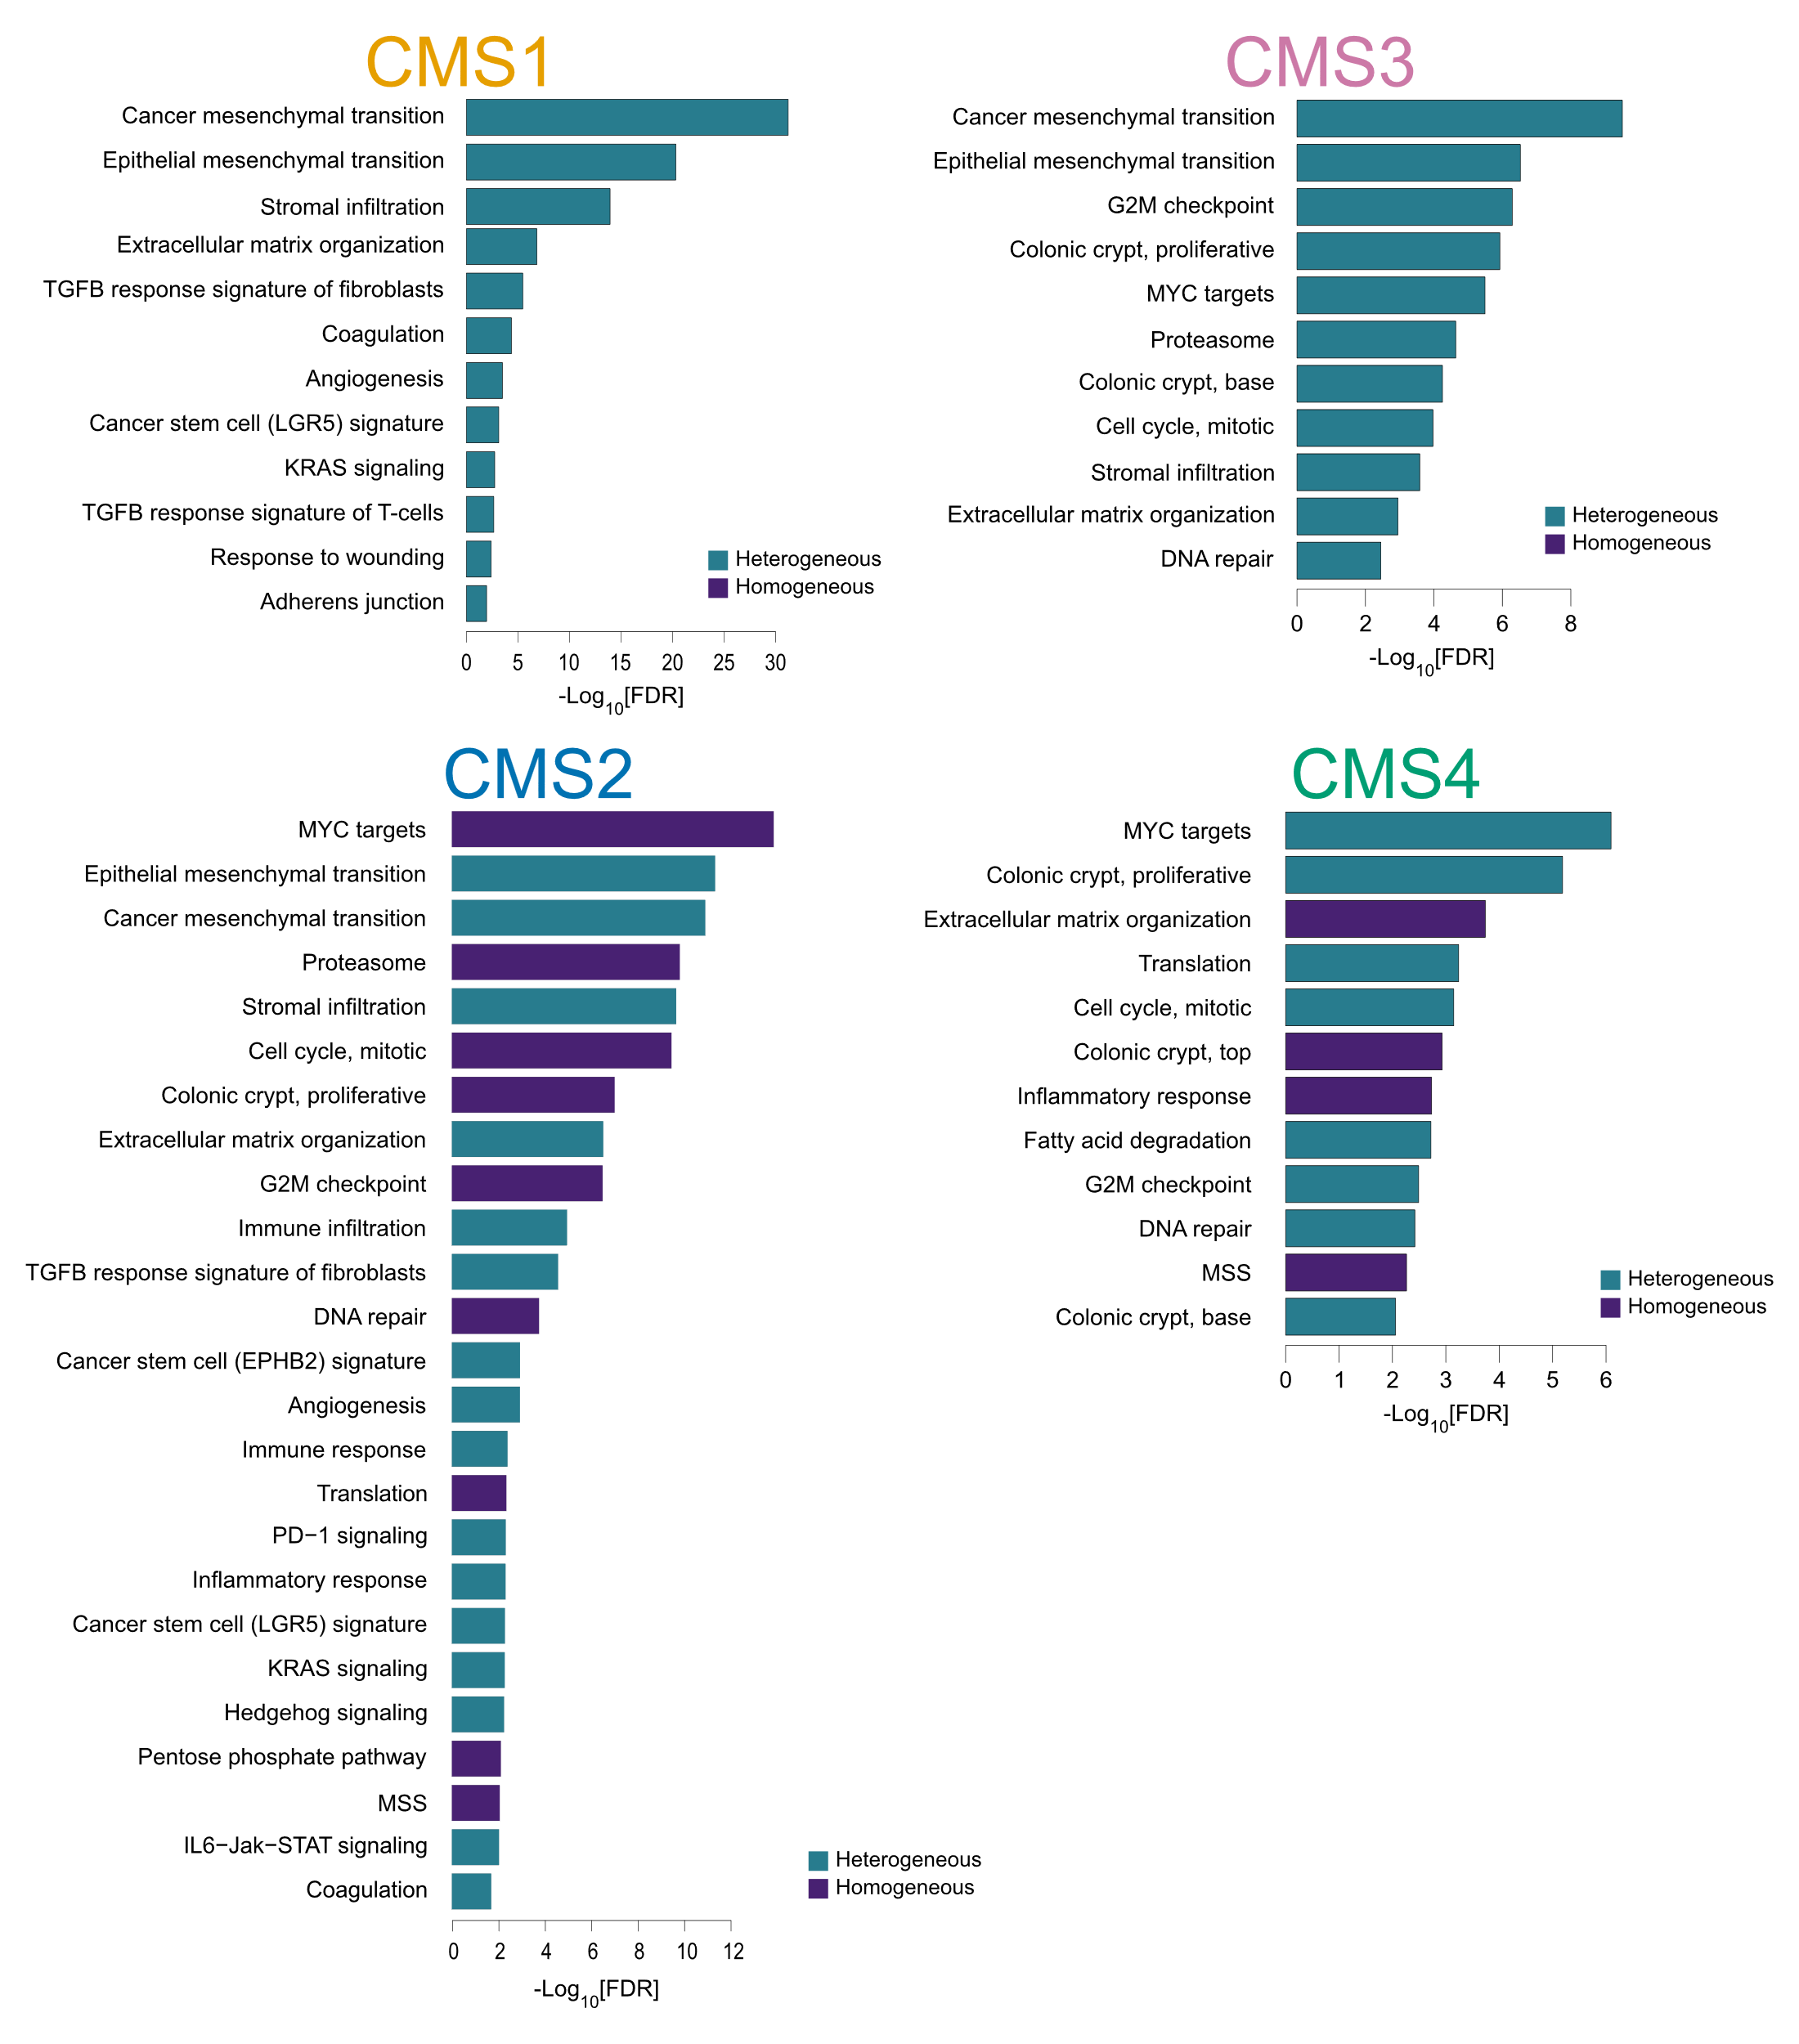

Figure S3. Gene set enrichment analyses of heterogeneous versus homogeneous tumors for each CMS group in the multiregional sample set
Bar plots of adjusted p-values (log10-scale) for significant results (FDR < 0.05) from gene set enrichment analyses of tumors with homogeneous versus heterogeneous CMS classifications, performed within each of the CMS groups separately on the custom gene set collection (n = 54). Unclassified tumors and tumors with undetermined CMS-heterogeneity were excluded (total n = 266, n_{CMS1} = 79, n_{CMS2} = 115, n_{CMS3} = 29 and n_{CMS4} = 43).

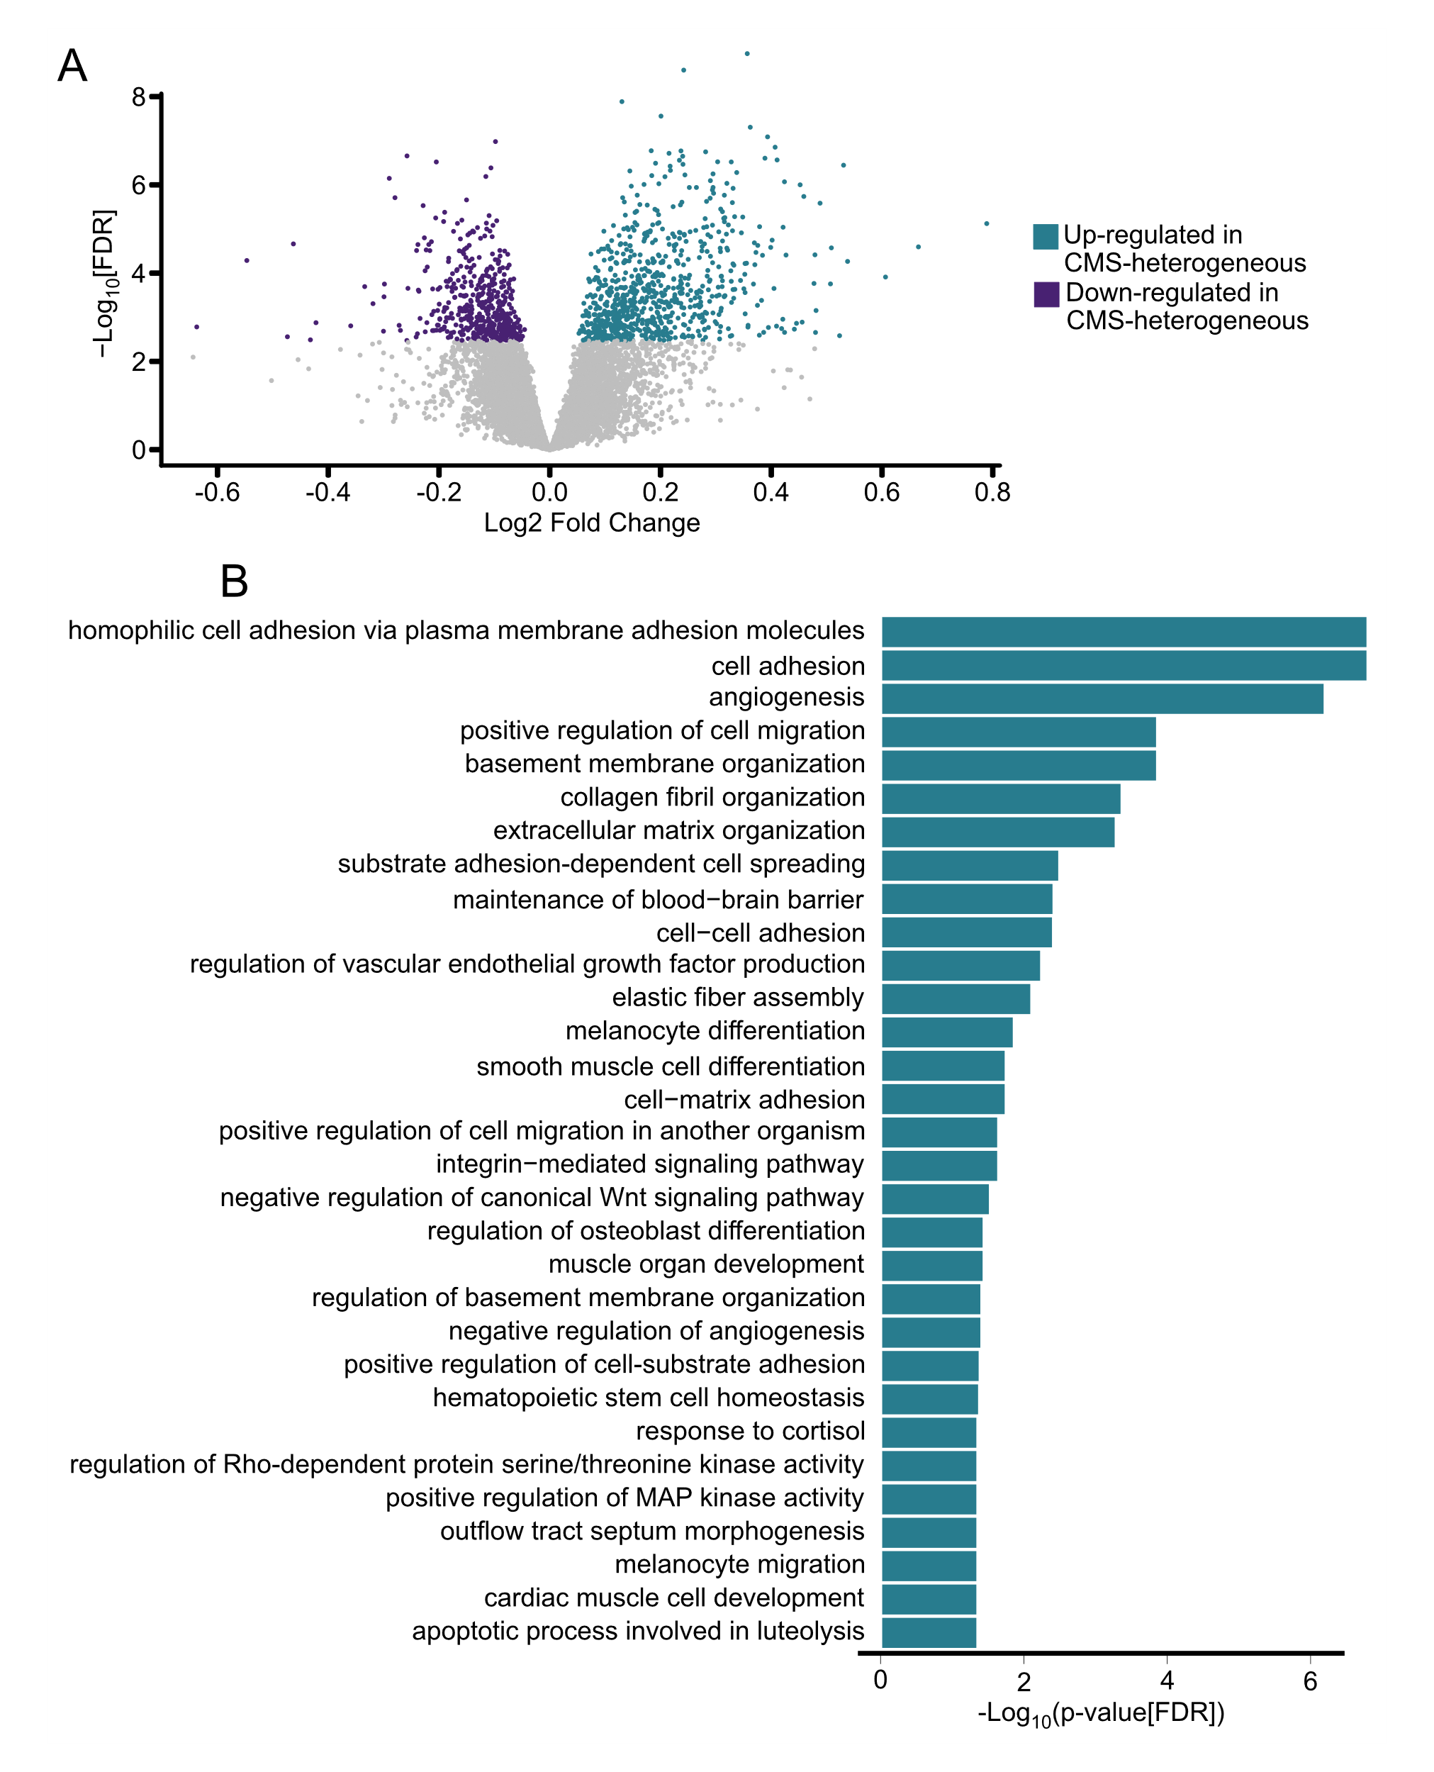

Figure S4. Differentially expressed genes between tumors in the multiregional sample set with heterogeneous versus homogeneous CMS classifications
A) Volcano plot of differentially expressed genes (n_{up} = 805, n_{down} = 537; FDR < 0.05) between tumors with heterogeneous compared to homogeneous intra-tumor classifications of multiregional samples. B) Bar plot of significant (FDR < 0.05) enrichments among TopGo ‘biological process’ terms for genes up-regulated in tumors with CMS heterogeneity (no significant enrichments for down-regulated genes).

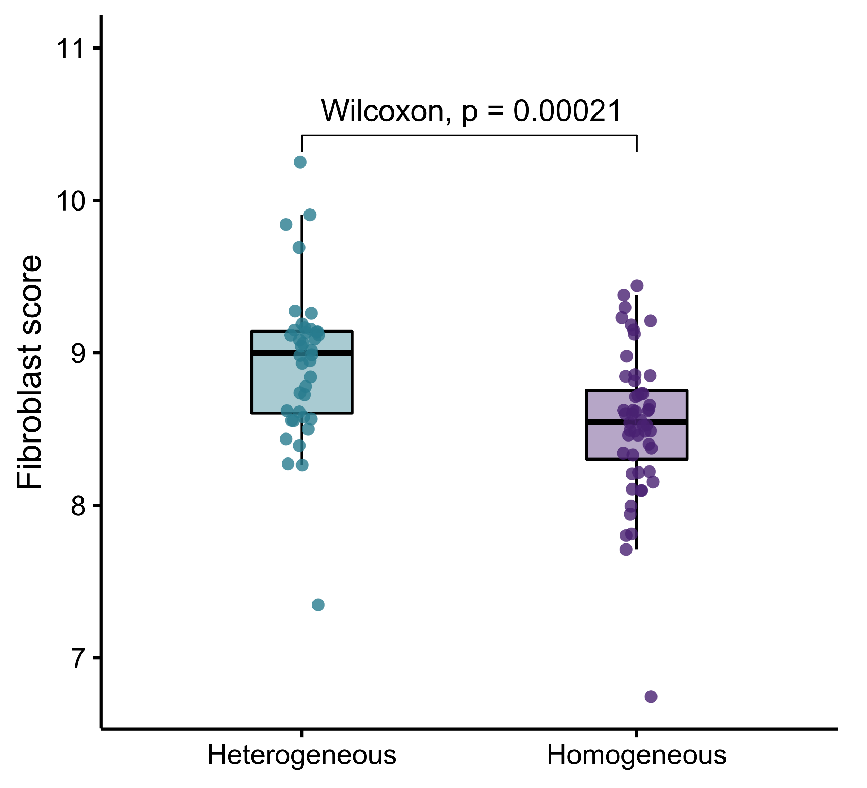

Figure S5. Abundance of cancer associated fibroblasts in tumors with homogeneous and heterogeneous CMS classifications of multiregional samples
Box plot of cancer-associated fibroblast scores of heterogeneous and homogeneous tumors (total n = 98 tumors; the highest scoring sample was plotted for each tumor).

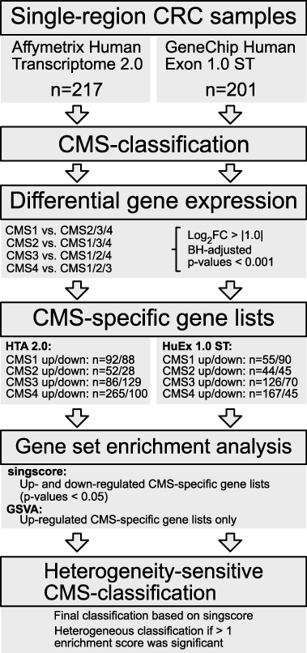

Figure S6. Overview of computational approach to estimate intra-tumor CMS heterogeneity in single samples of primary CRCs
Single samples from 418 primary tumors were classified using the original random forest CMSclassifier (posterior probability threshold 0.4). HTA and HuEx samples were analyzed separately. Differential gene expression analysis of each CMS class was used to identify CMS-specific gene lists. Gene set enrichment analysis of each CMS-specific gene list in each sample was performed with two algorithms and singscore was used for further analyses. Samples with significant enrichments for more than one CMS class (singscore p < 0.05) were considered to have intra-tumor CMS heterogeneity.

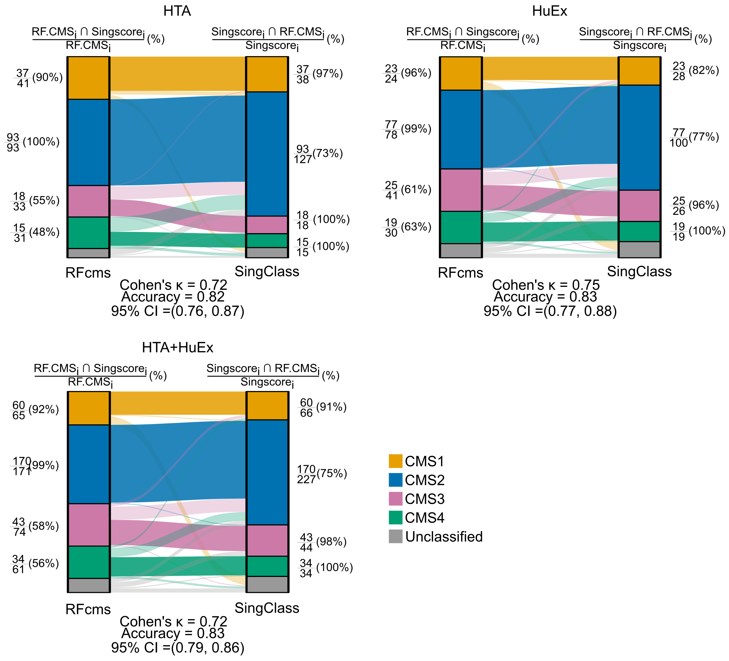

Figure S7. Concordance of CMS classification according to the original classifier and singscore enrichments in the single-sample primary tumor set
Alluvial plots are shown for tumors analyzed on HTA arrays (left; n = 217), HuEx arrays (right; n = 201) and both combined (bottom; n = 418). Cohen’s kappa and accuracy with 95% CI is indicated for all sample sets. Colors are according to the original CMS classification and the CMSclassifier using a posterior probability threshold of 0.4.

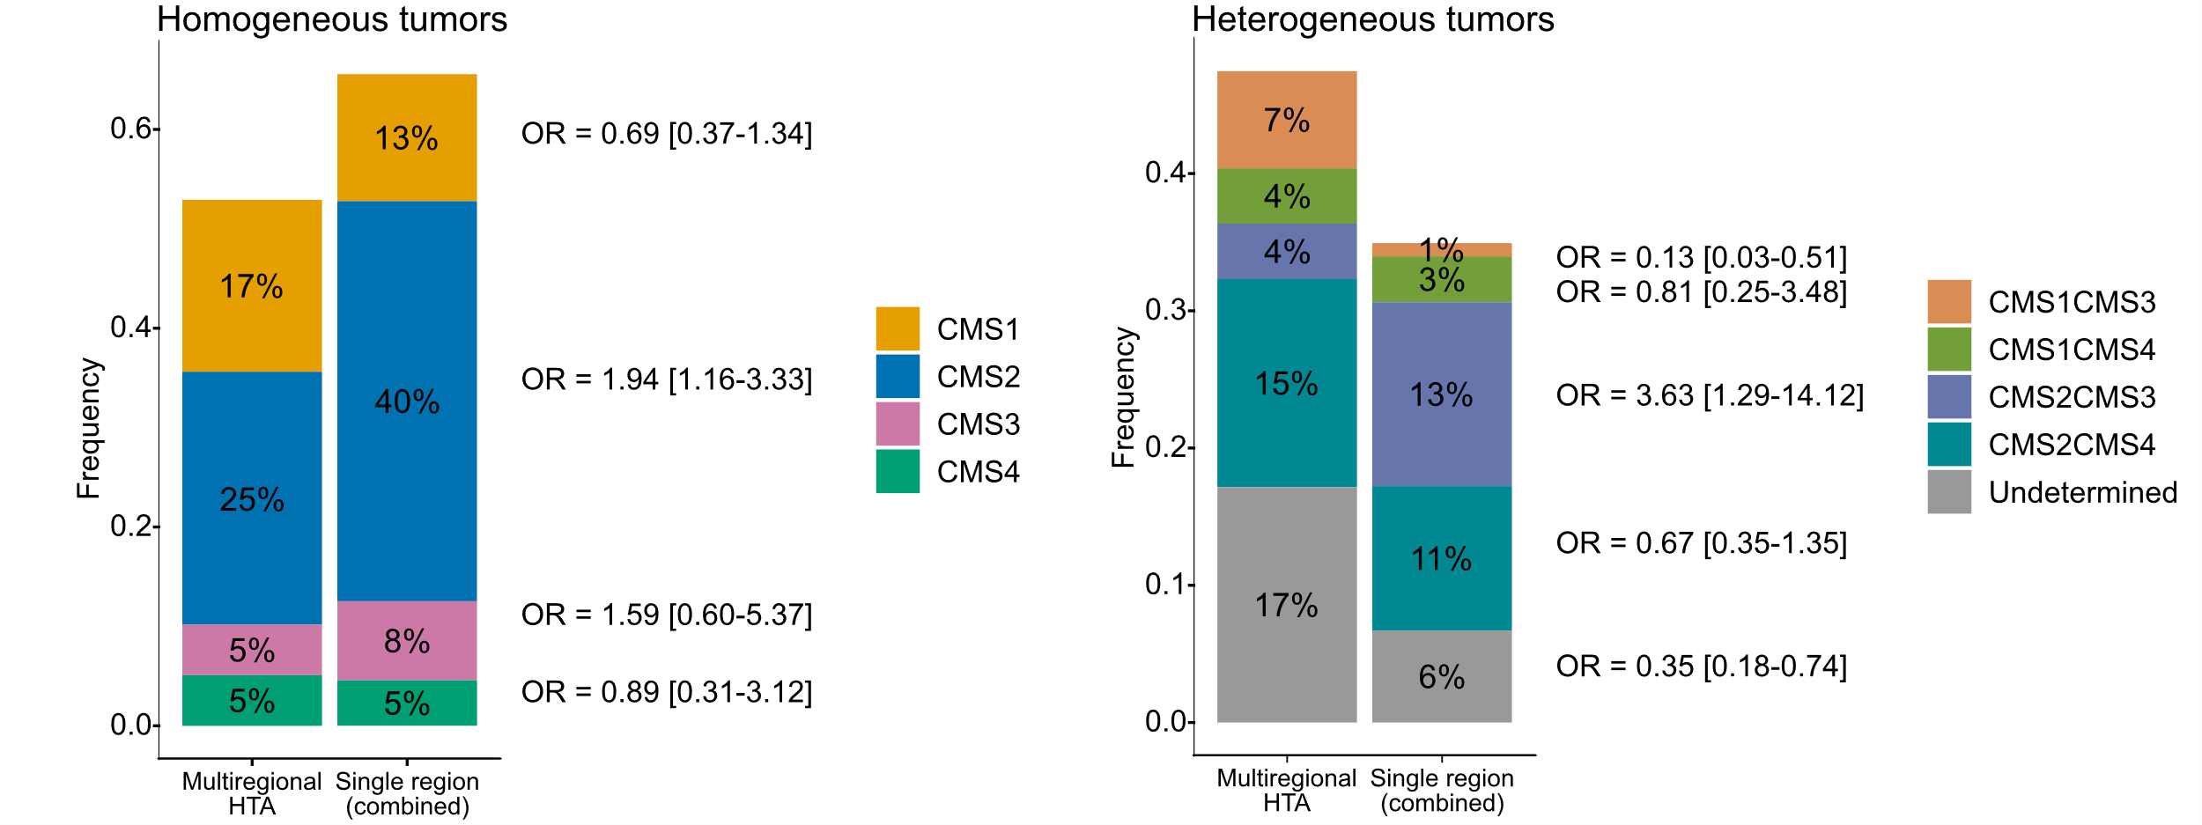

Figure S8. Frequencies of CMS classes in homogeneous tumors and CMS combinations in heterogeneous tumors
Frequencies are plotted for the multiregional sample set (n = 98 tumors; observed CMS heterogeneity) and single-sample primary tumors (n = 418; computational estimation of CMS heterogeneity) separately. Odds ratios (OR) with 95% confidence intervals were calculated by Fisher’s exact test.

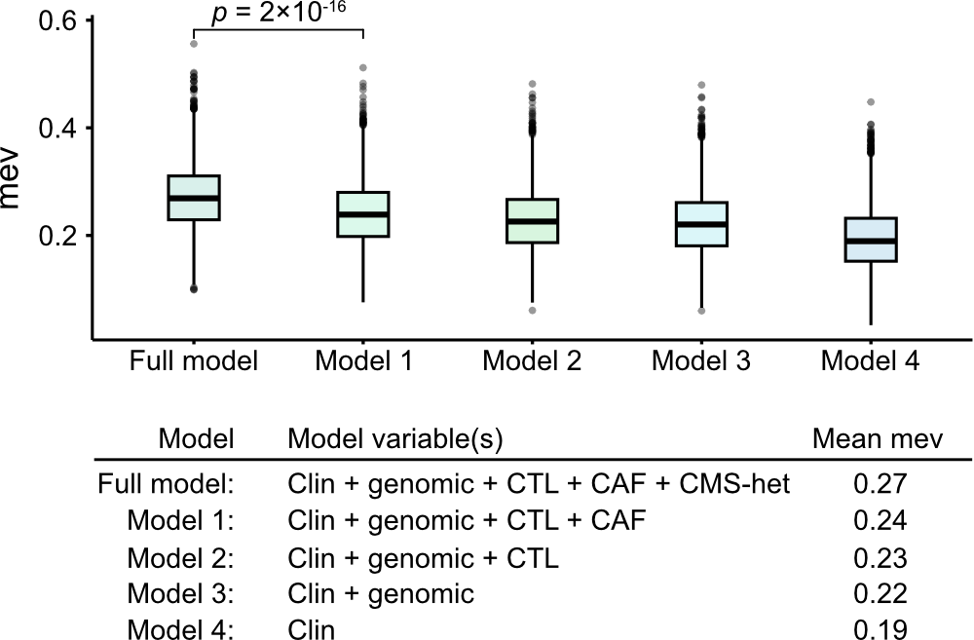

Figure S9. Explained variation in five-year relapse-free survival of multivariable Cox proportional hazards models
Boxplot of bootstrapped measures of explained variation (mev) for Cox proportional hazards models including the following variables: Clin, clinicopathological parameters (age, sex, TN stage, localization, adjuvant chemotherapy); genomic (MSI/KRAS/BRAF-status); CTL, cytotoxic lymphocyte score; CAF, cancer-associated fibroblast score; CMS-het, CMS heterogeneity.

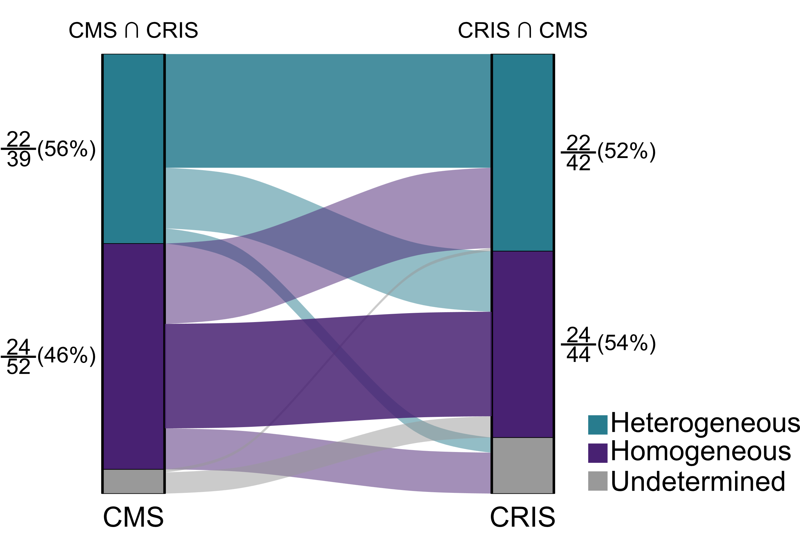

Figure S10. Limited concordance in intra-tumor heterogeneity according to CMS and CRIS
Alluvial plot illustrates the limited overlap of tumors classified as heterogeneous or homogeneous in the CMS and CRIS frameworks. The overlap (CMS ∩ CRIS or CRIS ∩ CMS) is indicated relative to the total number of tumors per group.

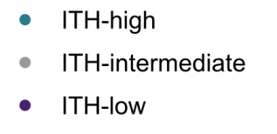
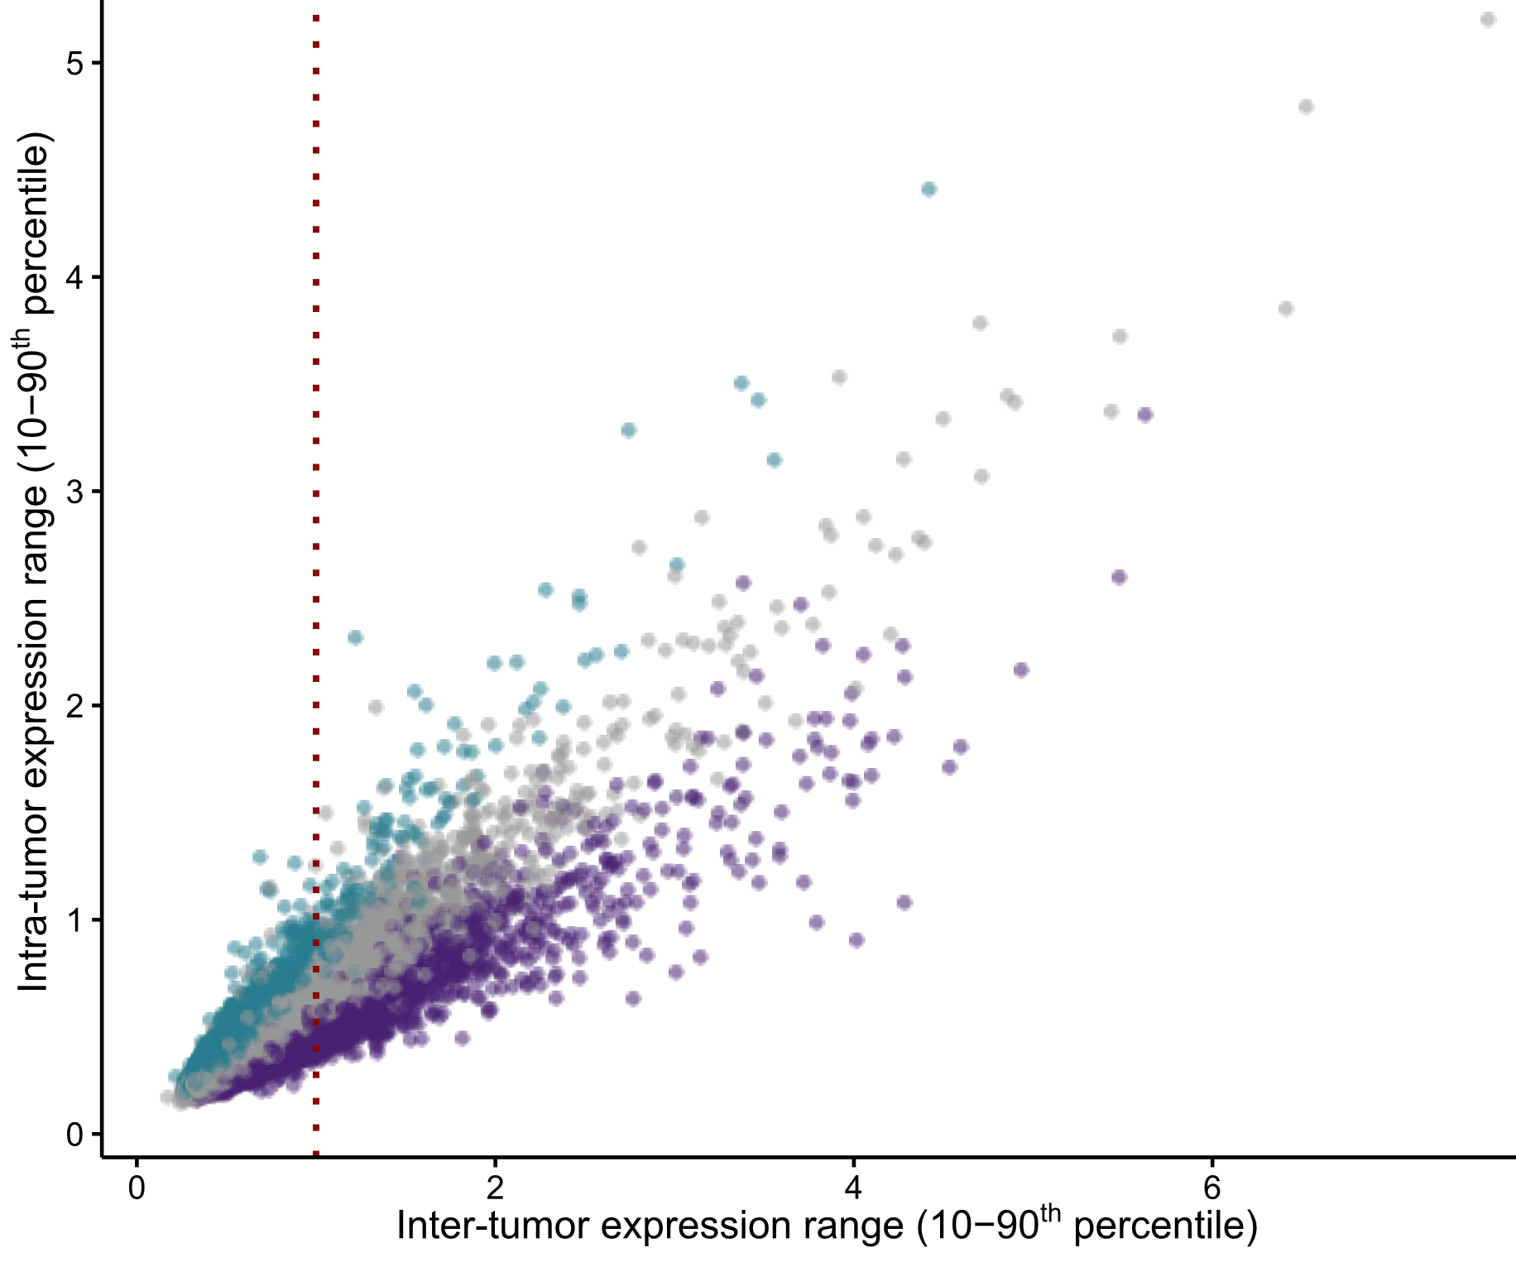

Figure S11. Intra-tumor versus inter-tumor expression variation of genes in the multiregional sample set
Scatterplot of the intra-tumor versus inter-tumor expression range (10-90th percentile range) of all genes (n = 18,823). Genes are colored according to three categories of intra-tumor heterogeneity, based on the custom thresholds for the ITH-score. The vertical red dashed line indicates the threshold for filtering of genes based on inter-tumor variability (10-90th percentile range of 1).

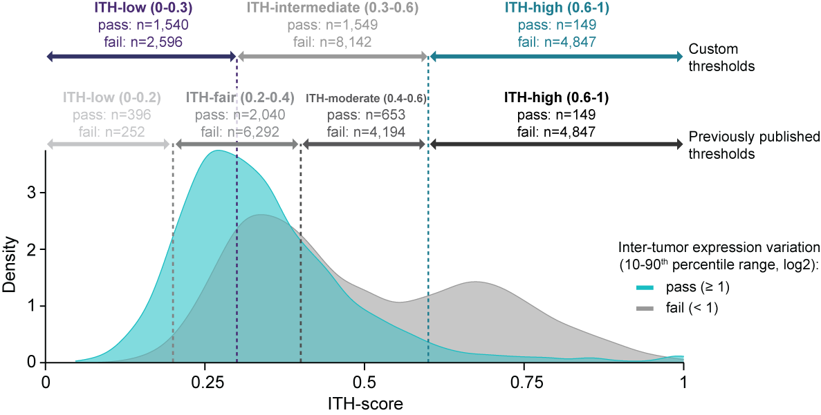

Figure S12. Distribution of genes according to ITH-score
Density plot of ITH-scores of all genes (n = 18,823) grouped according to the inter-tumor expression variation filter (10-90th percentile range above or below 1). Categorization of genes according to the ITH-score using custom and previously published thresholds (Gyanchandani et al. Clin Cancer Res 2016;22:5362-9) are indicated by dashed lines. The number of genes that passed or failed the inter-tumor expression variation threshold is indicated for all groups.

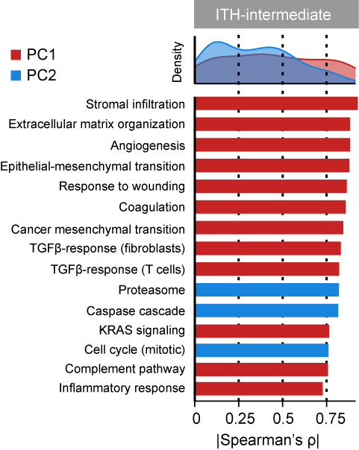

Figure S13. Gene set correlations of ITH-intermediate genes
Density plots (upper: all gene sets) and bar plots (lower: 15 top-ranked gene sets) of Spearman’s correlation coefficients (absolute values) between principal components (PC1 or PC2) of ITH-intermediate genes and single-sample enrichment scores of significantly correlated gene sets (p < 0.05) in the multiregional sample set (n = 286 primary tumor samples).

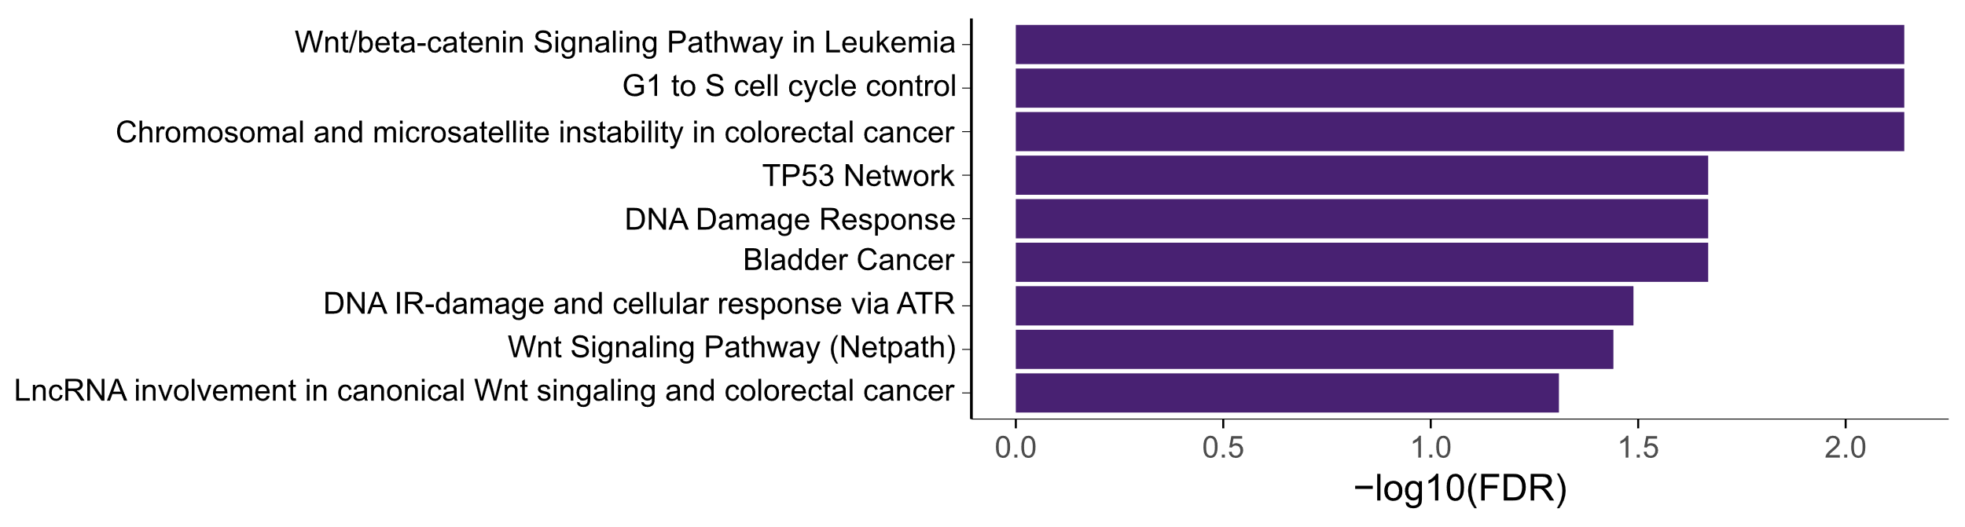

Figure S14. Gene set overrepresentation analysis of cancer-critical genes in the ITH-low category
Pathways from the Wikipathway cancer database significantly over-represented (FDR < 0.05) among ITH-low cancer-critical genes (genes included in the Cancer Gene Census). No significant over-representation was found for ITH-high and ITH-intermediate genes.

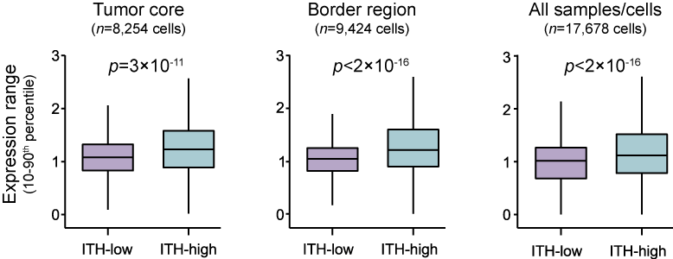

Figure S15. Validation of ITH-high and ITH-low gene categories in single-cell RNA sequencing data
Single-cell RNA sequencing data of 12 paired samples from 6 primary CRCs (representing the tumor core and border regions) were downloaded from GSE144735. Boxplots show the 10-90th percentile expression range of ITH-high and ITH-low genes in cells from the tumor core, border regions and both (p-values from Welch’s t-tests).

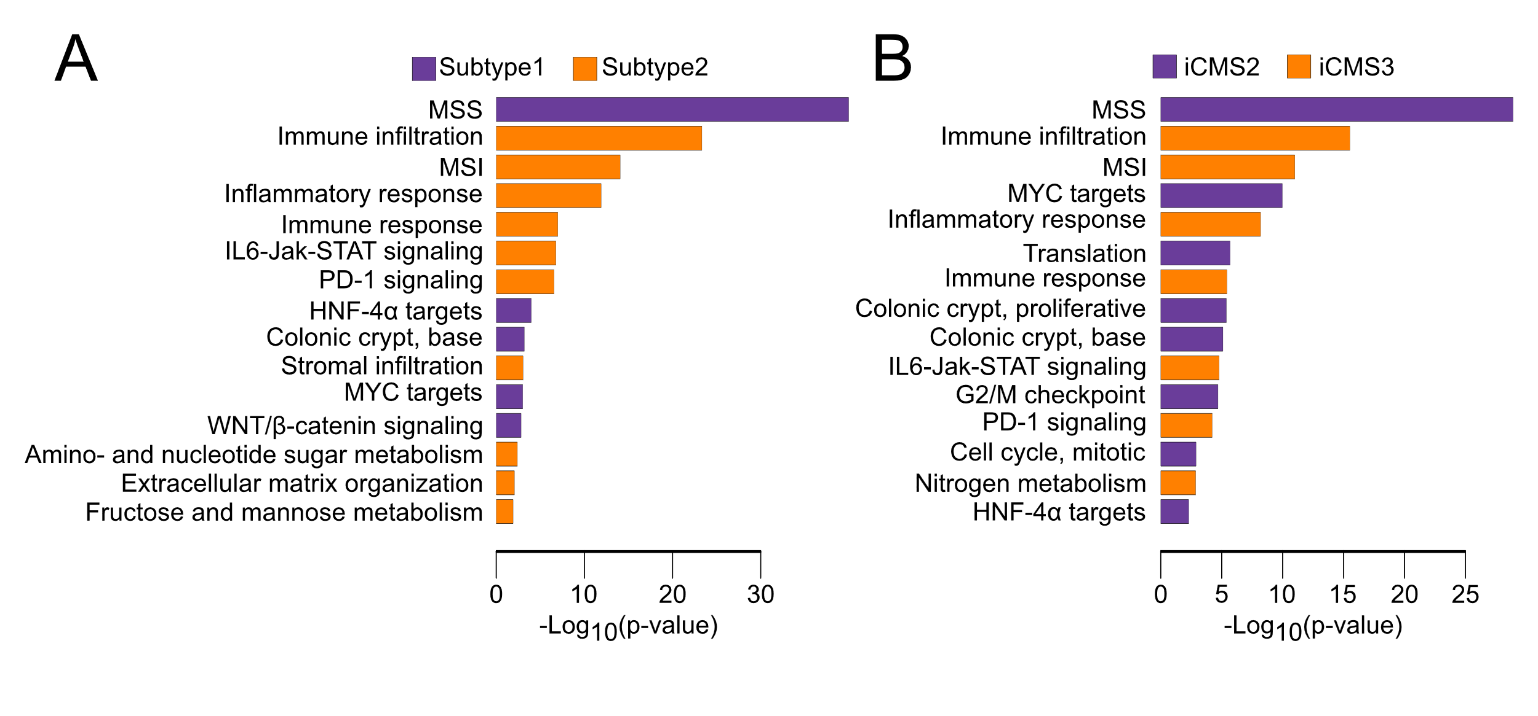Figure S16. Gene set enrichment analyses of subtypes in the k2 (ITH-low) and iCMS frameworks
Barplots of the 15 top-ranked gene sets (according to significance) from a custom gene set collection (n = 54) between subtypes of primary CRCs classified according to A) k2 from NMF of ITH-low genes (n = 704 classified samples) and B) iCMS (n = 643 classified samples).

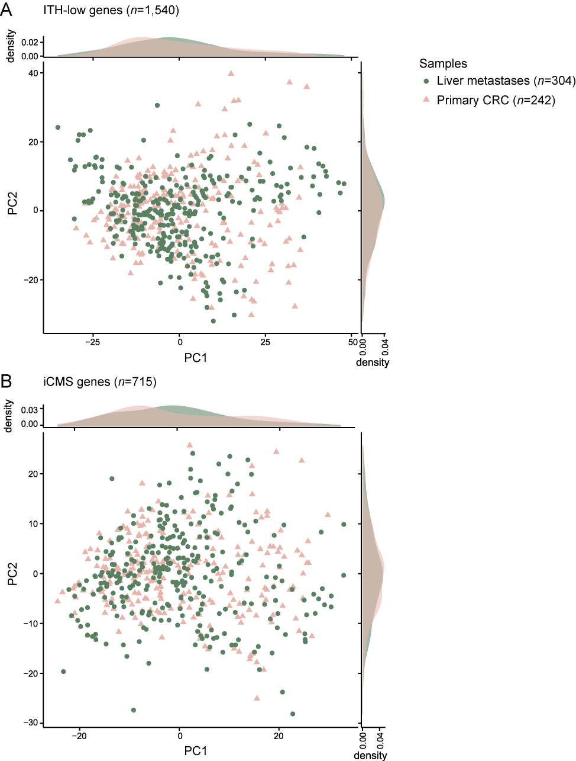

Figure S17. Principal components analysis of primary CRC and liver metastasis samples
PCA plot based on of A) ITH-low genes (from multiregional primary tumor samples) and B) iCMS template genes. Density plots show the distribution of PC1 and PC2 for primary CRC (pink) and liver metastases (green) samples separately.

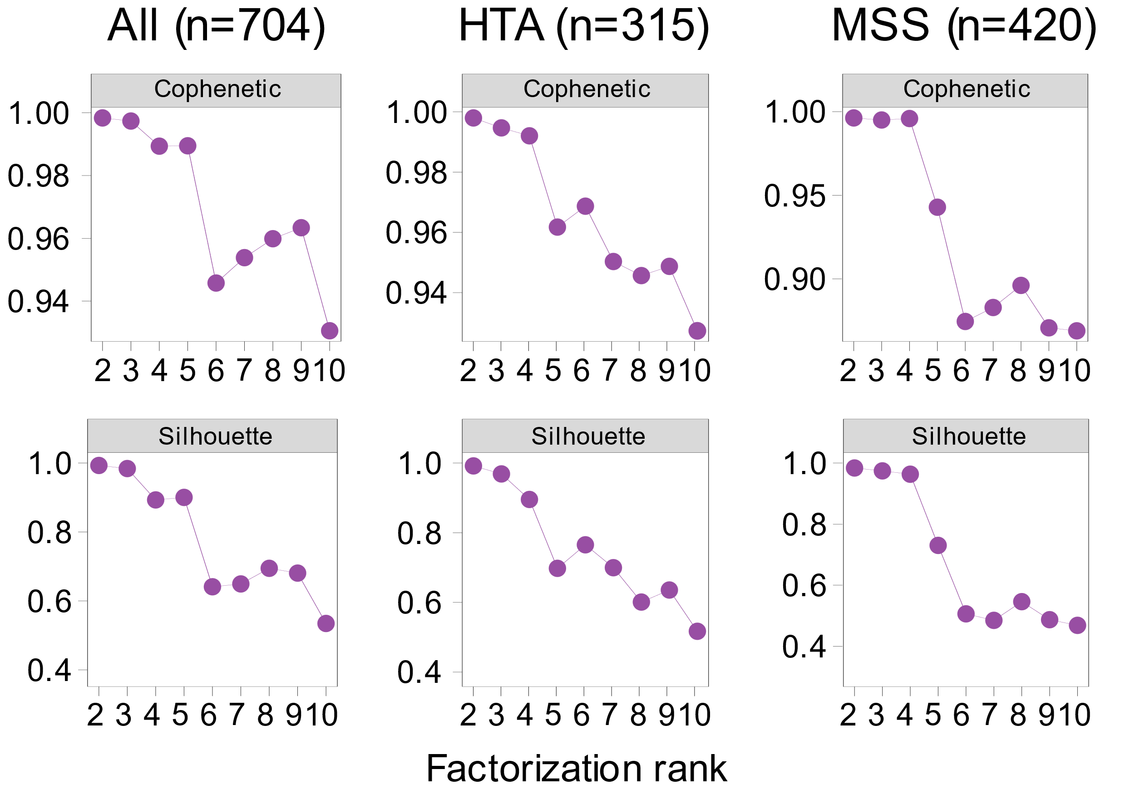

Figure S18. Cophenetic and silhouette scores from NMF clustering of different sample sets with a predefined interval of factorization ranks
Three different sample sets were analyzed by NMF based on ITH-low genes, including all primary tumor samples (left), one randomly selected sample from each primary tumor analyzed on HTA only (middle), and one randomly selected sample from each primary MSS tumor (HTA and HuEx; right).

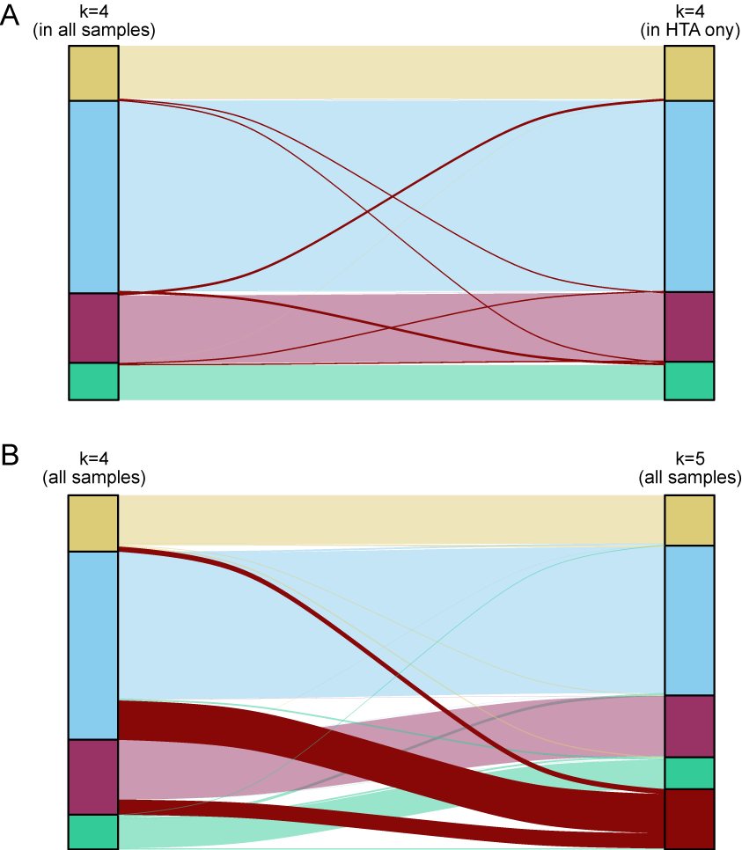

Figure S19. Alluvial plots of concordance in NMF classification between sample sets
A) Sample clustering at k=4 in the complete primary tumor sample set (left) and single, randomly selected samples from each tumor analyzed on HTA (right). Only overlapping samples between data sets are plotted (n = 315 tumors) and discordant classifications are indicated in dark red. B) Sample clustering at k=4 (left) and k=5 (right) in the complete primary tumor sample set (n = 704 samples). The largest cluster from k=4 (blue) was primarily subdivided into two clusters (blue and red) at k=5.

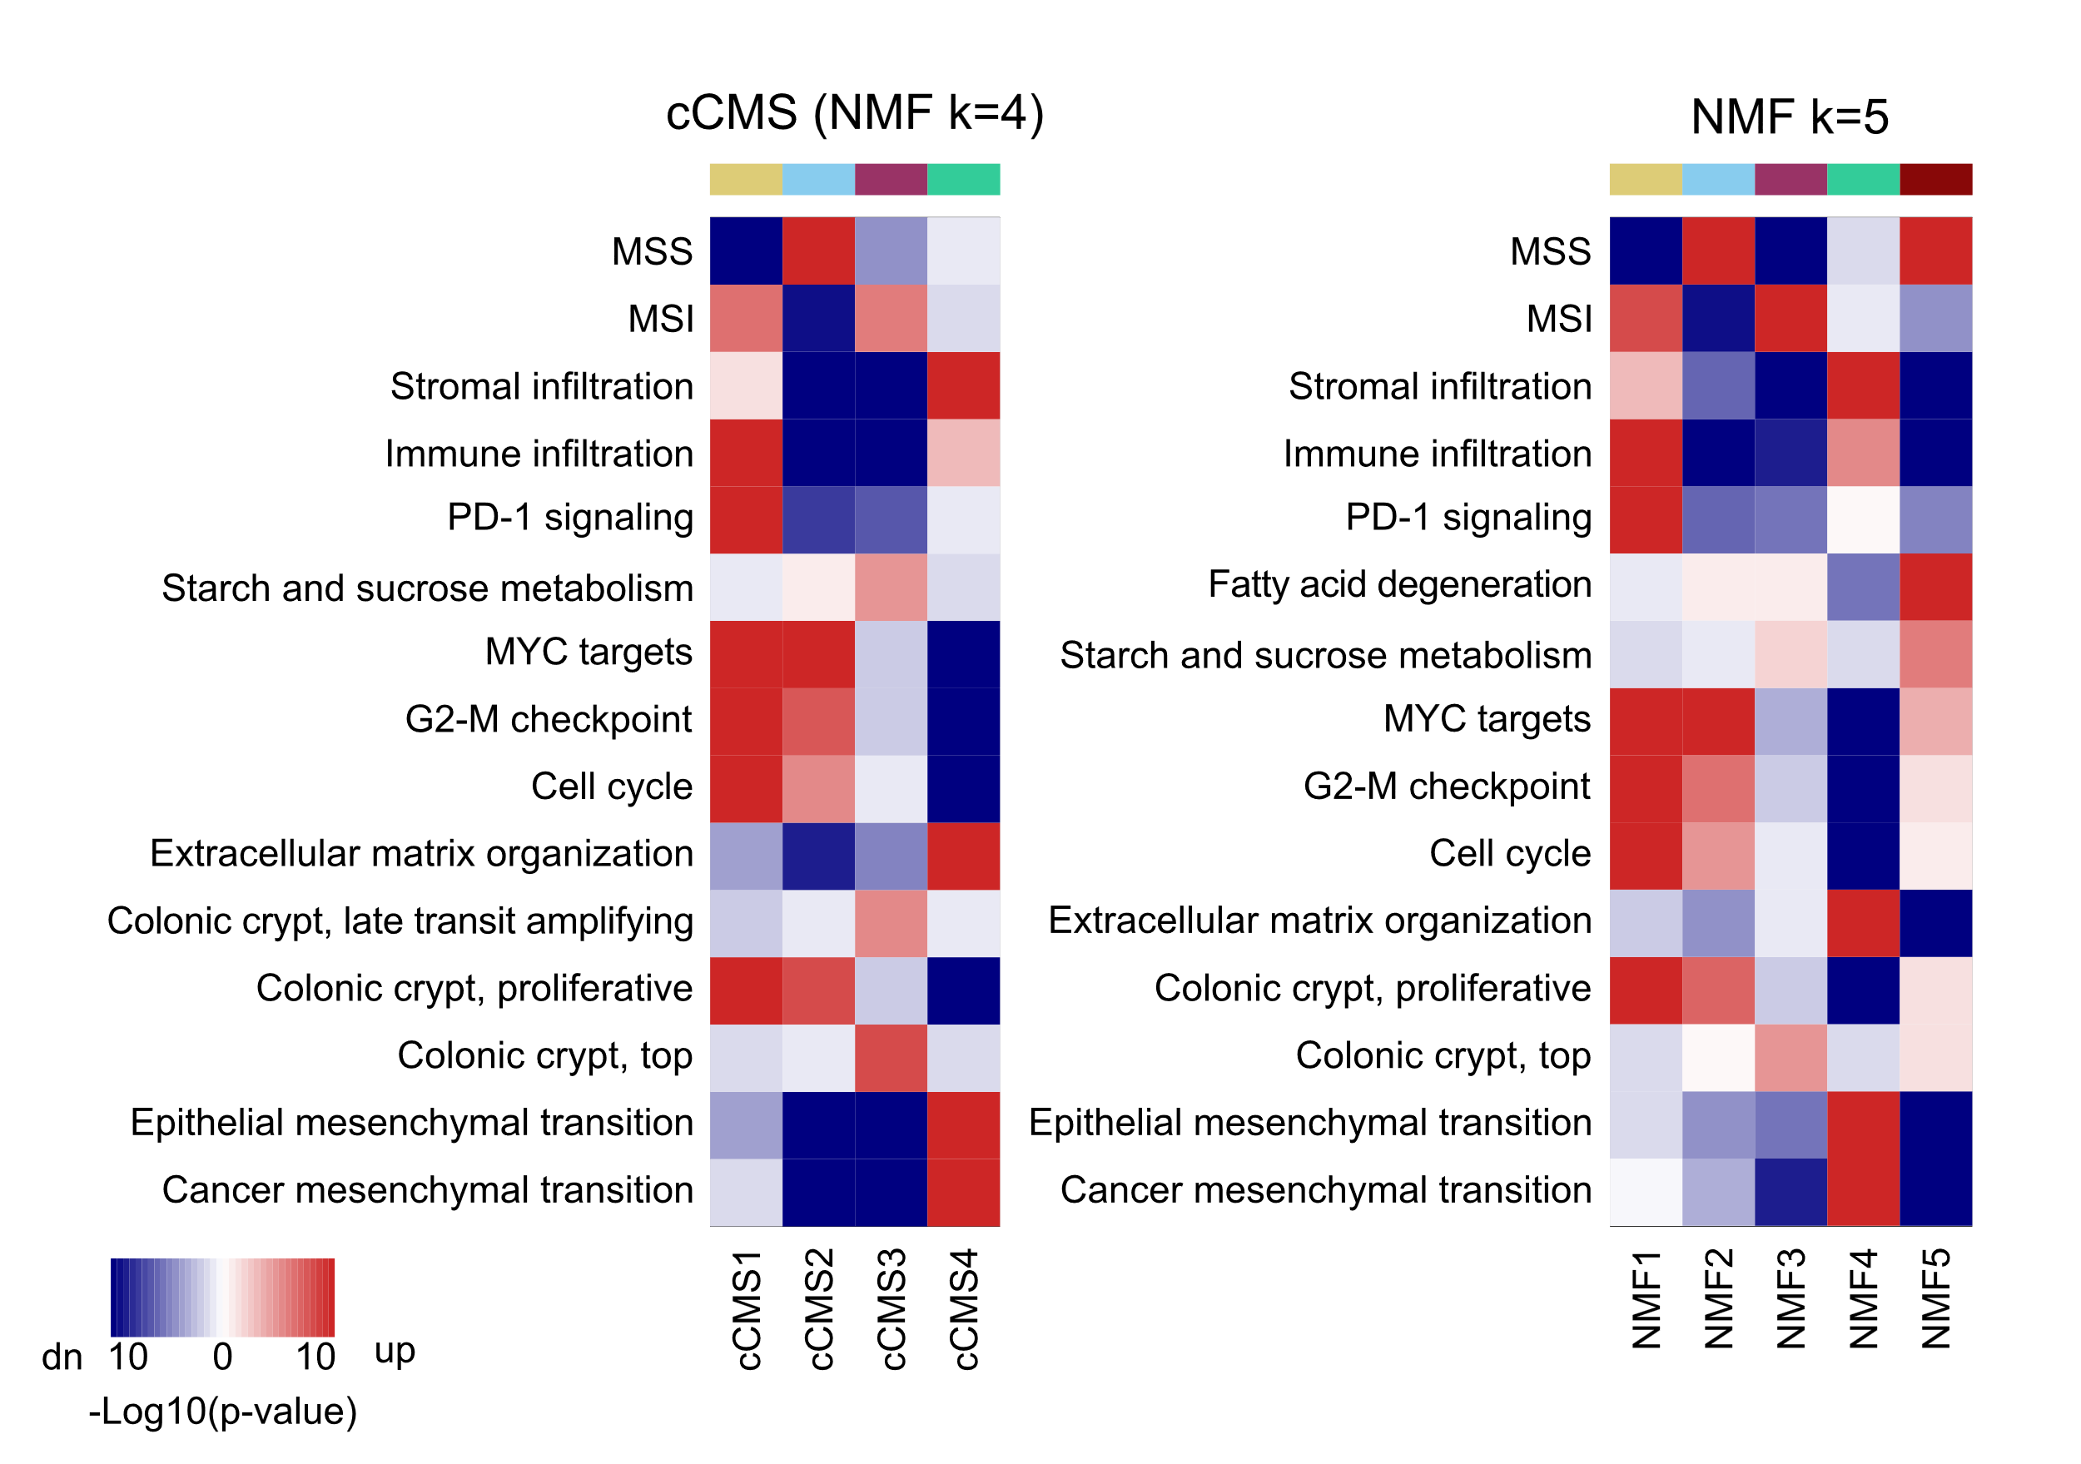

Figure S20. Gene set enrichment analyses of subtypes based on ITH-low genes
Heatmap of p-values (log10-scale) of significant enrichments (red: positive enrichments; blue: negative enrichments) from the custom gene set collection according to NMF classification at k=4 (cCMS) and k=5 clusters across all primary tumor samples (n = 704 samples from 516 tumors). The two clusters at k=5 (NMF2 and NMF5) that were subdivided from the blue cluster at k=4 (Supplementary Figure S19B) showed highly similar gene expression enrichments.

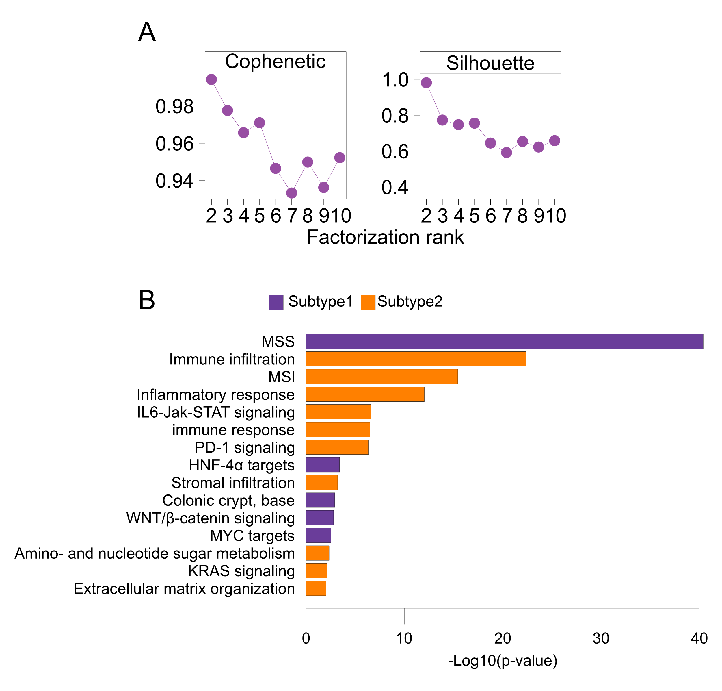

Figure S21. NMF classification based on ITH-low genes defined by previously published threshold
NMF was also tested on all primary tumor samples based on ITH-low genes defined as ITH-score ≤ 0.2 (n = 396 genes). A) Both the cophenetic coefficient (left) and silhouette width (right) indicated k=2 as the optimal number of sample clusters. B) Bar plot of top 15 gene sets (ranked based on significance) from enrichment analysis of the custom gene set collection comparing the two sample clusters. MSS-like and MSI-like expression characteristics were the main discriminatory features between the sample clusters.

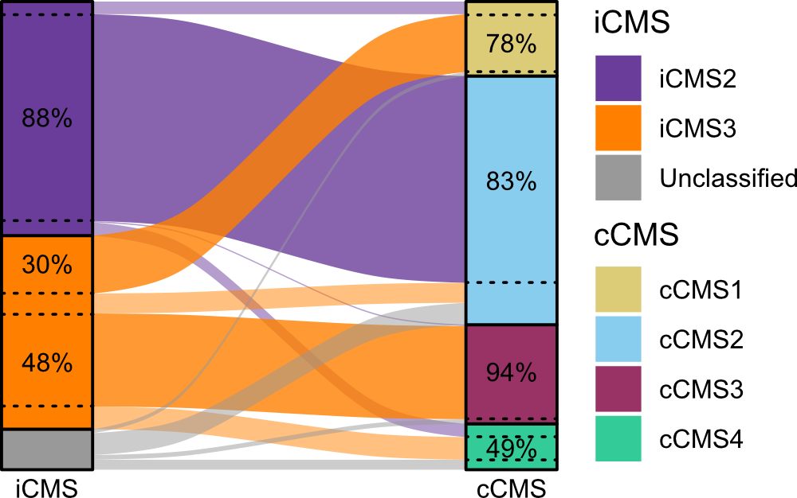

Figure S22. Classification concordance between iCMS and cCMS
Alluvial diagram illustrating concordance of iCMS and cCMS classifications in the complete primary tumor series (n = 704 samples). The sample overlap is indicated relative to the total sample number per subtype. 9% of samples were unclassified for iCMS.

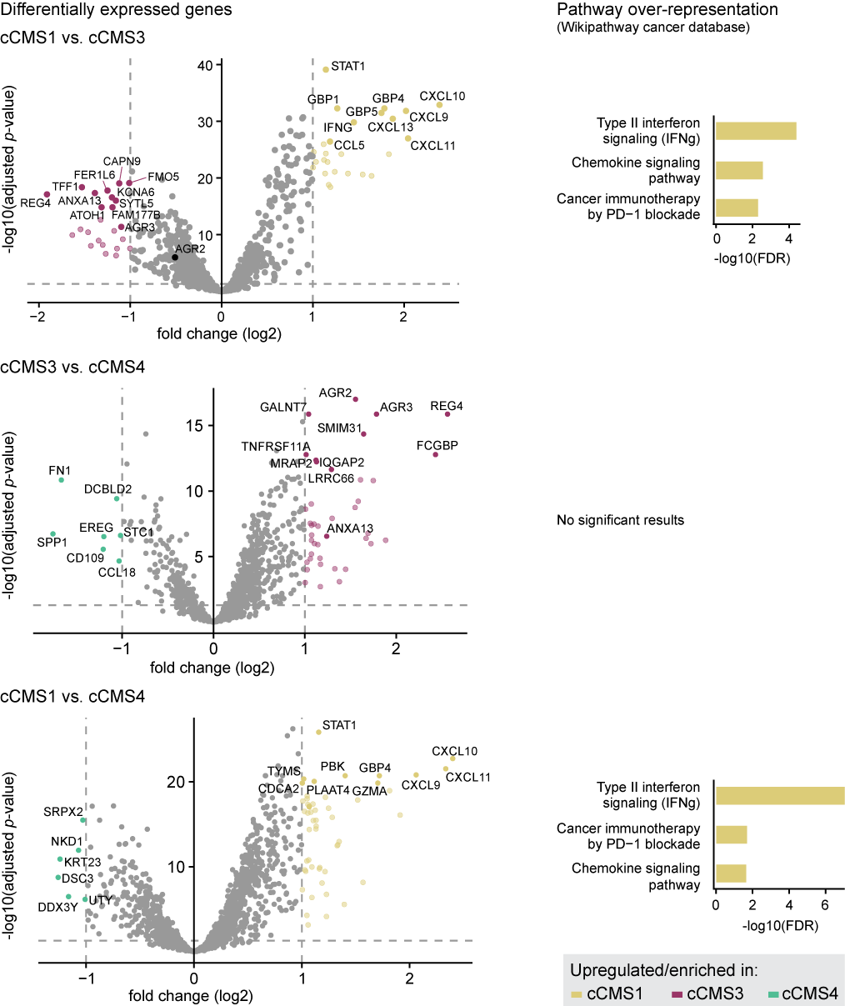

Figure S23. Differential expression of ITH-low genes among sample clusters split from the k2 cluster corresponding to iCMS3
The k2 sample cluster corresponding to iCMS3 were split into the k4 clusters cCMS1, cCMS3 and cCMS4 (Fig. 5B). Volcano plots (left) illustrate results from differential expression analysis of ITH-low genes between the sample groups as indicated. Genes with significant differential expression (adjusted p-value < 0.05 and log2 fold change>|1|; indicated by dashed lines) are highlighted by corresponding colors. Top ten (by adjusted p-value) and selected genes are annotated. Barplots (right) show all significant pathway enrichments (FDR < 0.05) of the differentially expressed genes in the Wikipathway cancer database, evaluated by the WEB-based Gene SeT AnaLysis Toolkit.

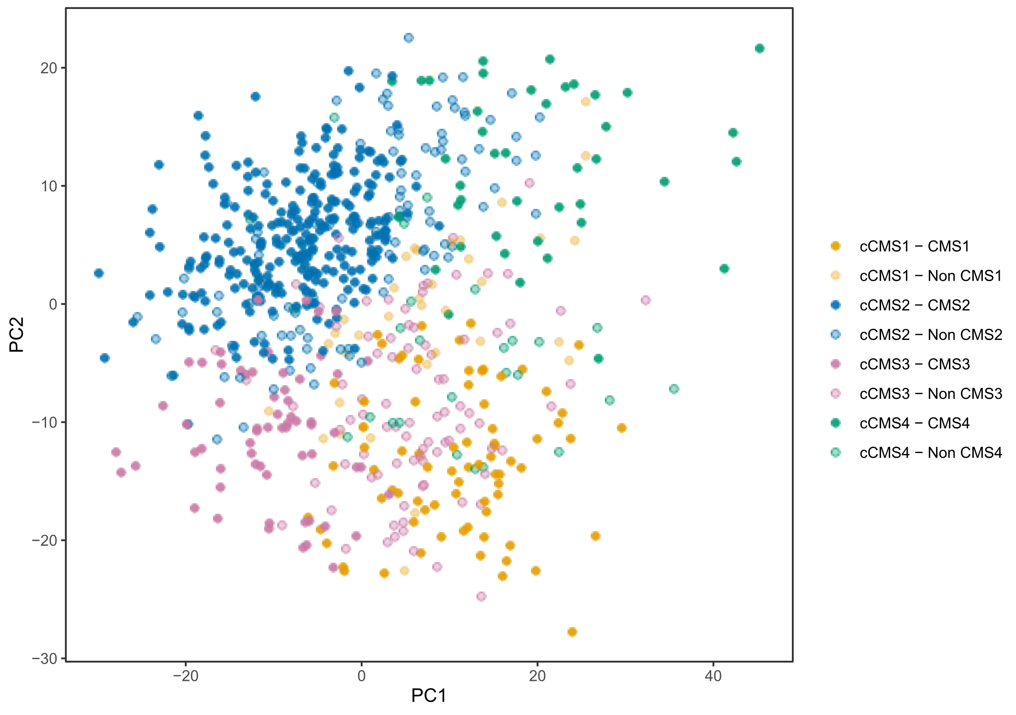Figure S24. PCA plot of the 1,000 most variable genes across all primary tumor samples (n = 704)
Samples are colored according to cCMS and CMS classifications. Samples with discordant classifications between the two frameworks are colored with lower opacity (for example, cCMS1 samples that are not CMS1 are colored in transparent yellow).

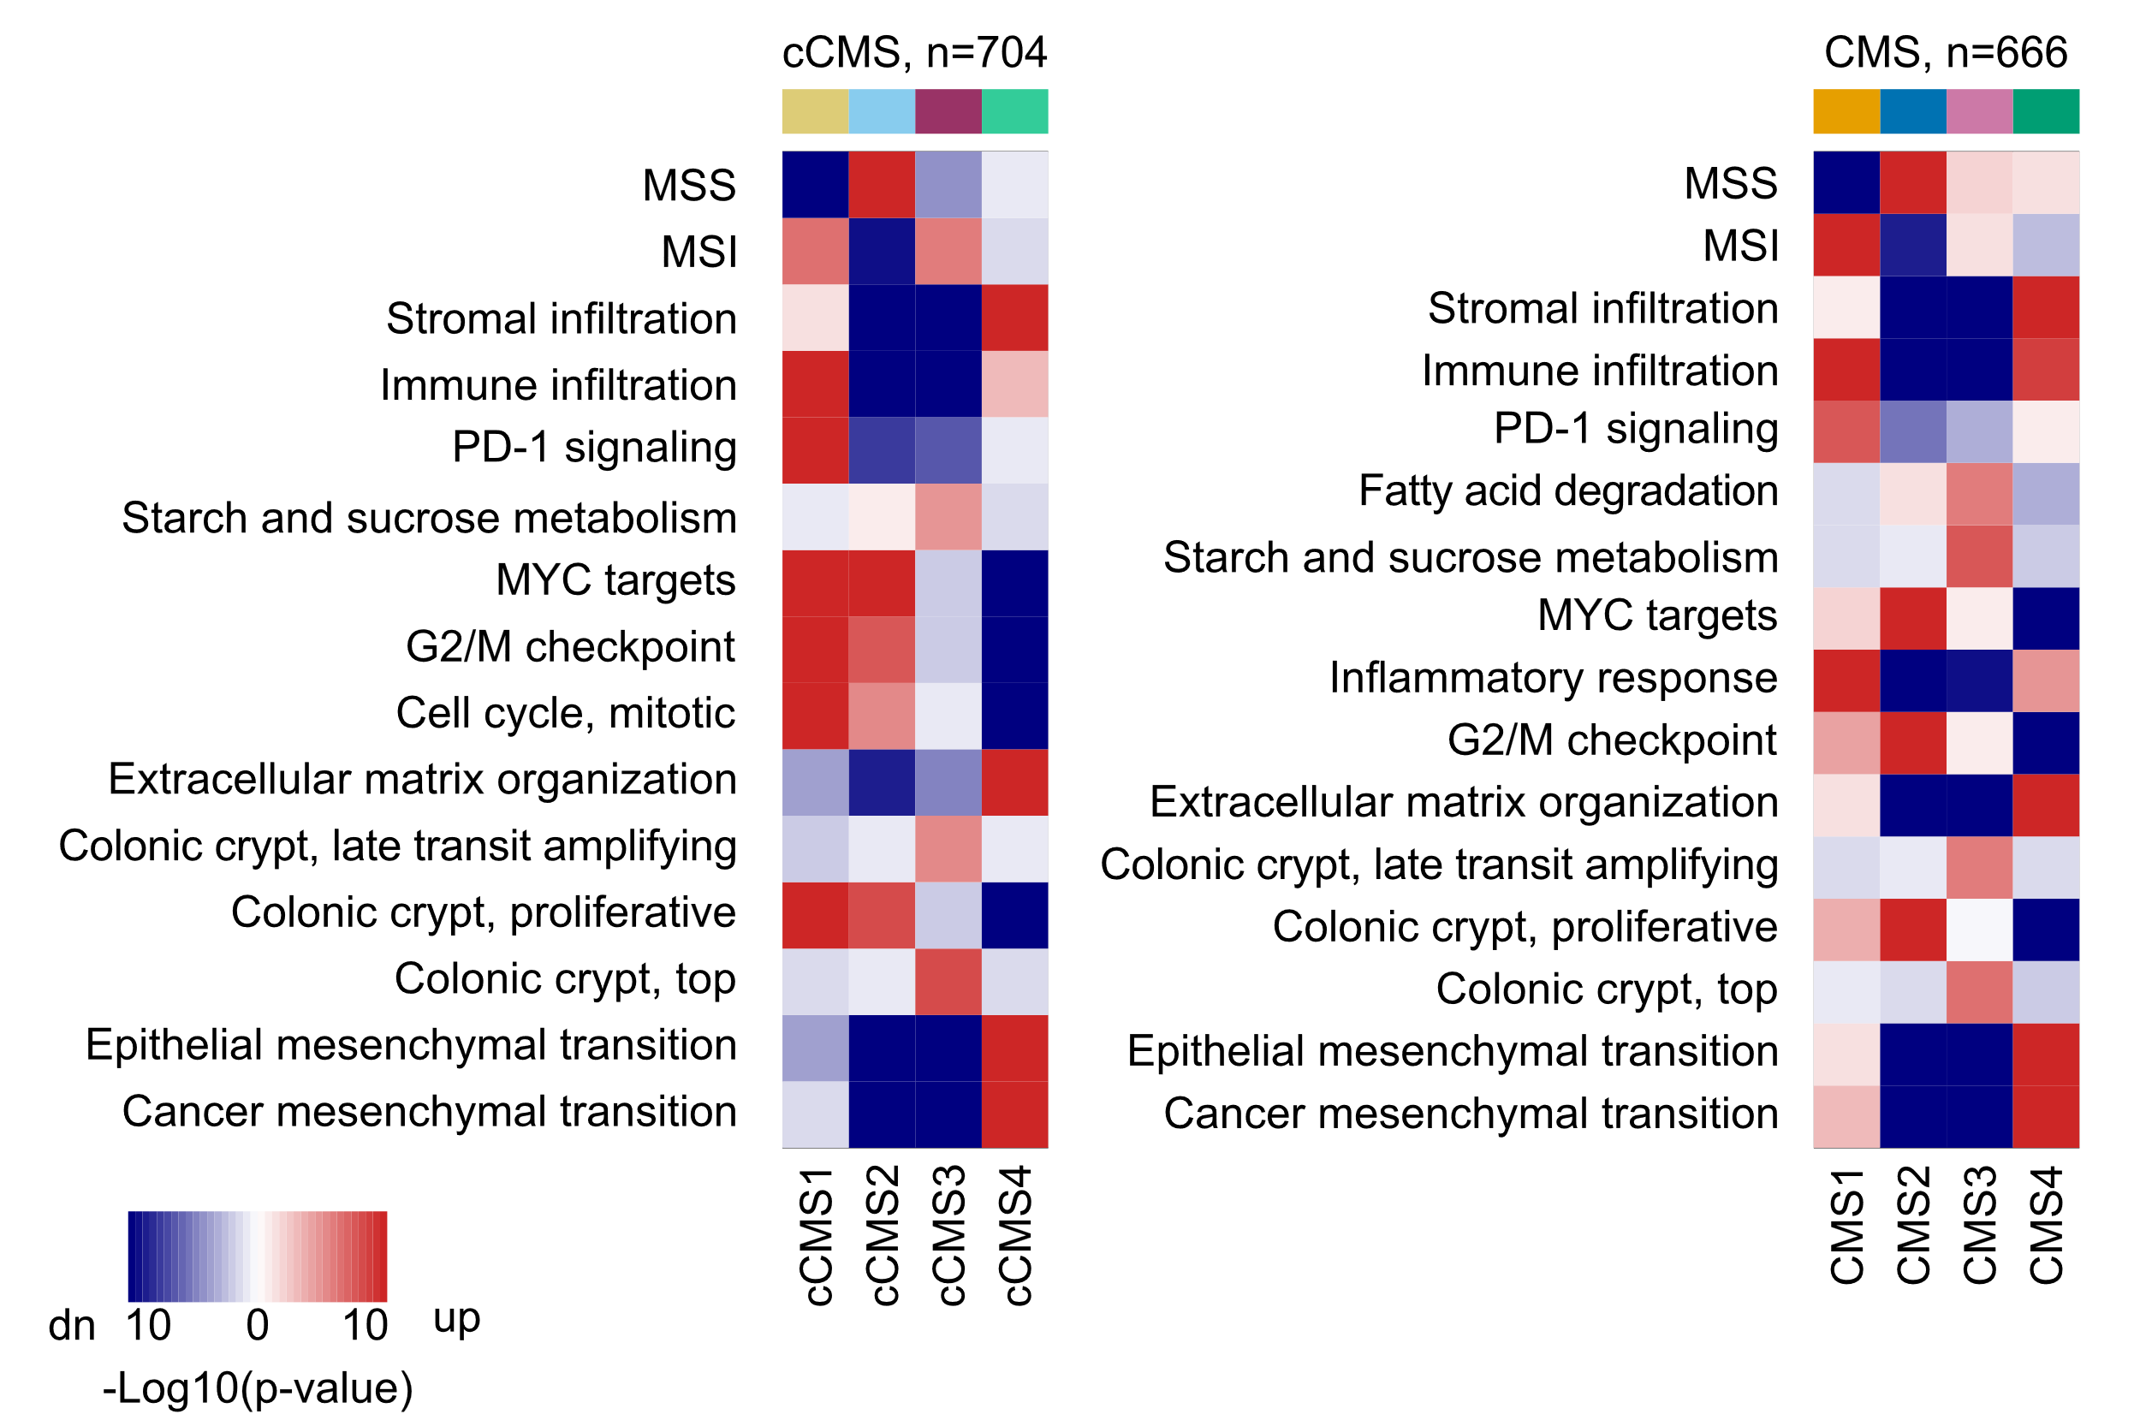

Figure S25. Gene set enrichment analyses according to cCMS and CMS classifications
Heatmap of p-values (log10-scale) of significant enrichments (red: positive enrichments; blue: negative enrichments) from the custom gene set collection, according to NMF classification based on ITH-low genes at k=4 (cCMS; n = 704 classified primary tumor samples) and the original CMS classification (n = 666 classified primary tumor samples).

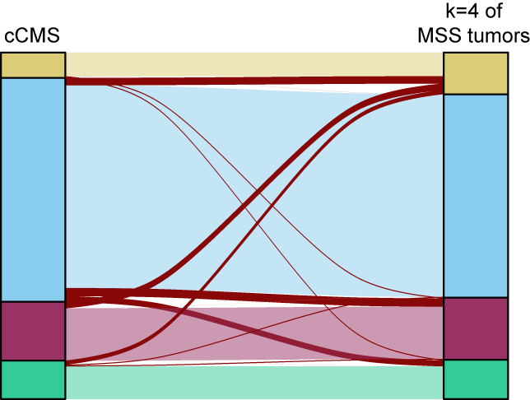

Figure S26. Classification concordance from subtype discovery of all primary CRC samples versus MSS samples only
Alluvial plots of the classification concordance of primary MSS CRC samples (n = 424) based on cCMS (using all primary tumor samples, both MSI and MSS, for subtype discovery) and a repeated subtype discovery of MSS samples only. Discordant classifications are marked in dark red. Subtype discovery was performed with NMF at k=4 on ITH-low genes in both approaches.

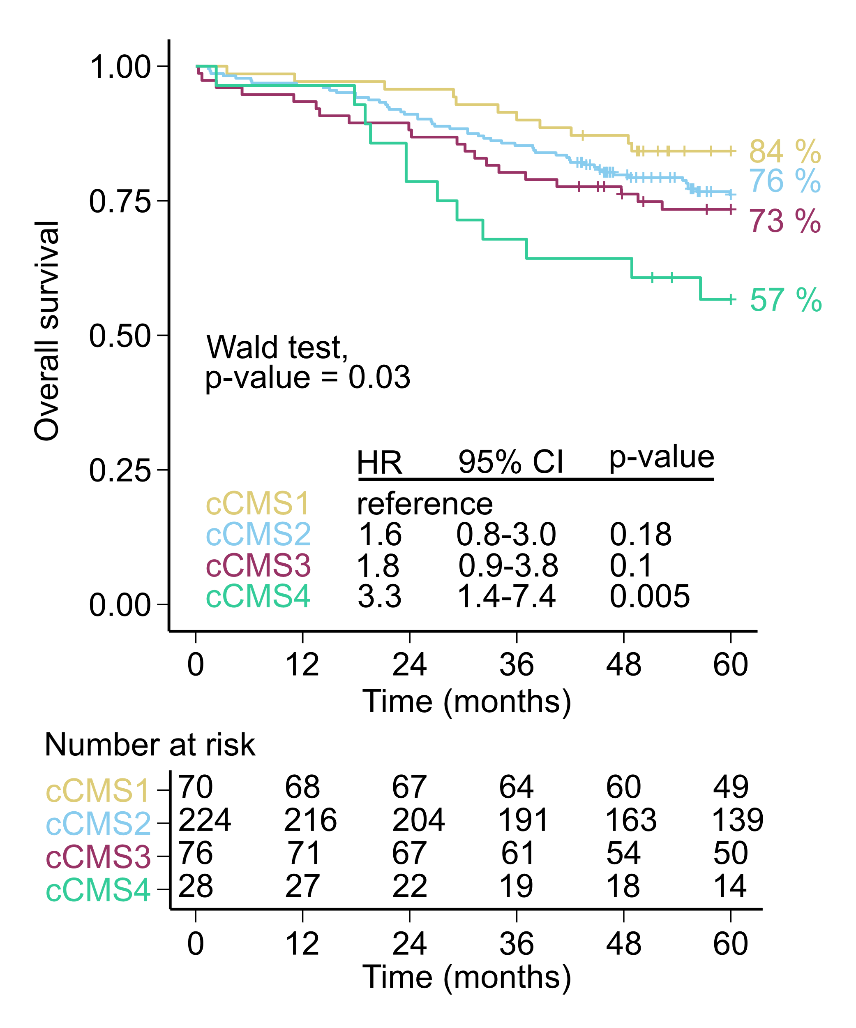

Figure S27. Kaplan-Meier plot of five-year overall survival according to cCMS in stage I-III CRC
Patients with stage IV CRC, incomplete resection (R-status ≠ 0), heterogeneous intra-tumor cCMS classifications, synchronous tumors, or pre-surgical radiation treatment were excluded from analysis (n = 398 patients included). Hazard ratios (HR) are from Cox proportional hazards analyses and p-values from Wald tests.

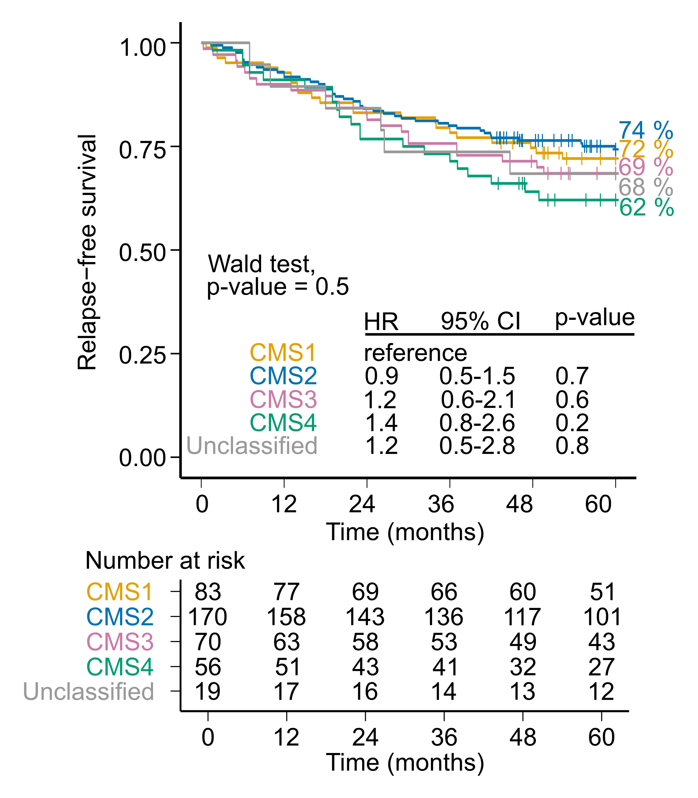

Figure S28. Kaplan-Meier plot of five-year relapse-free survival according to CMS in stage I-III CRC (in the subgroup of patients with concordant intra-tumor cCMS classifications)
Survival analysis according to CMS classification performed in the patient group analyzed in Figure 5D and 5E (patients with concordant intra-tumor cCMS classifications, n = 398). Tumor samples were classified with the original CMSclassifier algorithm and a posterior probability ≥ 0.4. Hazard ratios (HR) are from Cox proportional hazards analyses and p-values from Wald tests.

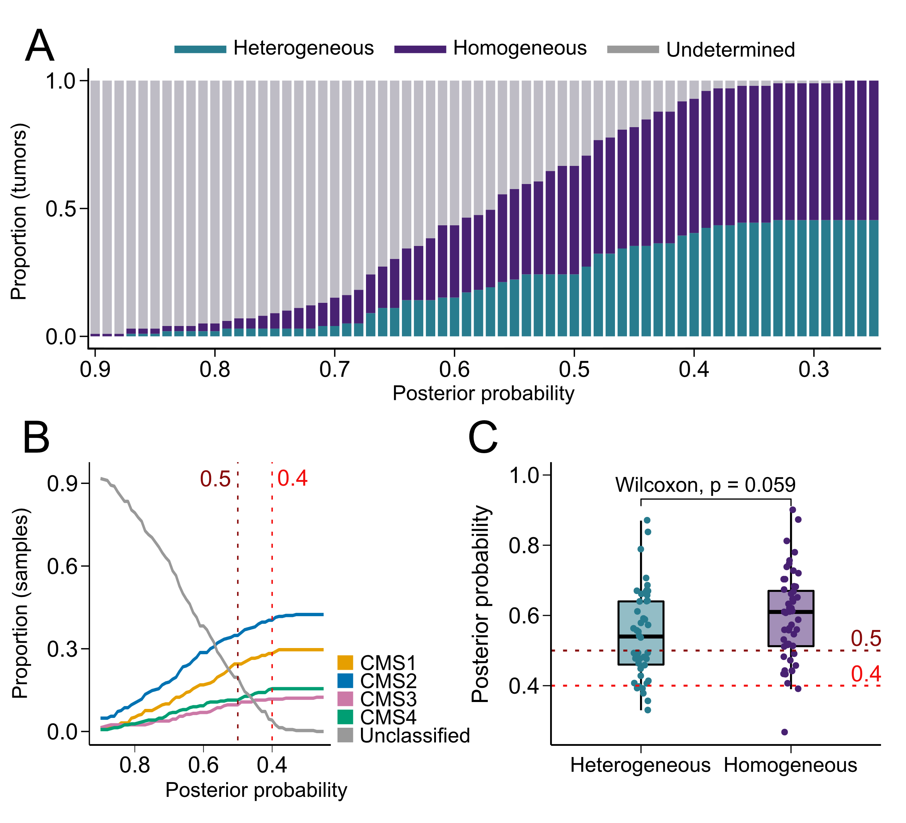

Figure S29. The posterior probability threshold has a limited effect on the frequency of intra-tumor CMS heterogeneity
A) The proportion of tumors (n = 98) in the multiregional sample set (n = 286) with heterogeneous and homogeneous CMS classification, as well as B) the subtype proportions across the sample set, plotted according to posterior probability thresholds (intervals of 0.01) from the random forest CMSclassifier. C) Boxplot showing the lowest posterior probability required to classify each tumor as either heterogeneous or homogeneous for CMS. Each data point represents one tumor, and tumors are grouped as homogeneous or heterogeneous for CMS at the indicated posterior probability. The posterior probability threshold for CMS classification did not have a strong impact on the relative proportions of tumors classified as homogeneous or heterogeneous, or on the relative distribution of the individual CMS classes. However, the proportion of unclassified samples and tumors varied inversely with the posterior probability, and appeared to stabilize at a low level at a posterior probability of approximately 0.4.
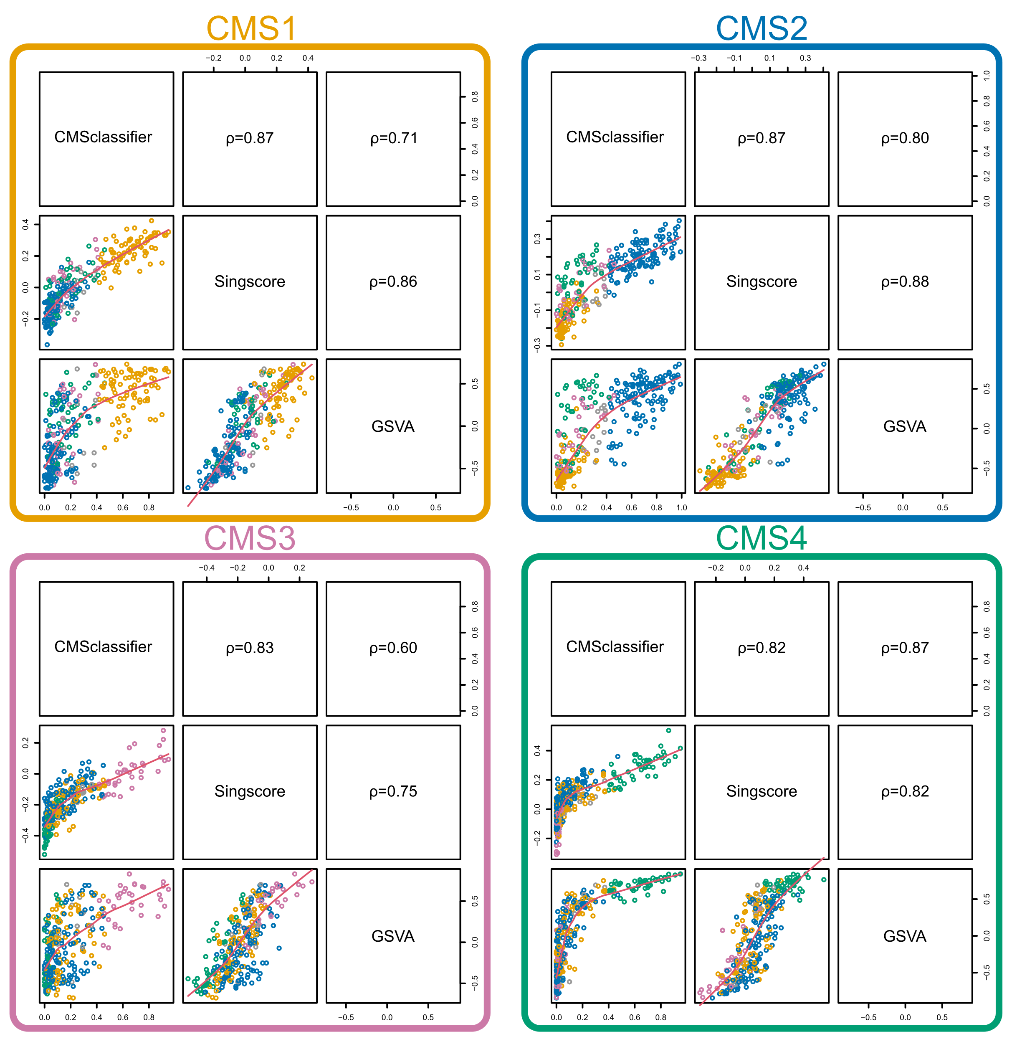

Figure S30. Comparisons of CMS scores from different methods in the multiregional sample set
CMS scores for each sample were obtained as the posterior probabilities (threshold > 0.4) from the original random forest CMSclassifier and as enrichment scores of CMS-specific gene sets using the GSVA and singscore algorithms (GSVA: based on up-regulated genes only). The lower left panels of each matrix show scatter plots of the respective CMS scores, with samples colored according to CMS class based on the CMSclassifier. The upper right panels show the corresponding Spearman’s rank correlation coefficients (ρ).

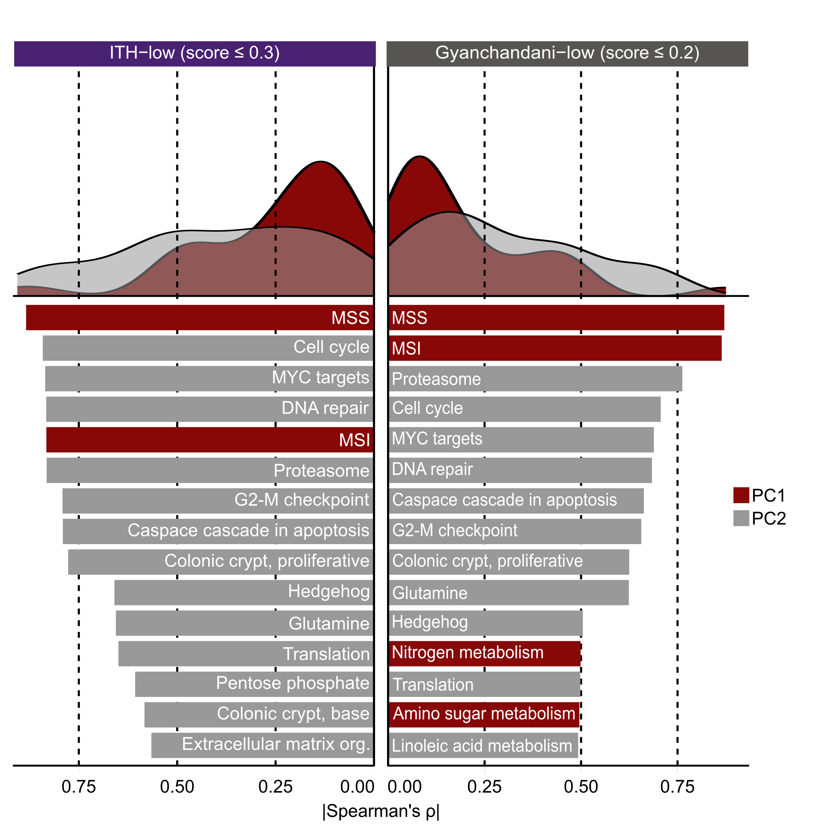

Figure S31. Gene set correlations for ITH-low genes according to original and custom ITH-score thresholds
Left and right plots compare results for custom and previously published ITH-score thresholds (Gyanchandani et al. Clin Cancer Res 2016;22:5362-9) to define ITH-low genes. The density plots show Spearman’s ρ (absolute values) from correlation analyses of principal components (PCs) 1 (red) or 2 (grey) of ITH-low genes with GSVA scores of the custom gene set collection (n = 54) in the multiregional sample set (n = 286 samples). The barplots show the 15 top ranked gene sets from the corresponding analyses.

