Supplementary materials
Table S1. The stability analysis of reference genes in different tissues.
Tissues | Methods | Ranking orders (Better--Good--Average)
Tissues | Methods | 1 | 2 | 3 | 4 | 5 | 6
Heart | Delta CT | β-actin | tubaα | ef1α | gapdh | α-actin | rpl13
Heart | BestKeeper | gapdh | β-actin | ef1α | tubaα | α-actin | rpl13
Heart | Normfinder | β-actin | tubaα | ef1α | gapdh | α-actin | rpl13
Heart | Genorm | β-actin | ef1α | gapdh | tubaα | α-actin | rpl13
Heart | Comprehensive ranking | β-actin | ef1α | gapdh | tubaα | α-actin | rpl13
Brain | Delta CT | β-actin | gapdh | ef1α | tubaα | α-actin | rpl13
Brain | BestKeeper | α-actin | β-actin | ef1α | tubaα | gapdh | rpl13
Brain | Normfinder | β-actin | gapdh | ef1α | tubaα | α-actin | rpl13
Brain | Genorm | tubaα | gapdh | β-actin | ef1α | α-actin | rpl13
Brain | Comprehensive ranking | β-actin | gapdh | tubaα | ef1α | α-actin | rpl13
Muscle | Delta CT | ef1α | tubaα | β-actin | α-actin | gapdh | rpl13
Muscle | BestKeeper | ef1α | tubaα | β-actin | gapdh | α-actin | rpl13
Muscle | Normfinder | β-actin | tubaα | ef1α | α-actin | gapdh | rpl13
Muscle | Genorm | β-actin | ef1α | tubaα | α-actin | gapdh | rpl13
Muscle | Comprehensive ranking | ef1α | β-actin | tubaα | α-actin | gapdh | rpl13
Gill | Delta CT | tubaα | ef1α | α-actin | β-actin | rpl13 | gapdh
Gill | BestKeeper | α-actin | ef1α | β-actin | tubaα | gapdh | rpl13
Gill | Normfinder | tubaα | ef1α | α-actin | rpl13 | gapdh | β-actin
Gill | Genorm | α-actin | ef1α | β-actin | tubaα | rpl13 | gapdh
Gill | Comprehensive ranking | ef1α | α-actin | tubaα | β-actin | rpl13 | gapdh
Liver | Delta CT | gapdh | ef1α | β-actin | rpl13 | tubaα | α-actin
Liver | BestKeeper | ef1α | β-actin | α-actin | gapdh | rpl13 | tubaα
Liver | Normfinder | gapdh | ef1α | β-actin | α-actin | tubaα | rpl13
Liver | Genorm | gapdh | rpl13 | tubaα | ef1α | β-actin | α-actin
Liver | Comprehensive ranking | gapdh | ef1α | β-actin | rpl13 | α-actin | tubaα
Kidney | Delta CT | ef1α | β-actin | gapdh | tubaα | α-actin | rpl13
Kidney | BestKeeper | β-actin | ef1α | gapdh | rpl13 | tubaα | α-actin
Kidney | Normfinder | ef1α | β-actin | tubaα | α-actin | gapdh | rpl13
Kidney | Genorm | β-actin | ef1α | gapdh | α-actin | tubaα | rpl13
Kidney | Comprehensive ranking | ef1α | β-actin | gapdh | tubaα | α-actin | rpl13
Intestines | Delta CT | β-actin | ef1α | tubaα | α-actin | gapdh | rpl13
Intestines | BestKeeper | α-actin | gapdh | ef1α | β-actin | rpl13 | tubaα
Intestines | Normfinder | β-actin | ef1α | tubaα | α-actin | gapdh | rpl13
Intestines | Genorm | β-actin | ef1α | α-actin | gapdh | tubaα | rpl13
Intestines | Comprehensive ranking | β-actin | ef1α | α-actin | gapdh | tubaα | rpl13

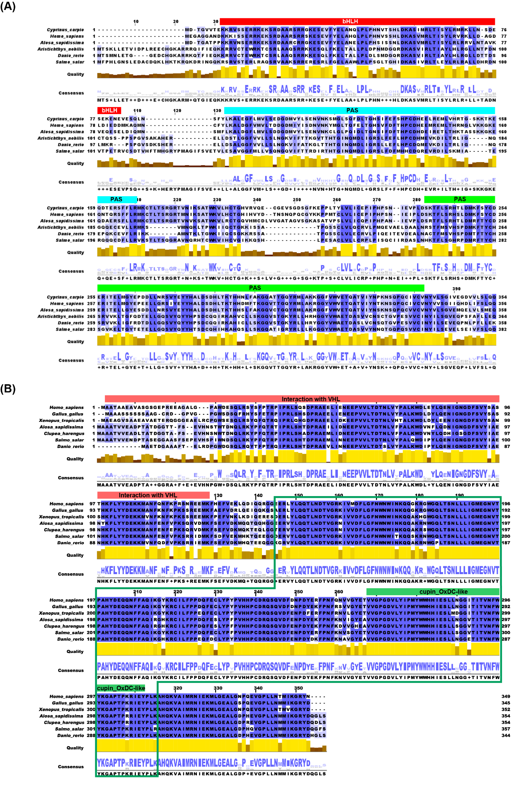
Fig. S1 Alignment of the amino acid sequences of AsHif1α (A) and AsFih1 (B).

