Electronic Supplementary Information

for

Pyridine-mediated B–B bond cleavage of tetrahydroxydiboron to synthesize n-doped SWCNTs with long-term air stability

Naoki Tanaka*, Aoi Hamasuna, Itsuki Yamaguchi, Koichiro Kato, and Tsuyohiko Fujigaya*

Corresponding Author
Naoki Tanaka: tanaka.naoki.468@m.kyushu-u.ac.jp
Tsuyohiko Fujigaya: fujigaya.tsuyohiko.948@m.kyushu-u.ac.jp

Figure S1 Seebeck coefficient of the doped SWCNT films using 4-CNpy (red), 4-Phpy (blue), 4-COOHpy (yellow green), and B₂(OH)₄ (green) in air. Black shows pristine SWCNT films.

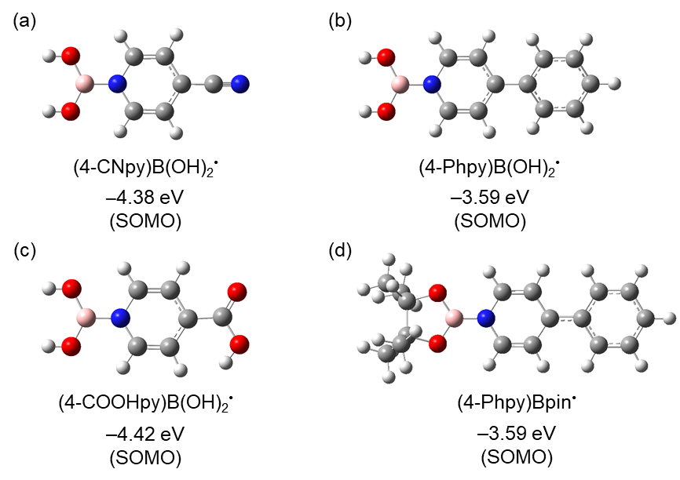

Figure S2. Energy levels of (4-CNpy)B(OH)₂•, (4-Phpy)B(OH)₂•, (4-COOHpy)B(OH)₂•, and (4-Phpy)Bpin• in optimized geometries [UB3LYP/6-31G++(d,p) level of theory].

Figure S3 XPS survey scans of the N-doped SWCNT films using B₂(OH)₄/4-Phpy.

Figure S4 XPS narrow scans of B 1s for pristine SWCNT film (black) and SWCNT film after immersing in B₂(OH)₄ solution (red).

Figure S5. Resonance structures of boryl radicals and dopant cations.

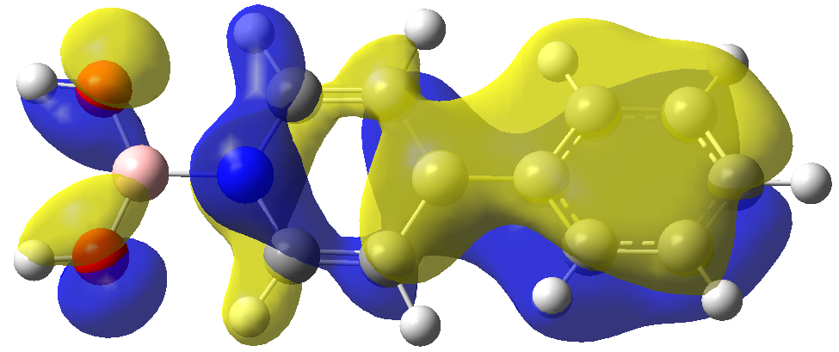

Figure S6. Molecular orbital of HOMO–7 of (4-Phpy)B(OH)₂⁺ in the optimized geometry [B3LYP/6-31G(d,p)].

Figure S7. Thermogravimetric analysis of pristine SWCNT film (black) the n-doped SWCNT films using B₂pin₂/4-Phpy (red) and B₂OH₄/4-Phpy (blue)

Table S1. Energy gain after doping of SWCNT using B₂OH₄/4-CNpy, B₂OH₄/4Phpy, B₂pin₂/4-CNpy, and B₂pin₂/4-Phpy.
 | Complex [Hartree] | SWCNT [Hartree] | Dopant [Hartree] | Energy gain [Hartree] | Energy gain [kcal/mol]
(4-CNpy)B(OH)₂  /SWCNT | –8151.952 | –7634.718 | –517.194 | –0.040 | –25.154
(4-Phpy)B(OH)₂  /SWCNT | –8290.791 | –7634.718 | –656.023 | –0.050 | –31.290
(4-CNpy)Bpin  /SWCNT | –8386.671 | –7634.718 | –751.899 | –0.053 | –33.223
(4-Phpy)Bpin  /SWCNT | –8525.510 | –7634.718 | –890.729 | –0.063 | –39.413

Table S2. Charge change of dopants before and after doping.
 | Molecular charge in isolation [e] | Molecular charge after doping [e]
(4-CNpy)B(OH)₂• | 0 | +0.02
(4-Phpy)B(OH)₂• | 0 | +0.21
(4-CNpy)Bpin• | 0 | +0.10
(4-Phpy)Bpin• | 0 | +0.01

