Table S2.
(A) Confusion matrix.
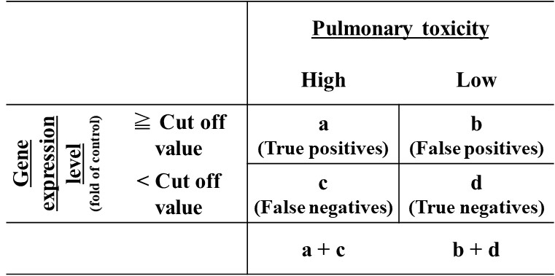
Sensitivity = $\frac{The number of the true positives}{The number of true positives + The number of false negatives}=\frac{a}{a + c}$
Specificity = $\frac{The number of true negatives}{The number of false positives + The number of true negatives}= \frac{d}{b + d}$
False positive = $\frac{The number of false positives}{The number of false positives + The number of true negatives}= \frac{b}{b + d}$
False negative = $\frac{The number false negatives}{The number of true positives + The number of false negatives}= \frac{c}{a + c}$
a: The number of true positives, b: The number of false positives,
c: The number of false negatives, d: The number of true negatives

(B) Example of confusion matrix.
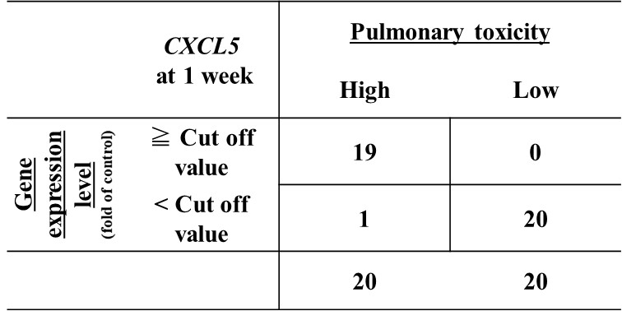
For example, in CXCL5 at 1 week after instillation:
Sensitivity = $\frac{19}{19 + 1}$ = 0.95, Specificity = $\frac{20}{0 + 20}$ =1.00,
False positive = $\frac{0}{0 + 20}$ = 0.00, False negative = $\frac{1}{19 + 1}$ = 0.05

