Table S1. P values of gene expression of 5 chemokines in lung exposed to nanomaterials.

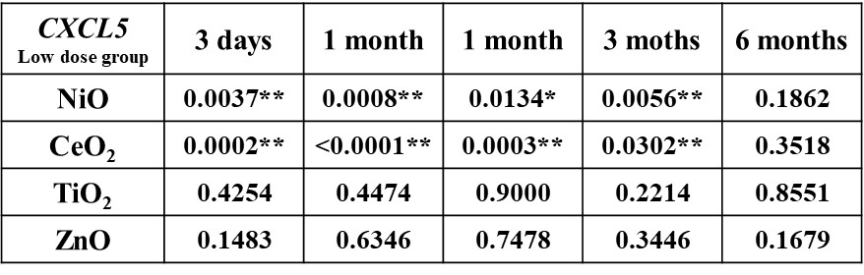
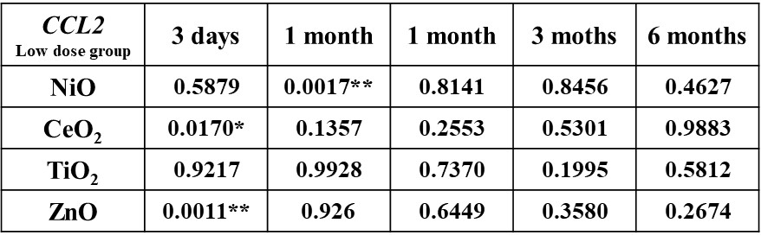
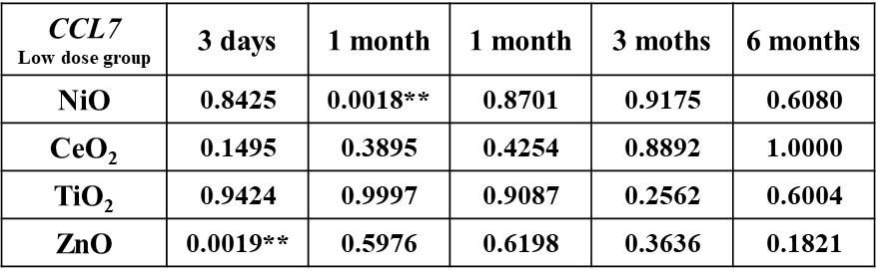
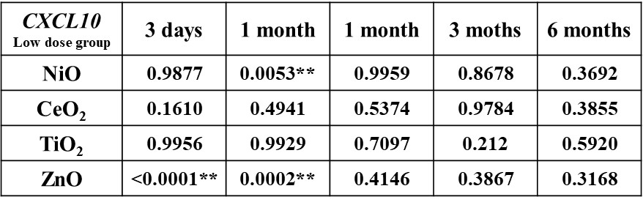
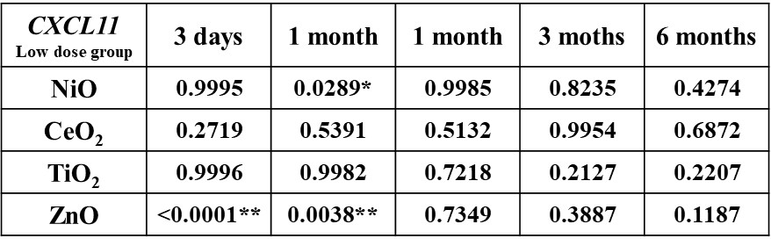

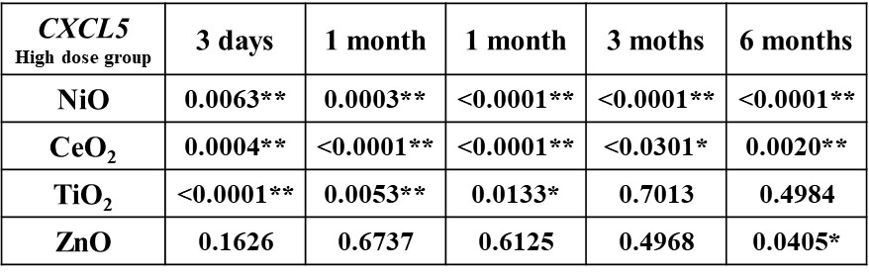
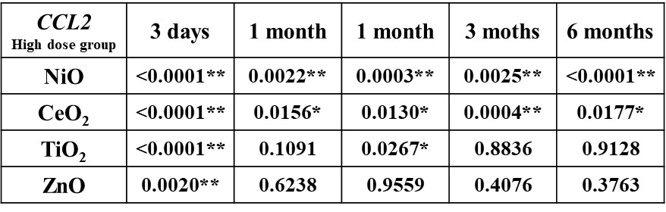
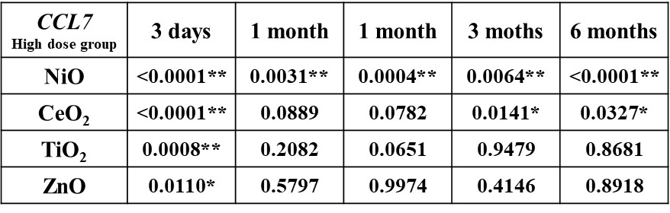
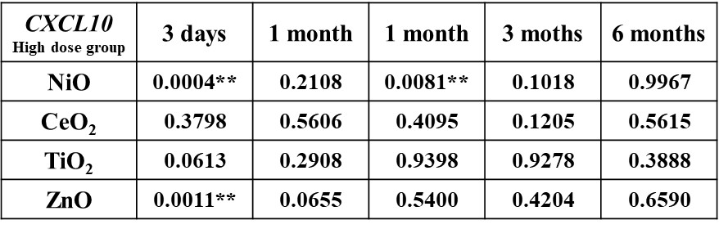
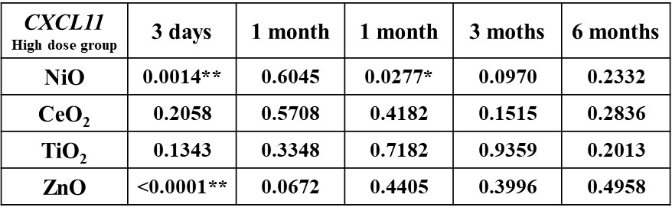
Asterisks indicate significant differences compared with each control (Dunnett’ test) (* p <0.05, ** p <0.01).

