SUPPLEMENTARY APPENDIX
Supplement to: Establishment and characterization of a patient-derived solitary fibrous tumor/hemangiopericytoma cell line model

CONTENTS
- Supplementary Figures
Supplementary Figure S1. Overview of whole transcriptomic sequencing data in SFT-S1 cell lines treated with or without dasatinib.
Supplementary Figure S2. Dose response curves for 10 of 14 targeted agents evaluated in the SFT-S1 cell line.
Supplementary Figure S3. Differentially Methylated Regions and Loci in the SFT-S1 cell line model compared to normal tissue.

- Supplementary Tables (excel file)
Supplementary Table S1. Short tandem repeat (STR) genotyping of the SFT-S1 cell line
Supplemental Table S2. List of nonsynonymous somatic mutations identified from whole-genome sequencing Supplementary Table S3. List of genes identified from somatic copy number alterations analysis
Supplementary Table S4. IC50 values of targeted agents in SFT-S1 cell line
Supplementary Table S5. List of transcripts in the tumor and matched adjacent normal tissue (expressed in transcripts per million)
Supplementary Table S6. Differentially-expressed genes between cell lines treated with and without dasatinib

SUPPLEMENTARY FIGURES
Supplementary Figure S1. Overview of whole transcriptomic sequencing data in SFT-S1 cell lines treated with or without dasatinib. a) Principal Component Analysis (PCA) plot showing that whole transcriptomic sequencing data clustered by treatment groups along PC1. b) Similar results were demonstrated on a distance plot.

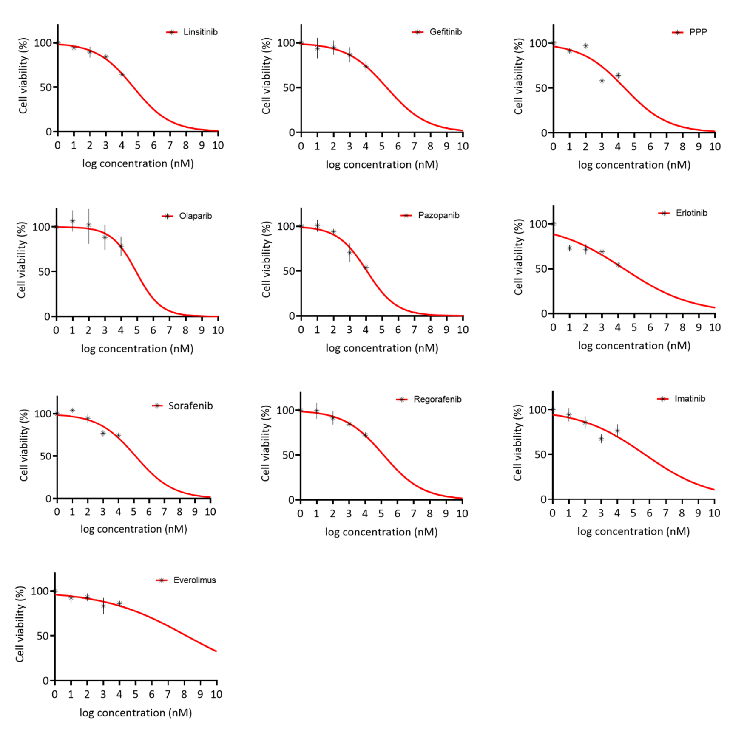
Supplementary Figure S2. Dose response curves for 10 of 14 targeted agents evaluated in the SFT-S1 cell line.

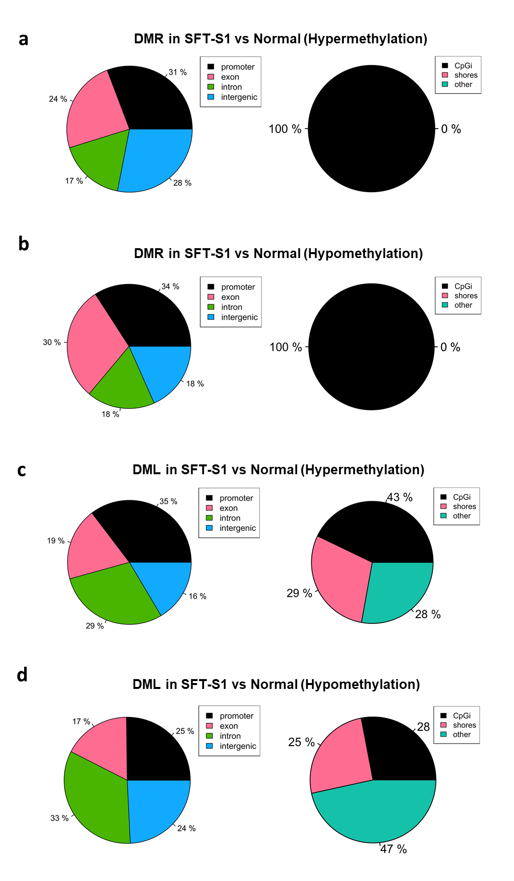
Supplementary Figure S3. Differentially Methylated Regions and Loci in the SFT-S1 cell line model compared to normal tissue. a-b) Percentage of the total Differentially Methylated Regions (DMRs) that are associated with a particular genomic location or CpG Islands (CGIs) in cell line vs normal tissue. c-d) Percentage of the total Differentially Methylated Loci (DML) that are associated with a particular genomic location or CpG Islands (CGIs) in cell line vs normal tissue.

