Supplementary information
Enhancement of Electrocatalysis through Magnetic Field Effects on Mass Transport
Priscila Vensaus,^{1,2,3,*} Yunchang Liang,^{1,2,*} Jean-Philippe Ansermet,² Galo J. A. A. Soler-Illia,³ Magalí Lingenfelder^{1,2,#}

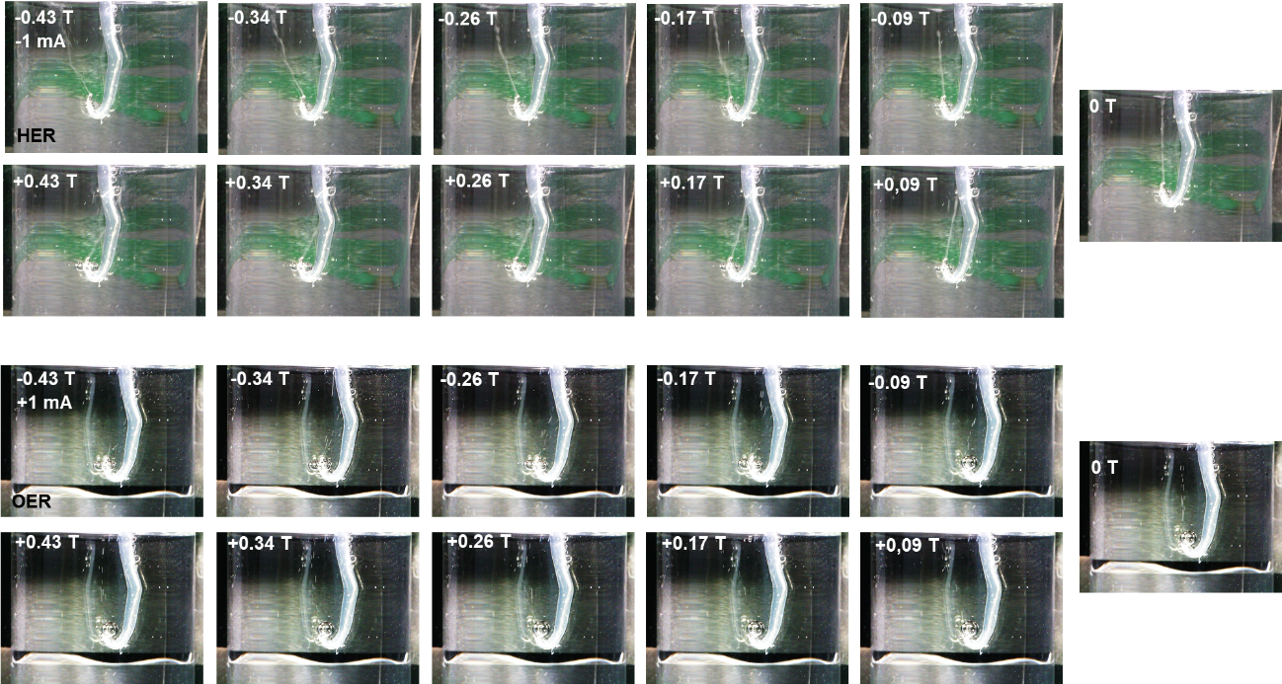
Supplementary Figure 1 | Photos of the H₂ and O₂ bubble movements under different magnetic fields. The fine line emanating from the electrode is a tight string of bubbles. Hydrogen bubbles are typically smaller and are seen as a straight line in the images. Oxygen bubbles tend to evolve as larger bubbles and can be seen separately.

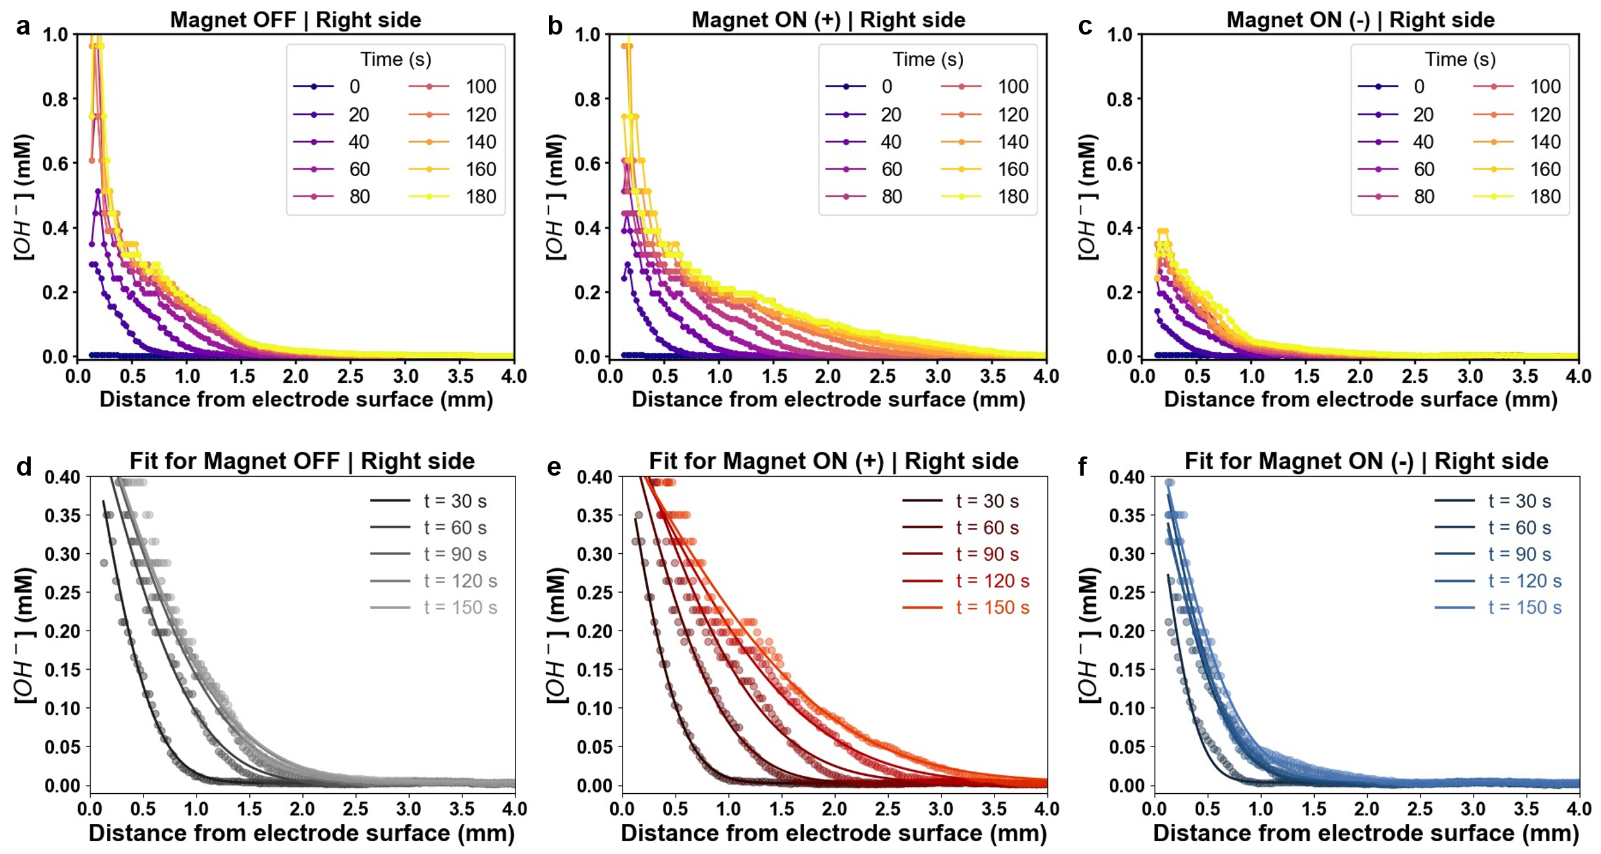
Supplementary Figure 2 | Estimated OH⁻ concentration profiles under different magnetic conditions (a – c) and their corresponding fits with equ 7 for data in the range of 0 to 0.40 mM (d-f).

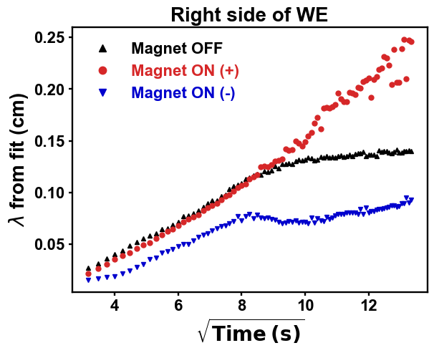
Supplementary Figure 3 | OH⁻ diffusion length (λ) vs the square root of time, estimated from the fitting of the concentration profiles shown in Suppl. Fig. 2. During the first 90 seconds of the reaction, the diffusion length follows a linear relationship with the square root of the time, as described by fickian diffusion ($λ=2\sqrt{Dt}$). After this time, diffusion of hydronium ions towards the right side of the Pt electrode seems to increase when the magnetic field is turned on towards the positive direction (slope slightly increases), while it leans towards a plateau in the case of negative direction or when the magnetic field was turned off.

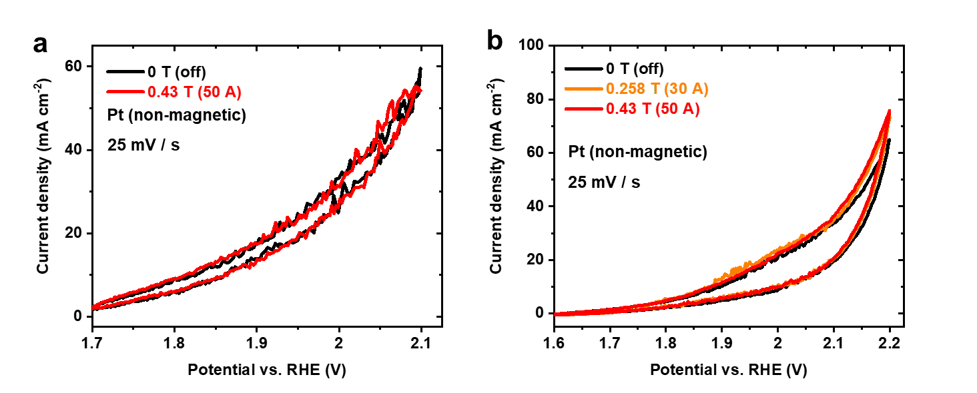
Supplementary Figure 4 | OER at a Pt microelectrode. No magnetic field effect can be seen when the upper potential was 2.1 V vs. RHE in a. Higher overpotentials in b led to enhancement in the current.

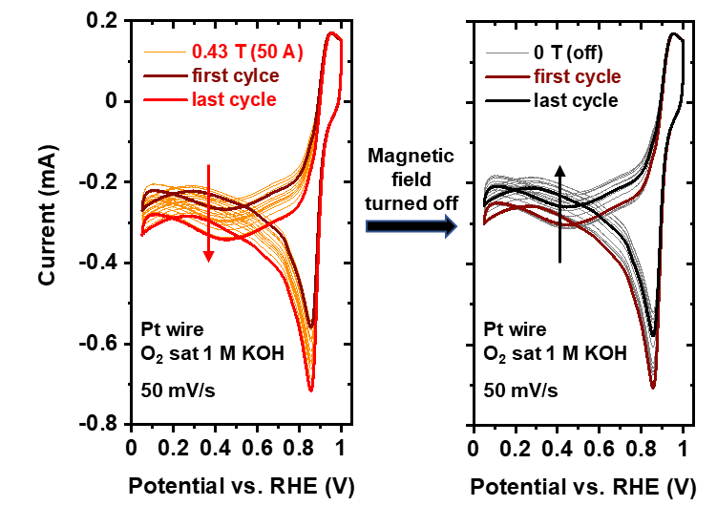
Supplementary Figure 5 | CV of a Pt wire in O₂-saturated KOH. The magnetic field was first switched to 0.43 T and several scans were recorded. Then the magnetic field was turned off. The first and last cycles in both cases are highlighted in bold.

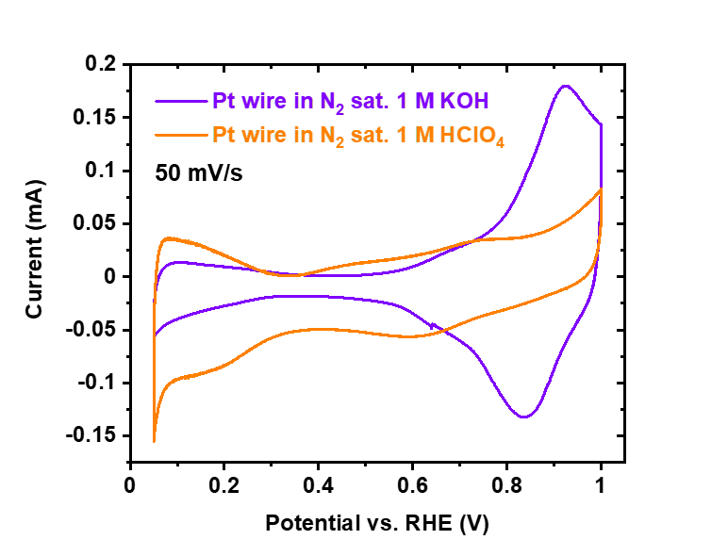
Supplementary Figure 6 | CVs of the Pt wire in N₂ saturated electrolytes. Note that the surface area of the Pt wire depends on the immersed length of the wire in the electrolytes.

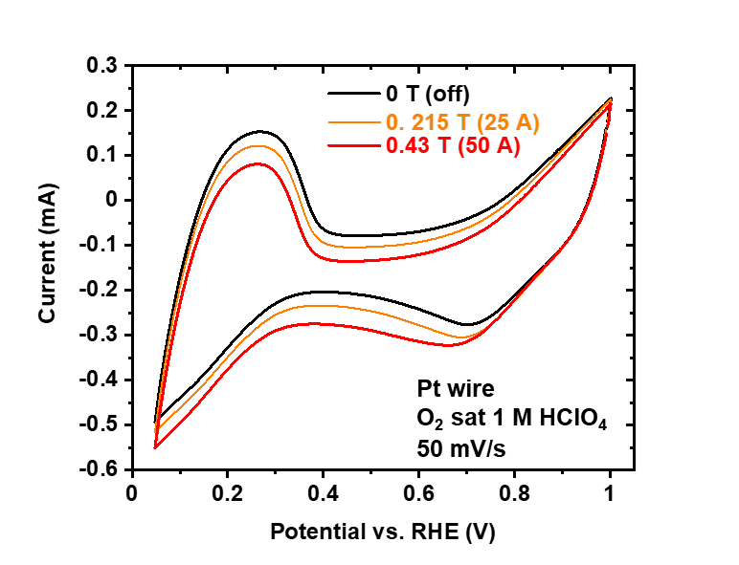
Supplementary Figure 7 | CVs of a Pt wire in O₂-saturated HClO₄. The magnetic field was first switched from 0 T (off) to 0.215 T, and finally, to 0.43 T. Only the last cycles under each magnetic field are shown here.
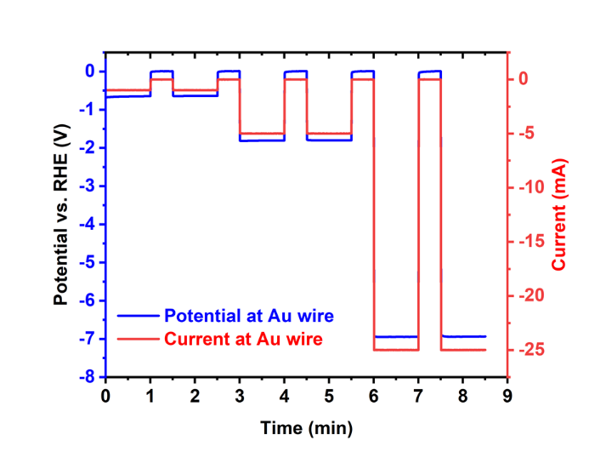
Supplementary Figure 8 | Potential and current at the Au WE next to the isolated Pt wire.

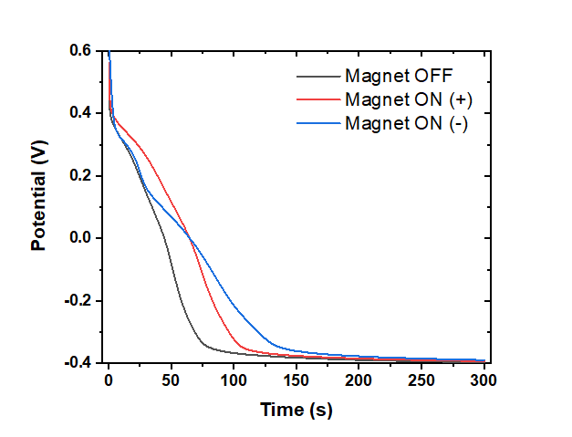
Supplementary Figure 9 | Chronopotentiometries at -0.2 mA of Pt foil WE during the recording of Supplementary Video 3.

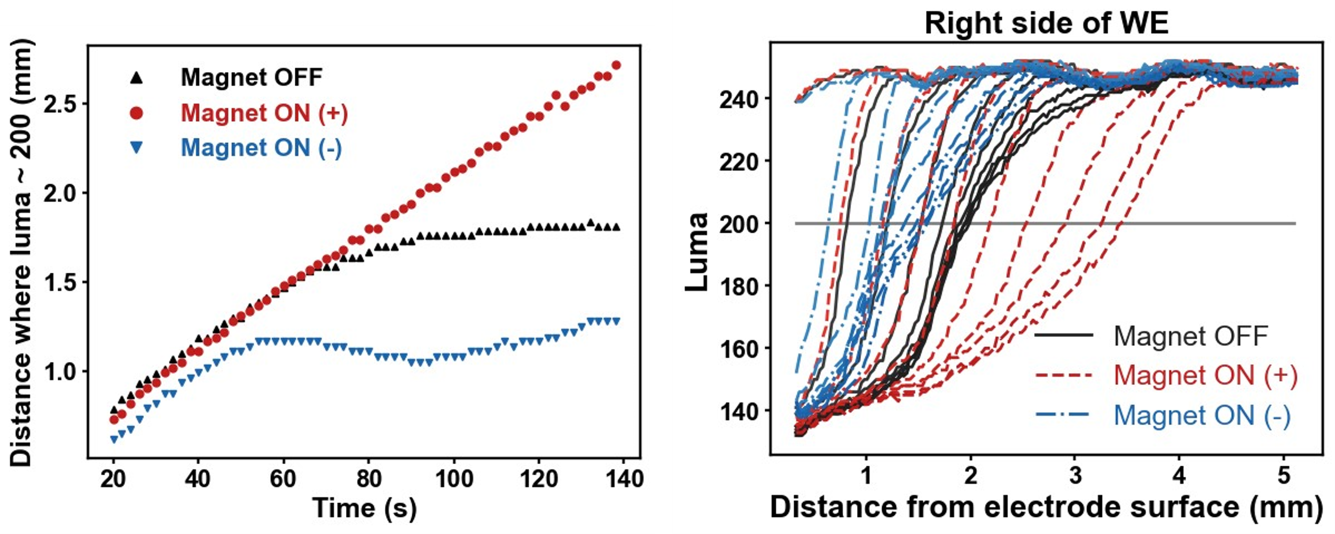
Supplementary Figure 10 | a, OH⁻ diffusion length (λ) vs. time, estimated by taking the value where luma = 200 in b.

